Calculator App Run

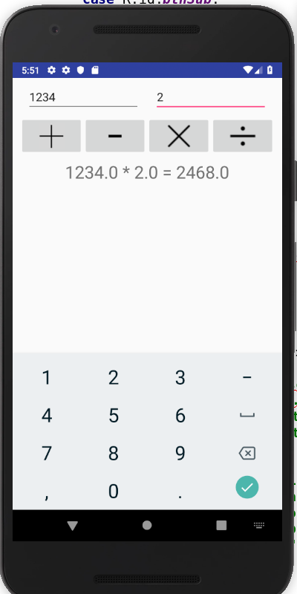

Calculator App Code

MainActivity.java

**package** com.example.a004893625csusbedu.simplecalc;

**import** android.os.Bundle;

**import** android.app.Activity;

**import** android.content.DialogInterface;

**import** android.content.DialogInterface.OnClickListener;

**import** android.text.TextUtils;

**import** android.view.Menu;

**import** android.view.View;

**import** android.widget.Button;

**import** android.widget.EditText;

**import** android.widget.ImageButton;

**import** android.widget.TextView;

**public class** MainActivity **extends** Activity **implements** View.OnClickListener {

EditText **etNum1**;

EditText **etNum2**;

ImageButton **btnAdd**;

ImageButton **btnSub**;

ImageButton **btnMult**;

ImageButton **btnDiv**;

TextView **tvResult**;

String **oper** = **""**;

*/** Called when the activity is first created. */*

@Override

**public void** onCreate(Bundle savedInstanceState) {

**super**.onCreate(savedInstanceState);

setContentView(R.layout.***activity_main***);

*// find the elements*

**etNum1** = (EditText) findViewById(R.id.***etNum1***);

**etNum2** = (EditText) findViewById(R.id.***etNum2***);

**btnAdd** = (ImageButton) findViewById(R.id.***btnAdd***);

**btnSub** = (ImageButton) findViewById(R.id.***btnSub***);

**btnMult** = (ImageButton) findViewById(R.id.***btnMult***);

**btnDiv** = (ImageButton) findViewById(R.id.***btnDiv***);

**tvResult** = (TextView) findViewById(R.id.***tvResult***);

*// set a listener*

**btnAdd**.setOnClickListener(**this**);

**btnSub**.setOnClickListener(**this**);

**btnMult**.setOnClickListener(**this**);

**btnDiv**.setOnClickListener(**this**);

}

@Override

**public void** onClick(View v) {

*//* ***TODO Auto-generated method stub***

**float** num1 = 0;

**float** num2 = 0;

**float** result = 0;

*// check if the fields are empty*

**if** (TextUtils.*isEmpty*(**etNum1**.getText().toString())

|| TextUtils.*isEmpty*(**etNum2**.getText().toString())) {

**return**;

}

*// read EditText and fill variables with numbers*

num1 = Float.*parseFloat*(**etNum1**.getText().toString());

num2 = Float.*parseFloat*(**etNum2**.getText().toString());

*// defines the button that has been clicked and performs the corresponding operation*

*// write operation into oper, we will use it later for output*

**switch** (v.getId()) {

**case** R.id.***btnAdd***:

**oper** = **"+"**;

result = num1 + num2;

**break**;

**case** R.id.***btnSub***:

**oper** = **"-"**;

result = num1 - num2;

**break**;

**case** R.id.***btnMult***:

**oper** = **"*"**;

result = num1 * num2;

**break**;

**case** R.id.***btnDiv***:

**oper** = **"/"**;

result = num1 / num2;

**break**;

**default**:

**break**;

}

*// form the output line*

**tvResult**.setText(num1 + **" "** + **oper** + **" "** + num2 + **" = "** + result);

}

}

activity_main.xml

*<?***xml version="1.0" encoding="utf-8"***?>*

<**LinearLayout xmlns:android="http://schemas.android.com/apk/res/android"**

**xmlns:app="http://schemas.android.com/apk/res-auto"**

**android:layout_width="match_parent"**

**android:layout_height="fill_parent"**

**android:orientation="vertical"**>

<**LinearLayout**

**android:id="@+id/linearLayout1"**

**android:layout_width="match_parent"**

**android:layout_height="wrap_content"**

**android:layout_marginLeft="10pt"**

**android:layout_marginTop="3pt"**

**android:layout_marginRight="10pt"**>

<**EditText**

**android:id="@+id/etNum1"**

**android:layout_width="match_parent"**

**android:layout_height="wrap_content"**

**android:layout_marginRight="5pt"**

**android:layout_weight="1"**

**android:inputType="numberDecimal"**></**EditText**>

<**EditText**

**android:id="@+id/etNum2"**

**android:layout_width="match_parent"**

**android:layout_height="wrap_content"**

**android:layout_marginLeft="5pt"**

**android:layout_weight="1"**

**android:inputType="numberDecimal"**></**EditText**>

</**LinearLayout**>

<**LinearLayout**

**android:id="@+id/linearLayout2"**

**android:layout_width="match_parent"**

**android:layout_height="wrap_content"**

**android:layout_marginLeft="5pt"**

**android:layout_marginTop="3pt"**

**android:layout_marginRight="5pt"**>

<**ImageButton**

**android:id="@+id/btnAdd"**

**android:layout_width="40dp"**

**android:layout_height="60dp"**

**android:layout_weight="1"**

**android:src="@drawable/plus"**></**ImageButton**>

<**ImageButton**

**android:id="@+id/btnSub"**

**android:layout_width="40dp"**

**android:layout_height="60dp"**

**android:layout_weight="1"**

**android:src="@drawable/minus"**></**ImageButton**>

<**ImageButton**

**android:id="@+id/btnMult"**

**android:layout_width="40dp"**

**android:layout_height="60dp"**

**android:layout_weight="1"**

**android:src="@drawable/multiplication"**></**ImageButton**>

<**ImageButton**

**android:id="@+id/btnDiv"**

**android:layout_width="40dp"**

**android:layout_height="60dp"**

**android:layout_weight="1"**

**android:src="@drawable/division"**></**ImageButton**>

</**LinearLayout**>

<**TextView**

**android:id="@+id/tvResult"**

**android:layout_width="match_parent"**

**android:layout_height="wrap_content"**

**android:layout_marginLeft="5pt"**

**android:layout_marginTop="3pt"**

**android:layout_marginRight="5pt"**

**android:gravity="center_horizontal"**

**android:textSize="12pt"**></**TextView**>

</**LinearLayout**>

Fragments App Run

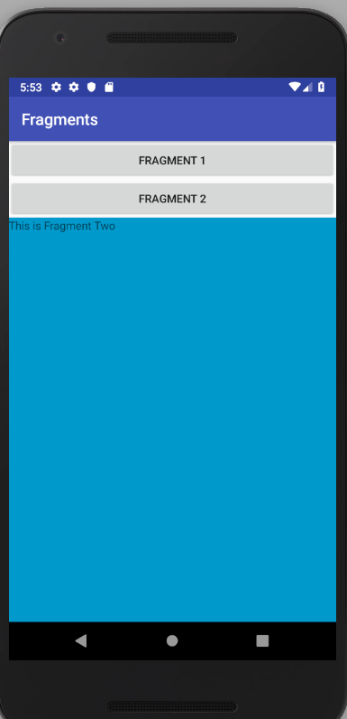

Fragments App Code

Fragment One Code

**package** com.example.a004893625csusbedu.fragments;

**import** android.content.Context;

**import** android.net.Uri;

**import** android.os.Bundle;

**import** android.app.Fragment;

**import** android.view.LayoutInflater;

**import** android.view.View;

**import** android.view.ViewGroup;

*/\*\**

*\* A simple {****@link*** *Fragment} subclass.*

*\* Activities that contain this fragment must implement the*

*\* {****@link*** *FragmentOne.OnFragmentInteractionListener} interface*

*\* to handle interaction events.*

*\* Use the {****@link*** *FragmentOne#newInstance} factory method to*

*\* create an instance of this fragment.*

*\*/*

**public class** FragmentOne **extends** Fragment {

@Override

**public** View onCreateView(LayoutInflater inflater, ViewGroup container,

Bundle savedInstanceState) {

*// Inflate the layout for this fragment*

**return** inflater.inflate(R.layout.***fragment_fragment_one***, container, **false**);

}

Fragment Two Code

**package** com.example.a004893625csusbedu.fragments;

**import** android.content.Context;

**import** android.net.Uri;

**import** android.os.Bundle;

**import** android.app.Fragment;

**import** android.view.LayoutInflater;

**import** android.view.View;

**import** android.view.ViewGroup;

*/\*\**

*\* A simple {****@link*** *Fragment} subclass.*

*\* Activities that contain this fragment must implement the*

*\* {****@link*** *FragmentTwo.OnFragmentInteractionListener} interface*

*\* to handle interaction events.*

*\* Use the {****@link*** *FragmentTwo#newInstance} factory method to*

*\* create an instance of this fragment.*

*\*/*

**public class** FragmentTwo **extends** Fragment {

@Override

**public** View onCreateView(LayoutInflater inflater, ViewGroup container,

Bundle savedInstanceState) {

*// Inflate the layout for this fragment*

**return** inflater.inflate(R.layout.***fragment_fragment_two***, container, **false**);

}

}

MainActivity Code

**package** com.example.a004893625csusbedu.fragments;

**import** android.app.Fragment;

**import** android.app.FragmentManager;

**import** android.app.FragmentTransaction;

**import** android.support.v7.app.AppCompatActivity;

**import** android.os.Bundle;

**import** android.view.View;

**public class** MainActivity **extends** AppCompatActivity {

@Override

**protected void** onCreate(Bundle savedInstanceState) {

**super**.onCreate(savedInstanceState);

setContentView(R.layout.***activity_main***);

}

**public void** ChangeFragment(View view) {

Fragment fragment;

**if**(view == findViewById(R.id.***button***)) {

fragment = **new** FragmentOne();

FragmentManager fm = getFragmentManager();

FragmentTransaction ft = fm.beginTransaction();

ft.replace(R.id.***fragment_place***, fragment);

ft.commit();

}

**if**(view == findViewById(R.id.***button2***)) {

fragment = **new** FragmentTwo();

FragmentManager fm = getFragmentManager();

FragmentTransaction ft = fm.beginTransaction();

ft.replace(R.id.***fragment_place***, fragment);

ft.commit();

}

}

}

activity_main.xml code

*<?***xml version="1.0" encoding="utf-8"***?>*

<**LinearLayout xmlns:android="http://schemas.android.com/apk/res/android"**

**xmlns:app="http://schemas.android.com/apk/res-auto"**

**xmlns:tools="http://schemas.android.com/tools"**

**android:layout_width="match_parent"**

**android:layout_height="match_parent"**

**android:orientation="vertical"**

**tools:context=".MainActivity"**>

<**Button**

**android:id="@+id/button"**

**android:layout_width="match_parent"**

**android:layout_height="wrap_content"**

**android:onClick="ChangeFragment"**

**android:text="Fragment 1"**

**android:visibility="visible"** />

<**Button**

**android:id="@+id/button2"**

**android:layout_width="match_parent"**

**android:layout_height="wrap_content"**

**android:onClick="ChangeFragment"**

**android:text="Fragment 2"** />

<**fragment**

**android:name="com.example.a004893625csusbedu.fragments.FragmentOne"**

**android:id="@+id/fragment_place"**

**android:layout_width="match_parent"**

**android:layout_height="match_parent"** />

</**LinearLayout**>

fragment_one.xml code

*?***xml version="1.0" encoding="utf-8"***?>*

<**FrameLayout xmlns:android="http://schemas.android.com/apk/res/android"**

**xmlns:tools="http://schemas.android.com/tools"**

**android:layout_width="match_parent"**

**android:layout_height="match_parent"**

**android:background="@android:color/holo_red_light"**

**tools:context=".FragmentOne"**>

*<!--* ***TODO: Update blank fragment layout*** *-->*

<**TextView**

**android:layout_width="match_parent"**

**android:layout_height="match_parent"**

**android:text="This is Fragment One"** />

</**FrameLayout**>

fragment_two.xml code

*<?***xml version="1.0" encoding="utf-8"***?>*

<**FrameLayout xmlns:android="http://schemas.android.com/apk/res/android"**

**xmlns:tools="http://schemas.android.com/tools"**

**android:layout_width="match_parent"**

**android:layout_height="match_parent"**

**tools:context=".FragmentTwo"**>

*<!--* ***TODO: Update blank fragment layout*** *-->*

<**TextView**

**android:layout_width="match_parent"**

**android:layout_height="match_parent"**

**android:background="@android:color/holo_blue_dark"**

**android:text="This is Fragment Two"** />

</**FrameLayout>**