Waleed Salem

Lab partner: Johnathon Hartsock

Lab 8: Magnetic Fields

Lab: Tuesday 6-9pm

1. Objective

The aim of the experiment is to prove that the Biot-Savart Law is an accurate description for the magnetic field of a current carrying coil.

1. Procedure

The experiment is performed by using a power supply, a 200-turn field coil and a sensor. For part 1 of the experiment the 200 turn field coil will have a current of 0.4, 0.8, 1.2, 1.6, and 2.0 amperes for each voltage check in the experiment. After the current has been set at the first value, place the sensor in the center of the field coil and begin monitoring the voltage. Document the value of the voltage and proceed to increment the current to 0.8 amperes, repeat the process for each value of current. The B field is the voltage to the 10^-3 which will convert the value to the Tesla unit. To get the theoretical value the formula is $\vec{B}\left(z\right)=µ₀N/2R$ where µ₀ is 4π\*10^-7, N is the number of field coil turns, I is the current, and R is the radius of the coil.

For part 2 of the experiment, the current is set at a constant 1.0 amperes and now the sensor distance from the coil will be the variable. Repeat the same process as part 1 of the experiment with the constant current, and place the sensor a distance of 0m, 0.05m, 0.1m, 0.15m, 0.20m, and 0.25m for each sensor check. Document the voltage and get the experimental B field the same way as the last part. To get the theoretical B field the formula is $\vec{B}\left(z\right)=µ₀N/2{R∗\left(R^{2}\right)}/{{\left(R^{2}+Z^{2}\right)}^{\left(3/2\right)}}$ where µ₀, N, and R are the same value as part 1, I = 1.0 amperes, and Z is the distance of the sensor from the coil.

1. Results

Section I.



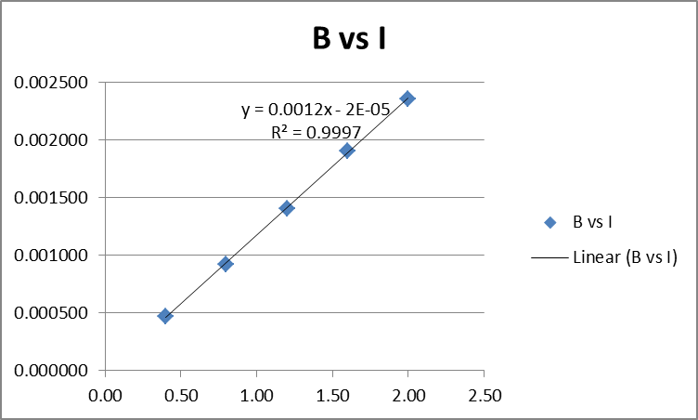

Section II.



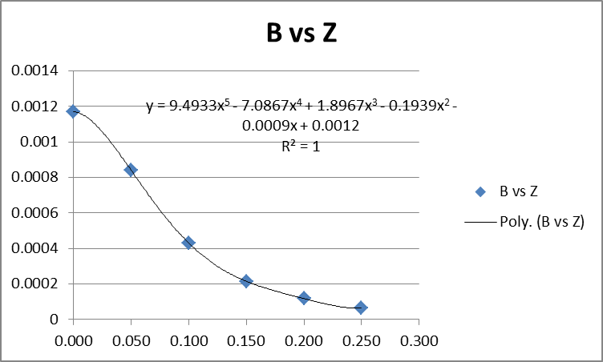

For section 1, the theoretical slope is 0.001197 while the experimental slope is 0.0012. The perecent discrepancy of the slopes is 0.25%. For section II the theoretical slope is 0.0001257, a linear trend line for the experimental data would not have represented an accurate slope.

1. Discussion

In section 1, the graph for the experimental data has an increasing slope. The slope value is 0.0012, while the experimental value is 0.001197. The percent discrepancy is 0.25% this shows that the two values are very consistent. Since the slopes are very close to one another. The experimental slope also shows that the magnetic field strength is directly proportional to the current in the coil. This is seen by how as the current in the coil increases, the magnetic field strength increases as well in a linear fashion. The striking similarities between the slopes also show this as they only have a 0.25% discrepancy.

In section 2 the graph of the experimental values show a negative slope that starts to approach a slope of zero as the sensor increases its distance from the coil. The magnetic field is behaving as expected from the theoretical values as all the discrepancies lie under 10 percent for the experimental and theoretical magnetic field. The magnetic field from the data seems to decrease the further the distance from the field.

For question 3, considering that the inner coil current is 1.0 A with a radius R, and the outer coil current is unknown but is of radius 2R. Using the formula $\vec{B}={\vec{B}}_{1}+{\vec{B}}_{2}$ and since the sensor is in the center the formula to use is $\vec{B}\left(z\right)=µ₀N/2R$. Using these formulas the current in the outer coil is equal to 2.0 A and the direction is counter clockwise.