Waled Salem
ID: 004893625
The graphsearch without the heap was very costly due to having to sort the open list data structure on every iteration, this added more time involved in search of a solution. The amount of time cost of having to sort throught the list on every iteration was detrimental towards finding a solution efficiently.

graphsearch18.py
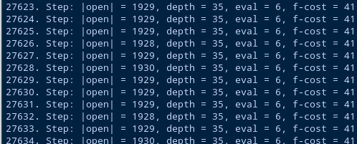

graphsearch18_heap.py
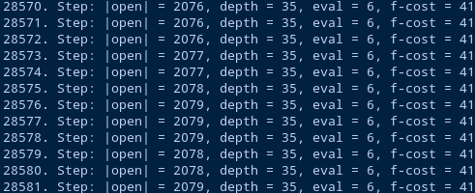

As you can see the cost for the standard graphsearch without the heap had a very similar search to the graphsearch containing the heap with 10 minute runs. The heap maintains the heap condition which is one of the few reasons that using a heap is much better for efficiently searching for a solution. Also the A* search with the heap was slightly faster than the original, it reached a higher step count than its predecessor.

