Los Angeles Daily High-Temperature Forecasting Laboratory: A Governed, Multi-Horizon Deep Learning System for Meteorological Prediction
Salem Morelli
PhD Research Project in Statistics
Independent Research Manuscript
August 24, 2026

Abstract
This report audits and formalizes a production-oriented laboratory for forecasting the Los Angeles daily high temperature at one-, three-, and five-day horizons. The repository integrates Open-Meteo historical and forecast data, National Weather Service (NWS) point forecasts and KLAX observations, a three-state weather-regime model, leakage-aware feature engineering, LSTM or Transformer sequence models, an optional XGBoost sleeve, Monte Carlo dropout, split-conformal intervals, publication governance, and realized-error attribution. The principal finding is methodological rather than promotional: the system has unusually clear forecast-clock, provenance, uncertainty, and publication contracts, but the supplied source files do not by themselves establish current out-of-sample superiority. A code audit identified several substantive safeguards. Targets are defined as feature_date plus h calendar days; the unlabeled live tail is preserved for inference; Fahrenheit metrics are computed after inverse scaling; skill is withheld below 30 realized cases and promotion below 60; NWS-anchored forecasts are separated from an independent model-only track; and calibrated intervals are suppressed when their center no longer matches the fitted conformity score. The audit also recovered a high-impact failure mode: a hard-coded NWS grid mismatch created an estimated 9-11°F warm benchmark bias and could transmit that bias through the anchoring overlay. A live /points self-check now detects such drift. The repository therefore functions credibly as a governed forecasting experiment, while confirmatory claims require archived model vintages, rolling-origin evaluation, benchmark independence, uncertainty scores, and artifact-backed confidence intervals for every horizon.
Keywords: temperature forecasting, Los Angeles, time series, LSTM, hidden Markov model, conformal prediction, forecast governance

Los Angeles Daily High-Temperature Forecasting Laboratory: A Governed, Multi-Horizon Deep Learning System for Meteorological Prediction

Research Objective and Questions
Operational weather prediction differs from ordinary supervised learning because labels arrive after the forecast, meteorological covariates have multiple issue times, forecast skill changes with lead time and regime, and public communication requires an authorization rule in addition to a point estimate. The laboratory is therefore evaluated as a sequence of statistical experiments rather than as one neural network. Its target is the daily maximum temperature at a Los Angeles/LAX location, issued for H = 1, 3, and 5 calendar days.
Four questions organize the report. First, does the repository define a leakage-free forecast clock that can be reconstructed after deployment? Second, do the model stack and uncertainty sleeve separate point prediction, interval calibration, and benchmark dependence? Third, do governance and attribution prevent an apparently precise but invalid forecast from becoming authoritative? Fourth, what evidence is still required before the system can support a scientific claim of improved Los Angeles forecast skill?

Scope of the Findings
The findings are based on a structural audit of the supplied repository files, including model constants, target construction, artifact contracts, validation code, workflow definitions, and retained negative results. No committed prediction artifacts were supplied with the report inputs. Consequently, repository statements about typical error are treated as project documentation rather than independently reproduced estimates. Figures 1, 2, and 5 summarize implemented contracts. Figures 3 and 4 are seeded synthetic mechanism checks and are labeled accordingly. This separation is essential to avoid converting an explanatory dashboard into an unverified results section.

Los Angeles as a Forecasting Environment
Los Angeles daily high temperature is shaped by coastal advection, the marine inversion, cloud cover, offshore flow, synoptic pressure, seasonal solar forcing, and local geography. A forecast at KLAX or a nearby grid point is not interchangeable with an inland Los Angeles basin forecast. This spatial sensitivity makes location provenance part of the estimand: changing the forecast grid changes the quantity being predicted, not merely the measurement instrument.
The repository uses a gridded target and supplements it with recent KLAX observations and an NWS point forecast. Open-Meteo historical data are reanalysis/model products constructed from observations and numerical weather models, whereas NWS and station streams have different generation and revision processes. Treating all inputs as iid measurements would understate source dependence and spatial representation error. The appropriate model is a multisource, nonstationary forecasting system in which source, issue time, and valid time are explicit variables.
Table 1
Data Sources and Inferential Roles
Source | Repository use | Inferential caution
Open-Meteo Historical Weather | Historical daily and hourly weather covariates | Reanalysis is model-assimilated, not a pure station observation
Open-Meteo Forecast | Seven-day gridded numerical forecast inputs | Model vintage and lead time must be archived to prevent look-ahead
NWS API | Official point-forecast benchmark and optional anchor | Anchored predictions are not independent of the benchmark
KLAX observations | Recent local verification and context | Station and grid representations differ
NOAA Niño 3.4 | Monthly climate-state covariate | Slow-moving index adds context, not daily causal identification
Note. Repository use is taken from the supplied source files. The inferential cautions are requirements for evaluation, not claims that the sources are defective.

Forecast Clock and Statistical Estimand
Let F_t denote the information available at the feature date t and Y_t the realized daily high. For horizon h in {1, 3, 5}, the point forecast is a function m_h(F_t) intended to estimate Y_{t+h}. The corrected repository contract is explicit: target_date_h equals feature_date plus h calendar days. Training uses rows for which all three targets are observed; live inference uses the newest feature row even though its future targets are missing.
Y_(t+h) = m_h(F_t) + epsilon_(t,h), h in {1, 3, 5} (1)
Figure 2
Calendar-Day Target Construction
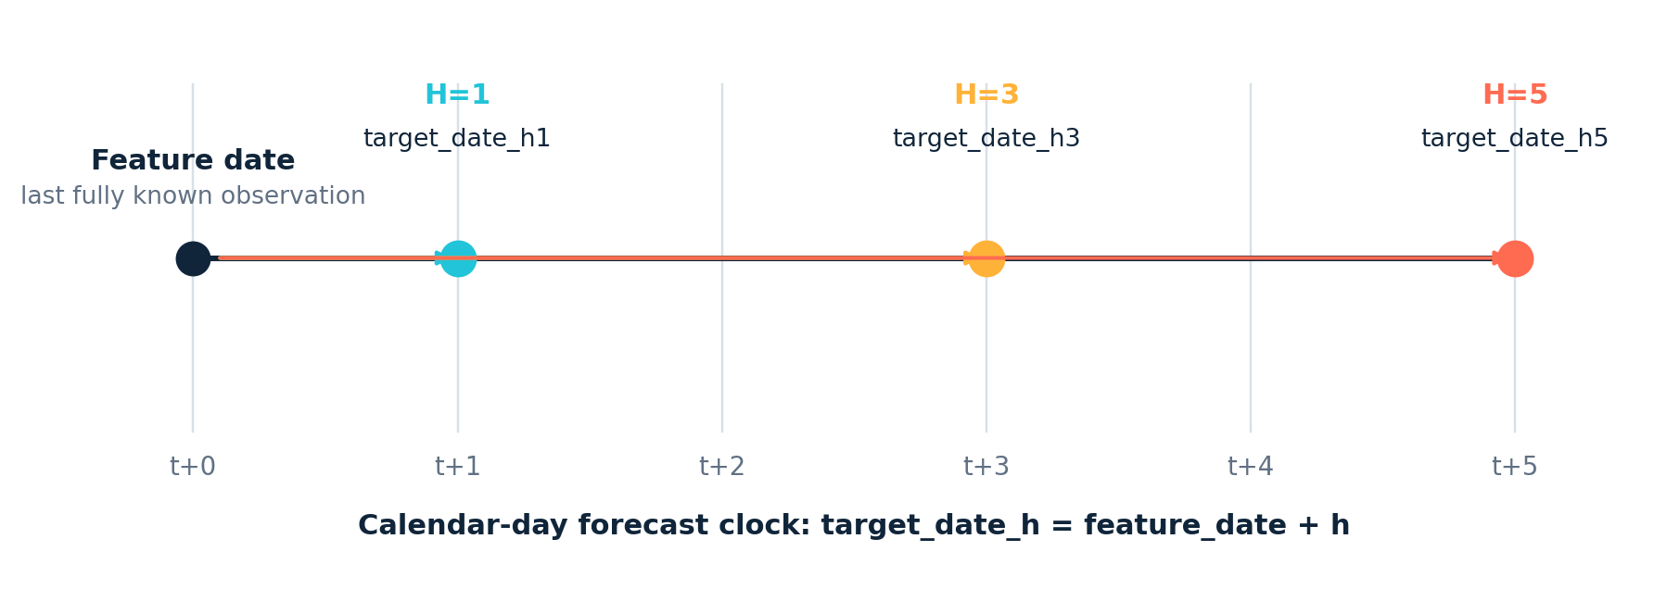
This clock resolves two common defects. Dropping every row with an unobserved future label would remove the live forecast row; computing realization against decision_date + h when decision and feature dates differ would attach the wrong outcome. Part 9 instead backfills against explicit target-date columns. A rigorous archive should also store the run timestamp, source issue timestamp, model version, and timezone so the complete information set F_t can be reconstructed.

Auditable System Architecture
Figure 1
Repository Pipeline From Data to Verified Publication
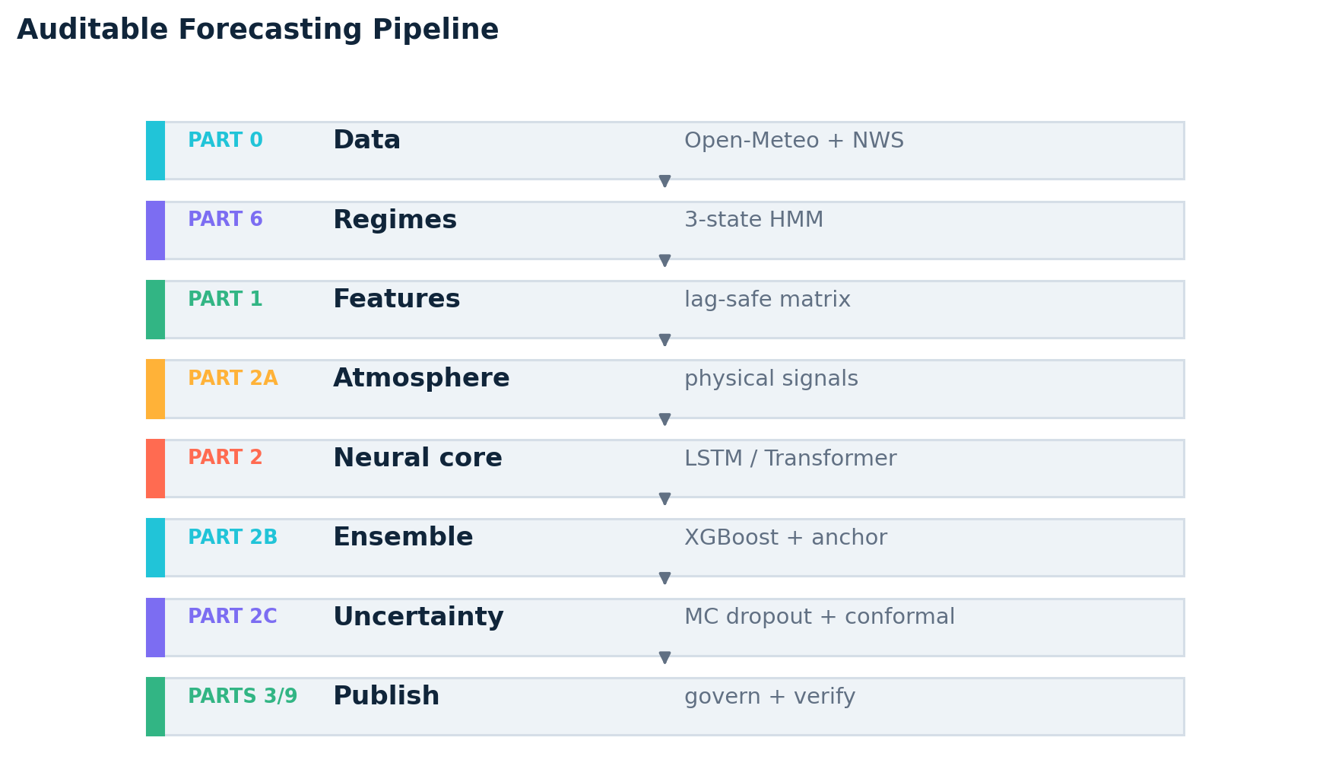
The modular sequence is a research strength because each part writes a typed artifact that can be inspected without retraining the full stack. Parts 0 and 6 establish the physical and regime state; Parts 1 and 2A create the lagged predictor surface; Part 2 estimates all three horizons jointly; Parts 2B and 2C add optional ensemble and uncertainty sleeves; and Parts 3 and 9 decide whether to publish and later score the forecast.
Optional sleeves are nonblocking by design, so missing XGBoost or BNN artifacts do not silently erase the raw neural output. The public dashboard follows a canonical fallback chain led by forecast_h*, then blend, XGBoost, and raw neural values. That behavior is useful for availability, but it makes forecast_source a necessary stratification variable in every evaluation. A pooled MAE across changing sources would mix distinct estimators.

Feature Engineering and Leakage Control
Part 1 builds a numeric, nonconstant feature matrix from weather lags, rolling summaries, calendar encodings, forecast inputs, and regime probabilities. Part 2A augments this matrix with pressure tendency, humidity and cloud structure, offshore-wind signals, marine-layer proxies, ENSO context, persistence, momentum, and climatological anomalies. Cyclic variables are represented with sine and cosine functions, preserving the adjacency of December and January or 359 degrees and 1 degree.
For a window length L = 14, the sequence input at feature date t is X_t = (x_{t-L+1}, ..., x_t). Every element must be measurable with respect to F_t. The target Y_{t+h}, revisions released after t, and forecast runs initialized after t are prohibited. The repository's validation suite checks exact duplicate features, redundant regime probabilities, schema consistency, and alpha-metadata drift. These checks address a subtle source of optimism: two columns with different names can be the same random variable, artificially inflating apparent feature diversity.
X_t in F_t, Y_(t+h) not in F_t, target_date_h = t + h (2)
The remaining recommendation is to version data by both valid time and issue time. Current reanalysis endpoints can revise historical values; training on a later vintage may provide information unavailable in the original live run. A forecast audit should therefore distinguish reproducible retrospective experiments from truly real-time backtests.

Regime Modeling
Part 6 fits a three-state Gaussian hidden Markov model to standardized temperature, humidity, cloud, pressure, wind, precipitation, diurnal-range, and seasonal features. With latent state S_t, transition matrix A, and Gaussian emissions, the model is defined by
P(S_t=j | S_(t-1)=i) = a_ij, X_t | S_t=j ~ N(mu_j, Sigma_j) (3)
The code retains neutral labels REGIME_0, REGIME_1, and REGIME_2 unless state means satisfy explicit physical rules. The current README maps one accepted state to DRY_CLEAR and another to MARINE_LAYER, while leaving SANTA_ANA unvalidated. Validated physical probabilities replace their source neutral columns to avoid perfect duplication. If HMM fitting fails, a deterministic KMeans fallback provides states, but those states lack Markov transition semantics and should be labeled as a different model class.
Regimes can improve conditional calibration if error distributions differ between marine and offshore conditions. They can also become narrative traps: a statistically distinct cluster does not prove a named physical mechanism. Evaluation should report horizon-by-regime MAE, bias, coverage, interval width, state occupancy, transition stability, and label sensitivity across rolling refits. Rare-state claims require an effective sample-size threshold.
Table 2
Model Components and Contracts
Component | Implemented contract | Primary risk
Target clock | feature_date + {1,3,5} calendar days | Off-by-one labels or future-target leakage
LSTM | 14-day sequence; 2 layers; hidden size 128; three heads | Small effective sample and recurrent overfit
Transformer | Alternative sequence backbone | Capacity exceeds evidence unless carefully regularized
XGBoost sleeve | Optional nonlinear tabular ensemble | Selection and blending optimism
BNN sleeve | 200 MC-dropout draws plus split conformalization | Dropout spread alone is not calibrated coverage
HMM | Three neutral Gaussian states; KMeans fallback | Physical labels can be over-interpreted

Deep Sequence Forecaster
The default neural core is a two-layer LSTM with hidden size 128, dropout 0.20, batch normalization, and three independent output heads. A Transformer is available as an alternative backbone. LSTMs use gated recurrence to preserve gradient flow over temporal lags (Hochreiter & Schmidhuber, 1997), whereas self-attention directly weights pairwise sequence relations (Vaswani et al., 2017). For a 14-day window, either can represent persistence, trend, and interactions, but architecture choice must be made with rolling-origin validation rather than capacity.
L(theta) = sum_h w_h n^-1 sum_t [Y_(t+h) - m_h(X_t; theta)]^2 (4)
The repository uses horizon weights 1.0, 0.8, and 0.6 for H = 1, 3, and 5; Adam optimization; a plateau scheduler; and early stopping. Importantly, metrics suffixed with _f are computed after inverse transformation to Fahrenheit. A scaled validation loss is useful for optimization but cannot be communicated as degrees Fahrenheit. The model also clips scaled outputs before inverse transformation, which stabilizes predictions but can create boundary mass; the frequency of clipping should be reported as a diagnostic.
The three heads share a representation, so errors across horizons are correlated. Joint multivariate scoring, monotonic constraints are not appropriate for temperature, but cross-horizon coherence and covariance should be measured. A multivariate Gaussian or quantile head could model this dependence directly, while the current design prioritizes robust point forecasts and separate interval construction.

Training Design and the Heat-Branch Experiment
A central repository finding is negative: the asymmetric heat-event branch is retained for controlled experiments but disabled in production. The source comments report that the branch worsened global LSTM MAE and still achieved 0 of 5 test-set heat-event hits. This is stronger scientific practice than silently deleting an unfavorable result. It separates a plausible decision objective—penalizing dangerous underprediction—from empirical evidence that the specific weighting scheme improved the model.
The experimental loss increased row weights for warm and heat cases and multiplied underprediction errors. Such a loss changes the estimand from the conditional mean toward a decision-weighted functional. It may improve extreme recall while worsening ordinary MAE, or it may simply overfit five events. A defensible rerun requires a larger predefined heat threshold set, blocked cross-validation, event-level confidence intervals, and comparison to a quantile or expectile objective.
L_heat = sum_(t,h) w_h omega(Y_(t+h)) [Y_(t+h)-m_h(X_t)]^2 kappa(e_(t,h)) (5)
Here omega increases case weight in warm regimes and kappa increases the cost only for negative forecast errors. Because the test set contained five relevant cases, a 0/5 hit rate has a very wide binomial uncertainty interval; it supports rejecting this production candidate, not a general conclusion that asymmetric objectives cannot help. The repository should retain experiment identifiers and out-of-fold predictions so future variants can be compared on identical event sets.

Ensembling and NWS Anchoring
Part 2B adds an XGBoost sleeve and writes a canonical forecast through a fallback and blending policy. Tree boosting can capture nonlinear thresholds and interactions in lagged tabular features (Chen & Guestrin, 2016), making it a reasonable complement to sequence models. Ensemble weights and model inclusion must be fitted only on past data, and the validation set used for selection cannot be reused as an unbiased final test.
The repository may apply an NWS anchor when the learned stack diverges materially from the official forecast. This is a governance overlay, not an independent model. If A_t is the anchor weight, the canonical forecast can be written
forecast_h = (1-A_t) model_h + A_t NWS_h (6)
When A_t > 0, comparing forecast_h with NWS_h partly compares NWS with itself. Part 9 addresses this by storing pre-anchor model values and reporting an independent model-only track. That distinction should be mandatory in every table: canonical operational error answers whether the published forecast was accurate, whereas model-only skill answers whether the learned estimator added information beyond NWS.
Anchoring also propagates benchmark defects. The audit found that an earlier hard-coded NWS grid location produced an estimated 9-11°F warm bias. Part 0 now resolves /points for the target coordinates and fails loudly when the grid drifts. This incident shows that data-location tests are as important as model-unit tests.

Mechanism Check: Spatial Benchmark Bias
Figure 3
Synthetic Illustration of Bias Transmission Through Anchoring
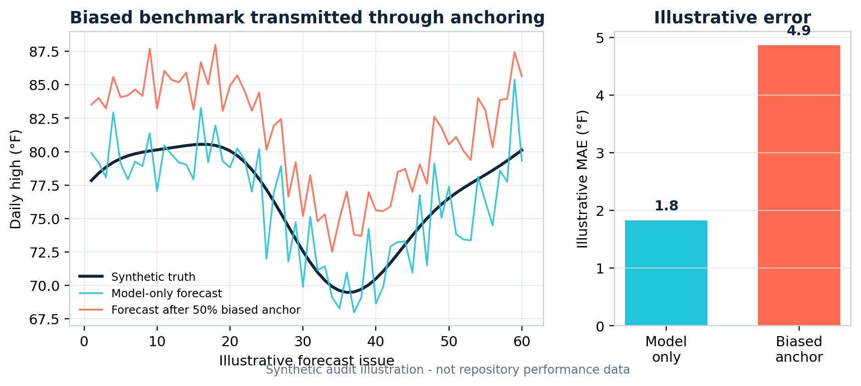
Note. This figure is a mechanism check generated from seeded synthetic data. It is not an estimate of repository MAE. The 10°F offset is chosen to reflect the magnitude described in the code audit.
The simulation makes the algebra visible. If the model error has mean zero and the benchmark has bias b, an anchor weight A induces approximate bias Ab even before considering variance. A 50% overlay on a 10°F location bias transmits about 5°F of expected bias. The exact operational effect depends on trigger frequency, anchor strength, and error correlation, so the repository correctly records per-horizon anchor flags.
A permanent control should record target latitude/longitude, resolved grid office and coordinates, station identifier, and response geometry in each forecast row. CI should test that documentation, constants, and live /points resolution agree. The supplied README still contains an endpoint example inconsistent with the corrected constants in Part 0, demonstrating documentation drift even after the computational fix.

Uncertainty Quantification
Part 2C uses 200 Monte Carlo dropout passes to produce a distribution of neural outputs, then calibrates residual radii with split conformal prediction. Dropout variability can be interpreted as an approximate Bayesian device under specific assumptions (Gal & Ghahramani, 2016), but raw spread does not guarantee coverage. Conformalization adds an empirical residual quantile to a fixed predictive center (Angelopoulos & Bates, 2023).
q_(1-alpha) = Quantile_{1-alpha} {|Y_i - m(X_i)| : i in calibration} (7)
C_alpha(X_new) = [m(X_new)-q_(1-alpha), m(X_new)+q_(1-alpha)] (8)
Figure 4
Synthetic Split-Conformal Interval Illustration
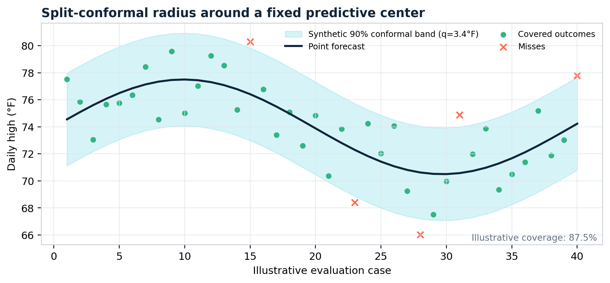
Note. Illustrative data show the method, not operational coverage. Time-series dependence and distribution shift weaken naive exchangeability assumptions.

Interval Semantics and Calibration Gates
The uncertainty code makes an unusually important semantic distinction. If the live interval is centered on the same raw LSTM/BNN mean used to fit conformity scores, it can be labeled conformal_calibrated when validation contracts pass. If the interval is recentered on a canonical forecast altered by XGBoost blending or NWS anchoring, the label becomes canonical_display_interval. The latter may be useful for display, but it does not inherit the original split-conformal coverage guarantee.
The code suppresses per-horizon displayability when the canonical center shifts more than 15°F from the diagnostic BNN mean. It also requires minimum validation and test coverage. These gates prevent a polished dashboard band from being misread as a calibrated interval. The next evaluation should additionally report mean interval width and the interval score of Gneiting and Raftery (2007), because broad intervals can achieve nominal coverage without being useful.
IS_alpha(L,U;y) = (U-L) + (2/alpha)(L-y)1{y<L} + (2/alpha)(y-U)1{y>U} (9)
Daily temperatures are serially dependent and regimes shift, so ordinary random split conformalization is not a complete guarantee. A rolling or weighted conformal design, with calibration points restricted to past dates and optionally similar regimes, better matches operational deployment. Coverage should be reported by horizon, season, regime, heat-event status, forecast source, and anchor status with binomial or bootstrap uncertainty.

Forecast Governance
Figure 5
Governed Publication Logic
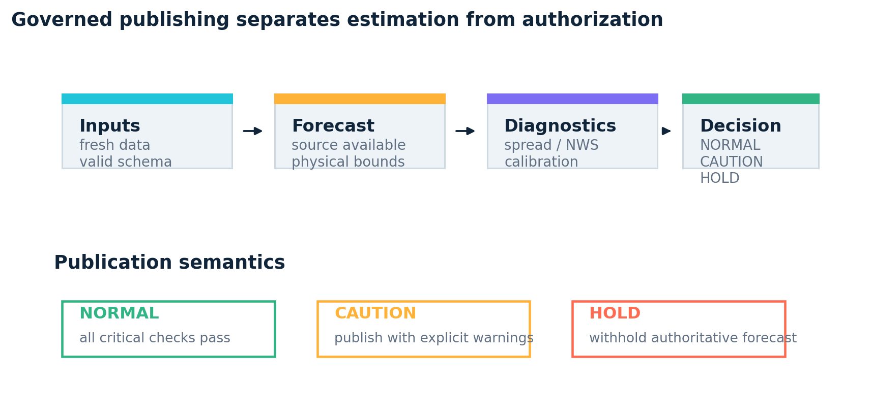
Part 3 treats publication as a decision distinct from estimation. It checks data and model freshness, schema integrity, forecast availability, physical bounds, spread, persistence, NWS divergence, and interval calibration. A critical failure can produce HOLD, while noncritical anomalies produce CAUTION. NWS deviation is a warning rather than an automatic veto, which avoids converting the benchmark into ground truth.
Table 4
Selected Forecast-Governance Contracts
Gate | Repository rule | Consequence
Data freshness | Latest observations within allowed age | Warning or hold according to severity
Model freshness | Retrain when model age exceeds seven days | Avoid silent model staleness
Forecast source | forecast_h* finite and source not unavailable | Critical failure if absent
Physical bounds | Canonical high between 32°F and 125°F | Critical failure outside range
Persistence sanity | Deviation from last observation bounded | Critical failure for implausible jump
NWS sanity | Tiered comparison to official benchmark | Warning only; not an automatic veto
BNN calibration | Intervals display only when calibration contracts pass | Suppress misleading uncertainty bands

Attribution, Skill, and Benchmark Independence
Part 9 backfills realized values by explicit target date and evaluates the canonical forecast against persistence, climatology, and NWS. It also computes a model-only path using pre-anchor values. For observations indexed by realized forecast cases, the principal metrics are
MAE_h = n_h^-1 sum_i |Y_(i,h) - forecast_(i,h)| (10)
RMSE_h = [n_h^-1 sum_i (Y_(i,h) - forecast_(i,h))^2]^(1/2) (11)
Skill_(h,b) = 1 - MAE_h / MAE_(h,b) (12)
Positive skill means improvement over baseline b; zero means equality; negative skill means degradation. MAE is readily interpretable in Fahrenheit, whereas RMSE emphasizes tail errors. Bias should accompany both. For cross-series comparison, scaled measures can be useful, but this single-target laboratory should prioritize degrees Fahrenheit and event-conditional error (Hyndman & Koehler, 2006).
Table 3
Forecast Verification Quantities
Quantity | Definition | Interpretation
MAE | n^-1 sum |y_t - yhat_t| | Typical absolute error in °F
RMSE | sqrt[n^-1 sum (y_t - yhat_t)^2] | Tail-sensitive error in °F
Bias | n^-1 sum (yhat_t - y_t) | Mean warm/cool directional error
Skill vs baseline | 1 - MAE_model / MAE_baseline | Positive only when model improves on baseline
Coverage | n^-1 sum 1{L_t <= y_t <= U_t} | Empirical interval hit rate
Interval score | width + miss penalties | Jointly rewards sharpness and calibration
Note. The source code withholds skill below 30 realized cases and model-promotion decisions below 60, reducing small-sample overinterpretation.

Software Engineering and Reproducibility
The master runner sequences parts, chooses train or predict mode, and supports model-age-based retraining. Daily GitHub Actions workflows run production and realized-value backfill, while CI validates code and artifacts. The Pages workflow publishes a static dashboard that reads committed artifacts. This arrangement turns the repository into an inspectable forecast ledger rather than a transient notebook.
Reproducibility requires more than a random seed. The archive should store source URLs and parameters, response checksums, issue and retrieval times, software versions, split dates, feature lists, scalers, model state, hyperparameters, training history, and prediction rows. The repository already writes many of these fields across part-specific artifacts. A manifest linking one run identifier to every artifact would make provenance atomic and prevent a dashboard from combining files from different runs.
The validator includes contract checks for target dates, artifact existence, forecast columns, BNN expectations, duplicate features, and metadata consistency. A future CI tier should run a small deterministic end-to-end fixture with mocked APIs, then assert that all target dates, units, anchor flags, interval labels, governance modes, and attribution counts agree. Separate integration tests should verify live NWS grid resolution without making ordinary CI depend on external availability.

Web Laboratory
The interactive page distinguishes committed artifacts from a transparent browser-only scenario sandbox. That boundary is scientifically necessary: moving a slider demonstrates sensitivity but does not rerun PyTorch or create empirical evidence. The report link added in this release provides the methodological context that a dashboard alone cannot carry.

Repository Audit Findings and Threats to Validity
Table 5
Principal Code-Audit Findings
Finding | Evidence in repository | Research implication
Corrected target clock | Explicit feature_date + h contract across Parts 1, 2, and 9 | Prevents horizon-label drift
Live-tail preservation | Training drops unlabeled rows; inference keeps newest feature row | Separates fitting from live prediction
Heat branch rejected | Default disabled after worse global MAE and 0/5 heat hits | Negative experiments are retained and governed
Grid-point self-check | Part 0 verifies hard-coded NWS grid against /points | Prevents silent location mismatch
NWS dependence disclosed | Anchor flags and model-only track coexist | Benchmark comparisons remain interpretable
Documentation drift | README endpoint example differs from corrected code constants | Documentation must be generated from code or CI-checked
Minimum-sample guards | Skill at n>=30; promotion at n>=60 | Prevents premature performance claims
Note. Findings refer to supplied source code and documentation. Operational metrics require the corresponding committed artifacts and model-vintage archive.
The dominant validity threats are temporal leakage, data-vintage mismatch, spatial representation error, small samples in rare heat regimes, adaptive model selection, benchmark dependence, nonstationary calibration, and pooled evaluation across changing forecast sources. The code substantially addresses the first, third, and sixth threats through target clocks, grid verification, and model-only attribution. It partially addresses small samples and calibration through display gates.
The largest remaining threat is evidential: source files describe a capable pipeline but do not substitute for a frozen out-of-sample experiment. Typical H=1 MAE values in the README should be treated as orientation until a dated attribution artifact provides sample size, evaluation interval, model version, baseline version, anchor frequency, and uncertainty. Likewise, a dashboard fallback dataset must never appear as live production evidence.

Recommendations and Conclusion

Confirmatory Evaluation Protocol
A decisive evaluation should freeze a minimum 12-month rolling-origin test period, archive every forecast as issued, and score H = 1, 3, and 5 separately. Primary endpoints should be MAE, bias, and interval score. Comparators should include persistence, climatology, Open-Meteo, NWS, model-only estimates, the unanchored ensemble, and the governed canonical forecast.
Results should be stratified by season, accepted HMM regime, heat-event status, anchor status, and forecast source. Promotion should require at least 60 cases per horizon, positive paired block-bootstrap skill, calibrated intervals with acceptable width, and no material governance regressions.

Conclusion
The Los Angeles temperature-forecasting laboratory is best understood as a governed statistical system. Its strongest contribution is the explicit separation of forecast time, model source, uncertainty semantics, publication authority, and post hoc attribution. The code audit documents meaningful corrections and retains a failed heat-branch experiment, which supports credible research practice. It also reveals how a spatial benchmark error can overwhelm model quality when an anchor is treated as infallible.
The evidence supports a qualified finding: the architecture is ready for confirmatory study, but superiority cannot be inferred from source code alone. Frozen vintages, rolling-origin tests, independent model-only comparisons, block-bootstrap uncertainty, and calibrated interval scoring can make the eventual claim defensible.

References
Angelopoulos, A. N., & Bates, S. (2023). A gentle introduction to conformal prediction and distribution-free uncertainty quantification. Foundations and Trends in Machine Learning, 16(4), 494-591. https://doi.org/10.1561/2200000101
Chen, T., & Guestrin, C. (2016). XGBoost: A scalable tree boosting system. Proceedings of the 22nd ACM SIGKDD International Conference on Knowledge Discovery and Data Mining, 785-794. https://doi.org/10.1145/2939672.2939785
Gal, Y., & Ghahramani, Z. (2016). Dropout as a Bayesian approximation: Representing model uncertainty in deep learning. Proceedings of Machine Learning Research, 48, 1050-1059.
Gneiting, T., & Raftery, A. E. (2007). Strictly proper scoring rules, prediction, and estimation. Journal of the American Statistical Association, 102(477), 359-378. https://doi.org/10.1198/016214506000001437
Hochreiter, S., & Schmidhuber, J. (1997). Long short-term memory. Neural Computation, 9(8), 1735-1780. https://doi.org/10.1162/neco.1997.9.8.1735
Hyndman, R. J., & Koehler, A. B. (2006). Another look at measures of forecast accuracy. International Journal of Forecasting, 22(4), 679-688. https://doi.org/10.1016/j.ijforecast.2006.03.001
James, G., Witten, D., Hastie, T., Tibshirani, R., & Taylor, J. (2023). An introduction to statistical learning: With applications in R (2nd ed.). Springer. https://doi.org/10.1007/978-3-031-38747-0
Morelli, S. (2026). Los Angeles Daily Temperature High [Computer software]. GitHub. https://github.com/salemmorelli1/Los-Angeles-Daily-Temperature-High

National Weather Service. (n.d.). API web service. Retrieved August 24, 2026, from https://www.weather.gov/documentation/services-web-api
Open-Meteo. (n.d.-a). Historical weather API. Retrieved August 24, 2026, from https://open-meteo.com/en/docs/historical-weather-api
Open-Meteo. (n.d.-b). Weather forecast API. Retrieved August 24, 2026, from https://open-meteo.com/en/docs
Paszke, A., Gross, S., Massa, F., Lerer, A., Bradbury, J., Chanan, G., Killeen, T., Lin, Z., Gimelshein, N., Antiga, L., Desmaison, A., Kopf, A., Yang, E., DeVito, Z., Raison, M., Tejani, A., Chilamkurthy, S., Steiner, B., Fang, L., ... Chintala, S. (2019). PyTorch: An imperative style, high-performance deep learning library. Advances in Neural Information Processing Systems, 32.
Rabiner, L. R. (1989). A tutorial on hidden Markov models and selected applications in speech recognition. Proceedings of the IEEE, 77(2), 257-286. https://doi.org/10.1109/5.18626
Shumway, R. H., & Stoffer, D. S. (2025). Time series analysis and its applications: With R examples (5th ed.). Springer. https://doi.org/10.1007/978-3-031-70584-7
Vaswani, A., Shazeer, N., Parmar, N., Uszkoreit, J., Jones, L., Gomez, A. N., Kaiser, L., & Polosukhin, I. (2017). Attention is all you need. Advances in Neural Information Processing Systems, 30.
Wasserman, L. (2004). All of statistics: A concise course in statistical inference. Springer.

Appendix A

Python Code for Figures and Data Tables
The complete script below reproduces Figures 1-5 and Tables 1-5. Synthetic mechanism figures are explicitly labeled and use fixed random seeds.
"""Reproduce every figure and data table in the LA forecasting report.
Repository-derived diagrams and tables summarize explicit source-code
contracts. Figures 3 and 4 are deliberately synthetic mechanism checks; they
are labeled as such in the report and are not represented as operational
forecast performance.
"""
from __future__ import annotations
import csv
from pathlib import Path
import matplotlib.pyplot as plt
import numpy as np
ROOT = Path(__file__).resolve().parent
FIGURES = ROOT / "figures"
TABLES = ROOT / "tables"
FIGURES.mkdir(parents=True, exist_ok=True)
TABLES.mkdir(parents=True, exist_ok=True)
NAVY = "#10253a"
CYAN = "#21c4d8"
SUN = "#ffb238"
CORAL = "#ff6b51"
GREEN = "#32b584"
VIOLET = "#7c6df2"
MUTED = "#617083"
PALE = "#eef3f7"
plt.rcParams.update(
{
"font.family": "DejaVu Sans",
"font.size": 10,
"axes.titlesize": 12,
"axes.labelsize": 10,
"axes.edgecolor": "#c7d0d9",
"axes.facecolor": "white",
"figure.facecolor": "white",
"grid.color": "#dfe6ec",
"grid.linewidth": 0.7,
}
)
def save(name: str) -> None:
plt.savefig(FIGURES / name, dpi=220, bbox_inches="tight", facecolor="white")
plt.close()
def write_csv(name: str, rows: list[list[str]]) -> None:
with (TABLES / name).open("w", newline="", encoding="utf-8") as stream:
csv.writer(stream).writerows(rows)
def pipeline_figure() -> None:
stages = [
("Part 0", "Data", "Open-Meteo + NWS"),
("Part 6", "Regimes", "3-state HMM"),
("Part 1", "Features", "lag-safe matrix"),
("Part 2A", "Atmosphere", "physical signals"),
("Part 2", "Neural core", "LSTM / Transformer"),
("Part 2B", "Ensemble", "XGBoost + anchor"),
("Part 2C", "Uncertainty", "MC dropout + conformal"),
("Parts 3/9", "Publish", "govern + verify"),
]
colors = [CYAN, VIOLET, GREEN, SUN, CORAL, CYAN, VIOLET, GREEN]

Appendix A (continued): Code, Part 2
fig, ax = plt.subplots(figsize=(10.0, 5.3))
ax.set_xlim(0, 10)
ax.set_ylim(0, 8.6)
ax.axis("off")
for index, ((part, title, detail), color) in enumerate(zip(stages, colors)):
row = 7 - index
y = row + 0.55
ax.add_patch(
plt.Rectangle((1.0, y - 0.37), 8.0, 0.72, facecolor=PALE, edgecolor="#d5dee7", lw=1.0)
)
ax.add_patch(plt.Rectangle((1.0, y - 0.37), 0.13, 0.72, facecolor=color, edgecolor=color))
ax.text(1.32, y + 0.11, part.upper(), color=color, weight="bold", size=8.4, va="center")
ax.text(2.44, y + 0.11, title, color=NAVY, weight="bold", size=11.2, va="center")
ax.text(5.15, y + 0.11, detail, color=MUTED, size=9.5, va="center")
if index < len(stages) - 1:
ax.annotate("", xy=(5, y - 0.55), xytext=(5, y - 0.37), arrowprops={"arrowstyle": "-|>", "color": MUTED, "lw": 1.2})
ax.set_title("Auditable Forecasting Pipeline", loc="left", color=NAVY, weight="bold", pad=12)
save("figure_1_pipeline.png")
def target_clock_figure() -> None:
fig, ax = plt.subplots(figsize=(9.7, 3.5))
ax.set_xlim(-0.3, 5.5)
ax.set_ylim(-0.5, 3.3)
ax.axis("off")
for day in range(6):
ax.plot([day, day], [0.45, 2.85], color="#d8e0e7", lw=0.8)
ax.text(day, 0.15, f"t+{day}", ha="center", color=MUTED, size=9)
ax.plot([0, 5], [1.65, 1.65], color=NAVY, lw=2)
ax.scatter([0], [1.65], s=130, color=NAVY, zorder=3)
ax.text(0, 2.27, "Feature date", ha="center", color=NAVY, weight="bold")
ax.text(0, 2.03, "last fully known observation", ha="center", color=MUTED, size=8.7)
for horizon, color in zip([1, 3, 5], [CYAN, SUN, CORAL]):
ax.scatter([horizon], [1.65], s=145, color=color, zorder=3)
ax.annotate("", xy=(horizon, 1.65), xytext=(0.08, 1.65), arrowprops={"arrowstyle": "-|>", "color": color, "lw": 1.3})
ax.text(horizon, 2.72, f"H={horizon}", ha="center", color=color, weight="bold")
ax.text(horizon, 2.43, f"target_date_h{horizon}", ha="center", color=NAVY, size=8.8)
ax.text(2.5, -0.26, "Calendar-day forecast clock: target_date_h = feature_date + h", ha="center", color=NAVY, weight="bold")
save("figure_2_target_clock.png")
def anchoring_mechanism_figure() -> None:
rng = np.random.default_rng(20260824)
days = np.arange(1, 61)
truth = 76 + 5.5 * np.sin(days / 8.0) + 1.2 * np.cos(days / 3.7)
model = truth + rng.normal(0.0, 2.0, size=days.size)
wrong_reference = truth + 10.0 + rng.normal(0.0, 1.7, size=days.size)
anchored = 0.5 * model + 0.5 * wrong_reference
abs_model = np.abs(model - truth)
abs_anchor = np.abs(anchored - truth)
fig, axes = plt.subplots(1, 2, figsize=(10.0, 3.8), gridspec_kw={"width_ratios": [1.6, 0.8]})
ax = axes[0]
ax.plot(days, truth, color=NAVY, lw=2.1, label="Synthetic truth")
ax.plot(days, model, color=CYAN, lw=1.2, alpha=0.9, label="Model-only forecast")
ax.plot(days, anchored, color=CORAL, lw=1.25, alpha=0.9, label="Forecast after 50% biased anchor")
ax.set_xlabel("Illustrative forecast issue")
ax.set_ylabel("Daily high (°F)")
ax.grid(True, alpha=0.8)
ax.legend(frameon=False, fontsize=8, ncol=1)
ax.set_title("Biased benchmark transmitted through anchoring", loc="left", color=NAVY, weight="bold")
ax = axes[1]
means = [abs_model.mean(), abs_anchor.mean()]
ax.bar([0, 1], means, color=[CYAN, CORAL], width=0.62)
ax.set_xticks([0, 1], ["Model\nonly", "Biased\nanchor"])
ax.set_ylabel("Illustrative MAE (°F)")
ax.grid(True, axis="y", alpha=0.8)
for i, value in enumerate(means):

Appendix A (continued): Code, Part 3
ax.text(i, value + 0.18, f"{value:.1f}", ha="center", color=NAVY, weight="bold")
ax.set_title("Illustrative error", color=NAVY, weight="bold")
fig.suptitle("Synthetic audit illustration - not repository performance data", y=0.01, color=MUTED, fontsize=8.5)
save("figure_3_anchor_mechanism.png")
def conformal_figure() -> None:
rng = np.random.default_rng(24)
x = np.arange(1, 41)
center = 74 + 3.5 * np.sin(x / 6.3)
truth = center + rng.normal(0, 2.2, size=x.size)
cal_residuals = np.abs(rng.normal(0, 2.0, size=120))
radius = float(np.quantile(cal_residuals, 0.90, method="higher"))
lower, upper = center - radius, center + radius
covered = (truth >= lower) & (truth <= upper)
fig, ax = plt.subplots(figsize=(9.8, 3.9))
ax.fill_between(x, lower, upper, color=CYAN, alpha=0.18, label=f"Synthetic 90% conformal band (q={radius:.1f}°F)")
ax.plot(x, center, color=NAVY, lw=2, label="Point forecast")
ax.scatter(x[covered], truth[covered], color=GREEN, s=20, label="Covered outcomes")
ax.scatter(x[~covered], truth[~covered], color=CORAL, marker="x", s=38, label="Misses")
ax.set_xlabel("Illustrative evaluation case")
ax.set_ylabel("Daily high (°F)")
ax.grid(True, alpha=0.8)
ax.legend(frameon=False, fontsize=8, ncol=2)
ax.set_title("Split-conformal radius around a fixed predictive center", loc="left", color=NAVY, weight="bold")
ax.text(0.99, 0.02, f"Illustrative coverage: {covered.mean():.1%}", transform=ax.transAxes, ha="right", color=MUTED, size=8.7)
save("figure_4_conformal.png")
def governance_figure() -> None:
fig, ax = plt.subplots(figsize=(9.8, 4.3))
ax.axis("off")
nodes = [
(0.06, 0.64, 0.20, 0.20, "Inputs", "fresh data\nvalid schema"),
(0.31, 0.64, 0.20, 0.20, "Forecast", "source available\nphysical bounds"),
(0.56, 0.64, 0.20, 0.20, "Diagnostics", "spread / NWS\ncalibration"),
(0.79, 0.64, 0.16, 0.20, "Decision", "NORMAL\nCAUTION\nHOLD"),
]
for index, (x, y, w, h, title, detail) in enumerate(nodes):
color = [CYAN, SUN, VIOLET, GREEN][index]
ax.add_patch(plt.Rectangle((x, y), w, h, facecolor=PALE, edgecolor="#cfd9e2", lw=1.0))
ax.add_patch(plt.Rectangle((x, y + h - 0.025), w, 0.025, facecolor=color, edgecolor=color))
ax.text(x + 0.02, y + h - 0.065, title, color=NAVY, weight="bold", va="top", size=11)
ax.text(x + 0.02, y + h - 0.12, detail, color=MUTED, va="top", size=9)
if index < len(nodes) - 1:
ax.annotate("", xy=(nodes[index + 1][0] - 0.01, y + h / 2), xytext=(x + w + 0.01, y + h / 2), arrowprops={"arrowstyle": "-|>", "color": NAVY, "lw": 1.25})
ax.text(0.05, 0.37, "Publication semantics", color=NAVY, weight="bold", size=12)
labels = [
("NORMAL", GREEN, "all critical checks pass"),
("CAUTION", SUN, "publish with explicit warnings"),
("HOLD", CORAL, "withhold authoritative forecast"),
]
for i, (label, color, detail) in enumerate(labels):
x = 0.06 + i * 0.30
ax.add_patch(plt.Rectangle((x, 0.13), 0.25, 0.15, facecolor="white", edgecolor=color, lw=1.5))
ax.text(x + 0.02, 0.235, label, color=color, weight="bold", size=10.5)
ax.text(x + 0.02, 0.17, detail, color=MUTED, size=8.7)
ax.set_title("Governed publishing separates estimation from authorization", loc="left", color=NAVY, weight="bold")
save("figure_5_governance.png")
def tables() -> None:
write_csv(
"table_1_data_sources.csv",
[
["Source", "Repository use", "Inferential caution"],
["Open-Meteo Historical Weather", "Historical daily and hourly weather covariates", "Reanalysis is model-assimilated, not a pure station observation"],
["Open-Meteo Forecast", "Seven-day gridded numerical forecast inputs", "Model vintage and lead time must be archived to prevent look-ahead"],

Appendix A (continued): Code, Part 4
["NWS API", "Official point-forecast benchmark and optional anchor", "Anchored predictions are not independent of the benchmark"],
["KLAX observations", "Recent local verification and context", "Station and grid representations differ"],
["NOAA Niño 3.4", "Monthly climate-state covariate", "Slow-moving index adds context, not daily causal identification"],
],
)
write_csv(
"table_2_model_contracts.csv",
[
["Component", "Implemented contract", "Primary risk"],
["Target clock", "feature_date + {1,3,5} calendar days", "Off-by-one labels or future-target leakage"],
["LSTM", "14-day sequence; 2 layers; hidden size 128; three heads", "Small effective sample and recurrent overfit"],
["Transformer", "Alternative sequence backbone", "Capacity exceeds evidence unless carefully regularized"],
["XGBoost sleeve", "Optional nonlinear tabular ensemble", "Selection and blending optimism"],
["BNN sleeve", "200 MC-dropout draws plus split conformalization", "Dropout spread alone is not calibrated coverage"],
["HMM", "Three neutral Gaussian states; KMeans fallback", "Physical labels can be over-interpreted"],
],
)
write_csv(
"table_3_metrics.csv",
[
["Quantity", "Definition", "Interpretation"],
["MAE", "n^-1 sum |y_t - yhat_t|", "Typical absolute error in °F"],
["RMSE", "sqrt[n^-1 sum (y_t - yhat_t)^2]", "Tail-sensitive error in °F"],
["Bias", "n^-1 sum (yhat_t - y_t)", "Mean warm/cool directional error"],
["Skill vs baseline", "1 - MAE_model / MAE_baseline", "Positive only when model improves on baseline"],
["Coverage", "n^-1 sum 1{L_t <= y_t <= U_t}", "Empirical interval hit rate"],
["Interval score", "width + miss penalties", "Jointly rewards sharpness and calibration"],
],
)
write_csv(
"table_4_governance.csv",
[
["Gate", "Repository rule", "Consequence"],
["Data freshness", "Latest observations within allowed age", "Warning or hold according to severity"],
["Model freshness", "Retrain when model age exceeds seven days", "Avoid silent model staleness"],
["Forecast source", "forecast_h* finite and source not unavailable", "Critical failure if absent"],
["Physical bounds", "Canonical high between 32°F and 125°F", "Critical failure outside range"],
["Persistence sanity", "Deviation from last observation bounded", "Critical failure for implausible jump"],
["NWS sanity", "Tiered comparison to official benchmark", "Warning only; not an automatic veto"],
["BNN calibration", "Intervals display only when calibration contracts pass", "Suppress misleading uncertainty bands"],
],
)
write_csv(
"table_5_audit.csv",
[
["Finding", "Evidence in repository", "Research implication"],
["Corrected target clock", "Explicit feature_date + h contract across Parts 1, 2, and 9", "Prevents horizon-label drift"],
["Live-tail preservation", "Training drops unlabeled rows; inference keeps newest feature row", "Separates fitting from live prediction"],
["Heat branch rejected", "Default disabled after worse global MAE and 0/5 heat hits", "Negative experiments are retained and governed"],
["Grid-point self-check", "Part 0 verifies hard-coded NWS grid against /points", "Prevents silent location mismatch"],
["NWS dependence disclosed", "Anchor flags and model-only track coexist", "Benchmark comparisons remain interpretable"],
["Documentation drift", "README endpoint example differs from corrected code constants", "Documentation must be generated from code or CI-checked"],
["Minimum-sample guards", "Skill at n>=30; promotion at n>=60", "Prevents premature performance claims"],
],
)
if __name__ == "__main__":
pipeline_figure()
target_clock_figure()
anchoring_mechanism_figure()
conformal_figure()
governance_figure()
tables()
print(f"Wrote figures to {FIGURES}")
print(f"Wrote tables to {TABLES}")

