U.S. Gas Price Forecasting Laboratory
A Reproducible Audit of Weekly Retail-Gasoline Prediction, Regime Inference,
Ensemble Learning, Forecast Governance, and Live Attribution
Salem Morelli
Independent PhD Research Laboratory
Statistics
August 24, 2026
Repository of record: salemmorelli1/Weekly-U.S.-Gas-Prices; audited main-branch artifact snapshot a020050 (August 19, 2026).

Abstract
This report evaluates a production-oriented research repository that forecasts the next weekly U.S. average price of regular conventional gasoline (Federal Reserve Economic Data series GASREGCOVW). The system joins Federal Reserve Economic Data, U.S. Energy Information Administration fundamentals, and market-price series; constructs 102 strictly backward-looking predictors; estimates a four-state Gaussian hidden Markov regime model; fits five core regressors; gates optional XGBoost and long short-term memory sleeves; fuses only accepted models; and records realized performance in an append-only prediction log. The committed snapshot contains 1,389 weekly observations from January 2000 through August 10, 2026 and one pending live target.
The audit finds strong software modularity but weak evidence of incremental forecast skill. On the stated trailing 52-week validation block, the core ensemble produced mean absolute error (MAE) of $0.131 per gallon and root mean squared error (RMSE) of $0.186. A recomputed same-window persistence forecast produced MAE of $0.069 and RMSE of $0.112; therefore the ensemble’s errors were approximately 1.91 and 1.67 times larger. Ridge regression was the strongest learned component (RMSE $0.164) but still trailed persistence. The XGBoost sleeve was correctly rejected, and the LSTM sleeve was intentionally skipped after the upstream gate failed. Only one live outcome had matured, so Diebold–Mariano, drift, and health claims were correctly marked insufficient.
The workflow describes a Monday release, whereas current EIA documentation states that sampled Monday prices are generally published Tuesday at approximately 10:00 a.m. Eastern Time. This clock mismatch must be corrected before performance claims expand. The repository is a valuable forecasting laboratory, but the present evidence does not support superiority over persistence. Keywords: gasoline prices, time-series forecasting, ensemble learning, hidden Markov model, forecast evaluation.

Research Objective and Audit Questions
The statistical objective is one-step-ahead prediction of the next observed weekly U.S. retail gasoline price. Let Y_t denote GASREGCOVW for week t and X_t the information set available at issuance. The implemented target is Y_(t+1), not a contemporaneous nowcast. This distinction is fundamental because FRED labels observations by reference week while EIA publishes the sampled price after collection. A valid forecast must freeze X_t before the target observation becomes available.
Y_(t+1) = f(X_t) + ε_(t+1), X_t measurable with respect to F_t (1)
Five questions guide the report. First, are source timestamps, publication lags, and the target week aligned? Second, do engineered features respect the information filtration and preserve the unlabeled live row? Third, do learned models improve on a persistence forecast on the identical validation dates? Fourth, are regime and sleeve labels supported by stable empirical evidence? Fifth, does the live attribution layer contain enough realized cases for inferential statements?
Inference boundary: This is a repository and artifact audit. It evaluates the implemented data contract and committed outputs. It does not establish causal effects of oil, inventories, taxes, or demand; it does not provide financial advice; and it does not claim that browser-side scenario controls reproduce the trained Python estimators.
The audit therefore separates descriptive market relationships, predictive holdout evidence, live operational evidence, and explanatory website simulations. Those categories answer different questions and should not be merged into a single performance claim.

Retail Gasoline Prices as a Statistical Measurement
Retail gasoline prices reflect crude-oil acquisition costs, refining margins, distribution and marketing costs, and taxes. The relative contributions change through time, so a stable predictive relationship is not guaranteed. The target series is weekly, national, not seasonally adjusted, and measured in dollars per gallon. Its persistence arises partly from slow retail pass-through and overlapping regional market conditions, making last week’s price an unusually competitive benchmark.
EIA’s weekly retail survey measures cash prices, including taxes, at sampled outlets as of 8:00 a.m. local time on Monday. Outlet observations are weighted using annual sales volumes; missing responses may be imputed. EIA generally publishes the estimate around 10:00 a.m. Eastern Time on Tuesday. In May 2018, EIA changed its survey sample and estimation methodology and cautioned that values across the break are not directly comparable for short-window change analysis.
Measurement element | Audited interpretation
Unit | U.S. dollars per gallon, taxes included
Frequency | Weekly reference observation
Collection | Sampled retail outlets, Monday 8:00 a.m. local
Publication | Generally Tuesday, approximately 10:00 a.m. ET
Method break | May 14, 2018 sample and estimator change
Consequently, the time index is not synonymous with data availability. Any automated weekly forecast must record source-vintage timestamps and guarantee that the target is unavailable at feature freeze time.

Data Architecture and Source Integration
Part 0 creates the canonical weekly table from FRED and market series; Part 0c augments it with EIA fundamentals. The committed master table contains 1,389 rows and 34 fields. The target gas_us_avg is joined to regional retail prices, West Texas Intermediate and Brent crude, RBOB gasoline, energy exchange-traded funds, the dollar index, Treasury yields, unemployment, gross domestic product growth, consumer-price indexes, petroleum stocks, refinery inputs, imports, demand, and derived stock-pressure indicators.
Source family | Examples | Statistical role
FRED / EIA retail | GASREGCOVW; Midwest gasoline | Target and regional confirmation
Crude / products | WTI, Brent, RBOB | Upstream cost and crack-spread proxies
EIA fundamentals | Stocks, demand, inputs, imports | Physical market pressure
Macro-financial | USD, yields, CPI, unemployment | Cost and demand context
Market sleeves | USO, XLE, S&P 500 | Forward-looking risk proxies
Coverage is broad but heterogeneous. Daily market series are collapsed to weekly rows; monthly and quarterly macroeconomic data remain step functions between releases; EIA fundamentals can be revised. Point-in-time reproducibility therefore requires vintage-aware retrieval or frozen raw snapshots. The repository currently versions processed artifacts, which is valuable, but a complete provenance manifest should also record source request time, raw response hash, and revision vintage.

Target Clock and Release-Schedule Risk
The repository README and workflow comments describe a Monday release and schedule full production at approximately 10:35 a.m. Eastern Time on Monday. Current EIA documentation instead states that Monday-morning prices are normally released Tuesday. The Wednesday backfill also describes itself as two days after a Monday release. These comments are internally consistent with one another but externally inconsistent with the official publication schedule.
F_t = σ{all source values actually published before issuance time t} (2)
This mismatch can create two failure modes. A Monday run can retrieve the prior published target and label it as current, shifting the training and live anchors by one week. Alternatively, the forecast may legitimately target the coming release, but the documentation can misstate when evaluation becomes possible. Both cases impair reproducibility because target_date and release_datetime are different variables.
Required correction: Move the production trigger to Tuesday after the EIA publication window—or explicitly define Monday issuance as a pre-release forecast—and store issue_datetime, reference_week, source_release_datetime, and target_observation_id in every log row. Test the clock against the latest official release before fitting.
The report preserves the committed artifacts as an August 2026 audit snapshot. It does not silently reinterpret their date fields. Future artifacts should include a release calendar that handles federal holidays, publication delays, daylight saving time, and source-vintage failures.

Historical Distribution of U.S. Retail Gasoline Prices
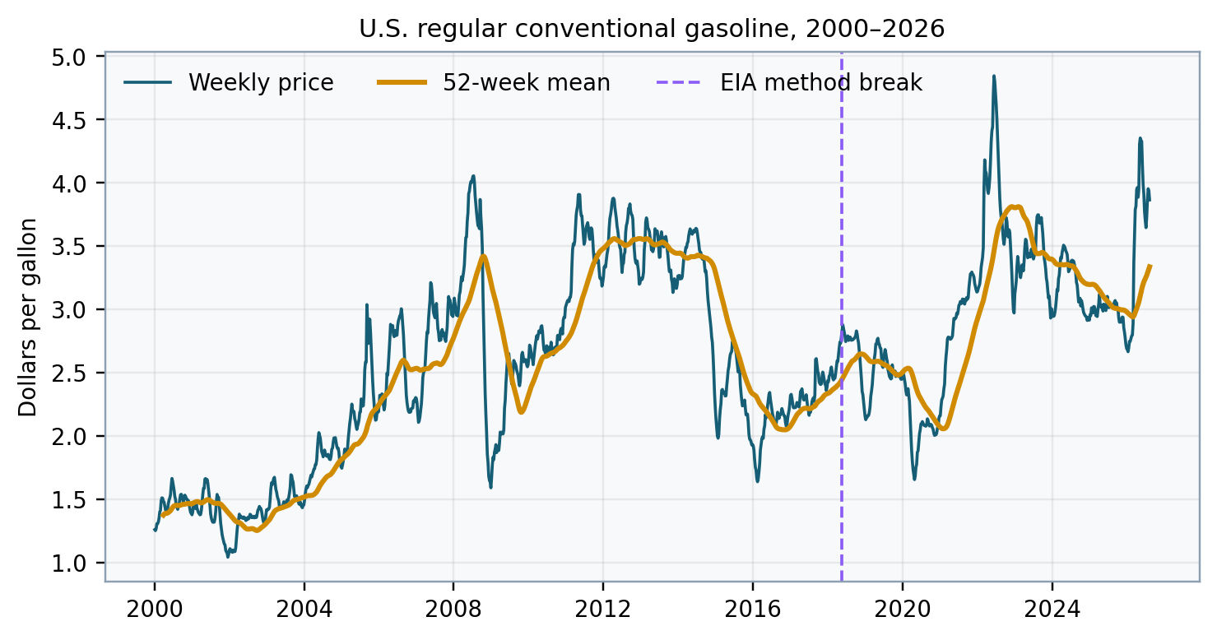
Figure 1. Weekly U.S. regular conventional gasoline price and 52-week mean, with the EIA methodology break marked.
Across 1,389 observations, the mean price was $2.612 per gallon (SD = $0.769), with a minimum of $1.042 and maximum of $4.844. The 2022 calendar-year mean was approximately $3.803 and included the sample maximum. The partial 2026 mean through August 10 was approximately $3.590, while the latest committed target value was $3.864.
Weekly changes averaged near zero ($0.0019) but were heavy-tailed relative to the mean, with a standard deviation of $0.0618, minimum of -$0.376, and maximum of $0.480. This combination of high level persistence and occasional large shocks motivates both persistence baselines and regime-aware diagnostics. It also makes squared-error losses sensitive to a small number of shock weeks.

Seasonality, Persistence, and Nonstationarity
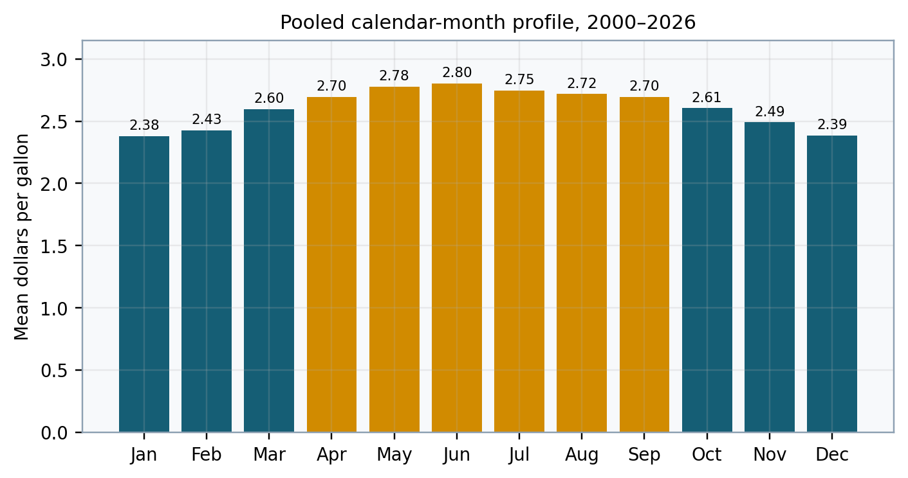
Figure 2. Pooled mean weekly retail-gasoline price by calendar month, 2000–2026.
Pooled monthly means rise from approximately $2.38 in January to $2.80 in June, then decline toward $2.39 in December. The profile is consistent with seasonal fuel specifications, travel demand, maintenance schedules, and broader market cycles. It is descriptive rather than causal because the distribution of years within every month is the same but long-run price levels and volatility vary across eras.
Raw-level correlations are high for petroleum-linked series: gas_us_avg correlates approximately .93 with WTI and .98 with RBOB in the committed table. Those coefficients should not be interpreted as structural elasticities. Trending and persistent price levels can generate large correlations without stable short-run predictive relationships. Forecast models should distinguish levels, changes, cointegrating structure, and release lags.
ΔY_t = Y_t - Y_(t-1), seasonal baseline = E(Y_t | month(t)) (3)
Benchmark implication: Because Y_t is highly persistent, the one-step forecast Y-hat_(t+1) = Y_t is not a trivial straw model. Any complex system should be promoted only after it beats persistence on identical dates and under the same information set.

Feature Engineering and Information Filtration
Part 1 produces 102 predictors and defines a one-week horizon. Lag windows include 1, 2, 3, 4, 6, 8, 12, 26, and 52 weeks. Feature families include lags, rolling moments, returns, momentum, volatility, seasonal encodings, WTI and RBOB signals, EIA stock and demand indicators, macroeconomic fields, and lagged regime probabilities. The implementation retains one unlabeled live row while using 1,388 labeled rows for fitting.
X_t = g(Y_(≤t), Z_(≤t), R_(≤t)); Y_(t+1) excluded from X_t (4)
Backward-looking transforms are appropriate only if their inputs were actually published by issuance. For daily traded prices this is straightforward. For revised or lower-frequency government series, indexing by economic reference date can leak information that was released later. Publication-lag transformations should therefore accompany ordinary lags.
Feature family | Examples | Primary risk
Autoregressive | 1–52 week lags; rolling moments | Persistence dominance
Petroleum | WTI, Brent, RBOB, stocks | Revisions and timing
Macro | CPI, unemployment, GDP | Ragged release calendar
Seasonal | Week/month Fourier terms | Era instability
Regime | Lagged HMM probabilities | State-label instability

End-to-End Forecast Architecture
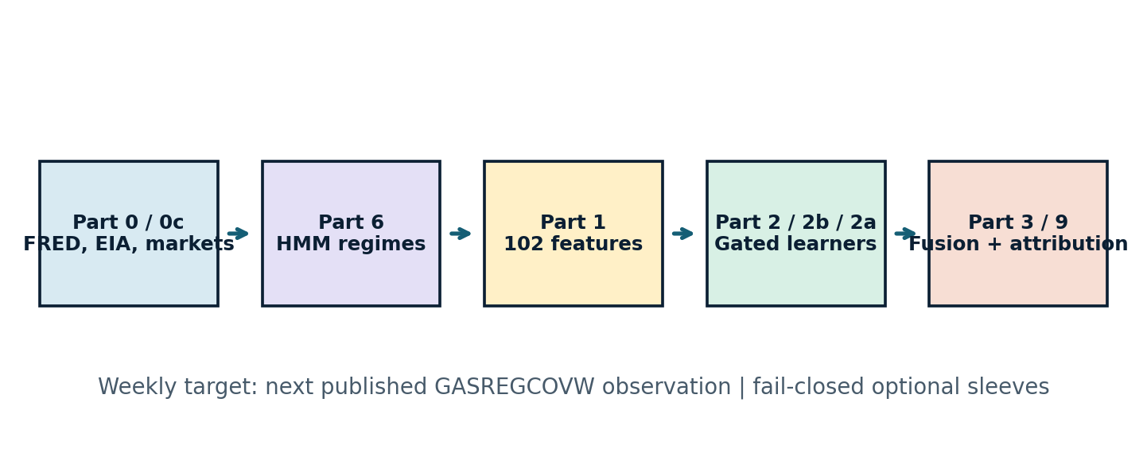
Figure 3. Audited execution order from data acquisition through live attribution.
The pipeline is intentionally modular. Part 0 and Part 0c assemble data; Part 6 estimates regimes; Part 1 builds features; Part 2 fits a core ensemble; Part 2b evaluates XGBoost; Part 2a evaluates an LSTM only after the XGBoost gate; Part 3 fuses accepted sleeves; and Part 9 scores matured forecasts. Optional modules fail closed instead of contaminating the canonical forecast when dependencies or validation gates fail.
That architecture is a strength. The central weakness is not modularity but evidence alignment. Each component must use the same frozen validation dates, target definition, and baseline. A model can appear strong relative to an all-history naive metric yet fail against a same-window persistence forecast. The report therefore recomputes the benchmark on the exact 52 validation dates.

Core Ensemble Geometry
The core ensemble contains histogram gradient boosting, random forest, gradient boosting, elastic net, and ridge regression. Models are fit on the historical labeled rows and evaluated on a trailing 52-week block. Inverse-RMSE weighting allocates more mass to lower-error components, after which the estimators are refit on all labeled data to issue the live forecast.
w_k = RMSE_k^(-1) / Σ_j RMSE_j^(-1) (5)
Y-hat_(t+1,ens) = Σ_k w_k Y-hat_(t+1,k) (6)
Committed weights were approximately .205 for histogram gradient boosting, .160 for random forest, .211 for gradient boosting, .180 for elastic net, and .244 for ridge. Ridge receives the largest weight because it achieved the best learned-model validation RMSE ($0.164). The current ensemble forecast for the August 17 target was $3.7758 per gallon.
Artifact semantics: The repository’s gas_forecast_tape.csv is generated after final refitting on all labeled rows. Rows flagged oos_val in that tape are therefore not honest out-of-sample predictions. The dedicated gas_oof_predictions.parquet is the correct research artifact for out-of-fold histories.
This distinction should be visible in the website and documentation. A refit tape is useful for fitted-value diagnostics, but it cannot support claims about prospective forecast accuracy.

Chronological Validation and the Persistence Benchmark
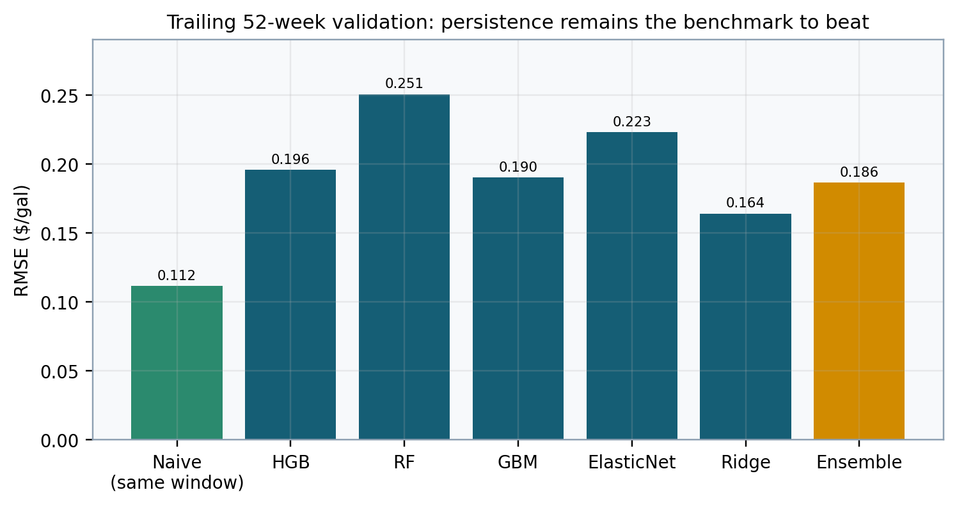
Figure 4. Trailing 52-week RMSE for the same-window persistence benchmark and learned models.
Model | MAE | RMSE | MAPE | R²
Persistence (same window) | $0.069 | $0.112 | — | —
Histogram gradient boosting | $0.148 | $0.196 | 4.43% | .874
Random forest | $0.189 | $0.251 | 5.52% | .793
Gradient boosting | $0.134 | $0.190 | 4.01% | .881
Elastic net | $0.154 | $0.223 | 4.31% | .836
Ridge | $0.106 | $0.164 | 2.99% | .911
Core ensemble | $0.131 | $0.186 | 3.82% | .886
The ensemble’s MAE and RMSE were 1.91 and 1.67 times the same-window persistence errors. Thus, the primary predictive hypothesis—incremental one-week skill over the last observed price—is not supported by this validation block.

Forecast Accuracy Metrics and Comparability
MAE = n^(-1) Σ |Y_t - Y-hat_t| (7)
RMSE = [n^(-1) Σ (Y_t - Y-hat_t)^2]^(1/2) (8)
MAPE = 100 n^(-1) Σ |(Y_t - Y-hat_t)/Y_t| (9)
R² = 1 - Σ(Y_t - Y-hat_t)^2 / Σ(Y_t - Y-bar)^2 (10)
MAE is directly interpretable in dollars per gallon; RMSE penalizes shock-week errors more strongly; MAPE rescales errors but remains asymmetric and can overweight low denominators; R² measures variance explained relative to a sample-mean reference, not forecast superiority over persistence. Directional accuracy answers a separate classification question and should not replace proper numeric-loss evaluation.
The committed part2 summary compares learned models on the trailing 52 weeks but reports naive metrics over all 1,388 labeled observations. Those values are not like-for-like because the gas-price level and volatility distribution differ across periods. The report’s persistence numbers were recomputed on the exact validation window: actual Y_(t+1) versus Y_t for the 52 target weeks.
Reporting rule: Every model-versus-baseline table should include one shared date range, one target definition, one missing-value rule, and one information set. If those elements differ, present separate descriptive panels instead of a skill comparison.

XGBoost and LSTM Promotion Gates
The XGBoost sleeve produced validation RMSE of approximately $0.194, compared with $0.186 for the core ensemble. Its promotion gate therefore failed, and its approximate $3.791 live forecast was excluded from canonical fusion. This is an appropriate fail-closed decision: architectural sophistication is not evidence of incremental skill.
The LSTM sleeve did not run because the XGBoost gate did not pass. The pipeline encodes this dependency to limit compute and prevent a loosely validated deep learner from entering production. Consequently, the artifact snapshot contains no valid LSTM performance result. The correct statement is “not evaluated under the current gate,” not “underperformed” or “passed.”
Sleeve | Validation status | Canonical weight | Interpretation
Core ensemble | Active | 1.00 | Only accepted predictive sleeve
XGBoost | Gate failed | 0.00 | RMSE exceeded core ensemble
LSTM | Skipped | 0.00 | Upstream gate not passed
A cleaner future design would evaluate each optional sleeve independently on frozen rolling-origin folds, then apply multiplicity-aware promotion rules. Chaining the LSTM test to XGBoost’s gate saves resources but prevents learning whether sequence structure adds value when tree boosting does not.

Hidden Markov Regime Model
Part 6 estimates a four-component Gaussian hidden Markov model from ten selected features. Let S_t denote the latent market state and X_t the observed standardized feature vector. The model assumes a first-order Markov state process and state-conditional Gaussian emissions.
p(x_(1:T),s_(1:T)) = π_(s1) ∏[t=2..T] A_(s(t-1),s(t)) ∏[t=1..T] p(x_t|s_t) (11)
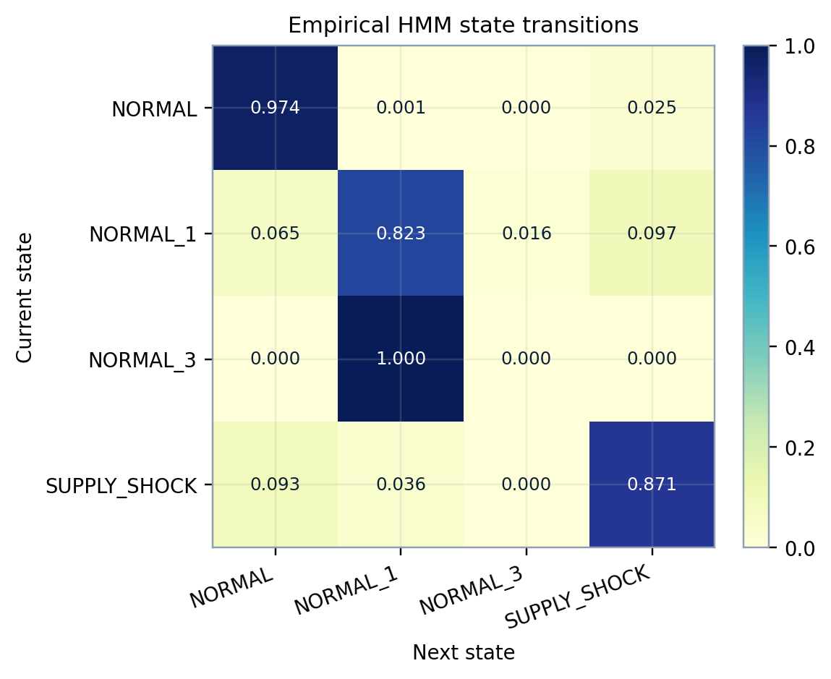
Figure 5. Empirical transition matrix from the committed regime tape.
The tape contains 1,077 NORMAL weeks, 249 SUPPLY_SHOCK weeks, 62 NORMAL_1 weeks, and one NORMAL_3 week. NORMAL and SUPPLY_SHOCK are persistent, with empirical self-transition probabilities near .974 and .871. The singleton state cannot support a stable physical interpretation. Regime names are descriptive post-fit labels rather than identified economic causes.

Regime Identifiability and Conditional Evaluation
Hidden-state numbering is permutation-invariant, and Gaussian components can split one broad distribution into multiple mathematically convenient clusters. The labels NORMAL_1 and NORMAL_3 acknowledge that two components lacked a validated physical identity. The latest state is SUPPLY_SHOCK with posterior probability approximately .9999, but that probability is conditional on the fitted model and feature scaling—not an externally calibrated probability of a causal supply event.
State | Count | Share | Empirical self-transition
NORMAL | 1,077 | 77.5% | .974
NORMAL_1 | 62 | 4.5% | .823
NORMAL_3 | 1 | 0.1% | .000
SUPPLY_SHOCK | 249 | 17.9% | .871
Regime features can still improve prediction if evaluated out of sample. Recommended diagnostics include fold-by-fold state occupancy, adjusted Rand index under refits, posterior entropy, transition uncertainty, and conditional model skill. A state with very low occupancy should be merged, regularized, or excluded from interpretation unless it recurs prospectively.
H(S_t|X) = -Σ_k p(S_t=k|X) log p(S_t=k|X) (12)
Claim boundary: Use “model-implied latent state” rather than “the market is in a supply shock.” The latter is a causal and semantic claim that the current artifacts do not identify.

Current Forecast Dispersion and Fusion
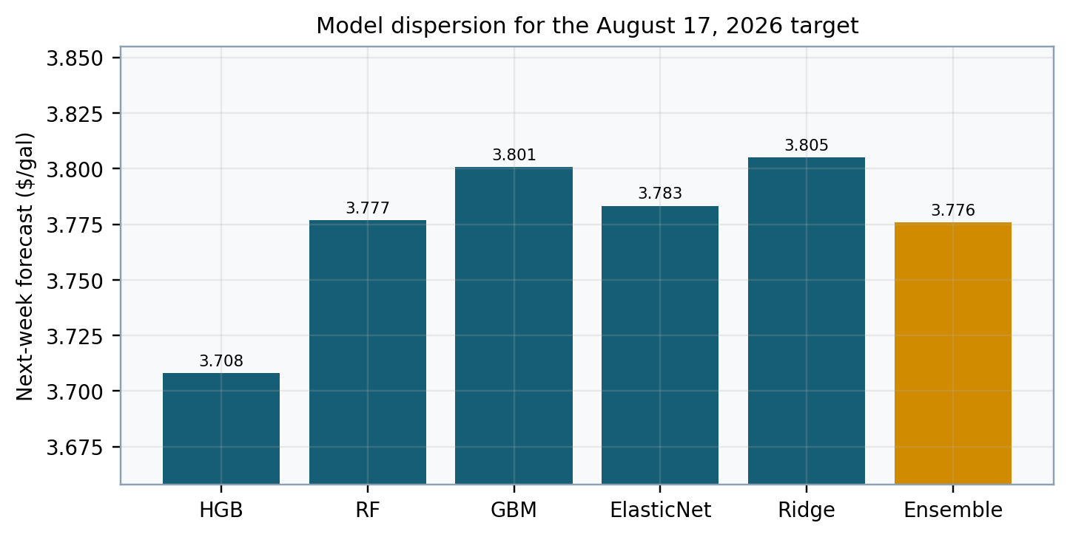
Figure 6. Core-model forecasts for the August 17, 2026 target.
Component forecasts ranged from approximately $3.708 to $3.805 per gallon, with an ensemble estimate of $3.7758. The dispersion is modest in absolute terms, but agreement among models trained on overlapping predictors is not a calibrated uncertainty interval. Correlated estimators can agree while all miss a shock.
Part 3 assigns weight 1.0 to the core ensemble because the XGBoost sleeve failed and the LSTM sleeve did not run. The forecast is marked low confidence under the latest SUPPLY_SHOCK state. That flag is a policy output, not a probabilistic coverage statement. A defensible interval would require residual calibration on strictly out-of-sample one-week forecasts and explicit treatment of serial dependence.
Website interpretation: The new interactive scenario lab visualizes directional pressure from user-selected inputs. It is an educational surrogate and never overwrites the committed $3.7758 model forecast or presents slider output as a trained prediction.

Live Attribution and Evidence Accumulation
The prediction log contains two issued forecasts in the committed snapshot. One target had matured: a prediction of $3.9373 for the August 10 reference week was compared with an observed $3.864, an absolute error of approximately $0.073 and MAPE of 1.90%. The August 17 forecast remained pending in the artifact snapshot. Part 9 therefore reports n_realized = 1 and correctly leaves aggregate MAPE, direction, drift, and Diebold–Mariano statistics unavailable.
d_t = L(e_model,t) - L(e_naive,t) (13)
DM = d-bar / sqrt(HACvar(d-bar)) (14)
A Diebold–Mariano comparison requires a sequence of paired loss differentials. With one observation, neither the mean differential nor its serial-dependence variance is estimable. The repository’s minimum live count of eight is a reasonable operational floor for displaying a preliminary statistic, but substantially more cases are needed for stable inference, especially when weekly losses are autocorrelated and shock regimes are sparse.
Live diagnostic | Snapshot status
Realized forecasts | 1
Pending forecasts | 1
Model health | Insufficient data
DM test | Insufficient data
Drift gate | Insufficient data

Forecast Governance and Operational Thresholds
The repository defines explicit health thresholds: MAPE above 3% warns and above 6% suspends; directional accuracy below 50% warns and below 40% stops; and an RMSE drift ratio above 1.5 warns and above 2.0 suspends. Such thresholds turn vague monitoring into auditable rules. They should remain inactive until minimum sample and coverage requirements are met.
Governance should distinguish three decisions: whether to issue a point forecast, whether to label the forecast low confidence, and whether to claim statistical superiority. A model can be numerically stable enough to issue while still lacking evidence of baseline skill. The current audit supports that middle state: the pipeline can generate research forecasts, but superiority should not be claimed.
Control | Present design | Recommended refinement
Model promotion | Single trailing-52 gate | Rolling-origin folds plus persistence
Live health | Minimum n = 8 | Display uncertainty and regime mix
Drift | RMSE ratio | Add feature and residual drift
Publication | Low-confidence label | Separate issue from skill claim
Every automated action should also store the commit SHA, model-artifact hash, source-vintage timestamps, validation-window dates, and the exact forecast row used for publication.

Threats to Validity
Internal validity is limited by heterogeneous release lags, revised macroeconomic series, a release-schedule documentation mismatch, and the ambiguity of the refit forecast tape. Statistical conclusion validity is limited by one validation block, model selection on that block, serial dependence, heavy-tailed errors, and only one realized live case. Construct validity is limited because an HMM “supply shock” label is not the same as an observed causal disruption.
External validity is constrained to one national retail series and an era spanning structural changes in survey methodology, refining configuration, regulation, taxes, and energy markets. Performance in 2025–2026 need not generalize to earlier or later price regimes. High raw-level correlations with crude and RBOB may reflect common trends rather than stable marginal predictive effects.
Software validity is stronger: the repository is modular, artifact-driven, and uses fail-closed optional sleeves. However, reproducibility would improve with an environment lock, immutable raw-source cache, deterministic seeds, release-calendar tests, and a single machine-readable evaluation table that includes every model and baseline on identical rows.
Interpretive conclusion: The audit does not show that ensemble learning is intrinsically unsuitable. It shows that this specific ensemble, on this specific 52-week block and target contract, did not outperform persistence.

Recommendations and Conclusion
First, correct the time contract. Schedule production after the official Tuesday publication or define the Monday run explicitly as a pre-release forecast, and store both reference week and release timestamp. Second, make same-window persistence the mandatory promotion baseline for every core and optional model. Third, use expanding or rolling-origin evaluation with multiple folds and report the distribution of skill, not one favorable window.
Fourth, generate honest out-of-fold predictions for the entire evaluation period and expose them as a CSV alongside the parquet artifact. Fifth, refit and label HMM states within each training fold, then measure state stability and conditional skill. Sixth, decouple the LSTM gate from XGBoost so sequence learning receives an independent test. Seventh, require prospective live evidence before activating health and Diebold–Mariano claims.
The project already has the right research-engineering instincts: modular stages, versioned artifacts, optional-sleeve gates, a prediction ledger, and live attribution. The central empirical conclusion is nonetheless negative and useful. The latest learned ensemble is less accurate than persistence on the audited validation block. Publishing that result plainly strengthens the thesis because it demonstrates benchmark discipline rather than model advocacy.
Decision: Retain the laboratory as an auditable forecasting experiment. Correct the release clock, elevate persistence to the canonical benchmark, and withhold production-skill claims until multi-window and prospective evidence support them.

References
Bergmeir, C., Hyndman, R. J., & Koo, B. (2018). A note on the validity of cross-validation for evaluating autoregressive time series prediction. Computational Statistics & Data Analysis, 120, 70–83. https://doi.org/10.1016/j.csda.2017.11.003
Breiman, L. (2001). Random forests. Machine Learning, 45, 5–32. https://doi.org/10.1023/A:1010933404324
Chen, T., & Guestrin, C. (2016). XGBoost: A scalable tree boosting system. In Proceedings of the 22nd ACM SIGKDD International Conference on Knowledge Discovery and Data Mining (pp. 785–794). https://doi.org/10.1145/2939672.2939785
Diebold, F. X., & Mariano, R. S. (1995). Comparing predictive accuracy. Journal of Business & Economic Statistics, 13(3), 253–263. https://doi.org/10.1080/07350015.1995.10524599
Friedman, J. H. (2001). Greedy function approximation: A gradient boosting machine. The Annals of Statistics, 29(5), 1189–1232. https://doi.org/10.1214/aos/1013203451
Hamilton, J. D. (1989). A new approach to the economic analysis of nonstationary time series and the business cycle. Econometrica, 57(2), 357–384.

References (Continued)
Hochreiter, S., & Schmidhuber, J. (1997). Long short-term memory. Neural Computation, 9(8), 1735–1780. https://doi.org/10.1162/neco.1997.9.8.1735
Hyndman, R. J., & Koehler, A. B. (2006). Another look at measures of forecast accuracy. International Journal of Forecasting, 22(4), 679–688. https://doi.org/10.1016/j.ijforecast.2006.03.001
Morelli, S. (2026). Weekly U.S. Gas Prices [Computer software]. GitHub. https://github.com/salemmorelli1/Weekly-U.S.-Gas-Prices
U.S. Energy Information Administration. (2026a). Factors affecting gasoline prices. https://www.eia.gov/energyexplained/gasoline/factors-affecting-gasoline-prices.php
U.S. Energy Information Administration. (2026b). Gasoline and diesel fuel update: Price survey methodology. https://www.eia.gov/petroleum/gasdiesel/gas_proc-methods.php
U.S. Energy Information Administration. (2026c). Open data API. https://www.eia.gov/opendata/
Federal Reserve Bank of St. Louis. (2026). U.S. regular conventional gas price (GASREGCOVW). FRED. https://fred.stlouisfed.org/series/GASREGCOVW

Appendix A: Reproduction Code for Tables and Figures
The following code reproduces the historical and same-window persistence summaries from committed repository CSV and JSON artifacts. It intentionally does not use the post-refit forecast tape as out-of-sample evidence.
from pathlib import Path
import json, pandas as pd, numpy as np
import matplotlib.pyplot as plt
ROOT = Path(__file__).resolve().parents[1]
master = pd.read_csv(ROOT / "artifacts_part0/gas_weekly_master.csv",
parse_dates=["week_date"])
forecast = pd.read_csv(ROOT / "artifacts_part2/gas_forecast_tape.csv",
parse_dates=["week_date"])
part2 = json.loads((ROOT / "artifacts_part2/gas_part2_summary.json").read_text())
# Descriptive statistics
y = master["gas_us_avg"].dropna()
print(y.describe())
monthly = (master.assign(month=master.week_date.dt.month)
.groupby("month")["gas_us_avg"].mean())
print(monthly)
# Same-window persistence benchmark: the 52 dates flagged by the repository.
# actual at row t is Y_(t+1); persistence is the preceding observed level Y_t.
val = forecast.loc[forecast["oos_val"].eq(1), ["week_date", "actual"]].copy()
history = master.set_index("week_date")["gas_us_avg"]
val["naive"] = [history.loc[d - pd.Timedelta(days=7)] for d in val.week_date]
err = val.actual - val.naive
print({"n": len(val), "mae": err.abs().mean(),
"rmse": np.sqrt(np.mean(err**2))})
Validation caveat: Use gas_oof_predictions.parquet for learned-model trajectories. The refitted gas_forecast_tape is appropriate for fitted diagnostics and current inference, not for out-of-sample accuracy claims.

Appendix B: Figure Construction and Audit Checks
# Historical series and survey-method break
fig, ax = plt.subplots(figsize=(8, 4))
ax.plot(master.week_date, master.gas_us_avg, lw=1, label="Weekly")
ax.plot(master.week_date, master.gas_us_avg.rolling(52).mean(),
lw=2, label="52-week mean")
ax.axvline(pd.Timestamp("2018-05-14"), ls="--", label="EIA method break")
ax.set_ylabel("Dollars per gallon"); ax.legend(); fig.tight_layout()
fig.savefig("gas_price_history.png", dpi=220)
# Metric comparability audit
assert len(val) == 52
assert val.week_date.min() == pd.Timestamp("2025-08-11")
assert val.week_date.max() == pd.Timestamp("2026-08-03")
assert not val[["actual", "naive"]].isna().any().any()
# Release-clock contract recommended for production artifacts
required_clock_fields = {
"issue_datetime", "reference_week", "source_release_datetime",
"target_observation_id", "model_commit_sha", "artifact_hash"
}
prediction_log_columns = set(pd.read_csv(
ROOT / "artifacts_part3/prediction_log.csv").columns)
print("Missing clock/provenance fields:",
sorted(required_clock_fields - prediction_log_columns))
Note. The interactive GitHub Pages laboratory uses native browser graphics and committed JSON/CSV telemetry. Its scenario sliders are explicitly labeled explanatory surrogates. The Python artifacts, not the webpage’s arithmetic, remain the authoritative computational record.

