The Numerov Method — Solutions to the Exercises
Worked solutions with predictions, computations, tables, convergence plots and discussion (companion to the course notes)
November 2026
Table of Contents
How the solutions are organised 3
Exercise 1 — Order from two grids 4
Exercise 2 — A better start 5
Exercise 3 — Points per wavelength 6
Exercise 4 — Dispersion relation in the scattering problem 8
Exercise 5 — Thick barrier 10
Exercise 6 — Smooth barrier 12
Exercise 7 — One-sided shooting 14
Exercise 8 — Anharmonic oscillator 16
Exercise 9 — Finite square well 18
Exercise 10 — Round-off in single precision 20
Appendix — Codes 22
Exercises 1–5 (Python) 22
Exercises 6–9 (Python) 25
Exercise 10 (Fortran 90, single and double precision) 29
Exercise 10 — plotting script 30

How the solutions are organised
Each solution follows the same pattern: (1) the question, (2) a prediction made from the theory of Part I of the course before computing, (3) the method (what was changed in the course codes), (4) the results, and (5) the answer and its explanation. All numbers were produced by the programs listed in the Appendix (ex01_05.py, ex06_09.py, ex10_precision.F90, ex10_plot.py). Units $ℏ=m=1$ throughout.
Ex. | Topic | Short answer
1 | Order from two grids | $p≈4.00$; the 17.6 (p = 4.14) is a round-off artefact
2 | Third-order Taylor start | Start error $O\left(h^{5}\right)$ ⇒ global order 4 restored (measured 4.00)
3 | Points per wavelength | $N_{min}=254$ ⇒ 51 points per wavelength for ${10}^{-6}$; error $={\left(kh\right)}^{4}/240$
4 | Discrete plane waves $e^{ik_{h}x}$ | Error falls by only 0–8 %: the dominant error is in the barrier, and $T$ ignores phases
5 | Thick barrier | $T=4.6537×{10}^{-15}$, WKB too small by the prefactor 2.56; $R+T$ cannot resolve $T$
6 | Smooth barrier | No correction needed: order 3.99–4.02, accuracy ${10}^{-12}$
7 | One-sided shooting | $E_{0}$ still converges for $5≲L≲20$, but the tail of $ψ$ is destroyed and $L≳27$ overflows
8 | Anharmonic oscillator | $ΔE_{n}/λ→3/4\left(2n^{2}+2n+1\right)$ as $λ→0$; at $λ=0.1$, $E_{0}=0.5591463271$
9 | Finite square well | 3 bound states, exact conditions satisfied; corrected scheme order 3.90, naive order 2
10 | Single precision | Optimum $h≈0.125$, best error $7.6×{10}^{-6}$ (double: $h≈0.008$, $1.1×{10}^{-11}$)

Exercise 1 — Order from two grids
Question. Using the Problem 1, Part A table, compute $p=\log_{2}\left[ε\left(h\right)/ε\left(h/2\right)\right]$ for every pair of rows and explain the last value (17.6).
Prediction. For a fourth-order method $ε\left(h\right)≈Ch^{4}$, so $ε\left(h\right)/ε\left(h/2\right)=16$ and $p=4$, as long as round-off is negligible.
Results (the table was extended by two more halvings to show what happens next):
N → 2N | ε(h) | ε(h/2) | ratio | p
25 → 50 | 1.554e-02 | 1.011e-03 | 15.4 | 3.94
50 → 100 | 1.011e-03 | 6.285e-05 | 16.1 | 4.01
100 → 200 | 6.285e-05 | 3.924e-06 | 16.0 | 4.00
200 → 400 | 3.924e-06 | 2.455e-07 | 16.0 | 4.00
400 → 800 | 2.455e-07 | 1.533e-08 | 16.0 | 4.00
800 → 1600 | 1.533e-08 | 9.503e-10 | 16.1 | 4.01
1600 → 3200 | 9.503e-10 | 5.401e-11 | 17.6 | 4.14
3200 → 6400 | 5.401e-11 | 2.180e-10 | 0.25 | −2.01
6400 → 12800 | 2.180e-10 | 1.509e-09 | 0.14 | −2.79
Explanation of 17.6.
- The first pair gives 3.94 because $h=0.4$ ($kh=0.8$) is not yet in the asymptotic regime: higher-order terms $h^{6},h^{8}$ still contribute.
- From $N=50$ to $N=1600$ the value is 4.00 ± 0.01 — the theoretical order.
- Extrapolating the clean $h^{4}$ law from $N=200$ predicts $ε\left(N=3200\right)=5.99×{10}^{-11}$; the computed value is $5.40×{10}^{-11}$. The measured error is smaller than the truncation error because the accumulated round-off error (of size ${10}^{-11}$ here, with a random sign) happens to partially cancel it. The ratio is therefore artificially large (17.6 instead of 16).
- One more halving confirms the diagnosis: the error increases ($p<0$). Below $h≈3×{10}^{-3}$ the round-off error, which grows roughly like $ϵ/h^{2}$ for a second-order recursion, dominates. A ratio larger than 16 is thus the first warning sign that the round-off floor has been reached; the optimum step for this problem is $h≈3×{10}^{-3}$.

Exercise 2 — A better start
Question. Use $ψ_{1}=kh-{\left(kh\right)}^{3}/6$. Predict, then measure, the global order.
Prediction. The exact value is $sinkh=kh-{\left(kh\right)}^{3}/6+{\left(kh\right)}^{5}/120-…$, so the start error is $δ={\left(kh\right)}^{5}/120=O\left(h^{5}\right)$. From Part I, a start error $δ$ produces a global error $O\left(δ/h\right)=O\left(h^{4}\right)$ — the same order as Numerov’s own truncation error. Predicted global order: 4. (The first-order start $ψ_{1}=kh$ has $δ=O\left(h^{3}\right)$ and gives order 2.)
Results ($k=2$, $X=10$):
N | h | error, exact start | error, Taylor 1st | error, Taylor 3rd | ratio (3rd)
25 | 0.400 | 1.554e-02 | 1.144e-01 | 1.647e-02 | —
50 | 0.200 | 1.011e-03 | 2.711e-02 | 1.021e-03 | 16.1
100 | 0.100 | 6.285e-05 | 6.694e-03 | 6.430e-05 | 15.9
200 | 0.050 | 3.924e-06 | 1.668e-03 | 4.014e-06 | 16.0
400 | 0.025 | 2.455e-07 | 4.168e-04 | 2.510e-07 | 16.0
800 | 0.0125 | 1.533e-08 | 1.042e-04 | 1.567e-08 | 16.0
1600 | 0.00625 | 9.503e-10 | 2.604e-05 | 9.716e-10 | 16.1
3200 | 0.003125 | 5.401e-11 | 6.510e-06 | 5.770e-11 | 16.8
Fitted orders: exact start 3.99, first-order Taylor 2.02, third-order Taylor 4.00.
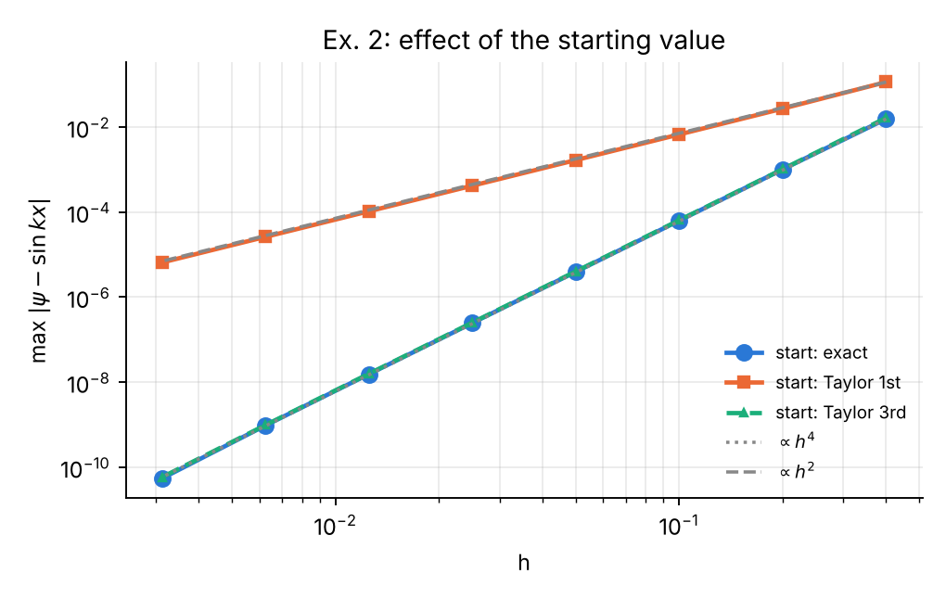
Exercise 2. The third-order Taylor start (triangles, dashed) lies on top of the exact start: the global order 4 is restored.
Answer. As predicted, the global order is 4. The third-order start adds only about 2 % to the error (the start contribution $\left|ε_{3}-ε_{\text{exact}}\right|$ is $1.4×{10}^{-6}$ at $N=100$ against a total of $6.4×{10}^{-5}$). Rule: the starting value must be accurate to $O\left(h^{5}\right)$; any Taylor start of order 4 or higher is sufficient.

Exercise 3 — Points per wavelength
Question. For the box ($L=1$), find the smallest $N$ that gives $E_{10}$ with relative error below ${10}^{-6}$; express it as points per wavelength and compare with the rule of thumb.
Theory (prediction). In the box, $sin\left(k_{h}x\right)$ with the discrete wave number $k_{h}$ satisfies the Numerov recursion exactly and vanishes at $x=0$ and $x=L$ when $k_{h}=nπ/L$. Hence the numerical eigenvalue obeys $k_{h}\left(E\right)=nπ/L$ exactly. Using the dispersion relation of Part I, $k_{h}=k\left[1+{\left(kh\right)}^{4}/480\right]$, the numerical $k$ is too small by the factor $1-{\left(kh\right)}^{4}/480$ and, since $E∝k^{2}$,
$$\frac{E_{n}^{\text{num}}-E_{n}}{E_{n}}≈-\frac{{\left(kh\right)}^{4}}{240}, kh=\frac{2π}{P},$$
where $P=λ/h$ is the number of grid points per wavelength. Setting this equal to ${10}^{-6}$:
$$P=\frac{2π}{{\left(240×{10}^{-6}\right)}^{1/4}}=\frac{2π}{0.1245}≈50.5.$$
The numerical energy is always below the exact one (as in the table of Problem 1).
Results. For $n=10$ the wavelength is $λ=2L/n=0.2$.
N | kh | relative error of $E_{10}$ | $${\left(kh\right)}^{4}/240$$
40 | 0.785 | 1.622e-03 | 1.585e-03
100 | 0.314 | 4.074e-05 | 4.059e-05
200 | 0.157 | 2.539e-06 | 2.537e-06
252 | 0.125 | 1.007e-06 | —
254 | 0.124 | 9.757e-07 | 9.751e-07
$N_{min}=254$, i.e. $h=0.00394$, 50.8 points per wavelength. The same criterion is independent of $n$, as the theory says:
n | N_min | points per wavelength
1 | 26 | 52.0
2 | 52 | 52.0
5 | 128 | 51.2
10 | 254 | 50.8
20 | 506 | 50.6
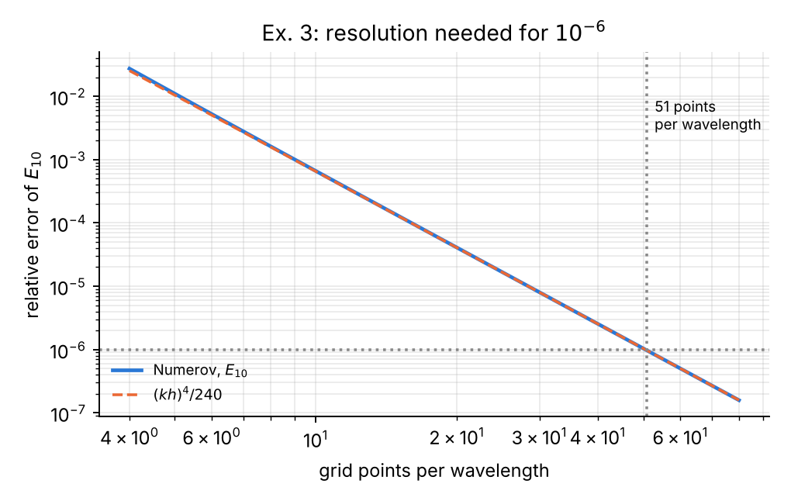
Exercise 3. Relative error of $E_{10}$ versus points per wavelength; the formula ${\left(kh\right)}^{4}/240$ (dashed) coincides with the computation.
Comparison with the rule of thumb. The rule “20–30 points per wavelength” of Part I gives relative errors of ${\left(2π/20\right)}^{4}/240=4.1×{10}^{-5}$ to ${\left(2π/30\right)}^{4}/240=8.0×{10}^{-6}$: it is adequate for 4–5 significant digits. For ${10}^{-6}$ one needs about 51 points per wavelength; in general $P≈2π {\left(240 ε\right)}^{-1/4}$ for a target relative error $ε$ — doubling the accuracy demand costs only a factor $2^{1/4}=1.19$ in grid points, the benefit of a fourth-order method.

Exercise 4 — Dispersion relation in the scattering problem
Question. Replace $e^{ikx}$ by $e^{ik_{h}x}$ in the starting values and in the extraction of $A,B$ (Problem 2). Does the error decrease? Why?
Prediction. In the free regions $V=0$ the discrete solutions of the Numerov recursion are exactly $e^{±ik_{h}x}$. With $e^{ik_{h}x}$ the right boundary is an exact transmitted discrete wave and the decomposition on the left is exact, so the free regions contribute no error and the result should not depend on the padding length. With $e^{ikx}$ the two starting values contain a tiny admixture of the reflected discrete wave, of relative size $∼\left(k_{h}-k\right)/k∼{\left(kh\right)}^{4}/480$. Two arguments suggest that the gain will be small: (i) $T=1/{\left|A\right|}^{2}$ depends only on moduli, so the accumulated phase error $k^{5}h^{4}X/480$ cancels; (ii) the ${\left(kh\right)}^{4}/480$ coefficient is small compared with the error committed inside the barrier.
Method. scatter(..., use_kh=True) computes $k_{h}=arccos​\left[\left(1-5/{12}{\left(kh\right)}^{2}\right)/\left(1+1/{12}{\left(kh\right)}^{2}\right)\right]/h$ and uses it in both the start and the $2×2$ extraction. The corrected discontinuity treatment of Problem 2 is used in all runs.
Results ($V_{0}=5$, $a=1$):
h | E=2, pad 2: $e^{ikx}$ | E=2, pad 2: $e^{ik_{h}x}$ | E=8, pad 2: $e^{ikx}$ | E=8, pad 2: $e^{ik_{h}x}$ | E=8, pad 20: $e^{ikx}$ | E=8, pad 20: $e^{ik_{h}x}$
0.1 | 8.41e-06 | 8.59e-06 | 3.12e-04 | 2.89e-04 | 3.19e-04 | 2.89e-04
0.05 | 5.40e-07 | 5.52e-07 | 2.10e-05 | 1.98e-05 | 2.16e-05 | 1.98e-05
0.025 | 3.43e-08 | 3.50e-08 | 1.34e-06 | 1.28e-06 | 1.38e-06 | 1.28e-06
0.0125 | 2.16e-09 | 2.20e-09 | 8.45e-08 | 8.09e-08 | 8.71e-08 | 8.09e-08
0.00625 | 1.36e-10 | 1.39e-10 | 5.29e-09 | 5.08e-09 | 5.46e-09 | 5.08e-09
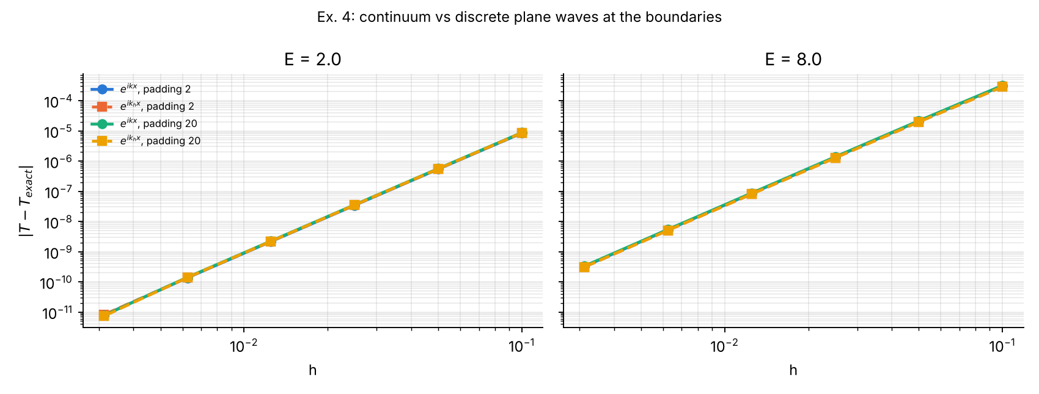
Exercise 4. The four curves for each energy practically coincide: replacing $k$ by $k_{h}$ does not change the convergence.
Answer. The error changes by only −8 % to +2 %, and the order remains 4. With $e^{ik_{h}x}$ the result becomes exactly independent of the padding length (identical digits for padding 2 and 20), which confirms that the free regions are now treated exactly; with $e^{ikx}$ a 2–10 % padding dependence remains. The error does not decrease substantially because:
- $T$ is phase-insensitive. The dominant consequence of $k≠k_{h}$ is a phase error, which cancels in ${\left|A\right|}^{2}$ and ${\left|B\right|}^{2}$.
- The error lives in the barrier. The remaining $O\left(h^{4}\right)$ error comes from integrating through the region $0<x<a$, where $ψ$ changes rapidly (evanescent or short-wavelength) and from the edge treatment — the boundary treatment cannot remove it.
The modification is still good practice: it makes the result independent of where the computational box ends.

Exercise 5 — Thick barrier
Question. Compute $T$ for $V_{0}=5$, $a=6$, $E=1$; compare with the WKB estimate $T≈e^{-2κa}$. What limits the accuracy, and what happens to $R+T$?
Analytical values. $κ=\sqrt{2\left(V_{0}-E\right)}=2.82843$, $κa=16.9706$.
Quantity | Value
Exact $T$ | 4.653679e-15
WKB $e^{-2κa}$ | 1.817843e-15
Thick-barrier limit $\frac{16E\left(V_{0}-E\right)}{V_{0}^{2}}e^{-2κa}$ | 4.653679e-15
Ratio exact/WKB | 2.560
For $κa≫1$, $\sinh^{2}\left(κa\right)≈e^{2κa}/4$ and the exact formula reduces to $T≈\frac{16E\left(V_{0}-E\right)}{V_{0}^{2}}e^{-2κa}$. The simple WKB exponent captures the exponential dependence perfectly but misses the prefactor $16E\left(V_{0}-E\right)/V_{0}^{2}=2.56$, which comes from the abrupt (non-WKB) edges of the barrier. The ratio WKB/exact = 0.391 is the same for every thickness $a≥1$ (table below).
Numerov results (corrected edge scheme):
h | T Numerov | relative error | R | R+T−1
0.05 | 4.65345430e-15 | 4.8e-05 | 0.99999999999999079 | −4.6e-15
0.025 | 4.65366495e-15 | 3.1e-06 | 0.99999999999996469 | −3.1e-14
0.0125 | 4.65367840e-15 | 2.0e-07 | 0.99999999999993749 | −5.8e-14
0.00625 | 4.65367925e-15 | 1.2e-08 | 1.00000000000018940 | +1.9e-13
0.003125 | 4.65367931e-15 | 6.0e-10 | 0.99999999999941325 | −5.8e-13
Thickness scan at $h=0.00625$:
a | T Numerov | T exact | relative error | WKB/exact | R+T−1
1 | 8.9258e-03 | 8.9258e-03 | 6.5e-09 | 0.391 | −3.8e-11
2 | 3.1243e-05 | 3.1243e-05 | 7.6e-09 | 0.391 | −2.8e-13
4 | 3.8131e-10 | 3.8131e-10 | 9.9e-09 | 0.391 | −1.4e-15
6 | 4.6537e-15 | 4.6537e-15 | 1.2e-08 | 0.391 | 1.9e-13
8 | 5.6796e-20 | 5.6796e-20 | 1.5e-08 | 0.391 | −4.7e-14
12 | 8.4597e-30 | 8.4597e-30 | 1.9e-08 | 0.391 | −5.0e-13
What limits the accuracy?
- $T$ itself is obtained with a relative accuracy of ${10}^{-8}$ even when $T∼{10}^{-30}$. This works because the backward integration goes in the stable direction: going from right to left through the barrier the physical solution grows like $e^{κ\left(a-x\right)}$, so round-off errors are swamped, and $T=1/{\left|A\right|}^{2}$ is computed directly from a large number ($\left|A\right|=1.5×{10}^{7}$) — never as a small difference.
- The remaining error is the Numerov discretisation error (order 4 in the table), whose relative size grows slowly (linearly) with $a$ because the phase/decay-rate error accumulates over the barrier: $6.5×{10}^{-9}$ at $a=1$ to $1.9×{10}^{-8}$ at $a=12$.
- The ultimate limit is overflow: $\left|A\right|∼e^{κa}$ exceeds ${10}^{308}$ when $κa>709$, i.e. $a≳250$ here.
What happens to $R+T$? $R=1-4.65×{10}^{-15}$ cannot be represented more precisely than about $±{10}^{-16}$ in double precision, and its round-off error (${10}^{-13}$–${10}^{-12}$: the relative round-off of $\left|A\right|$ and $\left|B\right|$, accumulated over thousands of steps) is larger than $T$ itself. $R+T-1$ therefore shows only round-off noise and contains no information about $T$. Conclusion: for opaque barriers never compute $T$ as $1-R$ and never use $R+T=1$ as an accuracy test; compute $T$ from the transmitted amplitude.

Exercise 6 — Smooth barrier
Question. Replace the square barrier by $V\left(x\right)=V_{0}/\cosh^{2}\left(x/w\right)$, whose exact $T$ is known; show that no correction is needed to obtain fourth order.
Exact result (Pöschl–Teller / Eckart barrier; Landau & Lifshitz §25) for $ℏ=m=1$ and $8V_{0}w^{2}>1$:
$$T\left(E\right)=\frac{\sinh^{2}\left(πkw\right)}{\sinh^{2}\left(πkw\right)+\cosh^{2}​\left(\frac{π}{2}\sqrt{8V_{0}w^{2}-1}\right)}, k=\sqrt{2E},$$
($\cosh^{2}→\cos^{2}\left(\frac{π}{2}\sqrt{1-8V_{0}w^{2}}\right)$ when $8V_{0}w^{2}<1$). Parameters: $V_{0}=5$, $w=0.5$ ($8V_{0}w^{2}=10$), computational box $\left[-12,12\right]$, where $V\left(±12\right)=3×{10}^{-20}$ is negligible.
Prediction. $V$ is analytic, so $ψ$ and all its derivatives are continuous; the Taylor expansions behind Numerov hold everywhere and the plain scheme should be fourth order with no special treatment.
Results. Plain Numerov, no edge nodes, no correction:
E | T Numerov (h = 0.01) | T exact | |ΔT| | R+T−1
1 | 0.0066549324 | 0.0066549324 | 3.6e-12 | 8.2e-13
3 | 0.1505171785 | 0.1505171781 | 3.7e-10 | 1.8e-13
5 | 0.6247014391 | 0.6247014405 | 1.4e-09 | 1.8e-13
8 | 0.9585694821 | 0.9585694818 | 2.5e-10 | 2.6e-13

h | |ΔT|, E = 2 | ratio | |ΔT|, E = 8 | ratio
0.1 | 1.40e-06 | — | 4.95e-06 | —
0.05 | 8.83e-08 | 15.9 | 5.02e-08 | 98.6
0.025 | 5.54e-09 | 15.9 | 4.85e-09 | 10.4
0.0125 | 3.47e-10 | 16.0 | 5.49e-10 | 8.8
0.00625 | 2.18e-11 | 15.9 | 4.17e-11 | 13.2
0.003125 | 1.33e-12 | 16.4 | 4.74e-12 | 8.8
order | 3.99 |  | 4.02
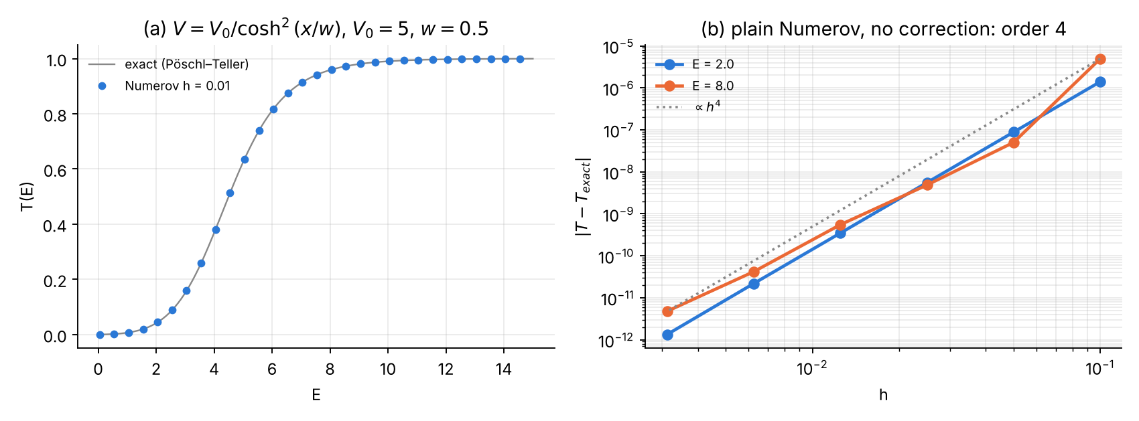
Exercise 6. (a) Transmission through the smooth barrier; (b) plain Numerov converges with slope 4 without any correction.
Answer. The fitted orders are 3.99 and 4.02: no correction is needed. Compare with the square barrier, where the uncorrected scheme was second order. For $E=8$ the individual ratios scatter (98.6, 10.4, …) because the error is a sum of several $h^{4}$ contributions of different sign that partly cancel at some $h$; the overall slope is still 4. The maximum error over $0<E<15$ at $h=0.01$ is $2.6×{10}^{-9}$. Lesson: the loss of order in Problem 2 was caused by the discontinuity of the potential, not by the scattering formulation.

Exercise 7 — One-sided shooting
Question. Modify Problem 3 to integrate from $-L$ to $+L$ and require $ψ_{N}=0$. For which $L$ does the bisection still converge to $E_{0}$? Explain with fault no. 4.
Method. $ψ_{0}=0$, $ψ_{1}={10}^{-10}$, Numerov from $-L$ to $+L$ with $h=0.01$; bisection on the sign of $F\left(E\right)=ψ_{N}\left(E\right)$ in $\left[0.3,0.7\right]$ (100 halvings).
Results.
L | $E_{0}$ (one-sided) | |E₀ − 0.5| | $$e^{L^{2}/2}$$
3 | 0.500391082888 | 3.9e-04 | 9.0e+01
4 | 0.500000490818 | 4.9e-07 | 3.0e+03
5 | 0.500000000038 | 3.8e-11 | 2.7e+05
6 | 0.499999999961 | 3.9e-11 | 6.6e+07
8 | 0.499999999961 | 3.9e-11 | 7.9e+13
10 | 0.499999999961 | 3.9e-11 | 5.2e+21
15 | 0.499999999961 | 3.9e-11 | 7.2e+48
20 | 0.499999999961 | 3.9e-11 | 7.2e+86
30 | overflow (NaN) | — | —
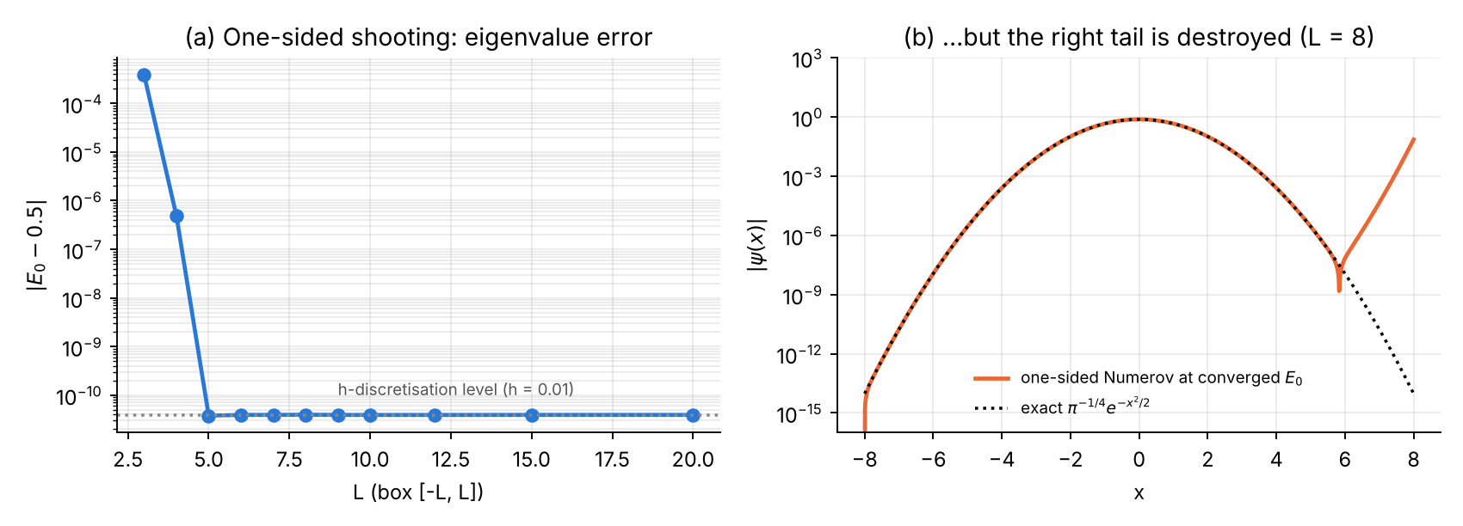
Exercise 7. (a) The eigenvalue from one-sided shooting reaches the two-sided accuracy for $L≥5$. (b) The wavefunction at the converged energy, $L=8$: the right tail departs from $e^{-x^{2}/2}$ at $x≈6$ and grows exponentially.
Answer and explanation. Perhaps surprisingly, the eigenvalue converges to $E_{0}$ for all $5≲L≲20$ with the same accuracy ($3.9×{10}^{-11}$) as the two-sided method. For $L<5$ the error is the box-truncation error (identical to the two-sided result of Problem 3); for $L≳27$ the computation overflows. What happens is:
- Beyond the right turning point the computed solution is $ψ=α\left(E\right) ϕ_{↓}+β\left(E\right) ϕ_{↑}$, with $ϕ_{↑}∼e^{+x^{2}/2}$. At $x=L$ the growing part dominates completely, so $signψ_{N}=signβ\left(E\right)$. $β\left(E\right)$ changes sign exactly at the discrete eigenvalue, and round-off adds to $β$ a contribution equivalent to an energy shift of order $ϵ≈{10}^{-16}$. Bisection on the sign is therefore insensitive to the instability: the eigenvalue survives.
- The wavefunction does not survive (fault no. 4). Even at the converged energy, the residual $β$ (from the finite bisection resolution and round-off) is amplified by $e^{x^{2}/2}$. Panel (b) shows that for $L=8$ the computed $ψ$ follows the exact Gaussian only up to $x≈6$ and then grows to $\left|ψ\left(L\right)\right|≈0.07$ — a value ${10}^{12}$ times larger than the exact $ψ\left(8\right)≈{10}^{-14}$. Such a function cannot be normalised reliably, and expectation values ($⟨x^{2}⟩$, the virial check) are wrong.
- Overflow. The growing solution reaches $∼{10}^{-10}e^{L^{2}}$ at $x=+L$; this exceeds the largest double ($1.8×{10}^{308}$) when $L^{2}≳732$, i.e. $L≳27$ (NaN at $L=30$).
So one-sided shooting gives correct energies for moderate $L$ but wrong wavefunctions and fails for large boxes; the two-sided method of Problem 3 avoids both problems by never integrating into a forbidden region.

Exercise 8 — Anharmonic oscillator
Question. Use the Problem 3 code for $V=x^{2}/2+λx^{4}$, $λ=0.1$; check against first-order perturbation theory $ΔE_{n}=\frac{3λ}{4}\left(2n^{2}+2n+1\right)$ for small $λ$.
First-order perturbation theory. With $x=\left(a+a^{†}\right)/\sqrt{2}$, $⟨n\left|x^{4}\right|n⟩=\frac{3}{4}\left(2n^{2}+2n+1\right)$, hence $ΔE_{n}^{\left(1\right)}=\frac{3λ}{4}\left(2n^{2}+2n+1\right)$: coefficients 0.75, 3.75, 9.75 for $n=0,1,2$. For the ground state the series continues $E_{0}=\frac{1}{2}+\frac{3}{4}λ-\frac{21}{8}λ^{2}+\frac{333}{16}λ^{3}-…$ (an asymptotic, divergent series).
Method. The Problem 3 module is imported unchanged and only its potential is replaced (P3.V = lambda x: 0.5*x*x + lam*x**4); box $\left[-6,6\right]$, $h=0.01$. As an independent check, the Hamiltonian is also diagonalised in a basis of 160 harmonic-oscillator states (ho_basis_energies).
Results.
λ | n | E Numerov | E basis | (E − E⁽⁰⁾)/λ | 1st-order coef.
1e-4 | 0 | 0.500074973732 | 0.500074973771 | 0.749737 | 0.75
1e-4 | 1 | 1.500374793721 | 1.500374793994 | 3.747937 | 3.75
1e-4 | 2 | 2.500974231527 | 2.500974232502 | 9.742315 | 9.75
1e-3 | 0 | 0.500747395535 | 0.500747395575 | 0.747396 | 0.75
1e-3 | 1 | 1.503729615426 | 1.503729615703 | 3.729615 | 3.75
1e-3 | 2 | 2.509674351733 | 2.509674352726 | 9.674352 | 9.75
1e-2 | 0 | 0.507256204483 | 0.507256204525 | 0.725620 | 0.75
1e-2 | 1 | 1.535648277992 | 1.535648278297 | 3.564828 | 3.75
1e-2 | 2 | 2.590845795041 | 2.590845796191 | 9.084580 | 9.75
0.1 | 0 | 0.559146327122 | 0.559146327184 | 0.591463 | 0.75
0.1 | 1 | 1.769502643379 | 1.769502643950 | 2.695026 | 3.75
0.1 | 2 | 3.138624305981 | 3.138624308498 | 6.386243 | 9.75
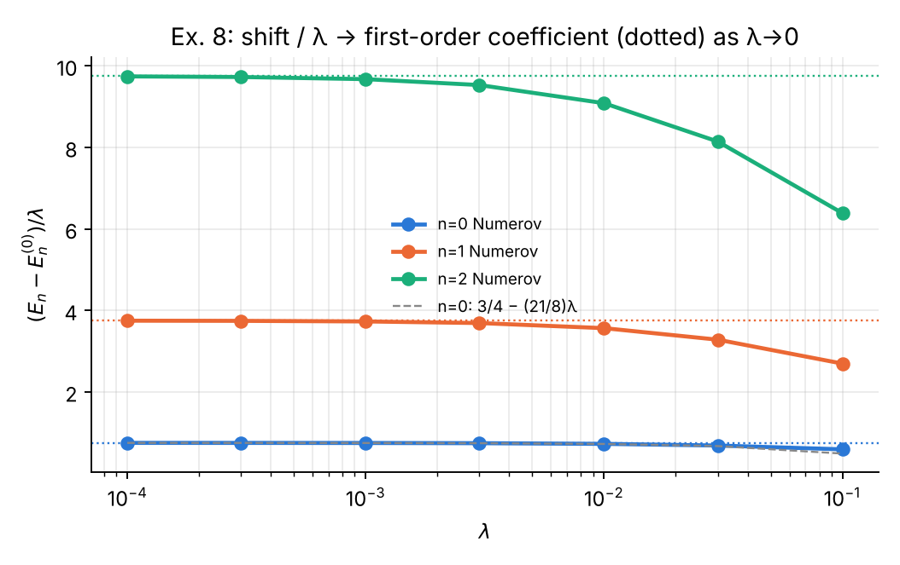
Exercise 8. Energy shift divided by λ; the dotted lines are the first-order coefficients $\frac{3}{4}\left(2n^{2}+2n+1\right)$, the dashed line the second-order result $\frac{3}{4}-\frac{21}{8}λ$ for $n=0$.
Answer.
- Small λ. $\left(E_{n}-E_{n}^{\left(0\right)}\right)/λ$ tends to 0.75, 3.75, 9.75 as $λ→0$ (at $λ={10}^{-4}$: 0.7497, 3.7479, 9.7423). The deviation is linear in $λ$, as expected from the second-order term: for $n=0$, $\frac{3}{4}-\frac{21}{8}\left({10}^{-3}\right)=0.747375$, and adding the third-order term $\frac{333}{16}{\left({10}^{-3}\right)}^{2}$ gives 0.747396 — exactly the computed value.
- λ = 0.1. $E_{0}=0.5591463271$, in agreement with the basis diagonalisation to $6×{10}^{-11}$ (the Numerov discretisation error at $h=0.01$). First-order perturbation theory gives 0.575 (+2.8 %); for $n=2$ it gives 3.475 instead of 3.1386 (+11 %), because the higher states extend to larger $\left|x\right|$ where $λx^{4}$ is no longer small. Adding more terms does not help much (second order 0.54875, third order 0.56956): the perturbation series is asymptotic.
- Practical remarks. The Problem 3 code works unchanged because the turning-point estimate $\sqrt{2E}$ lies slightly outside the true turning point, which only places the matching node a little inside the forbidden region — harmless. A smaller box ($L=6$) is sufficient because the quartic term makes the wavefunctions decay faster.

Exercise 9 — Finite square well
Question. Turn Problem 2 into a bound-state problem with $V=-V_{0}$ for $\left|x\right|<a/2$, using the shooting/matching method of Problem 3 and the discontinuity correction of Problem 2; verify the even-state condition $qtan\left(qa/2\right)=κ$.
Analytical scheme. With $E<0$, $q=\sqrt{2\left(V_{0}-\left|E\right|\right)}$ inside and $κ=\sqrt{2\left|E\right|}$ outside, matching $ψ'/ψ$ at $x=a/2$ gives
$$\text{even: }qtan\frac{qa}{2}=κ, \text{odd: }-qcot\frac{qa}{2}=κ.$$
With $V_{0}=10$, $a=2$: $\sqrt{2V_{0}} a/2=4.47$, so there are $⌈4.47/\left(π/2\right)⌉=3$ bound states (even, odd, even). They were found with a root finder (brentq) to ${10}^{-15}$.
Numerical scheme.
- Grid $\left[-8,8\right]$; the well edges $x=±1$ are grid nodes with $V=-V_{0}/2$.
- Outward Numerov from $-8$ and inward from $+8$, matched at the centre $x=0$ with the discrete Wronskian $D\left(E\right)$ of Problem 3. (The centre is inside the allowed region, and both integrations start in forbidden regions — the stable direction.)
- The edge correction of Problem 2 is applied in both directions: one-sided $V$ in stencils neighbouring an edge, and at an edge node the term $δ=-\frac{h^{3}}{12}\left[k^{2}\right]ψ'$, with $ψ'$ from the side already integrated: $\left(3ψ_{e}-4ψ_{e-1}+ψ_{e-2}\right)/2h$ outward, $\left(-3ψ_{e}+4ψ_{e+1}-ψ_{e+2}\right)/2h$ inward.
- Odd states have $ψ\left(0\right)=0$, so the two pieces are glued with the ratio at node $m+1$ instead of $m$.
Results ($h=0.01$, corrected):
state | E exact | E Numerov | |ΔE| | exact condition: lhs = κ | parity error
even (n=0) | −9.180259926233 | −9.180259901486 | 2.5e-08 | 4.2849177183 = 4.2849177183 | 2.5e-14
odd (n=1) | −6.779060021410 | −6.779059962042 | 5.9e-08 | 3.6821352559 = 3.6821352559 | 6.4e-10
even (n=2) | −3.054233508774 | −3.054233501211 | 7.6e-09 | 2.4715313103 = 2.4715313103 | 1.2e-13
The exact energies satisfy the transcendental conditions to all printed digits; inserting the numerical energies leaves residuals of $3.7×{10}^{-7}$, $2.3×{10}^{-7}$ and $1.5×{10}^{-8}$ — consistent with $\left|ΔE\right|$. The numerical wavefunctions have the correct parity ($ψ\left(-x\right)=±ψ\left(x\right)$).
Convergence (largest $\left|ΔE\right|$ among the three states):
h | misaligned | aligned $V_{0}/2$ | corrected
0.1 | 2.09e-02 | 3.64e-02 | 4.51e-04
0.05 | 5.12e-03 | 9.66e-03 | 3.28e-05
0.025 | 1.28e-03 | 2.48e-03 | 2.21e-06
0.0125 | 3.18e-04 | 6.28e-04 | 1.44e-07
0.00625 | 7.96e-05 | 1.58e-04 | 9.15e-09
0.003125 | 1.99e-05 | 3.97e-05 | 6.80e-10
order | 2.01 | 1.96 | 3.90
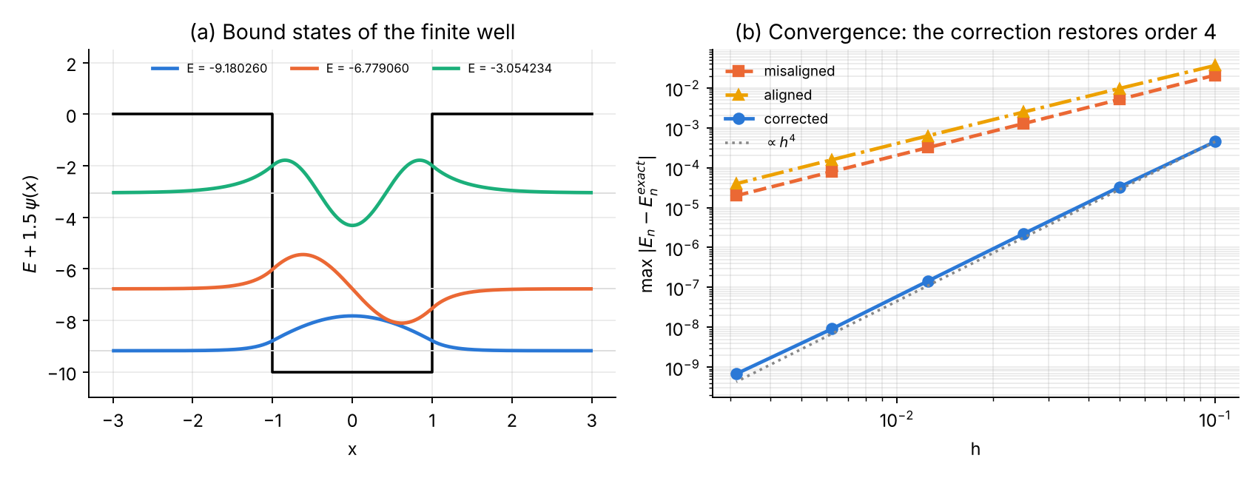
Exercise 9. (a) The three bound states of the finite well (even–odd–even); note the exponential tails in the classically forbidden regions. (b) Only the corrected treatment of the discontinuities converges with fourth order.
Answer. The method works and the exact even/odd conditions are verified. The behaviour seen for the barrier repeats exactly for the well: without the correction the energies converge only as $h^{2}$, with the correction as $h^{4}$ (at $h=0.003$ the corrected scheme is 30 000–60 000 times more accurate).

Exercise 10 — Round-off in single precision
Question. Repeat the $E_{0}$ study of Problem 3 in single precision (Fortran real(4)) and locate the new optimum $h$.
Theory (prediction). Total error $≈Ah^{4}+Bϵ/h^{2}$. Minimising, $h_{\text{opt}}={\left(Bϵ/2A\right)}^{1/6}∝ϵ^{1/6}$ and $ε_{min}∝ϵ^{2/3}$. With $ϵ_{\text{single}}/ϵ_{\text{double}}=1.19×{10}^{-7}/2.22×{10}^{-16}=5.4×{10}^{8}$:
- $h_{\text{opt}}$ should grow by ${\left(5.4×{10}^{8}\right)}^{1/6}=28.5$;
- $ε_{min}$ should grow by ${\left(5.4×{10}^{8}\right)}^{2/3}=6.6×{10}^{5}$.
Method. One Fortran source (ex10_precision.F90) with the working kind wp set by the preprocessor, compiled twice: -DWP=4 (single) and -DWP=8 (double). Two-sided Numerov, discrete-Wronskian matching, bisection carried down to machine precision, box $\left[-6,6\right]$.
Results.
N | h | |E₀−0.5| single | |E₀−0.5| double
12 | 1.0 | 4.96e-03 | 4.96e-03
24 | 0.5 | 2.52e-04 | 2.53e-04
48 | 0.25 | 1.72e-05 | 1.54e-05
96 | 0.125 | 7.63e-06 | 9.56e-07
192 | 0.0625 | 3.05e-05 | 5.96e-08
384 | 0.03125 | 1.83e-04 | 3.73e-09
768 | 0.015625 | 0 (lucky) | 2.32e-10
1536 | 0.0078125 | 0 (lucky) | 1.09e-11
3072 | 0.0039 | 1.53e-03 | 1.46e-11
6144 | 0.0020 | 8.85e-03 | 5.82e-11
12288 | 0.00098 | 3.39e-03 | 2.33e-10
24576 | 0.00049 | fails (no sign change) | 9.31e-10
49152 | 0.00024 | fails | 3.73e-09
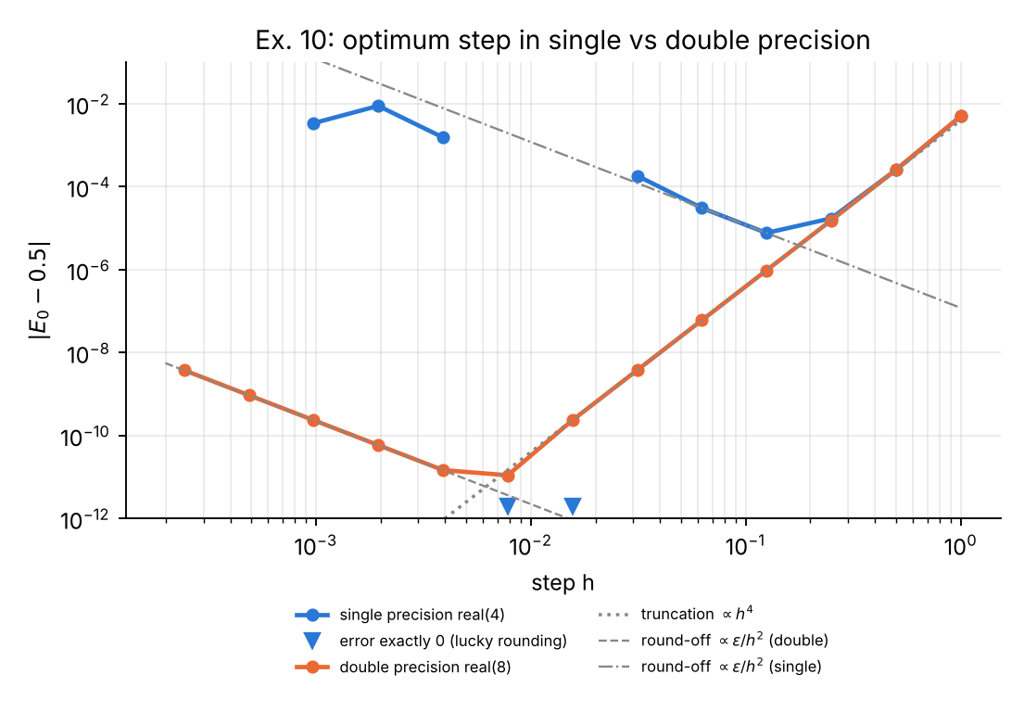
Exercise 10. Error of $E_{0}$ in single and double precision. Right branches: truncation ($h^{4}$); left branches: round-off ($∝ϵ/h^{2}$). The two exact zeros of the single-precision run (triangles) are accidental.
Answer.
- Single precision: optimum $h≈0.125$ ($N=96$, i.e. 8 points per unit length), best error $7.6×{10}^{-6}$. Below $h≈0.004$ the matching function is pure noise and the bisection no longer even finds a sign change.
- Double precision: optimum $h≈0.008$, best error $1.1×{10}^{-11}$; to the left of the optimum the error grows by a factor 4 per halving of $h$ — exactly the $ϵ/h^{2}$ law.
- Comparison with the prediction: the measured ratio of optimal steps is $0.125/0.0078=16$ (predicted 28.5 — on a grid of factor-2 steps this is within one step), and the ratio of minimum errors is $7.6×{10}^{-6}/1.1×{10}^{-11}=7×{10}^{5}$ (predicted $6.6×{10}^{5}$). The $ϵ^{2/3}$ law is confirmed remarkably well.
- The two runs coincide for $h≥0.5$: there the truncation error dominates and precision is irrelevant.
- The two “exact” single-precision results ($E_{0}=0.5$ exactly at $N=768,1536$) are accidents of rounding to the nearest representable float and must not be mistaken for convergence — a good reason to always look at the trend of the error, not individual values.
Practical lesson. In single precision Numerov cannot deliver more than about 5 significant digits, whatever the grid; refining beyond $h≈0.1$ makes the result worse. Scientific Numerov codes should always use double precision, and Richardson extrapolation from two moderately fine grids is preferable to brute-force refinement.

Appendix — Codes
All programs are in the accompanying zip archive. Run with
python3 ex01_05.py # exercises 1-5 (needs numpy, matplotlib)
python3 ex06_09.py # exercises 6-9 (needs scipy; imports ../python/p3_harmonic_oscillator.py)
python3 ex06_09.py 7 9 # only selected exercises
gfortran -O2 -cpp -DWP=4 -o ex10_sp ex10_precision.F90 && ./ex10_sp
gfortran -O2 -cpp -DWP=8 -o ex10_dp ex10_precision.F90 && ./ex10_dp
python3 ex10_plot.py # plots the two .dat files

Exercises 1–5 (Python)
File: ex01_05.py
#!/usr/bin/env python3
"""Solutions of exercises 1-5 of the Numerov course (hbar = m = 1)."""
import numpy as np
import matplotlib
matplotlib.use("Agg")
import matplotlib.pyplot as plt
C = ["#2a78d6", "#eb6834", "#1baf7a", "#eda100", "#e87ba4"]
def numerov(k2, p0, p1, h):
c = 1.0 + h * h * k2 / 12.0
p = np.zeros(len(k2), dtype=np.result_type(p0, p1, float))
p[0], p[1] = p0, p1
for n in range(1, len(k2) - 1):
p[n + 1] = ((12.0 - 10.0 * c[n]) * p[n] - c[n - 1] * p[n - 1]) / c[n + 1]
return p
def style(ax):
ax.spines[["top", "right"]].set_visible(False); ax.grid(alpha=.25, which="both")
# =================================================================== Ex 1
def ex1():
print("\n### Exercise 1: order from two grids (Problem 1, Part A)")
k, X = 2.0, 10.0
Ns = [25, 50, 100, 200, 400, 800, 1600, 3200, 6400, 12800]
e = []
for N in Ns:
h = X / N; x = np.arange(N + 1) * h
p = numerov(np.full(N + 1, k * k), 0.0, np.sin(k * h), h)
e.append(np.max(np.abs(p - np.sin(k * x))))
print(f"{'N -> 2N':>14} {'eps(h)':>10} {'eps(h/2)':>10} {'p':>6}")
for i in range(len(Ns) - 1):
print(f"{Ns[i]:6d}->{Ns[i+1]:6d} {e[i]:10.3e} {e[i+1]:10.3e} {np.log2(e[i]/e[i+1]):6.2f}")
# round-off estimate: eps_mach * N^2 (second-order recursion)
for N, ee in zip(Ns, e):
print(f"N={N:6d} error={ee:.2e} truncation est. {e[3]*(200/N)**4:.2e} roundoff est. eps*N^2={2.2e-16*N*N:.2e}")
return Ns, e
# =================================================================== Ex 2
def ex2():
print("\n### Exercise 2: third-order Taylor start psi_1 = kh - (kh)^3/6")
k, X = 2.0, 10.0
Ns = [25, 50, 100, 200, 400, 800, 1600, 3200]
res = {"exact": [], "Taylor 1st": [], "Taylor 3rd": []}
hs = []
for N in Ns:
h = X / N; x = np.arange(N + 1) * h; hs.append(h)
for lab, p1 in (("exact", np.sin(k * h)), ("Taylor 1st", k * h),
("Taylor 3rd", k * h - (k * h) ** 3 / 6)):
p = numerov(np.full(N + 1, k * k), 0.0, p1, h)
res[lab].append(np.max(np.abs(p - np.sin(k * x))))
print(f"{'N':>6} {'h':>8} {'exact':>10} {'Taylor1':>10} {'Taylor3':>10} {'ratio3':>7}")
for i, N in enumerate(Ns):
r = res["Taylor 3rd"][i - 1] / res["Taylor 3rd"][i] if i else np.nan
print(f"{N:6d} {hs[i]:8.5f} {res['exact'][i]:10.3e} {res['Taylor 1st'][i]:10.3e} "
f"{res['Taylor 3rd'][i]:10.3e} {r:7.2f}")
hs = np.array(hs)
for lab in res:
print(f" order {lab}: {np.polyfit(np.log(hs[:6]), np.log(res[lab][:6]), 1)[0]:.2f}")
# decomposition: Taylor-3 error minus exact-start error = start-value contribution
d = np.abs(np.array(res["Taylor 3rd"]) - np.array(res["exact"]))
print(" start-value contribution |e3-e_exact|:", " ".join(f"{v:.1e}" for v in d))
fig, ax = plt.subplots(figsize=(6, 3.8))
for i, (lab, st) in enumerate(zip(res, ("o-", "s-", "^--"))):
ax.loglog(hs, res[lab], st, color=C[i], lw=2, ms=7 - 2 * i, label=f"start: {lab}")
ax.loglog(hs, res["exact"][0] * (hs / hs[0]) ** 4, ":", color="#888888", label=r"$\propto h^4$")
ax.loglog(hs, res["Taylor 1st"][0] * (hs / hs[0]) ** 2, "--", color="#888888", label=r"$\propto h^2$")
ax.set(xlabel="h", ylabel=r"max $|\psi-\sin kx|$", title="Ex. 2: effect of the starting value")
ax.legend(frameon=False, fontsize=8); style(ax)
fig.tight_layout(); fig.savefig("ex2.png", dpi=170)
# =================================================================== Ex 3
def box_E(n, N, L=1.0):
h = L / N
f = lambda E: numerov(np.full(N + 1, 2 * E), 0.0, 1e-3 * h, h)[-1]
Ex = (n * np.pi / L) ** 2 / 2
a, b = Ex * (1 - 0.5 / n), Ex * (1 + 0.5 / n) # brackets only the n-th zero
fa = f(a)
assert np.sign(fa) != np.sign(f(b))
for _ in range(80):
m = 0.5 * (a + b); fm = f(m)
if np.sign(fm) == np.sign(fa): a, fa = m, fm
else: b = m
return 0.5 * (a + b), Ex
def ex3():
print("\n### Exercise 3: smallest N giving E_10 with rel. error < 1e-6 (box L=1)")
n = 10
Ns, errs = [], []
for N in range(20, 401, 2):
E, Ex = box_E(n, N)
Ns.append(N); errs.append(abs(E - Ex) / Ex)
Ns, errs = np.array(Ns), np.array(errs)
Nmin = Ns[np.argmax(errs < 1e-6)]
lam = 2.0 / n
print(f" N_min = {Nmin}, rel.err = {errs[Ns == Nmin][0]:.3e}, previous N={Nmin-2}: {errs[Ns == Nmin-2][0]:.3e}")
print(f" wavelength lambda = 2L/n = {lam}, points per wavelength = {Nmin*lam:.1f}, k h = {n*np.pi/Nmin:.4f}")
# theory: rel error of E ~ (k h)^4 / 240 for the box (from the dispersion relation)
for N in (40, 100, Nmin, 200):
E, Ex = box_E(n, N); kh = n * np.pi / N
print(f" N={N:4d} kh={kh:.3f} rel.err={abs(E-Ex)/Ex:.3e} (kh)^4/240={kh**4/240:.3e}")
# other n: N needed for 1e-6
print(" points per wavelength needed for 1e-6, other states:")
for nn in (1, 2, 5, 10, 20):
for N in range(max(8, 20 * nn), 4000, 2):
E, Ex = box_E(nn, N)
if abs(E - Ex) / Ex < 1e-6:
print(f" n={nn:3d}: N_min={N:5d} points/wavelength={N*2/nn:.1f}")
break
fig, ax = plt.subplots(figsize=(6, 3.8))
ppw = Ns * lam
ax.loglog(ppw, errs, color=C[0], lw=2, label=r"Numerov, $E_{10}$")
ax.loglog(ppw, (2 * np.pi / ppw) ** 4 / 240, "--", color=C[1], label=r"$(kh)^4/240$")
ax.axhline(1e-6, color="#888888", ls=":"); ax.axvline(Nmin * lam, color="#888888", ls=":")
ax.text(Nmin * lam * 1.04, 3e-3, f"{Nmin*lam:.0f} points\nper wavelength", fontsize=8)
ax.set(xlabel="grid points per wavelength", ylabel="relative error of $E_{10}$",
title="Ex. 3: resolution needed for $10^{-6}$")
ax.legend(frameon=False, fontsize=8); style(ax)
fig.tight_layout(); fig.savefig("ex3.png", dpi=170)
# =================================================================== general scattering solver
def scatter(E, h, Vfun, xl, xr, use_kh=False, edges=(), V0jump=None):
"""Backward Numerov for a general potential. edges: x-positions of jumps
(assumed on nodes); for those the corrected scheme of Problem 2 is used."""
k = np.sqrt(2 * E)
N = int(round((xr - xl) / h)); x = xl + h * np.arange(N + 1)
V = Vfun(x)
eidx = [int(round((xe - xl) / h)) for xe in edges]
Vl = {i: Vfun(np.array([x[i] - 1e-9]))[0] for i in eidx}
Vr = {i: Vfun(np.array([x[i] + 1e-9]))[0] for i in eidx}
for i in eidx:
V[i] = 0.5 * (Vl[i] + Vr[i])
c = 1 + h * h * 2 * (E - V) / 12
isedge = np.zeros(N + 1, bool); isedge[eidx] = True
if use_kh: # discrete wave number of the Numerov plane wave
a = (k * h) ** 2
kk = np.arccos((1 - 5 * a / 12) / (1 + a / 12)) / h
else:
kk = k
psi = np.zeros(N + 1, complex)
psi[N], psi[N - 1] = np.exp(1j * kk * x[N]), np.exp(1j * kk * x[N - 1])
for n in range(N - 1, 0, -1):
cp, cm = c[n + 1], c[n - 1]
if not isedge[n]:
if n + 1 < N + 1 and isedge[n + 1]: cp = 1 + h * h * 2 * (E - V[n]) / 12
if isedge[n - 1]: cm = 1 + h * h * 2 * (E - V[n]) / 12
rhs = (12 - 10 * c[n]) * psi[n] - cp * psi[n + 1]
if isedge[n]:
jump = 2 * (E - Vr[n]) - 2 * (E - Vl[n])
dpsi = (-3 * psi[n] + 4 * psi[n + 1] - psi[n + 2]) / (2 * h)
rhs += -h ** 3 / 12 * jump * dpsi
psi[n - 1] = rhs / cm
M = np.array([[np.exp(1j * kk * x[0]), np.exp(-1j * kk * x[0])],
[np.exp(1j * kk * x[1]), np.exp(-1j * kk * x[1])]])
A, B = np.linalg.solve(M, psi[:2])
# flux: incident current is proportional to the (discrete) velocity, identical on both sides
return 1 / abs(A) ** 2, abs(B) ** 2 / abs(A) ** 2
def T_square(E, V0, a):
kap = np.sqrt(2 * (V0 - E))
return 1 / (1 + V0 ** 2 * np.sinh(kap * a) ** 2 / (4 * E * (V0 - E)))
# =================================================================== Ex 4
def ex4():
print("\n### Exercise 4: plane waves e^{ikx} vs discrete e^{i k_h x}")
V0, a = 5.0, 1.0
Vf = lambda x: np.where((x > 0) & (x < a), V0, 0.0)
hs = np.array([0.1, 0.05, 0.025, 0.0125, 0.00625, 0.003125])
out = {}
for E in (2.0, 8.0):
Tex = T_square(E, V0, a) if E < V0 else 1 / (1 + V0 ** 2 * np.sin(np.sqrt(2 * (E - V0)) * a) ** 2 / (4 * E * (E - V0)))
for pad in (2.0, 20.0):
e1, e2 = [], []
for h in hs:
T1, _ = scatter(E, h, Vf, -pad, a + pad, False, edges=(0.0, a))
T2, _ = scatter(E, h, Vf, -pad, a + pad, True, edges=(0.0, a))
e1.append(abs(T1 - Tex)); e2.append(abs(T2 - Tex))
out[E, pad] = (e1, e2)
print(f" E={E}, padding={pad}:")
for i, h in enumerate(hs):
print(f" h={h:8.5f} |dT| e^ikx = {e1[i]:.3e} e^ik_hx = {e2[i]:.3e} ratio {e1[i]/e2[i]:.2f}")
fig, ax = plt.subplots(1, 2, figsize=(10, 3.8), sharey=True)
for j, E in enumerate((2.0, 8.0)):
for i, pad in enumerate((2.0, 20.0)):
e1, e2 = out[E, pad]
ax[j].loglog(hs, e1, "o-", color=C[2 * i], lw=2, label=f"$e^{{ikx}}$, padding {pad:g}")
ax[j].loglog(hs, e2, "s--", color=C[2 * i + 1], lw=2, label=f"$e^{{ik_hx}}$, padding {pad:g}")
ax[j].set(xlabel="h", title=f"E = {E}"); style(ax[j])
ax[0].set_ylabel(r"$|T-T_{exact}|$"); ax[0].legend(frameon=False, fontsize=7)
fig.suptitle("Ex. 4: continuum vs discrete plane waves at the boundaries", fontsize=10)
fig.tight_layout(); fig.savefig("ex4.png", dpi=170)
# =================================================================== Ex 5
def ex5():
print("\n### Exercise 5: thick barrier V0=5, a=6, E=1")
V0, a, E = 5.0, 6.0, 1.0
kap = np.sqrt(2 * (V0 - E)); k = np.sqrt(2 * E)
Tex = T_square(E, V0, a)
Twkb = np.exp(-2 * kap * a)
Tasym = 16 * E * (V0 - E) / V0 ** 2 * np.exp(-2 * kap * a)
print(f" kappa={kap:.5f}, kappa*a={kap*a:.4f}")
print(f" T exact = {Tex:.6e}")
print(f" T WKB e^-2ka = {Twkb:.6e} ratio exact/WKB = {Tex/Twkb:.4f}")
print(f" T asymptotic 16E(V0-E)/V0^2 e^-2ka = {Tasym:.6e} (prefactor {16*E*(V0-E)/V0**2:.3f})")
Vf = lambda x: np.where((x > 0) & (x < a), V0, 0.0)
rows = []
for h in (0.05, 0.025, 0.0125, 0.00625, 0.003125):
T, R = scatter(E, h, Vf, -2.0, a + 2.0, edges=(0.0, a))
rows.append((h, T, abs(T - Tex) / Tex, R, R + T - 1))
print(f" h={h:8.5f} T={T:.8e} rel.err={abs(T-Tex)/Tex:.2e} R={R:.17f} R+T-1={R+T-1:.2e}")
# growth factor inside the barrier
print(f" |A| ~ 1/sqrt(T) = {1/np.sqrt(Tex):.3e} (amplitude grows by e^(kappa a)={np.exp(kap*a):.2e} across barrier)")
# thickness scan
print(" thickness scan, h=0.00625:")
for aa in (1, 2, 4, 6, 8, 10, 12):
Vf2 = lambda x, aa=aa: np.where((x > 0) & (x < aa), V0, 0.0)
T, R = scatter(E, 0.00625, Vf2, -2.0, aa + 2.0, edges=(0.0, float(aa)))
Te = T_square(E, V0, aa)
print(f" a={aa:3d} T={T:.4e} exact={Te:.4e} rel.err={abs(T-Te)/Te:.2e} WKB/exact={np.exp(-2*kap*aa)/Te:.3f} R+T-1={R+T-1:.1e}")
if __name__ == "__main__":
ex1(); ex2(); ex3(); ex4(); ex5()

Exercises 6–9 (Python)
File: ex06_09.py
#!/usr/bin/env python3
"""Solutions of exercises 6-9 of the Numerov course (hbar = m = 1)."""
import sys
import numpy as np
from scipy.optimize import brentq
from scipy.linalg import eigh_tridiagonal, eigh
import matplotlib
matplotlib.use("Agg")
import matplotlib.pyplot as plt
sys.path.insert(0, "../python")
import p3_harmonic_oscillator as P3 # re-use the course code of Problem 3
C = ["#2a78d6", "#eb6834", "#1baf7a", "#eda100", "#e87ba4"]
def style(ax):
ax.spines[["top", "right"]].set_visible(False); ax.grid(alpha=.25, which="both")
def numerov(k2, p0, p1, h):
c = 1.0 + h * h * k2 / 12.0
p = np.zeros(len(k2)); p[0], p[1] = p0, p1
for n in range(1, len(k2) - 1):
p[n + 1] = ((12.0 - 10.0 * c[n]) * p[n] - c[n - 1] * p[n - 1]) / c[n + 1]
return p
# =================================================================== Ex 6
def T_poschl(E, V0, w):
k = np.sqrt(2 * E)
s = 8 * V0 * w * w
den = np.cosh(np.pi / 2 * np.sqrt(s - 1)) ** 2 if s > 1 else np.cos(np.pi / 2 * np.sqrt(1 - s)) ** 2
return np.sinh(np.pi * k * w) ** 2 / (np.sinh(np.pi * k * w) ** 2 + den)
def scatter_smooth(E, h, Vf, X):
k = np.sqrt(2 * E)
N = int(round(2 * X / h)); x = -X + h * np.arange(N + 1)
c = 1 + h * h * 2 * (E - Vf(x)) / 12
psi = np.zeros(N + 1, complex)
psi[N], psi[N - 1] = np.exp(1j * k * x[N]), np.exp(1j * k * x[N - 1])
for n in range(N - 1, 0, -1):
psi[n - 1] = ((12 - 10 * c[n]) * psi[n] - c[n + 1] * psi[n + 1]) / c[n - 1]
M = np.array([[np.exp(1j * k * x[0]), np.exp(-1j * k * x[0])],
[np.exp(1j * k * x[1]), np.exp(-1j * k * x[1])]])
A, B = np.linalg.solve(M, psi[:2])
return 1 / abs(A) ** 2, abs(B) ** 2 / abs(A) ** 2
def ex6():
print("\n### Exercise 6: smooth barrier V0/cosh^2(x/w), V0=5, w=0.5")
V0, w, X = 5.0, 0.5, 12.0
Vf = lambda x: V0 / np.cosh(x / w) ** 2
print(f" 8 V0 w^2 = {8*V0*w*w}; V(+-{X}) = {Vf(X):.1e} (negligible)")
for E in (1.0, 3.0, 5.0, 8.0):
T, R = scatter_smooth(E, 0.01, Vf, X)
print(f" E={E}: T={T:.10f} exact={T_poschl(E,V0,w):.10f} |dT|={abs(T-T_poschl(E,V0,w)):.2e} R+T-1={R+T-1:.1e}")
hs = np.array([0.1, 0.05, 0.025, 0.0125, 0.00625, 0.003125])
errs = {}
for E in (2.0, 8.0):
errs[E] = [abs(scatter_smooth(E, h, Vf, X)[0] - T_poschl(E, V0, w)) for h in hs]
print(f" E={E}: errors", " ".join(f"{e:.2e}" for e in errs[E]),
f" ratios", " ".join(f"{errs[E][i]/errs[E][i+1]:.1f}" for i in range(len(hs) - 1)),
f" order={np.polyfit(np.log(hs[:5]), np.log(errs[E][:5]), 1)[0]:.2f}")
# square barrier of the same area for comparison (naive scheme, edges on nodes, V0/2)
Eg = np.linspace(0.05, 15, 300)
Tn = np.array([scatter_smooth(E, 0.01, Vf, X)[0] for E in Eg])
Te = np.array([T_poschl(E, V0, w) for E in Eg])
print(f" max |dT| over 0<E<15 at h=0.01: {np.max(abs(Tn-Te)):.2e}")
fig, ax = plt.subplots(1, 2, figsize=(10, 3.7))
ax[0].plot(Eg, Te, color="#888888", lw=1, label="exact (Pöschl–Teller)")
ax[0].plot(Eg[::10], Tn[::10], "o", ms=4, color=C[0], label="Numerov h = 0.01")
ax[0].set(xlabel="E", ylabel="T(E)", title=r"(a) $V=V_0/\cosh^2(x/w)$, $V_0=5$, $w=0.5$")
ax[0].legend(frameon=False, fontsize=8)
for i, E in enumerate((2.0, 8.0)):
ax[1].loglog(hs, errs[E], "o-", color=C[i], lw=2, label=f"E = {E}")
ax[1].loglog(hs, errs[8.0][0] * (hs / hs[0]) ** 4, ":", color="#888888", label=r"$\propto h^4$")
ax[1].set(xlabel="h", ylabel=r"$|T-T_{exact}|$", title="(b) plain Numerov, no correction: order 4")
ax[1].legend(frameon=False, fontsize=8)
for a in ax: style(a)
fig.tight_layout(); fig.savefig("ex6.png", dpi=170)
# =================================================================== Ex 7
def ex7():
print("\n### Exercise 7: one-sided shooting for the oscillator ground state, h = 0.01")
h = 0.01
rows = []
for L in (3, 4, 5, 6, 7, 8, 9, 10, 12, 15, 20, 30, 38):
N = int(round(2 * L / h)); x = -L + h * np.arange(N + 1)
def F(E):
with np.errstate(all="ignore"):
return numerov(2 * E - x * x, 0.0, 1e-10, h)[-1]
a, b = 0.3, 0.7
fa, fb = F(a), F(b)
if not (np.isfinite(fa) and np.isfinite(fb)) or np.sign(fa) == np.sign(fb):
rows.append((L, np.nan, "no sign change / overflow"))
print(f" L={L:3d}: psi_N(0.3)={fa:.2e}, psi_N(0.7)={fb:.2e} -> no usable bracket")
continue
for _ in range(100):
m = 0.5 * (a + b); fm = F(m)
if np.sign(fm) == np.sign(fa): a, fa = m, fm
else: b = m
E = 0.5 * (a + b)
# sensitivity: how big is psi_N for dE = 1e-12 compared with its round-off noise?
rows.append((L, E, ""))
print(f" L={L:3d}: E0 = {E:.15f} |E0-0.5| = {abs(E-0.5):.2e} e^(L^2/2)={np.exp(L*L/2):.1e}")
# wavefunction obtained by one-sided shooting at the converged energy, L = 8
L = 8.0; N = int(round(2 * L / h)); x = -L + h * np.arange(N + 1)
E8 = [r[1] for r in rows if r[0] == 8][0]
p = numerov(2 * E8 - x * x, 0.0, 1e-10, h)
p /= np.max(abs(p[x < 0])) / np.pi ** -0.25 # scale so that psi(0) ~ exact
fig, ax = plt.subplots(1, 2, figsize=(10, 3.6))
Ls = [r[0] for r in rows if np.isfinite(r[1])]
es = [max(abs(r[1] - 0.5), 1e-17) for r in rows if np.isfinite(r[1])]
ax[0].semilogy(Ls, es, "o-", color=C[0], lw=2)
ax[0].axhline(3.9e-11, color="#888888", ls=":")
ax[0].text(9, 1e-10, "h-discretisation level (h = 0.01)", fontsize=8, color="#555555")
ax[0].set(xlabel="L (box [-L, L])", ylabel=r"$|E_0-0.5|$", title="(a) One-sided shooting: eigenvalue error")
ax[1].semilogy(x, np.abs(p) + 1e-300, color=C[1], lw=2, label="one-sided Numerov at converged $E_0$")
ax[1].semilogy(x, np.pi ** -0.25 * np.exp(-x * x / 2), ":", color="k", lw=1.5, label=r"exact $\pi^{-1/4}e^{-x^2/2}$")
ax[1].set(ylim=(1e-16, 1e3), xlabel="x", ylabel=r"$|\psi(x)|$", title="(b) ...but the right tail is destroyed (L = 8)")
ax[1].legend(frameon=False, fontsize=8, loc="lower center")
i_bad = np.where((x > 0) & (np.abs(p) > 10 * np.pi ** -0.25 * np.exp(-x * x / 2)))[0]
print(f" L=8: one-sided psi departs from exact (factor 10) beyond x = {x[i_bad[0]]:.2f}; psi(L) = {p[-1]:.2e}")
for a in ax: style(a)
fig.tight_layout(); fig.savefig("ex7.png", dpi=170)
# =================================================================== Ex 8
def ho_basis_energies(lam, M=160):
"""Independent check: diagonalise H in the harmonic-oscillator basis."""
n = np.arange(M + 4)
X = np.diag(np.sqrt((n[1:]) / 2.0), 1); X = X + X.T
X4 = np.linalg.matrix_power(X, 4)[:M, :M]
H = np.diag(np.arange(M) + 0.5) + lam * X4
return np.linalg.eigvalsh(H)
def ex8():
print("\n### Exercise 8: anharmonic oscillator V = x^2/2 + lambda x^4")
orig = P3.V
lam_list = [1e-4, 3e-4, 1e-3, 3e-3, 1e-2, 3e-2, 0.1]
table = {}
for lam in lam_list:
P3.V = lambda x, lam=lam: 0.5 * x * x + lam * x ** 4
x, h, st = P3.eigenstates(nmax=3, L=6.0, N=1200, Emax=8.0)
table[lam] = {n: E for n, E, _ in st}
P3.V = orig
print(f"{'lambda':>8} {'n':>2} {'E Numerov':>16} {'E basis':>16} {'dE/lambda':>11} {'1st-order coef':>14} {'1st-order E':>12}")
for lam in lam_list:
Eb = ho_basis_energies(lam)
for n in (0, 1, 2):
E = table[lam][n]
c1 = 0.75 * (2 * n * n + 2 * n + 1)
print(f"{lam:8.0e} {n:2d} {E:16.12f} {Eb[n]:16.12f} {(E-n-0.5)/lam:11.6f} {c1:14.4f} {n+0.5+c1*lam:12.6f}")
lam = 0.1
print(f" lambda=0.1: E0 = {table[0.1][0]:.10f}; first order 0.575, 2nd order 0.575-21/8*0.01 = {0.575-21/8*0.01:.6f},"
f" 3rd order + 333/16*0.001 = {0.575-0.02625+333/16*0.001:.6f}")
fig, ax = plt.subplots(figsize=(6.2, 3.9))
lams = np.array(lam_list)
for i, n in enumerate((0, 1, 2)):
y = [(table[l][n] - n - 0.5) / l for l in lam_list]
ax.semilogx(lams, y, "o-", color=C[i], lw=2, label=f"n={n} Numerov")
ax.axhline(0.75 * (2 * n * n + 2 * n + 1), color=C[i], ls=":", lw=1)
ax.semilogx(lams, 0.75 - 21 / 8 * lams, "--", color="#888888", lw=1, label="n=0: 3/4 − (21/8)λ")
ax.set(xlabel=r"$\lambda$", ylabel=r"$(E_n-E_n^{(0)})/\lambda$",
title="Ex. 8: shift / λ → first-order coefficient (dotted) as λ→0")
ax.legend(frameon=False, fontsize=8); style(ax)
fig.tight_layout(); fig.savefig("ex8.png", dpi=170)
# =================================================================== Ex 9
V0W, AW = 10.0, 2.0 # well depth and width
def well_exact():
"""Exact bound states from q tan(qa/2) = kappa (even), -q cot(qa/2) = kappa (odd)."""
res = []
f_even = lambda E: np.sqrt(2 * (V0W + E)) * np.tan(np.sqrt(2 * (V0W + E)) * AW / 2) - np.sqrt(-2 * E)
f_odd = lambda E: -np.sqrt(2 * (V0W + E)) / np.tan(np.sqrt(2 * (V0W + E)) * AW / 2) - np.sqrt(-2 * E)
Eg = np.linspace(-V0W + 1e-9, -1e-9, 200001)
for f, par in ((f_even, "even"), (f_odd, "odd")):
with np.errstate(all="ignore"):
v = f(Eg)
for i in np.where(np.sign(v[:-1]) != np.sign(v[1:]))[0]:
if np.isfinite(v[i]) and np.isfinite(v[i + 1]) and abs(v[i]) < 50 and abs(v[i + 1]) < 50:
res.append((brentq(f, Eg[i], Eg[i + 1], xtol=1e-15), par))
return sorted(res)
def well_solve(h, mode="corrected", L=8.0, Emin=None):
"""Two-sided shooting for the finite well; mode in {'misaligned','aligned','corrected'}."""
shift = 0.37 * h if mode == "misaligned" else 0.0
N = int(round(2 * L / h)); x = -L + shift + h * np.arange(N + 1)
inside = np.abs(x) < AW / 2
V = np.where(inside, -V0W, 0.0)
edges = []
if mode != "misaligned":
for xe in (-AW / 2, AW / 2):
i = int(np.argmin(abs(x - xe))); V[i] = -V0W / 2; edges.append(i)
Vl = {edges[0]: 0.0, edges[1]: -V0W} if edges else {}
Vr = {edges[0]: -V0W, edges[1]: 0.0} if edges else {}
isedge = np.zeros(N + 1, bool); isedge[edges] = True
m = int(np.argmin(abs(x))) # match at the centre of the well
corr = mode == "corrected"
def shoot(E):
k2 = 2 * (E - V); c = 1 + h * h * k2 / 12
def cc(j, centre): # weight of node j as seen from stencil 'centre'
if corr and isedge[j] and not isedge[centre]:
return 1 + h * h * 2 * (E - V[centre]) / 12
return c[j]
pL = np.zeros(N + 1); pL[1] = 1e-10
for n in range(1, m + 1):
rhs = (12 - 10 * c[n]) * pL[n] - cc(n - 1, n) * pL[n - 1]
if corr and isedge[n]:
dpsi = (3 * pL[n] - 4 * pL[n - 1] + pL[n - 2]) / (2 * h) # from the left (known) side
rhs += -h ** 3 / 12 * (2 * (E - Vr[n]) - 2 * (E - Vl[n])) * dpsi
pL[n + 1] = rhs / cc(n + 1, n)
pR = np.zeros(N + 1); pR[N - 1] = 1e-10
for n in range(N - 1, m - 1, -1):
rhs = (12 - 10 * c[n]) * pR[n] - cc(n + 1, n) * pR[n + 1]
if corr and isedge[n]:
dpsi = (-3 * pR[n] + 4 * pR[n + 1] - pR[n + 2]) / (2 * h) # from the right side
rhs += -h ** 3 / 12 * (2 * (E - Vr[n]) - 2 * (E - Vl[n])) * dpsi
pR[n - 1] = rhs / cc(n - 1, n)
pL /= np.max(abs(pL[:m + 2])); pR /= np.max(abs(pR[m - 1:]))
D = pL[m + 1] * pR[m] - pL[m] * pR[m + 1]
psi = np.concatenate([pL[:m + 1], pR[m + 1:] * pL[m + 1] / pR[m + 1]]) # glue (pR[m] may vanish for odd states)
return D, psi
Es = np.arange(-V0W + 0.01, -0.005, 0.01)
Ds = np.array([shoot(E)[0] for E in Es])
out = []
for i in np.where(np.sign(Ds[:-1]) != np.sign(Ds[1:]))[0]:
a, b, fa = Es[i], Es[i + 1], Ds[i]
for _ in range(70):
mm = 0.5 * (a + b); fm = shoot(mm)[0]
if np.sign(fm) == np.sign(fa): a, fa = mm, fm
else: b = mm
E = 0.5 * (a + b)
psi = shoot(E)[1]
psi /= np.sqrt(np.sum(psi ** 2) * h)
out.append((E, x, psi))
return out
def ex9():
print(f"\n### Exercise 9: finite square well V=-{V0W} for |x|<{AW/2}")
ex = well_exact()
for E, par in ex:
q, kap = np.sqrt(2 * (V0W + E)), np.sqrt(-2 * E)
lhs = q * np.tan(q * AW / 2) if par == "even" else -q / np.tan(q * AW / 2)
print(f" exact {par:4s}: E = {E:.12f} q={q:.6f} kappa={kap:.6f} check {lhs:.10f} = {kap:.10f}")
st = well_solve(0.01)
print(" Numerov, corrected scheme, h=0.01:")
for (E, x, psi), (Ee, par) in zip(st, ex):
q, kap = np.sqrt(2 * (V0W + E)), np.sqrt(-2 * E)
lhs = q * np.tan(q * AW / 2) if par == "even" else -q / np.tan(q * AW / 2)
print(f" E = {E:.12f} ({par}) |dE| = {abs(E-Ee):.2e} residual of exact condition {lhs-kap:.2e}"
f" parity check psi(x)={'+' if par=='even' else '-'}psi(-x): {np.max(abs(psi - (1 if par=='even' else -1)*psi[::-1])):.1e}")
hs = np.array([0.1, 0.05, 0.025, 0.0125, 0.00625, 0.003125])
errs = {m: [] for m in ("misaligned", "aligned", "corrected")}
for h in hs:
for mode in errs:
r = well_solve(h, mode)
errs[mode].append(max(abs(r[i][0] - ex[i][0]) for i in range(len(ex))))
print(f"{'h':>9} {'misaligned':>12} {'aligned':>12} {'corrected':>12} (max |dE| over all bound states)")
for i, h in enumerate(hs):
print(f"{h:9.5f} {errs['misaligned'][i]:12.2e} {errs['aligned'][i]:12.2e} {errs['corrected'][i]:12.2e}")
for mm in errs:
print(f" order {mm}: {np.polyfit(np.log(hs[:5]), np.log(errs[mm][:5]), 1)[0]:.2f}")
fig, ax = plt.subplots(1, 2, figsize=(10, 3.8))
xx = np.linspace(-3, 3, 7)
ax[0].plot([-3, -1, -1, 1, 1, 3], [0, 0, -V0W, -V0W, 0, 0], color="k", lw=1.5)
for i, (E, x, psi) in enumerate(st):
sel = abs(x) < 3
ax[0].axhline(E, color="#dddddd", lw=.8)
ax[0].plot(x[sel], E + 1.5 * psi[sel], color=C[i], lw=2, label=f"E = {E:.6f}")
ax[0].set(xlabel="x", ylabel=r"$E + 1.5\,\psi(x)$", title="(a) Bound states of the finite well")
ax[0].set(ylim=(-11, 2.5))
ax[0].legend(frameon=False, fontsize=7, loc="upper center", ncol=3)
st_ = {"misaligned": ("s--", C[1]), "aligned": ("^-.", C[3]), "corrected": ("o-", C[0])}
for mm in errs:
ax[1].loglog(hs, errs[mm], st_[mm][0], color=st_[mm][1], lw=2, label=mm)
ax[1].loglog(hs, errs["corrected"][0] * (hs / hs[0]) ** 4, ":", color="#888888", label=r"$\propto h^4$")
ax[1].set(xlabel="h", ylabel=r"max $|E_n-E_n^{exact}|$", title="(b) Convergence: the correction restores order 4")
ax[1].legend(frameon=False, fontsize=8)
for a in ax: style(a)
fig.tight_layout(); fig.savefig("ex9.png", dpi=170)
if __name__ == "__main__":
which = sys.argv[1:] or ["6", "7", "8", "9"]
for w in which:
{"6": ex6, "7": ex7, "8": ex8, "9": ex9}[w]()

Exercise 10 (Fortran 90, single and double precision)
File: ex10_precision.F90
!=======================================================================
! Exercise 10 -- ROUND-OFF: harmonic-oscillator ground state E_0 in
! single precision (real(4)) versus double precision (real(8)).
! The same source is compiled twice with the C preprocessor:
! gfortran -O2 -cpp -DWP=4 -o ex10_sp ex10_precision.F90
! gfortran -O2 -cpp -DWP=8 -o ex10_dp ex10_precision.F90
! Method: two-sided Numerov shooting with the discrete-Wronskian
! matching function D(E) (identical to Problem 3), box [-L, L], L = 6.
! Output: h, |E_0 - 0.5| for N = 12 ... 76800 (file ex10_wpX.dat)
!=======================================================================
module prec
implicit none
integer, parameter :: wp = WP
end module prec
module ho_shoot
use prec
implicit none
contains
function Dfun(E, L, N) result(D)
real(wp), intent(in) :: E, L
integer, intent(in) :: N
real(wp) :: D, h, x, c(0:N), pL(0:N), pR(0:N), sL, sR
integer :: j, m
h = 2.0_wp*L/N
do j = 0, N
x = -L + j*h
c(j) = 1.0_wp + h*h*(2.0_wp*E - x*x)/12.0_wp
end do
m = nint((sqrt(2.0_wp*E) + L)/h) ! node at the right turning point
m = max(2, min(m, N-2))
pL = 0.0_wp; pR = 0.0_wp
pL(1) = 1.0e-10_wp
do j = 1, m
pL(j+1) = ((12.0_wp - 10.0_wp*c(j))*pL(j) - c(j-1)*pL(j-1))/c(j+1)
end do
pR(N-1) = 1.0e-10_wp
do j = N-1, m, -1
pR(j-1) = ((12.0_wp - 10.0_wp*c(j))*pR(j) - c(j+1)*pR(j+1))/c(j-1)
end do
sL = maxval(abs(pL(0:m+1))); sR = maxval(abs(pR(m-1:N)))
D = (pL(m+1)/sL)*(pR(m)/sR) - (pL(m)/sL)*(pR(m+1)/sR)
end function Dfun
function ground_state(L, N) result(E)
real(wp), intent(in) :: L
integer, intent(in) :: N
real(wp) :: E, a, b, fa, fm, mid
integer :: it
a = 0.3_wp; b = 0.7_wp ! brackets only E_0 = 0.5
fa = Dfun(a, L, N)
do it = 1, 200 ! bisection down to machine precision
mid = 0.5_wp*(a + b)
if (mid <= a .or. mid >= b) exit
fm = Dfun(mid, L, N)
if (sign(1.0_wp, fm) == sign(1.0_wp, fa)) then
a = mid; fa = fm
else
b = mid
end if
end do
E = 0.5_wp*(a + b)
end function ground_state
end module ho_shoot
program ex10
use prec
use ho_shoot
implicit none
integer, parameter :: nN = 13
integer :: Ns(nN) = [12, 24, 48, 96, 192, 384, 768, 1536, 3072, 6144, 12288, 24576, 49152]
real(wp) :: L, E, h
integer :: i
character(len=20) :: fname
L = 6.0_wp
write(fname,'(a,i1,a)') 'ex10_wp', wp, '.dat'
open(10, file=fname, status='replace')
print '(a,i2,a,es10.3)', 'working precision: real(', wp, ') epsilon = ', epsilon(1.0_wp)
print '(a8,a12,a22,a14)', 'N', 'h', 'E_0', '|E_0 - 0.5|'
do i = 1, nN
h = 2.0_wp*L/Ns(i)
E = ground_state(L, Ns(i))
print '(i8,es12.4,f22.16,es14.4)', Ns(i), h, E, abs(E - 0.5_wp)
write(10,'(2es16.7)') real(h,8), real(abs(E - 0.5_wp),8)
end do
close(10)
end program ex10

Exercise 10 — plotting script
File: ex10_plot.py
#!/usr/bin/env python3
"""Plot ex10_wp4.dat / ex10_wp8.dat written by ex10_sp and ex10_dp."""
import numpy as np
import matplotlib
matplotlib.use("Agg")
import matplotlib.pyplot as plt
C = ["#2a78d6", "#eb6834"]
fig, ax = plt.subplots(figsize=(6.5, 4.6))
for i, (f, lab) in enumerate((("ex10_wp4.dat", "single precision real(4)"), ("ex10_wp8.dat", "double precision real(8)"))):
h, e = np.loadtxt(f, unpack=True)
ee = np.where((e > 0) & (e < 0.1), e, np.nan) # break the line at exact zeros / failures
ax.loglog(h, ee, "o-", color=C[i], lw=2, ms=5, label=lab)
z = e == 0
if z.any():
ax.plot(h[z], np.full(z.sum(), 2e-12), "v", color=C[i], ms=7, label="error exactly 0 (lucky rounding)")
hh = np.logspace(-3.7, 0, 50)
ax.loglog(hh, 9.6e-7 * (hh / 0.125) ** 4, ":", color="#888888", label=r"truncation $\propto h^4$")
ax.loglog(hh, 3.7e-9 * (hh / 2.44e-4) ** -2, "--", color="#888888", lw=1, label=r"round-off $\propto \epsilon/h^2$ (double)")
ax.loglog(hh, 3.05e-5 * (hh / 0.0625) ** -2, "-.", color="#888888", lw=1, label=r"round-off $\propto \epsilon/h^2$ (single)")
ax.set(ylim=(1e-12, 1e-1), xlabel="step h", ylabel=r"$|E_0-0.5|$",
title="Ex. 10: optimum step in single vs double precision")
ax.legend(frameon=False, fontsize=7, loc="upper center", bbox_to_anchor=(0.5, -0.16), ncol=2)
ax.spines[["top", "right"]].set_visible(False); ax.grid(alpha=.25, which="both")
fig.tight_layout(); fig.savefig("ex10.png", dpi=170)

