Special Functions of Mathematical Physics and the Numerov Method
Laguerre, Legendre, cylindrical and spherical Bessel functions — theory, computation, and the Schrödinger equation. A PhD-level study course with Python 3 and Fortran 2008 codes, verification, error analysis and exercises
November 2026
Table of Contents

How to use this course
This course is the sequel to The Numerov Method for the One-Dimensional Schrödinger Equation. It treats the four families of special functions that a physicist meets first when the Schrödinger equation is separated in three dimensions:
Chapter | Special function | Where it appears | Schrödinger problem solved with Numerov
1 | Generalised Laguerre polynomials $L_{n}^{\left(α\right)}$ | radial Coulomb problem | hydrogen atom
2 | Legendre polynomials and associated functions $P_{l}^{m}$ | polar-angle equation | rigid rotor / angular equation
3 | Cylindrical Bessel functions $J_{m}$ | radial equation in polar coordinates | particle in a circular (cylindrical) well
4 | Spherical Bessel functions $j_{l}$ | radial equation for $V=0$ | particle in a spherical well
Every chapter has the same structure, which mirrors the first course:
- The function: definition, differential equation, the main formulas, with references to the NIST Digital Library of Mathematical Functions (DLMF) and to standard textbooks.
- The physics: how the function arises from the Schrödinger equation, and the exact solution.
- Analytical scheme: the formulas the program uses, written before the code — Part A (computing the function itself) and Part B (solving the Schrödinger equation with Numerov).
- Logic charts.
- Codes: a Python 3 program and a Fortran 2008 program implementing the same algorithms. They agree to all printed digits.
- Results, normalisation and verification.
- Error analysis and convergence plots.
- Worked examples and exercises with answers.
Units: $ℏ=m=1$ throughout (and atomic units, $e=4πε_{0}=1$, for hydrogen).
Software. Python 3 with NumPy, SciPy, Matplotlib and mpmath (used only as a 50-digit reference, never inside the algorithms); gfortran (Fortran 2008 is needed for the intrinsics log_gamma, gamma and bessel_jn).
python3 ch1_laguerre_hydrogen.py # likewise ch2_..., ch3_..., ch4_...
gfortran -O2 -o ch1 ch1_laguerre_hydrogen.f90 && ./ch1 # likewise ch2 ... ch4
python3 plot_fortran_results.py # plots the .dat files written by the Fortran codes

Part 0 — Common foundations

What a “special function” is
Special functions are functions that have established names and notations because of their importance in analysis, physics and engineering; the term is defined by consensus rather than formally. In the narrow sense used here they are the special functions of mathematical physics: solutions of the ordinary differential equations obtained when a partial differential equation (Laplace, Helmholtz, Schrödinger, wave, heat) is solved by separation of variables [EoM; DLMF Ch. 10, 14, 18; Lebedev 1965]. The standard modern reference is the DLMF, the online version of the NIST Handbook of Mathematical Functions (Olver et al. 2010), which continues Abramowitz & Stegun (1964).
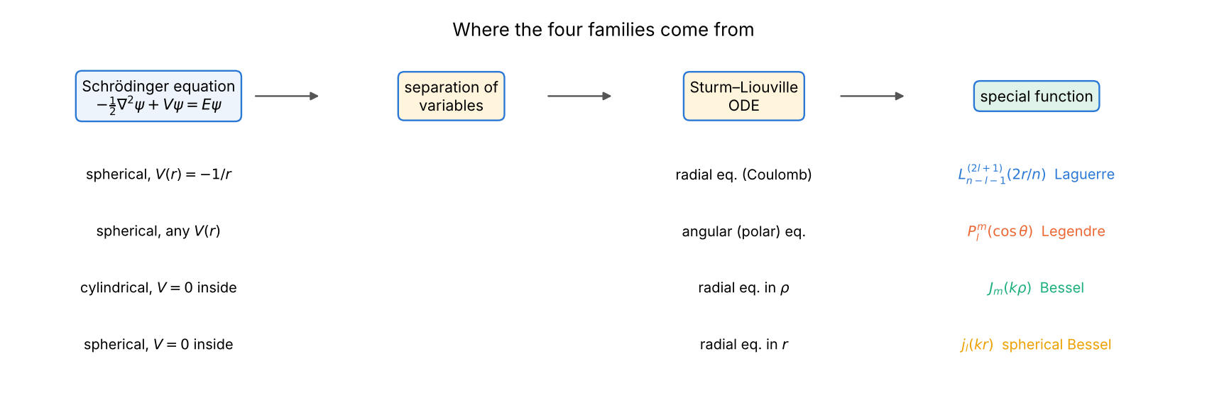
Separation of variables leads from the Schrödinger equation to the four families of this course.

Sturm–Liouville structure
All four ordinary differential equations are of Sturm–Liouville form
$$−\left(p\left(x\right) y′\right)′+q\left(x\right) y=λ w\left(x\right) y,$$
with a positive weight $w$. On an interval with suitable boundary conditions the eigenfunctions are orthogonal with weight $w$, the eigenvalues are real and simple, and the $n$-th eigenfunction has $n$ nodes (Sturm oscillation theorem). Orthogonality is therefore a built-in verification tool for every numerical solution in this course.
Family | $p\left(x\right)$ | $w\left(x\right)$ | interval | singular points
Laguerre $L_{n}^{\left(α\right)}$ | $x^{α+1}e^{−x}$ | $x^{α}e^{−x}$ | $[0,∞)$ | regular at 0, irregular at $∞$
Legendre $P_{l}^{m}$ | $1−x^{2}$ | 1 | $\left[−1,1\right]$ | regular at $±1$
Bessel $J_{m}\left(kr\right)$ | $r$ | $r$ | $\left[0,a\right]$ | regular at 0
spherical Bessel $j_{l}\left(kr\right)$ | $r^{2}$ | $r^{2}$ | $\left[0,a\right]$ | regular at 0

Liouville normal form — the bridge to Numerov
Numerov’s method (first course, Part I) integrates equations of the form $u″=−k^{2}\left(x\right) u$ without a first-derivative term. A Sturm–Liouville equation is brought to this form by a change of the dependent variable; in all our cases it is a multiplication by a power of the coordinate:
Equation | Substitution | Normal form
hydrogen, radial | $u=rR$ | $u″=\left[{l\left(l+1\right)}/{r^{2}}−2/r−2E\right]u$
polar angle | $u=\sqrt{sinθ} Θ$ | $u″=−\left[λ+1/4+{1/4−m^{2}}/{\sin^{2}θ}\right]u$
cylindrical radial | $u=\sqrt{r} R$ | $u″=−\left[2E−{m^{2}−1/4}/{r^{2}}\right]u$
spherical radial | $u=rR$ | $u″=−\left[2E−{l\left(l+1\right)}/{r^{2}}\right]u$
The two “square-root” transformations were verified symbolically (sympy residual = 0). They are exact, but they have a hidden cost discussed below: they make the solution non-analytic at the singular point.

Three-term recurrences and their stability
Every family in this course satisfies a three-term recurrence in its index, for example
$$J_{n+1}\left(x\right)=\frac{2n}{x}J_{n}\left(x\right)−J_{n−1}\left(x\right), \left(l+1\right)P_{l+1}=\left(2l+1\right)xP_{l}−lP_{l−1}.$$
Recurrences are the fastest and usually the most accurate way to compute special functions — provided they are run in the right direction. A second-order difference equation has two independent solutions $f_{n}$, $g_{n}$. If $f_{n}/g_{n}→0$ as $n→∞$, $f$ is called minimal and $g$ dominant. Round-off errors excite the dominant solution, so (Gautschi 1967; DLMF §3.6):
- a dominant solution can be computed forwards (Legendre $P_{l}$, Laguerre $L_{n}$, $Y_{n}$, $y_{l}$);
- a minimal solution must be computed backwards. $J_{n}\left(x\right)$ and $j_{l}\left(x\right)$ are minimal once $n>x$. Miller’s algorithm (Miller 1952; error analysis Olver 1964) starts far above the wanted index with arbitrary values, recurs downwards (the wanted solution grows in that direction), and fixes the scale with a known value or sum.
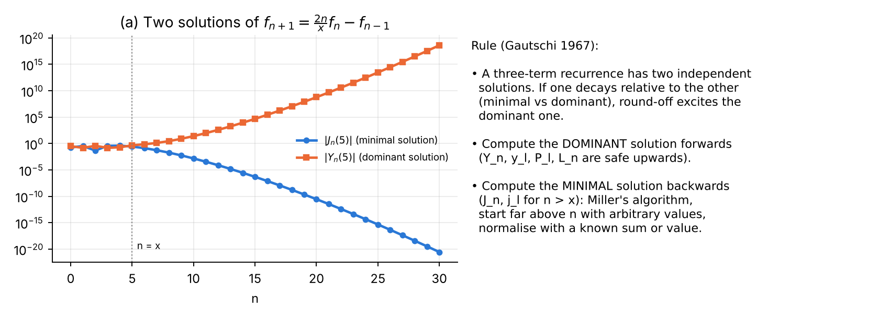
Minimal and dominant solutions of the Bessel recurrence, and the resulting rule.
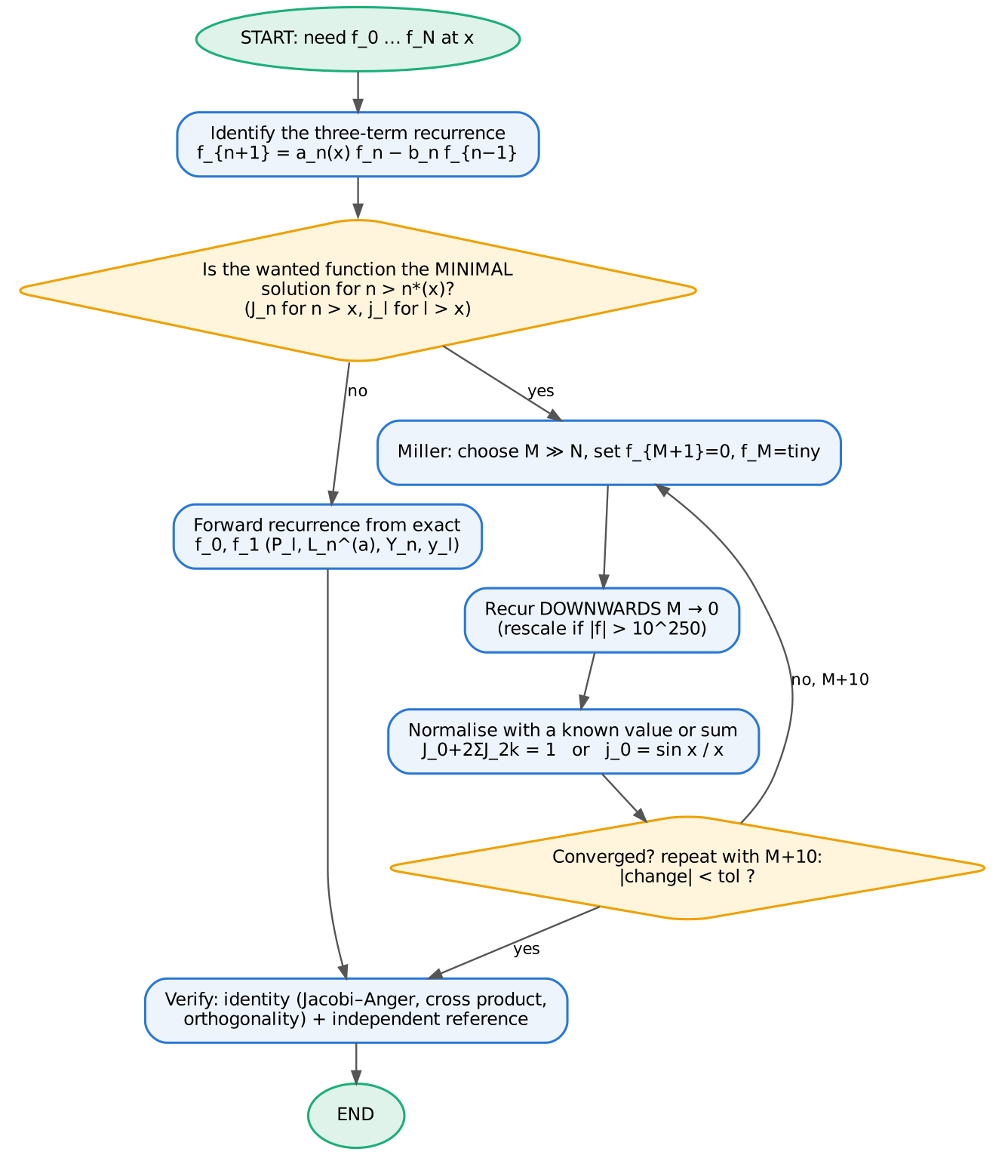
Logic chart: choosing the direction of a recurrence; Miller’s algorithm.

Gaussian quadrature
The zeros of orthogonal polynomials are the nodes of Gaussian quadrature: an $n$-point rule ∫wxfx dx≈i​wifxi is exact for polynomials of degree $≤2n−1$ (DLMF §3.5(v)). Nodes are found either by Newton’s method on $p_{n}$ with good initial guesses, or as eigenvalues of the symmetric tridiagonal Jacobi matrix built from the recurrence coefficients (Golub & Welsch 1969). We use Newton (in both languages) and Golub–Welsch (Python) as an independent check. Gauss rules converge exponentially for analytic integrands — a property we use both as a verification and as an example of error analysis.
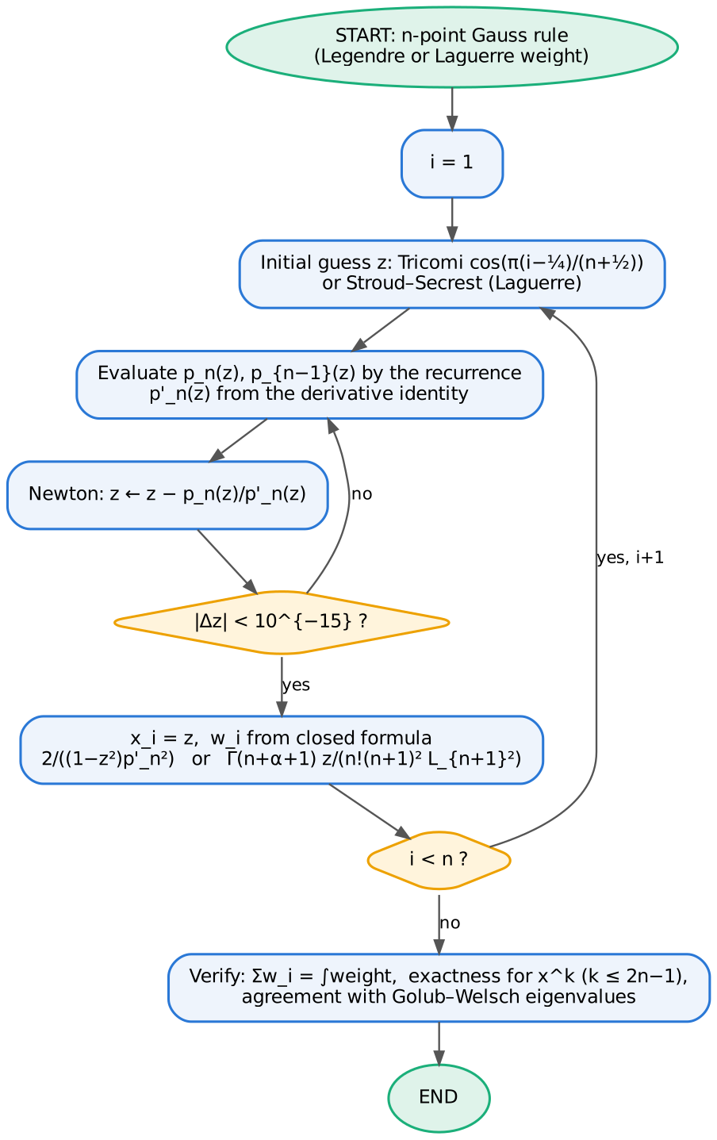
Logic chart of the Gauss-rule generator.

Numerov near a regular singular point: the Frobenius start and the start fault
Near $r=0$ the solutions of the normal-form equations behave like $r^{s}$, where $s$ solves the indicial equation:
Problem | regular solution | irregular solution | $u$ analytic at 0?
hydrogen / spherical well | $r^{l+1}$ | $r^{−l}$ | yes
circular well (index $m$) | $r^{m+1/2}$ | $r^{−m+1/2}$ (or $r^{1/2}lnr$ for $m=0$) | no
polar angle (index $m$) | $θ^{m+1/2}$ | $θ^{−m+1/2}$ (log for $m=0$) | no
Frobenius start. Inserting u=rsk​akrk into the equation gives a recurrence for the $a_{k}$; with 25–40 terms the series is accurate to machine precision for small $r$. The series values provide the starting values that Numerov needs (fault no. 2 of the first course).
The start fault. A useful way to understand what goes wrong near $r=0$ is the following argument. Suppose that near $r≈h$ the computation makes a relative error $δ$. Such a local error adds a small multiple of the irregular solution to the computed one, with amplitude
$$α ∼ δ \frac{u_{\text{reg}}\left(h\right)}{u_{\text{irr}}\left(h\right)} = δ h^{ s_{\text{reg}}−s_{\text{irr}}},$$
and the error in the eigenvalue is proportional to $α$. Two mechanisms produce an $h$-independent $δ$:
- Non-analytic solution, start at the first grid nodes. For $u∝r^{m+1/2}$, the Numerov stencil centred at node $j$ has a relative defect that depends on $j$ but not on $h$ (figure below, panel b), because $u^{\left(6\right)}∝r^{m−11/2}$. Hence $δ=O\left(1\right)$ and the eigenvalue error is $O\left(h^{2m}\right)$: no convergence for $m=0$, second order for $m=1$, fourth order only for $m≥2$.
- Analytic solution, “naive” textbook start $u_{0}=0, u_{1}=h^{l+1}$ with $c_{0}u_{0}$ taken as $0$. The correct value of $c_{0}u_{0}=\lim_{r→0}\left(u+{h^{2}}/{12}k^{2}u\right)$ is not zero when $k^{2}u$ has a finite limit at $r=0$ — this happens for the Coulomb term with $l=0$ and for the centrifugal term with $l=1$. The resulting defect gives order $h^{2}$ (hydrogen s states) and $h^{3}$ (p states).
The cure is simple: evaluate the Frobenius series on $\left[0,r_{s}\right]$ for a fixed $r_{s}$ (independent of $h$; we use $r_{s}=1/8$, $θ_{s}=0.4$ or $r_{s}=0.25$) and start Numerov from there. The solution is then smooth on the Numerov interval and fourth order is restored in every case. This “start fault and its cure” is the central numerical lesson of this course; each chapter demonstrates it.
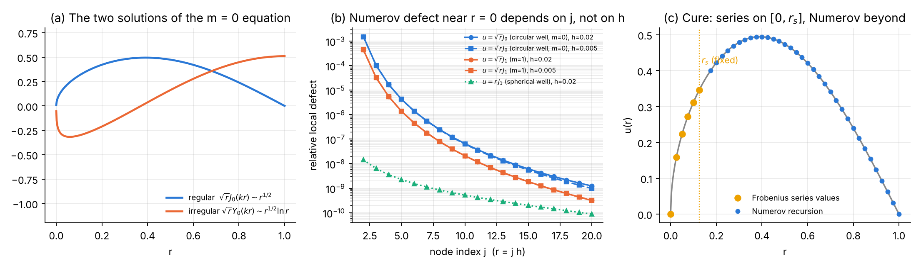
(a) Regular and irregular solutions for $m=0$. (b) Relative defect of the Numerov stencil applied to the exact solution near the origin: for $\sqrt{r}J_{m}$ it does not decrease with $h$ (curves for $h=0.02$ and $0.005$ coincide), for the analytic $rj_{1}$ it is tiny. (c) The cure: Frobenius series up to a fixed $r_{s}$, Numerov beyond.

Verification and error-analysis toolkit
Each program applies the following checks, which the student should regard as compulsory for any numerical work on special functions:
Check | What it tests
comparison with a 50-digit reference (mpmath) | absolute accuracy of the function values
independent identity (Jacobi–Anger, cross product, $∑w_{i}$, closed forms) | correctness without any reference software
comparison with SciPy / Fortran intrinsic bessel_jn | independent implementation
normalisation $∫u^{2}=1$ (Simpson) | eigenfunction scale; Simpson has $O\left(h^{4}\right)$ error, consistent with Numerov
comparison with the exact eigenfunction built from Part A | shape of the numerical solution
orthogonality, parity, node count | Sturm–Liouville structure
expectation values ($⟨r⟩$, $⟨r^{2}⟩$, $⟨\cos^{2}θ⟩$, virial theorem) | physics content of the wavefunction
observed order $p$ from a sequence of grids | correct implementation of a 4th-order method
Richardson extrapolation $E_{R}=\left(16E_{h/2}−E_{h}\right)/15$ | consistency of the $h^{4}$ error model
round-off floor, box-size truncation | limits of attainable accuracy

Chapter 1 — Laguerre polynomials and the hydrogen atom

1.1 The function
The generalised (associated) Laguerre polynomials $L_{n}^{\left(α\right)}\left(x\right)$, $α>−1$, are the polynomial solutions of
$$x y″+\left(α+1−x\right) y′+n y=0 \text{(DLMF §18.8)}.$$
Main properties (DLMF §18.3, §18.5, §18.9; Szegő 1939, ch. 5; Arfken et al. 2013, §18.3):
- Rodrigues formula: $L_{n}^{\left(α\right)}\left(x\right)=\frac{x^{−α}e^{x}}{n!}\frac{d^{n}}{dx^{n}}\left(e^{−x}x^{n+α}\right)$.
- Explicit sum: $L_{n}^{\left(α\right)}\left(x\right)=\sum_{k=0}^{n}{{\left(−1\right)}^{k}}\left({n+α \atop n−k}\right)\frac{x^{k}}{k!}$.
- Orthogonality on $[0,∞)$: $\int_{0}^{∞}{x^{α}}e^{−x}L_{m}^{\left(α\right)}L_{n}^{\left(α\right)} dx=\frac{Γ\left(n+α+1\right)}{n!} δ_{mn}$.
- Three-term recurrence: $\left(n+1\right)L_{n+1}^{\left(α\right)}=\left(2n+1+α−x\right)L_{n}^{\left(α\right)}−\left(n+α\right)L_{n−1}^{\left(α\right)}$, $L_{0}=1$, $L_{1}=1+α−x$.
- Derivative: $x \frac{d}{dx}L_{n}^{\left(α\right)}=nL_{n}^{\left(α\right)}−\left(n+α\right)L_{n−1}^{\left(α\right)}$.
- Generating function: n​Lnαxtn=1−t−α−1e−xt/1−t.
- Zeros: $n$ real simple zeros in $\left(0,4n+2α+2\right)$; they are the nodes of Gauss–Laguerre quadrature.
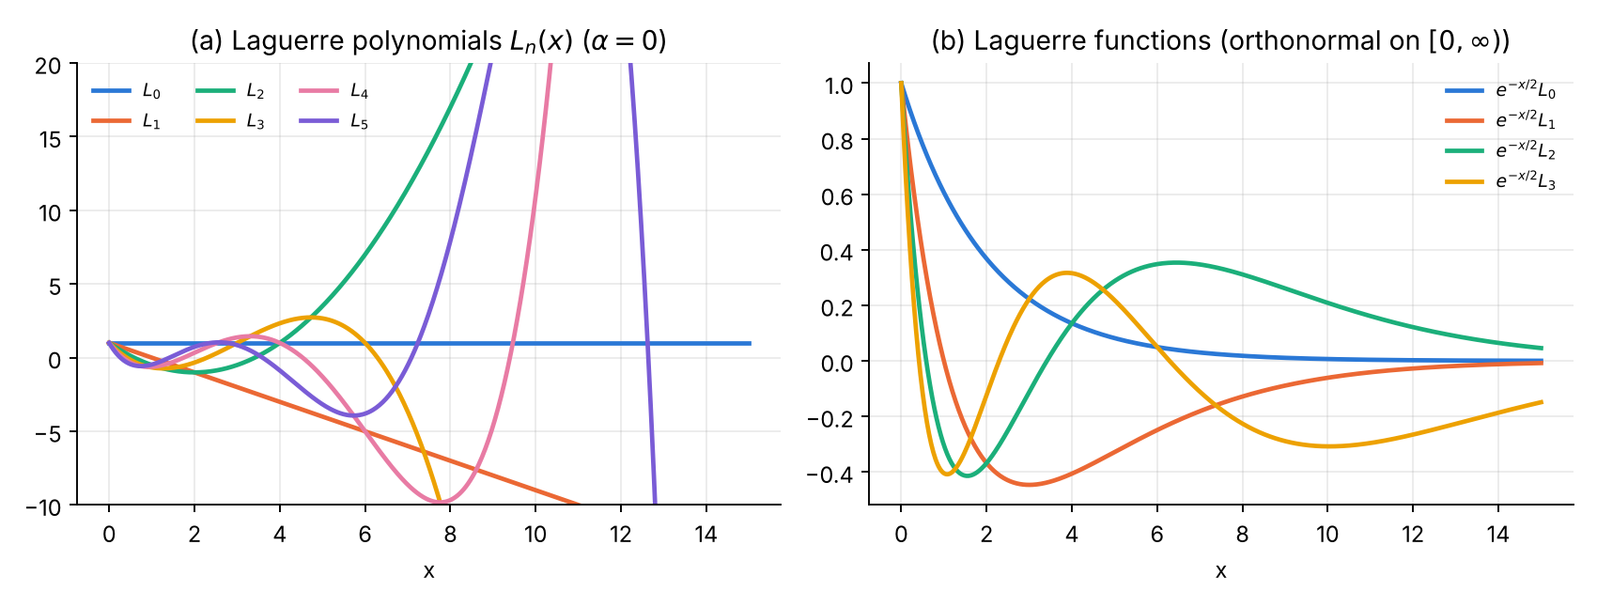
Laguerre polynomials and the orthonormal Laguerre functions $e^{−x/2}L_{n}\left(x\right)$.

1.2 The physics: hydrogen atom
For $V=−Z/r$ the separation $ψ=R_{nl}\left(r\right)Y_{lm}\left(θ,ϕ\right)$, $u=rR$, gives
$$u″=\left[\frac{l\left(l+1\right)}{r^{2}}−\frac{2Z}{r}−2E\right]u, u\left(0\right)=0, u\left(∞\right)=0.$$
Writing $u=ρ^{l+1}e^{−ρ/2}f\left(ρ\right)$, $ρ=2Zr/n$, turns this into the Laguerre equation with $α=2l+1$; normalisability forces $f$ to be a polynomial, which quantises the energy (Bethe & Salpeter 1957, §1–3; Landau & Lifshitz 1977, §36; Griffiths & Schroeter 2018, §4.2; DLMF §18.39):
$$E_{n}=−\frac{Z^{2}}{2n^{2}}, R_{nl}\left(r\right)=\sqrt{{\left(\frac{2Z}{n}\right)}^{3}\frac{\left(n−l−1\right)!}{2n \left(n+l\right)!}} e^{−ρ/2}ρ^{l} L_{n−l−1}^{\left(2l+1\right)}\left(ρ\right), n=l+1,l+2,…$$
Exact expectation values used for verification: $⟨r⟩=1/{2Z}\left[3n^{2}−l\left(l+1\right)\right]$, $⟨r^{2}⟩={n^{2}}/{2Z^{2}}\left[5n^{2}+1−3l\left(l+1\right)\right]$, $⟨1/r⟩=Z/n^{2}$, virial theorem $⟨V⟩=2E$.

1.3 Analytical scheme
Part A — computing $L_{n}^{\left(α\right)}$.
- Recurrence (stable: $L_{n}$ is a dominant solution) from $L_{0},L_{1}$.
- Explicit sum — for comparison only: its terms alternate in sign and grow like $x^{k}/k!$, so for large $x$ the sum suffers catastrophic cancellation.
- Gauss–Laguerre nodes: Newton iteration $z←z−L_{n}/L_{n}′$ with the Stroud–Secrest initial guesses (as in Numerical Recipes, Press et al. 2007, §4.6); weights $w_{i}=\frac{Γ\left(n+α+1\right) x_{i}}{n! {\left(n+1\right)}^{2} {\left[L_{n+1}^{\left(α\right)}\left(x_{i}\right)\right]}^{2}}$. Check: Golub–Welsch eigenvalues of the Jacobi matrix with diagonal $2k+1+α$ and off-diagonal $−\sqrt{k\left(k+α\right)}$.
Part B — Numerov for hydrogen.
- Grid $r_{j}=jh$, $j=0..N$, box $R=40n$ (the tail is $∝r^{n}e^{−r/n}$).
- $k_{j}^{2}=2E+2/r_{j}−l\left(l+1\right)/r_{j}^{2}$, $c_{j}=1+h^{2}k_{j}^{2}/12$.
- Frobenius start: u=rl+1k​akrk with $a_{0}=1$, $a_{1}=−2/\left(2l+2\right)$,
$$k\left(k+2l+1\right) a_{k}=−2a_{k−1}−2E a_{k−2},$$
- evaluated on all nodes $r_{j}≤r_{s}+h$, $r_{s}=0.25$. For comparison: the naive start $u_{0}=0$, $u_{1}=h^{l+1}$.
- Two-sided shooting (as for the oscillator of the first course): outward Numerov up to the node $m$ nearest the outer classical turning point $r_{t}=\left[1+\sqrt{1+2El\left(l+1\right)}\right]/\left(−2E\right)$; inward Numerov from $R$ with $u_{N}=0$, $u_{N−1}={10}^{−30}$.
- Matching function: discrete Wronskian $D\left(E\right)=u_{m+1}^{L}u_{m}^{R}−u_{m}^{L}u_{m+1}^{R}$; scan $E$ on a logarithmic grid, refine by bisection (60 halvings).
- Normalise with Simpson; compare with $rR_{nl}$ built from the Part A recurrence (so Part A is verified by Part B and vice versa).

1.4 Logic chart
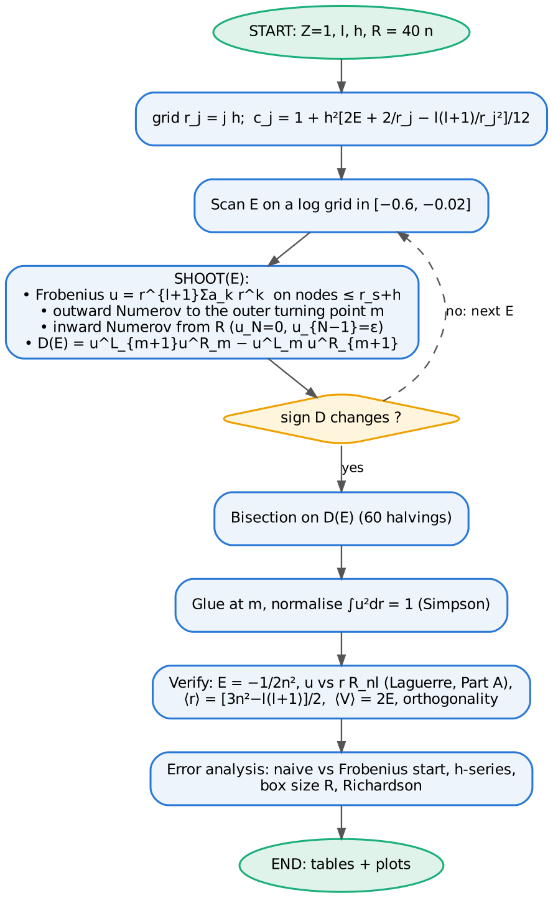
Logic chart of the hydrogen program (Part B). Part A follows the generic charts of Part 0.

1.5 Python 3 code
File: ch1_laguerre_hydrogen.py
#!/usr/bin/env python3
"""
Chapter 1 -- LAGUERRE POLYNOMIALS and the HYDROGEN ATOM (Numerov)
=================================================================
Part A : computation of the generalised Laguerre polynomials L_n^(a)(x)
* three-term recurrence (stable) DLMF §18.9
* explicit finite sum (cancellation!) DLMF §18.5
* Gauss-Laguerre nodes/weights: Newton on L_n^(a), and Golub-Welsch
* verification: orthogonality by quadrature, mpmath reference
* error analysis: sum vs recurrence, quadrature convergence
Part B : hydrogen atom, radial equation (hbar = m_e = e = 4 pi eps0 = 1, Z = 1)
u'' = [ l(l+1)/r^2 - 2/r - 2E ] u , u = r R(r)
exact E_n = -1/(2n^2), R_nl ~ e^{-r/n} (2r/n)^l L_{n-l-1}^{(2l+1)}(2r/n)
Numerov, two-sided shooting, Frobenius start at r_s, Wronskian matching
* verification: normalisation, comparison with the Laguerre-based
exact R_nl (computed with Part A), <r>, virial <V> = 2E, orthogonality
* error analysis: start at first grid nodes vs fixed r_s, h^4 law
Outputs: tables + ch1_functions.png, ch1_partA_errors.png, ch1_hydrogen.png,
ch1_convergence.png
"""
import numpy as np
from math import lgamma, exp, factorial
import mpmath as mp
from scipy.linalg import eigh_tridiagonal
from scipy.special import eval_genlaguerre
import matplotlib
matplotlib.use("Agg")
import matplotlib.pyplot as plt
C = ["#2a78d6", "#eb6834", "#1baf7a", "#eda100", "#e87ba4", "#7a5cd6"]
mp.mp.dps = 50
def style(ax):
ax.spines[["top", "right"]].set_visible(False); ax.grid(alpha=.25, which="both")
# ============================================================ PART A
def laguerre_rec(n, a, x):
"""L_0..L_n^(a)(x) by the three-term recurrence (returns array shape (n+1, len(x)))
(k+1) L_{k+1} = (2k+1+a-x) L_k - (k+a) L_{k-1}"""
x = np.asarray(x, float)
L = np.zeros((n + 1,) + x.shape)
L[0] = 1.0
if n >= 1:
L[1] = 1.0 + a - x
for k in range(1, n):
L[k + 1] = ((2 * k + 1 + a - x) * L[k] - (k + a) * L[k - 1]) / (k + 1)
return L
def laguerre_sum(n, a, x):
"""explicit sum L_n^(a)(x) = sum_k (-1)^k C(n+a, n-k) x^k / k!"""
x = np.asarray(x, float)
s = np.zeros_like(x)
for k in range(n + 1):
binom = exp(lgamma(n + a + 1) - lgamma(n - k + 1) - lgamma(a + k + 1))
s += (-1) ** k * binom * x ** k / factorial(k)
return s
def gauss_laguerre_newton(n, a=0.0, tol=1e-15):
"""nodes & weights of n-point Gauss-Laguerre rule: Newton on L_n^(a)
with the Stroud-Secrest / Numerical Recipes initial guesses."""
x = np.zeros(n); w = np.zeros(n)
for i in range(n):
if i == 0:
z = (1 + a) * (3 + 0.92 * a) / (1 + 2.4 * n + 1.8 * a)
elif i == 1:
z = x[0] + (15 + 6.25 * a) / (1 + 0.9 * a + 2.5 * n)
else:
ai = i - 1
z = x[i - 1] + ((1 + 2.55 * ai) / (1.9 * ai) + 1.26 * ai * a / (1 + 3.5 * ai)) \
* (x[i - 1] - x[i - 2]) / (1 + 0.3 * a)
for _ in range(100):
L = laguerre_rec(n, a, np.array([z]))[:, 0]
dL = (n * L[n] - (n + a) * L[n - 1]) / z # derivative, DLMF §18.9
dz = L[n] / dL
z -= dz
if abs(dz) < tol * max(1.0, z):
break
x[i] = z
Lp1 = laguerre_rec(n + 1, a, np.array([z]))[n + 1, 0]
w[i] = exp(lgamma(n + a + 1) - lgamma(n + 1)) * z / ((n + 1) ** 2 * Lp1 ** 2)
return x, w
def gauss_laguerre_gw(n, a=0.0):
"""Golub-Welsch: eigenvalues of the symmetric Jacobi matrix"""
k = np.arange(n)
d = 2 * k + 1 + a
e = -np.sqrt((k[1:]) * (k[1:] + a))
x, V = eigh_tridiagonal(d, e)
w = exp(lgamma(a + 1)) * V[0] ** 2
return x, w
def partA():
print("=" * 78)
print("PART A Generalised Laguerre polynomials L_n^(a)(x)")
print("=" * 78)
# --- 1. values vs high-precision reference
xs = np.array([0.5, 5.0, 20.0, 60.0])
print("Recurrence vs explicit sum vs mpmath (50 digits), n = 30, a = 1")
print(f"{'x':>6} {'recurrence':>24} {'mpmath':>24} {'rel.err rec':>12} {'rel.err sum':>12}")
for x in xs:
ref = float(mp.laguerre(30, 1, x))
r = laguerre_rec(30, 1, np.array([x]))[30, 0]
s = laguerre_sum(30, 1, np.array([x]))[0]
print(f"{x:6.1f} {r:24.15e} {ref:24.15e} {abs(r-ref)/abs(ref):12.2e} {abs(s-ref)/abs(ref):12.2e}")
# --- 2. Gauss-Laguerre rules
xn, wn = gauss_laguerre_newton(20)
xg, wg = gauss_laguerre_gw(20)
print(f"\n20-point Gauss-Laguerre: max|x_newton - x_GW| = {np.max(abs(xn-xg)):.2e}, "
f"max|w_newton - w_GW|/w = {np.max(abs(wn-wg)/wg):.2e}, sum w = {wn.sum():.15f}")
# --- 3. orthogonality by quadrature int e^-x x^a L_m L_n = Gamma(n+a+1)/n! delta
a = 2.0
xq, wq = gauss_laguerre_newton(40, a)
L = laguerre_rec(12, a, xq)
G = (L * wq) @ L.T
hn = np.array([exp(lgamma(n + a + 1) - lgamma(n + 1)) for n in range(13)])
print(f"orthogonality (a=2, n,m<=12, 40-pt rule): max |G_mn/h_n - delta| = "
f"{np.max(abs(G/np.sqrt(np.outer(hn,hn)) - np.eye(13))):.2e}")
print(f"agreement with scipy eval_genlaguerre (n<=12, 40 nodes): "
f"{np.max(abs(L - np.array([eval_genlaguerre(n, a, xq) for n in range(13)]))/(1+abs(L))):.2e}")
# --- error analysis figure data
xx = np.linspace(0.1, 100, 300)
ref = np.array([float(mp.laguerre(30, 1, x)) for x in xx])
e_rec = abs(laguerre_rec(30, 1, xx)[30] - ref) / abs(ref)
e_sum = abs(laguerre_sum(30, 1, xx) - ref) / abs(ref)
# quadrature convergence
ns = np.arange(2, 41, 2)
f1 = lambda x: np.cos(x) # int e^-x cos x = 1/2
f2 = lambda x: 1 / (1 + x) # int e^-x/(1+x) = e E1(1)
f3 = lambda x: np.sqrt(x) # int e^-x sqrt x = sqrt(pi)/2
ex2 = float(mp.e * mp.e1(1))
err = {k: [] for k in ("cos", "1/(1+x)", "sqrt")}
for n in ns:
xq, wq = gauss_laguerre_newton(n)
err["cos"].append(abs(wq @ f1(xq) - 0.5))
err["1/(1+x)"].append(abs(wq @ f2(xq) - ex2))
err["sqrt"].append(abs(wq @ f3(xq) - np.sqrt(np.pi) / 2))
print("\nGauss-Laguerre quadrature errors:")
for i, n in enumerate(ns):
if n in (2, 6, 10, 20, 30, 40):
print(f" n={n:2d}: cos {err['cos'][i]:.2e} 1/(1+x) {err['1/(1+x)'][i]:.2e} sqrt(x) {err['sqrt'][i]:.2e}")
sl = np.polyfit(np.log(ns[5:]), np.log(err["sqrt"][5:]), 1)[0]
print(f" sqrt(x): algebraic decay ~ n^{sl:.2f}")
# ---- figures
fig, ax = plt.subplots(1, 2, figsize=(10, 3.8))
x = np.linspace(0, 15, 600)
L = laguerre_rec(5, 0, x)
for n in range(6):
ax[0].plot(x, L[n], color=C[n], lw=2, label=f"$L_{n}$")
ax[0].set(ylim=(-10, 20), xlabel="x", title=r"(a) Laguerre polynomials $L_n(x)$ ($\alpha=0$)")
ax[0].legend(frameon=False, fontsize=8, ncol=3)
for n in range(4):
y = np.exp(-x / 2) * laguerre_rec(n, 0, x)[n]
ax[1].plot(x, y, color=C[n], lw=2, label=f"$e^{{-x/2}}L_{n}$")
ax[1].set(xlabel="x", title="(b) Laguerre functions (orthonormal on $[0,\\infty)$)")
ax[1].legend(frameon=False, fontsize=8)
for a_ in ax: style(a_)
fig.tight_layout(); fig.savefig("ch1_functions.png", dpi=170)
fig, ax = plt.subplots(1, 2, figsize=(10, 3.8))
ax[0].semilogy(xx, e_sum + 1e-17, color=C[1], lw=1.5, label="explicit sum")
ax[0].semilogy(xx, e_rec + 1e-17, color=C[0], lw=1.5, label="three-term recurrence")
ax[0].set(xlabel="x", ylabel="relative error", title=r"(a) $L_{30}^{(1)}(x)$ vs 50-digit reference")
ax[0].legend(frameon=False, fontsize=8)
for i, (k, mk) in enumerate(zip(err, ("o-", "s-", "^-"))):
ax[1].semilogy(ns, np.array(err[k]) + 1e-18, mk, color=C[i], lw=2, ms=4, label=fr"$\int_0^\infty e^{{-x}}\,{k}\,dx$" if k != "sqrt" else r"$\int_0^\infty e^{-x}\sqrt{x}\,dx$")
ax[1].set(xlabel="number of nodes n", ylabel="absolute error", title="(b) Gauss–Laguerre quadrature convergence")
ax[1].legend(frameon=False, fontsize=8)
for a_ in ax: style(a_)
fig.tight_layout(); fig.savefig("ch1_partA_errors.png", dpi=170)
# ============================================================ PART B
def R_exact(n, l, r):
"""normalised hydrogen radial function from the Laguerre recurrence (Part A)"""
rho = 2 * r / n
norm = np.sqrt((2.0 / n) ** 3 * exp(lgamma(n - l) - lgamma(n + l + 1)) / (2 * n))
return norm * np.exp(-rho / 2) * rho ** l * laguerre_rec(n - l - 1, 2 * l + 1, rho)[n - l - 1]
def frobenius(r, l, E, nterm=40):
"""u(r) = r^{l+1} sum a_k r^k, a_k k(k+2l+1) = -2 a_{k-1} - 2E a_{k-2}"""
a = [1.0, -2.0 / (2 * l + 2)]
for k in range(2, nterm):
a.append((-2 * a[k - 1] - 2 * E * a[k - 2]) / (k * (k + 2 * l + 1)))
s = np.zeros_like(r); p = np.ones_like(r)
for ak in a:
s += ak * p; p = p * r
return r ** (l + 1) * s
def simpson(y, h):
return h / 3 * (y[0] + y[-1] + 4 * y[1:-1:2].sum() + 2 * y[2:-1:2].sum())
def shoot(E, l, h, R, rs):
"""returns D(E), assembled u, matching index. rs = start radius (0 -> first nodes)"""
N = int(round(R / h)); r = h * np.arange(N + 1)
k2 = np.zeros(N + 1)
k2[1:] = 2 * E + 2 / r[1:] - l * (l + 1) / r[1:] ** 2
c = 1 + h * h * k2 / 12
naive = rs < 0 # textbook start u0=0, u1=h^{l+1}
js = 0 if naive else max(1, int(rs / h + 0.5))
# outer classical turning point E = -1/r + l(l+1)/(2r^2)
rt = (1 + np.sqrt(max(1 + 2 * E * l * (l + 1), 0))) / (-2 * E)
m = int(min(max(round(rt / h), js + 3), N - 3))
pL = np.zeros(N + 1)
if naive:
pL[1] = h ** (l + 1) # c_0 u_0 taken as 0 (wrong for l<=1)
else:
pL[:js + 2] = frobenius(r[:js + 2], l, E) # series up to the start nodes
for n in range(js + 1, m + 1):
pL[n + 1] = ((12 - 10 * c[n]) * pL[n] - c[n - 1] * pL[n - 1]) / c[n + 1]
pR = np.zeros(N + 1); pR[N - 1] = 1e-30
for n in range(N - 1, m - 1, -1):
pR[n - 1] = ((12 - 10 * c[n]) * pR[n] - c[n + 1] * pR[n + 1]) / c[n - 1]
sL = np.max(abs(pL[:m + 2])); sR = np.max(abs(pR[m - 1:]))
pL /= sL; pR /= sR
D = pL[m + 1] * pR[m] - pL[m] * pR[m + 1]
u = np.concatenate([pL[:m + 1], pR[m + 1:] * pL[m] / pR[m]])
return D, u, r
def eigen(n, l, h, R=None, rs=0.25):
"""bisection on D(E) in a bracket of +-15% around a scan-located root"""
Ex = -0.5 / n ** 2
R = 40.0 * n if R is None else R # box grows with n (u ~ r^n e^{-r/n})
a, b = Ex * 1.25, Ex * 0.75
fa = shoot(a, l, h, R, rs)[0]; fb = shoot(b, l, h, R, rs)[0]
assert np.sign(fa) != np.sign(fb), (n, l, h)
for _ in range(60):
mid = 0.5 * (a + b); fm = shoot(mid, l, h, R, rs)[0]
if np.sign(fm) == np.sign(fa): a, fa = mid, fm
else: b = mid
E = 0.5 * (a + b)
_, u, r = shoot(E, l, h, R, rs)
u /= np.sqrt(simpson(u * u, h))
ex = r * R_exact(n, l, r)
if np.dot(u, ex) < 0: u = -u
return E, u, r
def scan_levels(l, h=0.01, R=160.0, rs=0.25):
"""locate all levels of given l with E < -0.02 by scanning D(E) on a log grid"""
Eg = -np.exp(np.linspace(np.log(0.6), np.log(0.02), 500))
D = np.array([shoot(E, l, h, R, rs)[0] for E in Eg])
return [0.5 * (Eg[i] + Eg[i + 1]) for i in np.where(np.sign(D[:-1]) != np.sign(D[1:]))[0]]
def partB():
print("\n" + "=" * 78)
print("PART B Hydrogen atom: radial Schroedinger equation, Numerov, h = 0.01, R = 40 n")
print("=" * 78)
for l in (0, 1, 2):
lev = scan_levels(l)
print(f" scan l={l}: sign changes near E = " + ", ".join(f"{E:.4f}" for E in lev))
print(f"\n{'n':>2} {'l':>2} {'E Numerov':>17} {'E exact':>13} {'|dE|':>9} {'norm':>15} {'max|u-u_ex|':>12}"
f" {'<r>':>9} {'<r>exact':>9} {'<V>/2E':>10}")
states = {}
for (n, l) in ((1, 0), (2, 0), (2, 1), (3, 0), (3, 1), (3, 2), (4, 3)):
E, u, r = eigen(n, l, 0.01)
h = r[1]
ex = r * R_exact(n, l, r)
rexp = simpson(u * u * r, h)
Vexp = -simpson(np.concatenate([[0.0], u[1:] ** 2 / r[1:]]), h) # <V> = -<1/r>
states[n, l] = (u, r)
print(f"{n:2d} {l:2d} {E:17.12f} {-0.5/n**2:13.10f} {abs(E+0.5/n**2):9.1e} {simpson(u*u,h):15.12f} "
f"{np.max(abs(u-ex)):12.1e} {rexp:9.5f} {(3*n*n-l*(l+1))/2:9.5f} {Vexp/(2*E):10.7f}")
for l in (0, 1):
ns = [n for (n, ll) in states if ll == l]
def ov(a, b):
ua, ub = states[a, l][0], states[b, l][0]; k = min(len(ua), len(ub))
return simpson(ua[:k - (k + 1) % 2] * ub[:k - (k + 1) % 2], 0.01)
O = max(abs(ov(a, b)) for a in ns for b in ns if a < b)
print(f" orthogonality l={l}: max |<u_n|u_n'>| (n != n') = {O:.1e}")
# ---------------- convergence: start strategies
hs = np.array([0.08, 0.04, 0.02, 0.01, 0.005])
cases = [(1, 0), (2, 1), (3, 2)]
err = {}
for (n, l) in cases:
for rs, lab in ((-1.0, "naive"), (0.25, "Frobenius")):
err[n, l, lab] = [abs(eigen(n, l, h, rs=rs)[0] + 0.5 / n ** 2) for h in hs]
print("\nEigenvalue error vs h (naive start u0=0,u1=h^(l+1) | Frobenius start)")
print(f"{'h':>8}" + "".join(f" {'(%d,%d) naive' % c:>14} {'(%d,%d) Frob.' % c:>13}" for c in cases))
for i, h in enumerate(hs):
print(f"{h:8.4f}" + "".join(f" {err[c[0],c[1],'naive'][i]:14.2e} {err[c[0],c[1],'Frobenius'][i]:13.2e}" for c in cases))
for c in cases:
for lab in ("naive", "Frobenius"):
e = np.array(err[c[0], c[1], lab]); ok = e > 2e-12
p = np.polyfit(np.log(hs[ok][:5]), np.log(e[ok][:5]), 1)[0]
print(f" (n,l)={c}: {lab:12s} observed order {p:.2f}")
# Richardson
E1 = eigen(2, 1, 0.04)[0]; E2 = eigen(2, 1, 0.02)[0]
print(f"\nRichardson (2p): E(0.04)={E1:.12f} E(0.02)={E2:.12f} E_R={(16*E2-E1)/15:.12f} err={abs((16*E2-E1)/15+0.125):.1e}")
# box truncation
print("Box truncation (h=0.01), n=3,l=0:")
for R in (25, 30, 40, 50, 60, 80, 100, 120):
print(f" R={R:3d}: |dE| = {abs(eigen(3, 0, 0.01, R=float(R))[0] + 0.5/9):.2e}")
# ---------------- figures
fig, ax = plt.subplots(1, 2, figsize=(10, 3.9))
for i, (n, l) in enumerate(((1, 0), (2, 0), (2, 1), (3, 0), (3, 1), (3, 2))):
u, r = states[n, l]; sel = r < 25
ax[0].plot(r[sel], u[sel] ** 2, color=C[i], lw=2, label=f"{n}{'spd'[l]}")
ax[0].plot(r[sel][::60], (r * R_exact(n, l, r))[sel][::60] ** 2, "o", ms=2.5, color="#333333")
ax[0].set(xlim=(0, 25))
ax[0].set(xlabel="r (Bohr radii)", ylabel=r"$|u_{nl}(r)|^2=r^2|R_{nl}|^2$",
title="(a) Radial densities (lines: Numerov, dots: Laguerre exact)")
ax[0].legend(frameon=False, fontsize=8, ncol=2)
for i, (n, l) in enumerate(((1, 0), (2, 1), (3, 2), (3, 0))):
u, r = states[n, l]
ax[1].semilogy(r, abs(u - r * R_exact(n, l, r)) + 1e-18, color=C[i], lw=1.2, label=f"{n}{'spd'[l]}")
ax[1].set(xlim=(0, 60), ylim=(1e-15, 1e-8), xlabel="r", ylabel=r"$|u_{num}-u_{exact}|$", title="(b) Pointwise error, h = 0.01")
ax[1].legend(frameon=False, fontsize=8, ncol=4)
for a_ in ax: style(a_)
fig.tight_layout(); fig.savefig("ch1_hydrogen.png", dpi=170)
fig, ax = plt.subplots(figsize=(6.6, 5.4))
for i, c in enumerate(cases):
ax.loglog(hs, err[c[0], c[1], "naive"], "s--", color=C[i], lw=1.5, ms=5, label=f"{c[0]}{'spd'[c[1]]}: naive start $u_1=h^{{l+1}}$")
ax.loglog(hs, err[c[0], c[1], "Frobenius"], "o-", color=C[i], lw=2, ms=5, label=f"{c[0]}{'spd'[c[1]]}: Frobenius start")
ax.loglog(hs, err[1, 0, "Frobenius"][0] * (hs / hs[0]) ** 4, ":", color="#888888", label=r"$\propto h^4$")
ax.loglog(hs, err[1, 0, "naive"][0] * (hs / hs[0]) ** 2, "-.", color="#888888", label=r"$\propto h^2$")
ax.set(xlabel="h", ylabel=r"$|E_{nl}+1/2n^2|$", title="Hydrogen: convergence and the effect of the start")
ax.legend(frameon=False, fontsize=7, loc="upper center", bbox_to_anchor=(0.5, -0.15), ncol=2); style(ax)
fig.tight_layout(); fig.savefig("ch1_convergence.png", dpi=170)
if __name__ == "__main__":
partA(); partB()

1.6 Fortran 2008 code
File: ch1_laguerre_hydrogen.f90
!=======================================================================
! Chapter 1 -- LAGUERRE POLYNOMIALS and the HYDROGEN ATOM (Fortran 2008)
! Part A: L_n^(a)(x) by recurrence and by explicit sum, Gauss-Laguerre
! nodes/weights by Newton, orthogonality check, quadrature errors
! Part B: radial Schroedinger equation for hydrogen (atomic units, Z=1)
! u'' = [l(l+1)/r^2 - 2/r - 2E] u , E_n = -1/(2n^2)
! Numerov, two-sided shooting, Frobenius start, Wronskian matching
! Output: screen tables + ch1_f_states.dat, ch1_f_conv.dat
! Compile: gfortran -O2 -o ch1 ch1_laguerre_hydrogen.f90 && ./ch1
!=======================================================================
module laguerre_mod
implicit none
integer, parameter :: dp = kind(1.0d0)
real(dp), parameter :: pi = 3.141592653589793238_dp
contains
! L_0..L_n^(a)(x) by (k+1)L_{k+1} = (2k+1+a-x)L_k - (k+a)L_{k-1}
subroutine lag_rec(n, a, x, L)
integer, intent(in) :: n
real(dp), intent(in) :: a, x
real(dp), intent(out) :: L(0:n)
integer :: k
L(0) = 1.0_dp
if (n >= 1) L(1) = 1.0_dp + a - x
do k = 1, n-1
L(k+1) = ((2*k + 1 + a - x)*L(k) - (k + a)*L(k-1))/(k + 1)
end do
end subroutine lag_rec
real(dp) function lag(n, a, x)
integer, intent(in) :: n
real(dp), intent(in) :: a, x
real(dp) :: L(0:max(n,1))
call lag_rec(max(n,1), a, x, L); lag = L(n)
end function lag
! explicit sum sum_k (-1)^k C(n+a,n-k) x^k/k! (suffers cancellation)
real(dp) function lag_sum(n, a, x)
integer, intent(in) :: n
real(dp), intent(in) :: a, x
integer :: k
lag_sum = 0.0_dp
do k = 0, n
lag_sum = lag_sum + (-1)**k*exp(log_gamma(n+a+1) - log_gamma(real(n-k+1,dp)) &
- log_gamma(a+k+1) - log_gamma(real(k+1,dp)))*x**k
end do
end function lag_sum
! Gauss-Laguerre: Newton on L_n^(a) with Stroud-Secrest initial guesses
subroutine gauss_laguerre(n, a, x, w)
integer, intent(in) :: n
real(dp), intent(in) :: a
real(dp), intent(out) :: x(n), w(n)
real(dp) :: z, dz, L(0:n+1), dL
integer :: i, it, ai
do i = 1, n
if (i == 1) then
z = (1 + a)*(3 + 0.92_dp*a)/(1 + 2.4_dp*n + 1.8_dp*a)
else if (i == 2) then
z = x(1) + (15 + 6.25_dp*a)/(1 + 0.9_dp*a + 2.5_dp*n)
else
ai = i - 2
z = x(i-1) + ((1 + 2.55_dp*ai)/(1.9_dp*ai) + 1.26_dp*ai*a/(1 + 3.5_dp*ai)) &
*(x(i-1) - x(i-2))/(1 + 0.3_dp*a)
end if
do it = 1, 100
call lag_rec(n, a, z, L(0:n))
dL = (n*L(n) - (n + a)*L(n-1))/z
dz = L(n)/dL; z = z - dz
if (abs(dz) < 1.0d-15*max(1.0_dp, z)) exit
end do
x(i) = z
call lag_rec(n+1, a, z, L)
w(i) = exp(log_gamma(n+a+1) - log_gamma(real(n+1,dp)))*z/((n+1)**2*L(n+1)**2)
end do
end subroutine gauss_laguerre
end module laguerre_mod
module hydrogen_mod
use laguerre_mod
implicit none
contains
! normalised exact radial function u = r R_nl, using the Laguerre recurrence
real(dp) function u_exact(n, l, r)
integer, intent(in) :: n, l
real(dp), intent(in) :: r
real(dp) :: rho, nrm
rho = 2*r/n
nrm = sqrt((2.0_dp/n)**3*exp(log_gamma(real(n-l,dp)) - log_gamma(real(n+l+1,dp)))/(2*n))
u_exact = r*nrm*exp(-rho/2)*rho**l*lag(n-l-1, real(2*l+1,dp), rho)
end function u_exact
! Frobenius series u = r^{l+1} sum a_k r^k
real(dp) function frob(r, l, E)
real(dp), intent(in) :: r, E
integer, intent(in) :: l
real(dp) :: a(0:39), s, p
integer :: k
a(0) = 1.0_dp; a(1) = -2.0_dp/(2*l + 2)
do k = 2, 39
a(k) = (-2*a(k-1) - 2*E*a(k-2))/(k*(k + 2*l + 1))
end do
s = 0.0_dp; p = 1.0_dp
do k = 0, 39
s = s + a(k)*p; p = p*r
end do
frob = r**(l+1)*s
end function frob
real(dp) function simpson(y, h, n)
integer, intent(in) :: n
real(dp), intent(in) :: y(0:n), h
simpson = h/3*(y(0) + y(n) + 4*sum(y(1:n-1:2)) + 2*sum(y(2:n-2:2)))
end function simpson
! two-sided shooting; naive = .true. -> textbook start u0=0, u1=h^(l+1)
subroutine shoot(E, l, h, N, naive, D, u)
real(dp), intent(in) :: E, h
integer, intent(in) :: l, N
logical, intent(in) :: naive
real(dp), intent(out) :: D, u(0:N)
real(dp) :: r(0:N), c(0:N), pL(0:N), pR(0:N), rt, sL, sR
integer :: j, m, js
r = [(j*h, j=0,N)]
c(0) = 1.0_dp
c(1:N) = 1 + h*h*(2*E + 2/r(1:N) - l*(l+1)/r(1:N)**2)/12
rt = (1 + sqrt(max(1 + 2*E*l*(l+1), 0.0_dp)))/(-2*E)
m = min(max(nint(rt/h), nint(0.25_dp/h)+4), N-3)
pL = 0.0_dp
if (naive) then
js = 0; pL(1) = h**(l+1)
else
js = max(1, nint(0.25_dp/h)) ! Frobenius start at r_s = 0.25
do j = 0, js+1
pL(j) = frob(r(j), l, E)
end do
end if
do j = js+1, m
pL(j+1) = ((12 - 10*c(j))*pL(j) - c(j-1)*pL(j-1))/c(j+1)
end do
pR = 0.0_dp; pR(N-1) = 1.0d-30
do j = N-1, m, -1
pR(j-1) = ((12 - 10*c(j))*pR(j) - c(j+1)*pR(j+1))/c(j-1)
end do
sL = maxval(abs(pL(0:m+1))); sR = maxval(abs(pR(m-1:N)))
pL = pL/sL; pR = pR/sR
D = pL(m+1)*pR(m) - pL(m)*pR(m+1)
u(0:m) = pL(0:m); u(m+1:N) = pR(m+1:N)*pL(m)/pR(m)
end subroutine shoot
subroutine eigen(n, l, h, naive, E, u, Nout)
integer, intent(in) :: n, l
real(dp), intent(in) :: h
logical, intent(in) :: naive
real(dp), intent(out) :: E
real(dp), allocatable, intent(out) :: u(:)
integer, intent(out) :: Nout
real(dp) :: a, b, fa, fm, mid, Ex, D
integer :: it
Ex = -0.5_dp/n**2
Nout = nint(40.0_dp*n/h); Nout = Nout + mod(Nout, 2)
allocate(u(0:Nout))
a = 1.25_dp*Ex; b = 0.75_dp*Ex
call shoot(a, l, h, Nout, naive, fa, u)
do it = 1, 60
mid = 0.5_dp*(a + b)
call shoot(mid, l, h, Nout, naive, fm, u)
if (sign(1.0_dp, fm) == sign(1.0_dp, fa)) then
a = mid; fa = fm
else
b = mid
end if
end do
E = 0.5_dp*(a + b)
call shoot(E, l, h, Nout, naive, D, u)
u = u/sqrt(simpson(u*u, h, Nout))
end subroutine eigen
end module hydrogen_mod
program ch1
use laguerre_mod
use hydrogen_mod
implicit none
real(dp) :: xq(40), wq(40), Lm(0:12), G(0:12,0:12), hn, maxo, E, x
real(dp), allocatable :: u(:)
real(dp) :: hs(5) = [0.08_dp, 0.04_dp, 0.02_dp, 0.01_dp, 0.005_dp], errn(5), errf(5)
real(dp) :: rexp, vexp, mx, rr
integer :: i, j, k, n, l, ng, cases(2,3)
integer :: nlist(6) = [1, 2, 2, 3, 3, 3], llist(6) = [0, 0, 1, 0, 1, 2]
real(dp) :: xs(4) = [0.5_dp, 5.0_dp, 20.0_dp, 60.0_dp]
print '(a)', repeat('=',78)
print '(a)', 'PART A Laguerre polynomials (Fortran)'
print '(a)', repeat('=',78)
print '(a)', 'L_30^(1)(x): recurrence vs explicit sum (difference shows the cancellation of the sum)'
do i = 1, 4
x = xs(i)
print '(a,f5.1,a,es24.15,a,es24.15,a,es9.2)', ' x=', x, ' rec=', lag(30, 1.0_dp, x), &
' sum=', lag_sum(30, 1.0_dp, x), ' rel.diff=', abs(lag_sum(30,1.0_dp,x)/lag(30,1.0_dp,x) - 1)
end do
call gauss_laguerre(40, 2.0_dp, xq, wq)
G = 0.0_dp
do k = 1, 40
call lag_rec(12, 2.0_dp, xq(k), Lm)
do i = 0, 12
do j = 0, 12
G(i,j) = G(i,j) + wq(k)*Lm(i)*Lm(j)
end do
end do
end do
maxo = 0.0_dp
do i = 0, 12
do j = 0, 12
hn = sqrt(exp(log_gamma(i+3.0_dp) - log_gamma(i+1.0_dp))*exp(log_gamma(j+3.0_dp) - log_gamma(j+1.0_dp)))
maxo = max(maxo, abs(G(i,j)/hn - merge(1.0_dp, 0.0_dp, i == j)))
end do
end do
print '(a,es9.2)', ' orthogonality a=2, n,m<=12, 40-point Gauss-Laguerre: max|G/h - delta| = ', maxo
print '(a)', ' Gauss-Laguerre errors for int e^-x cos x = 1/2 and int e^-x sqrt(x) = sqrt(pi)/2:'
do n = 4, 40, 6
call gauss_laguerre(n, 0.0_dp, xq(1:n), wq(1:n))
print '(a,i3,a,es10.2,a,es10.2)', ' n=', n, ' cos: ', abs(sum(wq(1:n)*cos(xq(1:n))) - 0.5_dp), &
' sqrt: ', abs(sum(wq(1:n)*sqrt(xq(1:n))) - sqrt(pi)/2)
end do
print '(/a)', repeat('=',78)
print '(a)', 'PART B Hydrogen atom, Numerov h = 0.01, R = 40 n, Frobenius start'
print '(a)', repeat('=',78)
print '(a2,a3,a17,a14,a10,a16,a12,a10,a10,a11)', 'n', 'l', 'E Numerov', 'E exact', '|dE|', 'norm', &
'max|u-ue|', '<r>', '<r>ex', '<V>/2E'
open(10, file='ch1_f_states.dat', status='replace')
do i = 1, 6
n = nlist(i); l = llist(i)
call eigen(n, l, 0.01_dp, .false., E, u, ng)
mx = 0.0_dp
if (sum(u*[(u_exact(n,l,k*0.01_dp), k=0,ng)]) < 0) u = -u ! fix arbitrary sign
do j = 0, ng
rr = j*0.01_dp
mx = max(mx, abs(u(j) - u_exact(n, l, rr)))
end do
rexp = simpson(u*u*[(j*0.01_dp, j=0,ng)], 0.01_dp, ng)
vexp = -simpson([0.0_dp, u(1:ng)**2/[(j*0.01_dp, j=1,ng)]], 0.01_dp, ng)
print '(i2,i3,f17.12,f14.10,es10.1,f16.12,es12.1,f10.5,f10.5,f11.7)', n, l, E, -0.5_dp/n**2, &
abs(E + 0.5_dp/n**2), simpson(u*u, 0.01_dp, ng), mx, rexp, (3*n*n - l*(l+1))/2.0_dp, vexp/(2*E)
write(10,'(2i3,2es24.15)') n, l, E, abs(E + 0.5_dp/n**2)
deallocate(u)
end do
close(10)
cases = reshape([1,0, 2,1, 3,2], [2,3])
open(11, file='ch1_f_conv.dat', status='replace')
print '(/a)', 'Eigenvalue error vs h: naive start u1 = h^(l+1) | Frobenius start'
do k = 1, 3
n = cases(1,k); l = cases(2,k)
do i = 1, 5
call eigen(n, l, hs(i), .true., E, u, ng); errn(i) = abs(E + 0.5_dp/n**2); deallocate(u)
call eigen(n, l, hs(i), .false., E, u, ng); errf(i) = abs(E + 0.5_dp/n**2); deallocate(u)
write(11,'(2i3,3es16.7)') n, l, hs(i), errn(i), errf(i)
end do
print '(a,i1,a,i1,a,5es10.2)', ' (', n, ',', l, ') naive : ', errn
print '(a,i1,a,i1,a,5es10.2)', ' (', n, ',', l, ') Frobenius: ', errf
end do
close(11)
end program ch1

1.7 Results, normalisation and verification
Part A. $L_{30}^{\left(1\right)}\left(x\right)$ against a 50-digit reference:
x | recurrence | rel. error recurrence | rel. error explicit sum
0.5 | 2.163585262160450 | 1.2e-15 | 1.9e-12
5 | −4.516468178217739 | 5.9e-16 | 2.7e-07
20 | −1624.339169078655 | 1.4e-16 | 6.9e-02
60 | 4.650827778222133e+11 | 2.6e-16 | 2.3e-01
Further checks: the 20-point Gauss–Laguerre nodes from Newton and from Golub–Welsch agree to $3.6×{10}^{−14}$, $∑w_{i}=1$ to ${10}^{−14}$; orthogonality of $L_{0}^{\left(2\right)}…L_{12}^{\left(2\right)}$ with a 40-point rule holds to $2.8×{10}^{−14}$; agreement with SciPy eval_genlaguerre to $1.4×{10}^{−14}$. A 20-point rule integrates $x^{39}e^{−x}$ exactly ($4×{10}^{−16}$) but not $x^{40}e^{−x}$ ($7×{10}^{−12}$), as the theory of Gaussian quadrature predicts.
Part B. Hydrogen, $h=0.01$, Frobenius start:
n | l | E Numerov | E exact | |ΔE| | ∫u²dr | max|u − u_ex| | ⟨r⟩ | ⟨r⟩ exact | ⟨V⟩/2E
1 | 0 | −0.500000000093 | −0.5 | 9.3e-11 | 1.000000000000 | 9.4e-10 | 1.50000 | 1.5 | 1.0000000
2 | 0 | −0.125000000001 | −0.125 | 1.4e-12 | 1.000000000000 | 7.1e-11 | 6.00000 | 6 | 1.0000000
2 | 1 | −0.124999999999 | −0.125 | 1.5e-12 | 1.000000000000 | 8.2e-12 | 5.00000 | 5 | 1.0000000
3 | 0 | −0.055555555556 | −1/18 | 1.9e-13 | 1.000000000000 | 1.6e-11 | 13.50000 | 13.5 | 1.0000000
3 | 1 | −0.055555555555 | −1/18 | 5.2e-13 | 1.000000000000 | 8.3e-12 | 12.50000 | 12.5 | 1.0000000
3 | 2 | −0.055555555556 | −1/18 | 1.8e-13 | 1.000000000000 | 1.6e-12 | 10.50000 | 10.5 | 1.0000000
4 | 3 | −0.031250000000 | −1/32 | 1.0e-13 | 1.000000000000 | 3.1e-12 | 18.00000 | 18 | 1.0000000
The energy scan finds, for each $l$, exactly the levels $n=l+1,l+2,…$ — the $l$-degeneracy of the Coulomb problem is reproduced. States of equal $l$ are orthogonal (below ${10}^{−9}$), and the virial theorem holds to 7 digits.
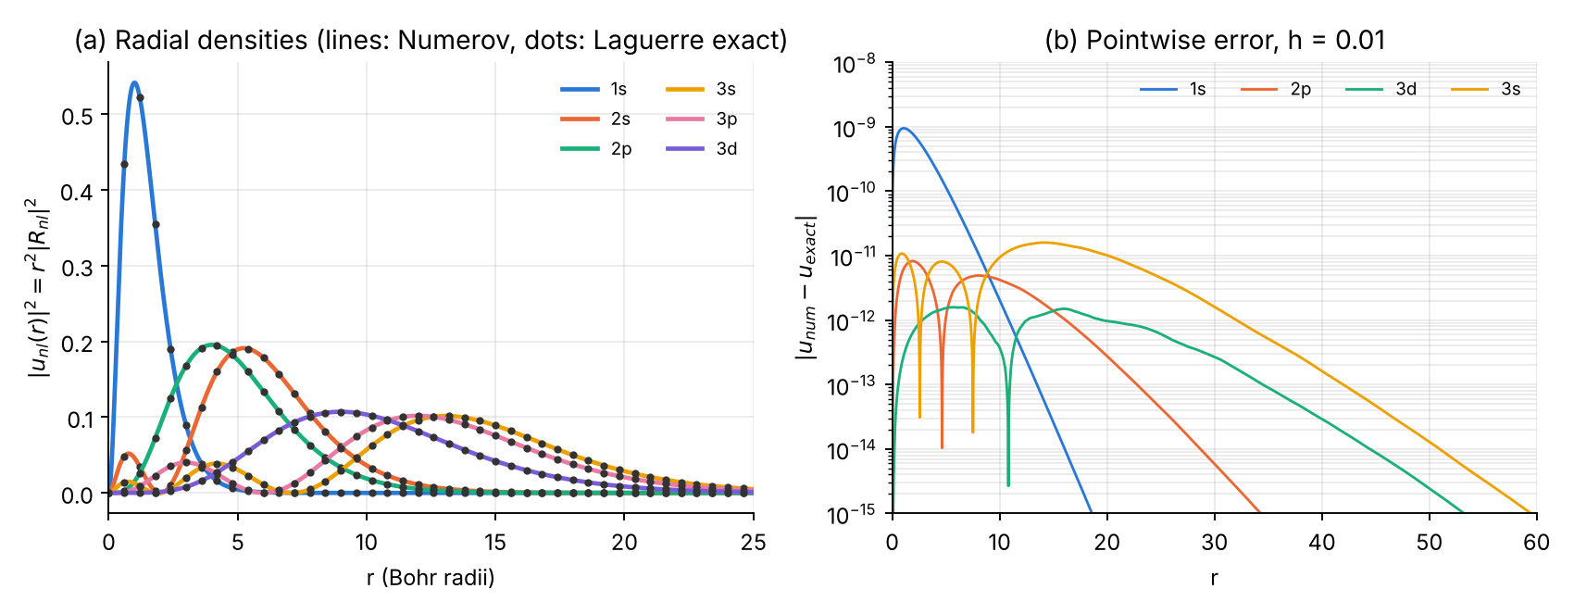
(a) Radial probability densities $u_{nl}^{2}$ (lines: Numerov; dots: exact functions built from the Laguerre recurrence). (b) Pointwise error at $h=0.01$.

1.8 Error analysis and convergence
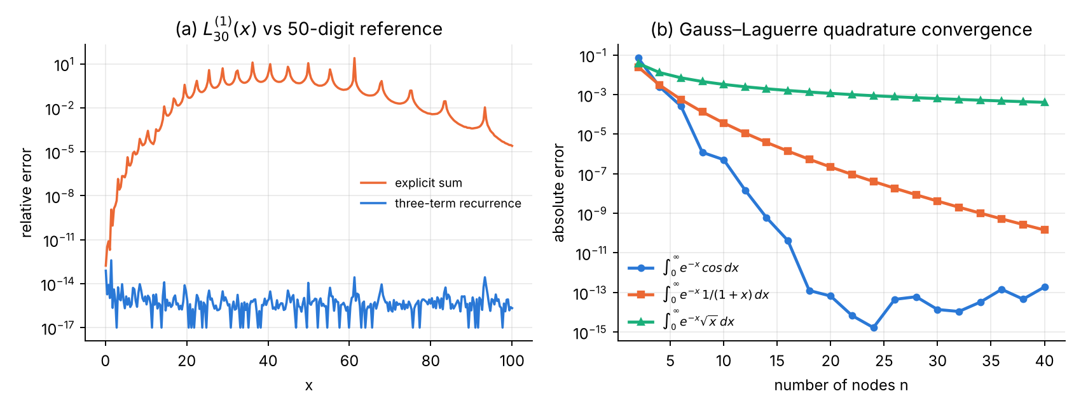
(a) $L_{30}^{\left(1\right)}$: the explicit sum loses all accuracy for $x≳15$, the recurrence stays at round-off level. (b) Gauss–Laguerre quadrature: exponential convergence for the entire function $cosx$, slower for $1/\left(1+x\right)$ (pole at $x=−1$), and only algebraic ($∝n^{−1.5}$) for $\sqrt{x}$, whose derivative is singular at the end point.
Discretisation error and the start (Part B).
h | 1s naive | 1s Frobenius | 2p naive | 2p Frobenius | 3d naive | 3d Frobenius
0.08 | 1.96e-03 | 3.73e-07 | 1.52e-06 | 6.63e-09 | 1.17e-10 | 1.17e-10
0.04 | 5.11e-04 | 2.37e-08 | 1.92e-07 | 4.15e-10 | 7.34e-12 | 7.34e-12
0.02 | 1.31e-04 | 1.47e-09 | 2.42e-08 | 2.59e-11 | 3.97e-13 | 3.87e-13
0.01 | 3.30e-05 | 9.25e-11 | 3.03e-09 | 1.47e-12 | 2.06e-13 | 1.85e-13
0.005 | 8.29e-06 | 5.23e-12 | 3.80e-10 | 1.60e-13 | 4.17e-13 | 5.28e-13
order | 1.97 | 4.02 | 2.99 | 4.00 | 3.99 | 3.99
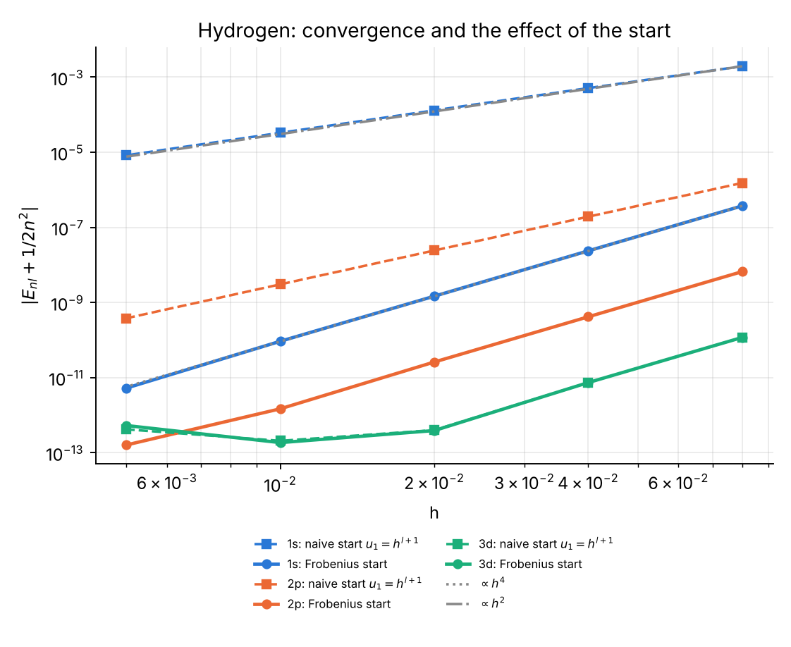
Hydrogen: convergence of the energy for the naive and the Frobenius start.
Interpretation (Part 0): $u$ is analytic, so the stencil itself is fine; but the naive start sets $c_{0}u_{0}=0$ although $\lim_{r→0}k^{2}u=2Zu′\left(0\right)≠0$ for $l=0$ and $=−l\left(l+1\right) u″\left(0\right)/2≠0$ for $l=1$. The resulting defect excites the irregular solution with relative amplitude $h^{2l+1}×δ$, giving order 2 for s states and 3 for p states. For $l≥2$ the limit vanishes and the naive start is harmless. With the Frobenius start the order is 4 for all $l$, until the round-off floor ($∼2×{10}^{−13}$) is reached.
Richardson extrapolation (2p): $E\left(0.04\right)=−0.124999999585$, $E\left(0.02\right)=−0.124999999974$, $E_{R}=−0.125000000000$ (error $8×{10}^{−15}$).
Box truncation ($3s$, $h=0.01$): replacing $u\left(∞\right)=0$ by $u\left(R\right)=0$ gives $\left|ΔE\right|=9.6×{10}^{−4}$ ($R=25$), $1.3×{10}^{−6}$ ($R=40$), $3.3×{10}^{−11}$ ($R=60$), $2×{10}^{−13}$ ($R≥80$). The decay is $∝R^{2n}e^{−2R/n}$, which motivates the choice $R=40n$.

1.9 Exercises
- Exactness of Gauss–Laguerre. Show that an $n$-point rule integrates $x^{k}e^{−x}$ exactly for $k≤2n−1$. Verify numerically for $n=20$. Answer: relative error $4×{10}^{−16}$ for $k=39$ and $7×{10}^{−12}$ for $k=40$.
- Cancellation in the explicit sum. Estimate the largest term of the explicit sum of $L_{30}^{\left(1\right)}\left(x\right)$ and explain why the relative error at $x=60$ is of order ${10}^{−1}$. Hint: the largest term is $≈x^{k}/k!⋅\left({31 \atop 30−k}\right)$ near $k≈x$; compare with $\left|L_{30}^{\left(1\right)}\left(60\right)\right|≈4.7×{10}^{11}$ and machine precision.
- $⟨r^{2}⟩$. Compute $⟨r^{2}⟩$ for the $3d$ state with the program and compare with $\frac{n^{2}}{2}\left[5n^{2}+1−3l\left(l+1\right)\right]$. Answer: 125.999999999 vs 126.
- Hydrogen-like ions. Generalise the code to nuclear charge $Z$ (change $2/r→2Z/r$ in $k^{2}$, in the Frobenius recurrence and in $R_{nl}$). Verify $E_{n}=−Z^{2}/2n^{2}$ for He$​^{+}$ ($Z=2$), and explain why the box can be taken $Z$ times smaller.
- Screened Coulomb (Yukawa) potential $V=−e^{−r/D}/r$, $D=10$. There is no closed form. Use the Coulomb Frobenius series with $E→E+1/D$ (why?) and compute the ground state for $h=0.02$ and $0.01$, then extrapolate. Answer: $E\left(0.02\right)=−0.40706410$, $E\left(0.01\right)=−0.40705880$, Richardson $E_{0}=−0.4070585$ (compare: $−0.5$ unscreened; first-order perturbation $−0.5+1/D=−0.4$).
- Naive start, theory. Show that $\lim_{r→0}\left(k^{2}u\right)$ equals $2Z$ for $l=0$ (with $u′\left(0\right)=1$) and $−2a$ for $l=1$ with $u=ar^{2}+…$, and use the argument of Part 0 to predict orders 2 and 3.

Chapter 2 — Legendre functions and the angular Schrödinger equation

2.1 The function
The associated Legendre equation (DLMF §14.2)
$$\left(1−x^{2}\right) y″−2x y′+\left[l\left(l+1\right)−\frac{m^{2}}{1−x^{2}}\right]y=0$$
has, for integer $0≤m≤l$, the solution bounded on $\left[−1,1\right]$
$$P_{l}^{m}\left(x\right)={\left(−1\right)}^{m}{\left(1−x^{2}\right)}^{m/2}\frac{d^{m}}{dx^{m}}P_{l}\left(x\right), P_{l}\left(x\right)=\frac{1}{2^{l}l!}\frac{d^{l}}{dx^{l}}{\left(x^{2}−1\right)}^{l} \text{(Rodrigues)}$$
(the factor ${\left(−1\right)}^{m}$ is the Condon–Shortley phase, used by the DLMF, mpmath and SciPy). Main properties (DLMF §14.7, §14.10, §14.17, §18.3, §18.9; Arfken et al. 2013, ch. 15; Lebedev 1965, ch. 7):
- Bonnet recurrence: $\left(l+1\right)P_{l+1}=\left(2l+1\right)xP_{l}−lP_{l−1}$, and $P_{l}′\left(x\right)=l \left[xP_{l}−P_{l−1}\right]/\left(x^{2}−1\right)$.
- Orthogonality: $\int_{−1}^{1}{P_{l}^{m}}P_{l′}^{m} dx=\frac{2}{2l+1}\frac{\left(l+m\right)!}{\left(l−m\right)!} δ_{ll′}$.
- Explicit sum: Plx=2−lk​−1klk2l−2klxl−2k.
- Generating function: 1−2xt+t2−1/2=l​Plxtl.
- Spherical harmonics: $Y_{lm}\left(θ,ϕ\right)={\overset{‾}{P}}_{l}^{m}\left(cosθ\right) e^{imϕ}/\sqrt{2π}$ with the orthonormal functions ${\overset{‾}{P}}_{l}^{m}=\sqrt{{2l+1}/2{\left(l−m\right)!}/{\left(l+m\right)!}} P_{l}^{m}$ (DLMF §14.30).
Overflow-free normalised recurrence (used in both codes): with $s=\sqrt{1−x^{2}}$,
$${\overset{‾}{P}}_{0}^{0}=1/{\sqrt{2}}, {\overset{‾}{P}}_{m}^{m}=−\sqrt{{2m+1}/{2m}} s {\overset{‾}{P}}_{m−1}^{m−1}, {\overset{‾}{P}}_{m+1}^{m}=\sqrt{2m+3} x {\overset{‾}{P}}_{m}^{m}, {\overset{‾}{P}}_{l}^{m}=a_{l}\left(x{\overset{‾}{P}}_{l−1}^{m}−\frac{{\overset{‾}{P}}_{l−2}^{m}}{a_{l−1}}\right), a_{l}=\sqrt{\frac{4l^{2}−1}{l^{2}−m^{2}}}.$$
No factorials appear, so arbitrarily large $l,m$ can be handled (the textbook form starts with $\left(2m−1\right)!!$, which overflows for $m≳150$).
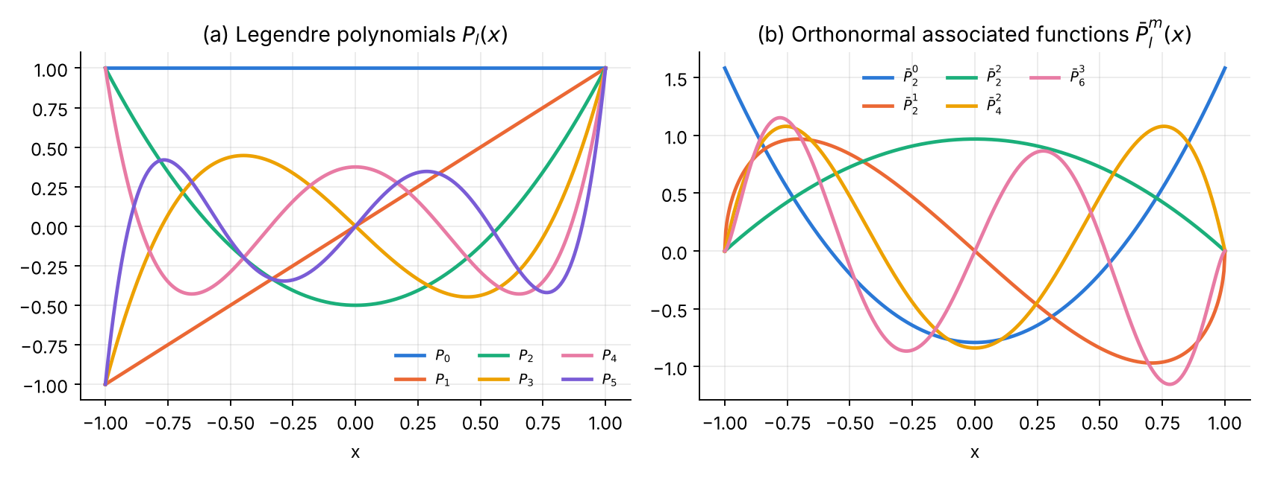
Legendre polynomials and orthonormal associated Legendre functions.

2.2 The physics: the angular equation
For any central potential, $ψ=R\left(r\right)Θ\left(θ\right)e^{imϕ}$ and the polar part satisfies
$$−\frac{1}{sinθ}\frac{d}{dθ}\left(sinθ\frac{dΘ}{dθ}\right)+\frac{m^{2}}{\sin^{2}θ}Θ=λ Θ,$$
i.e. the eigenvalue problem of ${\hat{L}}^{2}$. Regularity at both poles quantises $λ=l\left(l+1\right)$, $l=\left|m\right|,\left|m\right|+1,…$, with $Θ={\overset{‾}{P}}_{l}^{m}\left(cosθ\right)$ (Messiah 1961, App. B; Sakurai & Napolitano 2017, §3.6). The same equation is the Schrödinger equation of the rigid rotor (diatomic molecule) with $E=λ/2I$. Exact checks: $⟨\cos^{2}θ⟩=\frac{2l\left(l+1\right)−2m^{2}−1}{\left(2l−1\right)\left(2l+3\right)}$, parity $Θ\left(π−θ\right)={\left(−1\right)}^{l+m}Θ\left(θ\right)$.

2.3 Analytical scheme
Part A. Bonnet recurrence (stable forwards); explicit sum for comparison; normalised recurrence for ${\overset{‾}{P}}_{l}^{m}$; Gauss–Legendre nodes by Newton from Tricomi’s guesses $cos\left(π\left(i−1/4\right)/\left(n+1/2\right)\right)$, weights $w_{i}=2/\left[\left(1−x_{i}^{2}\right)P_{n}′{\left(x_{i}\right)}^{2}\right]$.
Part B. Liouville transform $u=\sqrt{sinθ} Θ$:
$$u″+\left[λ+1/4+\frac{1/4−m^{2}}{\sin^{2}θ}\right]u=0, u∼θ^{m+1/2} \left(θ→0\right), \int_{0}^{π}{u^{2}} dθ=\int_{0}^{π}{Θ^{2}}sinθ dθ.$$
- Grid $θ_{j}=jπ/N$, $N$ even; $c_{j}=1+h^{2}k_{j}^{2}/12$.
- Frobenius series u=θm+1/2k​akθ2k with 1/sin2θ=j​bjθ2j−2 ($b=1,1/3,1/{15},2/{189},1/{675},…$):
2k2k+2m ak=−λ+14 ak−1−14−m2j≥1​bjak−j.
- Two-sided shooting from both poles (the problem is symmetric), matched at $θ=π/2$ with the discrete Wronskian $D\left(λ\right)$; bracket $\left[l^{2}−1/2, l^{2}+2l+3/2\right]$, 64 bisections.
- Start either at the first two nodes or at fixed $θ_{s}=0.4$.

2.4 Logic chart
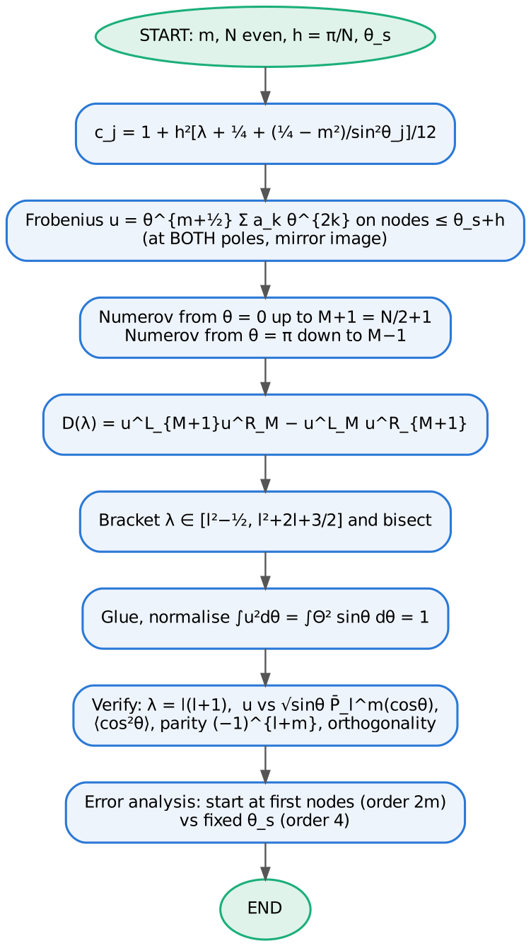
Logic chart of the angular-equation program.

2.5 Python 3 code
File: ch2_legendre_rotor.py
#!/usr/bin/env python3
"""
Chapter 2 -- LEGENDRE FUNCTIONS and the ANGULAR SCHROEDINGER EQUATION (Numerov)
===============================================================================
Part A : Legendre polynomials P_l(x) and associated functions P_l^m(x)
* Bonnet recurrence for P_l DLMF §14.10, §18.9
* normalised associated functions Pbar_l^m by the stable
recurrence in l (no factorials, no overflow) DLMF §14.10, §14.7
* explicit sum for P_l DLMF §18.5 (cancellation)
* Gauss-Legendre nodes and weights (Newton) DLMF §3.5(v)
* verification: orthonormality, mpmath reference, scipy lpmv
* error analysis: sum vs recurrence, unnormalised overflow,
Gauss-Legendre vs trapezoid convergence
Part B : angular equation (rigid rotor, hbar = I = 1, E = lambda/2)
-(1/sin t) d/dt (sin t dTheta/dt) + m^2/sin^2 t Theta = lambda Theta
Liouville transform u = sqrt(sin t) Theta :
u'' + [ lambda + 1/4 + (1/4 - m^2)/sin^2 t ] u = 0 , u ~ t^{m+1/2}
exact lambda = l(l+1), Theta = Pbar_l^m(cos t)
Numerov, two-sided shooting from both poles, Frobenius start,
Wronskian matching at t = pi/2
* verification: normalisation int u^2 dt = 1, comparison with Pbar_l^m,
<cos^2 t>, parity, orthogonality
* error analysis: start at first nodes (order 2m!) vs fixed t_s (order 4)
Outputs: tables + ch2_functions.png, ch2_partA_errors.png, ch2_rotor.png, ch2_convergence.png
"""
import numpy as np
from math import lgamma, exp, comb
import mpmath as mp
from scipy.special import lpmv
import matplotlib
matplotlib.use("Agg")
import matplotlib.pyplot as plt
C = ["#2a78d6", "#eb6834", "#1baf7a", "#eda100", "#e87ba4", "#7a5cd6"]
mp.mp.dps = 50
def style(ax):
ax.spines[["top", "right"]].set_visible(False); ax.grid(alpha=.25, which="both")
# ============================================================ PART A
def legendre_rec(L, x):
"""P_0..P_L(x) by Bonnet: (l+1) P_{l+1} = (2l+1) x P_l - l P_{l-1}"""
x = np.asarray(x, float)
P = np.zeros((L + 1,) + x.shape); P[0] = 1.0
if L >= 1: P[1] = x
for l in range(1, L):
P[l + 1] = ((2 * l + 1) * x * P[l] - l * P[l - 1]) / (l + 1)
return P
def legendre_sum(l, x):
"""explicit sum P_l = 2^-l sum_k (-1)^k C(l,k) C(2l-2k,l) x^{l-2k}"""
x = np.asarray(x, float)
return sum((-1) ** k * comb(l, k) * comb(2 * l - 2 * k, l) * x ** (l - 2 * k)
for k in range(l // 2 + 1)) / 2.0 ** l
def plm_bar(L, m, x):
"""orthonormal associated Legendre functions Pbar_l^m(x), l = m..L
(int_{-1}^{1} Pbar^2 dx = 1, Condon-Shortley phase included)
Pbar_m^m = -sqrt((2m+1)/(2m)) sqrt(1-x^2) Pbar_{m-1}^{m-1}, Pbar_0^0 = 1/sqrt 2
Pbar_{m+1}^m = sqrt(2m+3) x Pbar_m^m
Pbar_l^m = a_l ( x Pbar_{l-1}^m - Pbar_{l-2}^m / a_{l-1} ),
a_l = sqrt((4l^2-1)/(l^2-m^2))"""
x = np.asarray(x, float)
s = np.sqrt(np.maximum(1 - x * x, 0.0))
p = np.full_like(x, 1 / np.sqrt(2.0))
for k in range(1, m + 1):
p = -np.sqrt((2 * k + 1) / (2 * k)) * s * p
out = np.zeros((L + 1,) + x.shape)
out[m] = p
if L > m:
out[m + 1] = np.sqrt(2 * m + 3) * x * p
a = lambda l: np.sqrt((4 * l * l - 1) / (l * l - m * m))
for l in range(m + 2, L + 1):
out[l] = a(l) * (x * out[l - 1] - out[l - 2] / a(l - 1))
return out
def plm_unnorm(L, m, x):
"""textbook unnormalised recurrence (starts with (2m-1)!!: overflows for large m)"""
x = np.asarray(x, float)
with np.errstate(all="ignore"):
dfact = np.prod(np.arange(1, 2 * m, 2, dtype=float)) if m > 0 else 1.0
out = np.zeros((L + 1,) + x.shape)
out[m] = (-1) ** m * dfact * (1 - x * x) ** (m / 2)
if L > m: out[m + 1] = x * (2 * m + 1) * out[m]
for l in range(m + 1, L):
out[l + 1] = ((2 * l + 1) * x * out[l] - (l + m) * out[l - 1]) / (l - m + 1)
return out
def gauss_legendre(n, tol=1e-15):
"""Newton on P_n with the Tricomi initial guesses cos(pi (i-1/4)/(n+1/2))"""
x = np.zeros(n); w = np.zeros(n)
for i in range(n):
z = np.cos(np.pi * (i + 0.75) / (n + 0.5))
for _ in range(100):
P = legendre_rec(n, np.array([z]))[:, 0]
dP = n * (z * P[n] - P[n - 1]) / (z * z - 1)
dz = P[n] / dP; z -= dz
if abs(dz) < tol: break
P = legendre_rec(n, np.array([z]))[:, 0]
dP = n * (z * P[n] - P[n - 1]) / (z * z - 1)
x[i], w[i] = z, 2 / ((1 - z * z) * dP * dP)
return x[::-1], w[::-1]
def partA():
print("=" * 78)
print("PART A Legendre polynomials and associated Legendre functions")
print("=" * 78)
print("P_l(x): Bonnet recurrence vs explicit sum vs mpmath (50 digits)")
print(f"{'l':>4} {'x':>6} {'recurrence':>24} {'mpmath':>24} {'rel.err rec':>12} {'rel.err sum':>12}")
for l, x in ((10, 0.3), (40, 0.3), (60, 0.05), (100, 0.9)):
ref = float(mp.legendre(l, x))
r = legendre_rec(l, np.array([x]))[l, 0]; s = legendre_sum(l, np.array([x]))[0]
print(f"{l:4d} {x:6.2f} {r:24.15e} {ref:24.15e} {abs(r-ref)/abs(ref):12.2e} {abs(s-ref)/abs(ref):12.2e}")
print("\nNormalised Pbar_l^m vs unnormalised recurrence vs mpmath, x = 0.5")
for l, m in ((5, 2), (30, 10), (120, 100), (200, 180)):
nrm = mp.sqrt((2 * l + 1) / mp.mpf(2) * mp.factorial(l - m) / mp.factorial(l + m))
ref = nrm * mp.legenp(l, m, 0.5) # mpmath includes (-1)^m
pb = plm_bar(l, m, np.array([0.5]))[l, 0]
pu = plm_unnorm(l, m, np.array([0.5]))[l, 0]
pu_n = float(nrm) * pu if np.isfinite(pu) else np.nan
print(f" l={l:3d} m={m:3d}: Pbar = {pb: .15e} mpmath = {float(ref): .15e} rel.err {abs(pb-float(ref))/abs(float(ref)):.1e}"
f" unnormalised: {'overflow (inf)' if not np.isfinite(pu) else f'{pu_n: .6e}'}")
xg, wg = gauss_legendre(30)
P = plm_bar(20, 3, xg)[3:]
G = (P * wg) @ P.T
print(f"\northonormality of Pbar_l^3, l=3..20, 30-point Gauss-Legendre: max|G-I| = {np.max(abs(G-np.eye(len(G)))):.1e}")
ls = np.arange(3, 21)
scip = np.array([lpmv(3, l, xg) * np.sqrt((2 * l + 1) / 2 * exp(lgamma(l - 2) - lgamma(l + 4))) for l in ls])
print(f"agreement with scipy lpmv (normalised): {np.max(abs(P - scip)):.1e}")
print(f"30-point rule: sum w = {wg.sum():.15f}, int x^58 dx exact? err = {abs(wg@xg**58 - 2/59):.1e}")
# error data
xx = np.linspace(-0.999, 0.999, 400)
ref40 = np.array([float(mp.legendre(40, x)) for x in xx])
e_rec = abs(legendre_rec(40, xx)[40] - ref40) / (abs(ref40) + 1e-3)
e_sum = abs(legendre_sum(40, xx) - ref40) / (abs(ref40) + 1e-3)
ns = np.arange(2, 41, 2)
tests = {r"$e^x$": (np.exp, np.e - 1 / np.e), r"$1/(1+25x^2)$": (lambda x: 1 / (1 + 25 * x * x), 0.4 * np.arctan(5)),
r"$|x|^3$": (lambda x: abs(x) ** 3, 0.5)}
eg = {k: [] for k in tests}; et = []
for n in ns:
xq, wq = gauss_legendre(n)
for k, (f, ex) in tests.items():
eg[k].append(abs(wq @ f(xq) - ex) + 1e-18)
xt = np.linspace(-1, 1, n); ht = xt[1] - xt[0]
ft = np.exp(xt); et.append(abs(ht * (ft.sum() - 0.5 * (ft[0] + ft[-1])) - (np.e - 1 / np.e)))
print("\nGauss-Legendre quadrature errors (n nodes):")
for i, n in enumerate(ns):
if n in (2, 4, 8, 12, 20, 40):
print(f" n={n:2d}: " + " ".join(f"{k.strip('$')}: {eg[k][i]:.1e}" for k in tests) + f" trapezoid e^x: {et[i]:.1e}")
fig, ax = plt.subplots(1, 2, figsize=(10, 3.8))
x = np.linspace(-1, 1, 500)
P = legendre_rec(5, x)
for l in range(6):
ax[0].plot(x, P[l], color=C[l], lw=2, label=f"$P_{l}$")
ax[0].set(xlabel="x", title=r"(a) Legendre polynomials $P_l(x)$")
ax[0].legend(frameon=False, fontsize=8, ncol=3)
for i, (l, m) in enumerate(((2, 0), (2, 1), (2, 2), (4, 2), (6, 3))):
ax[1].plot(x, plm_bar(l, m, x)[l], color=C[i], lw=2, label=fr"$\bar P_{l}^{{{m}}}$")
ax[1].set(xlabel="x", title=r"(b) Orthonormal associated functions $\bar P_l^m(x)$")
ax[1].legend(frameon=False, fontsize=8, ncol=3)
for a_ in ax: style(a_)
fig.tight_layout(); fig.savefig("ch2_functions.png", dpi=170)
fig, ax = plt.subplots(1, 2, figsize=(10, 3.8))
ax[0].semilogy(xx, e_sum + 1e-18, color=C[1], lw=1.2, label="explicit sum")
ax[0].semilogy(xx, e_rec + 1e-18, color=C[0], lw=1.2, label="Bonnet recurrence")
ax[0].set(xlabel="x", ylabel="error / (|P|+10$^{-3}$)", title=r"(a) $P_{40}(x)$ vs 50-digit reference")
ax[0].legend(frameon=False, fontsize=8)
for i, k in enumerate(tests):
ax[1].semilogy(ns, eg[k], "o-", color=C[i], lw=2, ms=4, label=f"Gauss–Legendre, {k}")
ax[1].semilogy(ns, et, "s--", color="#888888", lw=1.5, ms=4, label=r"trapezoid, $e^x$")
ax[1].set(ylim=(1e-17, 1), xlabel="number of nodes n", ylabel="absolute error", title=r"(b) $\int_{-1}^{1} f\,dx$: quadrature convergence")
ax[1].legend(frameon=False, fontsize=7)
for a_ in ax: style(a_)
fig.tight_layout(); fig.savefig("ch2_partA_errors.png", dpi=170)
# ============================================================ PART B
INV_SIN2 = [1.0, 1 / 3, 1 / 15, 2 / 189, 1 / 675, 2 / 10395, 1382 / 58046625, 4 / 1403325]
def frobenius(t, m, lam, nterm=24):
"""u = t^{m+1/2} sum a_k t^{2k}; 1/sin^2 t = sum b_j t^{2j-2}
2k(2k+2m) a_k = -(1/4-m^2) sum_{j>=1} b_j a_{k-j} - (lam+1/4) a_{k-1}"""
q = 0.25 - m * m; L = lam + 0.25
b = INV_SIN2 + [0.0] * nterm # higher b_j negligible for t <= 0.5 at double precision
a = [1.0]
for k in range(1, nterm):
s = -L * a[k - 1] - q * sum(b[j] * a[k - j] for j in range(1, k + 1))
a.append(s / (2 * k * (2 * k + 2 * m)))
t = np.asarray(t, float)
return t ** (m + 0.5) * sum(ak * t ** (2 * k) for k, ak in enumerate(a))
def simpson(y, h):
return h / 3 * (y[0] + y[-1] + 4 * y[1:-1:2].sum() + 2 * y[2:-1:2].sum())
def shoot(lam, m, N, ts):
"""N even; grid t_j = j pi/N. ts = start angle (0 -> first nodes)."""
h = np.pi / N; t = h * np.arange(N + 1); t[N] = np.pi
k2 = np.zeros(N + 1)
k2[1:N] = lam + 0.25 + (0.25 - m * m) / np.sin(t[1:N]) ** 2
c = 1 + h * h * k2 / 12
js = max(1, int(ts / h + 0.5))
M = N // 2
pL = np.zeros(N + 1); pL[:js + 2] = frobenius(t[:js + 2], m, lam)
for n in range(js + 1, M + 1):
pL[n + 1] = ((12 - 10 * c[n]) * pL[n] - c[n - 1] * pL[n - 1]) / c[n + 1]
pR = np.zeros(N + 1); pR[N - js - 1:] = frobenius(np.maximum(np.pi - t[N - js - 1:], 0.0), m, lam)
for n in range(N - js - 1, M - 1, -1):
pR[n - 1] = ((12 - 10 * c[n]) * pR[n] - c[n + 1] * pR[n + 1]) / c[n - 1]
sL = np.max(abs(pL[:M + 2])); sR = np.max(abs(pR[M - 1:]))
pL /= sL; pR /= sR
D = pL[M + 1] * pR[M] - pL[M] * pR[M + 1]
# glue at M+1 or M, whichever is larger in |pR| (odd states vanish at pi/2)
j = M if abs(pR[M]) > abs(pR[M + 1]) else M + 1
u = np.concatenate([pL[:j + 1], pR[j + 1:] * pL[j] / pR[j]])
return D, u, t
def eigen(l, m, N, ts=0.4):
lex = l * (l + 1)
a, b = lex - l - 0.5, lex + l + 1.5 # brackets only lambda = l(l+1)
fa = shoot(a, m, N, ts)[0]
assert np.sign(fa) != np.sign(shoot(b, m, N, ts)[0])
for _ in range(64):
mid = 0.5 * (a + b); fm = shoot(mid, m, N, ts)[0]
if np.sign(fm) == np.sign(fa): a, fa = mid, fm
else: b = mid
lam = 0.5 * (a + b)
_, u, t = shoot(lam, m, N, ts)
h = t[1]
u /= np.sqrt(simpson(u * u, h))
ex = np.sqrt(np.abs(np.sin(t))) * plm_bar(l, m, np.cos(t))[l]
if np.dot(u, ex) < 0: u = -u
return lam, u, t, ex
def partB():
print("\n" + "=" * 78)
print("PART B Angular equation / rigid rotor: Numerov in theta, N = 400 (h = pi/400), t_s = 0.4")
print("=" * 78)
# scan to show the spectrum for m = 1
N = 400
lg = np.linspace(0.05, 45, 900)
D = np.array([shoot(L, 1, N, 0.4)[0] for L in lg])
roots = [0.5 * (lg[i] + lg[i + 1]) for i in np.where(np.sign(D[:-1]) != np.sign(D[1:]))[0]]
print(" scan m=1: sign changes of D(lambda) near " + ", ".join(f"{r:.2f}" for r in roots) + " (exact 2, 6, 12, 20, 30, 42)")
print(f"\n{'l':>2} {'m':>2} {'lambda Numerov':>18} {'l(l+1)':>7} {'|dlam|':>9} {'norm':>15} {'max|u-u_ex|':>12} {'<cos^2>':>10} {'exact':>10}")
store = {}
for (l, m) in ((0, 0), (1, 0), (2, 0), (1, 1), (2, 1), (3, 1), (2, 2), (3, 2), (5, 3)):
lam, u, t, ex = eigen(l, m, N)
h = t[1]
c2 = simpson(u * u * np.cos(t) ** 2, h)
c2ex = (2 * l * (l + 1) - 2 * m * m - 1) / ((2 * l - 1) * (2 * l + 3))
store[l, m] = (u, t, ex)
print(f"{l:2d} {m:2d} {lam:18.12f} {l*(l+1):7d} {abs(lam-l*(l+1)):9.1e} {simpson(u*u,h):15.12f} {np.max(abs(u-ex)):12.1e} {c2:10.7f} {c2ex:10.7f}")
ov = max(abs(simpson(store[a, 1][0] * store[b, 1][0], np.pi / N)) for a in (1, 2, 3) for b in (1, 2, 3) if a < b)
print(f" orthogonality m=1: max |<u_l|u_l'>| = {ov:.1e}; parity u(pi-t) = (-1)^(l+m) u(t): "
f"max err {max(np.max(abs(store[l,m][0][::-1] - (-1)**(l+m)*store[l,m][0])) for (l,m) in store):.1e}")
Ns = np.array([20, 40, 80, 160, 320, 640, 1280])
hs = np.pi / Ns
err = {}
for m, l in ((0, 2), (1, 2), (2, 3)):
for ts, lab in ((0.0, "first nodes"), (0.4, "t_s = 0.4")):
err[m, lab] = [abs(eigen(l, m, N, ts)[0] - l * (l + 1)) for N in Ns]
print("\nEigenvalue error vs h: Frobenius start at first two grid nodes vs at fixed t_s = 0.4")
print(f"{'N':>6} {'h':>8}" + "".join(f" {'m=%d nodes' % m:>12} {'m=%d t_s' % m:>11}" for m in (0, 1, 2)))
for i, N in enumerate(Ns):
print(f"{N:6d} {hs[i]:8.5f}" + "".join(f" {err[m,'first nodes'][i]:12.2e} {err[m,'t_s = 0.4'][i]:11.2e}" for m in (0, 1, 2)))
for m in (0, 1, 2):
for lab in ("first nodes", "t_s = 0.4"):
e = np.array(err[m, lab]); ok = e > 1e-12
print(f" m={m} {lab:12s}: observed order {np.polyfit(np.log(hs[ok][1:6]), np.log(e[ok][1:6]), 1)[0]:.2f}")
fig, ax = plt.subplots(1, 2, figsize=(10, 4.2), gridspec_kw={"width_ratios": [1.5, 1]})
for i, (l, m) in enumerate(((0, 0), (1, 0), (2, 0), (2, 1), (3, 2))):
u, t, ex = store[l, m]
ax[0].plot(t, u, color=C[i], lw=2, label=f"l={l}, m={m}")
ax[0].plot(t[::16], ex[::16], "o", ms=2.5, color="#333333")
ax[0].set(xlabel=r"$\theta$", ylabel=r"$u(\theta)=\sqrt{\sin\theta}\,\Theta(\theta)$",
title=r"(a) Numerov (lines) vs $\sqrt{\sin\theta}\,\bar P_l^m(\cos\theta)$ (dots)")
ax[0].legend(frameon=False, fontsize=7, ncol=2)
th = np.linspace(0, 2 * np.pi, 400)
for i, (l, m) in enumerate(((1, 0), (2, 0), (2, 1), (3, 2))):
rr = abs(plm_bar(l, m, np.cos(th))[l]) ** 2
ax[1].plot(rr * np.sin(th), rr * np.cos(th), color=C[i], lw=2, label=fr"$|Y_{{{l}{m}}}|^2$")
ax[1].set_aspect("equal"); ax[1].set(xlabel="x-z plane", title=r"(b) Polar plots of $|\bar P_l^m(\cos\theta)|^2$")
ax[1].legend(frameon=False, fontsize=7, loc="center left", bbox_to_anchor=(1.0, 0.5))
for a_ in ax: style(a_)
fig.tight_layout(); fig.savefig("ch2_rotor.png", dpi=170)
fig, ax = plt.subplots(figsize=(6.6, 4.2))
for i, m in enumerate((0, 1, 2)):
ax.loglog(hs, err[m, "first nodes"], "s--", color=C[i], lw=1.5, ms=5, label=f"m={m}: start at first nodes")
ax.loglog(hs, err[m, "t_s = 0.4"], "o-", color=C[i], lw=2, ms=5, label=fr"m={m}: Frobenius start at $\theta_s$=0.4")
ax.loglog(hs, err[1, "t_s = 0.4"][0] * (hs / hs[0]) ** 4, ":", color="#888888", label=r"$\propto h^4$")
ax.loglog(hs, err[1, "first nodes"][0] * (hs / hs[0]) ** 2, "-.", color="#888888", label=r"$\propto h^2$")
ax.set(xlabel=r"$h=\pi/N$", ylabel=r"$|\lambda-l(l+1)|$", title="Angular equation: the order of convergence is $\\min(4, 2m)$\nunless the start is moved away from the pole")
ax.legend(frameon=False, fontsize=7); style(ax)
fig.tight_layout(); fig.savefig("ch2_convergence.png", dpi=170)
if __name__ == "__main__":
partA(); partB()

2.6 Fortran 2008 code
File: ch2_legendre_rotor.f90
!=======================================================================
! Chapter 2 -- LEGENDRE FUNCTIONS and the ANGULAR EQUATION (Fortran 2008)
! Part A: P_l by Bonnet recurrence vs explicit sum, orthonormal associated
! functions Pbar_l^m by the stable l-recurrence, Gauss-Legendre
! rule by Newton, orthonormality and quadrature-error checks
! Part B: u = sqrt(sin t) Theta, u'' + [lam + 1/4 + (1/4-m^2)/sin^2 t] u = 0
! Numerov from both poles, Frobenius start at t_s (or first nodes),
! Wronskian matching at t = pi/2, lam = l(l+1)
! Output: screen tables + ch2_f_conv.dat
! Compile: gfortran -O2 -o ch2 ch2_legendre_rotor.f90 && ./ch2
!=======================================================================
module legendre_mod
implicit none
integer, parameter :: dp = kind(1.0d0)
real(dp), parameter :: pi = 3.141592653589793238_dp
contains
subroutine leg_rec(L, x, P)
integer, intent(in) :: L
real(dp), intent(in) :: x
real(dp), intent(out) :: P(0:L)
integer :: k
P(0) = 1.0_dp
if (L >= 1) P(1) = x
do k = 1, L-1
P(k+1) = ((2*k + 1)*x*P(k) - k*P(k-1))/(k + 1)
end do
end subroutine leg_rec
real(dp) function leg_sum(l, x) ! explicit sum (cancellation)
integer, intent(in) :: l
real(dp), intent(in) :: x
integer :: k
leg_sum = 0.0_dp
do k = 0, l/2
leg_sum = leg_sum + (-1)**k*exp(log_gamma(l+1.0_dp) - log_gamma(k+1.0_dp) - log_gamma(l-k+1.0_dp) &
+ log_gamma(2*l-2*k+1.0_dp) - log_gamma(l+1.0_dp) - log_gamma(l-2*k+1.0_dp))*x**(l-2*k)
end do
leg_sum = leg_sum/2.0_dp**l
end function leg_sum
! orthonormal associated Legendre functions Pbar_l^m, l = m..L
subroutine plm_bar(L, m, x, P)
integer, intent(in) :: L, m
real(dp), intent(in) :: x
real(dp), intent(out) :: P(0:L)
real(dp) :: s, p0, al, alm1
integer :: k
P = 0.0_dp
s = sqrt(max(1.0_dp - x*x, 0.0_dp))
p0 = 1.0_dp/sqrt(2.0_dp)
do k = 1, m
p0 = -sqrt((2*k + 1.0_dp)/(2*k))*s*p0
end do
P(m) = p0
if (L > m) P(m+1) = sqrt(2*m + 3.0_dp)*x*p0
do k = m+2, L
al = sqrt((4.0_dp*k*k - 1)/(real(k,dp)**2 - m*m))
alm1 = sqrt((4.0_dp*(k-1)**2 - 1)/(real(k-1,dp)**2 - m*m))
P(k) = al*(x*P(k-1) - P(k-2)/alm1)
end do
end subroutine plm_bar
subroutine gauss_legendre(n, x, w)
integer, intent(in) :: n
real(dp), intent(out) :: x(n), w(n)
real(dp) :: z, dz, P(0:n), dPn
integer :: i, it
do i = 1, n
z = cos(pi*(i - 0.25_dp)/(n + 0.5_dp))
do it = 1, 100
call leg_rec(n, z, P)
dPn = n*(z*P(n) - P(n-1))/(z*z - 1)
dz = P(n)/dPn; z = z - dz
if (abs(dz) < 1.0d-15) exit
end do
call leg_rec(n, z, P)
dPn = n*(z*P(n) - P(n-1))/(z*z - 1)
x(n+1-i) = z; w(n+1-i) = 2/((1 - z*z)*dPn*dPn)
end do
end subroutine gauss_legendre
end module legendre_mod
module rotor_mod
use legendre_mod
implicit none
real(dp), parameter :: b(0:7) = [1.0_dp, 1/3.0_dp, 1/15.0_dp, 2/189.0_dp, 1/675.0_dp, &
2/10395.0_dp, 1382/58046625.0_dp, 4/1403325.0_dp]
contains
real(dp) function frob(t, m, lam) ! u = t^{m+1/2} sum a_k t^{2k}
real(dp), intent(in) :: t, lam
integer, intent(in) :: m
real(dp) :: a(0:23), s, q, LL
integer :: k, j
q = 0.25_dp - m*m; LL = lam + 0.25_dp
a(0) = 1.0_dp
do k = 1, 23
s = -LL*a(k-1)
do j = 1, min(k, 7)
s = s - q*b(j)*a(k-j)
end do
a(k) = s/(2*k*(2*k + 2*m))
end do
s = 0.0_dp
do k = 0, 23
s = s + a(k)*t**(2*k)
end do
frob = t**(m + 0.5_dp)*s
end function frob
real(dp) function simpson(y, h, n)
integer, intent(in) :: n
real(dp), intent(in) :: y(0:n), h
simpson = h/3*(y(0) + y(n) + 4*sum(y(1:n-1:2)) + 2*sum(y(2:n-2:2)))
end function simpson
subroutine shoot(lam, m, N, ts, D, u)
real(dp), intent(in) :: lam, ts
integer, intent(in) :: m, N
real(dp), intent(out) :: D, u(0:N)
real(dp) :: h, t(0:N), c(0:N), pL(0:N), pR(0:N), sL, sR
integer :: j, js, Mm, jg
h = pi/N; t = [(j*h, j=0,N)]; t(N) = pi
c = 1.0_dp
c(1:N-1) = 1 + h*h*(lam + 0.25_dp + (0.25_dp - m*m)/sin(t(1:N-1))**2)/12
js = max(1, nint(ts/h)); Mm = N/2
pL = 0.0_dp; pR = 0.0_dp
do j = 0, js+1
pL(j) = frob(t(j), m, lam); pR(N-j) = frob(t(j), m, lam)
end do
do j = js+1, Mm
pL(j+1) = ((12 - 10*c(j))*pL(j) - c(j-1)*pL(j-1))/c(j+1)
end do
do j = N-js-1, Mm, -1
pR(j-1) = ((12 - 10*c(j))*pR(j) - c(j+1)*pR(j+1))/c(j-1)
end do
sL = maxval(abs(pL(0:Mm+1))); sR = maxval(abs(pR(Mm-1:N)))
pL = pL/sL; pR = pR/sR
D = pL(Mm+1)*pR(Mm) - pL(Mm)*pR(Mm+1)
jg = Mm; if (abs(pR(Mm+1)) > abs(pR(Mm))) jg = Mm + 1
u(0:jg) = pL(0:jg); u(jg+1:N) = pR(jg+1:N)*pL(jg)/pR(jg)
end subroutine shoot
subroutine eigen(l, m, N, ts, lam, u)
integer, intent(in) :: l, m, N
real(dp), intent(in) :: ts
real(dp), intent(out) :: lam, u(0:N)
real(dp) :: a, bb, fa, fm, mid, D
integer :: it
a = l*(l+1) - l - 0.5_dp; bb = l*(l+1) + l + 1.5_dp
call shoot(a, m, N, ts, fa, u)
do it = 1, 64
mid = 0.5_dp*(a + bb)
call shoot(mid, m, N, ts, fm, u)
if (sign(1.0_dp, fm) == sign(1.0_dp, fa)) then
a = mid; fa = fm
else
bb = mid
end if
end do
lam = 0.5_dp*(a + bb)
call shoot(lam, m, N, ts, D, u)
u = u/sqrt(simpson(u*u, pi/N, N))
end subroutine eigen
end module rotor_mod
program ch2
use legendre_mod
use rotor_mod
implicit none
integer, parameter :: NN = 400
real(dp) :: P(0:200), xq(30), wq(30), G(18,18), Pq(0:20), u(0:NN), ex(0:NN), lam, c2, c2ex, mx, t
real(dp), allocatable :: uu(:)
integer :: i, j, k, l, m, Ns(7) = [20, 40, 80, 160, 320, 640, 1280]
integer :: ll(9) = [0,1,2,1,2,3,2,3,5], mm(9) = [0,0,0,1,1,1,2,2,3], lconv(3) = [2, 2, 3]
real(dp) :: e1(7), e2(7), xA(3) = [0.3_dp, 0.3_dp, 0.9_dp]
integer :: lA(3) = [10, 40, 100]
print '(a)', repeat('=',78)
print '(a)', 'PART A Legendre functions (Fortran)'
print '(a)', repeat('=',78)
do k = 1, 3
l = lA(k); t = xA(k)
call leg_rec(l, t, P(0:l))
print '(a,i4,a,f4.1,a,es24.15,a,es24.15,a,es9.2)', ' l=', l, ' x=', t, ' Bonnet=', P(l), ' sum=', &
leg_sum(l, t), ' rel.diff=', abs(leg_sum(l, t)/P(l) - 1)
end do
call plm_bar(200, 180, 0.5_dp, P)
print '(a,es24.15,a)', ' Pbar_200^180(0.5) = ', P(200), ' (mpmath: 7.231608361615227e-02)'
call gauss_legendre(30, xq, wq)
G = 0.0_dp
do k = 1, 30
call plm_bar(20, 3, xq(k), Pq)
do i = 3, 20
do j = 3, 20
G(i-2,j-2) = G(i-2,j-2) + wq(k)*Pq(i)*Pq(j)
end do
end do
end do
do i = 1, 18
G(i,i) = G(i,i) - 1.0_dp
end do
print '(a,es9.2)', ' orthonormality Pbar_l^3 (l=3..20), 30-pt Gauss-Legendre: max|G-I| = ', maxval(abs(G))
print '(a)', ' Gauss-Legendre errors, int_{-1}^{1} e^x dx and int 1/(1+25x^2) dx:'
do k = 2, 30, 4
call gauss_legendre(k, xq(1:k), wq(1:k))
print '(a,i3,2es11.2)', ' n=', k, abs(sum(wq(1:k)*exp(xq(1:k))) - (exp(1.0_dp) - exp(-1.0_dp))), &
abs(sum(wq(1:k)/(1 + 25*xq(1:k)**2)) - 0.4_dp*atan(5.0_dp))
end do
print '(/a)', repeat('=',78)
print '(a)', 'PART B Angular equation, Numerov, N = 400, t_s = 0.4'
print '(a)', repeat('=',78)
print '(a2,a3,a18,a7,a10,a16,a12,a10,a10)', 'l', 'm', 'lambda', 'l(l+1)', '|dlam|', 'norm', 'max|u-ue|', &
'<cos^2>', 'exact'
do k = 1, 9
l = ll(k); m = mm(k)
call eigen(l, m, NN, 0.4_dp, lam, u)
do j = 0, NN
t = j*pi/NN
call plm_bar(l, m, cos(t), P(0:l))
ex(j) = sqrt(abs(sin(t)))*P(l)
end do
if (sum(u*ex) < 0) u = -u
mx = maxval(abs(u - ex))
c2 = simpson(u*u*cos([(j*pi/NN, j=0,NN)])**2, pi/NN, NN)
c2ex = (2.0_dp*l*(l+1) - 2*m*m - 1)/((2*l - 1)*(2*l + 3))
print '(i2,i3,f18.12,i7,es10.1,f16.12,es12.1,2f10.7)', l, m, lam, l*(l+1), abs(lam - l*(l+1)), &
simpson(u*u, pi/NN, NN), mx, c2, c2ex
end do
open(10, file='ch2_f_conv.dat', status='replace')
print '(/a)', 'Error of lambda vs N: Frobenius start at first nodes | at t_s = 0.4'
do m = 0, 2
do i = 1, 7
allocate(uu(0:Ns(i)))
call eigen(lconv(m+1), m, Ns(i), 0.0_dp, lam, uu); e1(i) = abs(lam - lconv(m+1)*(lconv(m+1)+1))
call eigen(lconv(m+1), m, Ns(i), 0.4_dp, lam, uu); e2(i) = abs(lam - lconv(m+1)*(lconv(m+1)+1))
write(10,'(i3,i6,3es16.7)') m, Ns(i), pi/Ns(i), e1(i), e2(i)
deallocate(uu)
end do
print '(a,i1,a,7es9.1)', ' m=', m, ' first nodes:', e1
print '(a,i1,a,7es9.1)', ' m=', m, ' t_s = 0.4 :', e2
end do
close(10)
end program ch2

2.7 Results, normalisation and verification
Part A.
l | x | Bonnet recurrence | rel. error recurrence | rel. error explicit sum
10 | 0.30 | 0.2514763495160157 | 2.2e-16 | 4.4e-16
40 | 0.30 | 0.1251158458557079 | 2.2e-16 | 3.0e-12
60 | 0.05 | −0.1019617243819477 | 0 | 8.2e-16
100 | 0.90 | 0.1022658205587189 | 4.1e-16 | 6.7e+17
For $l=100$, $x=0.9$ the explicit sum returns a number of order ${10}^{17}$ instead of $0.10$. The normalised recurrence gives ${\overset{‾}{P}}_{200}^{180}\left(0.5\right)=0.07231608361615147$ (relative error $1.1×{10}^{−14}$) where the unnormalised one overflows. Orthonormality of ${\overset{‾}{P}}_{3}^{3}…{\overset{‾}{P}}_{20}^{3}$ with a 30-point rule: $7×{10}^{−16}$; agreement with SciPy lpmv: $4×{10}^{−15}$.
Part B ($N=400$, $θ_{s}=0.4$). A scan of $D\left(λ\right)$ for $m=1$ finds sign changes near 2.02, 5.97, 11.98, 19.98, 29.98, 41.98 — exactly $l\left(l+1\right)$ for $l=1…6$ and no spurious root.
l | m | λ Numerov | l(l+1) | |Δλ| | ∫u²dθ | max|u − u_ex| | ⟨cos²θ⟩ | exact
0 | 0 | −0.000000002115 | 0 | 2.1e-09 | 1.000000000000 | 7.8e-09 | 0.3333333 | 0.3333333
1 | 0 | 1.999999994594 | 2 | 5.4e-09 | 1.000000000000 | 1.4e-08 | 0.6000000 | 0.6000000
2 | 0 | 5.999999991221 | 6 | 8.8e-09 | 1.000000000000 | 1.7e-08 | 0.5238095 | 0.5238095
1 | 1 | 2.000000000168 | 2 | 1.7e-10 | 1.000000000000 | 1.2e-10 | 0.2000000 | 0.2000000
2 | 1 | 5.999999998116 | 6 | 1.9e-09 | 1.000000000000 | 4.5e-10 | 0.4285714 | 0.4285714
3 | 1 | 11.999999979338 | 12 | 2.1e-08 | 1.000000000000 | 1.2e-09 | 0.4666667 | 0.4666667
2 | 2 | 5.999999999185 | 6 | 8.1e-10 | 1.000000000000 | 5.6e-11 | 0.1428571 | 0.1428571
3 | 2 | 11.999999989533 | 12 | 1.0e-08 | 1.000000000000 | 4.0e-10 | 0.3333333 | 0.3333333
5 | 3 | 29.999999892684 | 30 | 1.1e-07 | 1.000000000000 | 4.7e-09 | 0.3504273 | 0.3504274
Orthogonality for $m=1$: $7×{10}^{−10}$; parity ${\left(−1\right)}^{l+m}$ satisfied to $8×{10}^{−12}$.
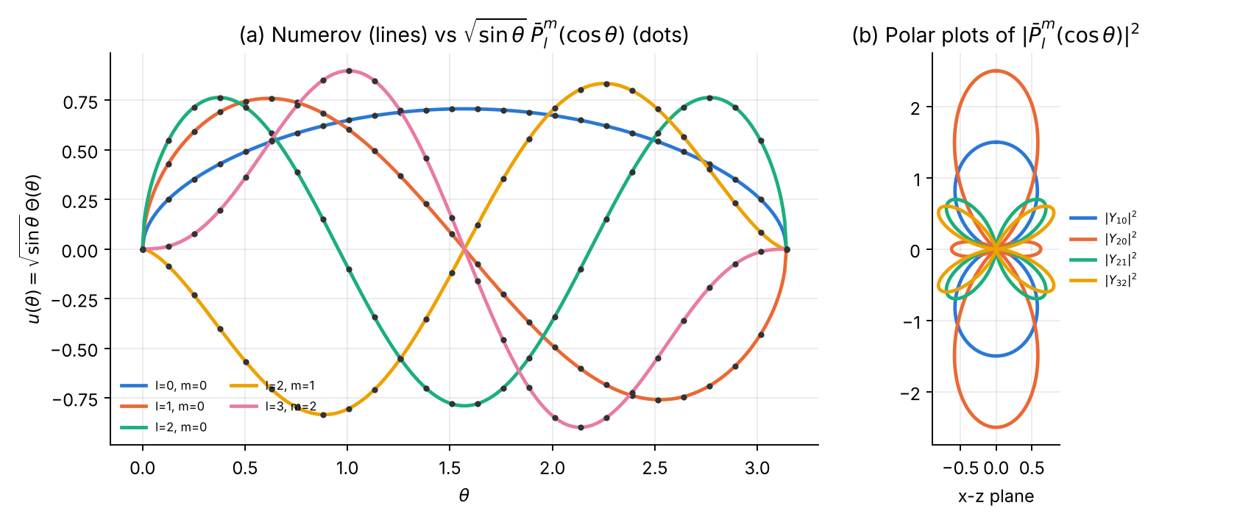
(a) Numerov solutions $u\left(θ\right)$ and the exact $\sqrt{sinθ} {\overset{‾}{P}}_{l}^{m}\left(cosθ\right)$. (b) Polar diagrams of ${\left|{\overset{‾}{P}}_{l}^{m}\left(cosθ\right)\right|}^{2}$ (the familiar orbital shapes).

2.8 Error analysis and convergence
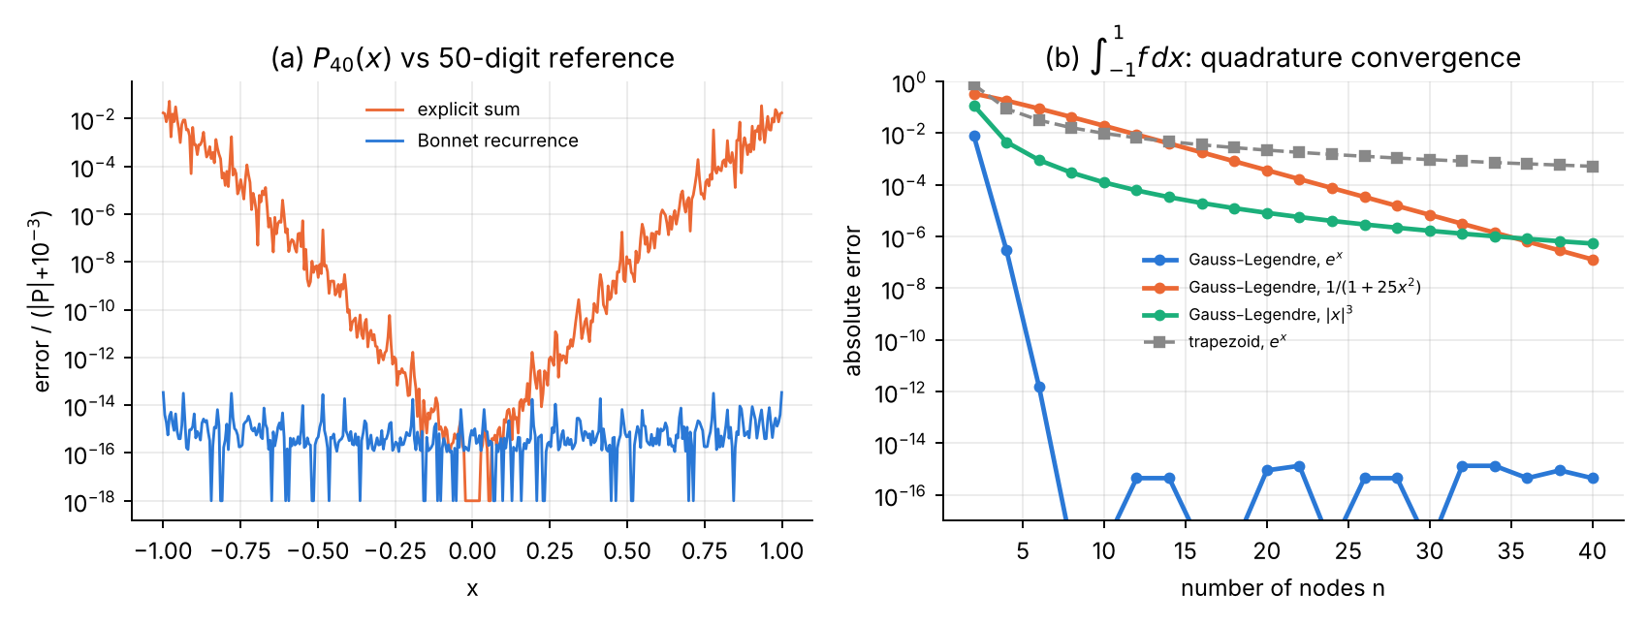
(a) $P_{40}\left(x\right)$: the explicit sum loses accuracy away from $x=0$, the Bonnet recurrence does not. (b) Gauss–Legendre converges exponentially for $e^{x}$ (machine precision with 8 nodes) and for the Runge function $1/\left(1+25x^{2}\right)$ (more slowly, because of the poles at $±i/5$), algebraically for ${\left|x\right|}^{3}$; the trapezoid rule converges only as $n^{−2}$.
N | h | m=0 first nodes | m=0 θ_s=0.4 | m=1 first nodes | m=1 θ_s=0.4 | m=2 first nodes | m=2 θ_s=0.4
20 | 0.157 | 1.44e-02 | 5.01e-04 | 2.84e-04 | 3.74e-04 | 1.65e-03 | 1.78e-03
40 | 0.0785 | 1.63e-02 | 6.88e-05 | 1.90e-04 | 2.03e-05 | 1.06e-04 | 1.06e-04
80 | 0.0393 | 1.70e-02 | 5.10e-06 | 5.60e-05 | 1.21e-06 | 6.93e-06 | 6.56e-06
160 | 0.0196 | 1.72e-02 | 3.49e-07 | 1.46e-05 | 7.30e-08 | 4.53e-07 | 4.09e-07
320 | 0.00982 | 1.73e-02 | 2.08e-08 | 3.69e-06 | 4.64e-09 | 2.95e-08 | 2.56e-08
640 | 0.00491 | 1.73e-02 | 1.40e-09 | 9.26e-07 | 2.83e-10 | 1.92e-09 | 1.59e-09
1280 | 0.00245 | 1.74e-02 | 9.75e-11 | 2.32e-07 | 2.00e-11 | 1.26e-10 | 1.04e-10
order |  | 0.0 | 3.9 | 1.9 | 4.0 | 3.9 | 4.0
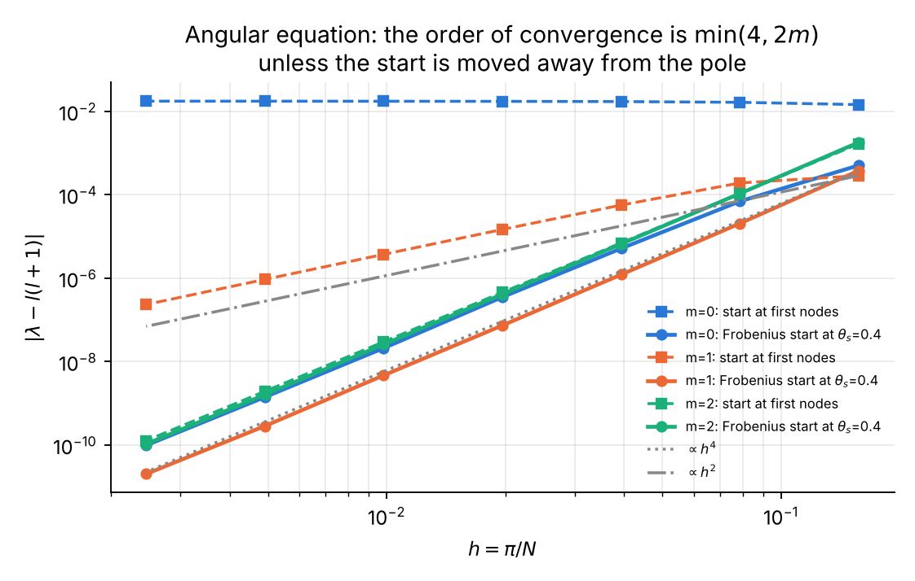
The start fault in the angular equation: with the start at the first grid nodes the order is $min\left(4,2m\right)$ — no convergence at all for $m=0$; the Frobenius start at fixed $θ_{s}$ gives order 4 for every $m$.
This table is the clearest illustration of the start fault of Part 0: for $m=0$ the error is $1.7×{10}^{−2}$ whatever the step — a calculation that looks perfectly converged in $h$ and is wrong in the second digit. Only a comparison with the exact result or a change of start strategy reveals it.

2.9 Exercises
- Gauss–Legendre exactness. Show that the $n$-point rule is exact for degree $2n−1$; verify that the 30-point rule integrates $x^{58}$ exactly. Answer: error $3.5×{10}^{−17}$.
- Addition theorem. Verify numerically $\sum_{m=−l}^{l}{{\left|Y_{lm}\left(θ,ϕ\right)\right|}^{2}}=\left(2l+1\right)/4π$ for $l=5$, $θ=0.7$ using plm_bar. Answer: $0.8753521870054248$ vs $0.8753521870054244$.
- Why does the Runge function converge slowly? Relate the convergence rate of Gauss–Legendre for $1/\left(1+25x^{2}\right)$ to the Bernstein ellipse through the poles $±i/5$, and estimate the rate $ρ^{−2n}$ with $ρ=0.2+\sqrt{1.04}=1.2198$. Answer: $ρ^{−80}=1.3×{10}^{−7}$, in agreement with the computed error $1.3×{10}^{−7}$ at $n=40$.
- Rotor in an electric field (Stark effect / hindered rotor). Add $βcosθ$ to the angular Hamiltonian ($m=0$): $u″+\left[λ+1/4+1/{4\sin^{2}θ}−βcosθ\right]u=0$. (a) Show that second-order perturbation theory gives $λ_{0}≈−β^{2}/6$. (b) Compute $λ_{0}$ for $β=0.1$ and $1$. (c) Trap: the Frobenius series must now include the expansion of $cosθ$ about each pole (different signs at the two poles); a series that ignores it gives a wrong answer that converges perfectly in $h$. Answer: $λ_{0}=−0.0016656495$ ($β=0.1$; perturbation theory $−0.0016667$), $λ_{0}=−0.157663483$ ($β=1$), confirmed by diagonalising the Hamiltonian in the basis ${\overset{‾}{P}}_{l}^{0}$, $l<40$, where $⟨l\left|cosθ\right|l+1⟩=\left(l+1\right)/\sqrt{\left(2l+1\right)\left(2l+3\right)}$.
- The $m=0$ fault, theory. Show that for $m=0$ the irregular solution behaves as $θ^{1/2}lnθ$ and explain why the eigenvalue error does not tend to zero: the ratio of regular to irregular solution at $θ≈h$ is $1/\left|lnh\right|$ instead of a positive power of $h$, and the contamination amplitude also involves the $h$-independent defect $δ$. The table shows that the error in fact settles at a constant, $≈1.7×{10}^{−2}$.

Chapter 3 — Cylindrical Bessel functions and the circular well

3.1 The function
Bessel’s equation of order $ν$ (DLMF §10.2; Watson 1944, ch. 3)
$$x^{2}y″+x y′+\left(x^{2}−ν^{2}\right) y=0$$
has the solution regular at the origin
$$J_{ν}\left(x\right)=\sum_{k=0}^{∞}{\frac{{\left(−1\right)}^{k}}{k! Γ\left(k+ν+1\right)}}(\frac{x}{2})^{2k+ν}$$
and a second solution $Y_{ν}$ that is singular at $x=0$ ($Y_{0}∼2/πlnx$, $Y_{n}∼−{\left(n−1\right)!}/π{\left(2/x\right)}^{n}$). For integer $n$ (DLMF §10.6, §10.9, §10.12, §10.17, §10.21; Watson 1944; Arfken et al. 2013, ch. 14):
- Recurrences: $J_{n−1}+J_{n+1}={2n}/xJ_{n}$, $J_{n−1}−J_{n+1}=2J_{n}′$.
- Integral representation (Bessel): $J_{n}\left(x\right)=\frac{1}{π}\int_{0}^{π}{cos}\left(nτ−xsinτ\right) dτ$.
- Generating function and Jacobi–Anger expansion: eixsinϕ=n​Jnxeinϕ, hence 1=J0+2k≥1​J2k and $cosx=J_{0}−2J_{2}+2J_{4}−…$
- Asymptotics: $J_{n}\left(x\right)≈\sqrt{2/πx}cos\left(x−nπ/2−π/4\right)$ for $x≫n$; $J_{n}\left(x\right)≈{\left(x/2\right)}^{n}/n!$ for $x≪\sqrt{n+1}$.
- Zeros $j_{n,s}$ (McMahon): $j_{n,s}≈β−\frac{μ−1}{8β}−\frac{4\left(μ−1\right)\left(7μ−31\right)}{3{\left(8β\right)}^{3}}$, $β=\left(s+n/2−1/4\right)π$, $μ=4n^{2}$.
- Orthogonality on $\left[0,1\right]$: $\int_{0}^{1}{J_{n}}\left(j_{n,s}r\right)J_{n}\left(j_{n,s′}r\right) r dr=1/2J_{n+1}{\left(j_{n,s}\right)}^{2} δ_{ss′}$.
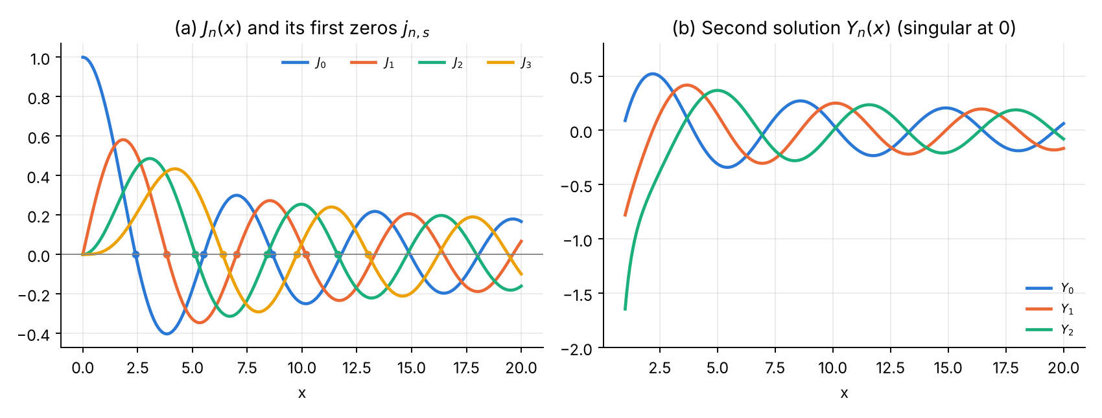
$J_{n}$ with its first zeros, and the singular second solution $Y_{n}$.

3.2 The physics: circular infinite well
A particle confined to a disc of radius $a=1$ (a “quantum corral”, a cylindrical waveguide, a drum) obeys $−1/2∇^{2}ψ=Eψ$ with $ψ=0$ at $r=1$. Separation $ψ=R\left(r\right)e^{imϕ}$ gives Bessel’s equation in $kr$, $k=\sqrt{2E}$; regularity at the origin selects $J_{m}$ and the boundary condition gives
$$E_{m,s}=\frac{j_{m,s}^{2}}{2}, R_{m,s}\left(r\right)=\frac{\sqrt{2} J_{m}\left(j_{m,s}r\right)}{\left|J_{m+1}\left(j_{m,s}\right)\right|} \left(\int_{0}^{1}{R^{2}} r dr=1\right).$$
States with $m≠0$ are doubly degenerate ($±m$). Exact check: $⟨r^{2}⟩=1/3+{2\left(m^{2}−1\right)}/{3j_{m,s}^{2}}$ (follows from the Bessel-function integrals of Watson 1944, §5.11).

3.3 Analytical scheme
Part A — computing $J_{n}\left(x\right)$.
- Power series — accurate for small $x$, but its terms reach $∼e^{x}/\sqrt{x}$ while the sum is $O\left(x^{−1/2}\right)$: cancellation for large $x$.
- Forward recurrence from $J_{0},J_{1}$ — unstable for $n>x$ ($J_{n}$ is minimal).
- Miller’s algorithm (recommended): choose even $M>max\left(n,x\right)+\sqrt{64max\left(n,x\right)}+10$, set $f_{M+1}=0$, $f_{M}={10}^{−30}$, recur downwards with rescaling, normalise by $f_{0}+2∑f_{2k}$.
- Trapezoid rule on the Bessel integral: the integrand is smooth and periodic, so the trapezoid rule converges geometrically once the number of panels exceeds $≈x+n$.
- Zeros: McMahon start, Newton with $J_{n}′=\left(J_{n−1}−J_{n+1}\right)/2$.
Part B — Numerov. $u=\sqrt{r} R$:
u″+2E−m2−14r2u=0, u1=0, u=rm+1/2k​akr2k, 2k2k+2m ak=−2E ak−1.
Outward shooting from the Frobenius values on $\left[0,r_{s}+h\right]$ ($r_{s}=1/8$, or the first two nodes for comparison) to $r=1$; bisection on the sign of $F\left(E\right)=u_{N}\left(E\right)$ in $\left[0.85,1.15\right]×j_{m,s}^{2}/2$, with the zeros from Part A.

3.4 Logic chart
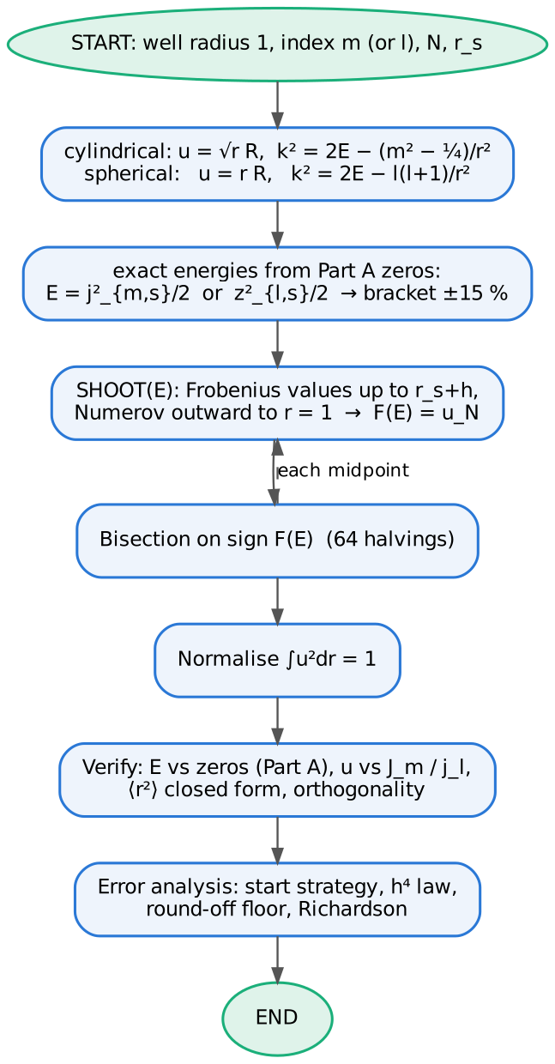
Logic chart common to Chapters 3 and 4 (Part B).

3.5 Python 3 code
File: ch3_bessel_circular.py
#!/usr/bin/env python3
"""
Chapter 3 -- BESSEL FUNCTIONS J_n (cylindrical) and the CIRCULAR INFINITE WELL
==============================================================================
Part A : computation of J_n(x)
* power series DLMF §10.2 (cancellation)
* forward recurrence J_{n+1} = (2n/x) J_n - J_{n-1} DLMF §10.6 (unstable n > x)
* Miller backward recurrence + normalisation
J_0 + 2 sum J_{2k} = 1 DLMF §3.6(iii), §10.12
* trapezoid on the Bessel integral DLMF §10.9 (geometric convergence)
* zeros j_{n,s}: McMahon asymptotics + Newton DLMF §10.21
* verification: mpmath 50-digit reference, Jacobi-Anger identity
cos x = J_0 - 2 J_2 + 2 J_4 - ... (DLMF §10.12), scipy.special.jv
Part B : particle in a circular infinite well of radius 1 (hbar = m = 1)
psi = R(r) e^{i m phi}, u = sqrt(r) R :
u'' + [ 2E - (m^2 - 1/4)/r^2 ] u = 0 , u(1) = 0 , u ~ r^{m+1/2}
exact E_{m,s} = j_{m,s}^2 / 2 , R = J_m(j r) sqrt(2)/|J_{m+1}(j)|
Numerov outward shooting with Frobenius start at r_s, bisection on u(1)
* verification: normalisation int R^2 r dr = 1, comparison with J_m,
orthogonality, energies vs zeros computed in Part A
* error analysis: start at first nodes (order 2m, no convergence for m=0)
vs fixed r_s (order 4); Richardson
Outputs: tables + ch3_functions.png, ch3_partA_errors.png, ch3_well.png, ch3_convergence.png
"""
import numpy as np
from math import factorial, lgamma, exp
import mpmath as mp
from scipy.special import jv
import matplotlib
matplotlib.use("Agg")
import matplotlib.pyplot as plt
C = ["#2a78d6", "#eb6834", "#1baf7a", "#eda100", "#e87ba4", "#7a5cd6"]
mp.mp.dps = 50
def style(ax):
ax.spines[["top", "right"]].set_visible(False); ax.grid(alpha=.25, which="both")
# ============================================================ PART A
def J_series(n, x, kmax=200):
"""J_n(x) = sum_k (-1)^k (x/2)^{2k+n} / (k! (k+n)!)"""
x = float(x); s = 0.0
term = (x / 2) ** n / factorial(n)
for k in range(kmax):
s += term
term *= -(x / 2) ** 2 / ((k + 1) * (k + 1 + n))
if abs(term) < 1e-17 * abs(s) and k > x: break
return s
def J_forward(nmax, x, J0, J1):
J = np.zeros(nmax + 1); J[0], J[1] = J0, J1
for n in range(1, nmax):
J[n + 1] = 2 * n / x * J[n] - J[n - 1]
return J
def miller_start(nmax, x, digits=16):
"""starting index for Miller's algorithm (Numerical Recipes style + margin)"""
return 2 * ((max(nmax, int(x)) + int(np.sqrt(digits * 4 * max(nmax, int(x), 1))) + 10) // 2)
def J_miller(nmax, x, M=None):
"""J_0..J_nmax(x) by backward recurrence from M (even), normalised with
J_0 + 2 (J_2 + J_4 + ...) = 1. Valid for x > 0."""
if M is None: M = miller_start(nmax, x)
M += M % 2
f = np.zeros(M + 2); f[M + 1] = 0.0; f[M] = 1e-30
for n in range(M, 0, -1):
f[n - 1] = 2 * n / x * f[n] - f[n + 1]
if abs(f[n - 1]) > 1e250: # rescale to avoid overflow
f[n - 1:] *= 1e-250
norm = f[0] + 2 * f[2:M + 1:2].sum()
return f[:nmax + 1] / norm
def J_trapezoid(n, x, K):
"""J_n(x) = (1/pi) int_0^pi cos(n t - x sin t) dt with K-panel trapezoid"""
t = np.linspace(0, np.pi, K + 1)
f = np.cos(n * t - x * np.sin(t))
return (f.sum() - 0.5 * (f[0] + f[-1])) / K
def J(n, x):
"""recommended: Miller for x>0, J_n(0)=delta"""
if x == 0: return 1.0 if n == 0 else 0.0
return J_miller(n + 1, x)[n]
def dJ(n, x):
Jm = J_miller(n + 2, x)
return (Jm[n - 1] - Jm[n + 1]) / 2 if n > 0 else -Jm[1]
def bessel_zeros(n, S):
"""first S positive zeros of J_n: McMahon start, Newton refinement"""
z = []
mu = 4 * n * n
for s in range(1, S + 1):
b = (s + n / 2 - 0.25) * np.pi
x = b - (mu - 1) / (8 * b) - 4 * (mu - 1) * (7 * mu - 31) / (3 * (8 * b) ** 3)
for _ in range(50):
Jm = J_miller(n + 2, x)
d = (Jm[n - 1] - Jm[n + 1]) / 2 if n > 0 else -Jm[1]
dx = Jm[n] / d; x -= dx
if abs(dx) < 1e-15 * x: break
z.append(x)
return np.array(z)
def partA():
print("=" * 78)
print("PART A Bessel functions of the first kind J_n(x)")
print("=" * 78)
print("J_n(x): series / Miller / mpmath")
print(f"{'n':>3} {'x':>6} {'Miller':>24} {'mpmath':>24} {'rel.err Miller':>15} {'rel.err series':>15}")
for n, x in ((0, 1.0), (5, 10.0), (0, 30.0), (3, 50.0), (20, 5.0), (50, 1.0)):
ref = float(mp.besselj(n, x))
jm = J(n, x); js = J_series(n, x)
print(f"{n:3d} {x:6.1f} {jm:24.15e} {ref:24.15e} {abs(jm-ref)/abs(ref):15.2e} {abs(js-ref)/abs(ref):15.2e}")
# forward recurrence instability at x = 1
x = 1.0
Jm = J_miller(30, x)
Jf = J_forward(30, x, Jm[0], Jm[1])
ref = np.array([float(mp.besselj(n, x)) for n in range(31)])
print("\nForward vs backward recurrence at x = 1 (relative error):")
for n in (2, 5, 10, 15, 20, 25, 30):
print(f" n={n:2d}: forward {abs(Jf[n]-ref[n])/abs(ref[n]):9.2e} Miller {abs(Jm[n]-ref[n])/abs(ref[n]):9.2e} J_n = {ref[n]:.3e}")
# Jacobi-Anger identity check
for x in (0.5, 7.3, 25.0):
Jm = J_miller(80, x)
s = Jm[0] + 2 * sum((-1) ** k * Jm[2 * k] for k in range(1, 40))
print(f" Jacobi-Anger x={x:5.1f}: J0 - 2J2 + 2J4 - ... - cos x = {s-np.cos(x):.1e}")
xs = np.linspace(0.1, 40, 50)
print(f" max |J_miller - scipy jv| for n<=10, 0.1<x<40: "
f"{max(np.max(abs(J_miller(10, x) - jv(np.arange(11), x))) for x in xs):.1e}")
z = {n: bessel_zeros(n, 5) for n in range(4)}
for n in range(4):
refz = [float(mp.besseljzero(n, s)) for s in range(1, 6)]
print(f" zeros J_{n}: " + ", ".join(f"{v:.12f}" for v in z[n]) + f" max err {max(abs(z[n]-refz)):.1e}")
# error-analysis data
xx = np.linspace(0.5, 60, 240)
ref0 = np.array([float(mp.besselj(0, x)) for x in xx])
e_ser = [abs(J_series(0, x) - r) for x, r in zip(xx, ref0)]
e_mil = [abs(J(0, x) - r) for x, r in zip(xx, ref0)]
Ms = np.arange(2, 62, 2)
x = 10.0; r5 = float(mp.besselj(5, x))
e_M = [abs(J_miller(5, x, M=M)[5] - r5) / abs(r5) if M > 5 else np.nan for M in Ms]
Ks = np.arange(2, 41, 1)
e_K = [abs(J_trapezoid(5, x, K) - r5) / abs(r5) + 1e-18 for K in Ks]
nn = np.arange(31)
e_f = abs(Jf - ref) / abs(ref); e_b = abs(J_miller(30, 1.0) - ref) / abs(ref)
print("\nMiller start index M (x=10, n=5): " + " ".join(f"M={M}:{e:.1e}" for M, e in zip(Ms, e_M) if M in (10, 16, 20, 26, 30, 40)))
print("Trapezoid panels K (x=10, n=5): " + " ".join(f"K={K}:{e:.1e}" for K, e in zip(Ks, e_K) if K in (5, 10, 15, 20, 25, 30)))
fig, ax = plt.subplots(1, 2, figsize=(10, 3.8))
xg = np.linspace(0.001, 20, 600)
for n in range(4):
ax[0].plot(xg, [J(n, v) for v in xg], color=C[n], lw=2, label=f"$J_{n}$")
ax[0].plot(z[n][:3], 0 * z[n][:3], "o", ms=4, color=C[n])
ax[0].axhline(0, color="#888888", lw=.8)
ax[0].set(xlabel="x", title=r"(a) $J_n(x)$ and its first zeros $j_{n,s}$")
ax[0].legend(frameon=False, fontsize=8, ncol=4)
from scipy.special import yv
for n in range(3):
ax[1].plot(xg[30:], yv(n, xg[30:]), color=C[n], lw=2, label=f"$Y_{n}$")
ax[1].set(ylim=(-2, 0.8), xlabel="x", title=r"(b) Second solution $Y_n(x)$ (singular at 0)")
ax[1].legend(frameon=False, fontsize=8)
for a_ in ax: style(a_)
fig.tight_layout(); fig.savefig("ch3_functions.png", dpi=170)
fig, ax = plt.subplots(1, 3, figsize=(13, 3.7))
ax[0].semilogy(xx, np.array(e_ser) + 1e-18, color=C[1], lw=1.5, label="power series")
ax[0].semilogy(xx, np.array(e_mil) + 1e-18, color=C[0], lw=1.5, label="Miller")
ax[0].set(xlabel="x", ylabel="absolute error", title=r"(a) $J_0(x)$: series cancellation")
ax[0].legend(frameon=False, fontsize=8)
ax[1].semilogy(nn[1:], e_f[1:] + 1e-18, "s-", color=C[1], lw=1.5, ms=4, label="forward recurrence")
ax[1].semilogy(nn[1:], e_b[1:] + 1e-18, "o-", color=C[0], lw=1.5, ms=4, label="backward (Miller)")
ax[1].set(xlabel="order n", ylabel="relative error", title="(b) Recurrence direction, x = 1")
ax[1].legend(frameon=False, fontsize=8)
ax[2].semilogy(Ms, e_M, "o-", color=C[0], lw=1.5, ms=4, label="Miller, start index M")
ax[2].semilogy(Ks, e_K, "s-", color=C[2], lw=1.5, ms=4, label="trapezoid, K panels")
ax[2].set(xlabel="M or K", ylabel="relative error", title=r"(c) Convergence for $J_5(10)$")
ax[2].legend(frameon=False, fontsize=8)
for a_ in ax: style(a_)
fig.tight_layout(); fig.savefig("ch3_partA_errors.png", dpi=170)
return z
# ============================================================ PART B
def frobenius(r, m, E, nterm=40):
"""u = r^{m+1/2} sum a_k r^{2k}, 2k(2k+2m) a_k = -2E a_{k-1}"""
r = np.asarray(r, float)
s = np.zeros_like(r); a = 1.0; p = np.ones_like(r)
for k in range(nterm):
s += a * p
a = -2 * E * a / ((2 * k + 2) * (2 * k + 2 + 2 * m)); p = p * r * r
return r ** (m + 0.5) * s
def simpson(y, h):
return h / 3 * (y[0] + y[-1] + 4 * y[1:-1:2].sum() + 2 * y[2:-1:2].sum())
def shoot(E, m, N, rs):
h = 1.0 / N; r = h * np.arange(N + 1)
k2 = np.zeros(N + 1); k2[1:] = 2 * E - (m * m - 0.25) / r[1:] ** 2
c = 1 + h * h * k2 / 12
js = max(1, int(rs / h + 0.5))
u = np.zeros(N + 1); u[:js + 2] = frobenius(r[:js + 2], m, E)
for n in range(js + 1, N):
u[n + 1] = ((12 - 10 * c[n]) * u[n] - c[n - 1] * u[n - 1]) / c[n + 1]
return u, r
def eigen(m, s, N, rs=0.125, zeros=None):
Ex = zeros[m][s - 1] ** 2 / 2
a, b = Ex * 0.85, Ex * 1.15
fa = shoot(a, m, N, rs)[0][-1]
for _ in range(64):
mid = 0.5 * (a + b); fm = shoot(mid, m, N, rs)[0][-1]
if np.sign(fm) == np.sign(fa): a, fa = mid, fm
else: b = mid
E = 0.5 * (a + b)
u, r = shoot(E, m, N, rs)
u /= np.sqrt(simpson(u * u, r[1]))
j = zeros[m][s - 1]
ex = np.sqrt(r) * np.array([J(m, j * v) for v in r]) * np.sqrt(2) / abs(J(m + 1, j))
if np.dot(u, ex) < 0: u = -u
return E, u, r, ex
def partB(z):
print("\n" + "=" * 78)
print("PART B Circular infinite well, radius 1: Numerov in u = sqrt(r) R, N = 400, r_s = 0.125")
print("=" * 78)
# scan, m = 0
Eg = np.linspace(0.5, 80, 800)
F = np.array([shoot(E, 0, 400, 0.125)[0][-1] for E in Eg])
roots = [0.5 * (Eg[i] + Eg[i + 1]) for i in np.where(np.sign(F[:-1]) != np.sign(F[1:]))[0]]
print(" scan m=0: sign changes of u(1;E) near " + ", ".join(f"{v:.2f}" for v in roots)
+ " (exact j_{0,s}^2/2 = " + ", ".join(f"{v**2/2:.2f}" for v in z[0][:4]) + ")")
print(f"\n{'m':>2} {'s':>2} {'E Numerov':>17} {'j^2/2 (Part A)':>17} {'|dE|':>9} {'norm':>15} {'max|u-u_ex|':>12} {'<r^2>':>10} {'exact':>10}")
store = {}
for (m, s) in ((0, 1), (0, 2), (0, 3), (1, 1), (1, 2), (2, 1), (3, 1)):
E, u, r, ex = eigen(m, s, 400, zeros=z)
Ex = z[m][s - 1] ** 2 / 2
store[m, s] = (u, r, ex)
print(f"{m:2d} {s:2d} {E:17.12f} {Ex:17.12f} {abs(E-Ex):9.1e} {simpson(u*u,r[1]):15.12f} {np.max(abs(u-ex)):12.1e} {simpson(u*u*r*r, r[1]):10.6f} {1/3+2*(m*m-1)/(3*z[m][s-1]**2):10.6f}")
ov = max(abs(simpson(store[0, a][0] * store[0, b][0], 1 / 400)) for a in (1, 2, 3) for b in (1, 2, 3) if a < b)
print(f" orthogonality (m=0, s=1,2,3): max |<u_s|u_s'>| = {ov:.1e}")
Ns = np.array([20, 40, 80, 160, 320, 640, 1280])
hs = 1.0 / Ns
err = {}
for m in (0, 1, 2):
Ex = z[m][0] ** 2 / 2
for rs, lab in ((0.0, "first nodes"), (0.125, "r_s")):
err[m, lab] = [abs(eigen(m, 1, N, rs, z)[0] - Ex) for N in Ns]
print("\nError of E_{m,1} vs h: Frobenius start at first nodes vs at fixed r_s = 0.125")
print(f"{'N':>6} {'h':>9}" + "".join(f" {'m=%d nodes' % m:>12} {'m=%d r_s' % m:>11}" for m in (0, 1, 2)))
for i, N in enumerate(Ns):
print(f"{N:6d} {hs[i]:9.6f}" + "".join(f" {err[m,'first nodes'][i]:12.2e} {err[m,'r_s'][i]:11.2e}" for m in (0, 1, 2)))
for m in (0, 1, 2):
for lab in ("first nodes", "r_s"):
e = np.array(err[m, lab]); ok = e > 1e-12
print(f" m={m} {lab:12s}: observed order {np.polyfit(np.log(hs[ok][1:6]), np.log(e[ok][1:6]), 1)[0]:.2f}")
E1 = eigen(0, 1, 160, 0.125, z)[0]; E2 = eigen(0, 1, 320, 0.125, z)[0]
ER = (16 * E2 - E1) / 15
print(f"Richardson m=0: E(1/160)={E1:.12f} E(1/320)={E2:.12f} E_R={ER:.12f} err={abs(ER - z[0][0]**2/2):.1e}")
fig, ax = plt.subplots(1, 2, figsize=(10, 3.9))
for i, (m, s) in enumerate(((0, 1), (0, 2), (1, 1), (2, 1), (1, 2))):
u, r, ex = store[m, s]
R = np.zeros_like(u); R[1:] = u[1:] / np.sqrt(r[1:]); R[0] = R[1] if m == 0 else 0
ax[0].plot(r, R, color=C[i], lw=2, label=f"m={m}, s={s}")
ax[0].plot(r[1::16], ex[1::16] / np.sqrt(r[1::16]), "o", ms=2.5, color="#333333")
ax[0].set(xlabel="r", ylabel="R(r)", title=r"(a) Radial functions (dots: $\sqrt{2}J_m(jr)/|J_{m+1}(j)|$)")
ax[0].legend(frameon=False, fontsize=7, ncol=2)
# 2D density of (m=1,s=2) cos(phi) standing wave
xg = np.linspace(-1, 1, 241); X, Y = np.meshgrid(xg, xg)
Rr = np.hypot(X, Y); Ph = np.arctan2(Y, X)
j = z[1][1]
psi = np.where(Rr <= 1, jv(1, j * Rr) * np.cos(Ph), np.nan)
im = ax[1].imshow(psi ** 2, extent=(-1, 1, -1, 1), origin="lower", cmap="Blues")
ax[1].set(title=r"(b) $|\psi|^2$ for m=1, s=2 ($\cos\phi$ standing wave)", xlabel="x", ylabel="y")
style(ax[0])
fig.tight_layout(); fig.savefig("ch3_well.png", dpi=170)
fig, ax = plt.subplots(figsize=(6.6, 4.2))
for i, m in enumerate((0, 1, 2)):
ax.loglog(hs, err[m, "first nodes"], "s--", color=C[i], lw=1.5, ms=5, label=f"m={m}: start at first nodes")
ax.loglog(hs, err[m, "r_s"], "o-", color=C[i], lw=2, ms=5, label=fr"m={m}: Frobenius start at $r_s$=1/8")
ax.loglog(hs, err[0, "r_s"][0] * (hs / hs[0]) ** 4, ":", color="#888888", label=r"$\propto h^4$")
ax.loglog(hs, err[1, "first nodes"][0] * (hs / hs[0]) ** 2, "-.", color="#888888", label=r"$\propto h^2$")
ax.set(xlabel="h = 1/N", ylabel=r"$|E_{m,1}-j_{m,1}^2/2|$", title="Circular well: the start fault (order $\\min(4,2m)$)\nand its cure")
ax.legend(frameon=False, fontsize=7); style(ax)
fig.tight_layout(); fig.savefig("ch3_convergence.png", dpi=170)
if __name__ == "__main__":
z = partA(); partB(z)

3.6 Fortran 2008 code
File: ch3_bessel_circular.f90
!=======================================================================
! Chapter 3 -- BESSEL FUNCTIONS J_n and the CIRCULAR INFINITE WELL (F2008)
! Part A: J_n(x) by Miller's backward recurrence (normalised with
! J0 + 2 sum J_2k = 1), forward recurrence, power series,
! zeros by McMahon + Newton; independent check with the Fortran
! 2008 intrinsic bessel_jn and the Jacobi-Anger identity
! Part B: u = sqrt(r) R, u'' + [2E - (m^2-1/4)/r^2] u = 0, u(1) = 0
! Numerov outward shooting + bisection, Frobenius start
! Output: screen tables + ch3_f_conv.dat
! Compile: gfortran -O2 -o ch3 ch3_bessel_circular.f90 && ./ch3
!=======================================================================
module bessel_mod
implicit none
integer, parameter :: dp = kind(1.0d0)
real(dp), parameter :: pi = 3.141592653589793238_dp
contains
! J_0..J_nmax(x), x > 0, Miller backward recurrence from even index M
subroutine j_miller(nmax, x, Jv, Mstart)
integer, intent(in) :: nmax
real(dp), intent(in) :: x
real(dp), intent(out) :: Jv(0:nmax)
integer, intent(in), optional :: Mstart
real(dp), allocatable :: f(:)
real(dp) :: nrm
integer :: M, k
if (present(Mstart)) then
M = Mstart
else
M = 2*((max(nmax, int(x)) + int(sqrt(64.0_dp*max(nmax, int(x), 1))) + 10)/2)
end if
M = M + mod(M, 2)
allocate(f(0:M+1))
f = 0.0_dp; f(M) = 1.0d-30
do k = M, 1, -1
f(k-1) = 2*k/x*f(k) - f(k+1)
if (abs(f(k-1)) > 1.0d250) f(k-1:M+1) = f(k-1:M+1)*1.0d-250
end do
nrm = f(0) + 2*sum(f(2:M:2))
Jv = 0.0_dp
Jv(0:min(nmax, M)) = f(0:min(nmax, M))/nrm
end subroutine j_miller
real(dp) function J(n, x)
integer, intent(in) :: n
real(dp), intent(in) :: x
real(dp) :: Jv(0:n+1)
if (x == 0.0_dp) then
J = merge(1.0_dp, 0.0_dp, n == 0); return
end if
call j_miller(n+1, x, Jv); J = Jv(n)
end function J
real(dp) function j_series(n, x)
integer, intent(in) :: n
real(dp), intent(in) :: x
real(dp) :: term
integer :: k
term = (x/2)**n/gamma(n + 1.0_dp); j_series = 0.0_dp
do k = 0, 300
j_series = j_series + term
term = -term*(x/2)**2/((k + 1)*(k + 1 + n))
if (abs(term) < 1.0d-17*abs(j_series) .and. k > x) exit
end do
end function j_series
subroutine bessel_zeros(n, S, z)
integer, intent(in) :: n, S
real(dp), intent(out) :: z(S)
real(dp) :: bb, mu, x, dx, Jv(0:n+2), d
integer :: k, it
mu = 4.0_dp*n*n
do k = 1, S
bb = (k + n/2.0_dp - 0.25_dp)*pi
x = bb - (mu - 1)/(8*bb) - 4*(mu - 1)*(7*mu - 31)/(3*(8*bb)**3)
do it = 1, 50
call j_miller(n+2, x, Jv)
if (n > 0) then
d = (Jv(n-1) - Jv(n+1))/2
else
d = -Jv(1)
end if
dx = Jv(n)/d; x = x - dx
if (abs(dx) < 1.0d-15*x) exit
end do
z(k) = x
end do
end subroutine bessel_zeros
end module bessel_mod
module well_mod
use bessel_mod
implicit none
contains
real(dp) function frob(r, m, E)
real(dp), intent(in) :: r, E
integer, intent(in) :: m
real(dp) :: a, s, p
integer :: k
s = 0.0_dp; a = 1.0_dp; p = 1.0_dp
do k = 0, 39
s = s + a*p
a = -2*E*a/((2*k + 2)*(2*k + 2 + 2*m)); p = p*r*r
end do
frob = r**(m + 0.5_dp)*s
end function frob
real(dp) function simpson(y, h, n)
integer, intent(in) :: n
real(dp), intent(in) :: y(0:n), h
simpson = h/3*(y(0) + y(n) + 4*sum(y(1:n-1:2)) + 2*sum(y(2:n-2:2)))
end function simpson
subroutine shoot(E, m, N, rs, u)
real(dp), intent(in) :: E, rs
integer, intent(in) :: m, N
real(dp), intent(out) :: u(0:N)
real(dp) :: h, r(0:N), c(0:N)
integer :: j, js
h = 1.0_dp/N; r = [(j*h, j=0,N)]
c(0) = 1.0_dp; c(1:N) = 1 + h*h*(2*E - (m*m - 0.25_dp)/r(1:N)**2)/12
js = max(1, nint(rs/h))
u = 0.0_dp
do j = 0, js+1
u(j) = frob(r(j), m, E)
end do
do j = js+1, N-1
u(j+1) = ((12 - 10*c(j))*u(j) - c(j-1)*u(j-1))/c(j+1)
end do
end subroutine shoot
subroutine eigen(m, Ex, N, rs, E, u)
integer, intent(in) :: m, N
real(dp), intent(in) :: Ex, rs
real(dp), intent(out) :: E, u(0:N)
real(dp) :: a, b, fa, mid
integer :: it
a = 0.85_dp*Ex; b = 1.15_dp*Ex
call shoot(a, m, N, rs, u); fa = u(N)
do it = 1, 64
mid = 0.5_dp*(a + b)
call shoot(mid, m, N, rs, u)
if (sign(1.0_dp, u(N)) == sign(1.0_dp, fa)) then
a = mid; fa = u(N)
else
b = mid
end if
end do
E = 0.5_dp*(a + b)
call shoot(E, m, N, rs, u)
u = u/sqrt(simpson(u*u, 1.0_dp/N, N))
end subroutine eigen
end module well_mod
program ch3
use bessel_mod
use well_mod
implicit none
integer, parameter :: NN = 400
real(dp) :: Jv(0:80), Jf(0:30), z(0:3,5), x, s, E, u(0:NN), uex(0:NN), r, Eex, e1(7), e2(7), maxd
real(dp), allocatable :: uu(:)
integer :: i, k, m, n, sidx, Ns(7) = [20, 40, 80, 160, 320, 640, 1280]
real(dp) :: xja(3) = [0.5_dp, 7.3_dp, 25.0_dp]
integer :: mlist(7) = [0,0,0,1,1,2,3], slist(7) = [1,2,3,1,2,1,1]
print '(a)', repeat('=',78)
print '(a)', 'PART A Bessel functions J_n (Fortran); reference = intrinsic bessel_jn'
print '(a)', repeat('=',78)
maxd = 0.0_dp
do i = 1, 400
x = 0.1_dp*i
call j_miller(10, x, Jv(0:10))
do n = 0, 10
maxd = max(maxd, abs(Jv(n) - bessel_jn(n, x)))
end do
end do
print '(a,es9.2)', ' max |J_miller - bessel_jn| for n<=10, 0.1<=x<=40: ', maxd
print '(a)', ' power series vs Miller (relative difference):'
print '(a,2es24.15,es10.2)', ' J_0(30): ', j_series(0, 30.0_dp), J(0, 30.0_dp), abs(j_series(0,30.0_dp)/J(0,30.0_dp)-1)
print '(a,2es24.15,es10.2)', ' J_3(50): ', j_series(3, 50.0_dp), J(3, 50.0_dp), abs(j_series(3,50.0_dp)/J(3,50.0_dp)-1)
call j_miller(30, 1.0_dp, Jv(0:30))
Jf(0) = Jv(0); Jf(1) = Jv(1)
do n = 1, 29
Jf(n+1) = 2*n/1.0_dp*Jf(n) - Jf(n-1)
end do
print '(a)', ' forward recurrence at x = 1, relative error vs Miller:'
do n = 5, 30, 5
print '(a,i3,a,es10.2,a,es10.2)', ' n=', n, ' forward ', abs(Jf(n)/Jv(n) - 1), &
' Miller vs bessel_jn ', abs(Jv(n)/bessel_jn(n, 1.0_dp) - 1)
end do
do k = 1, 3
x = xja(k)
call j_miller(80, x, Jv)
s = Jv(0)
do i = 1, 40
s = s + 2*(-1)**i*Jv(2*i)
end do
print '(a,f5.1,a,es9.1)', ' Jacobi-Anger x=', x, ': J0 - 2J2 + 2J4 - ... - cos x = ', s - cos(x)
end do
do m = 0, 3
call bessel_zeros(m, 5, z(m,:))
print '(a,i1,a,5f16.12)', ' zeros J_', m, ':', z(m,:)
end do
print '(a,4es9.1)', ' check |bessel_jn(m, j_m1)|:', (abs(bessel_jn(m, z(m,1))), m=0,3)
print '(/a)', repeat('=',78)
print '(a)', 'PART B Circular infinite well, Numerov, N = 400, r_s = 0.125'
print '(a)', repeat('=',78)
print '(a2,a3,a17,a17,a10,a16,a12,a10,a10)', 'm', 's', 'E Numerov', 'j^2/2', '|dE|', 'norm', 'max|u-ue|', '<r^2>', 'exact'
do k = 1, 7
m = mlist(k); sidx = slist(k); Eex = z(m,sidx)**2/2
call eigen(m, Eex, NN, 0.125_dp, E, u)
do i = 0, NN
r = i/real(NN,dp)
uex(i) = sqrt(r)*bessel_jn(m, z(m,sidx)*r)*sqrt(2.0_dp)/abs(bessel_jn(m+1, z(m,sidx)))
end do
if (sum(u*uex) < 0) u = -u
print '(i2,i3,2f17.12,es10.1,f16.12,es12.1,2f10.6)', m, sidx, E, Eex, abs(E - Eex), &
simpson(u*u, 1.0_dp/NN, NN), maxval(abs(u - uex)), &
simpson(u*u*[((i/real(NN,dp))**2, i=0,NN)], 1.0_dp/NN, NN), 1/3.0_dp + 2*(m*m - 1)/(3*z(m,sidx)**2)
end do
open(10, file='ch3_f_conv.dat', status='replace')
print '(/a)', 'Error of E_{m,1} vs N: start at first nodes | at r_s = 1/8'
do m = 0, 2
Eex = z(m,1)**2/2
do i = 1, 7
allocate(uu(0:Ns(i)))
call eigen(m, Eex, Ns(i), 0.0_dp, E, uu); e1(i) = abs(E - Eex)
call eigen(m, Eex, Ns(i), 0.125_dp, E, uu); e2(i) = abs(E - Eex)
write(10,'(i3,i6,3es16.7)') m, Ns(i), 1.0_dp/Ns(i), e1(i), e2(i)
deallocate(uu)
end do
print '(a,i1,a,7es9.1)', ' m=', m, ' first nodes:', e1
print '(a,i1,a,7es9.1)', ' m=', m, ' r_s = 1/8 :', e2
end do
close(10)
end program ch3

3.7 Results, normalisation and verification
Part A.
n | x | Miller | rel. error Miller | rel. error series
0 | 1 | 0.7651976865579666 | 0 | 0
5 | 10 | −0.2340615281867937 | 3.6e-16 | 3.9e-14
0 | 30 | −0.08636798358104024 | 3.2e-16 | 1.4e-04
3 | 50 | 0.09273480406163438 | 6.0e-16 | 2.9e+04
20 | 5 | 2.770330052128941e-11 | 3.5e-16 | 2.3e-16
50 | 1 | 2.906004948173239e-80 | 1.3e-16 | 1.3e-16
Forward recurrence at $x=1$ (started from exact $J_{0},J_{1}$): relative error $1.9×{10}^{−11}$ at $n=5$, $8.2$ at $n=10$, ${10}^{64}$ at $n=30$; Miller stays at $4×{10}^{−16}$. Independent checks: Jacobi–Anger identity satisfied to $4×{10}^{−16}$ for $x=0.5,7.3,25$; agreement with SciPy jv ($5×{10}^{−16}$) and with the Fortran intrinsic bessel_jn ($3×{10}^{−16}$, $n≤10$, $0.1≤x≤40$). Zeros $j_{n,s}$ ($n≤3$, $s≤5$) agree with mpmath to $≤2×{10}^{−15}$; e.g. $j_{0,1}=2.404825557696$, $j_{1,1}=3.831705970208$.
Part B ($N=400$, $r_{s}=1/8$):
m | s | E Numerov | j²/2 (Part A) | |ΔE| | ∫u²dr | max|u − u_ex| | ⟨r²⟩ | exact
0 | 1 | 2.891592973150 | 2.891592981473 | 8.3e-09 | 1.000000000000 | 1.7e-09 | 0.218057 | 0.218057
0 | 2 | 15.235631154365 | 15.235631171831 | 1.7e-08 | 1.000000000000 | 2.2e-09 | 0.311455 | 0.311455
0 | 3 | 37.443503350309 | 37.443503395348 | 4.5e-08 | 1.000000000000 | 1.9e-09 | 0.324431 | 0.324431
1 | 1 | 7.340985321312 | 7.340985321062 | 2.5e-10 | 1.000000000000 | 1.2e-10 | 0.333333 | 0.333333
1 | 2 | 24.609228154294 | 24.609228160847 | 6.6e-09 | 1.000000000000 | 4.3e-10 | 0.333333 | 0.333333
2 | 1 | 13.187308212838 | 13.187308213582 | 7.4e-10 | 1.000000000000 | 4.9e-11 | 0.409164 | 0.409164
3 | 1 | 20.353232907800 | 20.353232909100 | 1.3e-09 | 1.000000000000 | 1.8e-10 | 0.464353 | 0.464353
Orthogonality of the $m=0$ states: $7.5×{10}^{−10}$. (Note $⟨r^{2}⟩=1/3$ exactly for every $m=1$ state — a nice check of the formula.)
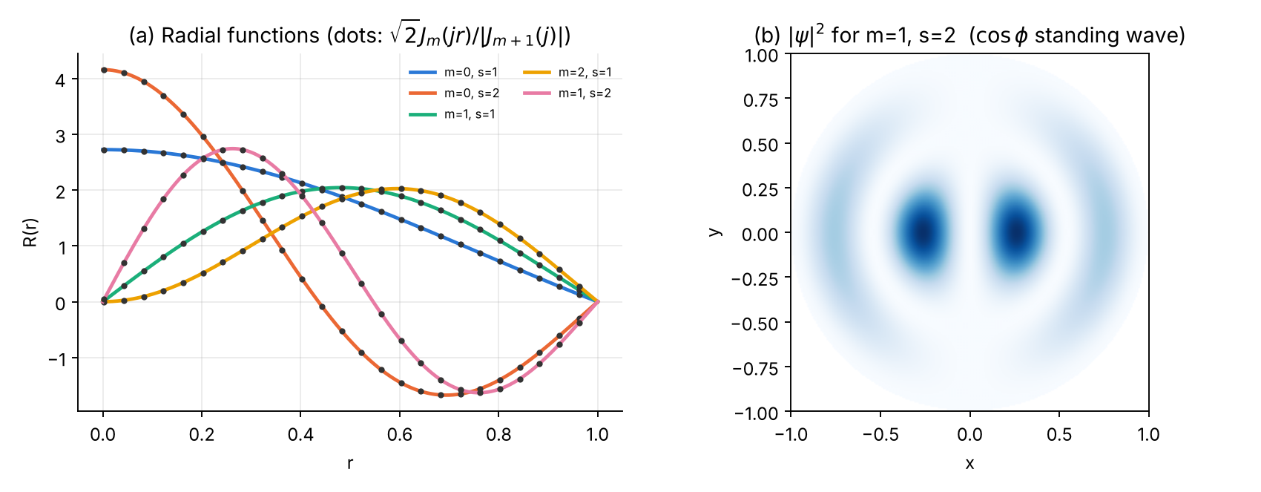
(a) Radial functions $R\left(r\right)$ (lines) and the exact $\sqrt{2}J_{m}\left(jr\right)/\left|J_{m+1}\left(j\right)\right|$ (dots). (b) Probability density of the real standing wave $J_{1}\left(j_{1,2}r\right)cosϕ$.

3.8 Error analysis and convergence
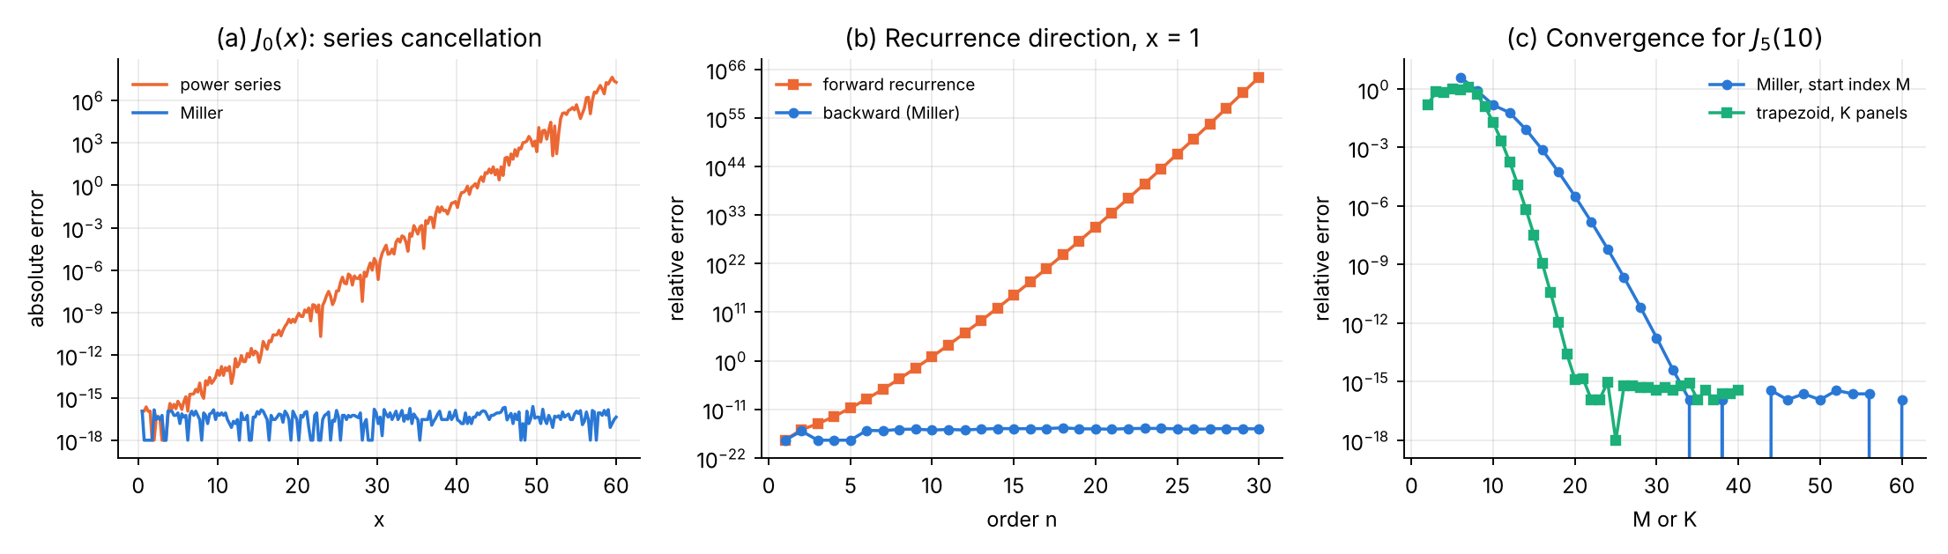
(a) The power series for $J_{0}$ loses accuracy like $e^{x}$. (b) Forward recurrence explodes for $n>x$; Miller’s backward recurrence does not. (c) Convergence of Miller’s algorithm with the start index $M$ and of the trapezoid rule with the number of panels $K$ for $J_{5}\left(10\right)$: both geometric; the trapezoid rule reaches machine precision with $K≈20$.
N | m=0 first nodes | m=0 r_s=1/8 | m=1 first nodes | m=1 r_s=1/8 | m=2 first nodes | m=2 r_s=1/8
20 | 1.25e-02 | 3.51e-04 | 2.34e-04 | 4.42e-07 | 1.22e-04 | 1.17e-04
40 | 1.27e-02 | 5.90e-05 | 6.85e-05 | 1.71e-06 | 7.99e-06 | 7.35e-06
80 | 1.28e-02 | 4.44e-06 | 1.79e-05 | 1.33e-07 | 5.23e-07 | 4.60e-07
160 | 1.29e-02 | 3.06e-07 | 4.51e-06 | 9.23e-09 | 3.41e-08 | 2.88e-08
320 | 1.29e-02 | 2.01e-08 | 1.13e-06 | 6.07e-10 | 2.22e-09 | 1.81e-09
640 | 1.29e-02 | 1.27e-09 | 2.83e-07 | 4.25e-11 | 1.31e-10 | 1.02e-10
1280 | 1.30e-02 | 7.57e-11 | 7.08e-08 | 2.19e-12 | 1.08e-11 | 1.08e-11
order | 0.0 | 3.9 | 2.0 | 3.8 | 4.0 | 4.0
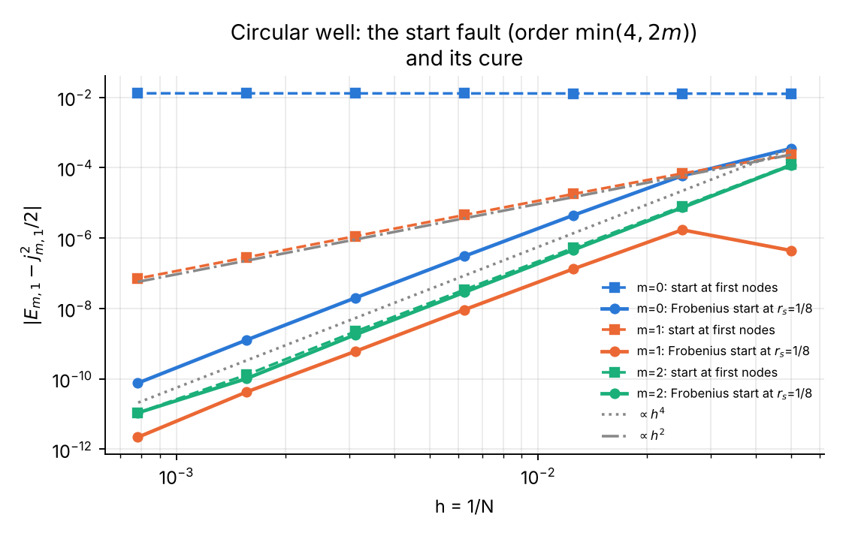
The start fault for the circular well: identical behaviour to the angular equation (order $min\left(4,2m\right)$), cured by the Frobenius start at a fixed radius.
At $N=20$ the $m=1$ entry with $r_{s}=1/8$ ($4.4×{10}^{−7}$) is accidentally small (errors of opposite sign cancel); the asymptotic $h^{4}$ behaviour starts at $N=40$. Richardson ($m=0$): $E\left(1/160\right)=2.891592675486$, $E\left(1/320\right)=2.891592961368$, $E_{R}=2.891592980427$, error $1.0×{10}^{−9}$ — a factor 20 better than the finer grid.

3.9 Exercises
- McMahon’s expansion. Compare the one-term ($β$) and two-term approximations with the exact zeros of $J_{0}$ for $s=1,5,20$. Answer: one-term errors $4.9×{10}^{−2}$, $8.4×{10}^{−3}$, $2.0×{10}^{−3}$; two-term errors $4.4×{10}^{−3}$, $2.4×{10}^{−5}$, $3.4×{10}^{−7}$ — an asymptotic expansion in $1/β$.
- Miller’s starting index. Find empirically the smallest $M$ that gives $J_{5}\left(10\right)$ to ${10}^{−13}$, and compare with the Numerical-Recipes rule $M≈2\left[\left(n+\sqrt{40n}\right)/2\right]$ (Press et al. 2007, §6.5). Answer from the plot: $M≈30$.
- Annular well $0.5<r<1$ (both walls hard), $m=0$. Show that the eigenvalue condition is $J_{0}\left(ka\right)Y_{0}\left(k\right)−J_{0}\left(k\right)Y_{0}\left(ka\right)=0$, and that for a thin annulus $k_{1}≈π/\left(1−a\right)$. Then solve it with Numerov — no special start is needed, since $r=0$ is excluded. Answer: $k_{1}=6.246061839$, $E=19.5066442$ (thin-annulus estimate $k=6.283$).
- Fault theory. For $m=1$, show that the ratio of the regular to the irregular solution at $r=h$ is $h^{2}$, and explain the observed order 2.
- Degeneracies. List the first ten levels of the circular well with their degeneracy (1 for $m=0$, 2 otherwise) and compare with the spectrum of a square box of the same area.

Chapter 4 — Spherical Bessel functions and the spherical well

4.1 The function
The spherical Bessel functions solve (DLMF §10.47)
$$x^{2}y″+2x y′+\left[x^{2}−l\left(l+1\right)\right] y=0, j_{l}\left(x\right)=\sqrt{\frac{π}{2x}} J_{l+1/2}\left(x\right), y_{l}\left(x\right)=\sqrt{\frac{π}{2x}} Y_{l+1/2}\left(x\right).$$
Main properties (DLMF §10.49–§10.53, §10.60; Arfken et al. 2013, §14.7; Messiah 1961, App. B.6):
- Elementary closed forms: $j_{0}=\frac{sinx}{x}$, $j_{1}=\frac{sinx}{x^{2}}−\frac{cosx}{x}$, $y_{0}=−\frac{cosx}{x}$, $y_{1}=−\frac{cosx}{x^{2}}−\frac{sinx}{x}$; in general (Rayleigh) $j_{l}={\left(−x\right)}^{l}(1/xd/{dx})^{l}{sinx}/x$.
- Recurrence (for both $j_{l}$ and $y_{l}$): $f_{l+1}=\frac{2l+1}{x}f_{l}−f_{l−1}$; derivative $j_{l}′=j_{l−1}−{l+1}/xj_{l}$.
- Small-$x$ series: $j_{l}\left(x\right)=\frac{x^{l}}{\left(2l+1\right)!!}\left[1−\frac{x^{2}}{2\left(2l+3\right)}+…\right]$.
- Cross product: $j_{l}\left(x\right) y_{l−1}\left(x\right)−j_{l−1}\left(x\right) y_{l}\left(x\right)=x^{−2}$ (DLMF §10.50).
- Plane-wave expansion: eikz=l​il2l+1jlkrPlcosθ (DLMF §10.60) — the basis of partial-wave scattering theory.
- Zeros $z_{l,s}$ of $j_{l}$: $z_{0,s}=sπ$; they interlace and determine the spectrum of the spherical well.
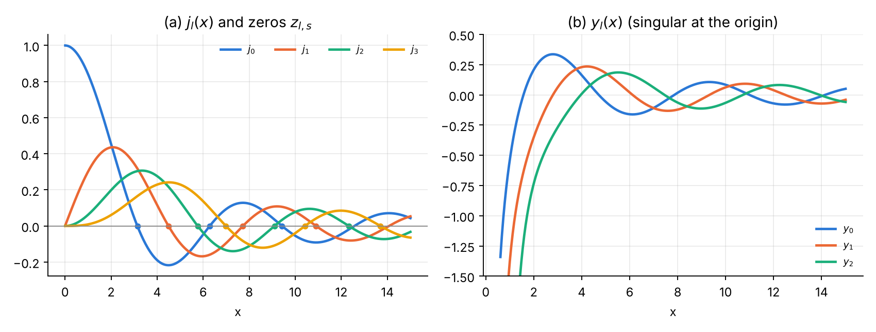
$j_{l}$ with its first zeros, and the singular $y_{l}$.

4.2 The physics: spherical infinite well
For $V=0$ inside a sphere of radius 1 and an infinite wall at $r=1$, $ψ=R\left(r\right)Y_{lm}$, $u=rR$:
$$u″+\left[2E−\frac{l\left(l+1\right)}{r^{2}}\right]u=0, u\left(0\right)=u\left(1\right)=0, E_{l,s}=\frac{z_{l,s}^{2}}{2}, R=\frac{\sqrt{2} j_{l}\left(z_{l,s}r\right)}{\left|j_{l+1}\left(z_{l,s}\right)\right|}.$$
Each level is $\left(2l+1\right)$-fold degenerate. This is the simplest model of a nucleus or a quantum dot: the level order $1s,1p,1d,2s,1f,2p,1g,…$ and the cumulative occupancies $2,8,18,20,34,40,58,68,90,92,…$ reproduce the first nuclear magic numbers 2, 8, 20 and, after the spin–orbit splitting is added, 28, 50, 82, 126 (Bohr & Mottelson 1969, vol. I, §2-4).

4.3 Analytical scheme
Part A.
- Upward recurrence from the closed forms — stable for $y_{l}$, unstable for $j_{l}$ when $l>x$ ($j_{l}$ is minimal).
- Miller’s algorithm for $j_{l}$: start at $M=l+x+20+\sqrt{40\left(l+x\right)}$, recur downwards, normalise with $j_{0}=sinx/x$ (or with $j_{1}$ where $j_{0}$ is near a zero).
- For $x<{10}^{−3}$: the series — the closed forms suffer catastrophic cancellation (e.g. $j_{3}$ is a difference of terms of size $x^{−4}$ whose result is $x^{3}/105$).
- Zeros: scan with step 0.1, then Newton.
Part B. Numerov for $u=rR$ with Frobenius series $u=r^{l+1}∑a_{k}r^{2k}$, $2k\left(2k+2l+1\right)a_{k}=−2Ea_{k−1}$, evaluated at the first nodes (here $u$ is analytic, so this is sufficient), compared with the naive start $u_{1}=h^{l+1}$; outward shooting and bisection as in Chapter 3.

4.4 Logic chart
See the logic chart of Section 3.4: the program is identical except for $k^{2}$, the Frobenius recurrence and the exact solution.

4.5 Python 3 code
File: ch4_spherical_bessel_well.py
#!/usr/bin/env python3
"""
Chapter 4 -- SPHERICAL BESSEL FUNCTIONS and the SPHERICAL INFINITE WELL
=======================================================================
Part A : computation of j_l(x), y_l(x)
* closed forms j_0 = sin x / x, j_1, y_0, y_1 DLMF §10.49
* upward recurrence f_{l+1} = (2l+1)/x f_l - f_{l-1} DLMF §10.51
(stable for y_l, UNSTABLE for j_l when l > x)
* Miller downward recurrence for j_l, normalised by j_0 = sin x / x
* small-x series j_l ~ x^l/(2l+1)!! (1 - x^2/(2(2l+3)) + ...) DLMF §10.53
* zeros z_{l,s}: bisection bracket + Newton, j_l' = j_{l-1} - (l+1) j_l / x
* verification: cross product j_l y_{l-1} - j_{l-1} y_l = x^{-2} (DLMF §10.50),
mpmath reference, scipy spherical_jn
Part B : particle in a spherical infinite well of radius 1 (hbar = m = 1)
psi = R(r) Y_lm, u = r R :
u'' + [ 2E - l(l+1)/r^2 ] u = 0 , u(1) = 0 , u ~ r^{l+1} (analytic!)
exact E_{l,s} = z_{l,s}^2/2, R = sqrt(2) j_l(z r)/|j_{l+1}(z)|
Numerov outward shooting, bisection on u(1)
* verification: normalisation, comparison with j_l, orthogonality, <r^2>
* error analysis: here the first-node start is harmless (u is analytic),
in contrast with Chapters 2-3; h^4 law, Richardson
Outputs: tables + ch4_functions.png, ch4_partA_errors.png, ch4_well.png, ch4_convergence.png
"""
import numpy as np
import mpmath as mp
from scipy.special import spherical_jn
import matplotlib
matplotlib.use("Agg")
import matplotlib.pyplot as plt
C = ["#2a78d6", "#eb6834", "#1baf7a", "#eda100", "#e87ba4", "#7a5cd6"]
mp.mp.dps = 50
def style(ax):
ax.spines[["top", "right"]].set_visible(False); ax.grid(alpha=.25, which="both")
def ref_j(l, x):
return float(mp.sqrt(mp.pi / (2 * mp.mpf(x))) * mp.besselj(l + mp.mpf(1) / 2, x))
def ref_y(l, x):
return float(mp.sqrt(mp.pi / (2 * mp.mpf(x))) * mp.bessely(l + mp.mpf(1) / 2, x))
# ============================================================ PART A
def j_up(L, x):
j = np.zeros(L + 1); j[0] = np.sin(x) / x
if L >= 1: j[1] = np.sin(x) / x ** 2 - np.cos(x) / x
for l in range(1, L):
j[l + 1] = (2 * l + 1) / x * j[l] - j[l - 1]
return j
def y_up(L, x):
y = np.zeros(L + 1); y[0] = -np.cos(x) / x
if L >= 1: y[1] = -np.cos(x) / x ** 2 - np.sin(x) / x
for l in range(1, L):
y[l + 1] = (2 * l + 1) / x * y[l] - y[l - 1]
return y
def j_series(l, x, nterm=30):
df = np.prod(np.arange(1, 2 * l + 2, 2, dtype=float))
s, t = 0.0, 1.0
for k in range(nterm):
s += t
t *= -x * x / (2 * (k + 1) * (2 * l + 2 * k + 3))
return x ** l / df * s
def j_miller(L, x, M=None):
"""downward recurrence from M, normalised with j_0 = sin x / x"""
if x < 1e-3: # tiny x: series is exact to round-off
return np.array([j_series(l, x) for l in range(L + 1)])
if M is None:
M = L + int(x) + 20 + int(np.sqrt(40 * (L + x)))
f = np.zeros(M + 2); f[M] = 1e-30
for l in range(M, 0, -1):
f[l - 1] = (2 * l + 1) / x * f[l] - f[l + 1]
if abs(f[l - 1]) > 1e250: f[l - 1:] *= 1e-250
j0 = np.sin(x) / x
# normalise with the larger of j_0, j_1 (j_0 vanishes at x = k pi)
j1 = np.sin(x) / x ** 2 - np.cos(x) / x
scale = j0 / f[0] if abs(j0) > abs(j1) else j1 / f[1]
return f[:L + 1] * scale
def jl(l, x):
return j_miller(l + 1, x)[l]
def jl_zeros(l, S):
"""first S zeros: bracket by scanning (step 0.1), then Newton"""
zs = []
x = l + 0.5 if l > 0 else 1.0
prev = jl(l, x)
while len(zs) < S:
x2 = x + 0.1; cur = jl(l, x2)
if np.sign(cur) != np.sign(prev):
z = 0.5 * (x + x2)
for _ in range(50):
jj = j_miller(l + 1, z)
d = (jj[l - 1] - (l + 1) / z * jj[l]) if l > 0 else -jj[1]
dz = jj[l] / d; z -= dz
if abs(dz) < 1e-15 * z: break
zs.append(z)
x, prev = x2, cur
return np.array(zs)
def partA():
print("=" * 78)
print("PART A Spherical Bessel functions j_l, y_l")
print("=" * 78)
print(f"{'l':>3} {'x':>6} {'j_l Miller':>24} {'mpmath':>24} {'rel.err Miller':>15} {'rel.err upward':>15}")
for l, x in ((2, 5.0), (5, 1.0), (10, 2.0), (20, 30.0), (30, 1.0), (3, 1e-4)):
ref = ref_j(l, x); jm = jl(l, x); ju = j_up(l, x)[l]
print(f"{l:3d} {x:6.0e} {jm:24.15e} {ref:24.15e} {abs(jm-ref)/abs(ref):15.2e} {abs(ju-ref)/abs(ref):15.2e}")
print("\ny_l by upward recurrence (stable):")
for l, x in ((5, 1.0), (20, 3.0), (30, 1.0)):
ref = ref_y(l, x); yu = y_up(l, x)[l]
print(f" l={l:2d} x={x}: y_l = {yu:.15e} mpmath {ref:.15e} rel.err {abs(yu-ref)/abs(ref):.1e}")
print("\nCross product j_l y_{l-1} - j_{l-1} y_l - 1/x^2 (independent check, DLMF §10.50):")
for x in (0.5, 3.0, 20.0):
jj = j_miller(25, x); yy = y_up(25, x)
cp = max(abs((jj[l] * yy[l - 1] - jj[l - 1] * yy[l]) * x * x - 1) for l in range(1, 26))
print(f" x={x:5.1f}: max over l=1..25 of |x^2 (j_l y_(l-1) - j_(l-1) y_l) - 1| = {cp:.1e}")
xs = np.linspace(0.05, 40, 80)
print(f" max |j_miller - scipy spherical_jn| (l<=15, 0.05<x<40) = "
f"{max(np.max(abs(j_miller(15, x) - spherical_jn(np.arange(16), x))) for x in xs):.1e}")
z = {l: jl_zeros(l, 4) for l in range(4)}
for l in range(4):
refz = [float(mp.findroot(lambda t: mp.sqrt(mp.pi/(2*t))*mp.besselj(l+0.5, t), v)) for v in z[l]]
print(f" zeros j_{l}: " + ", ".join(f"{v:.12f}" for v in z[l]) + f" max err vs mpmath {max(abs(z[l]-refz)):.1e}")
# error data
ls = np.arange(0, 31)
ref1 = np.array([ref_j(l, 1.0) for l in ls])
e_up = abs(j_up(30, 1.0) - ref1) / abs(ref1)
e_dn = abs(j_miller(30, 1.0) - ref1) / abs(ref1)
xx = np.logspace(-6, 0, 120)
ref3 = np.array([ref_j(3, x) for x in xx])
j3_closed = (15 / xx ** 4 - 6 / xx ** 2) * np.sin(xx) - (15 / xx ** 3 - 1 / xx) * np.cos(xx) # DLMF §10.49
e_cl = abs(j3_closed / xx * 1 - ref3) / abs(ref3)
e_cl = abs(((15 / xx ** 3 - 6 / xx) * np.sin(xx) - (15 / xx ** 2 - 1) * np.cos(xx)) / xx - ref3) / abs(ref3)
e_mi = np.array([abs(jl(3, x) - r) / abs(r) for x, r in zip(xx, ref3)])
print("\nj_3 closed trigonometric form vs Miller at small x (relative error):")
for x in (1e-1, 1e-2, 1e-3, 1e-4):
i = np.argmin(abs(xx - x))
print(f" x={xx[i]:.0e}: closed form {e_cl[i]:.1e} Miller/series {e_mi[i]:.1e}")
fig, ax = plt.subplots(1, 2, figsize=(10, 3.8))
xg = np.linspace(0.01, 15, 500)
for l in range(4):
ax[0].plot(xg, [jl(l, v) for v in xg], color=C[l], lw=2, label=f"$j_{l}$")
ax[0].plot(z[l][:3], 0 * z[l][:3], "o", ms=4, color=C[l])
ax[0].axhline(0, color="#888888", lw=.8)
ax[0].set(xlabel="x", title=r"(a) $j_l(x)$ and zeros $z_{l,s}$")
ax[0].legend(frameon=False, fontsize=8, ncol=4)
for l in range(3):
ax[1].plot(xg[20:], [y_up(l, v)[l] for v in xg[20:]], color=C[l], lw=2, label=f"$y_{l}$")
ax[1].set(ylim=(-1.5, 0.5), xlabel="x", title=r"(b) $y_l(x)$ (singular at the origin)")
ax[1].legend(frameon=False, fontsize=8)
for a_ in ax: style(a_)
fig.tight_layout(); fig.savefig("ch4_functions.png", dpi=170)
fig, ax = plt.subplots(1, 2, figsize=(10, 3.8))
ax[0].semilogy(ls, e_up + 1e-18, "s-", color=C[1], lw=1.5, ms=4, label="upward recurrence")
ax[0].semilogy(ls, e_dn + 1e-18, "o-", color=C[0], lw=1.5, ms=4, label="downward (Miller)")
ax[0].set(xlabel="l", ylabel="relative error", title=r"(a) $j_l(1)$: direction of recurrence")
ax[0].legend(frameon=False, fontsize=8)
ax[1].loglog(xx, e_cl + 1e-18, color=C[1], lw=1.5, label="closed trigonometric form")
ax[1].loglog(xx, e_mi + 1e-18, color=C[0], lw=1.5, label="Miller / series")
ax[1].set(xlabel="x", ylabel="relative error", title=r"(b) $j_3(x)$ for small x: cancellation")
ax[1].legend(frameon=False, fontsize=8)
for a_ in ax: style(a_)
fig.tight_layout(); fig.savefig("ch4_partA_errors.png", dpi=170)
return z
# ============================================================ PART B
def frobenius(r, l, E, nterm=40):
"""u = r^{l+1} sum a_k r^{2k}, 2k(2k+2l+1) a_k = -2E a_{k-1}"""
r = np.asarray(r, float); s = np.zeros_like(r); a = 1.0; p = np.ones_like(r)
for k in range(nterm):
s += a * p
a = -2 * E * a / ((2 * k + 2) * (2 * k + 2 * l + 3)); p = p * r * r
return r ** (l + 1) * s
def simpson(y, h):
return h / 3 * (y[0] + y[-1] + 4 * y[1:-1:2].sum() + 2 * y[2:-1:2].sum())
def shoot(E, l, N, rs, naive=False):
h = 1.0 / N; r = h * np.arange(N + 1)
k2 = np.zeros(N + 1); k2[1:] = 2 * E - l * (l + 1) / r[1:] ** 2
c = 1 + h * h * k2 / 12
if naive: # u0 = 0, u1 = h^{l+1}, c0 u0 = 0
js = 0; u = np.zeros(N + 1); u[1] = h ** (l + 1)
else:
js = max(1, int(rs / h + 0.5))
u = np.zeros(N + 1); u[:js + 2] = frobenius(r[:js + 2], l, E)
for n in range(js + 1, N):
u[n + 1] = ((12 - 10 * c[n]) * u[n] - c[n - 1] * u[n - 1]) / c[n + 1]
return u, r
def eigen(l, s, N, z, rs=0.0, naive=False):
Ex = z[l][s - 1] ** 2 / 2
a, b = Ex * 0.85, Ex * 1.15
fa = shoot(a, l, N, rs, naive)[0][-1]
for _ in range(64):
mid = 0.5 * (a + b); fm = shoot(mid, l, N, rs, naive)[0][-1]
if np.sign(fm) == np.sign(fa): a, fa = mid, fm
else: b = mid
E = 0.5 * (a + b)
u, r = shoot(E, l, N, rs, naive)
u /= np.sqrt(simpson(u * u, r[1]))
zz = z[l][s - 1]
ex = r * np.array([jl(l, zz * v) if v > 0 else (1.0 if l == 0 else 0.0) * zz for v in r]) * np.sqrt(2) / abs(jl(l + 1, zz))
ex[0] = 0.0
if np.dot(u, ex) < 0: u = -u
return E, u, r, ex
def r2_exact(l, z):
"""<r^2> = int_0^1 j_l(zr)^2 r^4 dr / int_0^1 j_l(zr)^2 r^2 dr, by 50-digit quadrature"""
f = lambda t: mp.besselj(l + mp.mpf(1) / 2, z * t) ** 2 / t # = (2 z/pi) j_l^2 * t^... common factor
num = mp.quad(lambda t: f(t) * t ** 4, [0, 1]); den = mp.quad(lambda t: f(t) * t ** 2, [0, 1])
return float(num / den)
def order(hs, e):
"""observed order, fitted only on the range where the error still drops (>6x per halving)"""
idx = [0]
for i in range(len(e) - 1):
if e[i] / e[i + 1] > 6: idx.append(i + 1)
else: break
idx = idx[1:] if len(idx) > 3 else idx
return np.polyfit(np.log(np.array(hs)[idx]), np.log(np.array(e)[idx]), 1)[0]
def partB(z):
print("\n" + "=" * 78)
print("PART B Spherical infinite well, radius 1: Numerov in u = r R, N = 400, Frobenius start at first nodes")
print("=" * 78)
Eg = np.linspace(0.5, 80, 800)
F = np.array([shoot(E, 1, 400, 0.0)[0][-1] for E in Eg])
roots = [0.5 * (Eg[i] + Eg[i + 1]) for i in np.where(np.sign(F[:-1]) != np.sign(F[1:]))[0]]
print(" scan l=1: sign changes of u(1;E) near " + ", ".join(f"{v:.2f}" for v in roots)
+ " (exact " + ", ".join(f"{v**2/2:.2f}" for v in z[1][:4]) + ")")
print(f"\n{'l':>2} {'s':>2} {'E Numerov':>17} {'z^2/2 (Part A)':>17} {'|dE|':>9} {'norm':>15} {'max|u-u_ex|':>12} {'<r^2>':>9} {'exact':>9}")
store = {}
for (l, s) in ((0, 1), (0, 2), (1, 1), (1, 2), (2, 1), (3, 1)):
E, u, r, ex = eigen(l, s, 400, z)
Ex = z[l][s - 1] ** 2 / 2
zz = z[l][s - 1]
store[l, s] = (u, r, ex)
print(f"{l:2d} {s:2d} {E:17.12f} {Ex:17.12f} {abs(E-Ex):9.1e} {simpson(u*u,r[1]):15.12f} {np.max(abs(u-ex)):12.1e} "
f"{simpson(u*u*r*r,r[1]):9.6f} {r2_exact(l, zz):9.6f}")
ov = max(abs(simpson(store[0, 1][0] * store[0, 2][0], 1 / 400)), abs(simpson(store[1, 1][0] * store[1, 2][0], 1 / 400)))
print(f" orthogonality (same l, different s): max |<u|u'>| = {ov:.1e}")
Ns = np.array([20, 40, 80, 160, 320, 640, 1280])
hs = 1.0 / Ns
err = {}
for l in (0, 1, 2):
Ex = z[l][0] ** 2 / 2
err[l, "naive"] = [abs(eigen(l, 1, N, z, naive=True)[0] - Ex) for N in Ns]
err[l, "Frobenius"] = [abs(eigen(l, 1, N, z)[0] - Ex) for N in Ns]
print("\nError of E_{l,1} vs h: naive start (u0=0, u1=h^(l+1)) vs Frobenius values at the first nodes")
print(f"{'N':>6} {'h':>9}" + "".join(f" {'l=%d naive' % l:>12} {'l=%d Frob.' % l:>11}" for l in (0, 1, 2)))
for i, N in enumerate(Ns):
print(f"{N:6d} {hs[i]:9.6f}" + "".join(f" {err[l,'naive'][i]:12.2e} {err[l,'Frobenius'][i]:11.2e}" for l in (0, 1, 2)))
for l in (0, 1, 2):
for lab in ("naive", "Frobenius"):
print(f" l={l} {lab:10s}: observed order {order(hs, err[l, lab]):.2f}")
E1 = eigen(1, 1, 80, z)[0]; E2 = eigen(1, 1, 160, z)[0]; ER = (16 * E2 - E1) / 15
print(f"Richardson l=1: E(1/80)={E1:.12f} E(1/160)={E2:.12f} E_R={ER:.12f} err={abs(ER-z[1][0]**2/2):.1e}")
fig, ax = plt.subplots(1, 2, figsize=(10, 3.9))
for i, (l, s) in enumerate(((0, 1), (0, 2), (1, 1), (2, 1), (3, 1))):
u, r, ex = store[l, s]
ax[0].plot(r, u, color=C[i], lw=2, label=f"l={l}, s={s}")
ax[0].plot(r[::16], ex[::16], "o", ms=2.5, color="#333333")
ax[0].set(xlabel="r", ylabel="u(r) = r R(r)", title=r"(a) Numerov vs $\sqrt{2}\,r\,j_l(zr)/|j_{l+1}(z)|$ (dots)")
ax[0].legend(frameon=False, fontsize=7, ncol=2)
lev = sorted([(z[l][s] ** 2 / 2, l, s + 1) for l in range(4) for s in range(3) if z[l][s] ** 2 / 2 < 60])
for E, l, s in lev:
ax[1].hlines(E, l - 0.3, l + 0.3, color=C[l], lw=2.5)
ax[1].text(l + 0.33, E, f"{s}{'spdf'[l]}", fontsize=7, va="center")
ax[1].set(xticks=range(4), xticklabels=["s (l=0)", "p (l=1)", "d (l=2)", "f (l=3)"], ylabel="E",
title="(b) Level scheme $E=z_{l,s}^2/2$ (cf. nuclear shell model)")
for a_ in ax: style(a_)
fig.tight_layout(); fig.savefig("ch4_well.png", dpi=170)
fig, ax = plt.subplots(figsize=(6.6, 5.4))
for i, l in enumerate((0, 1, 2)):
ax.loglog(hs, err[l, "naive"], "s--", color=C[i], lw=1.5, ms=5, label=f"l={l}: naive start $u_1=h^{{l+1}}$")
ax.loglog(hs, err[l, "Frobenius"], "o-", color=C[i], lw=2, ms=5, label=f"l={l}: Frobenius values at first nodes")
ax.loglog(hs, err[0, "Frobenius"][0] * (hs / hs[0]) ** 4, ":", color="#888888", label=r"$\propto h^4$")
ax.loglog(hs, err[1, "naive"][0] * (hs / hs[0]) ** 3, "-.", color="#888888", label=r"$\propto h^3$")
ax.set(xlabel="h = 1/N", ylabel=r"$|E_{l,1}-z_{l,1}^2/2|$", title="Spherical well: analytic u = r R needs no special start\n(only the naive $u_1$ for l = 1 is wrong)")
ax.legend(frameon=False, fontsize=7, loc="upper center", bbox_to_anchor=(0.5, -0.15), ncol=2); style(ax)
fig.tight_layout(); fig.savefig("ch4_convergence.png", dpi=170)
if __name__ == "__main__":
z = partA(); partB(z)

4.6 Fortran 2008 code
File: ch4_spherical_bessel_well.f90
!=======================================================================
! Chapter 4 -- SPHERICAL BESSEL FUNCTIONS and the SPHERICAL WELL (F2008)
! Part A: j_l by Miller downward recurrence (normalised by j_0 or j_1),
! y_l by the stable upward recurrence, small-x series, zeros;
! checks: cross product x^2 (j_l y_{l-1} - j_{l-1} y_l) = 1 and
! j_l(x) = sqrt(pi/2x) J_{l+1/2}(x) for l = 0 (sin x / x)
! Part B: u = r R, u'' + [2E - l(l+1)/r^2] u = 0, u(1) = 0
! Numerov + bisection; naive start vs Frobenius values
! Output: screen tables + ch4_f_conv.dat
! Compile: gfortran -O2 -o ch4 ch4_spherical_bessel_well.f90 && ./ch4
!=======================================================================
module sph_mod
implicit none
integer, parameter :: dp = kind(1.0d0)
real(dp), parameter :: pi = 3.141592653589793238_dp
contains
real(dp) function j_series(l, x)
integer, intent(in) :: l
real(dp), intent(in) :: x
real(dp) :: df, t
integer :: k
df = 1.0_dp
do k = 1, 2*l+1, 2
df = df*k
end do
j_series = 0.0_dp; t = 1.0_dp
do k = 0, 29
j_series = j_series + t
t = -t*x*x/(2*(k + 1)*(2*l + 2*k + 3))
end do
j_series = x**l/df*j_series
end function j_series
subroutine j_miller(L, x, jv)
integer, intent(in) :: L
real(dp), intent(in) :: x
real(dp), intent(out) :: jv(0:L)
real(dp), allocatable :: f(:)
real(dp) :: j0, j1, scale
integer :: M, k
if (x < 1.0d-3) then
do k = 0, L
jv(k) = j_series(k, x)
end do
return
end if
M = L + int(x) + 20 + int(sqrt(40*(L + x)))
allocate(f(0:M+1)); f = 0.0_dp; f(M) = 1.0d-30
do k = M, 1, -1
f(k-1) = (2*k + 1)/x*f(k) - f(k+1)
if (abs(f(k-1)) > 1.0d250) f(k-1:M+1) = f(k-1:M+1)*1.0d-250
end do
j0 = sin(x)/x; j1 = sin(x)/x**2 - cos(x)/x
if (abs(j0) > abs(j1)) then
scale = j0/f(0)
else
scale = j1/f(1)
end if
jv = f(0:L)*scale
end subroutine j_miller
subroutine y_up(L, x, yv)
integer, intent(in) :: L
real(dp), intent(in) :: x
real(dp), intent(out) :: yv(0:L)
integer :: k
yv(0) = -cos(x)/x
if (L >= 1) yv(1) = -cos(x)/x**2 - sin(x)/x
do k = 1, L-1
yv(k+1) = (2*k + 1)/x*yv(k) - yv(k-1)
end do
end subroutine y_up
subroutine j_up(L, x, jv)
integer, intent(in) :: L
real(dp), intent(in) :: x
real(dp), intent(out) :: jv(0:L)
integer :: k
jv(0) = sin(x)/x
if (L >= 1) jv(1) = sin(x)/x**2 - cos(x)/x
do k = 1, L-1
jv(k+1) = (2*k + 1)/x*jv(k) - jv(k-1)
end do
end subroutine j_up
real(dp) function jl(l, x)
integer, intent(in) :: l
real(dp), intent(in) :: x
real(dp) :: jv(0:l+1)
call j_miller(l+1, x, jv); jl = jv(l)
end function jl
subroutine jl_zeros(l, S, z)
integer, intent(in) :: l, S
real(dp), intent(out) :: z(S)
real(dp) :: x, x2, prev, cur, zz, dz, d, jv(0:l+1)
integer :: found, it
found = 0
x = merge(l + 0.5_dp, 1.0_dp, l > 0); prev = jl(l, x)
do while (found < S)
x2 = x + 0.1_dp; cur = jl(l, x2)
if (sign(1.0_dp, cur) /= sign(1.0_dp, prev)) then
zz = 0.5_dp*(x + x2)
do it = 1, 50
call j_miller(l+1, zz, jv)
if (l > 0) then
d = jv(l-1) - (l + 1)/zz*jv(l)
else
d = -jv(1)
end if
dz = jv(l)/d; zz = zz - dz
if (abs(dz) < 1.0d-15*zz) exit
end do
found = found + 1; z(found) = zz
end if
x = x2; prev = cur
end do
end subroutine jl_zeros
end module sph_mod
module swell_mod
use sph_mod
implicit none
contains
real(dp) function frob(r, l, E)
real(dp), intent(in) :: r, E
integer, intent(in) :: l
real(dp) :: a, s, p
integer :: k
s = 0.0_dp; a = 1.0_dp; p = 1.0_dp
do k = 0, 39
s = s + a*p
a = -2*E*a/((2*k + 2)*(2*k + 2*l + 3)); p = p*r*r
end do
frob = r**(l+1)*s
end function frob
real(dp) function simpson(y, h, n)
integer, intent(in) :: n
real(dp), intent(in) :: y(0:n), h
simpson = h/3*(y(0) + y(n) + 4*sum(y(1:n-1:2)) + 2*sum(y(2:n-2:2)))
end function simpson
subroutine shoot(E, l, N, naive, u)
real(dp), intent(in) :: E
integer, intent(in) :: l, N
logical, intent(in) :: naive
real(dp), intent(out) :: u(0:N)
real(dp) :: h, r(0:N), c(0:N)
integer :: j, js
h = 1.0_dp/N; r = [(j*h, j=0,N)]
c(0) = 1.0_dp; c(1:N) = 1 + h*h*(2*E - l*(l+1)/r(1:N)**2)/12
u = 0.0_dp
if (naive) then
js = 0; u(1) = h**(l+1)
else
js = 1; u(0) = 0.0_dp; u(1) = frob(r(1), l, E); u(2) = frob(r(2), l, E)
end if
do j = js+1, N-1
u(j+1) = ((12 - 10*c(j))*u(j) - c(j-1)*u(j-1))/c(j+1)
end do
end subroutine shoot
subroutine eigen(l, Eex, N, naive, E, u)
integer, intent(in) :: l, N
real(dp), intent(in) :: Eex
logical, intent(in) :: naive
real(dp), intent(out) :: E, u(0:N)
real(dp) :: a, b, fa, mid
integer :: it
a = 0.85_dp*Eex; b = 1.15_dp*Eex
call shoot(a, l, N, naive, u); fa = u(N)
do it = 1, 64
mid = 0.5_dp*(a + b)
call shoot(mid, l, N, naive, u)
if (sign(1.0_dp, u(N)) == sign(1.0_dp, fa)) then
a = mid; fa = u(N)
else
b = mid
end if
end do
E = 0.5_dp*(a + b)
call shoot(E, l, N, naive, u)
u = u/sqrt(simpson(u*u, 1.0_dp/N, N))
end subroutine eigen
end module swell_mod
program ch4
use sph_mod
use swell_mod
implicit none
integer, parameter :: NN = 400
real(dp) :: jv(0:30), ju(0:30), yv(0:30), z(0:3,4), x, cp, E, u(0:NN), uex(0:NN), Eex, e1(7), e2(7), r
real(dp) :: xc(3) = [0.5_dp, 3.0_dp, 20.0_dp]
real(dp), allocatable :: uu(:)
integer :: i, k, l, s, Ns(7) = [20, 40, 80, 160, 320, 640, 1280]
integer :: llist(6) = [0,0,1,1,2,3], slist(6) = [1,2,1,2,1,1]
print '(a)', repeat('=',78)
print '(a)', 'PART A Spherical Bessel functions (Fortran)'
print '(a)', repeat('=',78)
call j_miller(30, 1.0_dp, jv); call j_up(30, 1.0_dp, ju)
print '(a)', ' j_l(1): upward vs Miller (relative difference)'
do l = 5, 30, 5
print '(a,i3,a,es24.15,a,es10.2)', ' l=', l, ' Miller=', jv(l), ' rel.diff upward=', abs(ju(l)/jv(l) - 1)
end do
do k = 1, 3
x = xc(k)
call j_miller(25, x, jv(0:25)); call y_up(25, x, yv(0:25))
cp = 0.0_dp
do l = 1, 25
cp = max(cp, abs(x*x*(jv(l)*yv(l-1) - jv(l-1)*yv(l)) - 1))
end do
print '(a,f5.1,a,es9.1)', ' cross product x=', x, ': max_l |x^2 (j_l y_{l-1} - j_{l-1} y_l) - 1| = ', cp
end do
print '(a,es24.15,a)', ' j_3(1e-4) (series) = ', jl(3, 1.0d-4), ' (exact 9.523809518518520e-15)'
do l = 0, 3
call jl_zeros(l, 4, z(l,:))
print '(a,i1,a,4f16.12)', ' zeros j_', l, ':', z(l,:)
end do
print '(/a)', repeat('=',78)
print '(a)', 'PART B Spherical infinite well, Numerov, N = 400'
print '(a)', repeat('=',78)
print '(a2,a3,a17,a17,a10,a16,a12)', 'l', 's', 'E Numerov', 'z^2/2', '|dE|', 'norm', 'max|u-ue|'
do k = 1, 6
l = llist(k); s = slist(k); Eex = z(l,s)**2/2
call eigen(l, Eex, NN, .false., E, u)
uex(0) = 0.0_dp
do i = 1, NN
r = i/real(NN,dp)
uex(i) = r*jl(l, z(l,s)*r)*sqrt(2.0_dp)/abs(jl(l+1, z(l,s)))
end do
if (sum(u*uex) < 0) u = -u
print '(i2,i3,2f17.12,es10.1,f16.12,es12.1)', l, s, E, Eex, abs(E - Eex), simpson(u*u, 1.0_dp/NN, NN), &
maxval(abs(u - uex))
end do
open(10, file='ch4_f_conv.dat', status='replace')
print '(/a)', 'Error of E_{l,1} vs N: naive start | Frobenius values at first nodes'
do l = 0, 2
Eex = z(l,1)**2/2
do i = 1, 7
allocate(uu(0:Ns(i)))
call eigen(l, Eex, Ns(i), .true., E, uu); e1(i) = abs(E - Eex)
call eigen(l, Eex, Ns(i), .false., E, uu); e2(i) = abs(E - Eex)
write(10,'(i3,i6,3es16.7)') l, Ns(i), 1.0_dp/Ns(i), e1(i), e2(i)
deallocate(uu)
end do
print '(a,i1,a,7es9.1)', ' l=', l, ' naive :', e1
print '(a,i1,a,7es9.1)', ' l=', l, ' Frobenius:', e2
end do
close(10)
end program ch4

4.7 Results, normalisation and verification
Part A.
l | x | j_l (Miller) | rel. error Miller | rel. error upward recurrence
2 | 5 | 0.1347312100851252 | 0 | 0
5 | 1 | 9.256115861125814e-05 | 1.5e-16 | 4.4e-10
10 | 2 | 6.825300864974727e-08 | 1.9e-16 | 1.8e-04
20 | 30 | −0.01471159335342906 | 2.1e-15 | 5.9e-16
30 | 1 | 5.566831266981347e-43 | 1.4e-16 | 2.2e+66
3 | 10⁻⁴ | 9.523809518518520e-15 | 0 | 3.5e+11
$y_{l}$ by upward recurrence is accurate to $3×{10}^{−16}$ even for $y_{30}\left(1\right)≈−2.9×{10}^{40}$. The cross product $x^{2}\left(j_{l}y_{l−1}−j_{l−1}y_{l}\right)=1$ holds to $7×{10}^{−16}$ for $l≤25$ and $x=0.5,3,20$ — an independent check that needs no reference software. Agreement with SciPy spherical_jn: $1.4×{10}^{−15}$. Zeros (e.g. $z_{1,1}=4.493409457909$, $z_{2,1}=5.763459196895$) agree with mpmath to $≤2×{10}^{−15}$.
Part B ($N=400$, Frobenius start):
l | s | E Numerov | z²/2 (Part A) | |ΔE| | ∫u²dr | max|u − u_ex| | ⟨r²⟩ | exact
0 | 1 | 4.934802200474 | 4.934802200545 | 7.1e-11 | 1.000000000000 | 5.2e-11 | 0.282673 | 0.282673
0 | 2 | 19.739208797098 | 19.739208802179 | 5.1e-09 | 1.000000000000 | 7.6e-12 | 0.320668 | 0.320668
1 | 1 | 10.095364277786 | 10.095364278213 | 4.3e-10 | 1.000000000000 | 2.3e-11 | 0.374606 | 0.374606
1 | 2 | 29.839757959217 | 29.839757972055 | 1.3e-08 | 1.000000000000 | 3.0e-10 | 0.347297 | 0.347297
2 | 1 | 16.608730956157 | 16.608730957134 | 9.8e-10 | 1.000000000000 | 1.1e-10 | 0.438700 | 0.438700
3 | 1 | 24.415596820069 | 24.415596821810 | 1.7e-09 | 1.000000000000 | 2.5e-10 | 0.486924 | 0.486924
(The exact $⟨r^{2}⟩$ was obtained by 50-digit quadrature of $j_{l}^{2}$.) Orthogonality between states of equal $l$: $1.5×{10}^{−11}$.
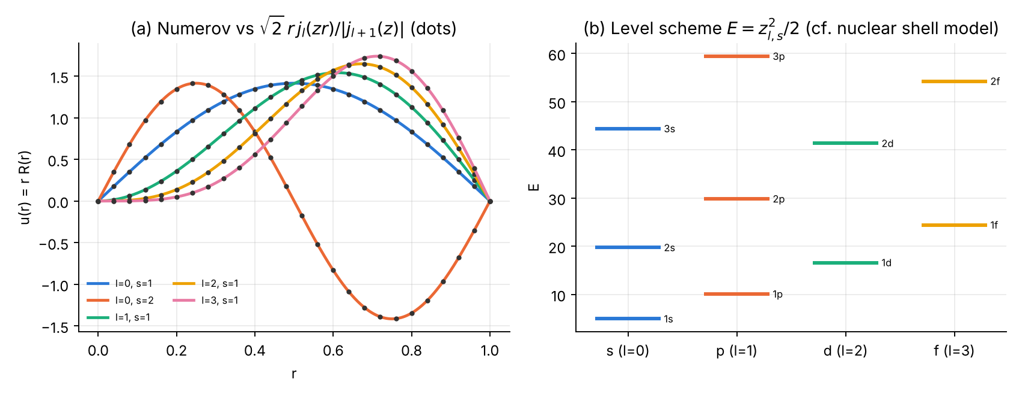
(a) Numerov $u\left(r\right)$ (lines) vs $\sqrt{2} r j_{l}\left(zr\right)/\left|j_{l+1}\left(z\right)\right|$ (dots). (b) Level scheme of the spherical well — the ordering behind the nuclear shell model.

4.8 Error analysis and convergence
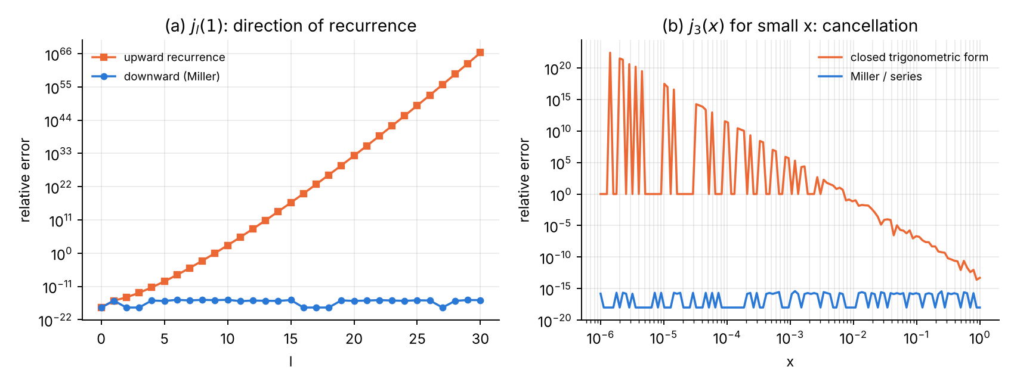
(a) $j_{l}\left(1\right)$: the upward recurrence loses about one digit per step of $l$ once $l>x$; Miller does not. (b) $j_{3}\left(x\right)$ from its closed trigonometric form: relative error grows like $x^{−7}$ for small $x$ (the result is $∼x^{3}$, the terms $∼x^{−4}$).
N | l=0 naive | l=0 Frobenius | l=1 naive | l=1 Frobenius | l=2 naive | l=2 Frobenius
20 | 1.25e-05 | 1.25e-05 | 9.37e-04 | 6.79e-05 | 1.57e-04 | 1.57e-04
40 | 7.83e-07 | 7.82e-07 | 1.13e-04 | 4.23e-06 | 9.76e-06 | 9.76e-06
80 | 4.89e-08 | 4.89e-08 | 1.38e-05 | 2.64e-07 | 6.10e-07 | 6.10e-07
160 | 3.05e-09 | 3.05e-09 | 1.71e-06 | 1.65e-08 | 3.81e-08 | 3.81e-08
320 | 2.71e-10 | 2.71e-10 | 2.13e-07 | 1.03e-09 | 2.38e-09 | 2.38e-09
640 | 3.40e-10 | 3.40e-10 | 2.66e-08 | 6.15e-11 | 1.48e-10 | 1.48e-10
1280 | 6.13e-10 | 6.13e-10 | 3.34e-09 | 1.53e-11 | 1.46e-11 | 8.76e-12
order | 3.85 | 3.85 | 3.01 | 4.01 | 3.91 | 4.01
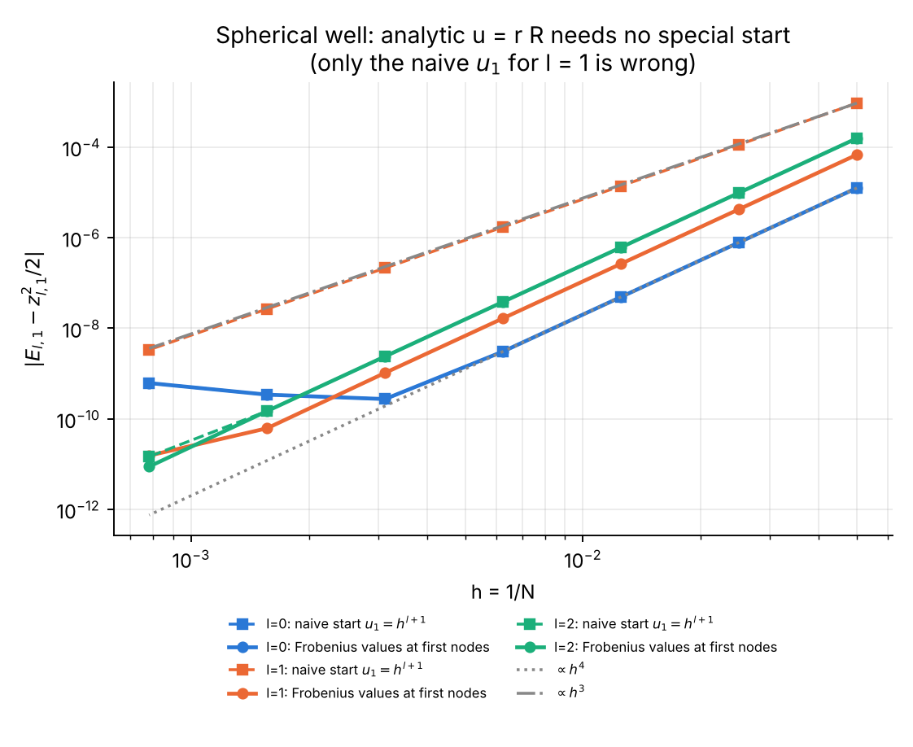
Spherical well: because $u=rR$ is analytic, Frobenius values at the first nodes are enough; only the naive start for $l=1$ (where $\lim_{r→0}k^{2}u≠0$) loses one order.
Observations:
- For $l=0$ the naive and Frobenius starts coincide: with $u_{0}=0$ the second start value only fixes the scale.
- The $l=0$ error stops decreasing at $≈3×{10}^{−10}$ and then grows: this is the round-off floor $∼ϵN^{2}$ already met in Exercise 1 of the first course (the eigenvalue is determined by the sign of $u_{N}$, which is a small difference of large accumulated quantities).
- Richardson ($l=1$): $E\left(1/80\right)=10.095364013952$, $E\left(1/160\right)=10.095364261698$, $E_{R}=10.095364278214$, error $7.5×{10}^{−13}$ (direct error on the finer grid: $1.7×{10}^{−8}$).
- Compared with Chapter 3: same equation type, same method — but the spherical problem has no start fault because the Liouville transformation $u=rR$ keeps the solution analytic, whereas $u=\sqrt{r}R$ does not.

4.9 Exercises
- Rayleigh’s formula. Derive $j_{2}$ and $y_{2}$ in closed form from Rayleigh’s formula, and check the cross product $j_{2}y_{1}−j_{1}y_{2}=x^{−2}$ symbolically.
- Where does the upward recurrence fail? Show that the relative error of upward $j_{l}\left(x\right)$ grows roughly like $|y_{l}\left(x\right)/j_{l}\left(x\right)| ϵ$ and compare with the table ($l=10$, $x=2$: $\left|y_{10}/j_{10}\right|=5×{10}^{12}$, so the predicted error is $≈5×{10}^{−4}$; observed $1.8×{10}^{−4}$).
- Finite spherical well (deuteron model). For $V=−V_{0}$ ($r<1$), $V_{0}=20$, $l=0$, derive the condition $qcotq=−κ$, $q=\sqrt{2\left(V_{0}−\left|E\right|\right)}$, $κ=\sqrt{2\left|E\right|}$, solve it, and reproduce the result with Numerov using the discontinuity treatment of the first course (Problem 2). Answer: two bound states, $E=−16.3537992$ and $E=−5.9978397$.
- Shell model. Using the zeros from Part A, order the levels $z_{l,s}$ and compute the cumulative occupancy $∑2\left(2l+1\right)$. Answer: $1s\left(3.142\right),1p\left(4.493\right),1d\left(5.763\right),2s\left(6.283\right),1f\left(6.988\right),2p\left(7.725\right),1g\left(8.183\right),2d\left(9.095\right),1h\left(9.356\right),3s\left(9.425\right)$; occupancies 2, 8, 18, 20, 34, 40, 58, 68, 90, 92.
- Partial-wave check. Verify numerically $\sum_{l=0}^{L}{\left(2l+1\right)}j_{l}{\left(x\right)}^{2}→1$ as $L→∞$ (DLMF §10.60) for $x=5$ and $x=30$; how large must $L$ be? Answer: the terms decay rapidly once $l>x$: for $x=5$ the defect $1−∑$ is $2×{10}^{−7}$ at $L=10$ and ${10}^{−14}$ at $L=15$; for $x=30$ it is $1.3×{10}^{−4}$ at $L=35$, $5×{10}^{−8}$ at $L=40$ and at round-off level for $L=50$.

Chapter 5 — Cross-check of the Fortran and Python implementations
The four Fortran 2008 programs implement exactly the same algorithms as the Python programs (same recurrences, same Frobenius series, same grids, same start index $j_{s}=nint\left(r_{s}/h\right)$, same bisection counts). All tables in Chapters 1–4 are reproduced by the Fortran codes to every printed digit; the only differences are at the round-off level (last digit of numbers below ${10}^{−12}$). In addition, the Fortran versions use independent references that are unavailable in pure Python: the Fortran 2008 intrinsic bessel_jn (agreement with Miller’s algorithm: $2.8×{10}^{−16}$ for $n≤10$, $0.1≤x≤40$), and the exact value $\left|J_{m}\left(j_{m,1}\right)\right|≤2×{10}^{−16}$ at the computed zeros.
The Fortran programs write their convergence data to ch1_f_conv.dat … ch4_f_conv.dat; plot_fortran_results.py produces the following figure.
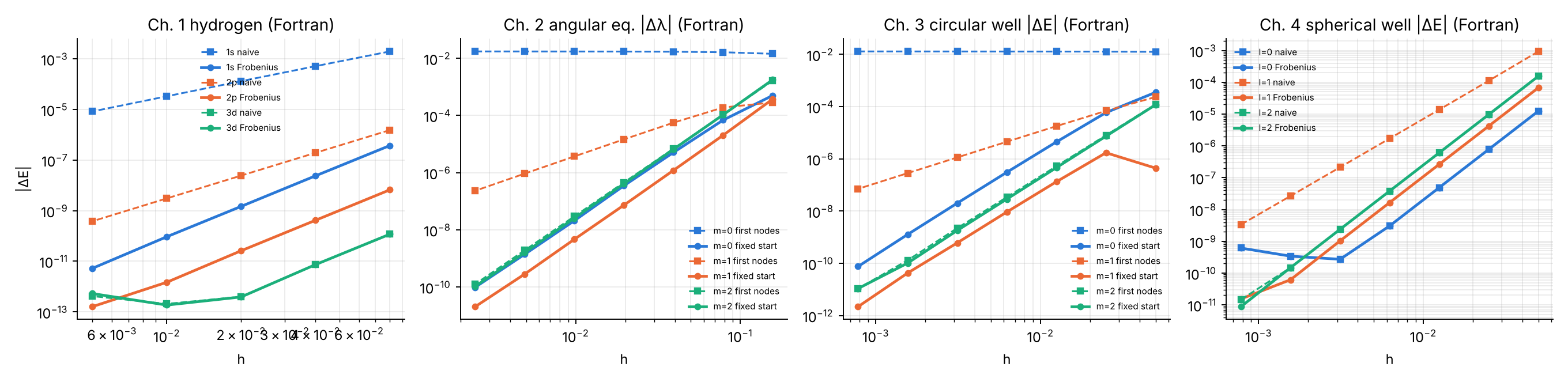
Convergence plots drawn from the Fortran output files. Left to right: hydrogen (naive vs Frobenius start), angular equation, circular well (start at first nodes vs at a fixed point), spherical well.
Pitfalls met while writing the Fortran versions (worth knowing for any Fortran work):
- Fortran is case-insensitive: a variable dP silently shadows the kind parameter dp, and N and n, Ex and ex are the same name. All three occurred and were caught by the compiler.
- Array constructors cannot be indexed directly ([1,2,3](i) is illegal) — use a named array.
- The rounding of $r_{s}/h=12.5$ differs between Python’s round (to even: 12) and Fortran’s nint (away from zero: 13); the Python codes use int(x + 0.5) to match.

Summary
 | Laguerre / hydrogen | Legendre / angular | Bessel $J_{m}$ / circular well | spherical Bessel / spherical well
Stable way to compute the function | forward recurrence | forward (normalised) recurrence | Miller (backward) | Miller for $j_{l}$, forward for $y_{l}$
What fails | explicit sum (cancellation) | explicit sum; unnormalised overflow | power series; forward recurrence $n>x$ | upward $j_{l}$; closed forms at small $x$
Gauss rule / zeros | Gauss–Laguerre (Newton, Golub–Welsch) | Gauss–Legendre | McMahon + Newton | scan + Newton
Liouville variable | $u=rR$ (analytic) | $u=\sqrt{sinθ} Θ$ (not analytic) | $u=\sqrt{r}R$ (not analytic) | $u=rR$ (analytic)
Shooting | two-sided, turning point | two-sided, both poles | outward, $u\left(1\right)=0$ | outward, $u\left(1\right)=0$
Start fault | naive start: order 2 (s), 3 (p) | first nodes: order $min\left(4,2m\right)$, none for $m=0$ | first nodes: order $min\left(4,2m\right)$ | naive start: order 3 for $l=1$
Cure | Frobenius series | Frobenius up to fixed $θ_{s}$ | Frobenius up to fixed $r_{s}$ | Frobenius values
Accuracy reached | ${10}^{−13}$ | ${10}^{−11}$ | ${10}^{−11}$ | ${10}^{−11}$
Key messages:
- Recurrences are the method of choice — in the stable direction. Dominant solutions forwards, minimal solutions backwards (Miller). Explicit sums and closed forms are for small arguments only.
- Always verify with an identity that does not use the code being tested: Jacobi–Anger, cross products, sums of weights, orthogonality, virial theorem.
- Separation of variables gives singular ODEs. Numerov keeps its fourth order only if the solution is smooth on the integration interval: start from a Frobenius series at a fixed point, never at the first grid nodes of a non-analytic solution.
- A calculation can converge perfectly in $h$ and still be wrong (angular equation, $m=0$: error $1.7×{10}^{−2}$ for every $h$). Convergence studies are necessary, not sufficient; comparison with an exact limit is indispensable.
- Richardson extrapolation and Gauss quadrature are cheap ways to gain digits — provided the error model ($h^{4}$, analyticity) actually holds.

References
Reference works on special functions
- [DLMF] F. W. J. Olver, D. W. Lozier, R. F. Boisvert, C. W. Clark et al. (eds.), NIST Digital Library of Mathematical Functions, https://dlmf.nist.gov — chapters 3 (numerical methods: §3.5 quadrature, §3.6 linear difference equations and Miller’s algorithm), 10 (Bessel functions: §10.2, §10.6, §10.9, §10.12, §10.21 zeros, §10.47–§10.60 spherical Bessel functions, §10.74 methods of computation), 14 (Legendre and related functions: §14.2, §14.7, §14.10, §14.17, §14.30), 18 (orthogonal polynomials: §18.3, §18.5, §18.8, §18.9, §18.39).
- F. W. J. Olver, D. W. Lozier, R. F. Boisvert, C. W. Clark (eds.), NIST Handbook of Mathematical Functions, Cambridge University Press (2010).
- M. Abramowitz and I. A. Stegun (eds.), Handbook of Mathematical Functions, NBS Applied Mathematics Series 55 (1964); chapters 8 (Legendre), 9–10 (Bessel), 22 (orthogonal polynomials).
- [EoM] “Special functions”, Encyclopedia of Mathematics, https://encyclopediaofmath.org/wiki/Special_functions.
Textbooks
- G. N. Watson, A Treatise on the Theory of Bessel Functions, 2nd ed., Cambridge University Press (1944).
- N. N. Lebedev, Special Functions and Their Applications, Prentice-Hall (1965); Dover reprint (1972).
- G. Szegő, Orthogonal Polynomials, AMS Colloquium Publications 23 (1939; 4th ed. 1975).
- G. E. Andrews, R. Askey and R. Roy, Special Functions, Encyclopedia of Mathematics and its Applications 71, Cambridge University Press (1999).
- N. M. Temme, Special Functions: An Introduction to the Classical Functions of Mathematical Physics, Wiley (1996).
- G. B. Arfken, H. J. Weber and F. E. Harris, Mathematical Methods for Physicists, 7th ed., Academic Press (2013), ch. 14 (Bessel), 15 (Legendre), 18 (Laguerre and other special functions).
Numerical methods
- A. Gil, J. Segura and N. M. Temme, Numerical Methods for Special Functions, SIAM (2007), ISBN 978-0-898716-34-4.
- W. Gautschi, “Computational aspects of three-term recurrence relations”, SIAM Review 9, 24–82 (1967), doi:10.1137/1009002.
- J. C. P. Miller, Bessel Functions, Part II, British Association Mathematical Tables vol. X, Cambridge University Press (1952) — origin of the backward-recurrence algorithm.
- F. W. J. Olver, “Error analysis of Miller’s recurrence algorithm”, Mathematics of Computation 18, 65–74 (1964).
- G. H. Golub and J. H. Welsch, “Calculation of Gauss quadrature rules”, Mathematics of Computation 23, 221–230 (1969), doi:10.2307/2004418.
- W. H. Press, S. A. Teukolsky, W. T. Vetterling and B. P. Flannery, Numerical Recipes, 3rd ed., Cambridge University Press (2007), §4.6 (Gaussian quadrature), §6.5 (Bessel functions).
- B. V. Numerov, “A method of extrapolation of perturbations”, Monthly Notices of the Royal Astronomical Society 84, 592 (1924).
- J. M. Thijssen, Computational Physics, 2nd ed., Cambridge University Press (2007).
Quantum mechanics
- H. A. Bethe and E. E. Salpeter, Quantum Mechanics of One- and Two-Electron Atoms, Springer (1957).
- L. D. Landau and E. M. Lifshitz, Quantum Mechanics (Non-relativistic Theory), 3rd ed., Pergamon (1977), §36 and Mathematical Appendices.
- A. Messiah, Quantum Mechanics, vol. I, North-Holland (1961), Appendix B (special functions).
- J. J. Sakurai and J. Napolitano, Modern Quantum Mechanics, 2nd ed., Cambridge University Press (2017).
- D. J. Griffiths and D. F. Schroeter, Introduction to Quantum Mechanics, 3rd ed., Cambridge University Press (2018), ch. 4.
- A. Bohr and B. R. Mottelson, Nuclear Structure, vol. I, Benjamin (1969).

