Salem Sif eddine 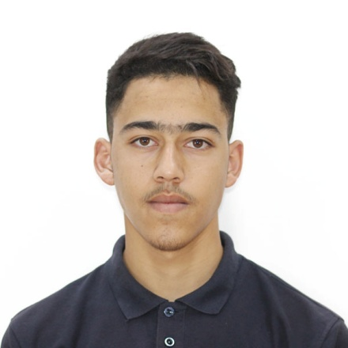

Phone N°:+213791517930

E-mail :salemsifeddine1@gmail.com

Address : Mesdour , Bouira, Algeria

EDUCATION

_**chaib saleh** primary school 2008-2009

_**guellil Mohamed** primary school 2009-2012

Graduation grade : very good (8/10)

_**Daoud ahmed** middle school 2012-2016

Graduation grade: good (13.02)

_**Meslem Mohamed** high school 2016-2019

Graduation grade: very good (16.02/20)

_**University of Mohamed bougara**

**Unstitute of electrical and electronic engineering**(studying in English)

2019-till now

**EXPERIENCEs**

**VOLUNTEER EXPERIENCE**

Volunteer in a **charity association**(“kafil el yatim”)- 2014-2015

Volunteer in a **charity association**(“el raid”)- 2015

Volunteer in **Aiesec** - summer 2020

**WORK**

Fiver, Upwork : about 1 year

Saggita production company : 5 months (decembre till now)

**skills**

_ **programming**(advanced)

1-Web development

2-Mobile development

3-automation with python

_**vedio edition** (good)

1-simple videos and for product marketing videos

_**Designing**(good)

1-simple designs and product marketing designs