ZVKY FORGE
art asset & animation pipeline
User Manual and Reference
A step-by-step walkthrough of every screen, with role-access notes
Internal training and reference document
Built 2026-09-28 from a running instance
Covers 60 designations and 65 permissions

Contents
If the page numbers below are blank, press Ctrl+A and then F9 to refresh them.

1. About this manual
ZVKY FORGE is the studio’s art asset and animation pipeline. Every piece of work in the studio lives in it as an asset, moves through a fixed set of review gates, and carries with it who did what and when.
This manual is a training and reference document for people inside the studio. It walks through every screen in the order somebody meets them, with a picture of each one taken from a running instance, and says at the end of each section who can do what.

1.1 How to read it
Each chapter covers one module. Inside a chapter you will find numbered steps you can follow at your own screen, a screenshot of what you should be seeing, and a shaded box headed WHO CAN DO THIS listing the designations that hold the actions in that chapter.
If a button described here is missing from your screen, that is the permission system working, not a fault. The application shows a person only the actions their designation holds. Chapter 13.6 and Appendix B explain how a Super Admin changes that.

1.2 Roles, permissions and access bands
The studio ships with 60 designations and 64 permissions. Rather than repeat eight or twenty designations on every page, this manual names the fourteen groups of designations that the permissions actually fall into, and calls them access bands. Appendix A lists every band and its members; Appendix B lists every permission and the band that holds it.
Two rules hold throughout. A permission says what somebody may do, never how much of the studio they may do it to — that reach comes from the designation itself. And Super Admin holds everything, including any permission added in future, without anybody switching it on.

1.3 About the screenshots
Every screenshot in this manual was taken from a live instance with a demo studio loaded: two clients (Aurora Games and Lumen Interactive), three projects, thirteen assets spread across every stage of the workflow, and seven people holding different designations. Nothing is a mock-up or a placeholder.
The person in the screenshots | Their designation | What they are used to show
Priya Nair | Super Admin | Settings, Users, Reports — everything
Rahul Menon | Team Lead | The first review gate, My Team
Ananya Rao | Creative Art Director | The second review gate, the project review queue
Vikram Shah | Producer | Sending a project to review, delivery
Meera Iyer | Game Artist | An artist’s own work: accepting, submitting, time sheets
Arjun Das | Game Artist | A second artist, so handovers have somewhere to go
Kavya Reddy | Game Animator | Animation work alongside art

2. Signing in and finding your way

2.1 Sign in
- Open the studio address in a browser. Chrome, Edge, Firefox and Safari are all fine; there is nothing to install.
- Type the email address the studio issued you and your password.
- Press Sign in.

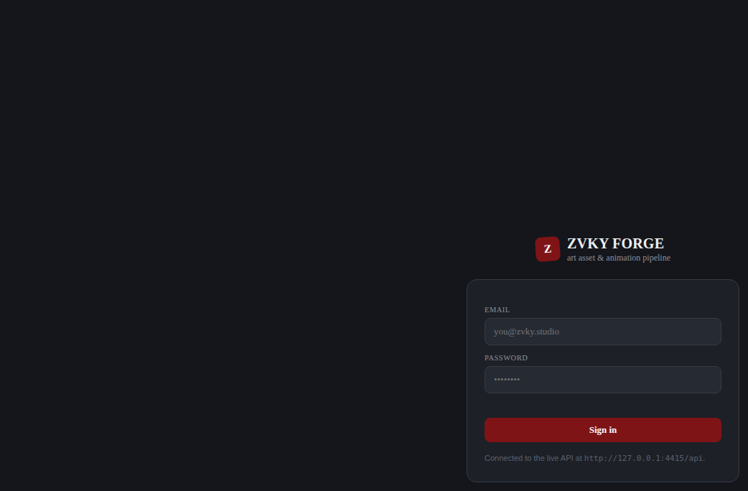
The sign-in screen.
Passwords must be at least 10 characters and contain an uppercase letter, a lowercase letter, a number and a symbol. The form checks each rule as you type when you change your password, so you can see which one you have not met yet.
IF YOU CANNOT GET IN
The studio may restrict sign-in to office IP addresses. If you are working from elsewhere and the page refuses you before it even asks for a password, ask a Super Admin to add your address in Settings (chapter 13.5).

2.2 The Quick Tour
The first time you sign in, a short guided tour opens by itself. It is not a generic tour: it walks only the tabs your designation actually gives you, so an artist sees four steps where a Super Admin sees twelve.
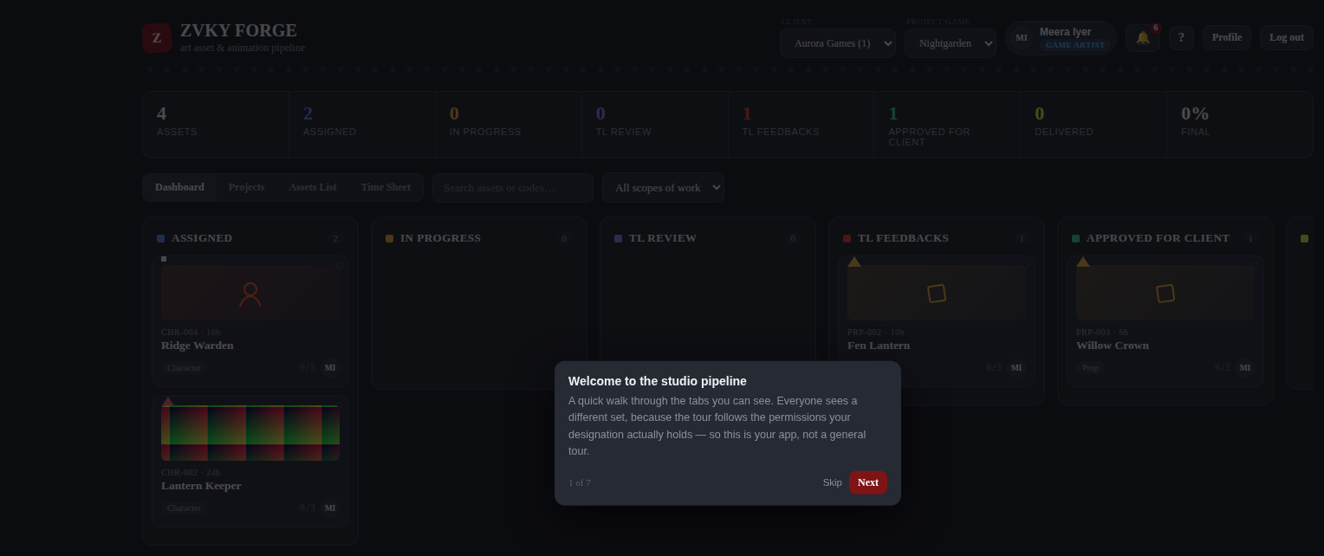
The Quick Tour, opening by itself on a first sign-in. The counter reads 1 of 7 for a Game Artist.
- Read the step, then press Next to move on, or Skip to leave the tour.
- Each step highlights the part of the screen it is describing.
- When you reach the end the tour closes and does not open again by itself.

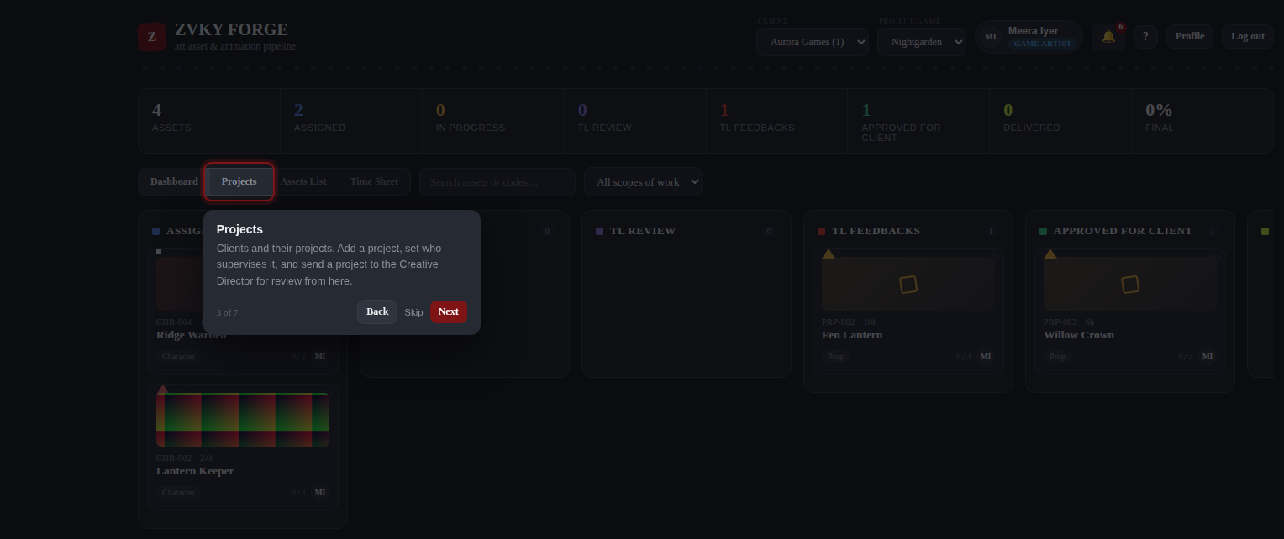
A later step. Each one points at a real tab or control.
You can reopen the tour at any time from the question-mark icon in the header, next to your name. Everybody has this — it needs no permission.

2.3 The header
The header, from left: the studio brand, the client and project pickers, your name and designation, the notification bell, the Quick Tour icon, Profile and Log out.
- Client and Project/Game — everything below the header is filtered to the project chosen here. Change the project and the whole page follows.
- Your name and designation — what the studio has you down as. If it is wrong, that is a Users change (chapter 11).
- The bell — notifications, with a count of the unread ones (chapter 12.1).
- The question mark — reopens the Quick Tour.
- Profile — your photo and your password (chapter 12.10).

2.4 The tabs
The row of tabs under the statistics strip is built from your permissions. Nobody sees a tab they cannot use.
Tab | What it holds | Who sees it
Dashboard | The board: every asset in the project, in columns by stage. | Everyone
Pending Actions | Project reviews waiting on you. | View Pending Actions
Projects | The projects under the chosen client, and the form to add one. | Anyone who may see or add projects
Assets List | The same assets as a table, with Active, Inactive, Archived and History. | Everyone
My Team | The people who report to you, and their load. | View Team
Time Sheet | Your week, and your team’s to read if you lead one. | Everyone
Reports | Efficiency and Idle. | View Reports
Users | The staff list. | User View
Settings | Everything configurable, and the Activity Log. | Any one Settings permission

3. The Dashboard
The Dashboard is the board: every asset in the chosen project, in a column for the stage it is at. It is the first thing everybody sees and the fastest way to answer "where is this?".

3.1 The statistics strip
The strip above the tabs: a count for every stage, and the percentage of the project that is finished.
The strip counts only what you are allowed to see. An artist looking at the same project as a producer will see smaller numbers, because the artist is counting their own work and the producer is counting the project.

3.2 The board
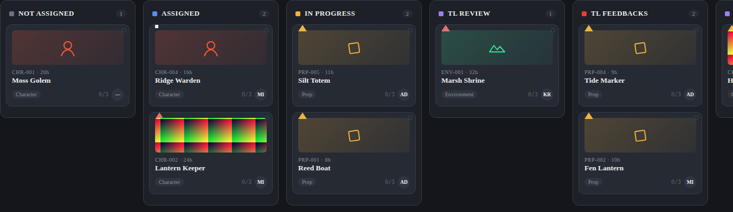
The board. Each column is a stage; each card is an asset.
- Choose a client, then a project, in the header.
- Scroll the board sideways to reach the later stages.
- Click any card to open the asset panel (chapter 6).

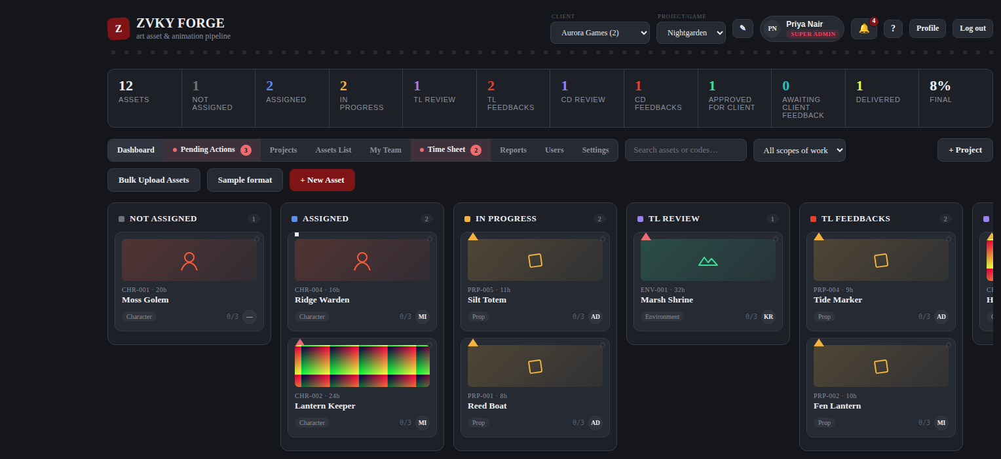
The whole Dashboard as a Super Admin sees it, with every column and both upload buttons.

3.3 What is on a card
- The preview image, if one has been set (chapter 6.3). Without one, the card shows the scope-of-work icon.
- The asset code and the estimate in hours — CHR-002 / 24h.
- The asset name.
- The scope of work, the task count, and the initials of whoever holds it.
- A coloured corner flag for priority.

COLOUR
Stage colours are deliberately distinct from the studio brand colour, so a red card never reads as branding and branding never reads as an alert.

WHO CAN DO THIS
Everybody can see the Dashboard. What appears on it depends on the designation: an artist sees their own work, a lead their team’s, and leadership the whole studio.
Everyone — 60 designations. Every designation in the studio, from Trainee upwards.

4. Clients and projects

4.1 The Projects tab
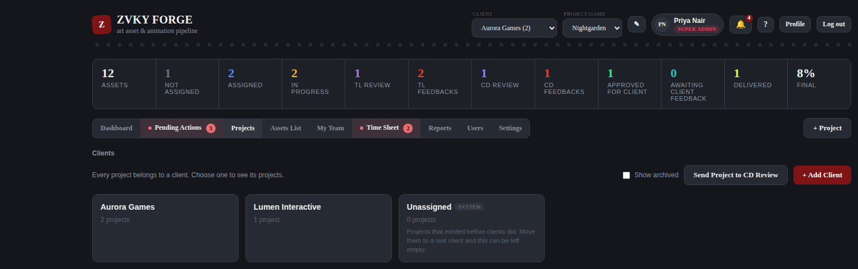
The projects under the chosen client.
Clients sit above projects. Choosing a client in the header narrows the project picker to that client’s work.
Opening a client lists its projects with what each one is and how it is going:
Column | What it shows
Project | Its name, and its code beside it.
Category | What kind of job it is — from the Project Categories list, which the studio keeps in Settings.
Start Date | When the project begins. Optional.
End Date | When it is due to finish. Optional.
Milestones | The dated stages inside the project — Art from here to here, Animation from there to there — one line each. Only the stages that apply to that project; a project with none shows a dash.
Total Bid Hours | Every asset’s Man Hours estimate, added up. What the project was quoted at.
Spent Time | The hours actually recorded against its assets.
Status | Active, closed or archived.

THE TWO FIGURES ARE WORKED OUT AS YOU LOOK AT THEM
Total Bid Hours and Spent Time are never stored on the project. They are counted from its assets on every read, so editing an estimate or finishing a round shows immediately, and there is nothing anybody has to remember to recalculate. Total Bid Hours counts EVERY asset under the project, whatever stage it is at and whichever tab it is on — an asset that has been delivered was still estimated, so it stays in the bid. Spent Time counts every round of every asset, including the finished rounds of people who have since handed the work on, and leaves out any stretch that was put on hold. It is the same figure, worked out the same way, that the Efficiency report shows per asset.

4.2 Creating a project
- Press + Project, at the right of the tab row.
- Give the project a name and pick the client it belongs to.
- Choose a Category, or leave it blank — it is optional. If the one you want is not in the list, pick "+ Add Category", type it and press Create: it is added to the studio’s list and selected straight away, without leaving the form.
- Give it a Start Date and an End Date if the project has them. Both are optional, and a start date after the end date is refused.
- Name the team leads who will run its first review gate.
- Name the production coordinators, if the studio uses them.
- Add up to two people to the supervision list — the ones accountable for the project overall.
- Save.

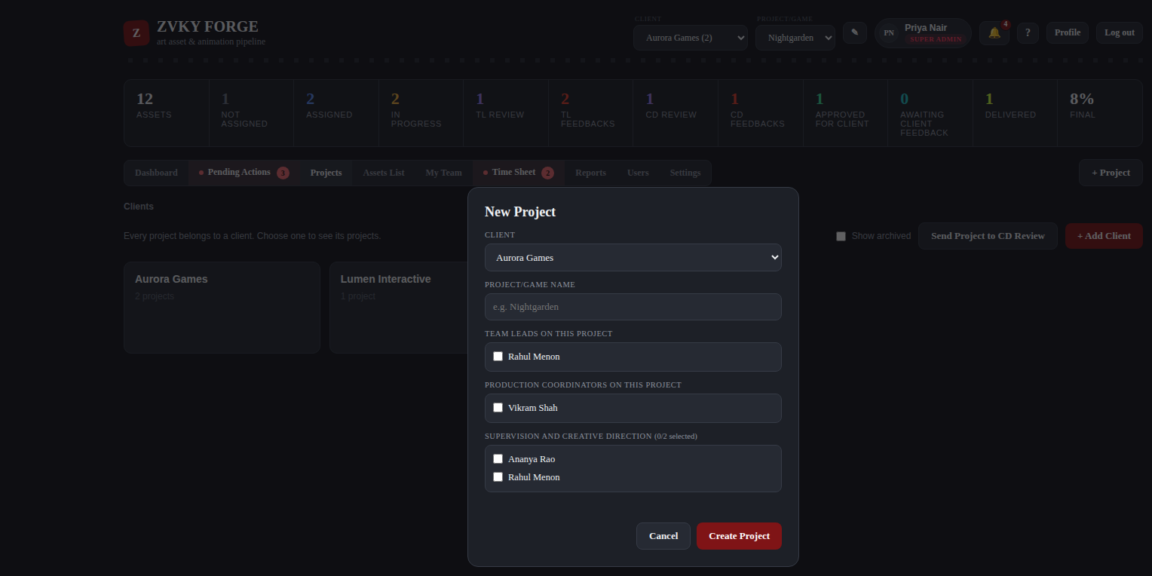
The new-project form.
THESE THREE LISTS ARE WHO MAY REVIEW THIS PROJECT’S WORK
The people named here are not only a record of who is involved. Anyone on any of the three lists can act on every asset in this project at TL Review, TL Feedbacks and TL Approved — whoever did the work, and whoever that person reports to. Leaving all three empty is allowed and falls back to the older behaviour, where an artist’s own lead reviews their work. All three stay editable from Edit Project afterwards. See 7.8b for the whole rule.

A PROJECT’S DATES DESCRIBE IT, THEY DO NOT POLICE IT
Start Date and End Date on a project are plain information. Nothing warns, blocks or moves when an end date passes with work outstanding, and a project whose dates are long past still takes new assets and still lets work be started on them. This is not the same field as an asset’s Start Date, which does hold Accept and Start closed until the day arrives (7.4).

TWO SUPERVISORS, AND NO MORE
The supervision list is capped at two people, and the cap is enforced by the server, not only by the form. This is deliberate: a list of five supervisors means nobody is supervising.

4.3 Closing a project
A finished project is closed rather than deleted, so its assets, time sheets and history stay readable. A closed project accepts no new assets and no changes to the ones it holds.

4.4 Archiving, and deleting for good
There are two levels, and the application steers you to the first. Archiving hides a client or a project from every dashboard and keeps everything under it — assets, submissions, review history, time sheets — ready to be restored. Permanent deletion is offered only where it costs nothing: something holding nothing.

Archiving
- Projects tab, then click the client.
- Archive client for the whole client, or Archive on a project’s row for one project.
- A project with undelivered assets asks you to confirm, and says how many.
- Restore brings either one back exactly as it was.

Deleting permanently
The Delete permanently button appears only once two things are true: the client or project is already archived, and it holds nothing. A client with any project, or a project with any asset, cannot be deleted at all — the button is not shown, because it is not something that could be allowed.
- Move or delete whatever it holds, until it holds nothing.
- Archive it.
- For a client: go back to the client list and tick Show archived — archived clients are not listed by default. The tick box says how many are hidden.
- Open it and press Delete permanently. This one cannot be undone.

WHERE THE DELETE OPTION SEEMS TO HAVE GONE
Archiving a client takes it out of the default list, and the Delete permanently button only exists once it is archived — so both can appear to vanish at the same moment. Tick Show archived and it is there. The built-in Unassigned client can never be deleted; it is where projects go before they have a client.

WHO CAN DO THIS
Adding, editing, closing and deleting projects and clients sits with the administration band. Everyone can see the clients they work under. One extra rule on projects: unless your designation sees the whole studio, you can only delete projects you created.
Administration — 8 designations. The people who run the studio’s records: staff, projects and clients.
Everyone — 60 designations. Every designation in the studio, from Trainee upwards.

5. Assets

5.1 Creating one asset
- On the Dashboard, press + New Asset.
- Give it a name.
- Choose the scope of work — Character, Prop, Environment, FX, Animation, Background, or whatever the studio has added. This decides the code prefix, so a character becomes CHR-004.
- Optionally set a category, a priority, an estimate in man hours, a description, and the two dates: Start Date and End Date (Deadline). Both are optional and independent of each other.
- Optionally choose an assignee. Leave it blank and the asset starts in Not Assigned.
- Save. The code is generated for you.

5.2 Bulk upload
For a batch, use Bulk Upload Assets. Press Sample format first to download a spreadsheet with the right columns and a filled-in example row.
Column | Required | What it does
No. | no | Your own row number. Not stored.
Asset Name | YES | The name.
Category | no | A new value here is added to the Settings list rather than rejected.
Scope of Work | YES | Character, Prop, Environment, FX, Animation, Background, or a new one.
Man Hours | no | The estimate. A positive number.
Assignee Email | no | A match assigns the asset immediately; a blank leaves it Not Assigned.
Start Date | no | DD-MM-YYYY. The asset cannot be started before this day.
End Date (Deadline) | no | DD-MM-YYYY. YYYY-MM-DD is accepted too. Sheets using the older "Deadline" heading still import.
Project Link | no | The brief or reference. Shown as Requirement / Reference Link.
Lead/Supervisor Notes | no | Visible only to designations holding Lead / Supervisor Notes.

A BAD ROW DOES NOT LOSE THE GOOD ONES
The upload reports every row it could not accept, with the row number and the reason, and imports the rest. An unrecognised column heading is reported rather than silently ignored, so a mis-saved file cannot quietly drop a column of deadlines.

5.3 The Assets List
The same assets as a table, which is easier than the board when there are many. It has four sub-tabs, and an asset appears in exactly one of them.
The table carries Start Date and End Date (Deadline) as columns, so a whole project’s schedule can be read down two columns without opening anything. Every column has a filter of its own (5.3a), and Time Spent is the whole asset with its rounds behind it (5.3b).
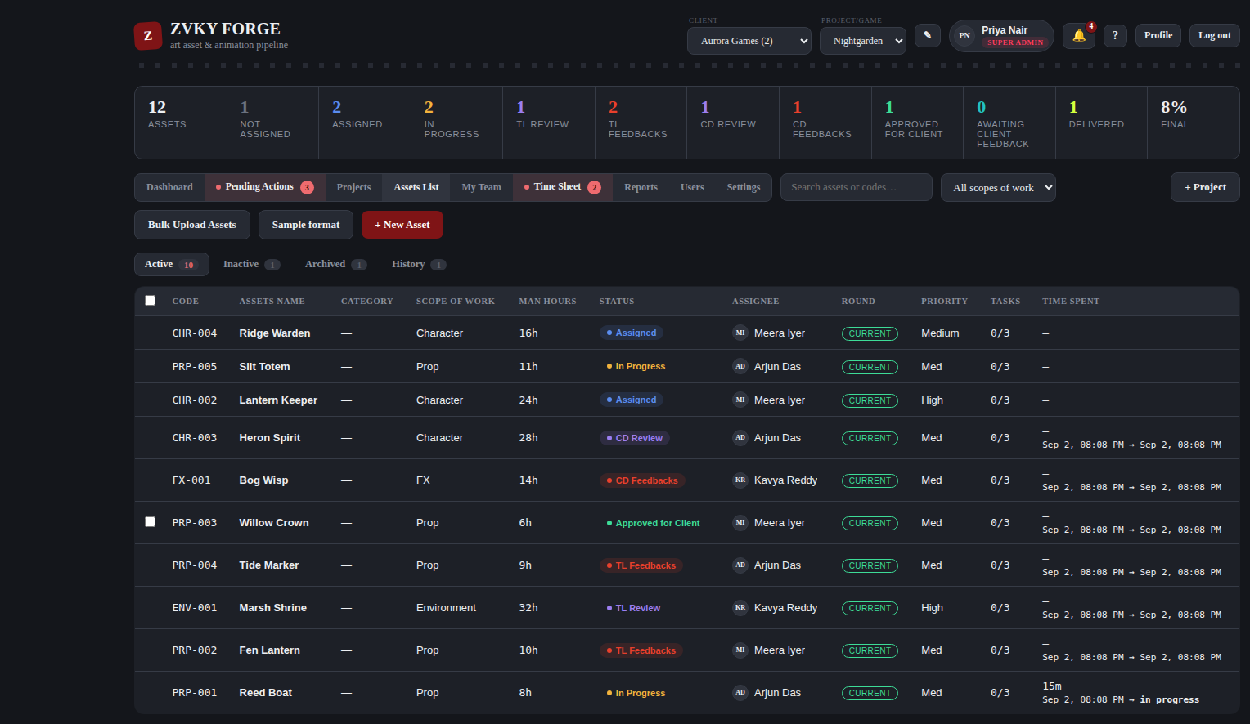
Active: everything still moving through the pipeline.
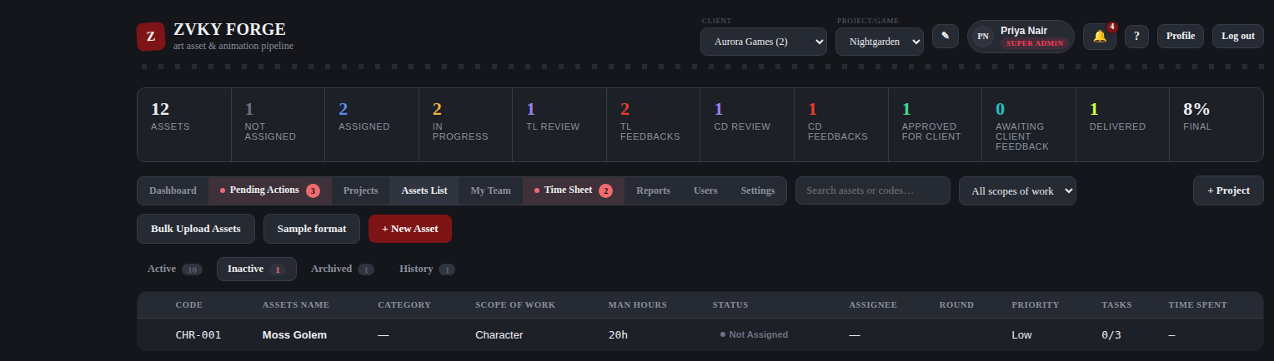
Inactive: work nobody has picked up — assets that are Not Assigned, or assigned and not yet accepted. This is where a batch is selected for 5.5.
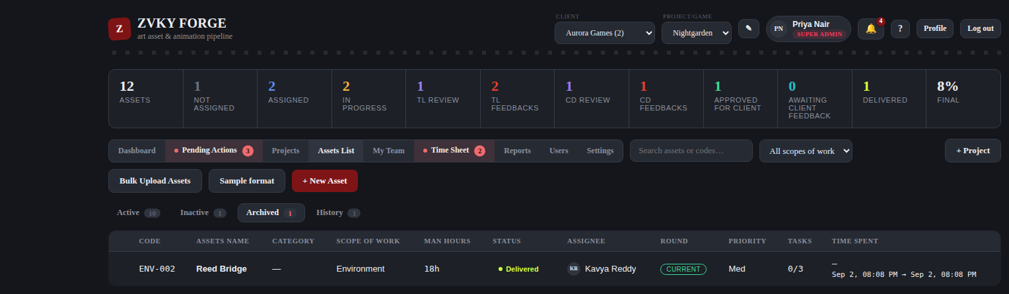
Archived: delivered work, kept for the record.
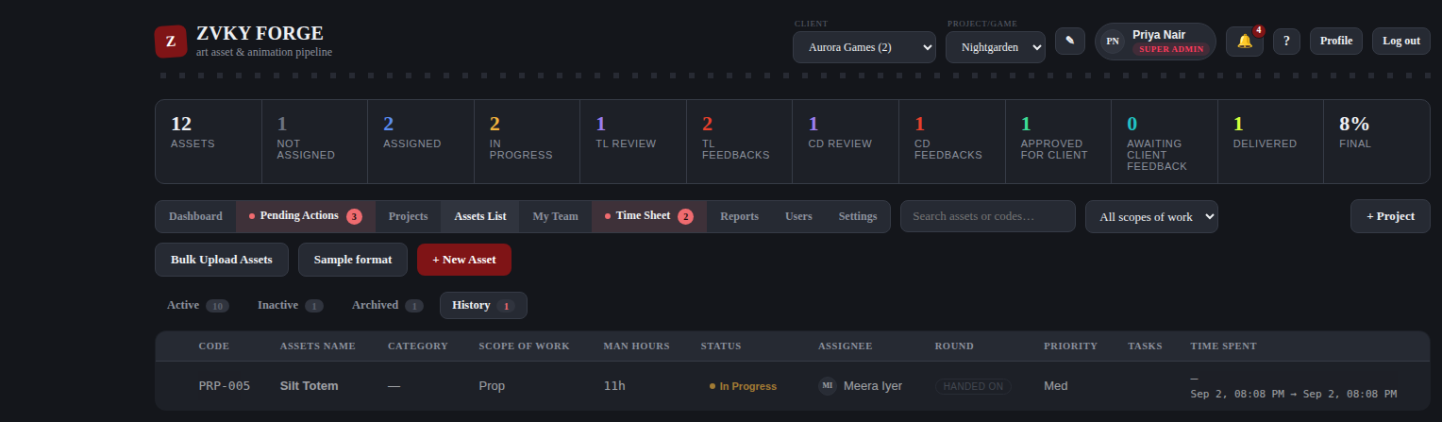
History: every stage change, who made it and when.

5.3a Filtering the list
A bar of filters sits under the sub-tabs, with one control for every column of the table — thirteen of them, each named after the heading it narrows. It is the same bar on all four sub-tabs.
- <strong>Code</strong> and <strong>Assets Name</strong> — type a fragment of either. Not case sensitive, and it matches anywhere in the value, not just the start.
- <strong>Category</strong>, <strong>Scope of Work</strong>, <strong>Assignee</strong>, <strong>Round</strong>, <strong>Priority</strong> and <strong>Tasks</strong> — a dropdown each.
- <strong>Status</strong> — a tick list rather than a dropdown, so several stages can be asked for at once. TL Review, TL Feedbacks and TL Approved together is the usual reason.
- <strong>Man Hours</strong> and <strong>Time Spent</strong> — a smallest and a largest, either on its own or both. Time Spent is typed in hours.
- <strong>Start Date</strong> and <strong>End Date (Deadline)</strong> — a from and a to, either on its own or both. Both ends are included.

EVERYTHING SET NARROWS TOGETHER. Choosing a project team member and a priority shows the rows that are both, not either — each filter takes away, none of them adds back. A filter left empty is not asked at all, so a bar with nothing in it shows the same list as no bar.
<strong>Reset filters</strong>, at the end of the bar, clears the lot in one press. It is greyed out while nothing is set, so it also says at a glance whether anything is being hidden. The count beside it says “showing 12 of 340” whenever a filter is on, and just the row count when none is.
THE FILTERS STAY PUT WHEN YOU CHANGE SUB-TAB
Filter by assignee on Active, switch to History, and it is still that person’s work you are looking at. That is the same thing the search box in the header already does on this screen, and it is what makes the counts on the sub-tabs useful: with a filter on, each tab’s number is how many MATCHING rows it holds, so the tabs themselves tell you where the rest of what you are looking for is.
A filter narrows within the sub-tab and never instead of it. Nothing set here can put an Archived row on the Active tab — the tab decides which rows exist, the filters decide which of those are shown.

WHY THERE IS NO PROJECT OR CLIENT FILTER. The Assets List is already one project, under one client, both chosen in the header — a control for either would have one option in it. Neither is a column of this table for the same reason. The header’s pickers are where that choice is made.
A tick made for a bulk action is not lost when a filter hides the row. The selection bar counts those separately — “3 hidden by the filter” — so narrowing, ticking, widening and ticking again adds up to what it says it does.

5.3b Time Spent, and what it is made of
The <strong>Time Spent</strong> column is the asset’s WHOLE recorded time — every round of work on it, summed. An asset that went out for changes, came back and was worked on again shows the first round’s hours plus the second’s, and a third and a fourth after that. It is worked out from the recorded stretches each time the list is drawn, so there is no stored total to go stale.
This used to read only the round in front of you, which meant the number went DOWN after a reassignment and looked as though the earlier work had been lost. It never was — it was in the database and in the P&L the whole time — but the column was answering a narrower question than its heading asks.
- Under the figure, <strong>"3 rounds"</strong> opens the breakdown: each round, how long it took, and who worked it, with the total at the bottom. Hovering gives the same thing as plain text, so it can be read without clicking and it survives a screenshot.
- On the <strong>History</strong> tab a row is one finished round rather than an asset, so the figure there is that round’s own time — with <em>of 2h 35m in total</em> under it, so the whole is never more than a glance away.
- Every round’s figure has already had the recording schedule applied to it (7.3a), so summing them cannot put back an evening, a weekend or a break.
- The asset panel carries the same breakdown, from the same numbers.

WHERE ELSE THIS FIGURE GOES
Time Spent is one column in the database — work_sessions.seconds — and everything that talks about hours reads it: the Assets List, the asset panel, the Efficiency and Idle reports, the hours the Time Sheet suggests, and both P&L tabs. They all count every round, so none of them can disagree with this column about what an asset cost.
The P&L counts only DELIVERED work, so an asset still in flight contributes nothing there while showing its hours here. That is the P&L’s own rule and not a disagreement; the two meet the moment the asset is delivered. A round still running is counted here as it goes and joins the P&L when it is handed in.

5.4 Delivering several at once
- On the Assets List, tick the assets you want to deliver.
- Press the bulk deliver action.
- Confirm.

Every asset in the batch is recorded individually in its own history, and the batch itself is recorded too, so a bulk delivery is as auditable as fifteen single ones.

5.5 Assigning and scheduling several at once
Handing out a batch of new work. Select the assets, choose one assignee and one pair of dates, and press Apply — whatever is filled in is applied to every asset selected.
- On the Assets List, open the Inactive sub-tab, where work nobody has picked up sits.
- Narrow the pile with the filter bar if it is a long one — 5.3a. Category and Scope of Work are the usual two.
- Tick the assets you want to set up.
- Press Assign & Schedule. The button says how many of your selection it will touch.
- Fill in any of Assignee, Start Date and End Date (Deadline), and press Apply.

- Each field is optional. Set only the dates to schedule a batch without changing who holds it, or only the assignee to hand work out without inventing a schedule for it.
- One value for all of them, not a value per asset. This is for the forty assets that all begin on the same Monday and all belong to the same person; anything more varied is done on each asset.
- A blank field is left alone, not cleared. Emptying a date that is already set is done on the asset itself, where you can see what you are clearing.
- A start date after the end date is refused before anything is written, and the message quotes both dates back.
- Every asset is reported on its own line. One that cannot be set up does not hold up the rest.

ONLY WORK NOBODY HAS STARTED
This sets up assets that are Not Assigned. Anything already on somebody’s desk is skipped and listed with the reason. That is not because the record would be lost — handing work over in bulk would keep the round and the history exactly as the single flow does — but because a handover ends somebody’s round and resets the Time Spent they can see, and doing that to forty assets from a tick list is a different act from doing it once with a name in front of you. Work under way is handed over one asset at a time, from its own panel.

Everything a single assignment does, a bulk one does: the asset moves to Assigned, a Round opens, the person is notified, and the change is written to that asset’s history and to the Activity Log. The batch itself is recorded too, so each asset’s history says which act it was part of. A Start Date set this way gates Accept and Start exactly as one typed on the asset does (7.4).
WHO CAN DO THIS
Creating assets and bulk upload sit with production planning. Editing and assigning are open to everyone who works on assets, within the reach their designation gives them. Deleting an asset is administration only. Delivery sits with the delivery band. Bulk Assign & Schedule starts with Super Admin alone and is granted in Settings → Role Permissions to the coordinators who plan work — and granting it opens the bulk panel without widening whose assets anybody may touch: each asset is still checked one by one.
Production planning — 23 designations. Coordinators, project managers, producers, leads, supervisors and above — the people who put work into the pipeline.
Everyone who works on assets — 51 designations. Everyone except the finance and administrative designations who never touch an asset.
Delivery — 18 designations. Production and account management — the people who hand finished work to a client.
Administration — 8 designations. The people who run the studio’s records: staff, projects and clients.
Super Admin only — 1 designations. Nobody else holds this out of the box.

6. The asset panel
Clicking any card or any row opens the asset panel from the right. Everything about one asset is here.

6.1 What is in it
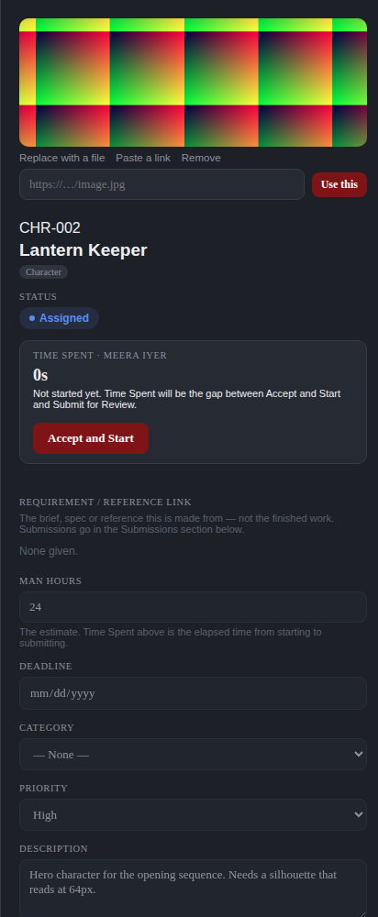
The asset panel. The preview image is at the top, then the code, the name, the stage, Time Spent, and the fields.
- Preview image, and the controls to change it.
- Code, name and scope of work.
- Status — the stage the asset is at.
- Time Spent — the gap between Accept and Start and Submit for Review, and the button for whichever of those is next.
- Requirement / Reference Link — the brief. Not the finished work.
- Man Hours, Start Date, End Date (Deadline), Category, Priority, Description.
- Tasks — the checklist, and the count the card shows.
- Notes, submissions and history, further down.

6.2 Who is holding it
The Assignee list in the panel is the ordinary way work changes hands, and it does three things depending on what is picked. Choosing somebody on a Not Assigned asset assigns it, and the asset moves to Assigned. Choosing somebody else on an asset already under way hands it over: the outgoing person’s round is closed with their hours intact, and the new person starts a fresh one.
Choosing Unassigned takes the work back off whoever holds it. The asset returns to Not Assigned — it goes back in the pool, and the card moves to the Not Assigned column — and any clock running on it stops. Two exceptions, both deliberate. Work that has already been submitted keeps its place in the review queue: unassigning an asset sitting in TL Review or CD Review clears the name but leaves the stage alone, so a reviewer does not lose a round somebody handed in. And the Bulk Assign panel has no Unassigned option: it only acts on Not Assigned assets, which have nobody on them to remove.
Every one of these is recorded in the asset’s history, naming who made the change, who it came off and who it went to.

6.3 The preview image
An asset can carry a preview image, shown both on its card and at the top of this panel. There are two ways to set one, and an asset holds one or the other, never both.

Uploading a file
- Open the asset panel.
- Press Upload an image, or Replace with a file if one is already set.
- Choose a JPG or PNG of up to 5 MB.

Pasting a link
- Press Paste a link.
- Put the image address into the box — it must start with http:// or https://.
- Press Use this.

A linked image is fetched by the browser each time, so it stays current if the source changes, and disappears if the source is taken down. When a link stops loading, the card and the panel fall back to the scope-of-work icon rather than showing a broken picture. An uploaded file has no such dependency.
Press Remove to clear either kind. Both setting and removing a preview are recorded in the Activity Log, naming the person and saying which kind it was.
WHO CAN DO THIS
The person an asset is assigned to can always change its preview image, even if their designation does not otherwise let them edit assets. Anyone else needs Asset Edit.
Everyone who works on assets — 51 designations. Everyone except the finance and administrative designations who never touch an asset.

6.4 Tasks and notes
Tasks are a checklist on the asset — the 0/3 on the card. Notes are a running conversation, kept with the asset rather than in anybody’s inbox.

6.5 History
Every stage change the asset has been through, with who made it, when, and what they wrote. This is the asset’s own record and is separate from the studio-wide Activity Log in chapter 13.7.

7. The workflow, stage by stage
Ten stages, and a fixed set of moves between them. Nothing moves an asset except one of these moves, and every one of them is recorded.

7.1 The eleven stages
Stage | What it means | Who puts it here
Not Assigned | The asset exists and nobody is holding it. | Whoever creates it, or a bulk upload with the Assignee Email column left blank.
Assigned | It is on somebody’s desk, not yet accepted. | Anyone who may assign work.
In Progress | The assignee has pressed Accept and Start. Time Spent runs from here, and pauses while the task is on hold. | The assignee, and nobody else.
TL Review | Submitted, waiting on the first review gate — the project’s team, see 7.8b. | The assignee, on Submit for Review.
TL Feedbacks | A reviewer asked for changes. Back with the assignee. | Anyone on the project team who may review at the first gate.
TL Approved | The work has passed the first gate. Waiting on a decision about where it goes next. | Anyone on the project team who may review at the first gate, on approval.
CD Review | Past the first gate and sent on, waiting on the Creative Director. | The reviewer, from TL Approved.
CD Feedbacks | The Creative Director asked for changes. Sits with the team lead until relayed. | The Creative Director.
Approved for Client | Cleared internally. Ready to leave the studio. | The Creative Director, or a lead who may skip the second gate.
Awaiting Client Feedback | It has gone to the client and the studio is waiting. | Whoever holds Send to Client Review.
Delivered | Finished and handed over. | Whoever holds Deliver, or the client approving.

7.2 Every move
Action | From | To | Permission
Assign | Not Assigned | Assigned | Asset Assign
Accept and Start | Assigned | In Progress | The assignee
Hold / Resume | In Progress / TL Feedbacks / CD Feedbacks | No change — the stage stays put | The assignee, with Hold / Resume Own Task
Submit for Review | Not Assigned / In Progress / TL Feedbacks | TL Review | The assignee
Submit for Review (after CD notes) | CD Feedbacks | CD Review or TL Review | The assignee
TL Approved | TL Review | TL Approved | TL Review
Request Changes | TL Review | TL Feedbacks | TL Review
Approve → Send to CD Review | TL Approved | CD Review | TL Review
Send to Client | TL Approved | Approved for Client | TL Send to Client
Approve for client | CD Review | Approved for Client | CD Review
Request changes | CD Review | CD Feedbacks | CD Review
Relay the notes | CD Feedbacks | CD Feedbacks (now with the assignee) | TL Review
Send to client review | Approved for Client | Awaiting Client Feedback | Send to Client Review
Client approved | Awaiting Client Feedback | Delivered | Record Client Approval
Client asked for changes | Awaiting Client Feedback | TL Feedbacks | Record Client Changes
Deliver | Approved for Client | Delivered | Deliver
Hand over (Reassign to Any User) | TL Review / CD Review / TL Feedbacks / CD Feedbacks | Assigned — the new person starts their own round | Asset Assign
Reassign to Same User | TL Feedbacks | Assigned — the same person, a fresh round | Asset Assign
Change the assignee | Not Assigned / Assigned / In Progress | Assigned | Asset Assign
Unassign (pick Unassigned in the Assignee list) | Assigned / In Progress | Not Assigned | Asset Assign

7.3 Accepting work
- Open the asset assigned to you.
- Read the brief in Requirement / Reference Link.
- Press Accept and Start.

An asset assigned to you, before you accept it. Time Spent reads 0s and has not begun.
The asset moves to In Progress and the clock starts. Nothing ticks on screen: Time Spent is the part of the span between this moment and the moment you submit that falls inside the studio’s working hours, less any stretch you put on hold (7.6).
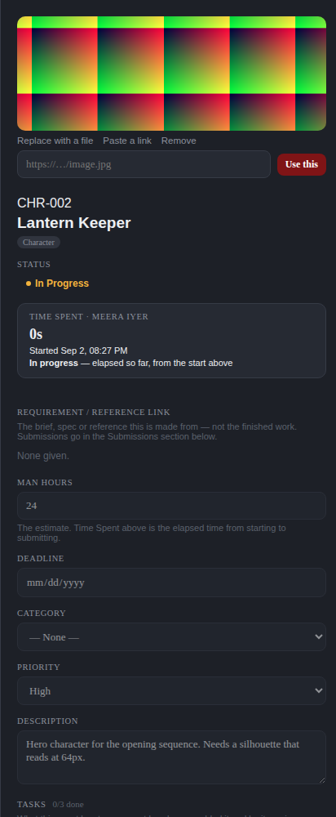
The same asset once started. The panel now shows when you started, and Time Spent is running.

7.3a The recording schedule
The clock counts working time, not wall-clock time. Start an asset at ten to seven on a Friday and submit it on Monday morning and it has cost about two hours, not sixty-three. What counts is set in Settings → Recording Hours (7.3c), and it is the same setting the Idle report and the Time Sheet already read.
THE STUDIO’S SCHEDULE, as shipped:
 | IST
Recording days | Monday to Friday. Nothing on Saturday or Sunday, ever.
Recording hours | 09:30 – 19:00
Morning break | 11:00 – 11:15 — recording stops
Lunch | 13:00 – 14:00 — recording stops
Afternoon break | 16:00 – 16:15 — recording stops
A full day | 8 hours, which is exactly what the Time Sheet allows in a day

THAT TABLE IS NOW A LIST YOU CAN EDIT, not a fixed form. It is four rows in Settings → Recording Hours — one Recording window and three Non-Recording ones — and a Super Admin can add, rename, narrow to particular days, switch off or delete any of them. Everything below is what those four rows currently say; 7.3c is how to change them, and what changes when you do.
- It is IST, always. The studio’s window is a wall clock in one office, so neither the server’s timezone nor your laptop’s changes what is recorded. Somebody working from another country has their hours measured against the studio’s day, not their own.
- A BREAK STOPS THE CLOCK and starts it again at the far end. A timer running at 10:45 is put down at 11:00 and picks up at 11:15; the same at one o’clock and at four. This changed: a break used to be subtracted from the total without stopping anything.
- A timer running when the day ends is put down at 19:00. Not when anybody noticed, and not when the server got round to it: the boundary is exact, so an evening left running costs the asset nothing.
- It starts again on its own the next working morning, at 09:30, with nobody pressing anything — and back-dated to 09:30, so signing in at eleven finds the morning already counted. Weekends and any other non-working day are skipped: a timer put down at seven on Friday starts again on Monday. See 7.3b for the cases where it does not.
- Starting outside a recording stretch is allowed. The click is never refused — you are taking the work on, and being made to wait would only mean recording a start time that was not true. The timer begins paused, accrues nothing, and joins the schedule at the next stretch.
- Public holidays are not recorded anywhere. A day the studio is shut for a festival still counts as a working day unless somebody changes the working days in Settings for that week.

THERE IS NO RESUME BUTTON FOR ANY OF THIS
Every stop and start above is the schedule’s, and it makes them on the server whether or not anybody has the app open. So there is nothing to press: the panel says which stop it is and when recording picks up, and that is the whole of it.
Hold keeps its Resume, and that is a different thing — a pause YOU chose, which the schedule does not undo, so the button is the only way back from it. The panel tells the two apart in as many words.

THE FIGURE DOES NOT DEPEND ON THE SERVER HAVING BEEN WATCHING
The schedule’s stops and starts are a LABEL on the work, not the measurement of it. A stretch’s seconds are worked out by laying it over the recording window, which takes out every break, evening and weekend inside it — so a day comes to the same total whether the server marked each boundary as it passed or was restarted at eleven and did not look again until the afternoon.
This had been wrong in both directions at once, and a restart in the middle of a day was enough to show it: a timer open since 10:28 was put down at 11:00 (the first boundary after it STARTED, rather than the last one before now) and picked up again at 16:15 (the start of the stretch we were in NOW, rather than the far end of the break it was actually stopped at). 11:15–13:00 and 14:00–16:00 belonged to no stretch at all, and the day read 2h 19m instead of 6h 05m. Both ends now ask the same question and the missing stretches are recorded.

WHERE THIS SHOWS UP. It is corrected at the source — one column, work_sessions.seconds — so every figure built on it moves together: Time Spent on the card and in the Assets List, the Efficiency report, the hours the Time Sheet suggests when you add a line, and the Fixed and Actual hours in the P&L. There is no screen where the old number survives, and none that needed its own fix.

7.3b When the overnight resume does NOT happen
The clock starting itself is only right while the work is still there to be done, so the application asks again at half past nine rather than assuming what was true at seven. Four answers mean no, and in each of them the timer stays down for you to pick up by hand:
- <strong>You submitted it.</strong> Work waiting on a reviewer is not work in progress, and nothing accrues against it. This is the case the check exists for.
- <strong>It was reassigned.</strong> Somebody else holds it now. Their clock starts when they press Accept and Start, in a round of their own — the overnight rule never reaches across an assignment.
- <strong>It was taken off everybody.</strong> Nobody holds it, so nobody’s clock runs.
- <strong>You started something else.</strong> The studio’s one-active-task rule holds here exactly as it does on the Resume button: the task you actually chose this morning keeps running, and last night’s waits.

A task you put down YOURSELF is also left alone. Hold and the working-hours pause look similar on screen and are one column apart in the record, but they are different things: one is a decision you made, and the application does not undo it overnight. Only the pause the studio applied starts itself again.
THE HOURS ARE THE STUDIO’S DAY, NOT YOUR ATTENDANCE
This records the working day as configured, not whether you were at your desk for it. A task left open overnight and forgotten will be counted from 09:30 until somebody submits it, holds it or hands it on. That is the studio’s decision and it is the point of the feature — the alternative, which this replaced, was a clock that stayed down until pressed and quietly lost a morning’s real work.
The panel says which state a task is in and the bell says when the clock started again, so the way to stop a figure you do not want is Hold. Breaks still come out either way.

Every stop and start runs on the server, on a schedule, not when somebody opens the page — so it happens at eleven o’clock with nobody looking, and a server restarted overnight does the missed ones on the way back up. Each is stamped at its own boundary whatever time the check actually ran, so a late tick costs nobody a correct number: open the app at ten and the state already reflects what should have happened at half past nine.

7.3c Setting the recording hours — Super Admin
Settings → Recording Hours is where the schedule above actually lives. It is two lists of named windows, and there is no limit on either: keep pressing + Add for as many as the studio needs.
List | What it does
Recording Hours | When the clock runs. Two windows that overlap are one stretch of recording, not two.
Non-Recording Hours | Cut out of the windows above — breaks, a lunch blackout, an after-hours block. A window in this list always wins over one in the other.

EACH ROW carries a start and an end, an optional label, the days of the week it applies on (all seven unless you narrow it), a "crosses midnight" box and an enabled switch. Save and delete are per row: one bad row shows its error under itself and every other row on the page carries on working.
- A LABEL IS WORTH SETTING even though it is optional. It is what the Working Hours summary, the audit trail and the overlap warnings call the window, so "Lunch block" reads better than "13:00–14:00" in all three.
- DAYS OF THE WEEK are what make a half day possible: a second Recording window of 10:00–14:00 ticked for Saturday alone gives the studio a short Saturday without touching the weekday one.
- CROSSES MIDNIGHT is for a window like 22:00–06:00. Without it an end before a start is refused, and the message says which box to tick. The days you pick are the days the window STARTS on — a Monday-to-Friday night shift records Saturday morning, because that is Friday night running on, and does not record Monday morning, because Sunday night is not a shift.
- ENABLED takes a window out of force without losing what it said. Use it to try a schedule for a week rather than deleting a row you will want back.
- OVERLAPS WARN, they do not refuse. Two Recording windows that overlap are a perfectly sensible thing to build out of "Core hours" plus "Friday late shift", so the conflicting labels are named and you decide. A window in the other list overlapping one here is not flagged at all — that is what the second list is for.

A CHANGE HERE CHANGES WHAT THE STUDIO RECORDS, FROM NOW ON
These rows are the clock, not a description of it. Time Spent on every card and in the Assets List, the Efficiency and Idle reports, the hours the Time Sheet suggests and the Fixed and Actual figures in both P&L tabs are all measured against these windows — there is one column behind all of them and this is what decides its value.
It is not retroactive. Seconds already recorded keep the window they were recorded under; what changes is everything measured from the moment you save. A timer running when you close a window is put down at that moment, and one running when you open one starts counting.
Switching every Recording window off, or covering them all with Non-Recording ones, stops time tracking for the whole studio. It is allowed — there has to be a way back from a schedule you want gone — and the page says so in a warning above the lists rather than letting you find out from a report.

WHO CAN OPEN IT. The Super Admin, and nobody else by default — not the roles that hold every other Settings section. It can be handed to a designation in Settings → Permissions (Manage Recording Hours), which is the only way anybody else gets it. The check is made on the server on every request, so the section being missing from somebody’s Settings page is a courtesy rather than the lock.
EVERY CHANGE IS LOGGED. Adding, editing and deleting a window each write an Activity Log entry naming who did it, when, and the window before and after — "Lunch 13:00–14:00, every day" against "Lunch 12:30–13:30, Mon/Tue/Wed/Thu/Fri". This is the setting that decides how everybody’s tracked time is read, so what it used to say is part of the record.
WHAT HAPPENED TO WORKING HOURS. That section is still there and still shows the studio’s day, the days it runs and the breaks that come out of it — worked out from these windows, by the same function the timer reads, so the two cannot disagree. What moved is where you change them. Hours in a working day stays on the Working Hours screen: it is what a full day is EXPECTED to be, which the Idle Report divides by, and it is not a window the clock runs in.

7.4 Not before the start date
An asset carrying a Start Date cannot be accepted before that day. The button is disabled until then and says which day it is waiting for, and the server refuses an early start as well — a disabled button is a courtesy, not the rule.
- On or after, not only on. A start date that slipped past unnoticed leaves the task late, not forbidden — it stays startable.
- No start date means no waiting. The field is optional, and blank behaves exactly as it did before the field existed.
- Today is IST, the same day boundary the Time Sheet uses, so a reader in another timezone sees the same answer as the studio.

7.5 One active task at a time
You may hold one piece of work open at a time. While an asset of yours is open, Accept and Start on every other asset assigned to you is disabled, and the panel says which asset is holding you up.
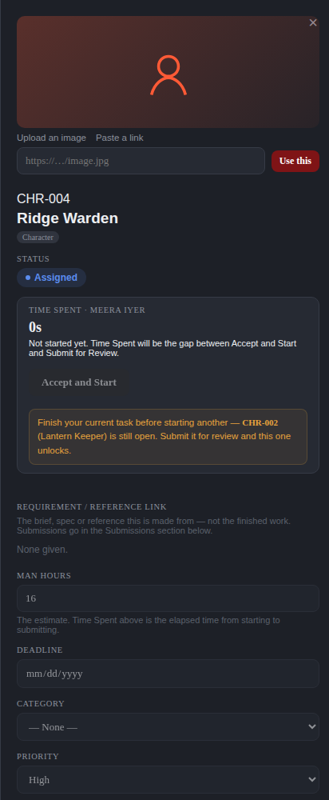
A second asset, refused. The button is greyed and the message names CHR-002 (Lantern Keeper) as the open one.
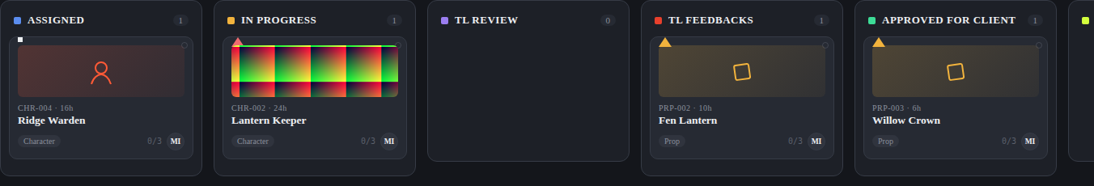
The same rule seen on the board.
- Submit your open asset for review and every other one unlocks immediately.
- The rule is enforced by the server as well as the screen, so it holds in a second browser tab too.
- It applies only to starting your own work. Reviewing, approving, relaying feedback, filling in a time sheet and everything else are untouched — a lead with their own asset under way still runs their queue.
- Rework after TL or CD feedback counts as open work, because it is started with the same button.

7.6 Putting a task on hold
Work stops for reasons that are nobody’s fault — a client call, a machine being reimaged, a day off in the middle of a long asset. Hold is how you say so, and the time between holding and resuming is left out of that asset’s Time Spent.
- With the asset In Progress, press Hold in the Time Spent box.
- Say why, in a line, or leave it blank — the reason is optional.
- Press Resume when you pick it up again. (That is for a hold YOU made, and it is the only Resume left in the app. A pause the recording schedule made — a break, or the end of the day — starts again by itself and has no button; see 7.3a.)

- Holding frees you to start something else. It is the one way to have a second task open without finishing the first.
- Resuming obeys the same one-task rule as starting. If something else is open when you press Resume, it is refused and names what to finish — holding is not a way around the rule.
- The asset does not change stage. It stays In Progress, or in whichever feedback stage its rework belongs to, and carries an On hold badge on the board and in the Assets List so a lead can see the work has stopped.
- The round is unchanged. A hold is not a submission, so picking the work up again continues the same round rather than starting a new one.
- You may hold as many tasks as you like. Each one keeps its badge, so none of them can be quietly forgotten.
- Hand a held task to somebody else and the hold does not follow it. Their Time Spent starts at nothing, and your hours stay on the asset.

WHAT THIS COSTS, AND WHY IT IS WORTH SAYING. Time Spent is working-hours time less whatever was declared as a hold, which means its accuracy depends on people pressing the button — exactly as the Time Sheet’s does. Two assets showing the same hours can mean different things, so the Efficiency report says how many of the assets it covers had time held back. Note also that the Idle report and the Efficiency report move in opposite directions for the same honest hold: the held gap is time nothing was open, so it reads as idle, while the asset’s efficiency improves. They measure different things and are meant to disagree here.
A studio that would rather nobody paused anything can switch Hold / Resume Own Task off for a designation in Settings → Role Permissions. Nobody is stranded by that: a task already on hold is picked up with the ordinary Accept and Start button, and Time Spent goes back to counting every hour between the two stamps.
Holding somebody ELSE’s task is not something anybody can do in this version, Super Admin included. A lead who needs work stopped reassigns the asset or moves its stage, both of which record who did it. A separate permission for holding on another person’s behalf could be added if the studio asks for one.

7.7 Submitting for review
- With the asset In Progress, scroll to Submissions in the panel.
- Attach the file, or paste the link to it.
- Press Submit for Review.

The asset moves to TL Review, Time Spent is fixed, and the reviewer is notified. You cannot submit work you never started — the stamps are what make Time Spent mean anything.

7.8 The first review gate
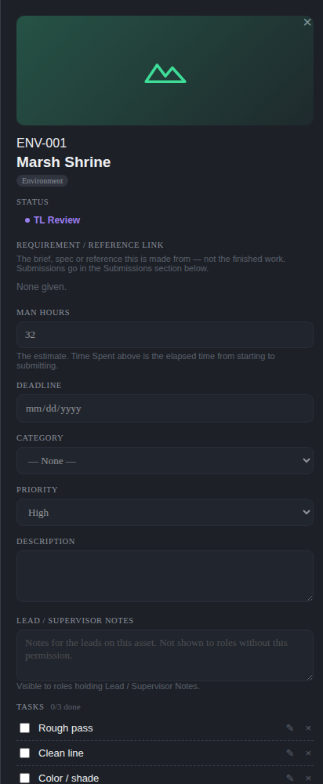
An asset at TL Review, seen by the team lead.
WHO STANDS AT THIS GATE: the PROJECT’S team. Anyone named on the project in one of four categories — <strong>Team Lead</strong>, <strong>Production Coordinator</strong>, <strong>Supervision</strong> or <strong>Creative Direction</strong> — can act on every asset in that project sitting at TL Review, TL Feedbacks or TL Approved. It does not matter which artist did the work, and it does not matter who that artist reports to. See 7.8b.
- Open the asset from your queue.
- Look at what was submitted.
- Press <strong>TL Approved</strong> to pass it, or <strong>Request Changes</strong> with a note saying what needs doing.

TWO BUTTONS, AND THAT IS THE WHOLE GATE. This screen asks one question — is the work good — and nothing else. It used to carry a third button that sent work straight to the client, which meant a lead was answering “is this good” and “who else needs to see it” in the same click. Approving now lands the asset in <strong>TL Approved</strong>, and the second question is asked there on its own (7.8a).

7.8a TL Approved — where does it go now?
An asset here has passed the first gate and is waiting on the lead to choose its route. Two buttons, and they are not the same kind of decision:
- <strong>Approve → Send to CD Review</strong> — the ordinary pipeline. The Creative Director looks at it next. Whoever may review at the first gate may do this.
- <strong>Send to Client</strong> — skips the Creative Director entirely and lands on Approved for Client, one step from Delivered. This needs <strong>TL Send to Client</strong> on top of the review permission, and a lead without it does not see the button.

WHY THE SECOND ONE IS GATED DIFFERENTLY. Passing work through a gate and walking around one are different authorities. TL Send to Client defaults to the full-access tier alone, so a studio grants it to particular senior leads deliberately rather than getting it by holding the review permission. Moving the button from the review pop-up to this screen did not move the authority behind it.
There is no route back into CD Review once Send to Client has been used — that is the point of it. A studio that wanted the work reviewed after all sends it back through the ordinary path by reassigning it.
WHO CAN DO THIS
The ordinary route on sits with the first review gate. Send to Client is its own permission and is Super Admin only out of the box.
First review gate — 23 designations. Everyone who may hold the Team Lead review: leads, supervisors, production and creative direction.

7.8b Who may act at these three stages
The first gate belongs to the project, not to the reporting line. Put somebody on a project’s team and they can review its work; take them off and they cannot. Nothing about who reports to whom comes into it.
The four categories are the three lists on the project form, which is where they are set:
- <strong>Team leads on this project</strong> — Team Lead and the other lead designations.
- <strong>Production coordinators on this project</strong> — Production Coordinator and the rest of Production.
- <strong>Supervision and Creative Direction</strong> — one section holding both, up to two people. An Art Supervisor and an Art Director, typically.

They are set when the project is created and stay editable afterwards from Edit Project. A change takes effect immediately — there is nothing to re-save on the assets themselves.
WHAT THIS REPLACED, AND WHY. The gate used to ask a question about the ARTIST: who is this person’s team lead, and is that you? Two things went wrong with that often enough to be worth naming. A lead staffed on a project could not clear work done by somebody who reported elsewhere — the asset simply sat there with nothing on screen explaining why. And a Production Coordinator running the project, or a Supervisor answerable for its look, is nobody’s “reports to”, so neither could act however plainly they were on the project.
EVERYBODY QUALIFYING CAN ACT — this is not one gatekeeper. If a project has a lead, a coordinator, a supervisor and a director on it, all four see the work and any of them can move it. Whoever gets there first moves it, exactly as two leads would have raced before.
NOBODY REVIEWS THEIR OWN WORK, and being on the project team does not change that. A lead who is on the project and is also the person who submitted the asset gets no review controls on it — a colleague on the same team clears it instead. This matters more than it used to, because leads can be handed work and are exactly the people likely to be on the team.
A PROJECT WITH NOBODY ON ITS TEAM keeps the older behaviour: the artist’s own lead reviews their work, and failing that any lead who can see it. Projects created before this change therefore carry on working rather than stalling at the first gate. Name one person on the project and the rule above takes over.
THE PERMISSION IS STILL THE SWITCH. Being on a project team does not hand anybody First Review Gate — it decides WHERE somebody who holds it may use it. Every designation the project form can name starts with the permission, and a Super Admin takes it away in Settings → Role Permissions like any other.
One thing the categories do not level out: handing rework to somebody else also needs <strong>Asset Assign</strong>, and Creative Direction does not hold that by default. A director on the project can Request Changes and approve, and will not see Hand over until that permission is granted. That is unchanged by any of this, and it is one toggle in Settings.
WHO CAN DO THIS
Any project-team member in the four categories, holding First Review Gate.
First review gate — 23 designations. Everyone who may hold the Team Lead review: leads, supervisors, production and creative direction.

7.9 TL Feedbacks
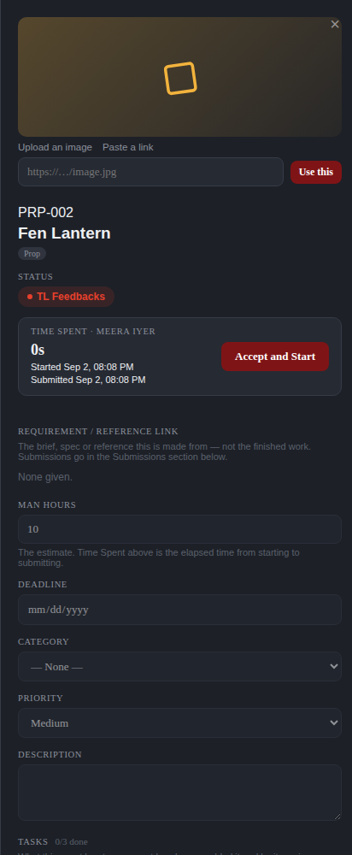
An asset returned with the lead’s notes, seen by the artist who holds it.
The asset comes back to you with the note attached. Press Accept and Start again to reopen it — which counts as your one active task — and Submit for Review when the changes are done. It goes back to the same gate.
The reviewer who sent it back has two ways to put the rework back on the board, and both are on this screen:
- <strong>Reassign to Same User</strong> — one click, straight back to whoever did the first round. This is the common case, and it used to be the one thing the screen would not do.
- <strong>Reassign to Any User</strong> — the full picker, for when the rework belongs with somebody else. They may be on something else, out, or simply the wrong fit for the note.

Both do the same move and go through the same rules: the asset leaves TL Feedbacks and returns to <strong>Assigned</strong> with a fresh round and a clock of its own, the designation is checked the same way, the history records it the same way, and the person picking it up is told. The earlier round’s hours stay on the record; the note and the whole history travel with the asset. Where the two differ, only the picker tells the previous holder that the work has moved — on the one-click path nobody has lost anything, so there is nothing to tell them.
The picker offers the studio’s ordinary eligible-assignee list, so a team lead appears in it and can be handed the rework like anyone else. Whoever is holding the asset is not in that list, because the button above it is how you send it back to them.
WHO CAN DO THIS
Who sees this control is the TL review permission plus Asset Assign, and being on this project’s team in one of the four categories — never a designation by name. Take First Review Gate away from a role in Settings → Permissions and the control goes with it for everyone holding that role; take the person off the project team and it goes for them on that project alone. See 7.8b.
First review gate — 23 designations. Everyone who may hold the Team Lead review: leads, supervisors, production and creative direction.

7.10 The Creative Director gate
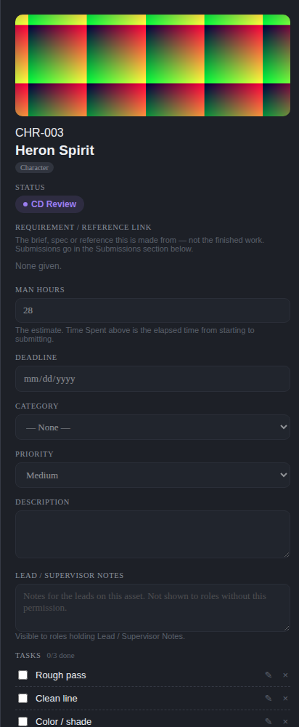
An asset at CD Review.
The Creative Director either approves it for the client, or submits feedback — one action, not two decisions. Approval moves it to Approved for Client. Feedback moves it to CD Feedbacks, which sits with the team lead.

7.11 CD Feedbacks and the relay
CD Feedbacks does not go straight back to the artist. It stops with a lead, who reads the Creative Director’s notes, adds their own reading of them if needed, and relays them on. Until they do, the artist cannot start the rework — and the application says so plainly rather than leaving the button silently dead.
Who may relay is the same question as who may review at the first gate, and gets the same answer: the project’s team, in the four categories described in 7.8b. It is one idea — who is standing at this project’s lead gate — and giving it two answers is how the two would drift apart.

7.12 Leaving the studio
From Approved for Client there are two routes, and a studio uses whichever matches how it works with that client.
- Deliver — the work is handed over and the asset is Delivered. One step.
- Send to client review — the asset moves to Awaiting Client Feedback while the client looks at it. If they approve, it becomes Delivered. If they ask for changes, it goes back to TL Feedbacks and round again.

WHO CAN DO THIS
The first gate sits with the first review gate band. The Creative Director gate and approval for client sit with creative direction. Delivery sits with the delivery band. The whole client-feedback loop — send, record approval, record changes — is Super Admin only out of the box and must be granted deliberately.
First review gate — 23 designations. Everyone who may hold the Team Lead review: leads, supervisors, production and creative direction.
Creative direction — 9 designations. The Creative Director gate: art direction and above.
Delivery — 18 designations. Production and account management — the people who hand finished work to a client.
Super Admin only — 1 designations. Nobody else holds this out of the box.

8. Project reviews and Pending Actions
Asset review is per asset. Project review is the other conversation: a producer asking the Creative Director to look at a project as a whole.

8.1 Sending a project to review
- Go to the Projects tab.
- Press Send Project to CD Review on the project.
- Say what you want looked at.
- Send.

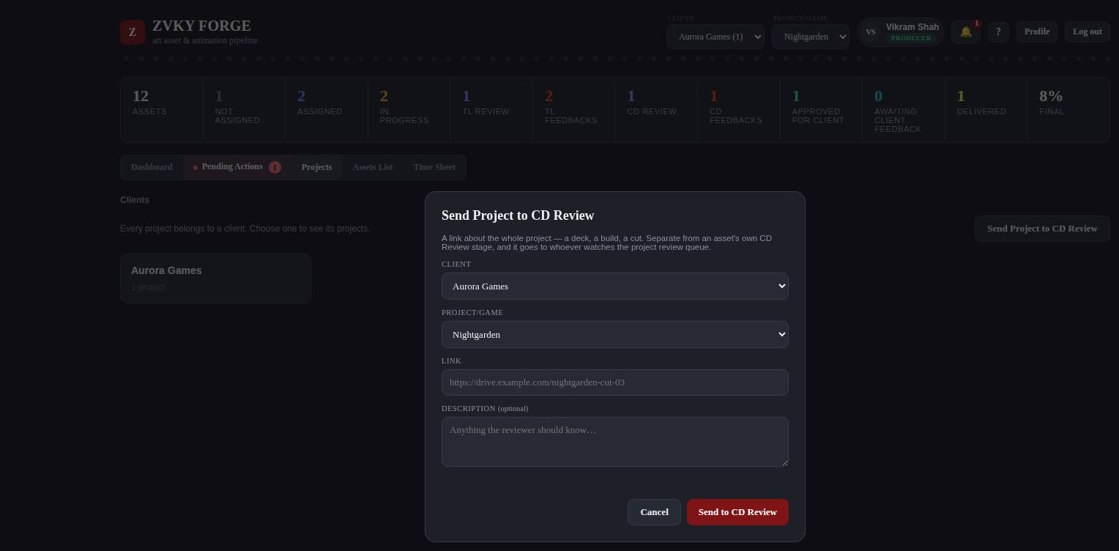
A producer sending a project to the Creative Director.

8.2 The reviewer’s queue
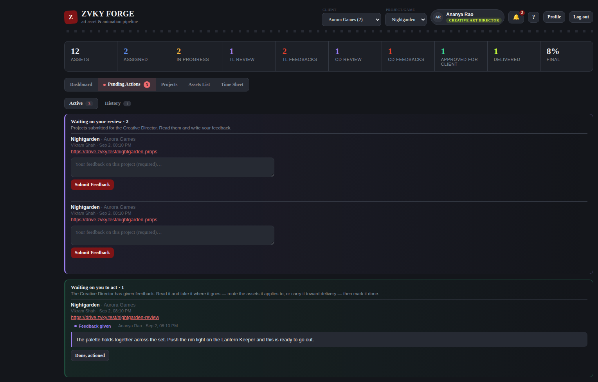
Pending Actions as the Creative Director sees it: Active for what is waiting, History for what has been answered.
- Open Pending Actions. The tab carries a count and is highlighted while something is waiting on you.
- Open a request and read it.
- Write your feedback and press Submit Feedback.

The submitter is notified the moment the feedback lands.

8.3 Acknowledging the answer
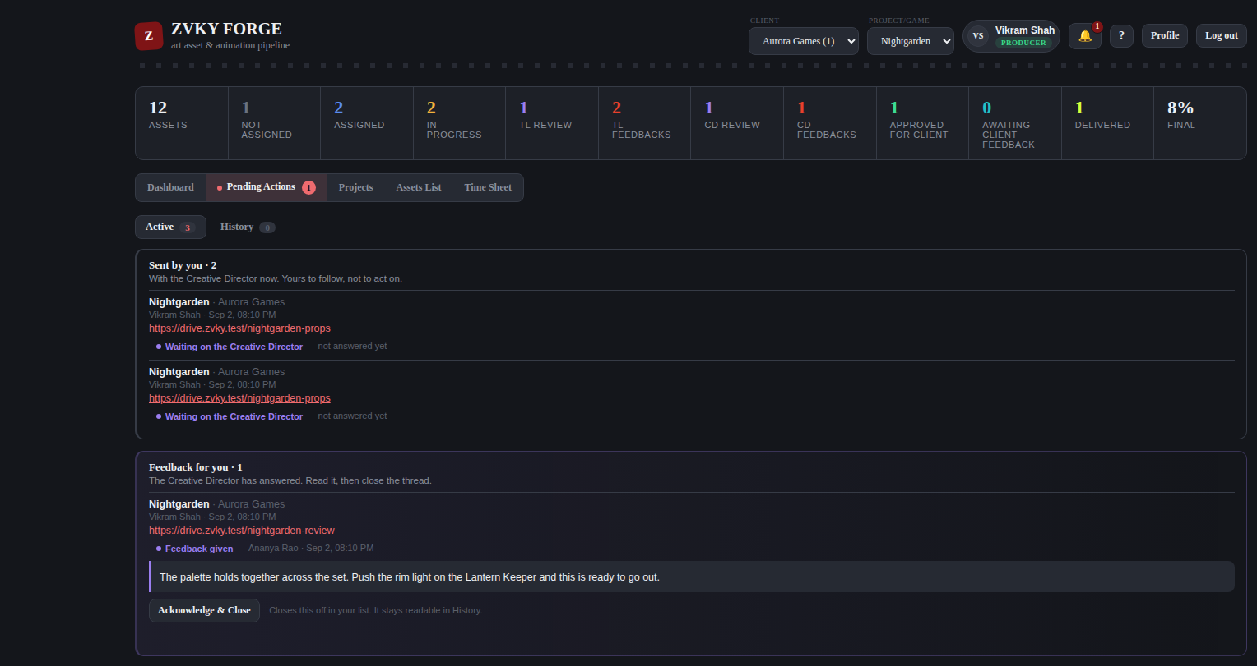
The producer’s side: their own submissions, and the answers that came back.
- Open Pending Actions.
- Read the feedback on your submission.
- Press Acknowledge and Close when you have acted on it.

Your own submissions never appear in your queue to answer — only in your queue to read.
THESE PERMISSIONS ARE NARROW OUT OF THE BOX
Sending a project to review, seeing Pending Actions, the review queue and the answering step are held by Super Admin, and in two cases the Creative Art Director, in a fresh deployment. A studio that wants its producers and directors using this must grant them in Settings first. This is the single most common reason the tab is missing for somebody who expects it.

WHO CAN DO THIS
The queue and the answering step sit with the Creative Art Director and Super Admin. Sending a project to review, and seeing your own submissions, are Super Admin only until granted.
Creative Art Director and Super Admin — 2 designations. A deliberately narrow pair: the project-review queue.
Super Admin only — 1 designations. Nobody else holds this out of the box.

9. Time Sheet
Everybody fills in their own. It is a weekday at a time, Monday to Friday, in Indian Standard Time, against the studio’s configured working hours.

9.1 Your week
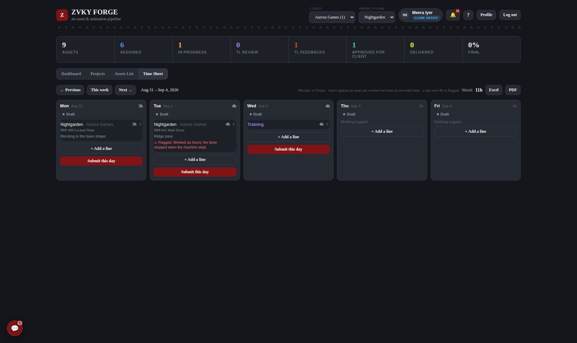
A week. Each day is a card with its lines, its total and its state. The window in force is printed at the top right.
The line above the days says what a day is flagged at. It is the studio’s own number rather than a fixed rule of the software: a Super Admin changes it in Settings (chapter 13.2) and the change applies to everybody from that moment.
THERE IS NO SATURDAY OR SUNDAY
The week shows five cards, Monday to Friday, and the API refuses a line dated to a weekend as well — so an out-of-date browser cannot put a row somewhere the screen will never show it. The date range at the top names the days actually shown, not the calendar week behind them.
Weekend WORK is not lost. Time recorded by the timer on a Saturday still counts towards the asset, and the hours it recorded are offered on the next weekday you file against that asset — because the figure is your whole recorded time on the asset, not that one day’s. What is gone is the weekend ROW, not the weekend’s hours. A weekend day that already carries lines from before this change is still shown, so nothing already filed disappears.

9.2 Adding a line
- Press + Add a line on the day.
- Choose the project, and the asset if the time was against one.
- If the line names an asset, the hours are worked out for you and the field is locked. If it does not — leave, a meeting, training, or project time with no asset named — type the hours in.
- Say what you did.
- Save.

WHERE THE FILLED-IN HOURS COME FROM
Choosing an asset fills in WHAT IS LEFT: the time you have recorded on that asset, less whatever you have already logged against it on any day. So a job that took three days offers its first day’s hours, then only what has accrued since, then only what accrued after that — the three add up to the time the asset recorded, once, instead of to that total three times over. The line under the field shows the arithmetic: what was recorded, what is already on your timesheet, and what is left.

THE FIGURE IS NOT YOURS TO TYPE
Where a line names an asset the hours are the software’s answer, not a suggestion: the field is locked, and the server works the number out again when the line is saved, so nothing typed into it would survive. The lock is the server’s rather than the field’s — a request made outside the form is worth the same calculated figure.
An asset still in progress offers the time elapsed so far, not counting anything it spent on hold. An asset you have already logged in full offers nothing and says so, and a second line against it is refused rather than filed as nought. An asset the timer has never run on cannot be logged against at all: time is measured from Accept and Start, and there is nothing for the sheet to read.
Because the figure is the whole outstanding balance rather than a part of it, filing a line claims everything not yet claimed. Skip a day and the next day’s line carries the earlier day’s hours too — the total across the asset is right either way, but the hours sit on the day they were filed.

IF THE NUMBER LOOKS WRONG, FLAG IT
Nobody can correct a locked figure, so the way to disagree with one is on the record instead of over it. Tick THIS FIGURE LOOKS WRONG under the Hours field and say briefly what is wrong — a timer left running, a stretch worked without starting it. The reason is required: a mark with no reason is one nobody can act on. It is stored with the line and shown beside the hours on the day, to you and to whoever reads your week. Raising or clearing a flag never changes the hours.

IT IS YOUR OWN RECORDED TIME, NOT THE ASSET’S
An asset handed over from somebody else carries their hours in its Time Spent on the Efficiency report, because that is what the asset cost. The figure offered here counts only your own stretches, because their hours are not yours to file. After a hand-over the two numbers differ, and both are right.

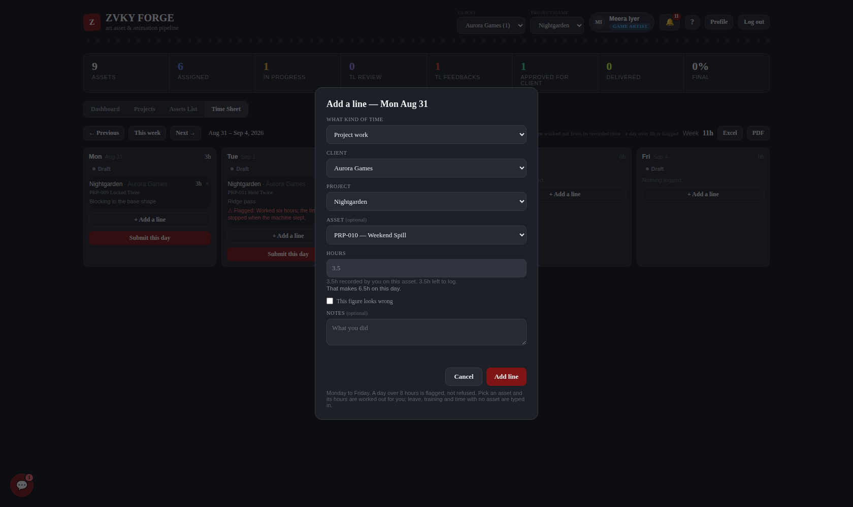
Adding a line.

9.3 The rules
- A line is a number of hours against one thing. There are no start and end times to give.
- The smallest line is a quarter of an hour; the largest single line is a day. A timer left running longer than that files a day and offers the rest again tomorrow.
- A day over 8 hours is FLAGGED, not refused. A long day is a real thing, and a form that refuses one teaches people to log eight and go home late.
- A line is either project work or non-project time, never both.
- Saturday and Sunday are not days the sheet has. A line dated to one is refused.
- Hours against an asset are calculated and locked; hours with no asset are typed.

WHAT THE SIMPLER FORM GIVES UP
A line used to be a stretch of the clock, and three rules went with it. Two are no loss: the 09:30–19:00 working window and the automatic lunch subtraction were only ever checks against times nobody types any more. The third is a real one. Two lines claiming the same hours used to be refused, and that is the single arithmetic mistake a timesheet cannot catch by adding up — the total looks perfectly reasonable. With hours alone there is nothing to compare, so the day total and its flag are the only defence left. Worth knowing when reading somebody’s week.

9.4 Submitting a day
- Fill in the day.
- Press Submit this day.

Submission is daily, not weekly, and it is the end of it: a submitted timesheet is nobody else’s to approve. Submitting locks the day so that filing it is a definite act rather than an autosave, and the state on each card — Draft or Submitted — says where it is.
YOU CAN TAKE A DAY BACK YOURSELF
A locked day carries a Reopen button for the person whose day it is. This exists BECAUSE approval does not: the way out of a locked day used to be asking your approver to send it back, and with nobody to ask, a mistyped 8 that should have been 0.8 would be permanent. Reopening is written to the day’s own history and to the Activity Log, so a day submitted, changed and submitted again says so. Only its owner can do it — a lead reading their team’s hours has no such button.

9.5 Reading your team’s hours
Holding View Team Timesheets puts a person picker above the week. Pick somebody and their week is drawn exactly as their own is, and entirely read-only. There is nothing to approve, nothing to send back and no queue — those went with the approval step. What is left is oversight, which is what a lead needed.
A flagged line shows its reason here too. Since the hours themselves are calculated, a flag is the only thing on the sheet somebody has written about a figure, and it is worth reading: it usually means the timer and the day did not agree.

9.6 Excel and PDF
Excel and PDF buttons sit at the top right of the week. Both export exactly what is on screen, for the week and the person shown.
WHO CAN DO THIS
Everybody fills in their own time sheet. Seeing a team’s sits with the leads and producers band, and seeing it is all it does. Studio leadership can see everybody’s. There is no Approve Timesheets permission any more — it was removed with the step it gated, rather than left as a switch that turns nothing on.
Everyone — 60 designations. Every designation in the studio, from Trainee upwards.
Leads and producers — 18 designations. The people who run a queue: they carry lead notes and approve their team’s time sheets.
Studio leadership — 7 designations. Administration without the Admin designation — the settings, reports and overrides tier.

10. Reports

10.1 Efficiency
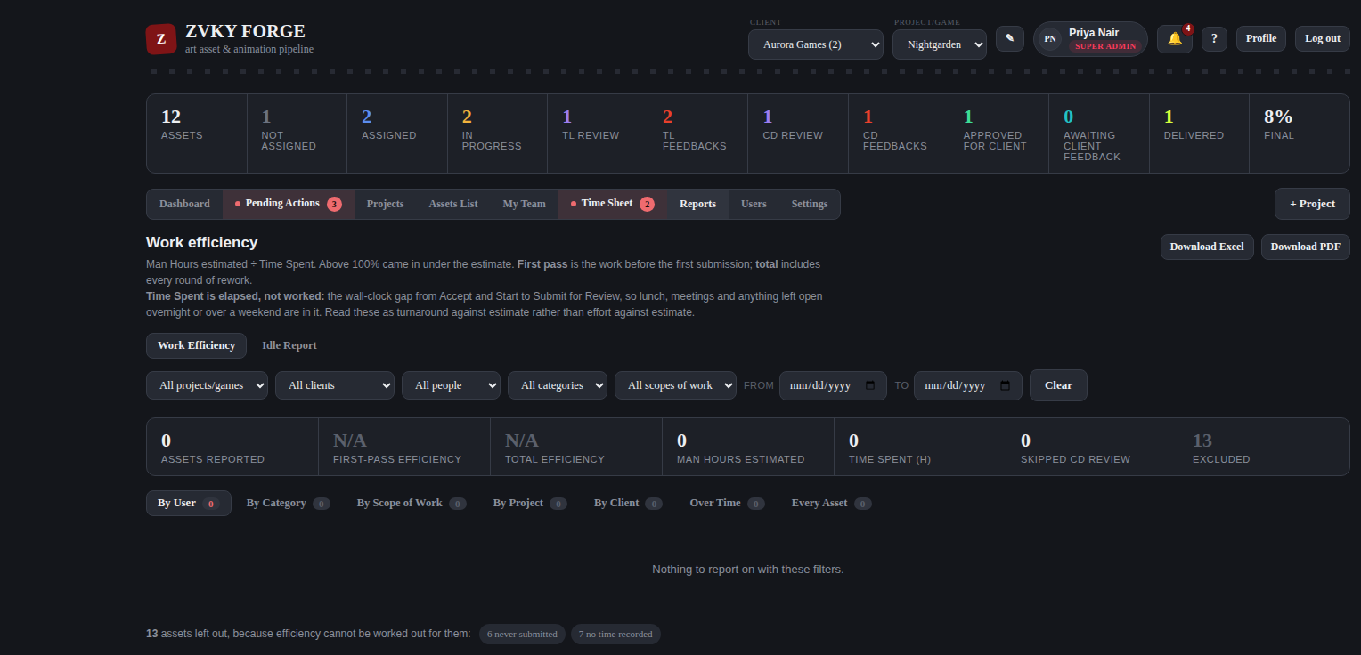
The Efficiency report: estimated against actual, by whichever view is chosen.
Efficiency compares the estimate on each asset — its man hours — against Time Spent, the gap between Accept and Start and Submit for Review, less any stretch put on hold. It can be read by user, by asset, by project or by scope of work.
The report says how many of the assets it covers had time held back, because two assets showing the same hours mean different things if one had a day taken out of it. Holding is something a person chooses to record, so an asset with no holds may still have been interrupted — the number is a measure of turnaround, not of effort.

10.2 Idle
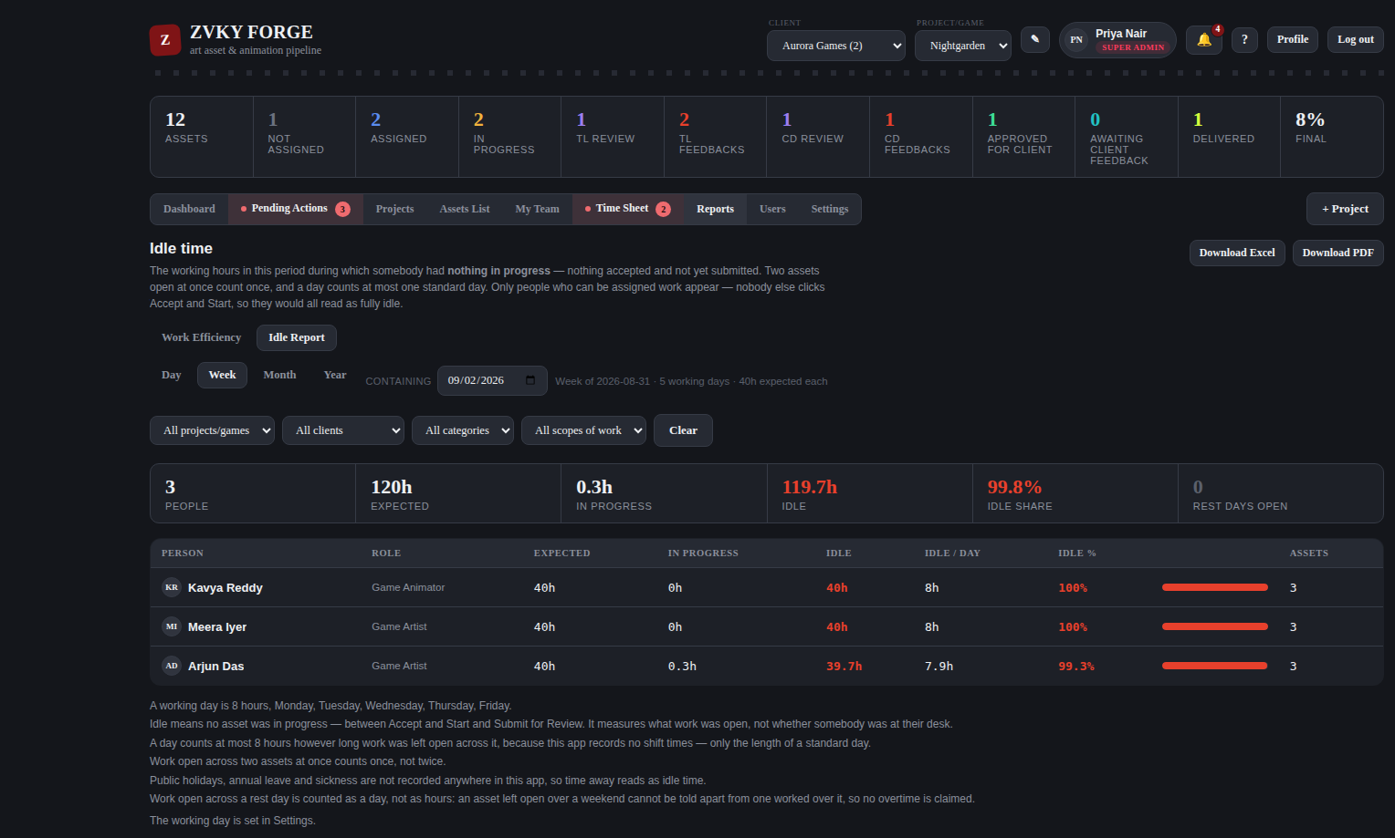
The Idle report: working time with no asset open.
Idle is working time during which somebody had nothing started. It is computed against the studio’s configured working hours, so time outside the working day and the lunch hour are not counted as idle. Overlapping sessions are counted once, not twice.
Time put on hold counts as idle here, and that is deliberate rather than an oversight: nothing was open, which is what this report measures. So a hold improves an asset’s efficiency and worsens the holder’s idle figure at the same time. The two reports answer different questions and are meant to disagree on this point — read either alone and the other will look wrong.

10.3 Idle Now
A sub-tab answering the immediate question: who has nothing open at this moment, and what is waiting on them. It is a separate permission from the staff list, because noticing a stalled queue and reading everybody’s reporting line are different needs.

10.4 Exports
Every report exports to Excel and to PDF. The exported file carries the view you were looking at, named after it, so an Idle export is not filed as an Efficiency one.
WHO CAN DO THIS
Reports sit with studio leadership, plus any designation given View Reports — Team Lead is a common one to add. The Idle report and Idle Now are separately granted.
Studio leadership — 7 designations. Administration without the Admin designation — the settings, reports and overrides tier.

10.5 Profit & Loss
Two tabs, the same projects, the same hours, two different questions. They are separately granted, so a producer can be given one without the other, and holding neither hides the screen entirely.
- Fixed P&L asks whether the work cost more or less than it was estimated at. Nothing on it is entered by hand — there is no contract value, no billing and no revenue figure on that tab at all.
- Actual P&L asks what the studio is making on a project. It has one field: the Total Project Value.

The two figures both tabs are built on
- Total Hours (Budgeted) — every asset’s Man Hours estimate, added up. The same number the Projects tab calls Total Bid Hours.
- Total Hours Recorded — hours logged against tasks that have reached Delivered. It rises as tasks are delivered and never needs touching. Working hours only, in IST (7.3a), so evenings and weekends are not in it.

BOTH TABS READ THE SECOND ONE, and it is genuinely one figure rather than two that happen to agree. Deliver a task and the recorded hours move on Fixed P&L and Actual P&L together, by the same amount.

How everything is costed
From the <strong>Rate Card</strong> in Settings, which says what one hour of each role and level costs. Hours are costed at the rate of the person who logged them; the estimate on an asset is costed at the rate of the person it is assigned to. Same list, same method, both sides — which is what makes the difference between them a difference in <em>hours</em> rather than an artefact of the two halves being priced differently.
- A correction spreads. Nothing is copied onto a row, so fixing a rate re-costs every project it applies to, for work already done as well as work still to come.
- An unpriced designation is not a free one. Its hours are counted and its cost is not, and the screen says so in as many words — the real figures are higher, and both the variance and the margin look better than the truth.

Fixed P&L
Total Hours (Budgeted), Total Hours Recorded, Budgeted Cost, Actual Cost and the Variance between them, in rupees and per cent, with a table breaking both sides down by role and level.
THE SIGN OF THE VARIANCE IS THE POINT. It is budgeted cost minus actual, so a <strong>positive</strong> figure is money the studio did not have to spend — a saving — and a <strong>negative</strong> one is an overrun. The percentage is against the budget: “we came in 39% under what we planned” is a statement about the plan. A project nobody estimated is <em>unplanned</em> rather than under budget, and says so rather than showing a confident zero.

Actual P&L
Total Project Value, Total Hours Recorded, Cost, Profit and Margin, with the same breakdown table. Profit is the value less the cost; margin is the profit as a share of the value.
The Total Project Value is the only figure in the whole feature that anybody types. A project with none entered has no profit and no margin and shows a dash — a different statement from a project worth nothing, and the two must not look alike.

What is no longer here
Billing Type, Invoiced to Date, Other Costs, the manual Project Team list, the typed Total Cost, the manually entered Fixed Contract Value and the second free-text rate list have all been removed. Every one of them was either a number the application already recorded or a number nobody kept up to date, and a stale figure in a P&L is worse than a missing one because it looks authoritative. The margin trend went with them: it was drawn from a snapshot written whenever somebody saved on the screen, and with nothing left to save it would have frozen while still looking live.
Their data has not been deleted. The columns and rows are still in the database; nothing reads them.
WHO CAN DO THIS
Access Fixed P&L is a view-only grant — there is nothing on that tab to change. Access Actual P&L covers the tab and its Total Project Value together. Manage Rate Card is the third, and it is the one with reach: the Rate Card costs every project at once. All three are Super Admin only out of the box.
Super Admin only — 1 designations. Nobody else holds this out of the box.

11. People

11.1 The Users tab
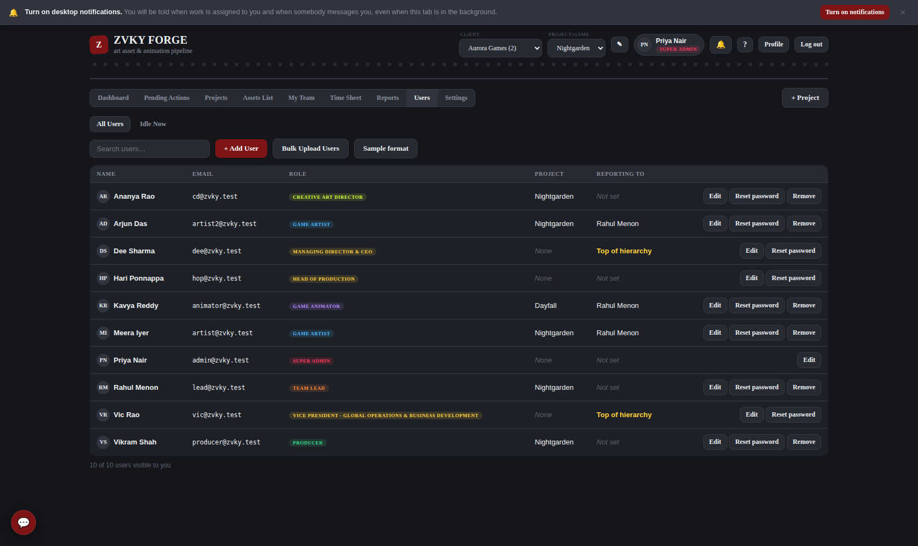
The staff list: name, designation, who they report to, and their projects.

11.2 Adding somebody
- Press + User.
- Give their name and the email they will sign in with.
- Choose their designation. What it can do comes from the tier behind it — pick the closest match.
- Set who they report to, and the project they are on.
- Set a first password, which they can change from Profile.

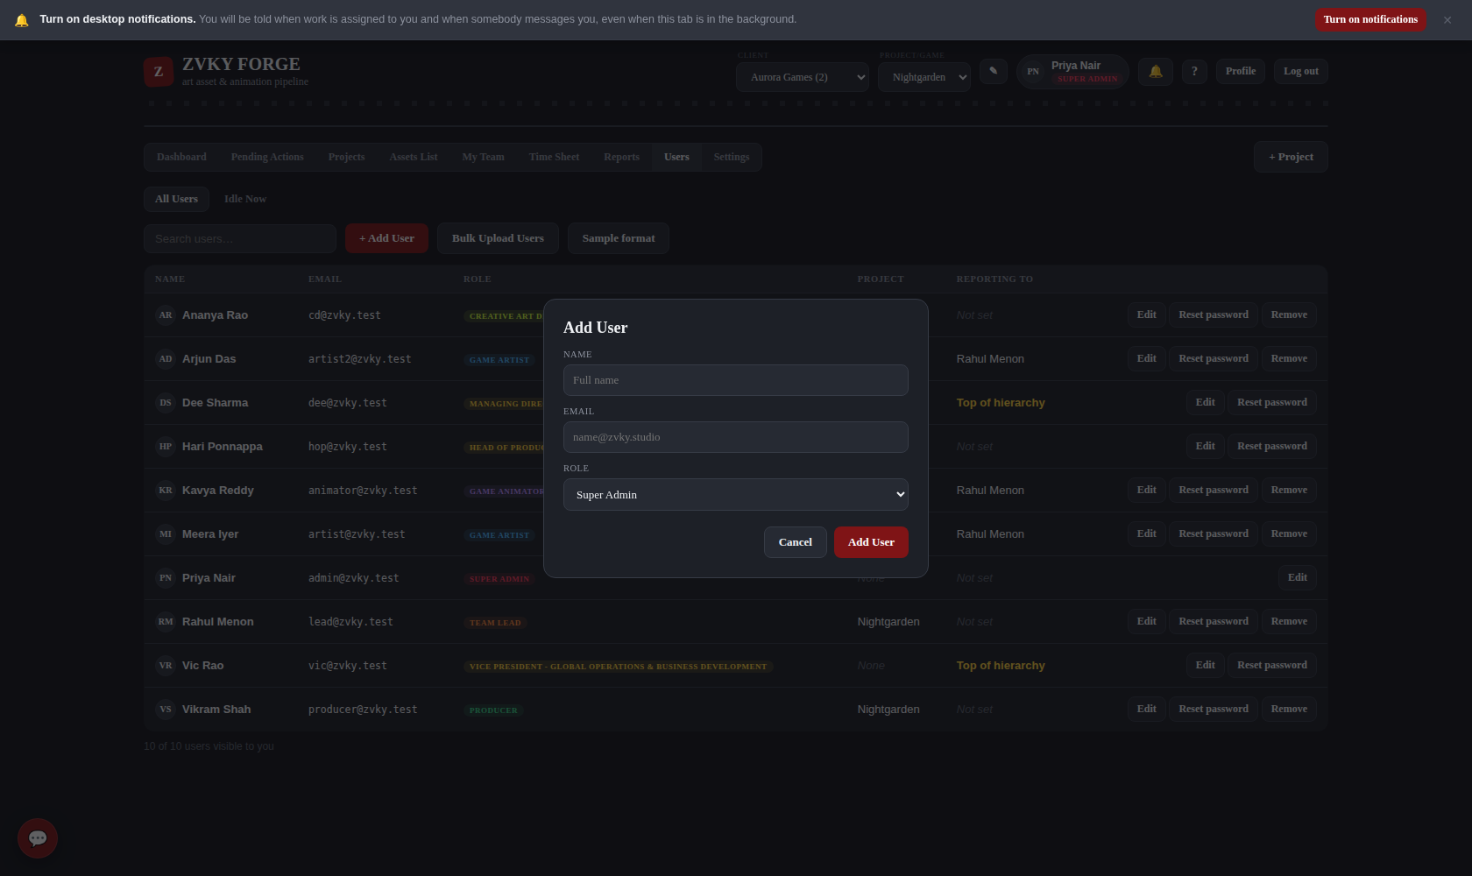
The new-user form.

11.3 Bulk user import
For a batch, the import takes a spreadsheet with the columns name, email, role, reports_to_email, project and password — the first three required. The asset uploader and the user uploader are separate and labelled, and each rejects the other’s file clearly rather than importing nonsense.

11.4 Resetting somebody’s password
When somebody is locked out, an administrator gives them a temporary one rather than being told what they had. Press Reset password on their row in the Users tab.
- The screen says what will happen, and asks you to confirm.
- The password they have been given is shown. Pass it on to them.
- Close the panel.

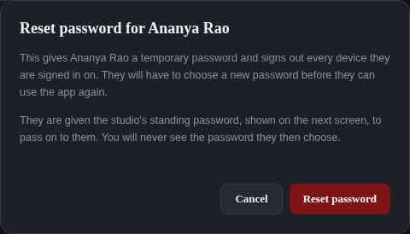
The confirmation. The screen after it shows the temporary password, once.
WHAT THE RESET DOES, AND WHAT IT DELIBERATELY DOES NOT
It signs out every device that account is signed in on, and it locks the account to one action: choosing a new password. Until they do, nothing else in the app answers them — enforced by the server, not just hidden by the screen, so the password they are given cannot be used to work.
It does NOT tell you their old password, and nobody — at any permission level — ever sees the password they then choose.
There is no email. This deployment has no mail transport configured, so the password travels by whatever channel the two of you already use. The account holder is told in the app that their password was reset and by whom.

IT IS THE STUDIO’S STANDING PASSWORD, NOT A ONE-OFF
A reset sets the same password every time — the one every new account is also created with. That is the studio’s choice, so an administrator has one thing to remember and one thing to say over the phone rather than a different string each time.
It carries a cost worth understanding. The password is not a secret and is not unique to the person: anybody who knows it and their email address could sign in and set a new one for them, in the window between the reset and that person signing in. The lock does not prevent this — it only prevents the account being USED without a change, and the change is exactly what an impostor would do. So tell the person promptly.
Two things reduce the risk. Set DEFAULT_USER_PASSWORD in the deployment’s .env so the value is not the one printed in this manual or in the source. And reset a password when the person is there to receive it, rather than in advance.

WHO MAY DO IT
Reset User Password is a permission like any other, and it starts switched on for the Super Admin and nobody else. Grant it in Settings → Permissions (chapter 13.1) to hand it to another designation.
One rule holds whoever has it: you cannot reset the password of an account that can change who may do what. Otherwise the permission would be a way of taking over the studio — grant it to somebody, and they reset the Super Admin. Nor can you reset your own from here; that is Profile, with your current password.

Every reset is on the Activity Log, naming who did it and to whom. The password itself is not in it, and is not in the notification either — the value is settable per deployment, so a log quoting it would be a log that leaks whatever a studio set it to.

11.5 My Team
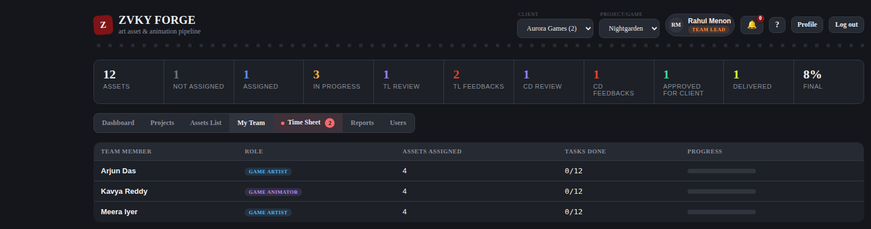
My Team: the people who report to you, what they are carrying and how far along it is.
WHO CAN DO THIS
Adding, editing and deleting people, changing designations, reporting lines, projects and passwords all sit with the administration band. My Team is open to anyone who supervises people.
Administration — 8 designations. The people who run the studio’s records: staff, projects and clients.
Anyone who supervises people — 14 designations. Anyone with a team under them, which is what the My Team tab lists.

11.6 MIS Project Access — Super Admin
The studio’s non-pipeline side — MIS, Finance, HR — sometimes needs to look into a project without working on it. Settings → MIS Project Access attaches somebody to the projects they should be able to see: pick the person, tick the projects, Save. Any number of projects, and it can be changed at any time.
IT GRANTS SIGHT, AND NOTHING ELSE
They get the project’s board, the time logged against it, and the reports built from that. They cannot create, edit, delete, assign, start, submit, review or reassign anything, and they cannot leave notes on its work.
That is not a switch on this screen — it is their designation. The screen only lists designations whose asset pipeline is closed, which is exactly the set for whom "attached to a project" can only mean reading it. Somebody who works on projects cannot be attached here at all; they are put on a project from their own profile, which is a different thing with a different permission.

- ONLY THE PROJECTS PICKED. This is not a switch that opens the whole studio. Attaching somebody to two projects shows them those two; every other project stays as invisible as it was.
- TAKING IT AWAY IS IMMEDIATE. Untick a project and Save, and the next thing they load no longer has it — no waiting for a session to end, and no sign-out needed. It is not retrospective: it stops them seeing the project from that moment, and nothing can un-see what somebody has already read. The Activity Log records what was looked at while the access was in place.
- WHAT THEY STILL NEED FOR REPORTS. Seeing a project is not the same as holding the report permissions. Grant View Reports, View Idle Report or the Time Sheet and P&L permissions in Settings → Permissions, and each one is then scoped to the projects they have been attached to — so one grant does not become studio-wide sight.
- THE SUPER ADMIN ALONE, by default. It can be handed to a designation in Settings → Permissions (Manage MIS Project Access), and the check is made on the server on every request.
- EVERY CHANGE IS RECORDED — who attached whom to what, and when — both on the row itself and in the Activity Log.

11.7 Outsource — freelancers and the work given to them
The Outsource tab is the studio’s record of work sent outside it: who the freelancers are, what each has been given, and what was agreed for it. It opens for Team Leads, Production, Creative Direction and above, and shows the outsourced work on the projects you can already see — a lead sees their own projects’, not the studio’s.
THE HOURS HERE ARE AGREED, NOT MEASURED
This is the one part of the application where an hours figure is typed rather than recorded. "Decided man hours" is what the studio and the freelancer settled on. Nothing on this tab starts a timer, writes a work session, or is touched by the recording schedule, the breaks or the overnight pause and resume — none of that applies to somebody the studio does not employ.
It can be revised. If the scope changes or a revision round adds hours, edit the figure; the change is written to the Activity Log with what it was before, because that number is what somebody is paid against.

- FREELANCERS ARE RECORDS, NOT ACCOUNTS. A freelancer has no login and no designation — they never sign in, and nothing about them appears in Users. Deactivate one rather than deleting them: an inactive freelancer takes no new work, and the work already recorded against them keeps its meaning.
- AN ASSIGNMENT MAY NAME AN ASSET, OR NOT. Link it to a tracked asset when the work is one, and the asset’s own Man Hours estimate is shown beside the agreed figure — two different numbers about the same work, both visible, neither standing in for the other. Leave it blank for work that never enters the pipeline.
- STATUS follows the work: Assigned, In Progress, Delivered, Revision Requested.
- THE SUMMARY totals the agreed hours per freelancer and splits them by project, which is what an invoice is raised against.

WHAT IT FIXES IN THE PROFIT & LOSS
The P&L costs work sessions at the Rate Card rate of the designation that logged them. A freelancer logs no sessions and holds no designation — so before this tab existed, a project that outsourced half its work reported half its cost, and a profit to match, with nothing on either tab able to say so.
Agreed hours × the freelancer’s rate now reaches both tabs as its own figure, and the variance and profit are taken from the two costs combined. A freelancer with no rate recorded contributes hours but no cost and is reported as unpriced, never folded in at zero — a zero there would make the project look cheaper than it was.

11.7a Assigning a task: inside the studio, or outside it
A task belongs to one person or the other, never both. The task panel has two sections — <b>Assignee</b> for somebody in the studio, and <b>Assign to freelancer</b> below it — and committing either one greys the other out.
- Open the task and find the two sections under the checklist.
- For internal work: pick the person, then press Assign. Picking a name no longer assigns on the spot — the button is the commitment.
- For outsourced work: pick the freelancer, press Assign to Freelancer, and enter the decided man hours when asked. The assignment is not made until there is a figure.
- To switch type: press Unassign on whichever section is active. Both sections open again and you can pick the other way.

THE GREYING OUT IS A COURTESY. THE RULE IS ON THE SERVER
Every route that can set an assignee — the panel, the Edit form, the handover and the bulk assign — refuses a task that is out with a freelancer, and says who holds it. The outsource side refuses a task somebody in the studio is already on. So the rule holds whether the refusal comes from a greyed-out button or from a browser left open on a stale page.
Bulk assign refuses PER TASK: run it over twenty and the one that is outsourced is named and skipped while the other nineteen go through.

- UNASSIGNING A FREELANCER DOES NOT DELETE ANYTHING. The assignment is marked cancelled and kept — the agreed hours may already have been quoted to them, so what was agreed and by whom stays on the record. What changes is that the task is the studio’s again and the hours stop costing the project.
- IT TAKES Manage Outsourcing — the same permission that gave the work out. Somebody who can only view the Outsource tab cannot take work back.
- AD HOC OUTSOURCED WORK IS OUTSIDE THIS. An assignment that names no task conflicts with no task, so a project can carry ad hoc outsourced work and still assign every one of its tasks normally.
- EVERY UNASSIGN IS LOGGED, with the figure that was agreed before it was taken back.

PAY RATES ARE A SEPARATE PERMISSION. Manage Outsourcing lets somebody add freelancers, give them work and set the agreed hours. See Freelancer Pay Rates — the Super Admin by default — is what shows the money: the rate, the cost column and the P&L figures above. Without it the tab shows the work and the hours and no money at all, and the rate is not merely hidden on the page, it is not sent to the browser. It is the same split the Profit & Loss permissions already make between reading a margin and being handed the Rate Card.

12. Notifications, chat and your profile

12.1 Notifications
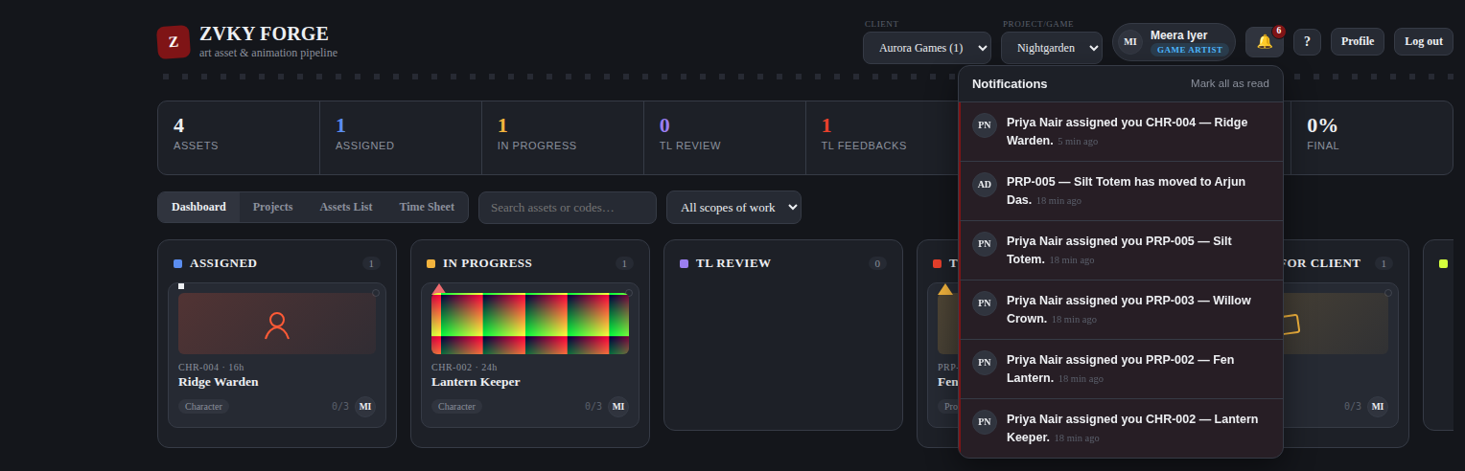
The notification panel, opened from the bell.
- The bell carries the number of unread notifications.
- Mark all as read clears the count.
- Clicking one opens the asset or the project it is about, switching the pickers if it is somewhere you are not currently looking.
- The same events also appear on your DESKTOP, outside the browser — see below.

What raises one:
Event | Who is told | What it says
Work is assigned to you | The new assignee | “Priya Nair assigned you FX-001 — Dragon Head.”
Work is taken off you | The outgoing assignee | Who it moved to, or that it is no longer assigned to anybody.
Work you handed out is submitted | Whoever assigned it, and the submitter’s team lead | “Ana Artist submitted FX-001 — Dragon Head in Reef Riches for review.”
A project is submitted for review | Everybody holding View Project Review Queue | Who submitted which project.
Your project submission is answered | The person who submitted it | That the answer is ready to read and close.
You are tagged in a chat message | Each person named, once | “Priya Nair mentioned you in Neon Drift.” Never what was said — see 12.7.
An administrator resets your password | The account holder only | Who did it. Never the password itself.

WHO HEARS ABOUT A SUBMISSION, AND WHY THOSE TWO
Whoever ASSIGNED the work — they handed it out and are waiting on it — and the submitter’s TEAM LEAD, who is the first review gate. If one person is both, they are told once, not twice. The person who pressed Submit is never told about their own submission, however many of those roles they hold.
It fires on SUBMIT and on nothing before it. Accept and Start raises nothing: that is somebody picking up work they had already been given, and nobody else is waiting on it. A resubmission after a lead has asked for changes is a new round and does raise a new one.

12.2 Desktop notifications
Everything in the table above, and every chat message, raises a notification on your DESKTOP as well as in the app, so you are told while working in something else. Each one carries a heading that says what kind of event it is — Assigned to you, Submitted for review, Work reassigned — and the same sentence the bell shows underneath it. A bar at the top of the screen asks for permission the first time you sign in; press Turn on notifications and answer your browser’s own prompt.
They arrive on their own, without reloading the page: the app checks for new ones every half minute and raises whatever has appeared since it last looked. Several at once — a batch of forty assets assigned in one action — raise ONE pop-up saying how many, rather than forty boxes up the side of the screen. The bell carries the count and the panel carries the rest.
WHAT "ON" AND "OFF" MEAN HERE, EXACTLY
There is no switch inside Zvky Forge to turn desktop notifications off. The only control is the browser’s, and that is not a choice the studio made — it is how the web works: no site can show a desktop notification without the browser’s permission, and no site can raise that prompt more than once per answer, suppress it, pre-answer it, or get around a refusal.
So: everybody is asked, anybody who has not answered is asked again next time they sign in, and Not now postpones rather than cancels. If somebody REFUSES the browser prompt, the app says so in a bar that cannot be dismissed, with what to change — rather than leaving them to wonder why nothing arrives. Only they can undo it, in their browser’s site settings.

TWO THINGS THAT ALSO STOP ONE ARRIVING
Notifications need a SECURE CONNECTION. Over plain http browsers do not allow them at all, and the same bar says so. They start working once the site is reached over https.
And granting the browser permission is not the same as the operating system letting it through. Somebody with Do Not Disturb or Focus on will see nothing, and the app is never told. The bell and the chat panel still carry everything either way — a desktop notification is a second copy, never the only one.

A message in the conversation you already have open, in a window you are looking at, does not raise one — you are reading it. Everything else does.

12.3 Chat
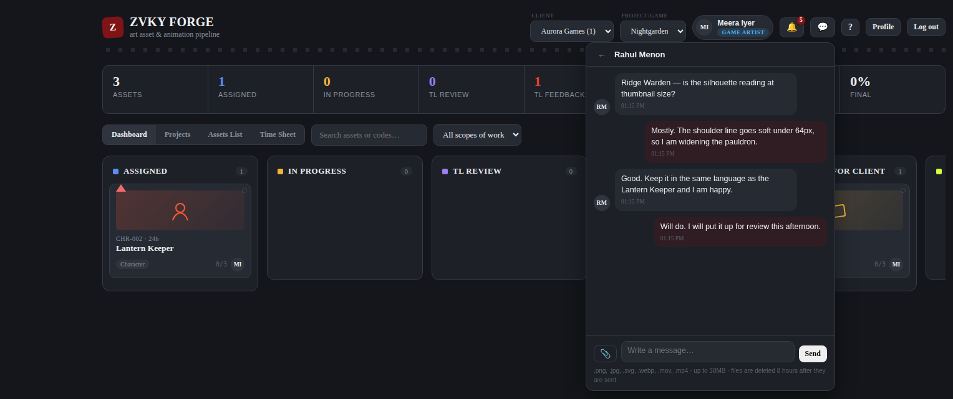
A one-to-one conversation, opened from the chat icon in the header.
The speech-bubble icon beside the bell opens chat. It carries the number of unread messages, the way the bell carries notifications.
WHO CAN DO THIS
Chat is open to everybody by default. A Super Admin can close it for a designation in Settings.
Everyone — 60 designations. Every designation in the studio, from Trainee upwards.

Messaging one person
- Press the chat icon.
- Press New message.
- Search for the person and pick them.
- Type, and press Enter. Shift+Enter starts a new line instead of sending.

There is one conversation per pair of people, and it is the same conversation from both ends — messaging somebody you have spoken to before reopens the thread rather than starting a second one.
YOU DO NOT NEED A PERMISSION TO MESSAGE A COLLEAGUE
Talking to one other person is what a colleague does, not a privilege the studio hands out, so Use Chat starts on for every designation — the same reasoning as filling in your own time sheet. It is still a toggle, so a studio that wants chat closed for a department can say so in Settings.

12.4 Groups
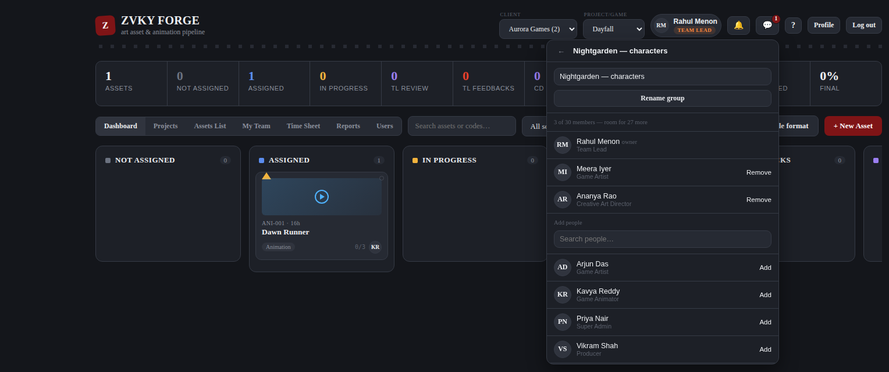
The member list of a group, as its owner sees it.
WHO CAN DO THIS
Starting a group is restricted. Everybody can already chat one to one without it.
Production planning and creative direction — 25 designations. The production planning band with Art Director and Creative Art Director added — everyone who runs work rather than doing it. Who may start a chat group.

- Press the chat icon, then New group.
- Give the group a name and tick the people to put in it.
- Press Create.

HOW BIG A GROUP MAY BE is a setting, not a fixed number. It was thirty; a Super Admin sets it in Settings → Chat, and can take the limit off altogether. Whatever it is, the panel shows the count as you tick and the one past the limit is refused rather than quietly dropped — and it is the server that refuses it, so a browser left open on an old number cannot get past it.
The person who created the group owns it. The owner renames it, adds people and removes them, from the member list behind the “N members” link in the conversation header. Anybody in a group can leave it.
AN OWNER WHO LEAVES HANDS THE GROUP ON
Ownership moves to whoever has been in the group longest, so a group never ends up with nobody able to manage it. When the last person leaves, the group is closed.
There is also a permission for the cases that rule does not cover — Manage Any Chat Group, held by the Super Admin and grantable to whoever moderates chat. It lets somebody rename a group they are in, and add or remove its members, without having created it. It does NOT open groups they are not in: being a member is still what lets anybody see a conversation at all.

12.4a The group size limit — Super Admin
Settings → Chat holds one number: the largest a chat group may be, counting whoever created it. It applies to every group in the studio and is checked on the server on every group creation and every member added.
- UNLIMITED is a tick box, not a large number. Tick it and no group has a cap at all.
- Zero and negatives are refused. Zero is the plausible thing to type when Unlimited was meant, so the message says where that lives rather than only saying no.
- There is no database limit. Above about five hundred the member list and the add-people dialog stop being readable, which is the only practical ceiling — the screen says so and does not refuse it.
- The Super Admin alone, by default. It can be handed to a designation in Settings → Permissions (Manage Chat Settings), and the check is made on the server on every request.
- Every change is written to the Activity Log with the old value beside the new one.

LOWERING THE LIMIT NEVER REMOVES ANYBODY
A group that is already larger than a new, smaller limit keeps every person in it. Nothing is broken up, nobody is turned out of a conversation, and the group goes on working exactly as it did. What changes is only that it will take no more members until it drops below the cap on its own.
The screen says how many groups are currently above the limit, so lowering it is a decision made with the number in view rather than found out afterwards.

12.5 Files in chat
The paperclip attaches a file. Six formats are carried — .png, .jpg, .svg, .webp, .mov and .mp4 — up to 30MB each. Anything else is refused with a message naming what was wrong.

Saving one
Every attachment in a conversation carries a download button, and it saves the file exactly as it was sent — pictures are shrunk on screen to fit the panel, never in the file itself. On a picture or a video the button sits in the top corner and appears when the pointer is over it; on a phone, and on a row for a file that is not shown inline, it is simply there. The filename is still a link, as it always was.
- Anybody who can see the message can save what is in it — the person who sent it and everybody who received it, in a one-to-one conversation and in a group alike.
- The file keeps its own name. A screenshot pasted in is saved as pasted-20260418-143210.png rather than as whatever the browser would have called it.
- An expired attachment has no button: there is nothing left on the server to fetch.

Pasting a screenshot
A picture on the clipboard can go straight into the message box: click into it and press Ctrl+V (Cmd+V on a Mac). The image is attached the same way the paperclip attaches one — a thumbnail appears above the box with a × to take it back off, and it sends as an ordinary attachment. It works in a one-to-one conversation and in a group, and the picture can go on its own or alongside something typed.
- Pasting ordinary text is unchanged — it goes into the box as text, as it always did.
- Copying words and a picture together attaches the picture and types the words.
- The same six formats and the same 30MB ceiling apply, with the same refusal. A screenshot copied as a GIF is turned away exactly as a .gif chosen through the paperclip would be.
- Up to five files on one message, however they were added.

CHAT FILES ARE DELETED AFTER TWELVE HOURS
A screenshot pasted in to ask “is this the right blue” has done its job by the end of the day, and chat is not the studio’s archive. Twelve hours after it is sent — a working day and the evening after it — the file is deleted. THE MESSAGE STAYS: the words are kept, and the attachment is replaced by a line naming the file and saying it has expired. Anything worth keeping belongs on the asset, where submissions and reference links live.

Text messages do not expire. A conversation’s history stays until the conversation itself is gone.

12.6 Sent, delivered, read
Every message you send carries a mark beside its time, and it means what the same marks mean everywhere else:
Mark | What it means | When it changes
One check | Sent. It is on the server and cannot now be lost. | The moment the message goes.
Two checks, grey | Delivered. It has reached everybody’s Zvky Forge. | When their app next looks — they do not have to do anything, and neither do you.
Two checks, blue | Read. Everybody has opened the conversation and seen it. | When the last of them looks at the thread.

- The marks move on your screen by themselves. You never have to reload to watch a message go from one check to two to blue.
- In a GROUP both double marks mean everybody: grey once the last person’s app has it, blue once the last person has read it. One person on leave keeps a message grey, which is the point.
- In a group, tap the marks to see WHO — every member, with when it reached them and when they read it, or that it has not reached them yet. Only the person who sent a message can open that.
- Somebody who leaves a group stops holding a message back. The “everybody” is recalculated from whoever is in the group now.
- A message sent to somebody who is not signed in stays on one check until they are, then goes to two on its own.

READ MEANS SOMEBODY LOOKED, NOT THAT THE APP WAS RUNNING
Zvky Forge sitting behind another window goes on receiving — messages still arrive and still go to two grey checks. Blue needs the conversation to be open and on screen. So the two marks answer two different questions: “has it got there” and “has anybody looked at it”, which is exactly the difference somebody waiting on an answer cares about.

12.7 Tagging somebody — @mentions
Type @ in the message box and a list of people opens. Keep typing to narrow it — “@pri” finds Priya Nair — then press Enter, or Tab, or click the one you want. The name goes into the message highlighted, and stays highlighted once it is sent.
- The list offers the people in THAT conversation and nobody else. In a group, its members; in a one-to-one, the other person. Somebody who is not in the room cannot be tagged from it.
- Tag as many people as you like in one message. Each of them is told once, however many times their name appears in it.
- You are not offered to yourself, because tagging yourself would notify nobody.
- Delete the name again before sending and it stops being a tag — nothing is sent to anybody.

A TAG IS LOUDER THAN A MESSAGE, ON PURPOSE
An ordinary message shows up in the chat panel and on your phone. Being TAGGED also raises a notification in the bell and on your desktop, headed “You were mentioned” — the same channel an assignment uses, and a different one from chat’s own. Clicking it opens the conversation.
It says who tagged you and which conversation, and never what was said. That is the same rule the rest of chat follows: a message on a lock screen is the one place this application could show a private conversation to whoever is standing nearby. The app is two taps away.
There is no way to mute a conversation in Zvky Forge, so nothing can currently stop a tag — or any other chat notification — reaching you. If muting is ever added, a tag is built to come through it.

12.8 Designations nobody may write to unasked
A designation can be shielded: nobody starts a conversation with it, or adds it to a group, unless they hold Message a Shielded Designation. Out of the box that shields Managing Director & CEO and Vice President — Global Operations & Business Development, and only the Super Admin can reach them.
WHO CAN DO THIS
Going through a shield.
Super Admin only — 1 designations. Nobody else holds this out of the box.

- The shield is one way round. A shielded designation still messages anybody it likes.
- Anybody it has written to can write back — otherwise its own messages would be unanswerable.
- Shielded people are left out of the New message and Add people lists rather than shown and refused.
- History stays readable. What stops is writing more into a conversation they never took part in.

IT IS A SWITCH, NOT TWO NAMES IN THE CODE
Open Inbox is an ordinary permission on the Role Permissions screen, held by every designation by default and switched OFF to shield one. So a studio that wants a third designation shielded, or wants one of these two reachable again, changes a checkbox — there is no list of job titles buried in the application to keep in step with the studio’s own.

12.9 Who can read a conversation
This chapter said, until the studio decided otherwise, that nobody could ever read a conversation they were not in. That is no longer true, and the paragraph saying it has been replaced rather than left standing. What follows is what is true now.
INSIDE CHAT, A CONVERSATION IS PRIVATE TO THE PEOPLE IN IT
Nobody reads a conversation through the chat panel that they are not in — not a Super Admin, not the holder of any permission. There is no chat permission that opens somebody else’s messages, no way to reach one from the panel, and a file link is not a way round it: the membership check is inside the query that fetches the bytes.

OUTSIDE IT, THERE IS NOW ONE SCREEN THAT READS EVERYTHING
Settings → Chat Activity shows every message in the studio, one-to-one and group, with its sender, its conversation and its text. It is behind its own permission — View Chat Activity — which starts held by the Super Admin and nobody else, and is deliberately narrower than the Activity Log beside it.
It is a separate screen with a separate key on purpose. Granting it changes nothing about how chat works, and holding every chat permission does not open it. See chapter 13.5.

The cost is worth stating plainly, because it did not stop being real when the studio authorised it: people say different things when they know they are read, including “I think this brief is wrong” — the sentence a studio most needs somebody to be able to send. Tell people that chat is logged. In some places that is a legal expectation as well as a decent one; either way, the application cannot do it for you, and the permission carries a warning saying so to whoever grants it.

12.10 Your profile
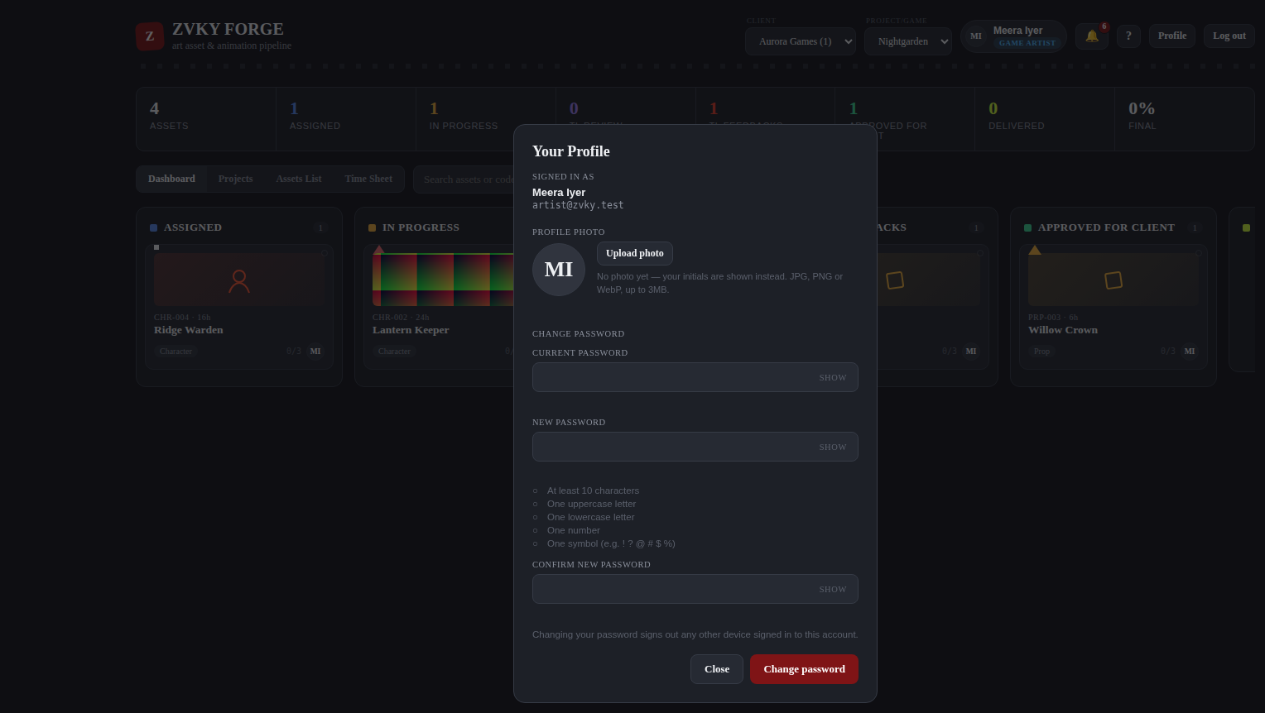
The Profile panel: your photo, and your password.

Your photo
- Press Profile.
- Choose an image and crop it in the preview.
- Save.

Your photo appears everywhere you are represented — on cards, in the staff list, in My Team and in the header.

Your password
- Press Profile.
- Give your current password, then the new one twice.
- Save.

CHANGING YOUR PASSWORD SIGNS OUT YOUR OTHER SESSIONS
Every other browser and device signed in as you is signed out immediately. This is deliberate: a password is changed because it may be known, and a session that outlives the change would defeat the point.

13. Settings
Settings is not one screen but a set of them, and you get only the ones your designation holds. A person given one Settings permission gets this page with exactly that one section on it.

13.1 The Settings index
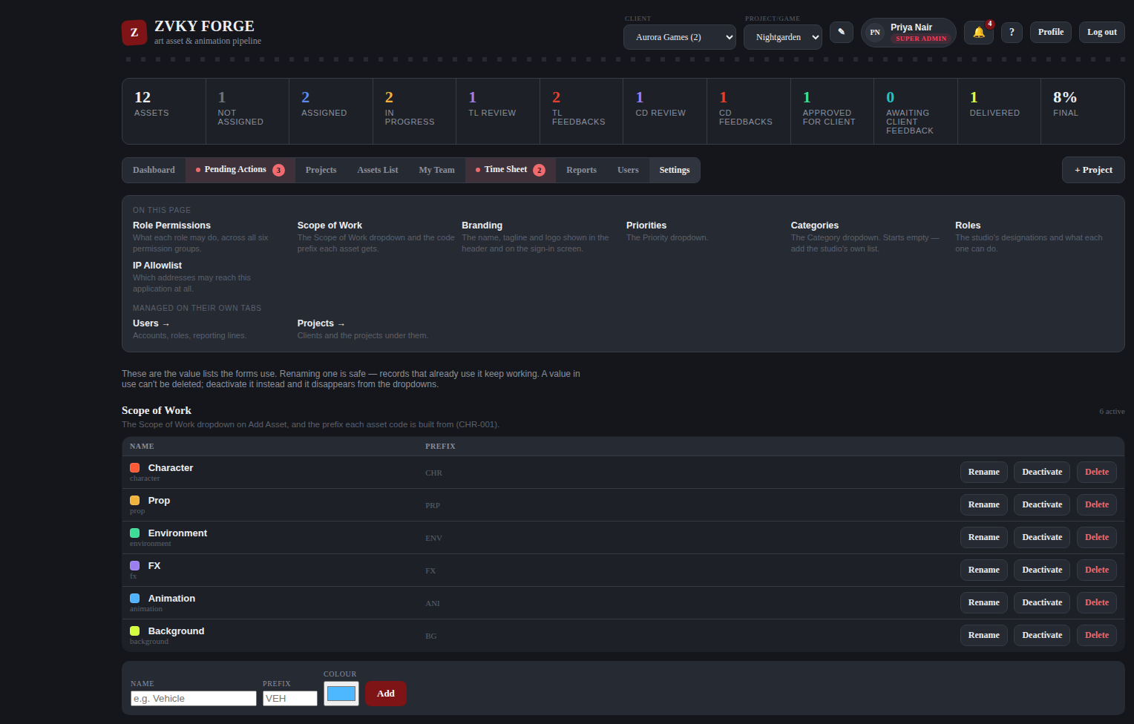
The Settings page. The index at the top lists what you hold and, greyed, what lives elsewhere.

13.2 Working hours and lunch
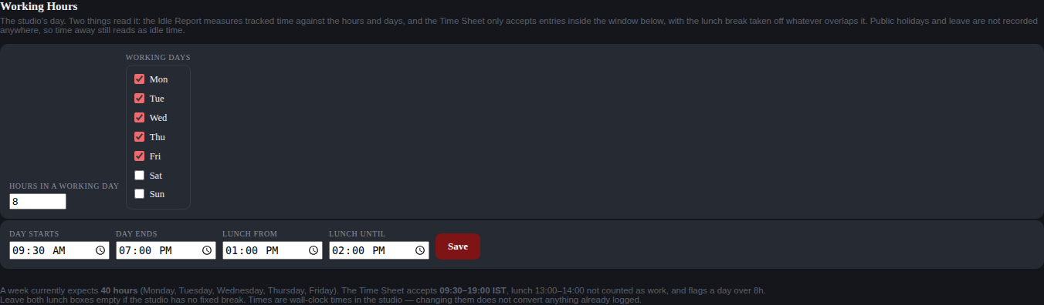
The working-hours control.
- Tick the days the studio works. Monday to Friday out of the box.
- Set the start and end of the working day.
- Set the start and end of each break, or clear both ends of one the studio does not have.
- Save.

This one setting drives four things: what the timer records, what the Time Sheet will accept, how much of a line counts as work, and what the Idle report treats as working time. The form refuses a window that cannot hold the 8-hour daily maximum, a break outside the day, half a break, two breaks that overlap, or a day that ends before it starts, and says why in each case.
THE TIMER IS THE NEWEST OF THE FOUR, and the one worth knowing about before changing anything here. Time Spent on every asset is the part of its start-to-submit span that falls inside the days and hours on this screen (7.3a). A change here is NOT retroactive: each stretch of work is measured against the window in force at the moment it ends, and that figure is then stored, so widening or narrowing the day changes what is recorded from now on and leaves finished work exactly as it was. That is deliberate — a setting that silently rewrote last quarter’s hours would rewrite last quarter’s P&L with them. The times are read as IST wherever the server and the reader happen to be.
WHO CAN DO THIS
Changing the working day is a studio-wide decision, so it sits with leadership rather than with the people who fill in time sheets.
Studio leadership — 7 designations. Administration without the Admin designation — the settings, reports and overrides tier.

13.3 Branding
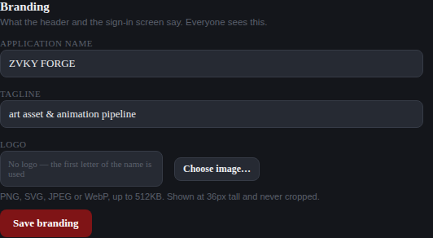
Branding: the studio name and the colour used across the application.
WHO CAN DO THIS
The studio name and colour are leadership’s to set.
Studio leadership — 7 designations. Administration without the Admin designation — the settings, reports and overrides tier.

13.4 The value lists
Six lists feed the dropdowns on the forms. Each is edited in Settings, and each is its own permission.
List | What it feeds
Scope of Work | The Scope of Work dropdown, and the prefix each asset code is built from (CHR-001).
Priorities | The Priority dropdown on Add Asset and in the asset panel.
Asset Categories | The Category dropdown on an asset — what kind of thing it is. Starts empty.
Project Categories | The Category dropdown on a project — what kind of job it is. A separate list, starting empty.
Milestone Types | The stages a project can be planned in — the Milestones column. Art and Animation to begin with; add the studio’s own.
Roles | The Role dropdown on Add User. What a designation can do comes from the tier behind it.

THE TWO CATEGORY LISTS ARE SEPARATE ON PURPOSE
A project’s category answers "what kind of work is this" — a slot game, a pitch, a co-development. An asset’s answers "what kind of thing is this" — a character, an environment, an effect. Sharing one list would put both vocabularies in both dropdowns and make each of them wrong, and there is no way back once a studio has filled it in. They are two lists, in two tables, behind two permissions, with no values in common.

RENAMING IS SAFE; DELETING IN-USE VALUES IS NOT ALLOWED
Renaming a value leaves every record that uses it working. A value in use cannot be deleted at all — deactivate it instead and it disappears from the dropdowns while the existing records keep their meaning.

WHO CAN DO THIS
Each list is a separate permission, so a studio can let somebody manage its project categories without also handing them the asset categories or the designations list. All five sit with leadership by default.
Studio leadership — 7 designations. Administration without the Admin designation — the settings, reports and overrides tier.

13.5 The IP allowlist
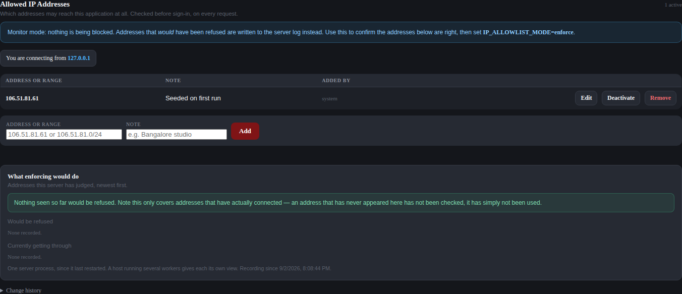
The IP allowlist.
Restricts sign-in to named addresses or ranges, written as single addresses or in CIDR notation. Every change is recorded with who made it. There are deliberate escape hatches so a studio cannot lock itself out entirely.
A CHANGE CAN TAKE UP TO HALF A MINUTE TO APPLY EVERYWHERE
The studio runs on more than one copy of the application at once, and each copy keeps its own working list so it can check an address without pausing to look it up. A change you make here reaches the copy that handled it immediately and the others within about thirty seconds — so if you add an address and it does not work on the very first try, wait a moment and try again before assuming it did not save. The same applies to removing one: allow half a minute before treating the access as withdrawn.

WHO CAN DO THIS
Super Admin, and nobody else. Sign-in restriction is not something to hand out.
Super Admin only — 1 designations. Nobody else holds this out of the box.

13.6 Role permissions
The Role Permissions section before a designation is chosen.
- Choose a designation from the dropdown.
- Tick or untick the actions it should hold. They are grouped by module.
- Save. Everyone holding that designation changes on their next request.

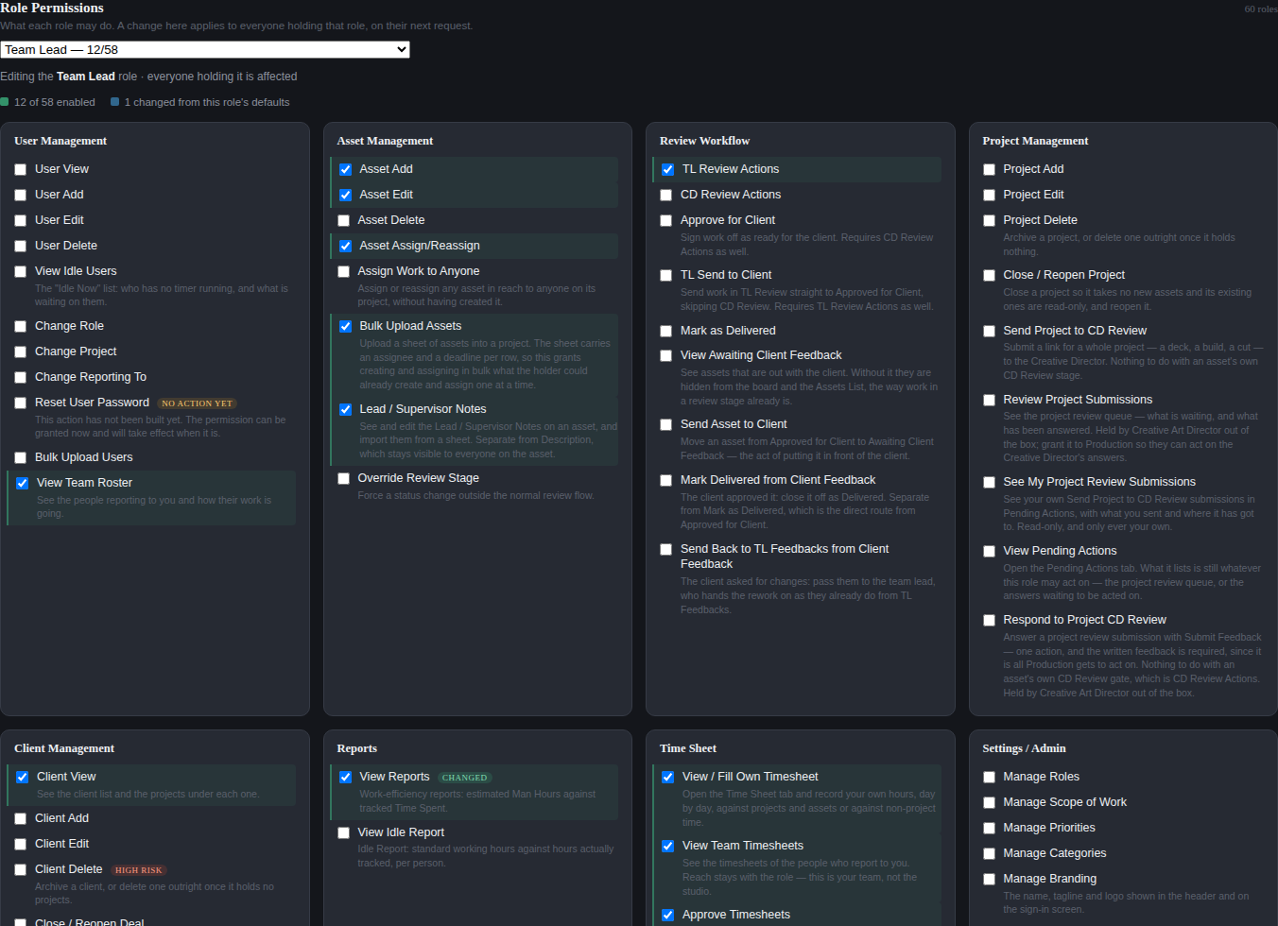
The permission grid for one designation. Shown here to the first screenful; the real grid runs to all 64 permissions.
- A change here applies to everybody holding that designation, not to one person.
- Super Admin holds every permission, including any added in future, and cannot be edited down.
- Every change is written to the Activity Log, naming the designation, the permission and the direction.

WHO CAN DO THIS
Super Admin, and nobody else — this is the screen that decides what everybody else may do.
Super Admin only — 1 designations. Nobody else holds this out of the box.

13.7 The Activity Log
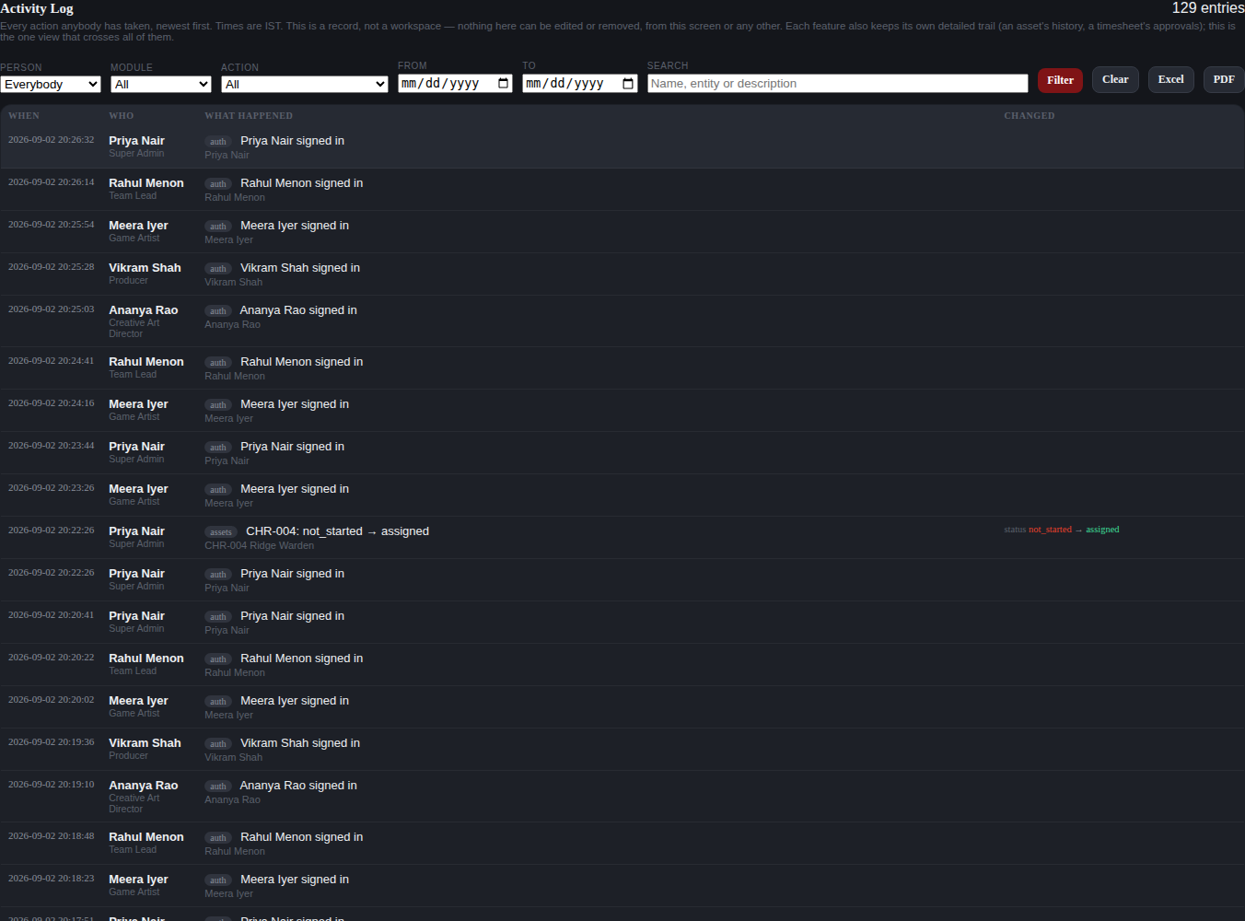
The Activity Log. Shown here to the first screenful of a much longer list.
One consolidated record of every action anybody takes, newest first, with the person’s name and designation beside it. Times are IST.
- Filter by person, by module, by action, by date range, or search the text.
- Where a change has a before and an after — a stage move, a permission toggle, a preview image set — the entry shows both.
- Nothing here can be edited or removed, from this screen or any other.
- Export the filtered view to Excel or PDF.

IT ADDS TO THE EXISTING TRAILS, IT DOES NOT REPLACE THEM
An asset still keeps its own history, a project review its own feedback trail, and a time sheet its own approval log. The Activity Log is the one view that crosses all of them.

WHO CAN DO THIS
Studio leadership. The log is readable, filterable and exportable, and editable by nobody.
Studio leadership — 7 designations. Administration without the Admin designation — the settings, reports and overrides tier.

13.8 Chat Activity
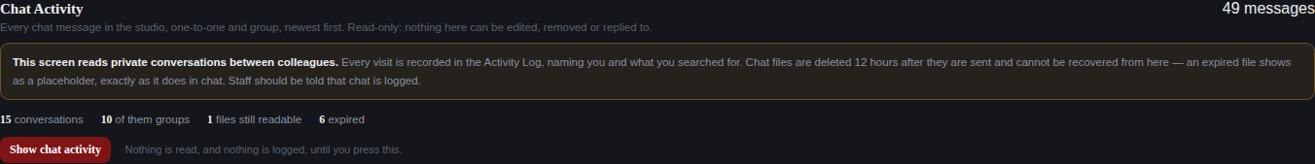
Chat Activity, before anything has been read. Nothing is fetched, and nothing is logged, until the button is pressed.
Every chat message in the studio — one-to-one and group — with its sender, its conversation, when it was sent and its full text. Read-only: nothing here can be edited, removed or replied to, and there is no way to join a conversation from it.
- Filter by person, by whether it was one-to-one or a group, by date range, by whether there was a file, or search the text.
- The person filter reaches BOTH SIDES — what somebody said, and what was said in a room they are in.
- A one-to-one conversation is named by both people in it; a group by its title and its current membership.
- A file inside its twelve-hour window opens from here. Past it, the same placeholder as in chat.
- Group notices — "X created this group" — are in the record too, marked as notices rather than as somebody’s message.

READING IT IS ITSELF RECORDED
Every visit writes a line to the Activity Log naming who looked and what they filtered by — not what they read. Opening a file writes its own line naming the file. That is what makes the screen accountable rather than merely permitted, and it is why the listing sits behind a button: a section that loaded itself would record a visit every time anybody opened Settings for any reason, and bury the times somebody actually went looking.

IT PRESERVES NOTHING
Chat files are still deleted twelve hours after they are sent, here as everywhere. This screen cannot recover one, and cannot keep one alive — oversight reads what is there, it does not extend what would otherwise have gone.

BEFORE YOU GRANT IT
View Chat Activity starts held by the Super Admin and nobody else — deliberately narrower than the Activity Log above it, because what people DID to the work and what people SAID to each other are different kinds of access. Extending it is a decision, not a default.
Tell staff that chat is logged before granting it, not after. Many organisations disclose this as a matter of practice and in some places it is a legal expectation; the application cannot do it for you. The permission carries this warning on the Role Permissions screen so whoever grants it reads it at the moment they do.

WHO CAN DO THIS
The Super Admin alone, until somebody decides otherwise.
Administration — 8 designations. The people who run the studio’s records: staff, projects and clients.

13.9 The integration API — how another system reaches Forge
Forge can accept requests from another system in the studio — a Dev & QA tool, a build server, a script on somebody’s machine — under /api/integration. Nothing in the screens above changes; this is a separate door with its own locks, and it is the only part of the application no person signs in to.
A caller is a MACHINE, not an account. It holds no designation, appears in no user list, and is never granted a permission on the Role Permissions screen — every ownership and project-scope rule in Forge is written about a person, and answering those questions on behalf of a build server is not something the application should be asked to do. What a credential may do is written on the credential itself.
- FOUR LOCKS, in order, and every one of them can refuse on its own: the address it came from, the signature on the request, the credential it presented, and whether that credential is allowed the action it asked for.
- THE CREDENTIAL. Issued as a key, stored only as a SHA-256 hash — so the key itself exists nowhere in the database and cannot be read back out of it, only replaced. Each one carries the list of actions it is allowed; asking for anything outside that list is refused with 403, which is a different answer from "I do not know you" on purpose. Deactivating a credential stops it at once.
- THE SIGNATURE. Every request carries X-Integration-Signature with a timestamp and an HMAC-SHA256 over the timestamp, the method, the path and the exact bytes of the body. A request more than five minutes out of step with the server clock is refused whichever way it is out, so a captured request cannot be replayed later. Its secret is separate from the one Forge uses to sign what it sends OUT, so a leak in one direction is not a leak in both.
- ITS OWN ADDRESS LIST, separate from the sign-in allowlist in 13.5. Two different questions — which offices may sign in, and which machines may call the API — and answering them from one list would mean whoever maintains the studio’s offices silently decided whether a build server could reach Forge. It ships in MONITOR mode: it writes down what it would have refused and refuses nothing, until somebody confirms the real address and turns it on deliberately.
- A RATE LIMIT, the same shape as the one on sign-in. An external caller retrying a failing job in a loop is the ordinary way this becomes a problem.

EVERY INTEGRATION ACTION APPEARS IN THE ACTIVITY LOG, NAMED
A call that changes something is recorded like any other change, with the actor shown as "integration:<name of the credential>" rather than as a person or as a blank. The log is the answer to "who did this" and a machine is as answerable as anybody — which also means a credential that is later withdrawn leaves a history that can still be read.

THE SAME REQUEST TWICE DOES THE WORK ONCE
Every call here that changes something carries an Idempotency-Key, chosen by the caller. Send the same key with the same request again — which is what a caller does when its connection dropped and it cannot tell whether the work landed — and Forge hands back the FIRST response without doing anything a second time. Send the same key with a DIFFERENT request and it is refused, because one of those two requests would otherwise be quietly lost.
The record of what happened is written in the same breath as the change itself, so there is no moment where one exists without the other. An attempt that fails writes nothing at all, which is what lets the caller simply send it again.
Keys are remembered for a week and then forgotten. That is longer than any real retry and short enough that the record does not grow forever — a caller that reuses a key a fortnight later is treated as making a new request, which is worth knowing if anything at your end recycles them.

AND IF A MESSAGE NEVER ARRIVES, THE OTHER SYSTEM CAN COME AND ASK
Delivery is not the only route. The other system can also ask Forge directly for everything that has happened since the last thing it saw, a page at a time, and keep asking until it has caught up. That is what makes a lost message recoverable rather than simply lost — and it reads the same record the sending works from, so a replay can never disagree with the original.
Messages Forge eventually GAVE UP sending are included in that, deliberately. A message that could not be delivered is the one most worth being able to fetch; if giving up on sending it also put it out of reach, one failure would become two.

A RETRY THAT ARRIVES WHILE THE FIRST ONE IS STILL RUNNING
The key is claimed before the work starts, so a second copy of a request cannot slip in alongside the first — it is told, in as many words, that the original is still being processed, and to come back for the result. That answer is deliberately different from the one given to a key reused for genuinely different work: one means wait, the other means something at the calling end is wrong, and a tool that could not tell them apart would keep retrying the mistake.
If the process handling a request is killed halfway — a restart, a crash — the claim it left behind is treated as abandoned after two minutes, and the next retry takes the work over and runs it properly. Without that, one badly timed restart would make a single key unusable forever.

IF IT IS NOT CONFIGURED, IT IS SHUT, NOT OPEN
The signing secret lives in the server environment and nowhere else. A deployment where it has not been set answers every integration request with 503 and does no work, rather than treating "no secret" as "no signature needed" — which would turn a setup that was never finished into an open door, quietly, and only on the deployment where it mattered.

AND THE OTHER DIRECTION: WHAT FORGE TELLS DEV & QA
When something happens here that the other system needs to know about, the change and a note to send it are written together, in one movement — so there is no version of events where the work happened and nobody was told, or where somebody was told about work that did not happen. The sending itself happens a moment later, separately.
THAT SEPARATION IS THE WHOLE POINT. Nothing about sending can reach back into the thing that caused it: if the other system is down, slow, or accepting messages and never answering, the work in Forge is unaffected — not slowed, not failed, not undone. The notes simply wait.
If a message cannot be delivered it is tried again after a minute, then five minutes, half an hour, two hours, six hours, and a day — seven attempts over a little more than twenty-four hours. That is long enough to cover an afternoon’s outage at the other end with nobody doing anything, and short enough that a receiver down for a week becomes something a person is told about rather than something the studio quietly keeps shouting at. A message the other system actively refuses — as opposed to failing to answer — is not retried at all, because sending it six more times would not make it any more acceptable.

WHO CAN DO THIS
Nobody, in the sense this column usually means. There is no screen and no permission: credentials and addresses are set on the server by whoever runs the deployment, deliberately out of reach of anybody signed in to Forge — including the Super Admin. A door that the application could open for itself is not a door.
Super Admin only — 1 designations. Nobody else holds this out of the box.

Appendix A. Designations and access bands
The studio ships with 60 designations. Between them they hold 65 permissions, which fall into only 14 distinct groups of holders. Those groups are the access bands this manual names. Everything below describes a fresh deployment; a Super Admin may change any of it in Settings.

Everyone (60 designations)
Every designation in the studio, from Trainee upwards.
Designations in this band
Trainee - Test Engineer, Trainee Game Animator, Trainee Game Artist, Junior Accountant, Associate - UI/UX Designer, Associate Game Animator, Associate Game Artist, Associate Game Designer, Associate Game Developer, Associate Game Mathematician, Associate Math Analyst, Associate Technical Artist, Associate Test Engineer, Associate Unity Developer, Game Animator, Game Artist, Game Developer, Technical Artist, Test Engineer, Unity Developer, Game Designer, Game Mathematician, MIS Analyst, Talent Acquisition Specialist, Account Manager - Marketing, Senior Game Animator, Senior Game Artist, Senior Motion Graphics Artist, Senior Technical Artist, Senior UI/UX Designer, Senior Unity Developer, Assistant Manager - HR Generalist, Associate Project Manager, Consultant - Lead Game Designer, Senior Operations Financial Analyst, People & Culture Partner, Production Coordinator, Senior Business Development Executive, Senior Production Coordinator, Project Manager, Associate Team Lead, Creative Producer, Producer, Team Lead, Associate Animation Supervisor, Senior Project Manager, Senior Producer, Senior Team Lead, Technical Manager, Art Supervisor, Associate Art Director, Art Director, Creative Art Director, Admin, Head of Production, General Manager, CTO, Vice President - Global Operations & Business Development, Managing Director & CEO, Super Admin

Holds: asset.hold, client.view, timesheet.own, chat.use

Everyone who works on assets (51 designations)
Everyone except the finance and administrative designations who never touch an asset.
Designations in this band
Trainee - Test Engineer, Trainee Game Animator, Trainee Game Artist, Associate - UI/UX Designer, Associate Game Animator, Associate Game Artist, Associate Game Designer, Associate Game Developer, Associate Game Mathematician, Associate Math Analyst, Associate Technical Artist, Associate Test Engineer, Associate Unity Developer, Game Animator, Game Artist, Game Developer, Technical Artist, Test Engineer, Unity Developer, Game Designer, Game Mathematician, Account Manager - Marketing, Senior Game Animator, Senior Game Artist, Senior Motion Graphics Artist, Senior Technical Artist, Senior UI/UX Designer, Senior Unity Developer, Associate Project Manager, Consultant - Lead Game Designer, Production Coordinator, Senior Production Coordinator, Project Manager, Associate Team Lead, Creative Producer, Producer, Team Lead, Associate Animation Supervisor, Senior Project Manager, Senior Producer, Senior Team Lead, Technical Manager, Art Supervisor, Associate Art Director, Admin, Head of Production, General Manager, CTO, Vice President - Global Operations & Business Development, Managing Director & CEO, Super Admin

Holds: asset.edit, asset.assign

Production planning (23 designations)
Coordinators, project managers, producers, leads, supervisors and above — the people who put work into the pipeline.
Designations in this band
Account Manager - Marketing, Associate Project Manager, Production Coordinator, Senior Production Coordinator, Project Manager, Associate Team Lead, Creative Producer, Producer, Team Lead, Associate Animation Supervisor, Senior Project Manager, Senior Producer, Senior Team Lead, Technical Manager, Art Supervisor, Associate Art Director, Admin, Head of Production, General Manager, CTO, Vice President - Global Operations & Business Development, Managing Director & CEO, Super Admin

Holds: asset.add, asset.bulk_upload

First review gate (23 designations)
Everyone who may hold the Team Lead review: leads, supervisors, production and creative direction.
Designations in this band
Account Manager - Marketing, Associate Project Manager, Senior Production Coordinator, Project Manager, Associate Team Lead, Creative Producer, Producer, Team Lead, Associate Animation Supervisor, Senior Project Manager, Senior Producer, Senior Team Lead, Technical Manager, Art Supervisor, Associate Art Director, Art Director, Creative Art Director, Head of Production, General Manager, CTO, Vice President - Global Operations & Business Development, Managing Director & CEO, Super Admin

Holds: review.tl

Leads and producers (18 designations)
The people who run a queue: they carry lead notes and approve their team’s time sheets.
Designations in this band
Associate Project Manager, Senior Production Coordinator, Project Manager, Associate Team Lead, Creative Producer, Producer, Team Lead, Associate Animation Supervisor, Senior Project Manager, Senior Producer, Senior Team Lead, Technical Manager, Art Supervisor, Associate Art Director, Art Director, Creative Art Director, Head of Production, Super Admin

Holds: asset.lead_notes, timesheet.team

Anyone who supervises people (14 designations)
Anyone with a team under them, which is what the My Team tab lists.
Designations in this band
Account Manager - Marketing, Associate Team Lead, Team Lead, Associate Animation Supervisor, Senior Team Lead, Technical Manager, Art Supervisor, Associate Art Director, Head of Production, General Manager, CTO, Vice President - Global Operations & Business Development, Managing Director & CEO, Super Admin

Holds: user.view_team

Delivery (18 designations)
Production and account management — the people who hand finished work to a client.
Designations in this band
Account Manager - Marketing, Associate Project Manager, Production Coordinator, Senior Production Coordinator, Project Manager, Creative Producer, Producer, Senior Project Manager, Senior Producer, Art Director, Creative Art Director, Admin, Head of Production, General Manager, CTO, Vice President - Global Operations & Business Development, Managing Director & CEO, Super Admin

Holds: review.deliver

Creative direction (9 designations)
The Creative Director gate: art direction and above.
Designations in this band
Account Manager - Marketing, Art Director, Creative Art Director, Head of Production, General Manager, CTO, Vice President - Global Operations & Business Development, Managing Director & CEO, Super Admin

Holds: review.cd, review.approve_client

Administration (8 designations)
The people who run the studio’s records: staff, projects and clients.
Designations in this band
Account Manager - Marketing, Admin, Head of Production, General Manager, CTO, Vice President - Global Operations & Business Development, Managing Director & CEO, Super Admin

Holds: user.view, user.add, user.edit, user.delete, user.change_role, user.change_project, user.change_reporting, user.reset_password, user.bulk_upload, asset.delete, project.add, project.edit, project.delete, project.close, client.add, client.edit, client.delete, client.close

Studio leadership (7 designations)
Administration without the Admin designation — the settings, reports and overrides tier.
Designations in this band
Account Manager - Marketing, Head of Production, General Manager, CTO, Vice President - Global Operations & Business Development, Managing Director & CEO, Super Admin

Holds: user.idle_view, asset.assign_any, asset.override_stage, review.tl_send_client, report.view, report.idle, timesheet.all, settings.roles, settings.asset_types, settings.priorities, settings.categories, settings.project_categories, settings.branding, settings.working_hours, settings.audit_logs, settings.activity_log

Everyone except the shielded designations (58 designations)
Everybody whose Open Inbox is on — which is every designation except the two the studio shields from unsolicited chat.
Designations in this band
Trainee - Test Engineer, Trainee Game Animator, Trainee Game Artist, Junior Accountant, Associate - UI/UX Designer, Associate Game Animator, Associate Game Artist, Associate Game Designer, Associate Game Developer, Associate Game Mathematician, Associate Math Analyst, Associate Technical Artist, Associate Test Engineer, Associate Unity Developer, Game Animator, Game Artist, Game Developer, Technical Artist, Test Engineer, Unity Developer, Game Designer, Game Mathematician, MIS Analyst, Talent Acquisition Specialist, Account Manager - Marketing, Senior Game Animator, Senior Game Artist, Senior Motion Graphics Artist, Senior Technical Artist, Senior UI/UX Designer, Senior Unity Developer, Assistant Manager - HR Generalist, Associate Project Manager, Consultant - Lead Game Designer, Senior Operations Financial Analyst, People & Culture Partner, Production Coordinator, Senior Business Development Executive, Senior Production Coordinator, Project Manager, Associate Team Lead, Creative Producer, Producer, Team Lead, Associate Animation Supervisor, Senior Project Manager, Senior Producer, Senior Team Lead, Technical Manager, Art Supervisor, Associate Art Director, Art Director, Creative Art Director, Admin, Head of Production, General Manager, CTO, Super Admin

Holds: chat.open_inbox

Production planning and creative direction (25 designations)
The production planning band with Art Director and Creative Art Director added — everyone who runs work rather than doing it. Who may start a chat group.
Designations in this band
Account Manager - Marketing, Associate Project Manager, Production Coordinator, Senior Production Coordinator, Project Manager, Associate Team Lead, Creative Producer, Producer, Team Lead, Associate Animation Supervisor, Senior Project Manager, Senior Producer, Senior Team Lead, Technical Manager, Art Supervisor, Associate Art Director, Art Director, Creative Art Director, Admin, Head of Production, General Manager, CTO, Vice President - Global Operations & Business Development, Managing Director & CEO, Super Admin

Holds: chat.group_create

Creative Art Director and Super Admin (2 designations)
A deliberately narrow pair: the project-review queue.
Designations in this band
Creative Art Director, Super Admin

Holds: project.review_queue, pending.view, project.review_respond

Super Admin only (1 designations)
Nobody else holds this out of the box.
Designations in this band
Super Admin

Holds: asset.bulk_assign, review.client_view, review.client_send, review.client_deliver, review.client_return, project.review_send, project.review_mine, chat.message_protected, settings.ip_allowlist, settings.chat_activity, settings.permissions

Appendix B. Every permission, and who holds it
Read out of a fresh deployment. The right-hand column names the access band from Appendix A, which is where you will find the designations it covers.

User Management
Permission | Key | Held by
User View | user.view | Administration
User Add | user.add | Administration
User Edit | user.edit | Administration
User Delete | user.delete | Administration
View Idle Users | user.idle_view | Studio leadership
Change Role | user.change_role | Administration
Change Project | user.change_project | Administration
Change Reporting To | user.change_reporting | Administration
Reset User Password | user.reset_password | Administration
Bulk Upload Users | user.bulk_upload | Administration
View Team Roster | user.view_team | Anyone who supervises people

Asset Management
Permission | Key | Held by
Asset Add | asset.add | Production planning
Asset Edit | asset.edit | Everyone who works on assets
Asset Delete | asset.delete | Administration
Asset Assign/Reassign | asset.assign | Everyone who works on assets
Assign Work to Anyone | asset.assign_any | Studio leadership
Bulk Upload Assets | asset.bulk_upload | Production planning
Lead / Supervisor Notes | asset.lead_notes | Leads and producers
Hold / Resume Own Task | asset.hold | Everyone
Bulk Assign & Schedule Assets | asset.bulk_assign | Super Admin only
Override Review Stage | asset.override_stage | Studio leadership

Review Workflow
Permission | Key | Held by
TL Review Actions | review.tl | First review gate
CD Review Actions | review.cd | Creative direction
Approve for Client | review.approve_client | Creative direction
TL Send to Client | review.tl_send_client | Studio leadership
Mark as Delivered | review.deliver | Delivery
View Awaiting Client Feedback | review.client_view | Super Admin only
Send Asset to Client | review.client_send | Super Admin only
Mark Delivered from Client Feedback | review.client_deliver | Super Admin only
Send Back to TL Feedbacks from Client Feedback | review.client_return | Super Admin only

Project Management
Permission | Key | Held by
Project Add | project.add | Administration
Project Edit | project.edit | Administration
Project Delete | project.delete | Administration
Close / Reopen Project | project.close | Administration
Send Project to CD Review | project.review_send | Super Admin only
Review Project Submissions | project.review_queue | Creative Art Director and Super Admin
See My Project Review Submissions | project.review_mine | Super Admin only
View Pending Actions | pending.view | Creative Art Director and Super Admin
Respond to Project CD Review | project.review_respond | Creative Art Director and Super Admin

Client Management
Permission | Key | Held by
Client View | client.view | Everyone
Client Add | client.add | Administration
Client Edit | client.edit | Administration
Client Delete | client.delete | Administration
Close / Reopen Client | client.close | Administration

Reports
Permission | Key | Held by
View Reports | report.view | Studio leadership
View Idle Report | report.idle | Studio leadership

Time Sheet
Permission | Key | Held by
View / Fill Own Timesheet | timesheet.own | Everyone
View Team Timesheets | timesheet.team | Leads and producers
View All Timesheets | timesheet.all | Studio leadership

Chat
Permission | Key | Held by
Use Chat | chat.use | Everyone
Open Inbox | chat.open_inbox | Everyone except the shielded designations
Message a Shielded Designation | chat.message_protected | Super Admin only
Create Chat Group | chat.group_create | Production planning and creative direction

Settings / Admin
Permission | Key | Held by
Manage Roles | settings.roles | Studio leadership
Manage Scope of Work | settings.asset_types | Studio leadership
Manage Priorities | settings.priorities | Studio leadership
Manage Asset Categories | settings.categories | Studio leadership
Manage Project Categories | settings.project_categories | Studio leadership
Manage Branding | settings.branding | Studio leadership
Manage Working Hours | settings.working_hours | Studio leadership
Manage IP Allowlist | settings.ip_allowlist | Super Admin only
View Audit Logs | settings.audit_logs | Studio leadership
View Activity Log | settings.activity_log | Studio leadership
View Chat Activity | settings.chat_activity | Super Admin only
Manage Role Permissions | settings.permissions | Super Admin only

Appendix C. Keeping this manual current
This document is generated, not typed into Word. Both things most likely to go stale — the screenshots and the permission tables — are produced from a running instance each time it is built, so a rebuild cannot leave a picture of last month behind.

What is generated
- Every screenshot is captured by a script that signs in as each demo designation and drives the real buttons.
- Every permission table is read out of a pristine deployment, so it says what the software ships with rather than what somebody remembers.
- The access bands are derived from those tables. A permission added to the catalogue appears in Appendix B on the next build without anybody editing this document.

What a new feature needs
Documenting a change is part of building it, not a separate job afterwards. When a feature ships, four things bring this manual up with it:
- A section in the right chapter, written as steps somebody can follow.
- A screenshot, added to the capture script so it is re-taken on every build.
- A role note, naming the access band — which the permission tables will already know about.
- A slide in the deck, if the feature is one a new joiner needs to know exists.

THE STANDING RULE
Every feature prompt from here on should say what this documentation needs added. A feature that ships undocumented is a feature the studio has to be told about person by person.

