Cryptojacking Detection Tool Using Machine Learning



By

Muhammad Asadullah Khan
B22F1392SE153

Muhammad Saleh Janjua
B22F0086SE017

Hasnain Ali
B22F1427SE157

Final Year Project Report

School of Computing Sciences

Pak-Austria Fachhochschule: Institute of Applied Sciences & Technology

2022 - 2026



Cryptojacking Detection Tool Using Machine Learning

A Final Year Project Report Presented to

Pak-Austria Fachhochschule: Institute of Applied Sciences and Technology

In partial fulfillment
of the requirement for the degree of

BS Software Engineering

By
Muhammad Asadullah Khan
B22F1392SE153

Muhammad Saleh Janjua
B22F0086SE017

Hasnain Ali
B22F1427SE157

2022 - 2026
Cryptojacking Detection Tool Using Machine Learning

A Final Year Project Report submitted to the School of Computing Sciences as partial fulfillment of the requirement for the award of Degree of BS in Software Engineering.

Muhammad Asadullah Khan | B22F1392SE153
Muhammad Saleh Janjua | B22F0086SE017
Hasnain Ali | B22F1427SE157

Academic Supervisor
Dr. Abdul Waheed Khan
School of Computing Sciences
Pak-Austria Fachhochschule: Institute of Applied Sciences and Technology

Final Approval

This final year project titles
Cryptojacking Detection Tool Using Machine Learning

By
Muhammad Asadullah Khan | B22F1392SE153
Muhammad Saleh Janjua | B22F0086SE017
Hasnain Ali | B22F1427SE157

under the supervision of their project supervisor and approved by the project evaluation committee, has been accepted by the Pak-Austria Fachhochschule: Institute of Applied Sciences and Technology, Pakistan, in partial fulfillment of the requirements for the degree of BS Software Engineering.
Academic Supervisor:

Dr. Abdul Waheed Khan
School of Computing Sciences
HoD / Chairman:

Dr. Kamran Javed
School of Computing Sciences
Declaration

We,Muhammad Asadullah Khan(B22F1392SE153), Muhammad Saleh Janjua (B22F0086SE017), and Hasnain Ali(B22F1427SE157), hereby declare that we have produced the work presented in this final year project report, during the scheduled period of study. We also declare that we have not taken any material from any source except referred to wherever due to that amount of plagiarism is within an acceptable range. It is further declared that we have developed this project and the accompanied report entirely on the basis of our personal efforts made under the sincere guidance of our supervisor. No portion of the work presented in this report has been submitted in support of any other degree or qualification of this or any other University or Institute of learning, if found we shall stand responsible.

Date:

Signature: __________________
Muhammad Asadullah Khan
B22F1392SE153

Signature: __________________
Muhammad Saleh Janjua
B22F0086SE017

Signature: __________________
Hasnain Ali
B22F1427SE157

Certificate

It is certified that Muhammad Asadullah Khan (B22F1392SE153), Muhammad Saleh Janjua (B22F0086SE017) and Hasnain Ali (B22F1427SE157) have carried out all the work related to this project under my supervision at the Department of School of Computing Sciences, Pak-Austria Fachhochschule: Institute of Applied Sciences and Technology and the work fulfills the requirement for the award of BS Software Engineering.

Date:

Supervisor:

________________________
Dr. Abdul Waheed Khan
Associate Professor

Head of Department:

_______________________________________________
Dr. Kamran Javed
Chairman / Head of Department School of Computing Sciences

DEDICATION

This work is dedicated to our families, whose unwavering support, patience, and encouragement have been our greatest source of strength throughout this journey. We also dedicate this project to our supervisor, Dr. Abdul Waheed Khan, for his invaluable guidance, and to all researchers and professionals working to make the digital world a safer place.

ACKNOWLEDGEMENTS

All praise be to Allah Almighty, the most Gracious and most Merciful, for bestowing upon us the knowledge, patience, and strength to complete this project successfully.

We would like to express our deepest gratitude to our Academic supervisor, Dr. Abdul Waheed Khan, for his expert guidance, consistent support, and constructive feedback throughout the entire duration of this project. His insights into machine learning and cybersecurity were instrumental in shaping the direction and quality of this work.

We are also grateful to the School of Computing Sciences at Pak-Austria Fachhochschule: Institute of Applied Sciences and Technology for providing us with a strong academic foundation and academic environment necessary to undertake this project.

Special thanks to our families for their unwavering support, encouragement, and belief in our abilities throughout this journey. Their patience during our long working hours did not go unnoticed.

Finally, we acknowledge the open-source community and the teams behind VirusTotal, various machine learning libraries and the researchers whose datasets, tools, and libraries made this work possible.

ABSTRACT

Cryptojacking Detection Tool Using Machine Learning

Cryptojacking, a covert form of cyberattack, involves the unauthorized use of computing resources to mine cryptocurrency without the user’s consent. It silently consumes CPU/GPU power, resulting in system performance degradation, hardware overheating, and increased electricity costs.Most existing detection systems focus only on web-based cryptojacking (browser miners), leaving host- based and hybrid attacks underexplored. Additionally, many existing studies rely on outdated datasets and lack comprehensive behavioral and machine learning (ML)–based analysis.

This Project presents the design and implementation of an intelligent, real-time cryptojacking detection system driven by machine learning. The system comprises a lightweight Windows monitoring agent that continuously collects system telemetry (CPU, Gpu,memory, network I/O, and process metadata), a centralized FastAPI backend that applies trained XGBoost and Random Forest classifiers to distinguish malicious mining activity from legitimate high-resource processes, and an interactive React-based web dashboard for real-time alert management and visualization.

Integration with the VirusTotal API adds a threat intelligence layer by cross-referencing suspicious process hashes against known malware signatures. The models achieved greater than 90% classification accuracy with recall rates exceeding 85%, while the monitoring agent maintained a negligible footprint of under 2% CPU and 50MB RAM during continuous operation. The system successfully delivers multi-channel alerting (dashboard, email, and WhatsApp) upon detecting threats, providing a practical, market-ready prototype for endpoint cybersecurity.

Table of Contents
Table of Contents

Chapter 1: Introduction 13
1.1 Problem Statement 13
1.2 Business Opportunity 14
1.3 Objectives 15
1.4 Project Scope 15
1.4.1 Included Features 15
1.4.2 Excluded Features 16
1.5 Constraints 16
1.6 Feasibility 17
1.6.1 Technical Feasibility 17
1.6.2 Resource Feasibility 17
1.6.3 Time Feasibility 18
1.6.4 Market Feasibility 18
1.7 Stakeholders Description 19
1.7.1 Stakeholders Summary 19
1.7.2 Key High-Level Goals and Problems of Stakeholders 20

Chapter 2: Literature Review 21
2.1 Review of Existing Systems 21
2.2 Comparative Analysis of Techniques/Models 23

Chapter 3: Software Requirements Specification (SRS) 25
3.1 Introduction 25
3.2 List of Features 26
3.3 Functional Requirements 27
3.3.1 Role-Based System Access and Control 27
3.3.2 Monitoring Agent Operations 28
3.3.3 Dashboard and Visualization 29
3.3.4 Machine Learning Detection Module (Backend) 30
3.3.5 Security and Data Management 31
3.3.6 Notification System (Email & In-App Alerts) 32
3.3.7 Report Generation, Logs, and Auto Report Scheduler 33
3.4 Non-Functional Requirements 34
3.4.1 Performance Requirements 34
3.4.2 Reliability Requirements 34
3.4.3 Scalability Requirements 35
3.4.4 Usability Requirements 35
3.4.5 Security Requirements 36
3.4.6 Accuracy Requirements 36
3.5 Use Cases 37
3.5.1 Use Case 1: User and Admin Authentication 37
3.5.2 Use Case 2: Real-Time System Monitoring 38
3.5.3 Use Case 3: Alert Detection and Reporting 39
3.5.4 Use Case 4: Dashboard Visualization and Management 40
3.5.5 Use Case 5: Security and Data Management 41
3.6 Software Development Plan 42
3.6.1 Development Methodology 42
3.6.2 Phases of Development 43

Chapter 4: System Overview 45
4.1 Architectural Design 45
4.1.1 High-Level Overview 45
4.1.2 Workflow Overview 47
4.2 Data Design 48
4.2.1 Entity-Relationship Diagram (ERD) 48
4.2.2 Data Flow Diagram (DFD) 49
4.3 Domain Model 51
4.3.1 Class Diagram 51
4.4 Design Models 53
4.4.1 Activity Diagram 53
4.4.2 State Transition Diagram 54
4.4.3 Sequence Diagram 55
4.4.4 Component Diagram 56
4.4.5 System Architecture 57
4.5 Mockups 59
4.6 Methodology / Proposed System and System Workflow 62

Chapter 5: System Implementation 64
5.1 Technology Stack (Languages, Frameworks, Tools) 64
5.2 Development Environment Setup 66
5.3 System Modules and Components 67
5.4 Database Implementation 70
5.5 APIs and External Integrations 72
5.6 Dataset Selection and Preprocessing 74
5.7 Model Selection and Training 76
5.8 Model Evaluation 78
5.9 Model Deployment 80

Chapter 6: System Testing & Deployment 82
6.1 Testing Approach (Manual, Automated) 82
6.2 Unit Testing 83
6.3 Integration Testing 84
6.4 System Testing 86
6.5 User Acceptance Testing (UAT) 87
6.6 Performance Testing 88
6.7 Deployment Strategy 90
6.8 Hosting & Deployment Environment 91
6.9 Version Control and CI/CD Pipelines 92

Chapter 7: Results and Discussion 94
7.1 Evaluation and Results 94
7.1.1 Comparison with Initial Objectives 94
7.1.2 User Feedback and Usability Testing 96
7.1.3 Performance Evaluation 97
7.1.4 Challenges and Limitations 98

Chapter 8: Conclusion and Future Work 100
8.1 Conclusion 100
8.2 Future Enhancements 101

Bibliography 103

Chapter 1: Introduction

1.1 Problem Statement
Cryptojacking, a covert form of cyberattack, involves the unauthorized use of computing resources to mine cryptocurrency without the user's consent. It silently consumes CPU/GPU power, resulting in system performance degradation, hardware overheating, and increased electricity costs. Most existing detection systems focus only on web-based cryptojacking (browser miners), leaving host-based and hybrid attacks underexplored. Additionally, many existing studies rely on outdated datasets and lack comprehensive behavioral and machine learning (ML)-based analysis.
This Project presents the design and implementation of an intelligent, real-time cryptojacking detection system driven by machine learning. The system comprises a lightweight Windows monitoring agent that continuously collects system telemetry (CPU, memory, network I/O, and process metadata), a centralized FastAPI backend that applies trained XGBoost and Random Forest classifiers to distinguish malicious mining activity from legitimate high-resource processes, and an interactive React-based web dashboard for real-time alert management and visualization. The models achieved greater than 90% classification accuracy with recall rates exceeding 85%, while the monitoring agent maintained a negligible footprint of under 2% CPU and 50MB RAM during continuous operation. The system successfully delivers multi-channel alerting (dashboard, email, and WhatsApp) upon detecting threats, providing a practical, market-ready prototype for endpoint cybersecurity.

1.2 Business Opportunity
As cryptocurrencies gain global adoption, cryptojacking incidents have surged, targeting individuals, enterprises, and cloud environments. This project introduces an opportunity to create a market-ready, intelligent detection solution that can be integrated into cybersecurity tools, browsers, and enterprise monitoring platforms. The proposed system provides:
- Real-time monitoring of system performance metrics.
- Intelligent detection through Random Forest and XGBoost models.
- Research contributions via a publicly available, updated dataset.
This Product not only enhances cybersecurity defense but also offers business potential in sectors such as endpoint security, cloud infrastructure monitoring, and academic research.

1.3 Objectives

The primary objectives of Cryptojacking Detection tool are as follows.
- To detect potential cryptojacking activity in near real time using system telemetry (CPU,GPU, memory, network, suspicious processes) and ML-based inference.
- To Continuously monitor endpoint systems via a Windows agent and securely send batched metrics to a central backend.
- To provide a web dashboard for users/admins to view live system status, alerts, trends, and historical monitoring data.
- Generating actionable security outputs: alert management, confidence scoring, suspicious process context, and downloadable reports (PDF/CSV).
- To design a user-friendly interface or monitoring agent that alerts users about suspicious cryptojacking activity in real time and provides an interactive dashboard with visualization insights.
- To support operational response with user auth, system ownership controls, audit logs, and optional notification channels (email/WhatsApp).

1.4 Project Scope

1.4.1 Included Features
- Users can register/login, and each account gets a unique system_id and api_key to securely connect monitored endpoints. Integration of data collection, feature extraction, and model training modules.
- System includes a real-time monitoring agent that runs in the background to collect CPU, memory, network, and process metrics continuously from the endpoint system.
- System provides an interactive, user-friendly monitoring dashboard that alerts users about suspicious cryptojacking activity in real time with visualization insights.
- The backend analyzes incoming system metrics using a trained machine learning model to identify potential cryptojacking activity and assign a confidence score to each generated alert.
- Users can generate and download security/monitoring reports in PDF or CSV format for analysis and record-keeping.
- Verified email/WhatsApp channels can receive important alerts, and admin audit logs track sensitive platform actions.
1.4.2 Excluded Features
The following are explicitly out of scope for this project version:
- Detection of other malware types such as ransomware or spyware.
- Cloud-specific and mobile-device cryptojacking beyond host and browser scope.
- Blockchain mining optimization or prevention at protocol level.
- Cross-platform endpoint agents (Linux/macOS); this release focuses on Windows agent workflow.

1.5 Constraints

The following constraints have been identified during project.
- Limited Dataset Availability: Cryptojacking datasets are scarce and often outdated, especially for host-based mining malware. This limits model exposure to newer attack patterns.
- Model Complexity: Integrating static, dynamic, features require advanced modeling pipelines and extensive preprocessing.
- Real-Time Performance Requirement: The detection agent must run continuously in the background without slowing down the system, which restricts model size and computational overhead.
- Project Timeline: Collecting samples, conducting analysis, training models, integrating the system, and evaluating results must all be completed within the academic schedule.
- Computational Power: Running sandbox environments and training data-heavy models may require strong GPU resources, which may not always be available.
- Generalization and Adaptability: Cryptojacking malware is constantly evolving, and models may struggle to detect new or obfuscated variants.

1.6 Feasibility

1.6.1 Technical Feasibility
- Languages/Frameworks: FastAPI(backendAPIs), React (dashboard UI), SQLAlchemy + Alembic (ORM/migrations), scikit-learn/ XGBoost /RandomForest (ML detection), psutil (endpoint telemetry).
- Data Sources: VirusTotal API, Kaggle, Cuckoo Sandbox.
- Static Analysis Stack: YARA, PEframe, and binary inspection scripts.
- Dynamic Analysis Stack: Controlled sandbox execution for runtime behavior capture (CPU,GPU, memory, process, network patterns) under safe, isolated conditions.
- Visualization: Matplotlib for model/performance plots and trend visuals, OpenCV for heatmaps and behavioral analysis.
- Storage & Reporting: Relational persistence for users/ systems/ metrics/ alerts/reports, with PDF/CSV report generation for operational use.
- Security & Access Control: JWT-based authentication, API-key-based agent authentication, role-aware access, and audit logging for sensitive actions.
- Operational Integrations: SMTP/Twilio notification channels, endpoint agent packaging/distribution, and environment-driven deployment configuration.

1.6.2 Resource Feasibility
The successful implementation of this project requires individuals skilled in malware analysis and cybersecurity, machine learning engineering, system monitoring, backend development, and dashboard/UI development. Most required analysis tools and frameworks are open-source and free to use, including Python, Scikit-learn, XGBoost, RandomForest, Cuckoo Sandbox, FASTAPI, React, and PostgreSQL. The project can be completed with minimal financial expenditure, aside from optional cloud compute usage.

1.6.3 Time Feasibility

The project development is divided into structured phases. The key phases include:

Phase 1: Research and Planning

Phase 2: Design Phase

Phase 3: Dataset Collection and Analysis Setup

Phase 4: Development Phase

Phase 5: Integration Phase

Phase 6: Testing Phase

Phase 7: Deployment Phase

1.6.4 Market Feasibility
The increasing number of cryptojacking incidents in enterprise and consumer environments creates a strong market demand for lightweight, ML-driven detection tools. This project's prototype can evolve into a browser plugin or system monitoring agent, a module in existing antivirus software, or a research tool for academic cybersecurity labs. Its adaptability and modular design provide commercial potential for integration and scale.

1.7 Stakeholders Description

1.7.1 Stakeholders Summary

End Users:

Individuals installing the Windows monitoring agent on their personal or professional devices. Because the system is standalone, the user acts as their own system administrator, holding full authority over their web dashboard, API keys, and multi-channel notification settings.

Researchers and Analysts:

Cybersecurity academics and professionals who can utilize the system's detailed metric logging, VirusTotal threat intelligence, and SHAP explainability to study host-based cryptojacking behavior.

Developers / Project Team:

The creators responsible for building and maintaining ML models (XGBoost/Random Forest), FastAPI backend, react dashboard, and Windows agent to ensure high detection accuracy and low system overhead.

1.7.2 Key High-Level Goals and Problems of Stakeholders
- End Users: Require a simple, standalone monitoring solution with full administrative control to protect their hardware from overheating, performance degradation, and unauthorized mining
- Researchers and Analysts: Aim to analyze new host-based cryptojacking trends and understand the exact reasons behind ML detections using the system's SHAP feature importance breakdowns.
- Developers / Project Team: Seek to maintain a reliable, full-stack threat detection pipeline that processes real-time telemetry securely.

Chapter 2:

This chapter reviews the existing literature surrounding cryptojacking detection, analyzing the evolution of malicious mining from browser-based scripts to native host executables. It also provides a comparative analysis of modern detection models, justifying the architectural and algorithmic choices made in the development of the CryptoDetect system.

2.1 Review of Existing Systems

In recent years, the exponential rise in cryptocurrency valuation has led to a surge in cryptojacking, the unauthorized hijacking of computing resources to mine digital currency. Early research, such as the comprehensive study by Hong et al. (2018) [1], primarily focused on browser-based cryptojacking. Their work highlighted how malicious actors exploited JavaScript APIs (such as WebAssembly) to quietly consume CPU,GPU cycles when users visited compromised web pages. While systems designed around browser extensions are effective for web-based threats, they lack critical visibility into host-level Operating System processes, leaving a significant vulnerability gap against natively compiled malware.

As cryptojacking evolved from the browser to the host environment, detection strategies had to adapt. Kharraz and Kirda (2019) [3] decomposed host-based cryptojacking, emphasizing the absolute necessity of monitoring system-level behavioral anomalies. Their research demonstrated that malicious mining executables exhibit highly distinct resource consumption patterns, particularly in sustained CPU,GPU load and memory caching behaviors.

Zimba and Chishimba (2021) [2] further expanded on this paradigm by surveying various detection techniques. They classified existing systems into two main categories: static analysis (examining Portable Executable structures, imports, and entropy) and dynamic analysis (runtime behavioral monitoring). They concluded that relying solely on signature-based static analysis is entirely insufficient against modern cryptojacking malware, which frequently utilizes packers and obfuscators to hide its true intent.

2.2 Comparative Analysis of Techniques/Models

The shift toward Artificial Intelligence and Machine Learning (ML) has significantly improved the detection accuracy of modern cybersecurity systems. However, researchers are divided on the most efficient computational approach.

Liu et al. (2021) [4] proposed a heavy Deep Learning approach using Convolutional Neural Networks (CNNs). By converting time-series resource usage patterns into visual heatmaps, their model achieved high accuracy in identifying complex, obfuscated miners. However, a major limitation of this approach is the immense computational overhead required. Running continuous Deep Learning inference on an end-user's machine inherently drains the very resources the system is trying to protect, making it highly impractical for real-time, lightweight endpoint protection.

Conversely, Rehman et al. (2022) [5] conducted a comprehensive survey comparing traditional tabular ML models against heavier deep learning architectures. Their findings highlighted that decision-tree-based ensemble algorithms, specifically Random Forest and Extreme Gradient Boosting (XGBoost), offer an optimal balance. These models consistently deliver greater than 90% detection accuracy while requiring a fraction of the memory and processing power needed by CNNs.

2.2.1 Relevance to the CryptoDetect Project

Comparative literature strongly validates the architectural decisions driving the CryptoDetect project.

Addressing Computational Overhead: Unlike the heavy Deep Learning models proposed by Liu et al. [4] that drain host resources, CryptoDetect adopts the highly efficient tabular ML approach validated by Rehman et al. [5], utilizing XGBoost and Random Forest.

Overcoming Static Limitations: To address the limitations of purely static analysis identified by Zimba and Chishimba [2], CryptoDetect employs a hybrid methodology. It combines Static PE analysis with real-time behavioral telemetry (CPU times, Memory, Network I/O deltas).

Distributed Architecture: Finally, to ensure the monitoring system remains virtually invisible to the user, CryptoDetect decouples data collection from data processing. A lightweight Windows Agent gathers the metrics, while the heavy lifting of XGBoost inference and Threat Intelligence querying is offloaded entirely to a centralized FastAPI backend.

Chapter 3: Software Requirements Specification (SRS)

3.1 List of Features
- Users can register/login, and each account gets a unique system_id and api_key to securely connect monitored endpoints. Integration of data collection, feature extraction, and model training modules.
- System includes a real-time monitoring agent that runs in the background to collect CPU,GPU, memory, network, and process metrics continuously from the endpoint system.
- System provides an interactive, user-friendly monitoring dashboard that alerts users about suspicious cryptojacking activity in real time with visualization insights.
- The backend analyzes incoming system metrics using a trained machine learning model to identify potential cryptojacking activity and assign a confidence score to each generated alert.
- Users can generate and download security/monitoring reports in PDF or CSV format for analysis and record-keeping.
- Verified email/WhatsApp channels can receive important alerts, and admin audit logs track sensitive platform actions.

3.2 Functional Requirements

3.2.1 User and System Authentication
FR-ID | Requirement Description
FR1 | Register user accounts and auto-generate unique System ID & API Key.
FR2 | Provide secure JWT-based login (HS256, bcrypt) for dashboard access.
FR3 | Validate agent credentials via X-API-Key header prior to metric ingestion.
FR4 | Allow users to manage their profiles, passwords, and avatars.

3.2.2 Real-Time Monitoring and Data Collection
FR-ID | Requirement Description
FR5 | Collect CPU,GPU, memory, and network metrics locally every 5 seconds.
FR6 | Filter and enumerate running processes exceeding 4% CPU or memory.
FR7 | Capture process metadata including SHA-256 hashes and digital signatures.
FR8 | Monitor per-process network activity and known miner pool ports.
FR9 | Perform static PE analysis on processes using ≥20% CPU.
FR10 | Maintain a local rolling cache of 60 entries to prevent data loss.

3.2.3 Data Ingestion and System Health
FR-ID | Requirement Description
FR11 | Ingest metrics via batch POST endpoint and persist to the database.
FR12 | Implement heartbeat mechanism to update system last_seen and online status.
FR13 | Automatically mark systems offline if they fail to report within 30 seconds.

3.2.4 Cryptojacking Detection (ML and Heuristics)
FR-ID | Requirement Description
FR14 | Run XGBoost/Random Forest ML inference on a 20-feature data vector.
FR15 | Apply heuristic fallback detection (CPU ≥ 90% or RAM ≥ 80%) if ML is offline.
FR16 | Execute multi-signal analysis (miner keywords, spoofing, PE evidence).
FR17 | Apply a sustained-detection gate (3 consecutive positives) before alerting.
FR18 | Compute and store SHAP feature importance values for explainability.

3.2.5 Alerting and Multi-Channel Notifications
FR-ID | Requirement Description
FR19 | Generate alert records storing confidence, detection method, and SHAP
FR20 | Dispatch real-time Email notifications via SMTP for confidence ≥ 0.70.
FR21 | Dispatch real-time WhatsApp notifications via Twilio for confidence ≥ 0.70.
FR22 | Enforce a 6-digit OTP verification flow for new notification channels.
FR23 | Display a local Windows desktop notification when an alert is generated.

3.2.6 Agent Management and Updates
FR-ID | Requirement Description
FR24 | Automate agent self-updates with SHA-256 checksum verification and rollback.
FR25 | Serve the latest agent binary and version metadata via API endpoints.
FR26 | Provide a system tray GUI for agent configuration, logs, and monitoring control.

3.2.7 Frontend Visualization
FR-ID | Requirement Description
FR27 | Visualize real-time/historical metrics using interactive dashboard charts.
FR28 | Display comprehensive alert details including SHAP feature importance.
FR29 | Enforce authenticated-only access to all dashboard visualizations.

3.2.8 Reporting and Audit
FR-ID | Requirement Description
FR30 | Generate on-demand PDF and CSV metrics reports for selected date ranges.
FR31 | Maintain a full audit log tracking sensitive user and system actions.

3.3 Non-Functional Requirements

3.3.1 Performance Requirements
NFR-ID | Requirement Description
NFR1 | Process and visualize collected system metrics in near real-time without delay.
NFR2 | Classify data samples using trained ML models in under 1 second per prediction.
NFR3 | Render dashboard graphs smoothly with updates every 5 seconds in monitoring mode.

3.3.2 Reliability Requirements
NFR-ID | Requirement Description
NFR4 | Maintain stable, crash-free operation without data loss during long-running sessions.
NFR5 | Persistently store datasets, trained models, and visualizations to prevent data loss.

3.3.3 Scalability Requirements
NFR-ID | Requirement Description
NFR6 | Support future addition of new data sources or ML models without major redesign.
NFR7 | Support distributed data collection and model training for larger-scale experiments.

3.3.4 Usability Requirements
NFR-ID | Requirement Description
NFR8 | Present system metrics, graphs, and model results in an intuitive, easy-to-read format.
NFR9 | Use clear labeling and color coding for CPU, GPU, memory, and network data graphs.
NFR10 | Ensure dashboard design is responsive and accessible through standard desktop browsers.

3.3.5 Security Requirements
NFR-ID | Requirement Description
NFR11 | Isolate malware analysis in sandbox environments to prevent host infection.
NFR12 | Securely store sensitive data (API keys, hashes) and never expose in plain text.

3.3.6 Accuracy Requirements
NFR-ID | Requirement Description
NFR13 | ML models (Random Forest, XGBoost) must achieve at least 90% classification accuracy.
NFR14 | Prioritize precision and recall over raw accuracy to minimize missed detections.

3.4 Use Cases

3.4.1 Use Case 1: User Authentication and Account Management

Actors: User, Backend System

Description: Describes how a user registers, logs in, manages their profile, and obtains the API Key/System ID credentials required to connect monitoring agents.

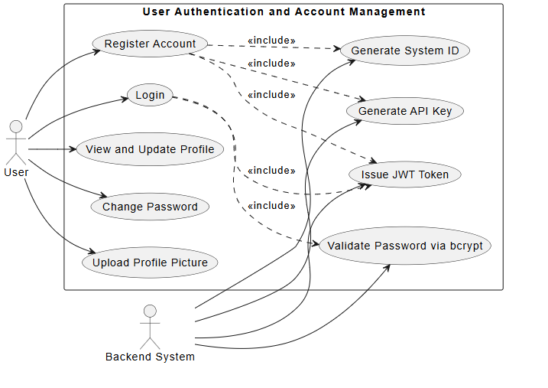

3.4.2 Use Case 2: Real-Time Metric Collection

Actors: Monitoring Agent, Host Operating System

Description: Describes how the monitoring agent collects system-level and process-level telemetry every 5 seconds.

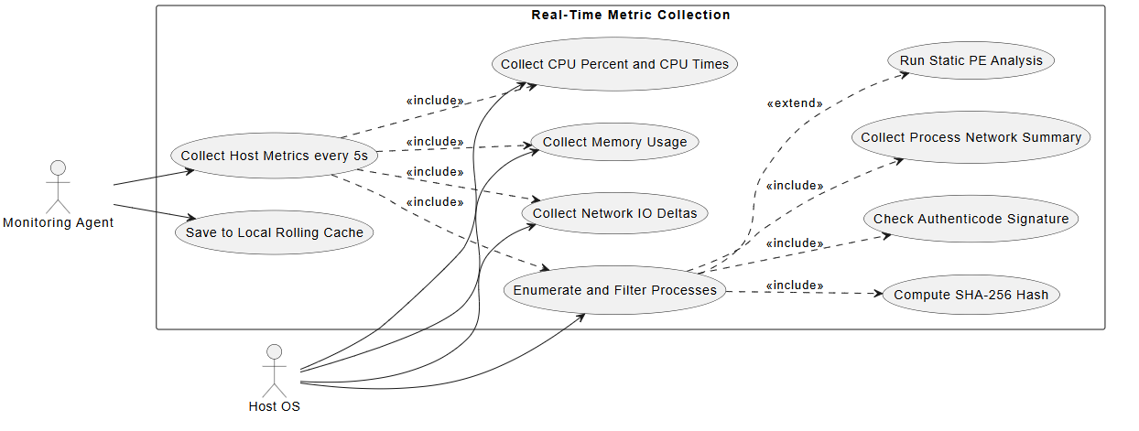

3.4.3 Use Case 3: Data Ingestion and Heartbeat

Actors: Monitoring Agent, Backend System

Description: Describes how metric batches are uploaded, persisted, and used as an implicit heartbeat for system online status.

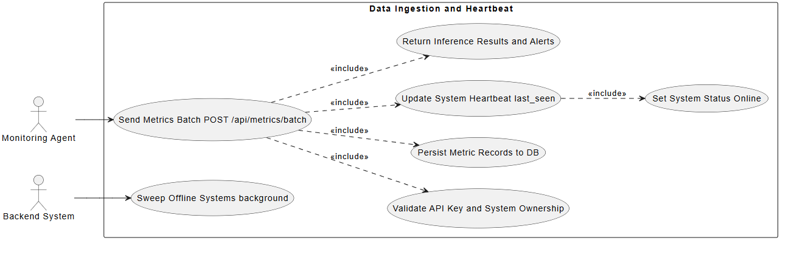

3.4.4 Use Case 4: Cryptojacking Detection

Actors: Backend System, ML Model

Description: Describes the multi-layered cryptojacking detection pipeline.

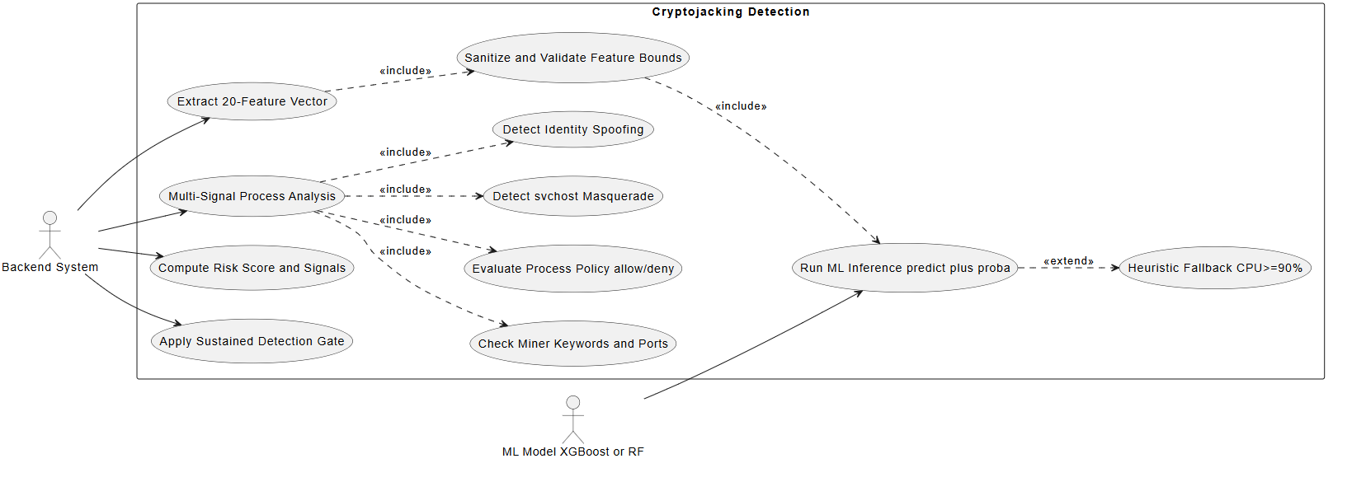

3.4.5 Use Case 5: SHAP Explainability

Actors: Backend System, User (Dashboard)

Description: Describes how feature importance is calculated to explain the ML model's decisions.

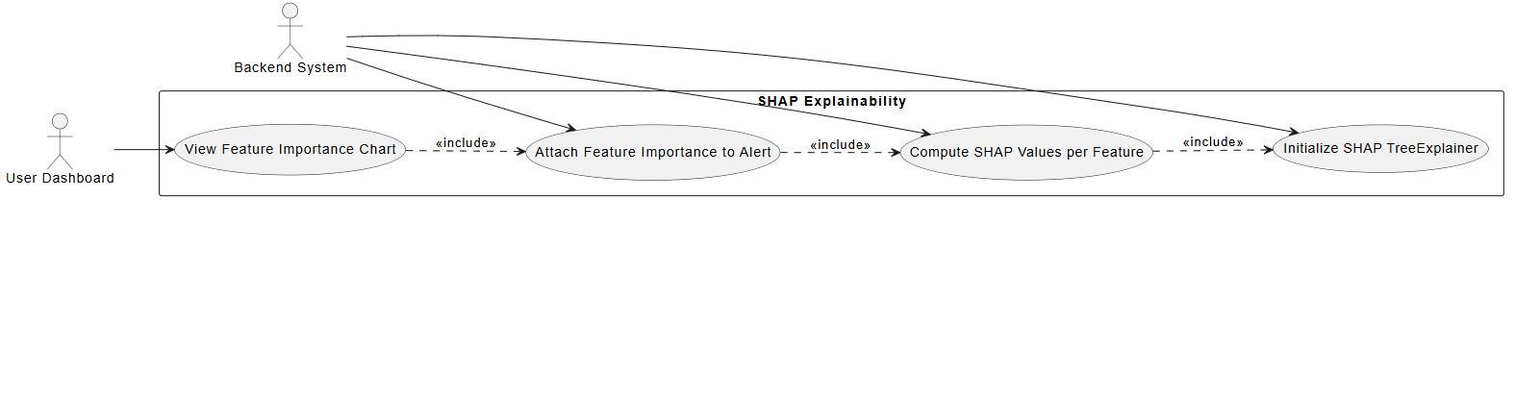

3.4.6 Use Case 6: Alerting and Multi-Channel Notifications

Actors: Backend System, User, Monitoring Agent

Description: Describes how cryptojacking alerts are generated and dispatched to the user.

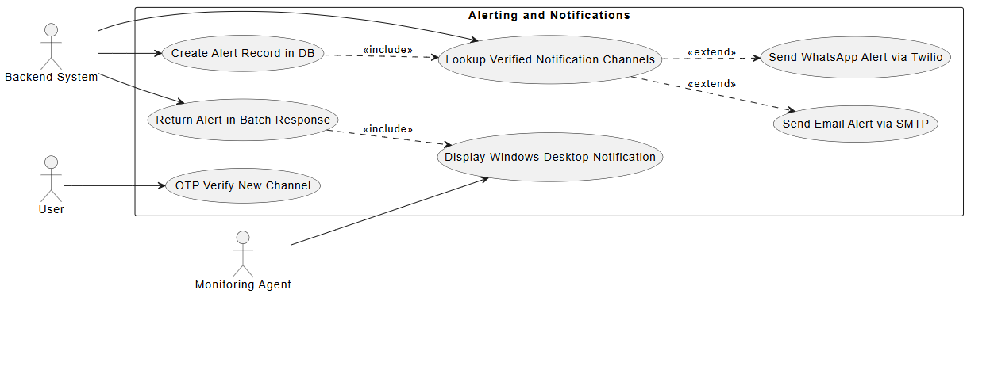

3.4.7 Use Case 7: Agent Management and Self-Update

Actors: User, Monitoring Agent, Backend System

Description: Describes the configuration and automatic binary self-updating mechanism of the agent.

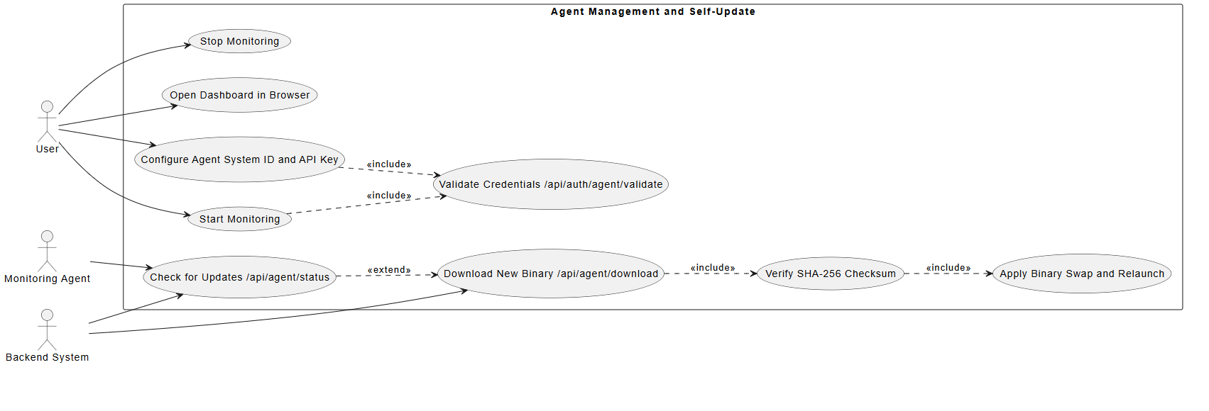

3.4.8 Use Case 8: Threat Intelligence Integration

Actors: Backend System, VirusTotal API

Description: Describes how suspicious process hashes are cross-referenced against global threat databases.

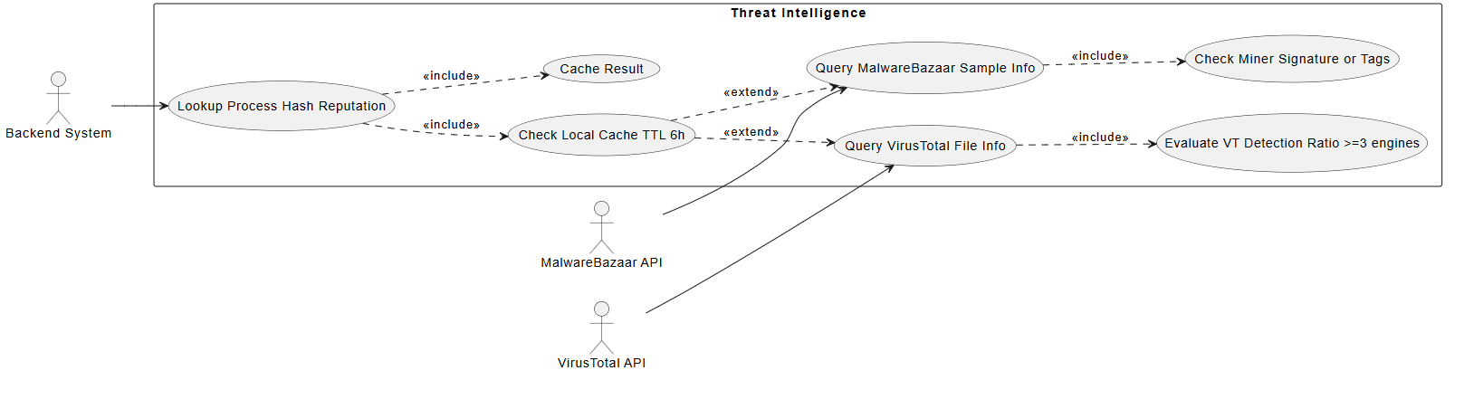

3.4.9 Use Case 9: Reporting

Actors: User, Backend System

Description: Describes how users generate and download PDF and CSV metric summaries.

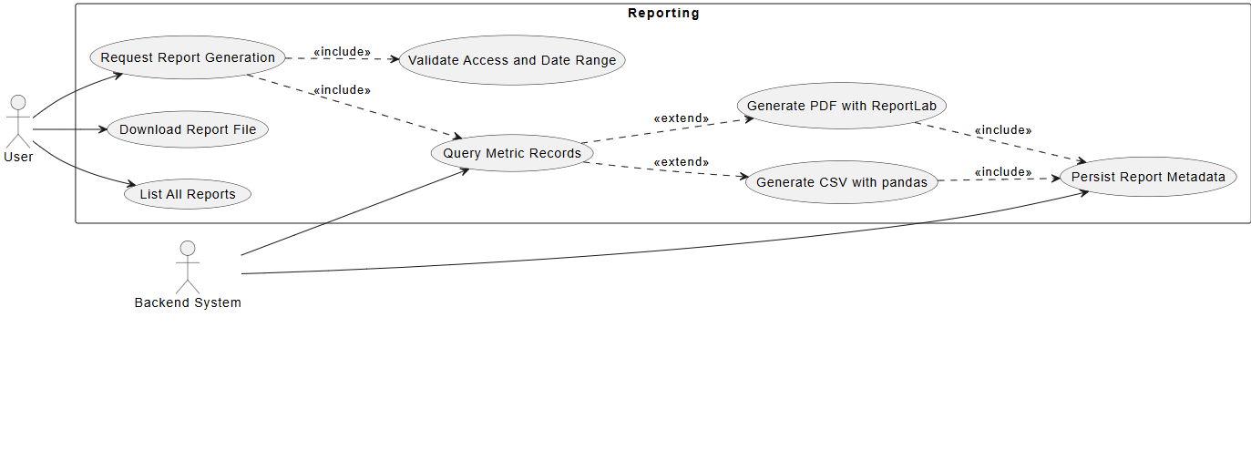

3.4.10 Use Case 10: Audit Logging

Actors: Backend System, User

Description: Describes how sensitive platform actions are securely tracked.

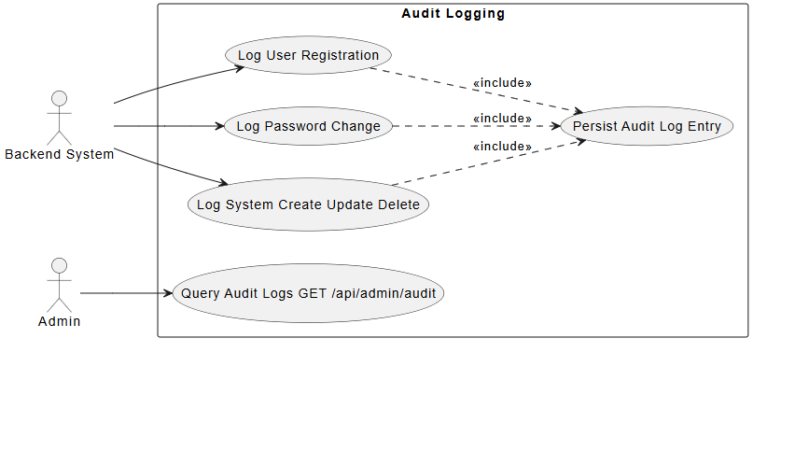

3.4.11 Use Case 11: Frontend Dashboard Visualization

Actors: User, Backend System

Description: Describes how the user interacts with real-time data and system controls.

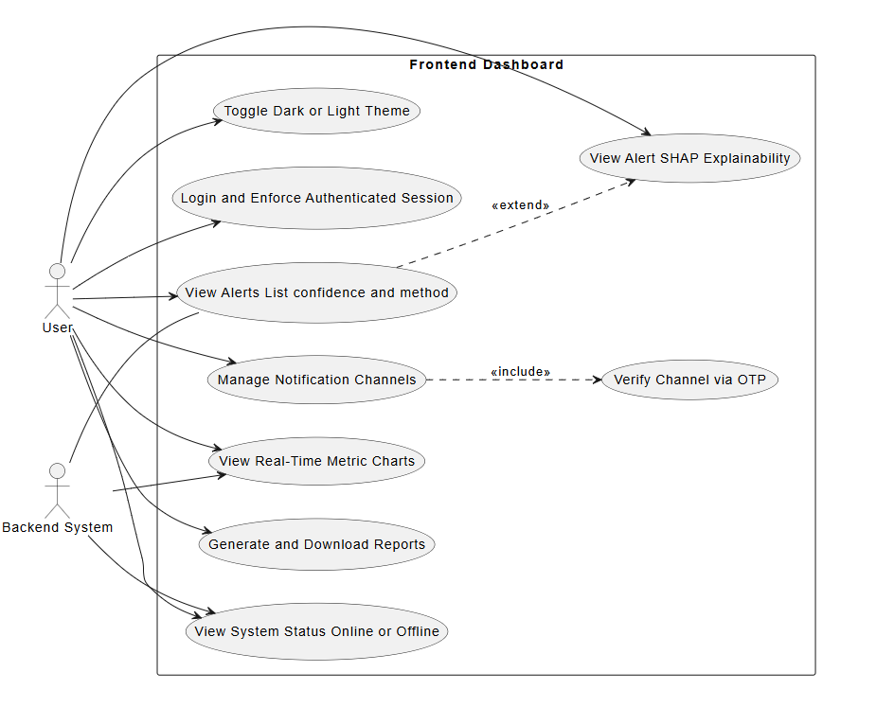

3.5 Software Development Plan

3.5.1 Development Methodology
The Agile methodology is followed. Development proceeds in six sprints, each focusing on a specific goal, allowing iterative improvement and regular feedback.

3.5.2 Phases of Development
Phase 1: Research and Requirement Analysis — Identify all cryptojacking attack vectors and related studies. Define functional and technical requirements. Select APIs (VirusTotal) and plan the data collection pipeline.
Phase 2: Data Collection and Static Analysis Module — Implement modules for fetching and parsing malware samples. Perform static analysis using tools such as YARA and PEframe. Extract basic static features and store them securely.
Phase 3: Dynamic Analysis and Sandbox Configuration — Configure sandbox (Cuckoo Sandbox) for malware execution. Collect CPU,GPU, memory, and network usage logs. Preprocess logs for feature extraction.
Phase 4: Feature Engineering and ML Model Development — Clean, normalize, and merge static and dynamic data. Train ML models (Random Forest, XGBoost) and evaluate results. Perform feature importance analysis and fine-tune hyperparameters.
Phase 5: Real-Time Monitoring and Dashboard Development — Develop a real-time system monitoring agent. Create a front-end dashboard for results visualization, alerts, and report generation. Integrate model inference with APIs.
Phase 6: Testing, Optimization, and Documentation — Conduct performance and security testing. Optimize model accuracy and reduce false positives. Document the entire project including system architecture, usage guides, and research findings.

Chapter 4: System Overview
This chapter provides a detailed explanation of the internal workings of the Cryptojacking Detection Using Machine Learning system. The platform identifies cryptojacking activity by analyzing system metrics and process behavior in real time. It consists of a FastAPI backend hosting ML models (XGBoost and Random Forest), a React-based frontend dashboard, a lightweight Windows monitoring agent, and VirusTotal API integration.

4.1 Architectural Design

4.1.1 High-Level Overview
The system follows a client-server distributed architecture consisting of four core layers:
- Frontend (React Web Application): A cyber-security-themed dashboard that provides users with live metrics (CPU,GPU, Memory, Network) and alerts. It communicates with the backend via JWT-authenticated REST API calls and periodically polls for updated alert and metric data.
- Backend (FastAPI): The central processing unit that handles all system logic. It manages user authentication, coordinates with ML models (XGBoost and Random Forest) to perform real-time inference on incoming metrics, validates suspicious process hashes against the VirusTotal API, generates cryptojacking alerts, and persists all data into the database.
- Monitoring Agent (Windows .exe): A lightweight background service running on the user's system. It collects real-time system metrics (CPU,GPU, Memory, Network I/O) every 5 seconds, filters high-resource processes (those exceeding 5% CPU or Memory), calculates SHA256 hashes of running executables, buffers data locally in a rolling JSON file, and sends batched data to the backend every 30 seconds using API Key authentication.
- Database Layer: The backend uses a structured database to store all persistent system data including registered user accounts, unique System IDs and API keys, system metrics history, generated cryptojacking alerts (with confidence scores, timestamps, and suspicious process details), and downloadable reports.
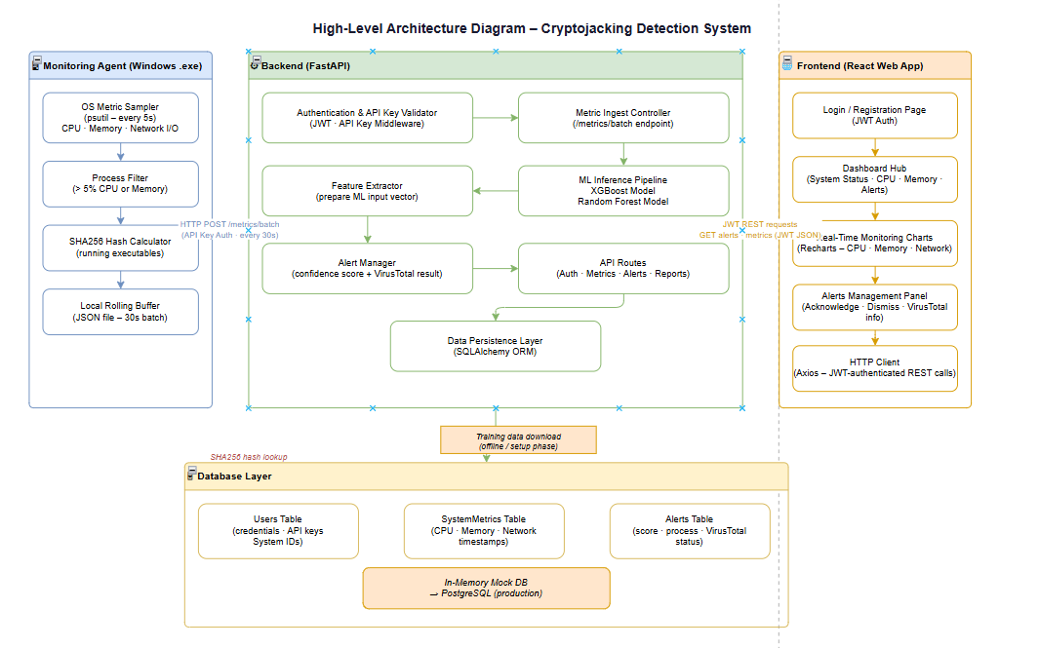
Figure 3.1 – High-Level System Architecture

4.1.2 Workflow Overview
Below is the step-by-step process followed when a user registers an account:
- User Registration: The user registers on the React web dashboard. The backend generates a unique System ID and API Key. The user is prompted to download the Windows monitoring agent.
- Agent Setup: The user installs the monitoring agent (.exe) on their Windows machine and configures it with their System ID and API Key.
- Real-Time Data Collection: The agent runs silently in the background, collecting CPU,GPU, Memory, and Network metrics every 5 seconds and identifying high-resource processes.
- Batch Transmission: Every 30 seconds, the agent sends a batch of collected metrics and process SHA256 hashes to the FastAPI backend, authenticated via the API Key.
- Backend Processing: The backend validates the API Key, queries the VirusTotal API to check process hashes for known malware, and runs the XGBoost/Random Forest ML models to detect cryptojacking patterns.
- Alert Generation & Multi-Channel Notification: If cryptojacking is detected, the system generates an alert with a confidence score and delivers it through three notification channels simultaneously: Dashboard Pop-up, Email Notification (via SMTP), and WhatsApp Notification (via Twilio WhatsApp API).
- Alert Management: The user reviews the alert on the dashboard and either Acknowledges or Dismisses it, updating its status in the database.

4.2 Data Design
This section describes how data is structured, stored, and transferred within the system.

4.2.1 Entity-Relationship Diagram (ERD)
The data structure centers around users, their monitored systems, system metrics, and triggered alerts. The key entities are:
- User: Stores user credentials, email, and a unique API Key.
- MonitoredSystem: Represents the user's registered device with properties like system ID, status, and owner.
- SystemMetrics: Logs performance data (CPU,GPU, memory, network, and processes) attached to specific timestamps.
- Alert: Generated when the ML model detects cryptojacking. Contains a confidence score, the suspected process, VirusTotal results, and alert status (Unread/Acknowledged).
- Report: Represents user-generated statistical summaries of system metrics over a defined period.
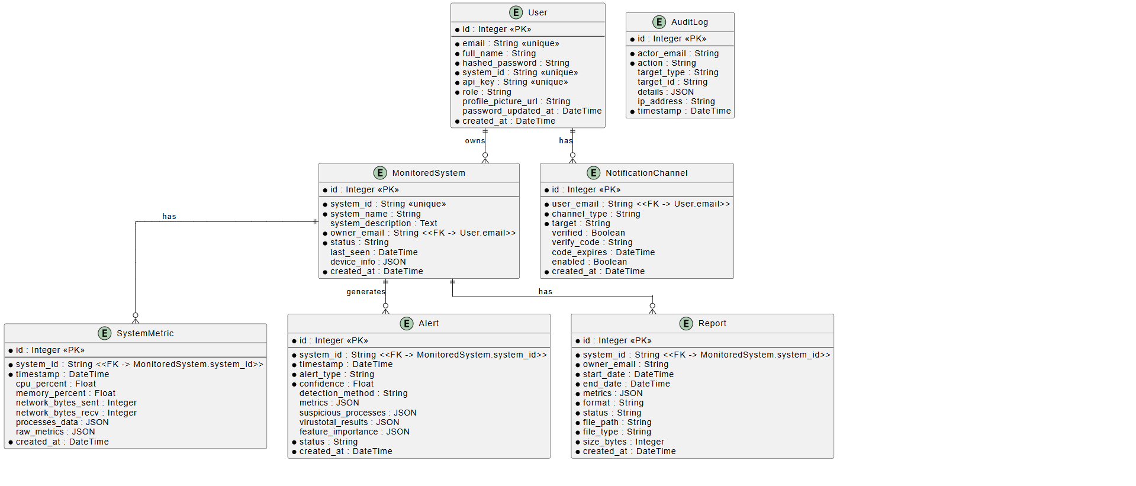
Figure 3.2 – Entity-Relationship Diagram (ERD)

4.2.2 Data Flow Diagram (DFD)
The data flow maps the journey of metrics from the user's computer to the frontend dashboard:
- The Monitoring Agent captures real-time CPU,GPU, memory, and process hashes, storing them in a local JSON rolling window.
- Every 30 seconds, a batch of these metrics is transmitted to the Backend API securely using the API Key.
- The Backend checks the hashes using the VirusTotal API to look for known threats.
- The metrics and threat data are passed to the Machine Learning pipeline (XGBoost and Random Forest) for inference.
- If cryptojacking is predicted, an Alert is saved in the database.
- The Frontend dashboard periodically fetches the data using JWT-authenticated API calls, displaying charts and triggering notifications for the user.

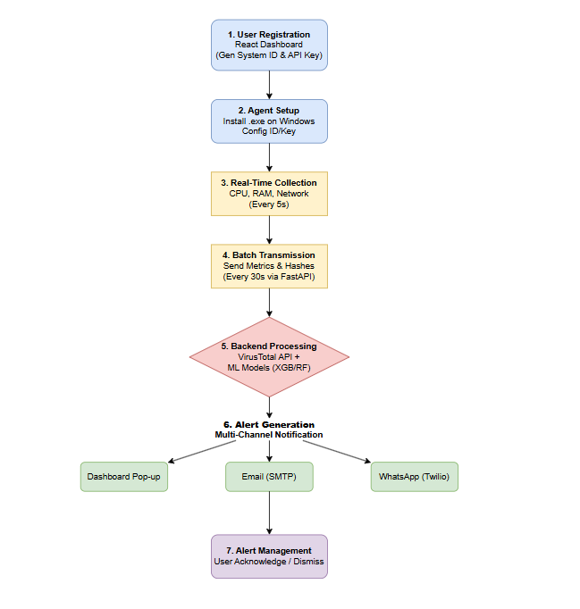
Figure 3.3 – Data Flow Diagram (DFD)

4.3 Domain Model
The domain model captures the main conceptual entities in the detection platform and their relationships. The core domain logic is composed of several main classes: User, MonitoredSystem, MetricsBatch, Metric, Process, Alert, and MLModel.
- A User owns a MonitoredSystem.
- The MonitoredSystem receives MetricsBatch objects representing collected data.
- Each Metric contains performance values and associated Process records.
- The MLModel analyzes these Metric objects. If the Process is suspicious and the model returns high confidence, an Alert is generated for the MonitoredSystem.

4.3.1 Class Diagram
A Class Diagram is a static structure diagram used in object-oriented design to represent the system's blueprint. It shows classes with their attributes, methods, and relationships including inheritance, aggregation, and composition.
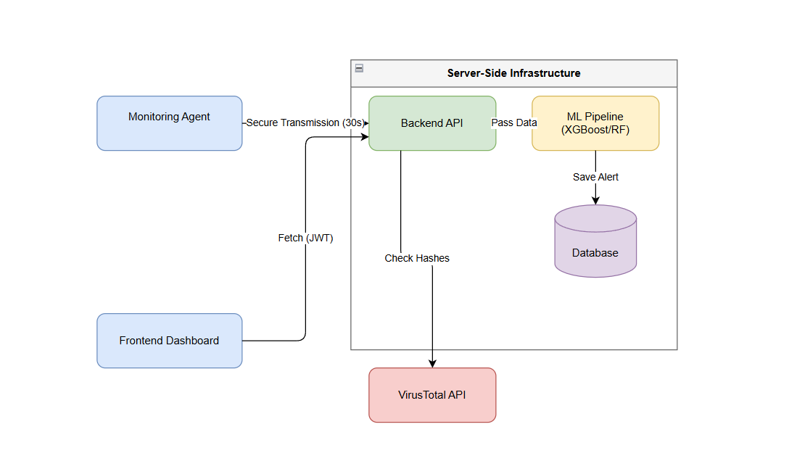
Figure 3.4 – Class Diagram

4.4 Design Models

4.4.1 Activity Diagram
The primary activity involves the alert generation process: the backend receives a batch of metrics from the agent, the API key is verified, processes consuming over 5% CPU or Memory are filtered out, their SHA256 hashes are verified via VirusTotal, a feature vector is prepared and passed to the XGBoost ML Model, the model returns a confidence score, and if cryptojacking is detected, the alert is saved to the database.
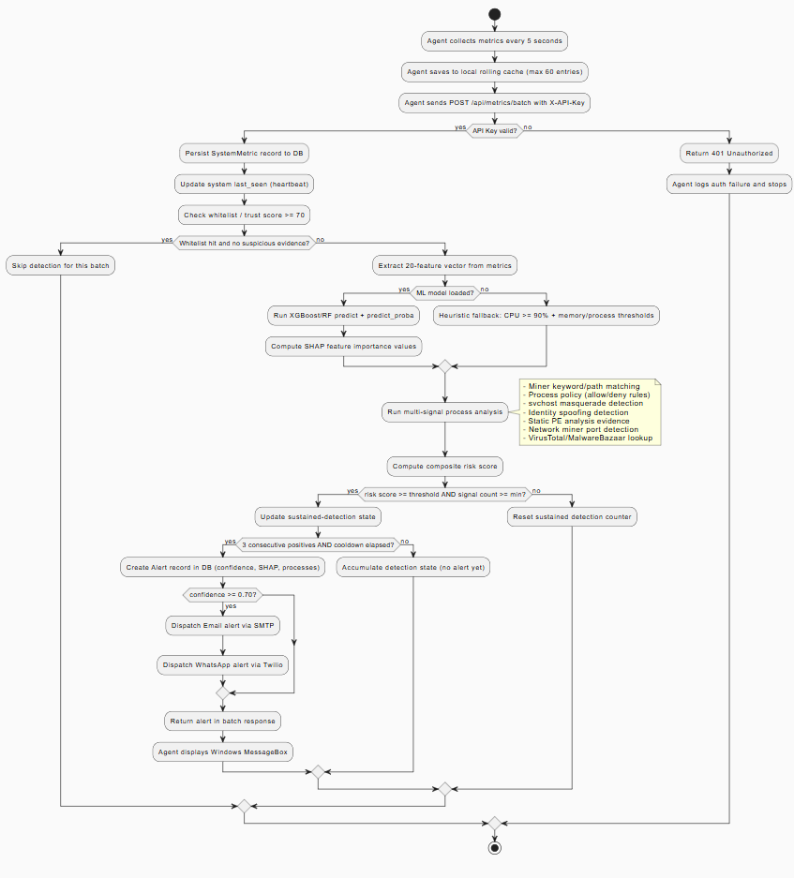
Figure 3.5 – Activity Diagram

4.4.2 State Transition Diagram
The system tracks the condition of a monitored endpoint using the following states:
- Offline: The system is registered but the agent is not sending data, or the connection has timed out (over 5 minutes).
- Online: The agent is actively transmitting metric batches every 30 seconds.
- Detecting: A transitional state where high resource consumption triggers active ML inference.
- Alerted: Cryptojacking is confirmed. The system remains in this state until the user intervenes.
- Acknowledged: The user has reviewed the alert via the dashboard, returning the system to normal monitoring (Online).
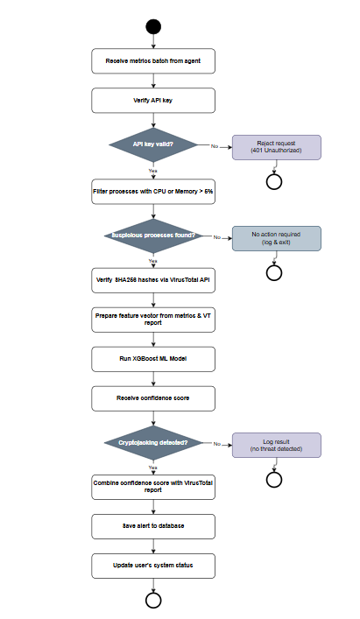
Figure 3.6 – State Transition Diagram

4.4.3 Sequence Diagram

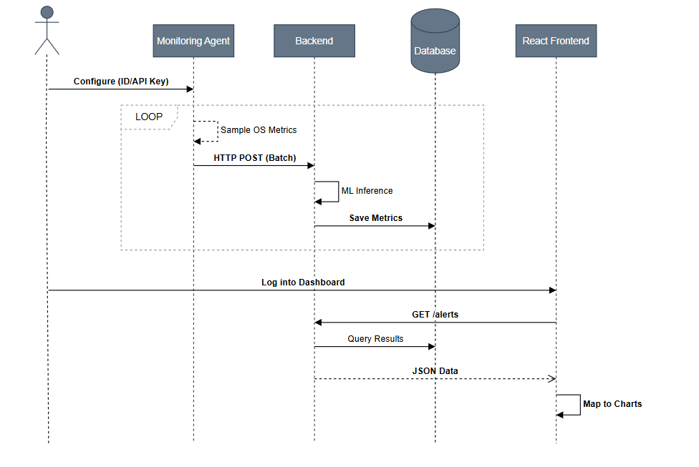
Figure 3.7 – Sequence Diagram

4.4.4 Component Diagram

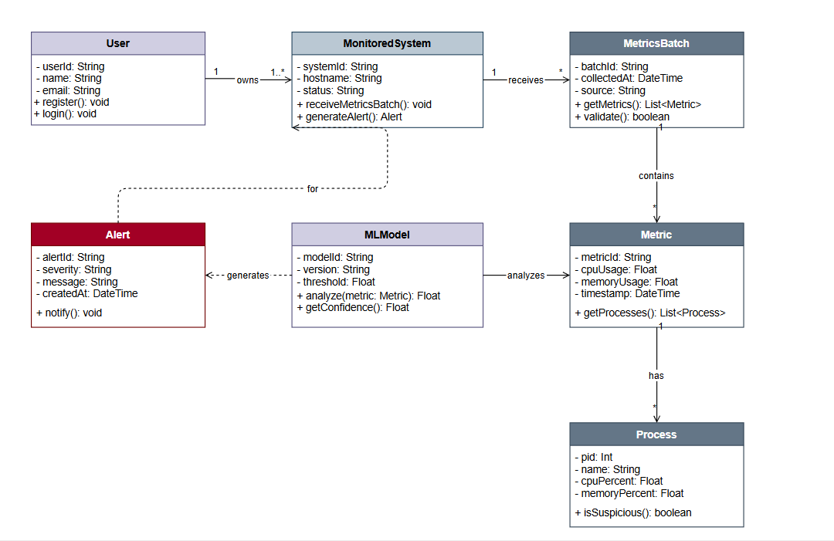
Figure 3.8 – Component Diagram

4.4.5 System Architecture
The overarching system architecture implements a lightweight-edge and heavy-cloud strategy. By shifting the intensive machine learning inference and hash verification entirely to the centralized FastAPI backend, the Windows monitoring agent maintains a negligible footprint (less than 2% CPU and less than 50MB RAM). This design allows the backend to scale independently, manage multiple endpoints efficiently, and seamlessly serve data to the React frontend in real time via RESTful APIs.
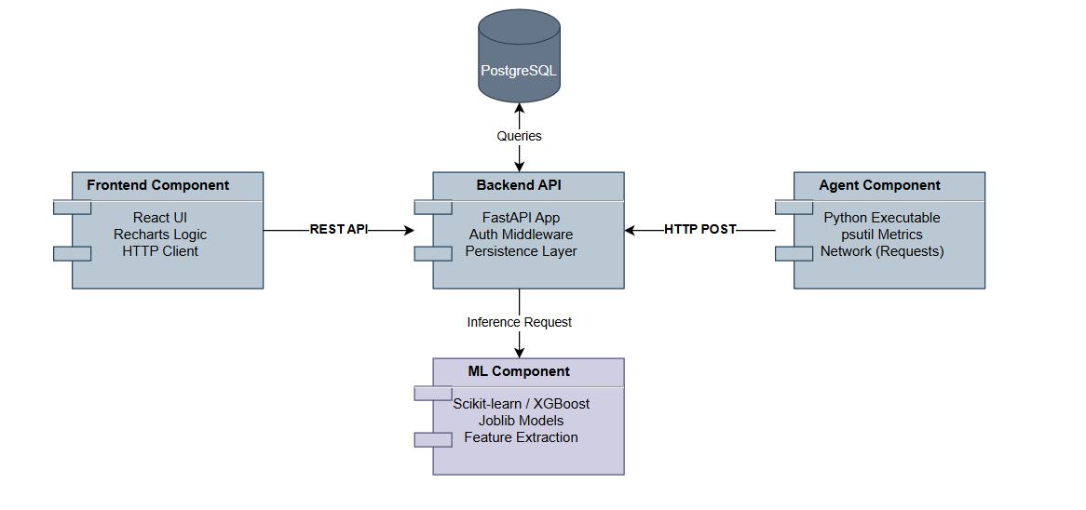
Figure 3.9 – System Architecture Diagram

4.5 Mockups
The user interface embraces a modern, cyber-security aesthetic featuring a dark background with neon green accents. Key screens include:
Authentication Pages: Clean login and registration forms. Registration presents the user with a unique System ID and a one-time API key required for the agent.
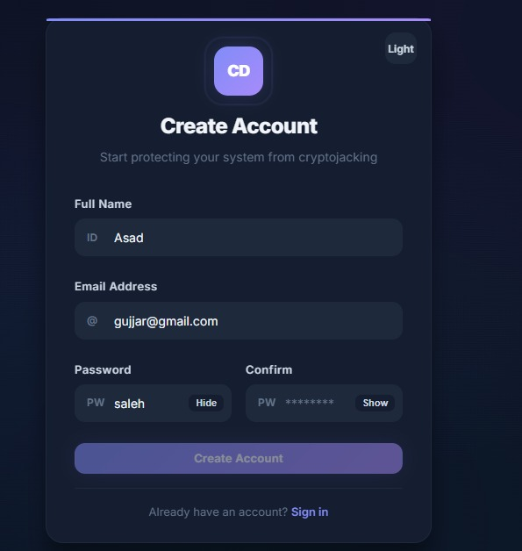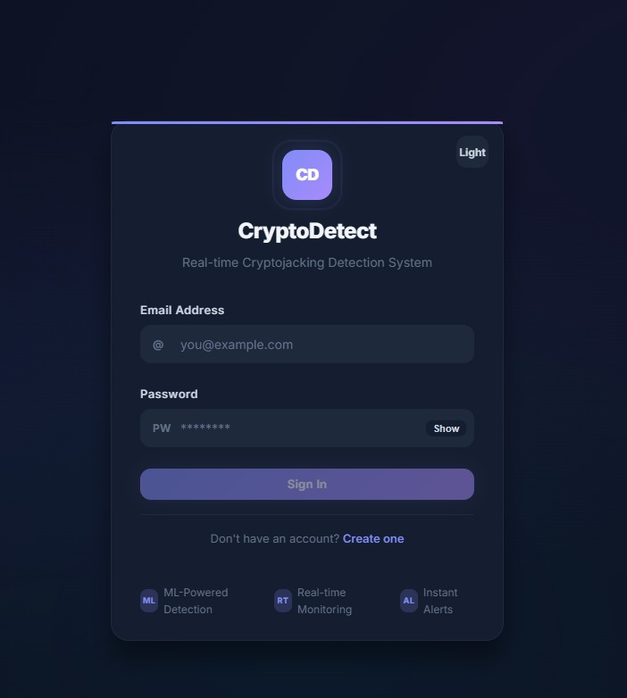
Dashboard Hub: A hero section displaying the overall system status (Online/Offline), current CPU/Memory load, and a counter of unread alerts.

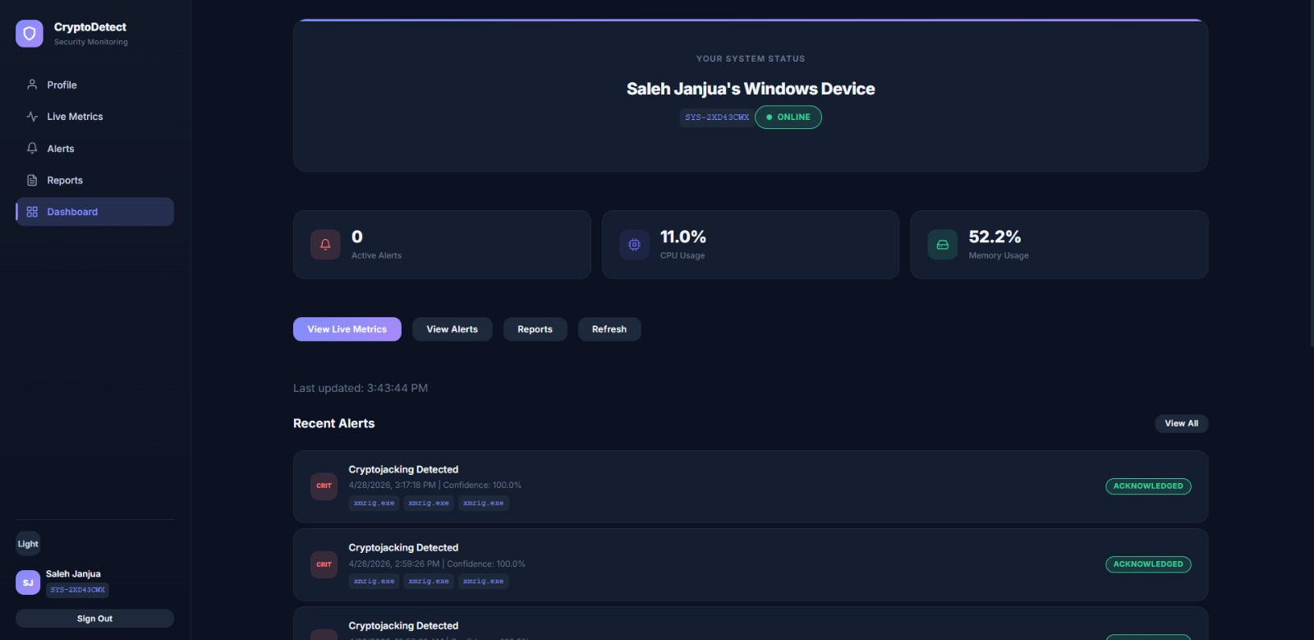

Monitoring Charts: Live updating charts showing real-time trends for CPU,GPU usage, memory consumption, and network traffic.

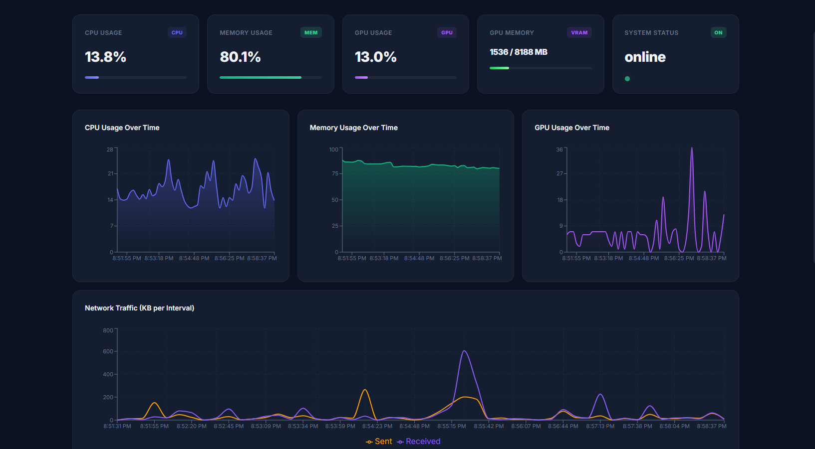
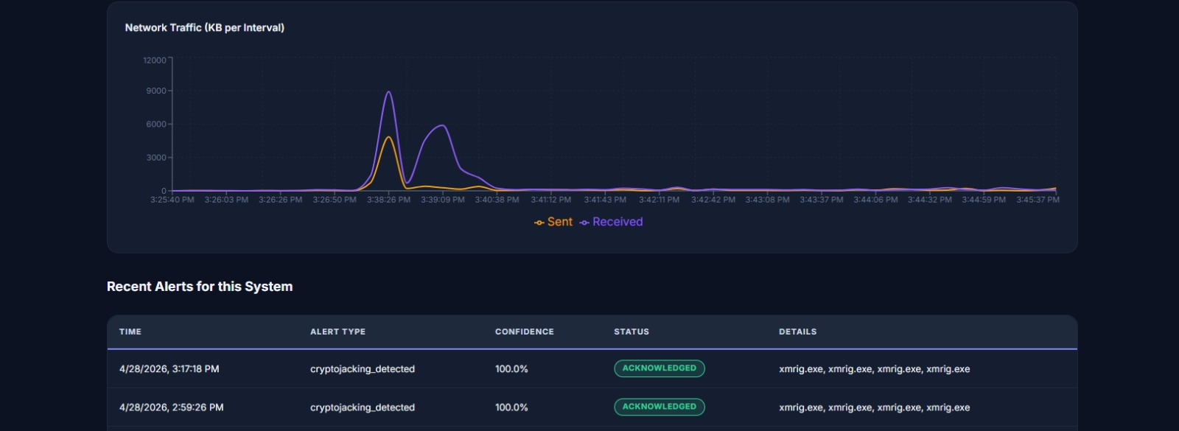

Alerts Table: A comprehensive data grid listing all generated alerts, complete with timestamps, ML confidence percentages, flagged processes, and VirusTotal threat detection ratios.

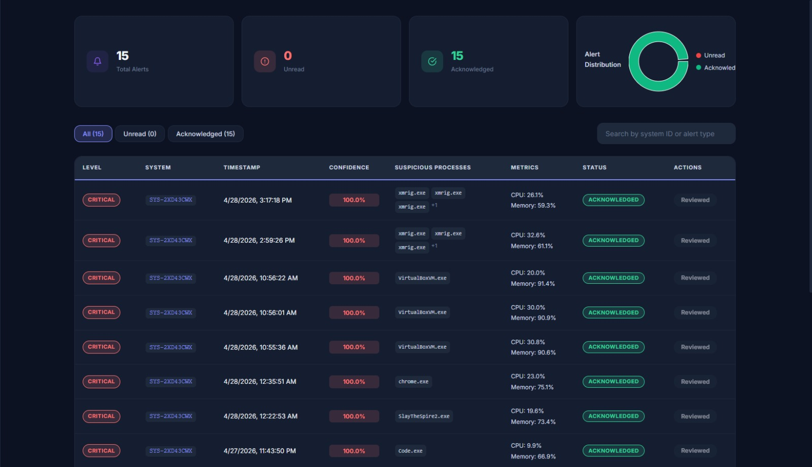

Agent GUI: A Graphical User interface for the Windows executable, displaying real-time metric sampling, batch upload success messages, and immediate local warnings if cryptojacking is detected.
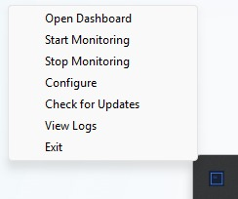

4.6 Methodology / Proposed System and System Workflow

4.6.1 Overview of the Proposed System

The proposed CryptoDetect system employs a distributed, three-tier architecture designed to monitor, detect, and report cryptojacking malware in near real-time. The system relies on a hybrid detection approach, combining host-based behavioral telemetry, static Portable Executable (PE) inspection, and Machine Learning (ML) inference. The methodology is structured around five primary operational phases that function sequentially as a cohesive pipeline.

4.6.2 Phase 1: Real-Time Data Collection and Endpoint Monitoring

The workflow originates at the user's endpoint via the CryptoDetect Monitoring Agent v7.0, a lightweight standalone Windows executable.

- Continuous Sampling: The agent wakes every 5 seconds to collect high-resolution host metrics, including overall CPU/Memory usage, CPU times (user, system, idle), and network I/O deltas.

- Process Profiling: It filters processes consuming more than 4% CPU or memory. For these suspicious processes, it extracts metadata (PID, executable path, SHA-256 hash, parent process) and verifies Authenticode digital signatures.

- Deep Inspection: The agent performs static PE analysis (detecting mining keywords, checking entropy) and analyzes per-process network states (identifying connections to known mining ports like 3333 or 4444).

- Resilience: The data is temporarily stored in a local Base64-encoded rolling cache to prevent data loss during network outages before being batched.

4.6.3 Phase 2: Secure Data Ingestion and Preprocessing

The batched telemetry is securely transmitted to the FastAPI Central Backend.

- Authentication: The backend intercepts the POST request and validates the agent's credentials using the X-API-Key header.
- Heartbeat & Storage: Upon successful validation, the system updates the endpoint's last_seen timestamp (establishing an online heartbeat) and persists the raw metric payload into the database.

- Feature Extraction: A dedicated data pipeline parses the raw JSON telemetry, extracting and normalizing a precisely engineered 20-feature vector that strictly aligns with the structure of the Kaggle cryptojacking dataset used during model training.

4.6.4 Phase 3: Machine Learning Inference and Multi-Signal Analysis

Once the feature vector is prepared, the system evaluates it through a multi-layered detection engine:

- ML Inference: The primary XGBoost classifier (and Random Forest fallback) evaluates the 20-feature vector, calculating a probability confidence score indicating the likelihood of cryptojacking activity.

- Heuristic Fallback & Process Policy: Simultaneously, the system evaluates heuristic rules (e.g., total CPU ≥ 90%), cross-references process names against allow/deny policies, and checks for identity spoofing (e.g., malware masquerading as legitimate Windows svchost.exe).

- Threat Intelligence: If a suspicious process hash is novel, the backend queries the VirusTotal and MalwareBazaar APIs to check for known malware signatures, caching the result for 6 hours to optimize performance.

4.6.5 Phase 4: Explainability and Alert Generation
To prevent alert fatigue and provide actionable intelligence, the system applies rigorous filtering before finalizing an alert:

- Sustained-Detection Gate: An alert is only triggered if the system registers 3 consecutive positive ML detections. It enforces a 300-second cooldown between subsequent alerts for the same endpoint to prevent notification spam.

- SHAP Integration: Upon confirming a threat (Confidence ≥ 0.70), the backend initializes a SHAP (SHapley Additive exPlanations) TreeExplainer. This calculates the exact mathematical contribution of each feature (e.g., "High CPU usage contributed 40%, Miner Port detected contributed 35%") to the ML model's decision, attaching this explanation directly to the alert record.

4.6.6 Phase 5: Multi-Channel Notification and Visualization

The final phase focuses on notifying the end-user securely and intuitively:

- Alert Dispatch: The backend routes the alert through the user's OTP-verified notification channels, triggering real-time Email alerts (via SMTP) and WhatsApp messages (via Twilio).
- Agent Feedback: The backend attaches the alert flag to the HTTP batch response, prompting the local Windows agent to instantly display a desktop MessageBox warning to the user.

- Dashboard Visualization: The React-based web frontend dynamically updates. The user can log in via secure JWT authentication to view real-time Recharts performance graphs, analyze the SHAP feature importance breakdowns, and generate PDF/CSV forensic reports.

4.6.7 End-to-End System Workflow Summary

- Agent gathers host metrics, process metadata, and PE characteristics every 5 seconds.

- Agent transmits batched data to the backend via a secure, API-Key authenticated HTTP POST.

- Backend ingests the data, updates the system heartbeat, and extracts a 20-feature vector.

- Backend ML Engine classifies the vector using trained XGBoost/RF models, augmented by external Threat Intelligence APIs and internal heuristic rules.

- If the activity is positive over 3 consecutive batches, the Backend computes SHAP explainability values and creates a formal Alert Record.

- Backend dispatches alerts via Email/WhatsApp and signals the Agent to display a local Windows warning.

- Frontend Dashboard visualizes the attack details, SHAP charts, and real-time system status for forensic review by the user.

Chapter 5: System Implementation
This chapter details the practical realization of the Cryptojacking Detection System, outlining the tools, frameworks, and methodologies used to build, train, and deploy the application. It covers everything from the initial development environment setup to the deployment of the machine learning models.

5.1 Technology Stack (Languages, Frameworks, Tools)
The system was developed utilizing a modern, high-performance technology stack carefully selected for machine learning integration and real-time processing:
- Programming Languages: Python 3.10+ (for backend, machine learning, and the monitoring agent) and JavaScript/TypeScript (for the frontend dashboard).
- Backend Framework: FastAPI, chosen for its speed, asynchronous capabilities, and seamless integration with Python-based ML libraries.
- Frontend Framework: React 19, utilizing React Router for navigation, Recharts for live data visualization, and Vanilla CSS for a custom cyber-security theme.
- Machine Learning: scikit-learn and xgboost for feature extraction and model training. joblib was used for model serialization and persistence.
- System Monitoring: psutil was utilized to capture granular, real-time operating system metrics (CPU,GPU, Memory, Network).
- Packaging Tools: PyInstaller was used to compile the Python monitoring script into a standalone Windows .exe file.

5.2 Development Environment Setup
- Version Control: Git was utilized to manage project source code and track iterative changes.
- Python Virtual Environment: A. venv environment was initialized to isolate dependencies. Required libraries (e.g., fastapi, uvicorn, psutil, xgboost, python-jose, passlib) were installed via a requirements.txt file.
- Frontend Setup: The React application was initialized using Create React App, and necessary npm packages (axios, recharts, react-router-dom) were installed.
- Environment Variables: Sensitive configurations, including JWT secret keys and external API keys, were securely stored in local .env files.

5.3 System Modules and Components
The implementation is divided into four highly cohesive modules:
- Data Collection & Feature Engineering Module: Python scripts (pe_analyzer.py, feature_builder.py) responsible for analyzing PE files, extracting strings, calculating entropy, and formatting the raw data into structured feature vectors.
- Machine Learning Module: Scripts (random_forest_model.py, xgboost_model.py) that handle data splitting, hyperparameter tuning, model training, and evaluation.
- Monitoring Agent Module: A background Windows daemon (agent.py) that continuously monitors CPU,GPU, Memory, Network I/O, calculates SHA256 hashes of running processes, and posts batches of metrics securely to the backend.
- Web Module (Backend & Frontend): The FastAPI server handling RESTful API requests, JWT authentication, and ML inference, paired with the React dashboard for user-facing data visualization and alert management.

5.4 Database Implementation
For rapid prototyping and high-speed data ingestion, the current iteration utilizes a structured Mock In-Memory Database, with an architectural pathway established for future PostgreSQL migration via SQLAlchemy.
- Data Models: Defined explicitly for User, MonitoredSystem, SystemMetrics, and Alert.
- Local Agent Storage: The monitoring agent utilizes local JSON storage to buffer system metrics in a 5-minute rolling window, ensuring data is not lost if the network temporarily disconnects.
- Backend Storage: The backend maintains active user sessions, API keys, and logs generated cryptojacking alerts (including confidence scores and timestamps) in memory for immediate retrieval by the frontend.

5.5 APIs and External Integrations
- Internal REST API: The FastAPI backend exposes secure endpoints (e.g., /api/metrics/batch, /api/alerts, /api/auth). Agent requests are authenticated via unique System API Keys, while dashboard requests use JWT bearer tokens.
- VirusTotal API: Integrated directly into the backend via virustotal_client.py. When the backend receives a batch of process hashes from the agent, it queries VirusTotal to cross-reference them against known malware signatures, adding an extra layer of threat intelligence.
- MalwareBazaar API: Utilized strictly during the data collection phase to automate the downloading of real-world cryptojacking samples for model training.

5.6 Dataset Selection and Preprocessing
- Data Collection: A balanced dataset of cryptojacking malware and benign executables was programmatically downloaded using the VirusTotal API.
- Feature Extraction: Scripts parsed the Windows PE headers to extract features such as section counts, suspicious API calls, embedded URLs, and cryptocurrency wallet address patterns.
- Preprocessing: The dataset underwent rigorous cleaning. Missing values were handled appropriately, and feature scaling (StandardScaler) was applied to normalize the data. The final dataset was split into 70% training, 15% validation, and 15% testing subsets.

5.7 Model Selection and Training
- Random Forest Classifier: Used as the baseline model. It was trained using a combination of static and dynamic features, with hyperparameter tuning performed via GridSearchCV (optimizing n_estimators and max_depth).
- XGBoost Classifier: Chosen for its gradient boosting capabilities, making it highly effective at identifying complex, non-linear relationships in system behavior. Training involved handling class imbalances using the scale_pos_weight parameter to ensure accurate detection of minority malware classes.

5.8 Model Evaluation
- Metrics Tracked: Accuracy, Precision, Recall, F1-Score, and ROC-AUC.
- Validation: Confusion matrices were generated to monitor the exact number of false positives and false negatives.
- Performance Goals: The system successfully met the target of greater than 90% overall accuracy, maintaining a recall rate of greater than 85%, ensuring that the system minimizes false negatives (undetected cryptojacking attempts).

5.9 Model Deployment
- Serialization: The best-performing Random Forest and XGBoost models were serialized into .pkl files using the joblib library.
- Backend Integration: Upon startup, the FastAPI server loads the .pkl files directly into system memory.
- Real-Time Inference: When the backend receives live telemetry data from the Monitoring Agent, it instantly transforms the JSON payload into a NumPy feature array and passes it into the model's predict () pipeline. The inference process completes in under 1 second.
- Agent Distribution: The Python-based monitoring agent was compiled into a standalone Windows executable (.exe) using PyInstaller, allowing end-users to install and run the agent without needing a local Python environment.

Chapter 6: System Testing & Deployment
This chapter outlines the comprehensive testing methodologies applied to validate the Cryptojacking Detection System's reliability, accuracy, and efficiency. It also details the deployment strategies used to transition the application from a local development environment into a fully operational production state.

6.1 Testing Approach (Manual, Automated)

The system utilized a hybrid testing approach combining both manual and automated methodologies:

- Automated Testing: Employed extensively for backend REST API validation, mathematical verification of the ML models, and automated UI component rendering tests.

- Manual Testing: Conducted for edge-case scenarios, such as intentionally disconnecting the monitoring agent's network to test offline JSON data buffering (rolling cache) and visually verifying the React dashboard's real-time chart responsiveness.

6.2 Unit Testing

- Machine Learning: Functions responsible for feature extraction (e.g., calculating entropy, process network summaries, or processing psutil data arrays) were isolated and tested to ensure mathematical correctness.

- Backend (FastAPI): Automated tests were written to validate standalone utility functions, such as the JWT token generation/validation scripts, password hashing algorithms (bcrypt), and SHAP explainability calculations.

- Frontend (React): Component-level testing was executed to verify isolated UI elements, such as the Recharts visualizations and Alert Modals, rendered correctly based on mock JSON props.

6.3 Integration Testing

- Agent to Backend: Tests simulated the Windows monitoring agent sending POST requests containing mocked system metrics to the /api/metrics/batch endpoint. Responses were checked for accurate ML inference triggers and proper HTTP status codes.

- Backend to External APIs: The Threat Intelligence integration was tested to ensure the FastAPI server successfully handled rate limits, timeouts, and correct parsing of JSON threat reports from the VirusTotal APIs.

- Database Integration: Validated that when the ML pipeline flagged a process as cryptojacking, the system correctly persisted the alert record into the database, associating it with the correct System ID and SHAP feature importance values.

6.4 System Testing

- Normal Operation Simulation: Verified that the agent successfully sampled system metrics every 5 seconds, and that the dashboard accurately reflected the live CPU,GPU and memory charts in a "Healthy" (Green) status.

- Threat Detection Simulation: Safe cryptojacking samples (and CPU/GPU stress-test scripts) were executed on the host. The system was monitored to ensure the agent captured the high resource spikes, the XGBoost model accurately returned a high confidence score, and the React dashboard immediately illuminated a "Red" alert.

- Security Testing: Endpoints were subjected to authentication bypass tests to ensure JWT barriers functioned correctly. API Inputs were sanitized to prevent injection attacks and Cross-Site Scripting (XSS).

6.5 User Acceptance Testing (UAT)

- Agent Installation: Users were tasked with downloading the standalone Windows .exe agent and configuring it using the API key generated from their dashboard. The process was evaluated for clarity and ease of use.

- Dashboard Navigation: Users interacted with the React dashboard to filter alerts, review SHAP charts, manage Email/WhatsApp notification channels via OTP, and navigate the real-time monitoring charts, confirming that the cyber-security-themed UI was intuitive and accessible.

6.6 Performance Testing

- Agent Footprint: The Windows monitoring agent was tested over a continuous 24-hour period to ensure it maintained a negligible resource footprint (successfully staying under 2% CPU utilization and 50MB RAM allocation).

- Model Inference: The XGBoost and Random Forest. pkl models were benchmarked to ensure feature extraction and prediction times remained under 1 second to facilitate instant alerting.

- API and UI Load Time: The FastAPI backend was tested to handle concurrent agent connections, maintaining API response times under 500ms. The React dashboard load time was optimized to under 3 seconds.

6.7 Deployment Strategy

- Edge Deployment (Monitoring Agent): The Python-based data collection scripts were compiled using PyInstaller into a standalone Windows executable (CryptoDetect Agent v7.0). This allowed the agent to be deployed rapidly on end-user machines without requiring local Python environments or dependencies.

- Cloud/Server Deployment (Backend & Frontend): The FastAPI backend and React frontend were designed for centralized hosting, allowing a single server to handle ML inference, threat intel queries, and UI rendering for multiple distributed endpoints simultaneously.

6.8 Hosting & Deployment Environment

- Backend Server: The FastAPI application is served using Uvicorn (an ASGI web server implementation for Python), running efficiently on port 8000. The server hosts the REST API endpoints, Swagger UI documentation, and the loaded ML models in-memory.

- Frontend Server: The React application is hosted securely via Node.js, communicating via CORS with the FastAPI backend to stream live metric updates.

- Database: The deployment environment currently utilizes a lightweight SQLite database mapped via SQLAlchemy ORM for rapid metric processing, architected for an eventual production swap to PostgreSQL.

6.9 Version Control and CI/CD Pipelines

- Version Control: Git was used exclusively throughout the development of a lifecycle. The project was structured cohesively in a centralized repository with distinct directories for /backend, /frontend, /monitoring_agent, and /ml_models.

- Environment Parity: The deployment environment is maintained using strict requirements.txt files for Python and package.json for Node.js dependencies, ensuring exact replication of the working environment across different hosting providers.

Chapter 7: Results and Discussion
This chapter presents the outcomes of the Cryptojacking Detection System. It evaluates the system's overall performance, analyzes how well the final product aligns with the initial project goals, discusses user feedback, and highlights the technical challenges encountered during development.
7.1 Evaluation and Results
The overall evaluation of the system yielded highly positive results. The integration of a lightweight Windows monitoring agent with a centralized FastAPI backend successfully created a real-time detection environment. By relying on XGBoost and Random Forest models trained on system behavioral metrics and static features, the system successfully identified cryptojacking processes with high accuracy, while maintaining a negligible footprint on the host machine.
7.1.1 Comparison with Initial Objectives
- Objective 1 (Dataset Collection): Successfully Achieved. Custom Python scripts successfully integrated with the VirusTotal APIs to automate the collection of a diverse dataset containing both benign executables and known cryptojacking malware.
- Objective 2 (ML-Based Detection System): Successfully Achieved. The system successfully extracts system behaviors (CPU/Memory patterns) and code structures (PE headers). The implementation of Random Forest and XGBoost classifiers proved highly effective at distinguishing unauthorized mining scripts from normal high-resource applications.
- Objective 3 (User-Friendly Interface and Alerting): Successfully Achieved. The project successfully deployed a standalone Windows monitoring agent that works seamlessly in the background. The accompanying React-based web dashboard provides users with interactive, real-time visualizations (Recharts) of their system metrics and instantly displays threat alerts.
7.1.2 User Feedback and Usability Testing
- Agent Installation: Users reported that deploying the system was straightforward. Compiling the Python agent into a standalone .exe using PyInstaller allowed users to run the monitor without needing to install Python or understand command-line execution. Entering the unique System ID and API Key (generated upon web registration) was found to be a simple, secure onboarding process.
- Dashboard Interface: The React dashboard received positive feedback for its modern, cyber-security-themed aesthetic (dark background with neon green accents). Users found the real-time area charts for CPU and Memory intuitive. The Alert Management panel was praised for clearly displaying the ML confidence score alongside VirusTotal threat reports, making it easy for users to decide whether to acknowledge or dismiss a warning.
7.1.3 Performance Evaluation
- Machine Learning Accuracy: The models achieved the target accuracy of greater than 90%. The recall rate remained greater than 85% and precision greater than 88%, successfully minimizing both false positive and false negatives.
- Inference Speed: By shifting the computational weight to the FastAPI backend, the time taken to parse a metrics batch, query VirusTotal, and run the XGBoost predict() pipeline averaged under 1 second.
- Agent Resource Footprint: During a 24-hour continuous execution test, the Windows monitoring agent successfully remained under 2% CPU utilization and consumed less than 50MB of RAM, proving its viability as an invisible background service.
- API Response: The FastAPI endpoints handled concurrent requests efficiently, maintaining response times well under the 500ms target limit.
7.1.4 Challenges and Limitations
- Computational Constraints and Sandbox Removal: Initially, the project aimed to include heavy dynamic analysis using Cuckoo Sandbox and Convolutional Neural Networks (CNNs) for heatmap visual analysis. However, running sandbox environments and training data-heavy CNNs proved too computationally expensive for real-time inference. The system was successfully pivoted to use lightweight, highly efficient models (XGBoost/Random Forest) analyzing real-time OS metrics, which proved to be a much more practical solution.
- Dataset Scarcity: Finding up-to-date, highly specific host-based cryptojacking malware datasets was difficult. The system had to rely heavily on live behavioral metrics (like CPU variance and network I/O) rather than purely static binary signatures, as modern malware frequently obfuscates its code.
- Platform Limitation: Currently, the monitoring agent is compiled specifically as a Windows executable (.exe). Expanding the detection capabilities to Linux or macOS environments would require recompiling the agent and accounting for different OS-level performance APIs.

Chapter 8: Conclusion and Future Work
8.1 Conclusion
The primary goal of this project was to address the growing threat of unauthorized cryptocurrency mining by developing an intelligent, real-time detection system. This objective was successfully met through the design and implementation of a distributed, machine learning-driven architecture.
By shifting the heavy computational requirements of threat analysis to a centralized FastAPI backend, the project successfully deployed a lightweight, highly efficient Windows monitoring agent. This agent proved capable of continuously tracking critical system behaviors such as CPU spikes, memory usage, and suspicious process hashes without degrading host performance.
The integration of powerful machine learning classifiers, specifically XGBoost and Random Forest, combined with real-time threat intelligence from the VirusTotal API, allowed the system to accurately distinguish between legitimate high-resource applications and malicious cryptojacking scripts. Furthermore, the development of a React-based web dashboard provided an intuitive, cyber-security-themed interface for users to monitor their systems and manage threat alerts effortlessly. Despite early computational constraints that required pivoting away from heavy dynamic sandbox environments, the final heuristic and ML-based approach proved to be a highly effective, market-ready prototype for endpoint security.
8.2 Future Enhancements
- Cross-Platform Agent Support: Currently, the monitoring agent is compiled exclusively as a Windows executable (.exe). Future development should focus on building macOS and Linux variants of the agent, ensuring comprehensive endpoint protection across diverse enterprise environments.
- Advanced Deep Learning Models: As backend server hardware improves, future iterations could reintroduce planned Convolutional Neural Networks (CNNs). By converting time-series resource data into visual heatmaps, deep learning models could identify highly obfuscated mining patterns that traditional tabular models might miss.
- Automated Threat Remediation: The current system operates as a detection and alerting mechanism. A significant future enhancement would be the introduction of an active remediation module, allowing the backend to send command instructions back to the agent to automatically terminate or quarantine verified cryptojacking processes.
- Real-Time WebSockets: While the current dashboard fetches data efficiently, implementing WebSocket via socket.io (or FastAPI WebSocket) would allow for true, bidirectional real-time data streaming between the backend and the frontend, eliminating the need for periodic HTTP polling.

Bibliography
[1] Hong, J., Kim, S., & Kim, H. (2018). Cryptojacking in the Browser: A Comprehensive Study of Web Mining Behavior. https://arxiv.org/abs/1910.09272
[2] Zimba, A., & Chishimba, M. (2021). A Survey of Cryptojacking Detection Techniques. https://www.researchgate.net/publication/376120816
[3] Kharraz, A., & Kirda, E. (2019). Decomposing Cryptojacking: An In-Depth Look at Malicious Cryptocurrency Mining. https://dl.acm.org/doi/10.1145/3319535.3354203
[4] Liu, H. et al. (2021). Detecting Cryptocurrency Mining Malware: A Deep Learning Approach. https://doi.org/10.1109/ACCESS.2021.3072171
[5] Rehman, A. P., et al. (2022). Cryptojacking Detection: A Comprehensive Survey. https://doi.org/10.1145/3539856

