

**Capstone Project Report**

**Report 4 – Software Design Document**

– Ho Chi Minh city, January 2021 –

**Table of Contents**

I. Project Report 3

1. Status Report 3

2. Team Involvements 3

3. Issues/Suggestions 3

II. Software Design Document 4

1. Overall Description 4

1.1 Assumptions 4

1.2 Design Constraints 4

1.3 [Technology Suggestion] 5

2. System Architecture Design 5

2.1 Overall Architecture 5

2.2 System Architecture 5

2.3 Package Diagram 5

3. System Detailed Design 6

3.1 <Feature Name1> 6

4. Class Specifications 7

4.1 XYZ Class 7

4.2 ABC Class 7

4.3 … 8

5. Data & Database Design 8

5.1 Database Design 8

5.2 Data File Design 8

# I. Project Report

## 1. Status Report

|  |  |  |  |
| --- | --- | --- | --- |
| **#** | **Work Item** | **Status** | **Notes (Work Item in Details)** |
| 1 |  | Pending |  |
| 2 |  | In Progress |  |
| 3 |  | Completed |  |

## 2. Team Involvements

|  |  |  |  |
| --- | --- | --- | --- |
| **#** | **Task** | **Member** | **Notes (Task Details, etc.)** |
| 1 |  | NguyenLG |  |
| 2 |  | HaPTN |  |
| 3 |  | GiaNG |  |

## 3. Issues/Suggestions

|  |  |  |  |
| --- | --- | --- | --- |
| **#** | **Issue** | **Status** | **Notes (Solution, Suggestion, etc.)** |
| 1 |  | Pending |  |
| 2 |  | In Progress |  |
| 3 |  | Completed |  |

# II. Software Design Document

## 1. Overall Description

### 1.1 Assumptions

This system is designed basing on these following assumptions:

- Web application

- ReactJS

- Spring boot

- MySQL

- 3-Tier architecture

### 1.2 Design Constraints

This system should be complied with following items:

* The system should work on Laptop, Tablet, Mobile.
* The system must run over the Internet; all the hardware shall require connect to the Internet.
* The system shall communicate through HTTP protocol over the Internet.
* The system shall available 24/7.

## 2. System Architecture Design

### 2.1 Overall Architecture

*[Select suitable architecture style and describe the architectural diagram in the relationship/connection to the external systems. The content of this section include the overall diagram and the explanation for each of the diagram components]*

Our system is built on three-tier architecture, which allows us to modularize the user interface, business logic, and data storage layers. As a result, we gain great flexibility, code reusable, and easy maintenance for not only developing but also implementing the system.

|  |  |
| --- | --- |
| **Overall Architecture Data Dictionary** | |
| **Name** | **Description** |
| Presentation Tier | This tier provides a user interface and handles user interactions. It communicates with the application tier which provides the results to the browser. |
| Application Tier | This tier contains a set of rules for processing information and business logic. All communication goes through the application tier. |
| Data Tier | This tier comprises the database where the information processed by the application tier is stored. |

### 2.3 Package Diagram

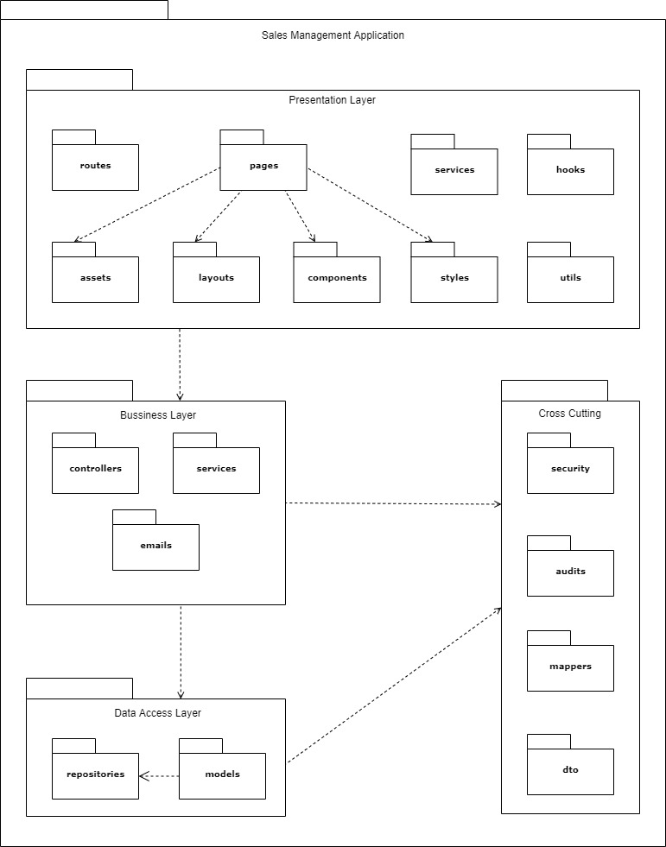

Figure 1 Package Diagram

|  |  |  |
| --- | --- | --- |
| **No** | **Package** | **Description** |
| 01 | routes | The package contains functions for app navigation. |
| 02 | pages | The package contains the pages of the routing. |
| 03 | services | The package contains functions to manage API. |
| 04 | hooks | The package contains custom hook functions. |
| 05 | assets | The package contains images and icons. |
| 06 | layouts | The package contains layout components for the app. |
| 07 | components | The package contains UI components that can be shared. |
| 08 | styles | The package contains global CSS, JavaScript for application-level styles. |
| 09 | utils | The package contains all the helper functions. |
| 10 | controllers | The package contains classes provide RESTful web services. |
| 11 | services | The package contains classes for business logic. |
| 12 | emails | The package contains a class provides email service. |
| 13 | repositories | The package contains classes responsible for communicating with data sources, processing queries, and returning data types requested by the Service layer. |
| 14 | models | The package contains classes that represent persisted data to the database. |
| 15 | security | The package contains classes for JWT handling, authentication, and authorization. |
| 16 | audits | The package contains classes for auditing entity objects. |
| 17 | mappers | The package contains a class to convert data between the DTO and entity objects. |
| 18 | dto | The package contains classes to aggregate and encapsulate data for transfer. |

## 3. System Detailed Design

### 3.1 Overall

#### Class Diagram

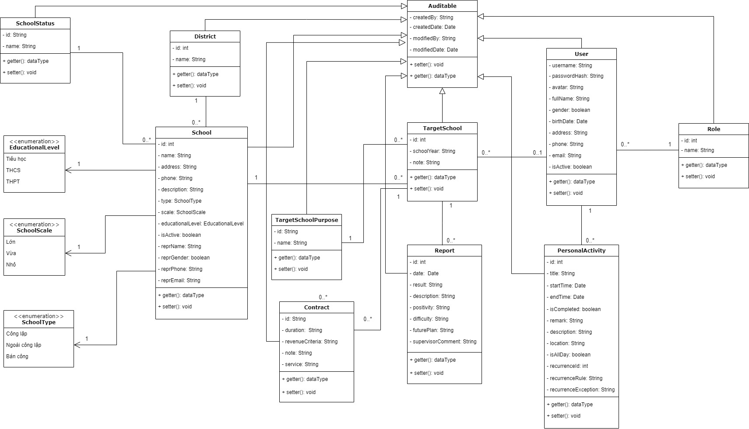

Figure 1: Class diagram

#### b. Sequence Diagram(s)

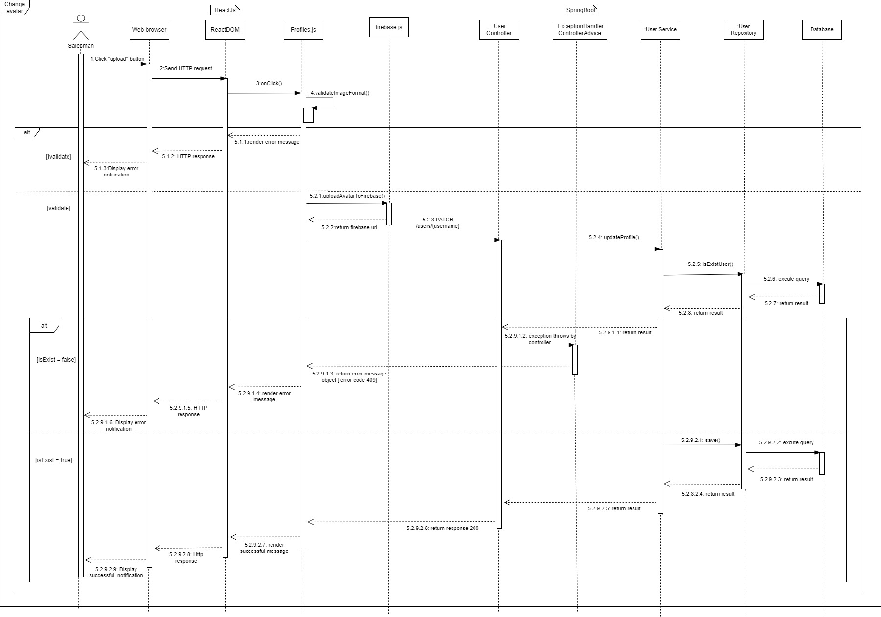

Figure 2: Change avatar

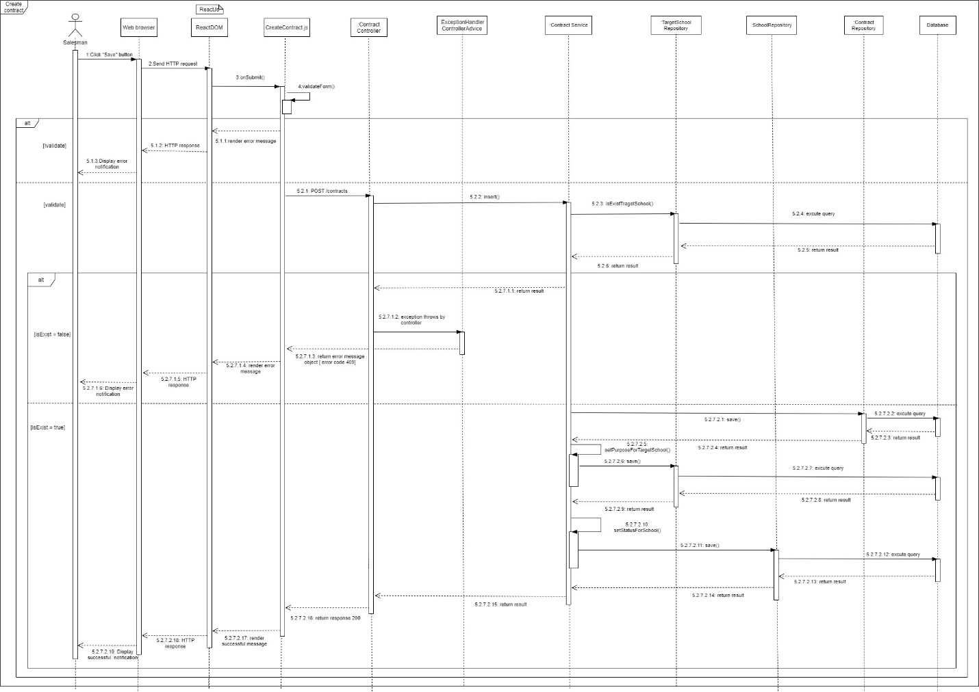

Figure 3: Create contract

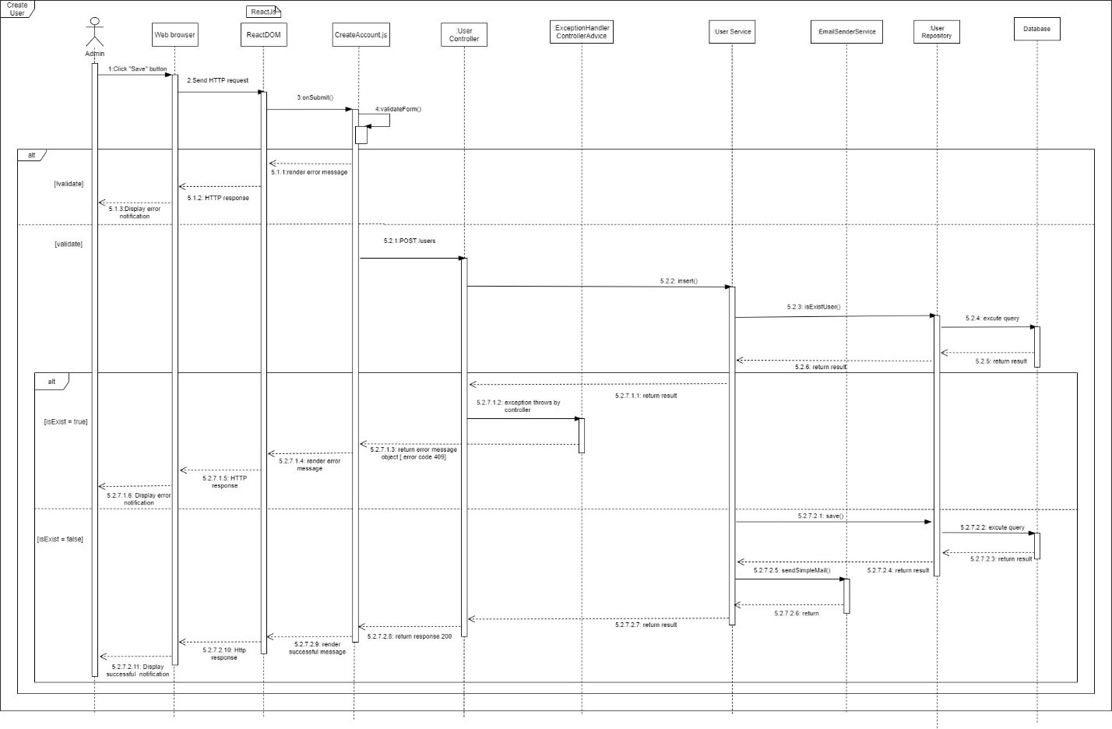

Figure 4: Create user

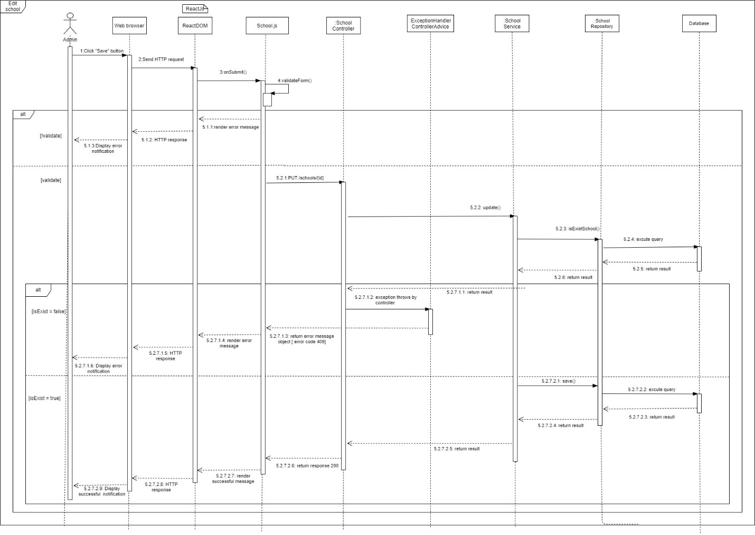

Figure 5: Edit school

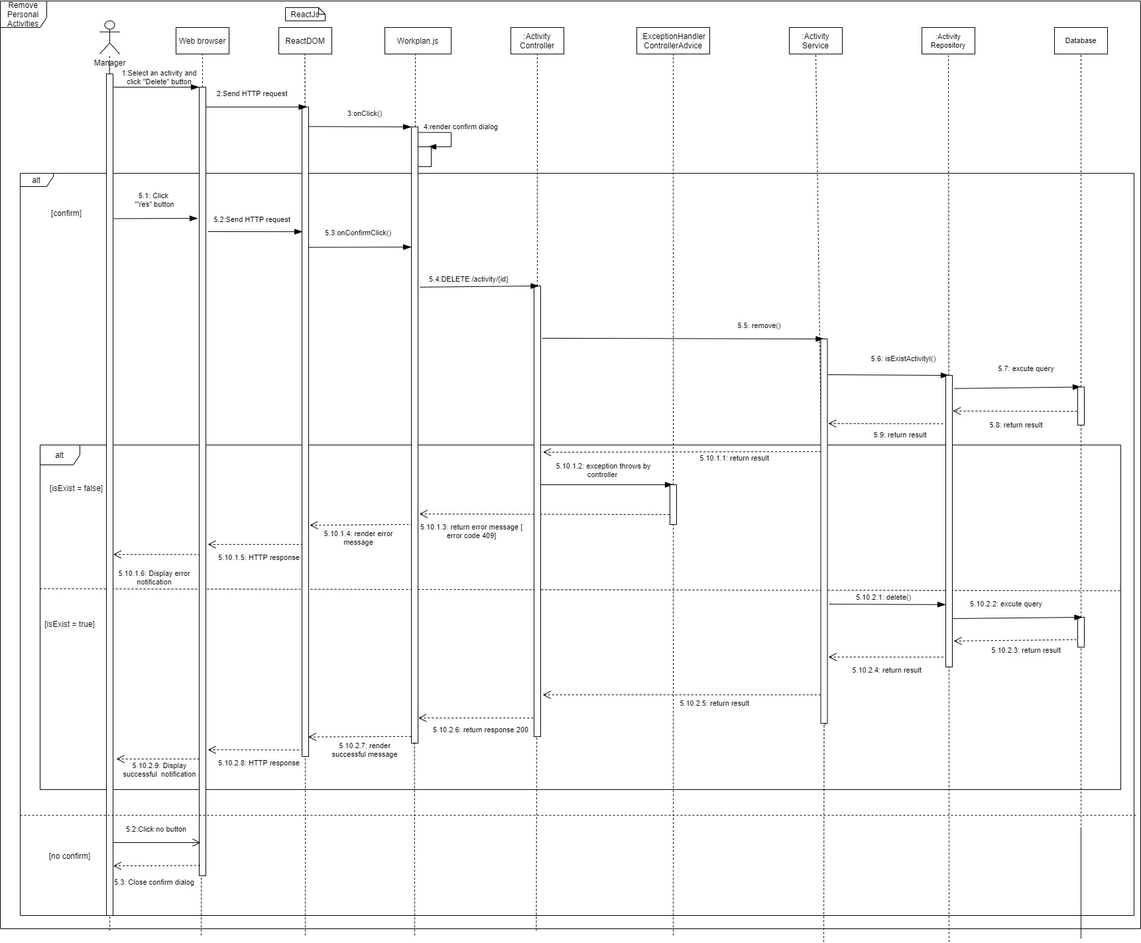

Figure 6: Remove personal activities

#### c. Activity Diagram(s)

1. **<Sales Manager>** **Create target school**

Summary: This diagram shows the process by which the sales manager creates a target school.

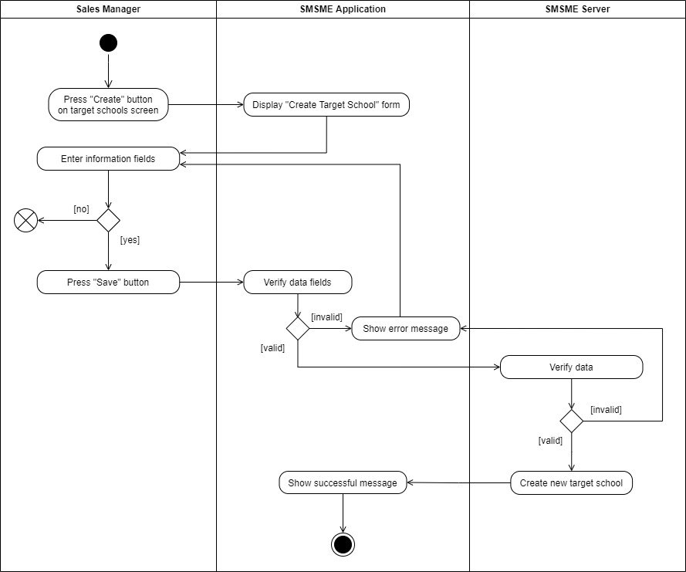

Figure 1: Create target school

1. **<Sales Manager> Assign salesman**

Summary: This diagram shows the process by which the sales manager assigns a salesman to a target school.

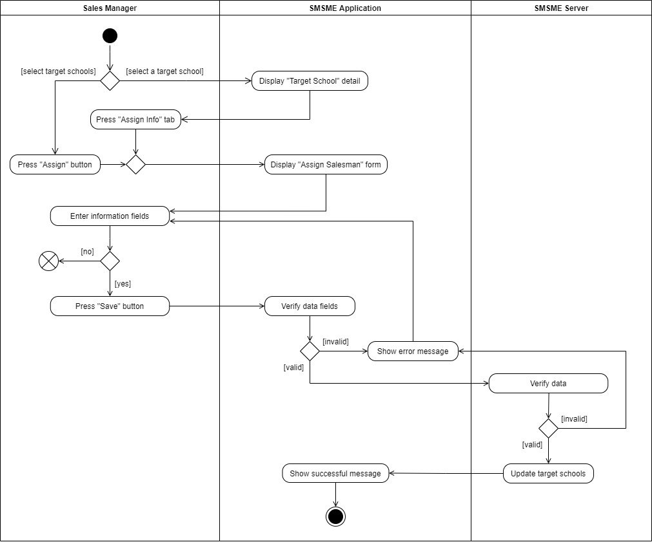

Figure 2: Assign salesman

1. **<Sales Manager> Update target school**

Summary: This diagram shows the process by which the sales manager updates a target school.

Figure 3: Update target school

1. **<Sales Manager> Remove target school**

Summary: This diagram shows the process by which the sales manager removes a target school.

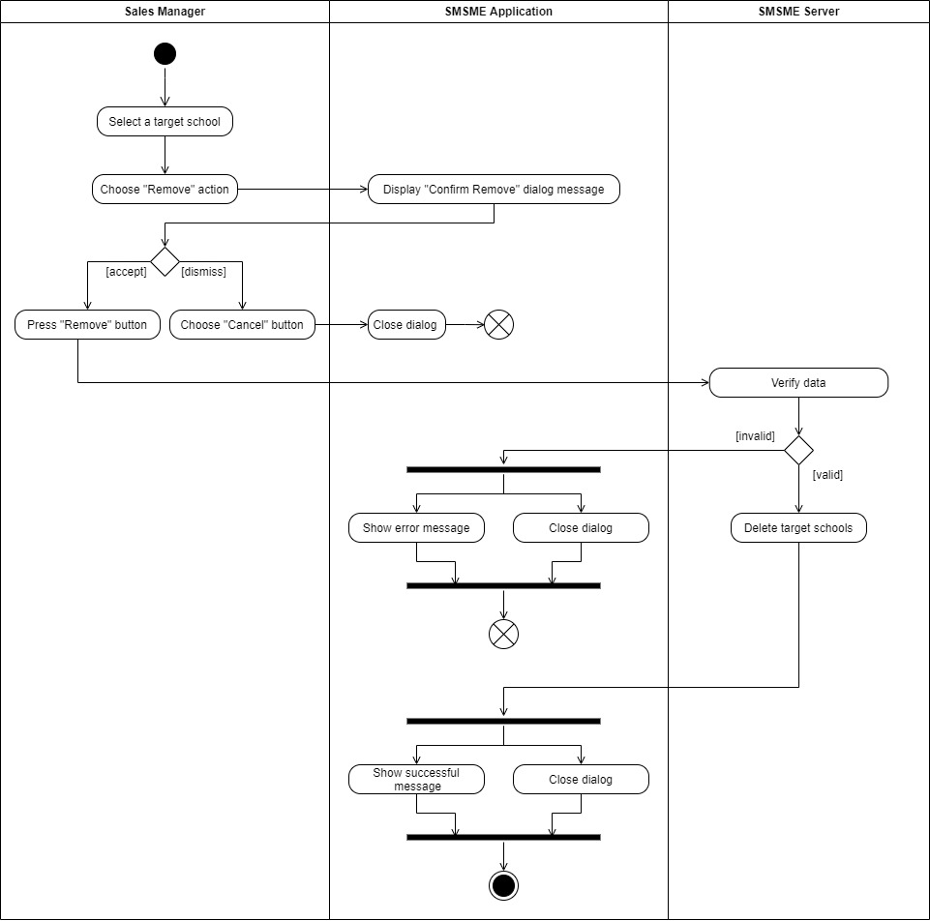

Figure 4: Remove a target school

1. **<Sales Manager/ Salesman> Create report**

Summary: This diagram shows the process by which the sales manager or salesman create a report.

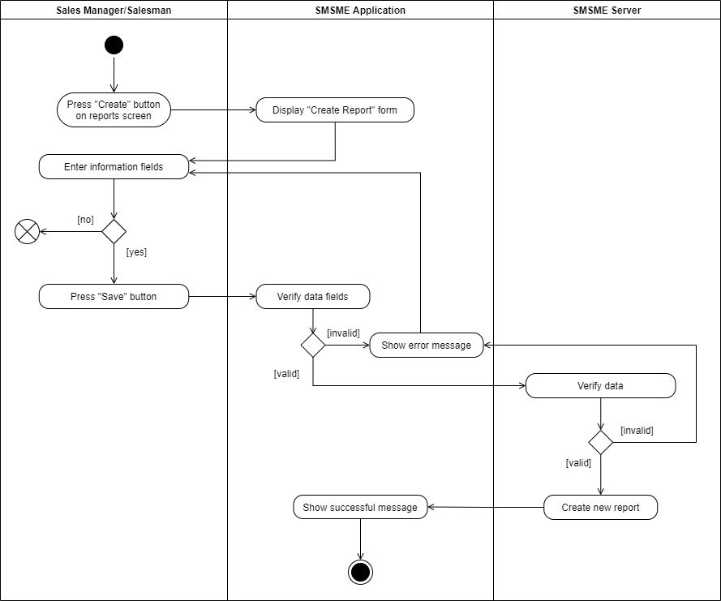

Figure 5: Create reports

1. **<Sales Manager/ Salesman> Update report**

Summary: This diagram shows the process by which the sales manager or salesman update a report.

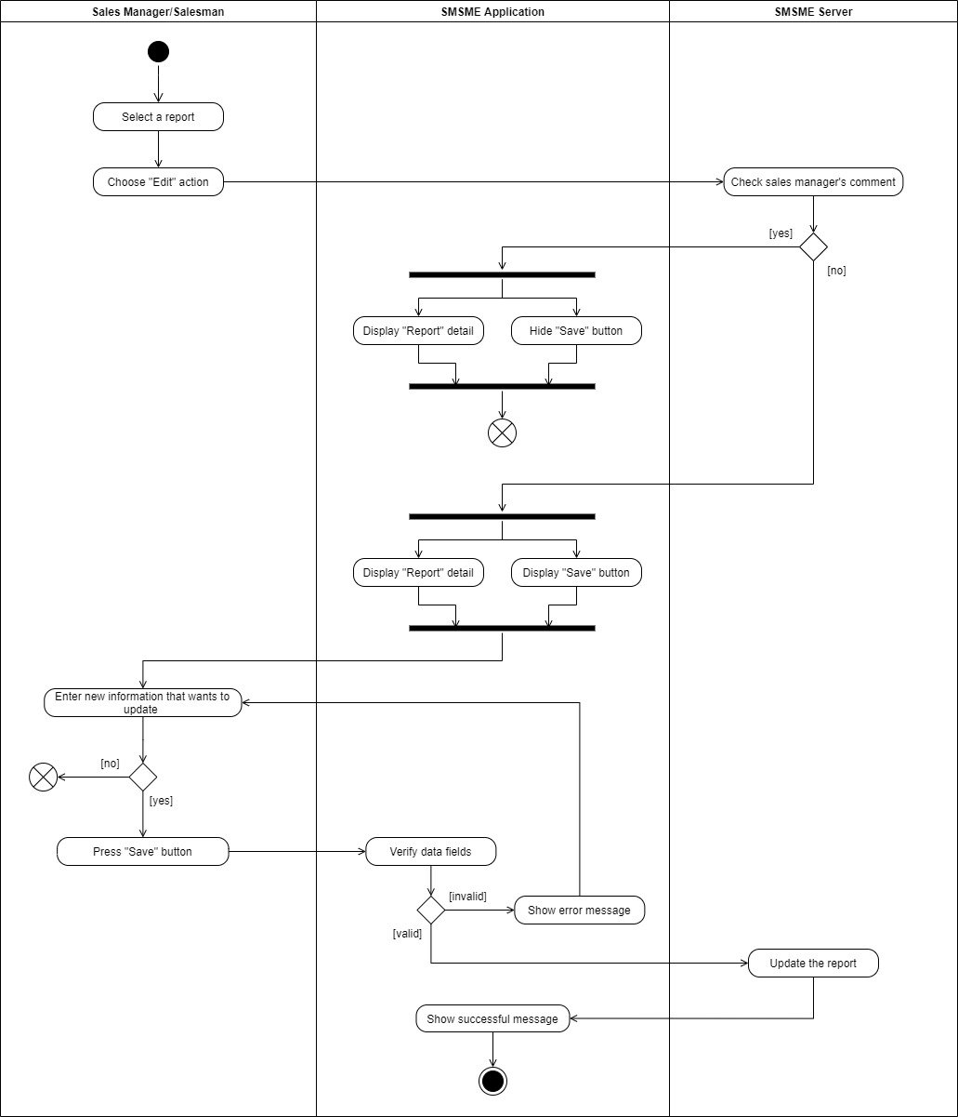

Figure 6: Update report

## 4. Class Specifications

### 4.1 User

|  |  |  |  |
| --- | --- | --- | --- |
| **Attribute** | **Type** | **Visibility** | **Description** |
| username | String | private | The unique identifier of a user |
| passwordHash | String | private | The password hash of the user |
| fullName | String | private | The full name of the user |
| address | String | private | The address of the user |
| email | String | private | The email of the user |
| phone | String | private | The phone number of the user |
| isActive | boolean | private | The active status of the user |
| avatar | String | private | The avatar of the user |
| gender | boolean | private | The gender of the user |
| birthDate | Date | private | The birthdate of the user |

|  |  |  |  |  |
| --- | --- | --- | --- | --- |
| **No** | **Method** | **Visibility** | **Return Type** | **Description** |
| 1 | getter | public | dataType | get attribute value |
| 2 | setter | public | void | set attribute value |

### 4.2 PersonalActivity

|  |  |  |  |
| --- | --- | --- | --- |
| **Attribute** | **Type** | **Visibility** | **Description** |
| id | int | private | The unique identifier of a personal activity |
| title | String | private | The title of the personal activity |
| startTime | Date | private | The start time of the personal activity |
| endTime | Date | private | The end time of the personal activity |
| isCompleted | boolean | private | The completed status of the personal activity |
| remark | String | private | The remark of the personal activity |
| description | String | private | The description of the personal activity |
| location | String | private | The location of the personal activity |
| isAllDay | boolean | private | The all day status of the personal activity |
| recurrenceId | int | private | The unique identifier of a recurrence |
| recurrenceRule | String | private | The rule of the recurrence |
| recurrenceException | String | private | The exception of the recurrence |

|  |  |  |  |  |
| --- | --- | --- | --- | --- |
| **No** | **Method** | **Visibility** | **Return Type** | **Description** |
| 1 | getter | public | dataType | get attribute value |
| 2 | setter | public | void | set attribute value |

### 4.3 Role

|  |  |  |  |
| --- | --- | --- | --- |
| **Attribute** | **Type** | **Visibility** | **Description** |
| id | int | private | The unique identifier of a role |
| name | String | private | The name of the role |

|  |  |  |  |  |
| --- | --- | --- | --- | --- |
| **No** | **Method** | **Visibility** | **Return Type** | **Description** |
| 1 | getter | public | dataType | get attribute value |
| 2 | setter | public | void | set attribute value |

### 4.4 Auditable

|  |  |  |  |
| --- | --- | --- | --- |
| **Attribute** | **Type** | **Visibility** | **Description** |
| createdBy | String | private | Auditing who created |
| createdDate | Date | private | The date created for auditing |
| modifiedBy | String | private | Auditing who modified |
| modifiedDate | Date | private | The date modified for auditing |

|  |  |  |  |  |
| --- | --- | --- | --- | --- |
| **No** | **Method** | **Visibility** | **Return Type** | **Description** |
| 1 | getter | public | dataType | get attribute value |
| 2 | setter | public | void | set attribute value |

### 4.5 TargetSchool

|  |  |  |  |
| --- | --- | --- | --- |
| **Attribute** | **Type** | **Visibility** | **Description** |
| id | int | private | The unique identifier of a target school |
| schoolYear | String | private | The school year of the target school |
| note | String | private | The note of the target school |

|  |  |  |  |  |
| --- | --- | --- | --- | --- |
| **No** | **Method** | **Visibility** | **Return Type** | **Description** |
| 1 | getter | public | dataType | get attribute value |
| 2 | setter | public | void | set attribute value |

### 4.6 Report

|  |  |  |  |
| --- | --- | --- | --- |
| **Attribute** | **Type** | **Visibility** | **Description** |
| id | int | private | The unique identifier of a report |
| date | Date | private | The date of the report |
| result | String | private | The result of the report |
| description | String | private | The description of the report |
| positivity | String | private | The positivity of the report |
| difficulty | String | private | The difficulty of the report |
| futurePlan | String | private | The future plan of the report |
| supervisorComment | String | private | The supervisor comment of the report |

|  |  |  |  |  |
| --- | --- | --- | --- | --- |
| **No** | **Method** | **Visibility** | **Return Type** | **Description** |
| 1 | getter | public | dataType | get attribute value |
| 2 | setter | public | void | set attribute value |

### 4.7 School

|  |  |  |  |
| --- | --- | --- | --- |
| **Attribute** | **Type** | **Visibility** | **Description** |
| id | int | private | The unique identifier of a school |
| name | String | private | The name of the school |
| address | String | private | The address of the school |
| phone | String | private | The phone number of the school |
| type | SchoolType | private | The school type of the school |
| scale | SchoolScale | private | The school scale of the school |
| educationalLevel | EducationalLevel | private | The educational level of the school |
| description | String | private | The description of the school |
| isActive | boolean | private | The active status of the school |
| reprName | String | private | The name of the representative |
| reprGender | boolean | private | The gender of the representative |
| reprPhone | String | private | The phone number of the representative |
| reprEmail | String | private | The email of the representative |

|  |  |  |  |  |
| --- | --- | --- | --- | --- |
| **No** | **Method** | **Visibility** | **Return Type** | **Description** |
| 1 | getter | public | dataType | get attribute value |
| 2 | setter | public | void | set attribute value |

### 4.8 District

|  |  |  |  |
| --- | --- | --- | --- |
| **Attribute** | **Type** | **Visibility** | **Description** |
| id | int | private | The unique identifier of a district |
| name | String | private | The name of the district |

|  |  |  |  |  |
| --- | --- | --- | --- | --- |
| **No** | **Method** | **Visibility** | **Return Type** | **Description** |
| 1 | getter | public | dataType | get attribute value |
| 2 | setter | public | void | set attribute value |

### 4.9 SchoolStatus

|  |  |  |  |
| --- | --- | --- | --- |
| **Attribute** | **Type** | **Visibility** | **Description** |
| id | String | private | The unique identifier of a school status |
| name | String | private | The name of the school status |

|  |  |  |  |  |
| --- | --- | --- | --- | --- |
| **No** | **Method** | **Visibility** | **Return Type** | **Description** |
| 1 | getter | public | dataType | get attribute value |
| 2 | setter | public | void | set attribute value |

### 4.10 TargetSchoolPurpose

|  |  |  |  |
| --- | --- | --- | --- |
| **Attribute** | **Type** | **Visibility** | **Description** |
| id | String | private | The unique identifier of a target school purpose |
| name | String | private | The name of the target school purpose |

|  |  |  |  |  |
| --- | --- | --- | --- | --- |
| **No** | **Method** | **Visibility** | **Return Type** | **Description** |
| 1 | getter | public | dataType | get attribute value |
| 2 | setter | public | void | set attribute value |

### 4.11 EducationalLevel

|  |  |  |  |
| --- | --- | --- | --- |
| **Attribute** | **Type** | **Visibility** | **Description** |
| Tiểu học |  |  | Enum attribute |
| THCS |  |  | Enum attribute |
| THPT |  |  | Enum attribute |

### 4.12 SchoolScale

|  |  |  |  |
| --- | --- | --- | --- |
| **Attribute** | **Type** | **Visibility** | **Description** |
| Lớn |  |  | Enum attribute |
| Vừa |  |  | Enum attribute |
| Nhỏ |  |  | Enum attribute |

### 4.13 SchoolType

|  |  |  |  |
| --- | --- | --- | --- |
| **Attribute** | **Type** | **Visibility** | **Description** |
| Công lập |  |  | Enum attribute |
| Ngoài công lập |  |  | Enum attribute |
| Bán công |  |  | Enum attribute |

## 5. Data & Database Design

### 5.1 Physical diagram

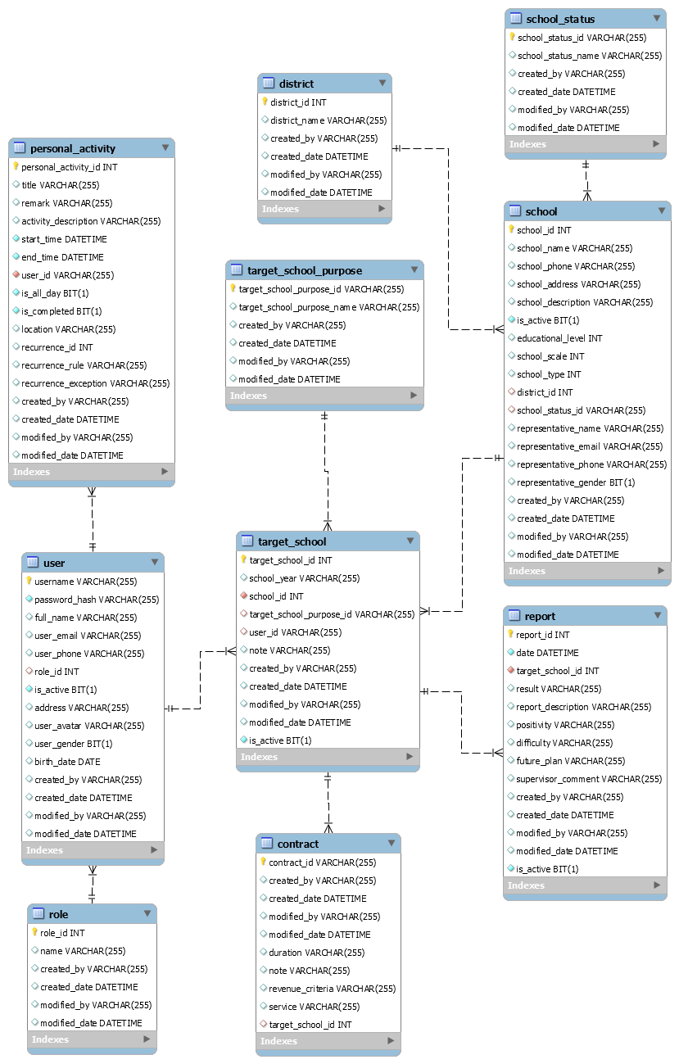

#### a. school

|  |  |  |  |  |  |  |  |
| --- | --- | --- | --- | --- | --- | --- | --- |
| **#** | **Field name** | **Type** | **Size** | **Unique** | **Not Null** | **PK/FK** | **Notes** |
| 1 | school_id | int |  | X | X | X |  |
| 2 | school_name | varchar | 255 |  |  |  |  |
| 3 | school_phone | varchar | 255 |  |  |  |  |
| 4 | school_address | varchar | 255 |  |  |  |  |
| 5 | school_description | varchar | 255 |  |  |  |  |
| 6 | is_active | bit |  |  | X |  |  |
| 7 | education_level | int | 255 |  |  |  |  |
| 8 | school_scale | int |  |  |  |  |  |
| 9 | school_type | int |  |  |  |  |  |
| 10 | district_id | int |  |  |  |  |  |
| 11 | school_status_id | varchar | 255 |  |  |  |  |
| 12 | representative_name | varchar | 255 |  |  |  |  |
| 13 | representative_email | varchar | 255 |  |  |  |  |
| 14 | representative_phone | varchar | 255 |  |  |  |  |
| 15 | representative_gender | bit |  |  |  |  |  |
| 16 | created_by | varchar | 255 |  |  |  | Use for auditing |
| 17 | created_date | datetime |  |  |  |  | Use for auditing |
| 18 | modified_by | varchar | 255 |  |  |  | Use for auditing |
| 19 | modified_date | datetime |  |  |  |  | Use for auditing |

#### b. district

|  |  |  |  |  |  |  |  |
| --- | --- | --- | --- | --- | --- | --- | --- |
| **#** | **Field name** | **Type** | **Size** | **Unique** | **Not Null** | **PK/FK** | **Notes** |
| 1 | district_id | int |  | X | X | X |  |
| 2 | district_name | varchar | 255 |  |  |  |  |
| 3 | created_by | varchar | 255 |  |  |  | Use for auditing |
| 4 | created_date | datetime |  |  |  |  | Use for auditing |
| 5 | modified_by | varchar | 255 |  |  |  | Use for auditing |
| 6 | modified_date | datetime |  |  |  |  | Use for auditing |

#### c. school_status

|  |  |  |  |  |  |  |  |
| --- | --- | --- | --- | --- | --- | --- | --- |
| **#** | **Field name** | **Type** | **Size** | **Unique** | **Not Null** | **PK/FK** | **Notes** |
| 1 | school_status_id | varchar | 255 | X | X | X |  |
| 2 | school_status_name | varchar | 255 |  |  |  |  |
| 3 | created_by | varchar | 255 |  |  |  | Use for auditing |
| 4 | created_date | datetime |  |  |  |  | Use for auditing |
| 5 | modified_by | varchar | 255 |  |  |  | Use for auditing |
| 6 | modified_date | datetime |  |  |  |  | Use for auditing |

#### d. target_school

|  |  |  |  |  |  |  |  |
| --- | --- | --- | --- | --- | --- | --- | --- |
| **#** | **Field name** | **Type** | **Size** | **Unique** | **Not Null** | **PK/FK** | **Notes** |
| 1 | target_school_id | int |  | X | X | X |  |
| 2 | school_year | varchar | 255 |  |  |  |  |
| 3 | school_id | int |  |  | X |  |  |
| 4 | target_school_purpose_id | varchar | 255 |  |  |  |  |
| 5 | user_id | varchar | 255 |  |  |  |  |
| 6 | note | varchar | 255 |  |  |  |  |
| 7 | created_by | varchar | 255 |  |  |  | Use for auditing |
| 8 | created_date | datetime |  |  |  |  | Use for auditing |
| 9 | modified_by | varchar | 255 |  |  |  | Use for auditing |
| 10 | modified_date | datetime |  |  |  |  | Use for auditing |

#### e. report

|  |  |  |  |  |  |  |  |
| --- | --- | --- | --- | --- | --- | --- | --- |
| **#** | **Field name** | **Type** | **Size** | **Unique** | **Not Null** | **PK/FK** | **Notes** |
| 1 | report_id | int |  | X | X | X |  |
| 2 | date | datetime |  |  | X |  |  |
| 3 | target_school_id | int |  |  | X |  |  |
| 4 | result | varchar | 255 |  |  |  |  |
| 5 | report_description | varchar | 255 |  |  |  |  |
| 6 | positivity | varchar | 255 |  |  |  |  |
| 7 | difficulty | varchar | 255 |  |  |  |  |
| 8 | future_plan | varchar | 255 |  |  |  |  |
| 9 | supervisor_comment | varchar | 255 |  |  |  |  |
| 10 | created_by | varchar | 255 |  |  |  | Use for auditing |
| 11 | created_date | datetime |  |  |  |  | Use for auditing |
| 12 | modified_by | varchar | 255 |  |  |  | Use for auditing |
| 13 | modified_date | datetime |  |  |  |  | Use for auditing |

#### f. target_school_purpose

|  |  |  |  |  |  |  |  |
| --- | --- | --- | --- | --- | --- | --- | --- |
| **#** | **Field name** | **Type** | **Size** | **Unique** | **Not Null** | **PK/FK** | **Notes** |
| 1 | target_school_purpose_id | varchar | 255 | X | X | X |  |
| 2 | target_school_purpose_name | varchar | 255 |  |  |  |  |
| 3 | created_by | varchar | 255 |  |  |  | Use for auditing |
| 4 | created_date | datetime |  |  |  |  | Use for auditing |
| 5 | modified_by | varchar | 255 |  |  |  | Use for auditing |
| 6 | modified_date | datetime |  |  |  |  | Use for auditing |

#### g. user

|  |  |  |  |  |  |  |  |
| --- | --- | --- | --- | --- | --- | --- | --- |
| **#** | **Field name** | **Type** | **Size** | **Unique** | **Not Null** | **PK/FK** | **Notes** |
| 1 | username | varchar | 255 | X | X | X |  |
| 2 | password_hash | varchar | 255 |  | X |  |  |
| 3 | full_name | varchar | 255 |  |  |  |  |
| 4 | user_email | varchar | 255 |  |  |  |  |
| 5 | user_phone | varchar | 255 |  |  |  |  |
| 6 | role_id | int |  |  |  |  |  |
| 7 | is_active | bit |  |  | X |  |  |
| 8 | address | varchar | 255 |  |  |  |  |
| 9 | user_avatar | varchar | 255 |  |  |  |  |
| 10 | user_gender | bit |  |  |  |  |  |
| 11 | birth_date | date |  |  |  |  |  |
| 12 | created_by | varchar | 255 |  |  |  | Use for auditing |
| 13 | created_date | datetime |  |  |  |  | Use for auditing |
| 14 | modified_by | varchar | 255 |  |  |  | Use for auditing |
| 15 | modified_date | datetime |  |  |  |  | Use for auditing |

#### h. role

|  |  |  |  |  |  |  |  |
| --- | --- | --- | --- | --- | --- | --- | --- |
| **#** | **Field name** | **Type** | **Size** | **Unique** | **Not Null** | **PK/FK** | **Notes** |
| 1 | role_id | int |  | X | X | X |  |
| 2 | name | varchar | 255 |  |  |  |  |
| 3 | created_by | varchar | 255 |  |  |  | Use for auditing |
| 4 | created_date | datetime |  |  |  |  | Use for auditing |
| 5 | modified_by | varchar | 255 |  |  |  | Use for auditing |
| 6 | modified_date | datetime |  |  |  |  | Use for auditing |

#### i. personal_activity

|  |  |  |  |  |  |  |  |
| --- | --- | --- | --- | --- | --- | --- | --- |
| **#** | **Field name** | **Type** | **Size** | **Unique** | **Not Null** | **PK/FK** | **Notes** |
| 1 | personal_activity_id | int |  | X | X | X |  |
| 2 | title | varchar | 255 |  |  |  |  |
| 3 | remark | varchar | 255 |  |  |  |  |
| 4 | activity_description | varchar | 255 |  |  |  |  |
| 5 | start_time | datetime |  |  | X |  |  |
| 6 | end_time | datetime |  |  | X |  |  |
| 7 | user_id | varchar | 255 |  | X |  |  |
| 8 | is_all_day | bit |  |  | X |  |  |
| 9 | is_completed | bit |  |  | X |  |  |
| 10 | location | varchar | 255 |  |  |  |  |
| 11 | recurrence_id | int |  |  |  |  |  |
| 12 | recurrence_rule | varchar | 255 |  |  |  |  |
| 13 | recurrence_exception | varchar | 255 |  |  |  |  |
| 14 | created_by | varchar | 255 |  |  |  | Use for auditing |
| 15 | created_date | datetime |  |  |  |  | Use for auditing |
| 16 | modified_by | varchar | 255 |  |  |  | Use for auditing |
| 17 | modified_date | datetime |  |  |  |  | Use for auditing |

#### j. contract

|  |  |  |  |  |  |  |  |
| --- | --- | --- | --- | --- | --- | --- | --- |
| **#** | **Field name** | **Type** | **Size** | **Unique** | **Not Null** | **PK/FK** | **Notes** |
| 1 | contract_id | int |  | X | X | X |  |
| 2 | duration | varchar | 255 |  |  |  |  |
| 3 | note | varchar | 255 |  |  |  |  |
| 4 | revenue_criteria | varchar | 255 |  |  |  |  |
| 5 | Service | varchar | 255 |  |  |  |  |
| 6 | target_school_id | int |  |  |  |  |  |
| 7 | created_by | varchar | 255 |  |  |  | Use for auditing |
| 8 | created_date | datetime |  |  |  |  | Use for auditing |
| 9 | modified_by | varchar | 255 |  |  |  | Use for auditing |
| 10 | modified_date | datetime |  |  |  |  | Use for auditing |

### 5.2 Data File Design

We use firebase to store images.

|  |  |  |  |
| --- | --- | --- | --- |
| **#** | **File Name** | **Type** | **Notes** |
| 1 | avatars | JPG, JPEG, PNG | The images are used for user avatar. |