

**Capstone Project Report**

**Report 6 – Software User Guides**

– Hanoi, August 2019 –

**Table of Contents**

I. Project Report 3

1. Status Report 3

2. Team Involvements 3

3. Issues/Suggestions 3

II. Release Package & User Guides 4

1. Deliverable Package 4

1.1 Source codes & documents 4

1.2 Known Issues, Limitations & Restrictions 4

2. Installation Guides 4

2.1 System Requirements 4

2.2 Setup Files 4

2.3 Installation Instruction 4

3. User Manual 4

3.1 Terms and definitions 4

3.2 System requirements 4

3.3 Application Usage 5

3.4 Troubleshooting 5

# I. Project Report

## 1. Status Report

|  |  |  |  |
| --- | --- | --- | --- |
| **#** | **Work Item** | **Status** | **Notes (Work Item in Details)** |
| 1 | Deliverable Package | In Progress |  |
| 2 | Installation Guides | In Progress |  |
| 3 | User Manual | In Progress |  |
| 4 | Japanese User Manual | Pending |  |

## 2. Team Involvements

|  |  |  |  |
| --- | --- | --- | --- |
| **#** | **Task** | **Member** | **Notes (Task Details, etc.)** |
| 1 |  | HaPTN |  |
| 2 |  | NguyenLG |  |
| 3 |  | GiaNH |  |

## 3. Issues/Suggestions

|  |  |  |  |
| --- | --- | --- | --- |
| **#** | **Issue** | **Status** | **Notes (Solution, Suggestion, etc.)** |
| 1 |  | Pending |  |
| 2 |  | In Progress |  |
| 3 |  | Completed |  |

# II. Release Package & User Guides

## 1. Deliverable Package

### 1.1 Source codes & documents

| **No.** | **Items** | **Sub-Items** | **Type** | **Version** |
| --- | --- | --- | --- | --- |
| ***Code Package*** | | | | |
| 1 | Web Apps |  | New | 1.0.0 |
| 2 | API Services |  | New | 1.0.0 |
| ***Database*** | | | | |
| 1 | Tables | contract.sql | New | 1.0.0 |
| district.sql | New | 1.0.0 |
| personal_activity.sql | New | 1.0.0 |
| report.sql | New | 1.0.0 |
| role.sql | New | 1.0.0 |
| school.sql | New | 1.0.0 |
| school_status.sql | New | 1.0.0 |
| target_school.sql | New | 1.0.0 |
| target_school_purpose.sql | New | 1.0.0 |
| user.sql | New | 1.0.0 |
| ***Documents*** | | | | |
| 1 | Introduction | Report1_Project Introduction.docx | New | 1.0.0 |
| 2 | Management Plan | Report2_Project Management Plan.docx | New | 1.0.0 |
| 3 | Requirement | Report3_Software Requirement Specification.docx | New | 1.0.0 |
| 4 | Design | Report4_Software Design Document.docx | New | 1.0.0 |
| 5 | Testing | Report5_Test Documentation.docx | New | 1.0.0 |
| Report5_Test Case Document.docx | New | 1.0.0 |
| Report5_Unit Test Case.docx | New | 1.0.0 |
| 6 | User Guides | Report6_Software User Guides.docx | New | 1.0.0 |
| 7 | Final | Report7_Final Project Report.docx | New | 1.0.0 |

### 1.2 Known Issues, Limitations & Restrictions

* The current system does not provide a mobile app version for the user.
* The current system does not support communication channel with customers.
* The web application responsive interface has not stable yet.
* The interface still lacks consistency, may or may not cause uncomfortable for the user.
* The current application only supports English default.
* The system lacks testing, which leads to application performance or bugs that may cause during implementation.
* During the lack of team resources, some main features of the application have not been implemented.

## 2. Installation Guides

### System Requirements

* + 1. **Hardware Requirements**
* Scince this system is a web application, all the devices using the system must run over the Internet.
* Our system is deployed on the server, which the minimum requirements services to run in the following:

For Web App service:

|  |  |
| --- | --- |
| **Hardware** | **Minimum Requirements** |
| vCPU | 1 |
| Operation System | Linux Server/Window server |
| Memory (GiB) | 1GiB |

For API Services service:

|  |  |
| --- | --- |
| **Hardware** | **Minimum Requirements** |
| vCPU | 1 |
| Operation System | Linux Server/Window server |
| Memory | 1GiB |

For Database service:

|  |  |
| --- | --- |
| **Hardware** | **Minimum Requirements** |
| vCPU | 1 |
| Operation System | Linux server/Window sẻver |
| Computer Memory | 1GiB |

* + 1. **Software Requirements**

This web application works with: Chrome (version 52 or above), Firefox (version 51 or above), Edge (version 14 or above), Safari (version 10 or above), or Opera (version 38 or above) browser.

### 2.2 Setup Files

N/A

### 2.3 Installation Instruction

N/A

## 3. User Manual

### 3.1 Terms and definitions

* This system is built for Major Education with a project code SMSME, which stands for Sales Management System for Major Education.
* This system is an enterprise application, with the license rules and terms of use belong to Major Education.

### System requirements

**3.2.1. Hardware Requirements**

* Scince this system is a web application, all the devices using the system must run over the Internet.
* Our system is deployed on the server, which the minimum requirements services to run in the following:

For Web App service:

|  |  |
| --- | --- |
| **Hardware** | **Minimum Requirements** |
| vCPU | 1 |
| Operation System | Linux Server/Window server |
| Memory (GiB) | 1GiB |

For API Services service:

|  |  |
| --- | --- |
| **Hardware** | **Minimum Requirements** |
| vCPU | 1 |
| Operation System | Linux Server/Window server |
| Memory (GiB) | 1GiB |

For Database service:

|  |  |
| --- | --- |
| **Hardware** | **Minimum Requirements** |
| vCPU | 1 |
| Operation System | Linux server/Window sẻver |
| Memory (GiB) | 1GiB |

**3.2.2. Software Requirements**

This web application works with: Chrome (version 52 or above), Firefox (version 51 or above), Edge (version 14 or above), Safari (version 10 or above), or Opera (version 38 or above) browser.

### 3.3 Application Usage

#### a. Overview

The target users that SMSME mainly aims to are salesmen and sales managers of the Sales Department of Major Education.

For salesmen, this software would help them manage their work-plan as well as their tasks easier and more visually, submit daily reports more directly and they can also monitor other salesmen’s works.

For sales managers, they would not have to collect and analyze all salesmen’s reports manually. Now they can supervise salesmen or search for reports more easily. Moreover, they can see the overall picture of the company's business process, including what schools are lead or customers, who are the most effective salesmen,…

#### b. Accounts

Purpose

* The admin manages user accounts

Functions

* View list of accounts
* View account’s details
* Search accounts
* Create accounts
* Edit account’s information

User interface(s)

Figure 1 Accounts list

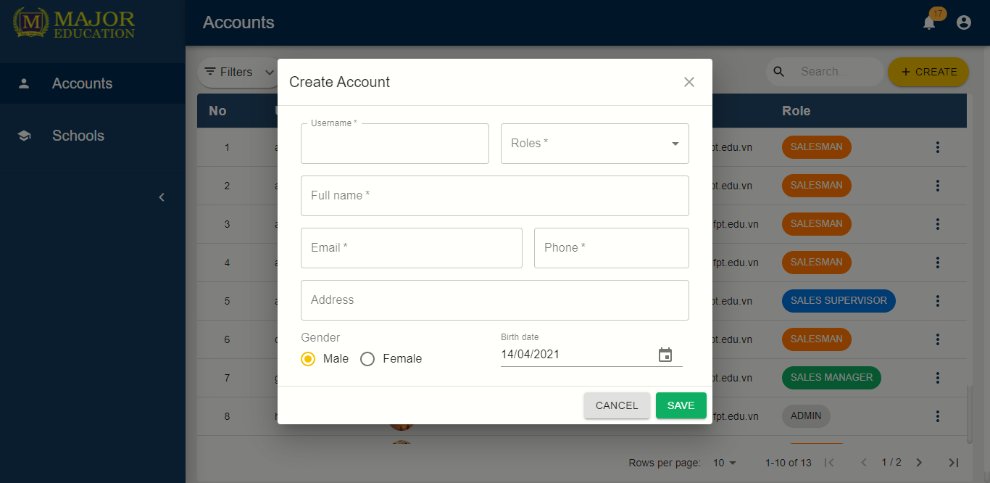

Figure 2 Create Account

Figure 3 Account detail

#### c. Schools

Purpose

* The admin manages schools info
* The sales manager edits schools info
* The sales supervisor edits schools info
* The salesman edits schools info

Functions

* View list of schools
* View school’s details
* Search schools
* Create schools
* Edit school’s information

User interface(s)

Figure 4 Schools list

Figure 5 School detail

#### d. Target schools

Purpose

* The sales manager manages target schools
* The sales supervisor manages target schools
* The salesman view assigned of target schools

Functions

* View list of target shools
* View target school’s details
* Search target schools
* Create target schools
* Edit targets information
* Assign salesmen to target schools
* Remove target schools

User interface(s)

Figure 6 Target Schools list

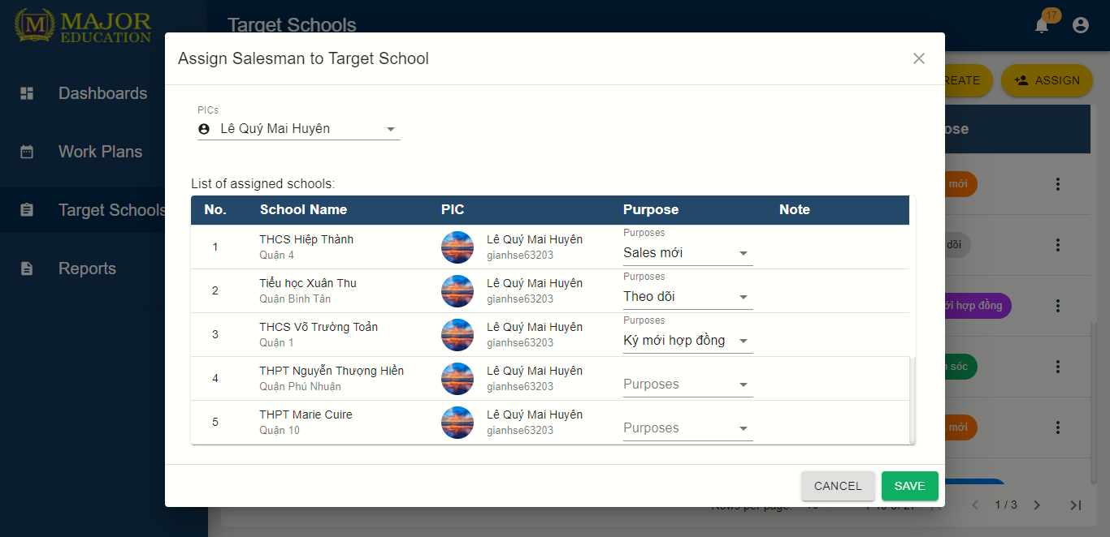

Figure 7 Assign Salesmen to target schools

#### e. Reports

Purpose

* The sales manager manages personal daily reports
* The sales supervisor manages personal daily reports
* The salesman manages personal daily reports
* The sales manager comments on salesman’s report
* The sales department monitors their reports

Functions

* View list of reports
* View report’s details
* Search reports
* Create reports
* Edit report's information
* Comment reports
* Remove reports

User interface(s)

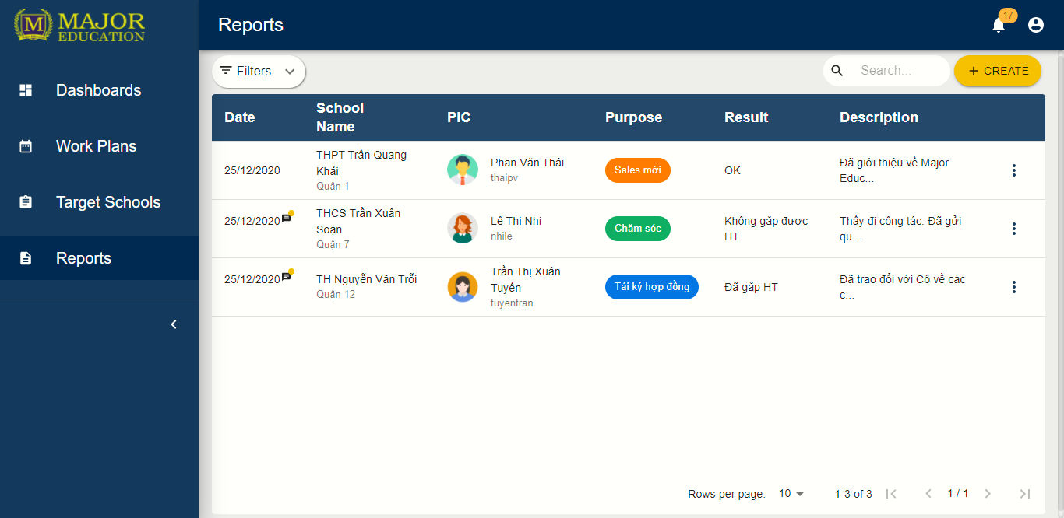

Figure 8 Report list

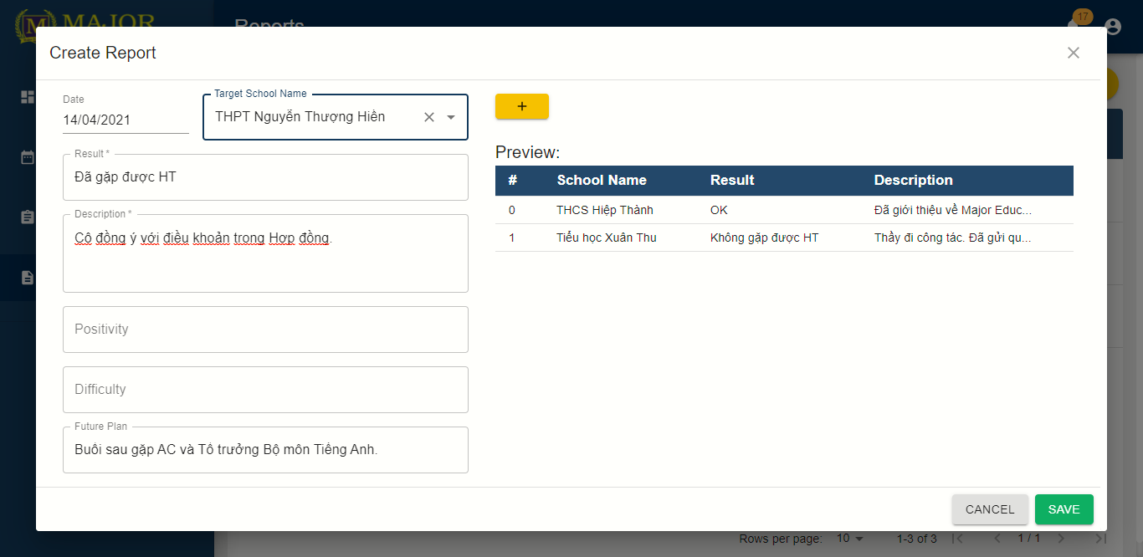

Figure 9 Create Reports

#### f. Profiles

Purpose

* The user edits personal profile

Functions

* View profile
* Edit profile

User interface(s)

Figure 10 Profile

#### g. Workplans

Purpose

* The user manages personal workplans

Functions

* View workplans
* View personal activities’s details
* Create personal activities
* Edit personal activities
* Remove personal activities

User interface(s)

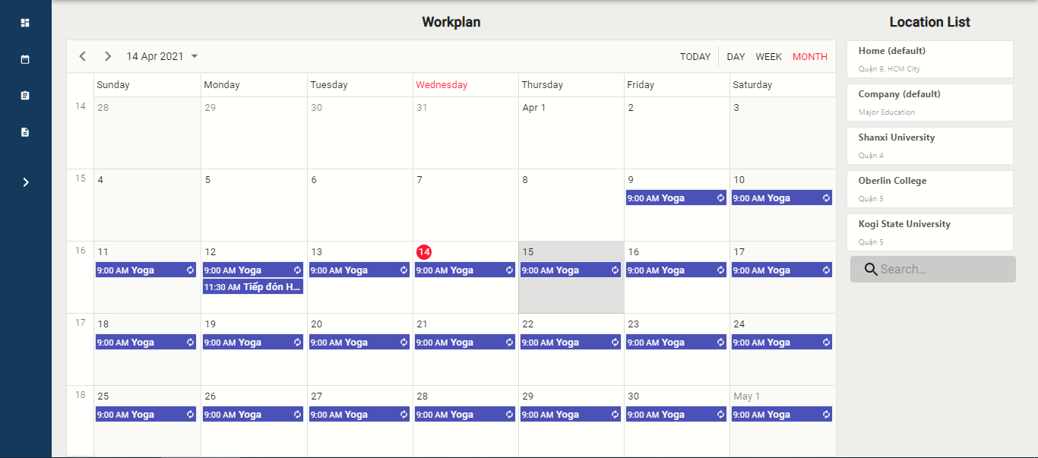

Figure 11 Workplan

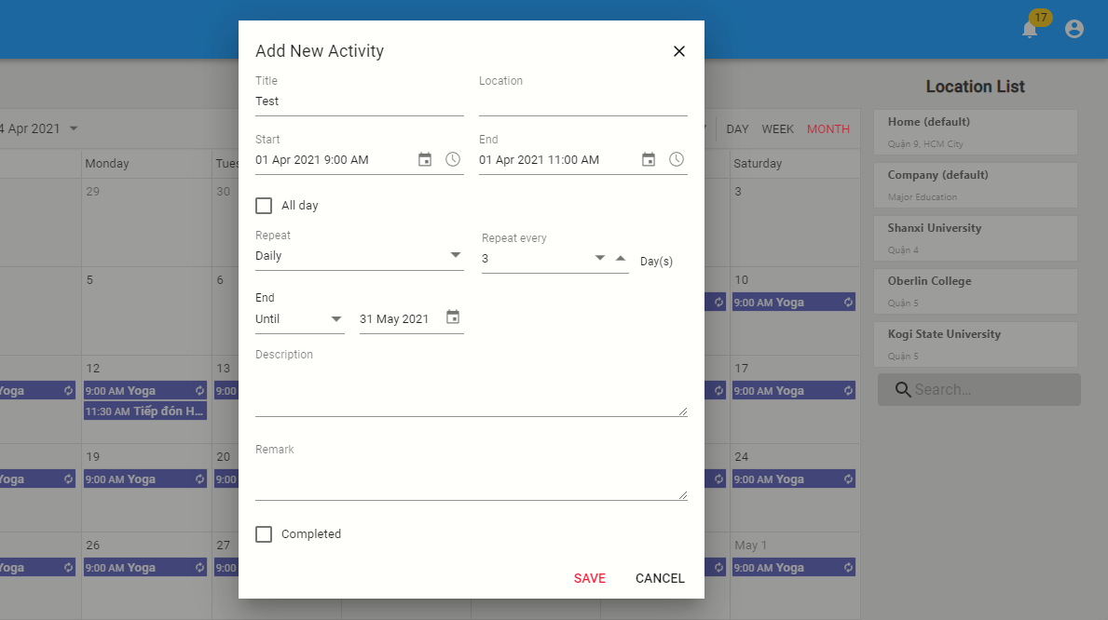

Figure 12 Add New Activity

#### h. Dashboards

Purpose

* The sales department tracks their work process

Functions

* View dashboards

User interface(s)

Figure 13 Dashboards

#### i. Contarcts

Purpose

* The sales manager manages contracts ?
* The salesman tracks assigned contarcts

Functions

* View list of contracts ?
* View contract’s details
* Search contracts ?
* Create contracts ?
* Edit contacrts’s information ?

User interface(s)

#### j. Logins

Purpose

* The unauthorized user logins the system
* The user retrieve their password

Functions

* Login with username and password
* Forget password

User interface(s)

Figure 14 Login

#### k. Logout

Purpose

* The authorized user logouts the system

Functions

* Logout

User interface(s)

Figure 15 Log out

### 3.4 Troubleshooting

1. **Web App layout broke during cross-device use**

Problems:

* The application responsive interface has not supported for all devices

Workaround:

* Refresh the web app page
* Contacts the system developers for more supports

1. **Avatar or images loading time is long**

Problems:

* The Internet connection is slow or unstable

Workaround:

* Refresh the web app page
* Connect with a better Internet connection

1. **Data record loading time is long**

Problems:

* The Internet connection is slow or unstable

Workaround:

* Refresh the web app page
* Connect with a better Internet connection