**Problem Statement**

Little Lemon is a small restaurant that has been expanding over the years due to its experience and dishes. In an effort to enhance the operations of the establishment, the company needs an online reserve-a-table feature on its website, so the clients can ensure their reservation from their smart devices/computers whenever they want. This feature will allow the staff to identify the number of customers per hour and attract newcomers.  With the aforementioned statement, the user story that results is: “As a User, I want to be able to reserve a table from my smartphone, so I can do it whenever and wherever I want.”

**User Persona**

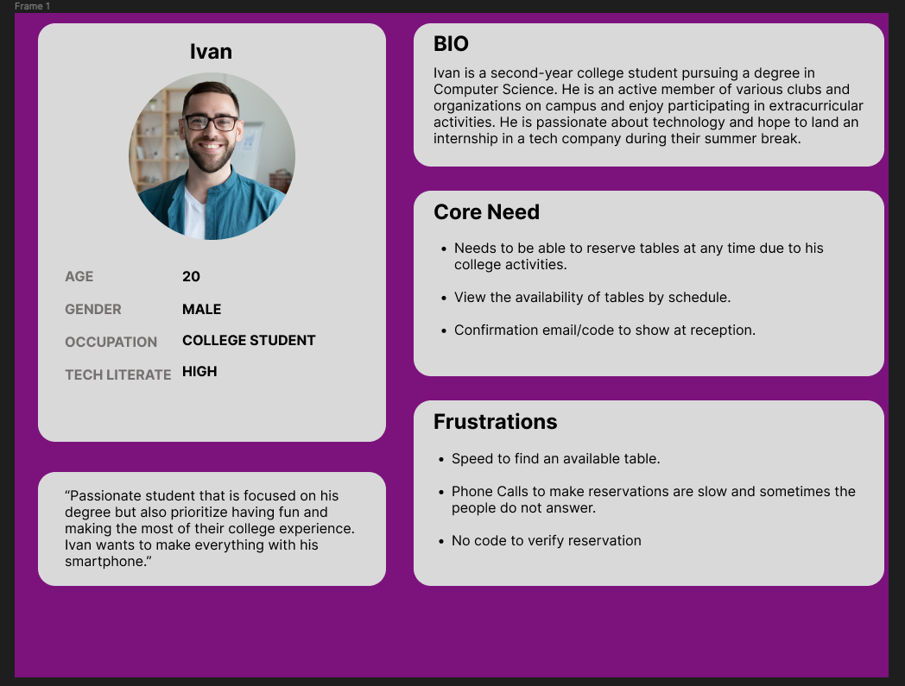

<https://www.figma.com/file/745L3wnyqLNczvwW3F9oeZ/User-Persona?t=FHFufnYVMkz80eDW-1>

**Journey Map**

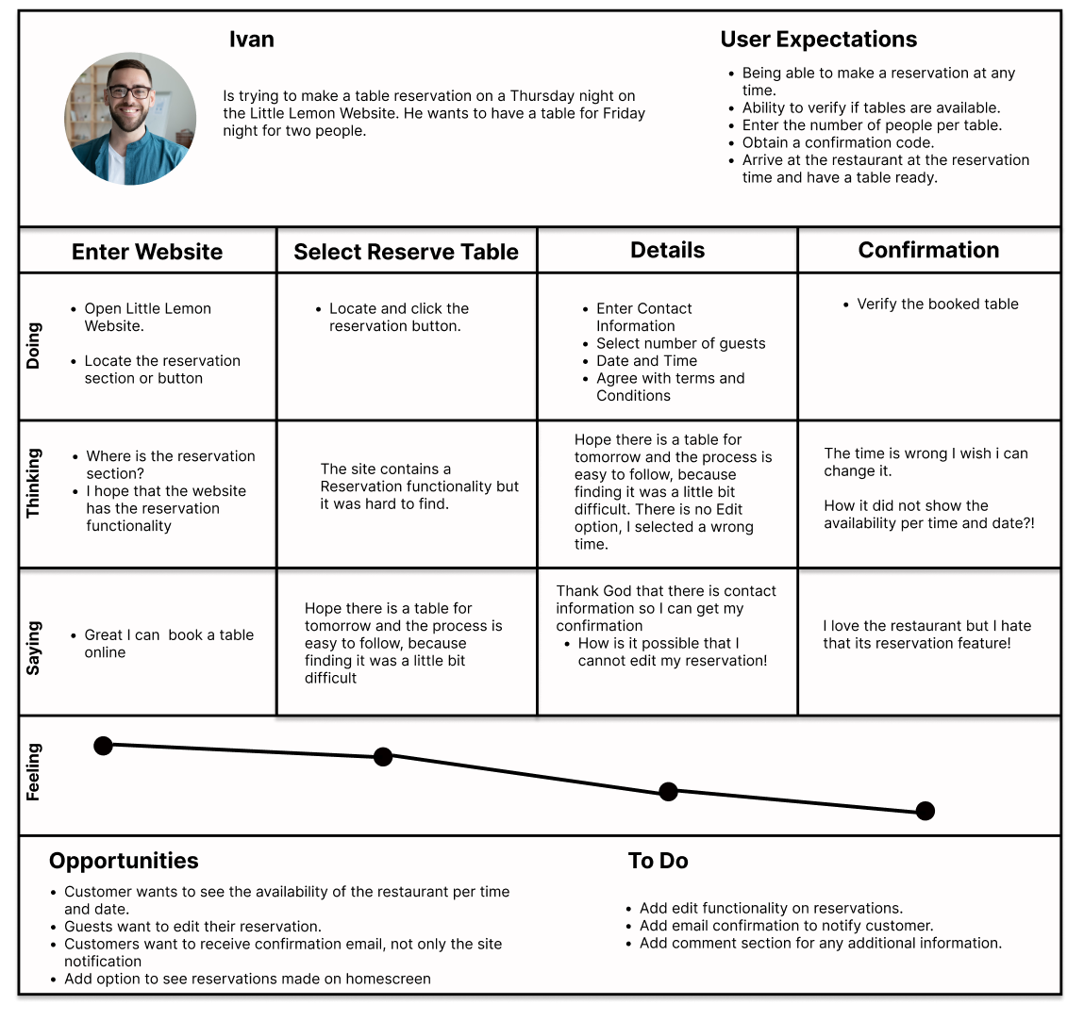

<https://www.figma.com/file/KPZYsYJcGyKYhpRRmE9Rw3/CustomerJourneyMap?t=FHFufnYVMkz80eDW-1>

**Wireframes**

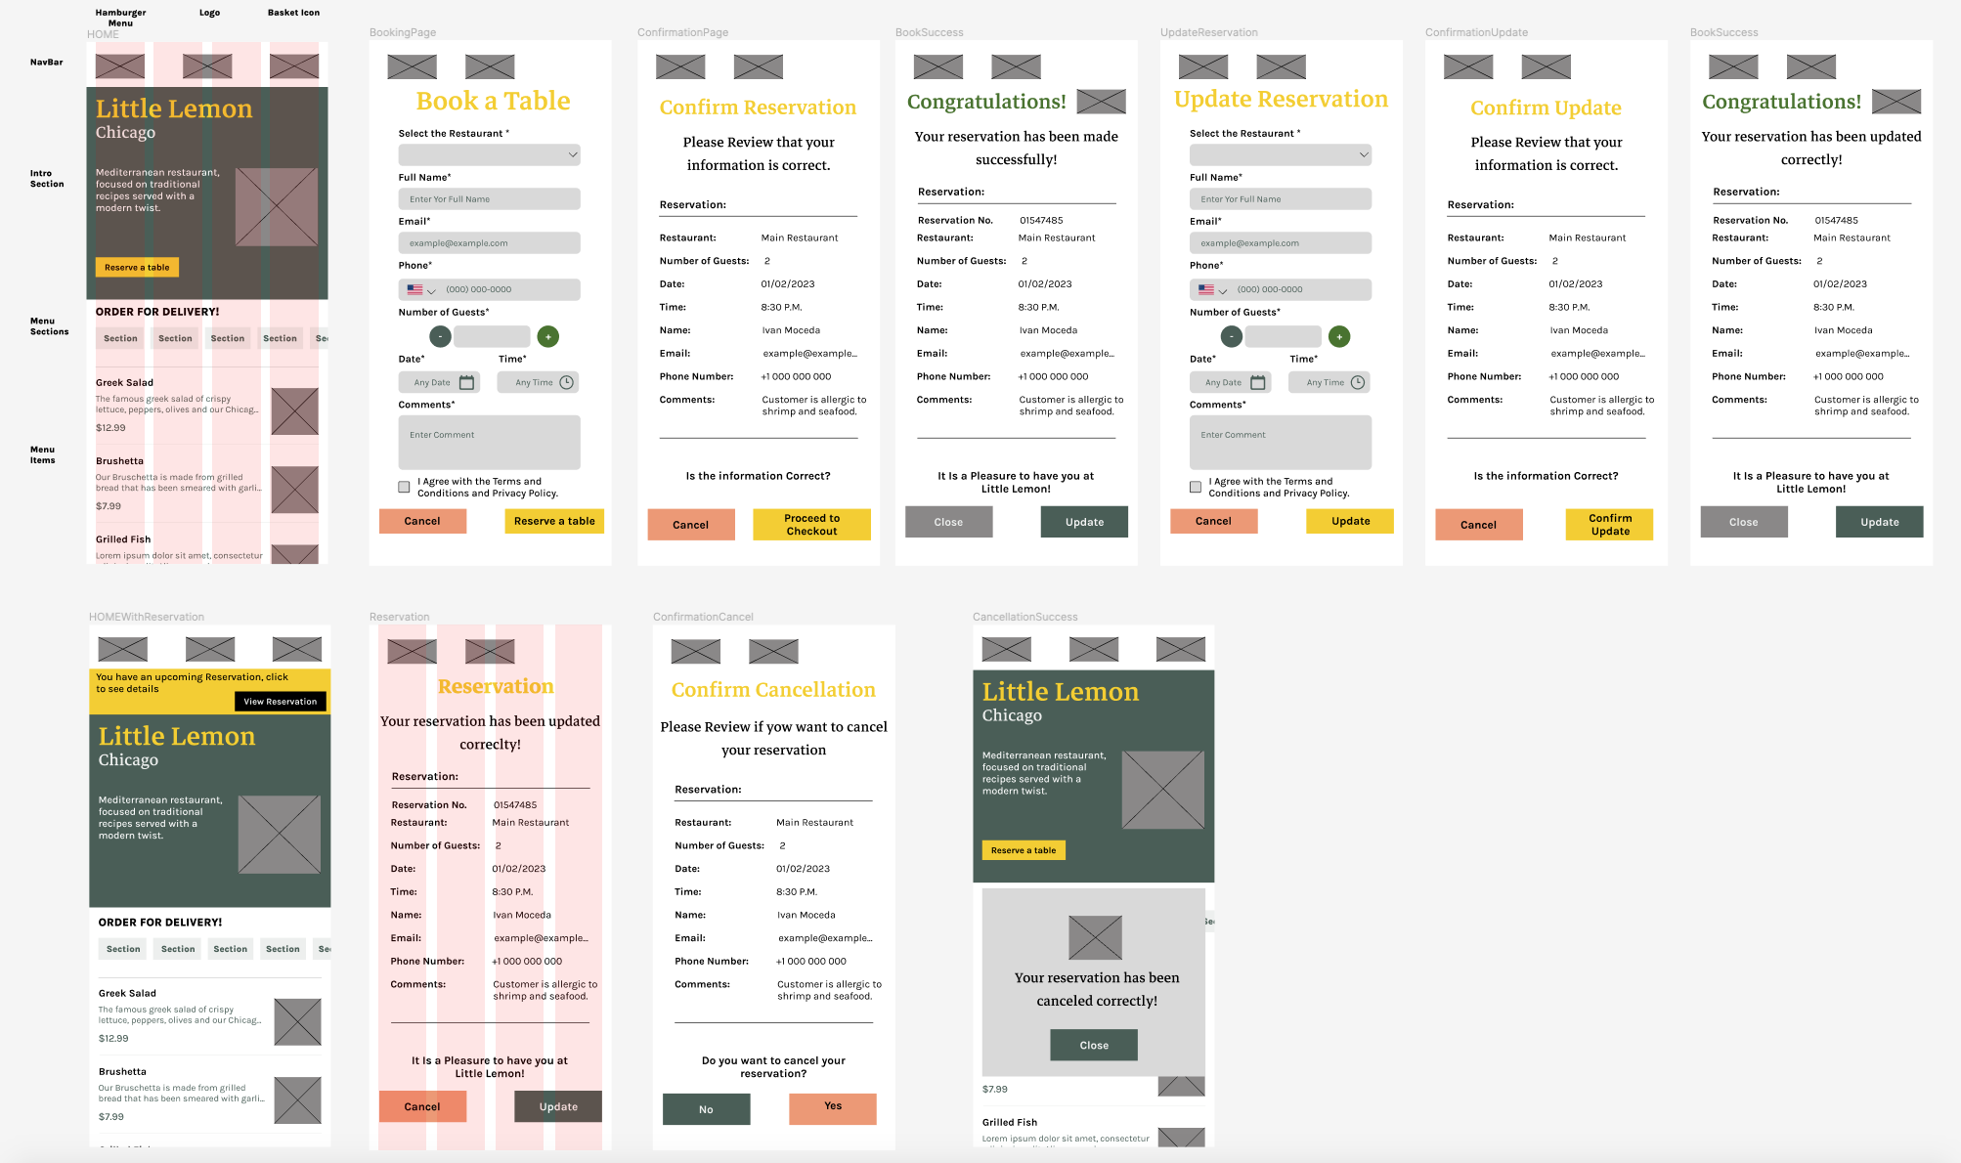

[**https://www.figma.com/file/Ls8rYPTMhRUT4mYe45PlVI/BookTableWireframe?node-id=0%3A1&t=63HO722tcqqm8Pk2-1**](https://www.figma.com/file/Ls8rYPTMhRUT4mYe45PlVI/BookTableWireframe?node-id=0%3A1&t=63HO722tcqqm8Pk2-1)

**Prototype**

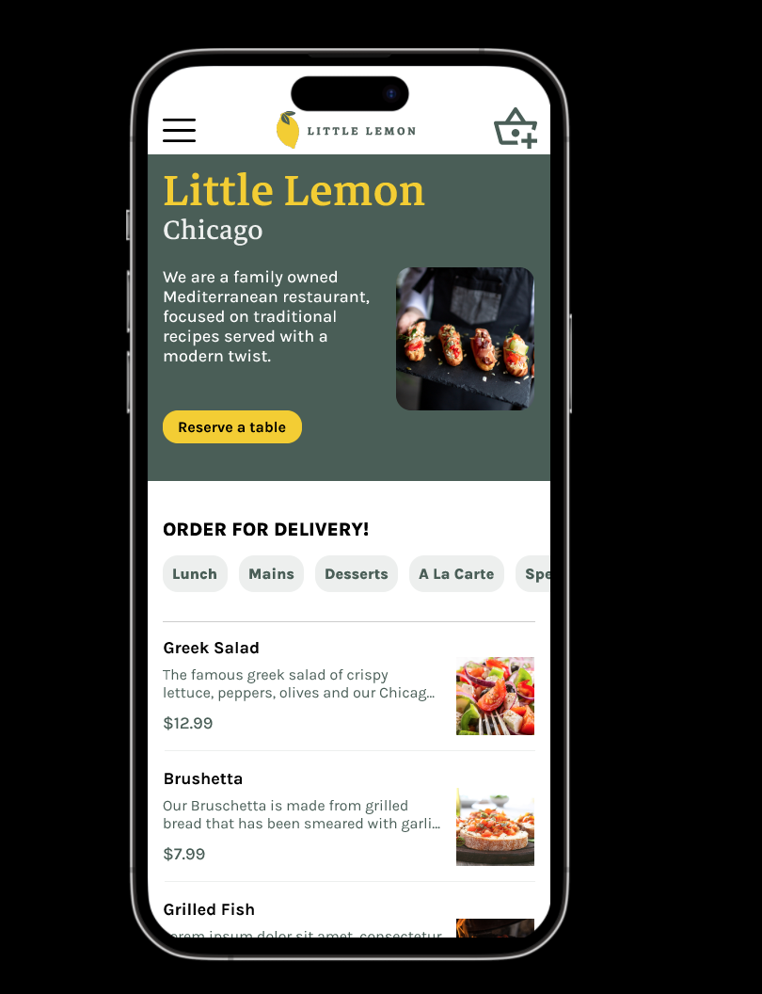

**Prototype Mode:** [**https://www.figma.com/proto/wZtOv0FGxgL7XVxh06t1Ed/BookTablePrototype?scaling=scale-down&page-id=0%3A1&starting-point-node-id=23%3A330&node-id=1-36**](https://www.figma.com/proto/wZtOv0FGxgL7XVxh06t1Ed/BookTablePrototype?scaling=scale-down&page-id=0%3A1&starting-point-node-id=23%3A330&node-id=1-36)

**Figma Files:**

[**https://www.figma.com/file/wZtOv0FGxgL7XVxh06t1Ed/BookTablePrototype?t=FHFufnYVMkz80eDW-1**](https://www.figma.com/file/wZtOv0FGxgL7XVxh06t1Ed/BookTablePrototype?t=FHFufnYVMkz80eDW-1)