# Investigating the Effects of Short Waves (Chop) on Wave Energy Converters (WECs)

## Summary

Short waves (i.e., chop generated from local winds, or “wind chop”) are rarely considered in numerical or physical modeling campaigns as these waves typically contain only a fraction of the total energy in the sea state.

However, despite their lower energy content, short waves can be the dominant factor in determining a device's direction and therefore its response. Short waves can also elicit motions in a device that actually exceed the extreme design responses calculated for swell. Furthermore, because the energy content of short waves is concentrated at higher frequencies, they are likely to be particularly influential on the response of small wave energy converters (WECs), which are of growing interest for blue economy applications.

Hence, this seedling aims to develop the capability in WEC-Sim to model the effect of short waves on the performance of WECs. After this modelling capability is developed, we will investigate the effects of chop on different reference model 3 (RM3) device sizes (0.5-m to 20-m diameter) so that numerical modelers have a guide for if/when this phenomenon could affect the power performance estimates of their device. Lastly, we aim to investigate the effect of chop on a directional WEC (an attenuator) to determine how much short waves with different headings can impact the response of a directional device.

## Background

A common approach to evaluating a WEC design is to simulate the device in a range of sea states, compute the average power produced in each sea state, and assemble a power matrix. By considering a device's power matrix in conjunction with a joint probability distribution plot, it is possible to estimate the annual energy production (AEP) for a particular device at a particular location.

In this approach, each sea state is expressed by its unimodal spectrum parameters (typically a Pierson-Moskowitz or JONSWAP spectrum). However, depending on the site location it can be common to observe bimodal spectra—often with different headings.

We currently have no approach in WEC-Sim for considering this kind of combined sea state. Therefore, we typically only consider the dominant sea state in our assessments (since this contains the most energy). However, the orientation of a directional WEC can be influenced by chop—accounting for it could lead to different conclusions. Furthermore, small WECs are likely to be much more responsive to the shorter, higher- frequency wind waves. Hence, neglecting this component of the sea state could potentially lead to over- or under-estimating a device's response and performance.

## Objectives

The main objectives of this seedling project are to:

* Develop the tools required to simulate bimodal sea states (i.e., combining swell and chop in WEC-Sim)
* Investigate how the size of a WEC influences its sensitivity to short waves, focusing on the omnidirectional WEC, RM3
* Investigate how the direction of short waves influences the response of a directional WEC (e.g., an attenuator hit by chop from various angles)
* Provide guidance to the wave energy community regarding if/when they need to consider the effects of short waves on their device, and how they can explore these effects with WEC-Sim.

## Activities up to $50k

### Expanding WEC-Sim's Capabilities to Model Bimodal Sea States With Distinct Headings

This task focuses on including wind chop functionality within WEC-Sim. Although spectra can be combined in WEC-Sim, some additional effort is required to account for bimodal sea states with more than one heading. Although there will be some interaction between the waves from the different sources, typically this interaction is small, and the spectra can generally be linearly superimposed without too much loss of accuracy.

### Determining Input Wave Data

Thirty-minute-averaged, 45-day buoy time histories are provided by the National Data Buoy Center (NDBC) for many locations in U.S. waters via their website. We will select some sample buoys to investigate this effect at different locations over 45-day windows. We will also contact NDBC to obtain more extensive time histories, which would enable AEP assessments.

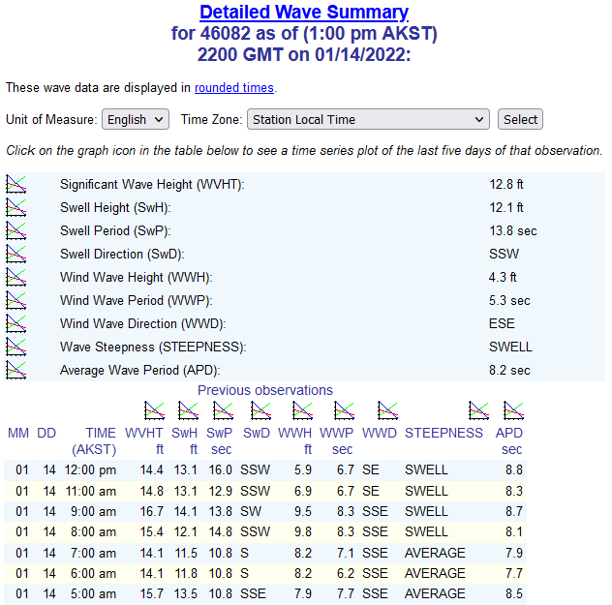

### Quantifying the Effect of Chop on Different Scale RM3 Devices

RM3's original diameter is 20 m. We will create scaled RM3 models from 0.5 m to 20 m diameter to investigate at what scale the effects of short waves start to significantly impact performance estimates (if at all).

### Preparation of Data for Public Use and Reporting on Findings

All models, data and postprocessing scripts will be well organized and made public for the use of others. A summary report will be prepared alongside the data for additional explanation of the methods - ensuring all the data is reproducible.

## Project Plan

**Task 1: Expand WEC-Sim**

1. Modify WEC-Sim excitation force function to pass 2 spectra with distinct Hs, Tp and direction parameters.
2. Verify implementation.

**1-2 weeks**

**Task 2: Gather representative input data**

1. Determine input wave data from NDBC database – using buoys that record swell parameters and wind wave parameters separately
2. Pick some representative cases and reach out to resource characterization experts for advice.

**1 week**

**Task 3: Simulate different scale RM3 WECs**

1. Create around 20 RM3 meshes (from 0.5m to 20m)
2. Run BEM code for the 2 headings determined in task 2
3. Simulate in unimodal PM spectra for dominant sea state
4. Simulate in bimodal spectra
5. Compare average power for the different scale device – to see if smaller WECs are more sensitive to chop, and how much it could

**2-4 weeks**

**Task 4: Dissemination**

1. Summary report on our findings
2. Publication of models on the WEC-Sim Applications repo
3. Results data pushed to MHK DR

**1 week**

## Staff planning

**Sal: 2 months (100% Aug, 50% Sep-Oct)**

**Dave: 1 month (25% time Aug, Sep, Oct, Nov)**

## Timeline

Final report

Bimodal forces implemented in WEC-Sim

Completed comparison of avg power for 20 RM3 devices in uni and bimodal spectra

Selection of representative sea states

**Nov**

**Oct**

**Sep**

**Aug**