#1.AFFINE CIPHER
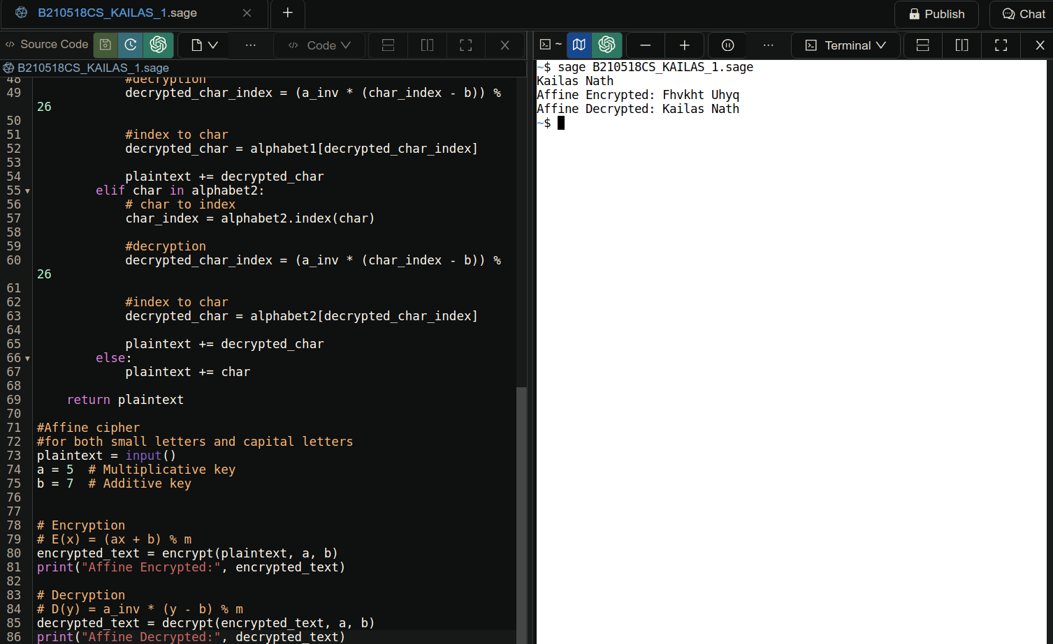

The Affine cipher is a type of substitution cipher that is part of the classical ciphers. It combines two separate transformations: one linear (multiplication) and one shift (addition). In this implementation, we use the Affine cipher to encrypt and decrypt text, allowing for both uppercase and lowercase letters.There are two main functions that are used here.

Encryption Function - encrypt(plaintext, a, b)

This function takes the plaintext to be encrypted, a multiplicative key a, and an additive key b as input.It transforms the plaintext into ciphertext using the Affine cipher formula.
The function handles both uppercase and lowercase letters, leaving non-alphabet characters unchanged.

Decryption Function - decrypt(ciphertext, a, b)

This function takes the ciphertext to be decrypted, a multiplicative key a, and an additive key b as input.It reverses the encryption process by applying the Affine cipher decryption formula.
The modular multiplicative inverse of a (inverse_mod(a,m)* ) is calculated within this function to correctly decrypt the ciphertext. The modular multiplicative inverse is crucial in Affine decryption because it ensures that the original plaintext can be accurately

*The inverse_mod function \is used to calculate the modular multiplicative inverse of an integer 'a' modulo another integer 'm.' It returns the value of 'x' that satisfies the equation: a * x ≡ 1 (mod m)

#2.HILL CIPHER
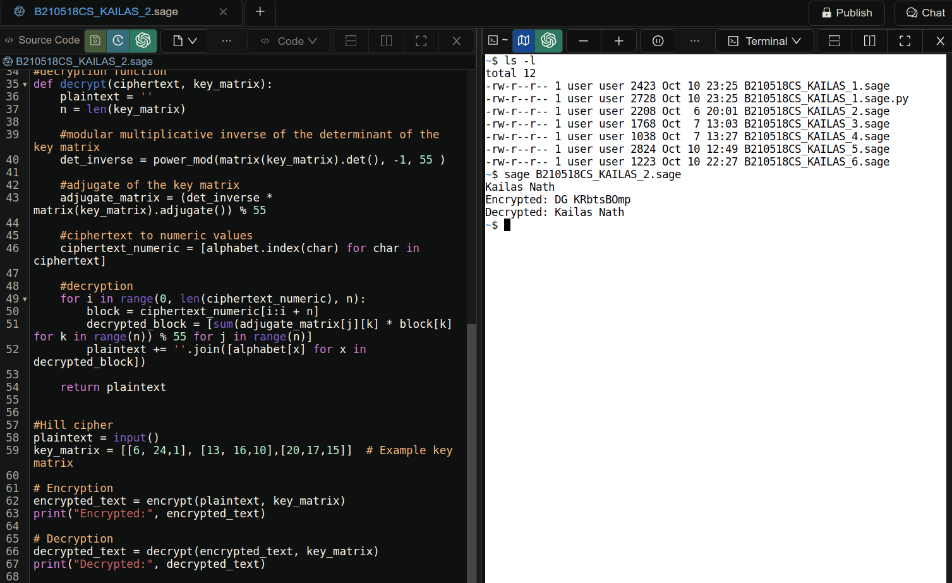
The Hill cipher is a polygraphic substitution cipher that uses a matrix to encrypt and decrypt messages. It encrypts block of letters and offers more security than affine ciphers. The key matrix should be a square matrix inorder for the encryption to work properly.

Encryption Function - encrypt(plaintext, key_matrix)

The encrypt function takes the plaintext and a key matrix as input and returns the corresponding ciphertext. This function is responsible for applying the Hill cipher encryption algorithm divides the input text into block and converts them into numeric value then appy the matrix multiplication and convert it back to the alphabetic form.

Decryption Function - decrypt(ciphertext, key_matrix)

The decrypt function applies the Hill cipher decryption algorithm to convert ciphertext back into plaintext. It requires the ciphertext and the original key matrix used for encryption as input. The function calculates the modular multiplicative inverse of the determinant of the key matrix* and uses the adjoint of the key matrix to perform decryption.

*det_inverse = power_mod(matrix(key_matrix).det(), -1, 55) finds the modular multiplicative inverse of the determinant of the key matrix, -1 indicates that the inverse has to be found and 55 is the modulo.

#3.SHIFT CIPHER
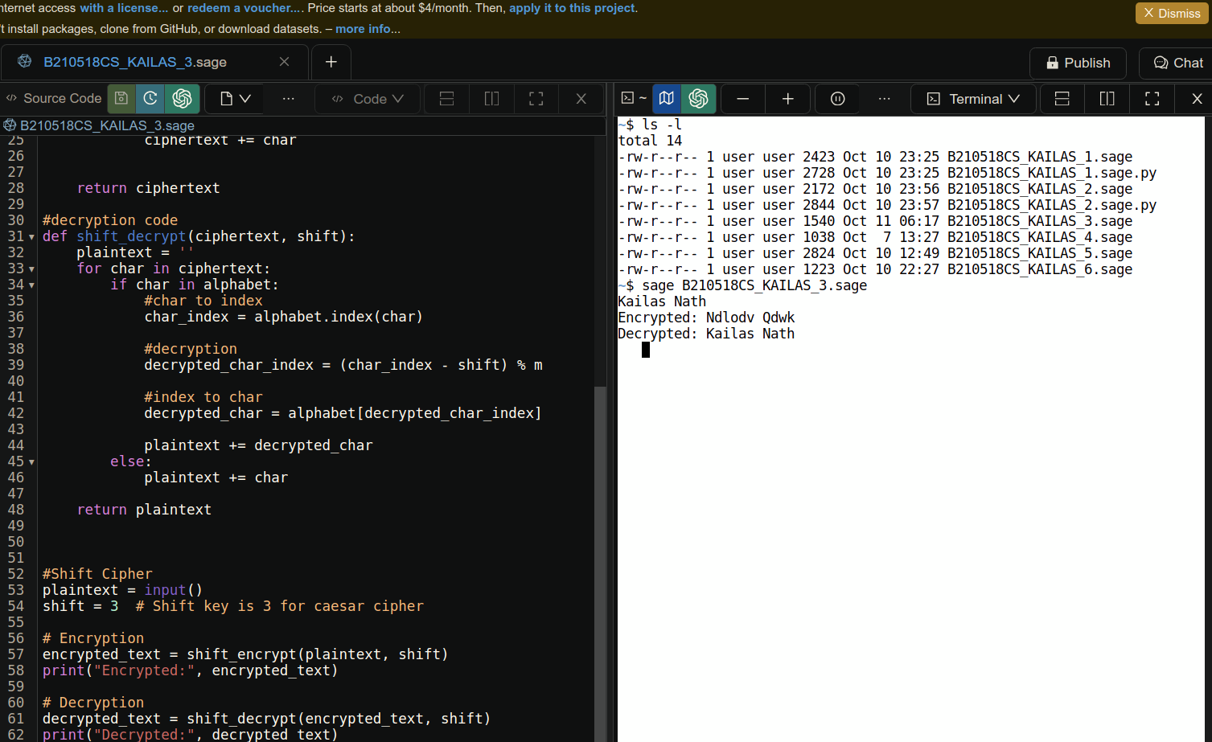
A shift cipher, also known as a Caesar cipher, is a simple substitution cipher where each letter is shifted a certain number of places down or up the alphabet. This type of cipher is named after Julius Caesar, who is historically known to have used a simple letter shift to protect his private messages.

Encryption Function - shift_encrypt(plaintext, shift)

The shift_encrypt function performs a basic shift cipher encryption on a given plaintext using the shift value 3. It shifts characters within a defined alphabet, and non-alphabet characters remain unaffected.

Decryption Function - shift_decrypt(ciphertext, shift)

The shift_decrypt function reverses the shift cipher encryption by applying a decryption shift value to the ciphertext. It restores the original plaintext by shifting characters within a predefined alphabet while leaving non-alphabet characters unchanged.

#4.SUBSTITUTION CIPHER
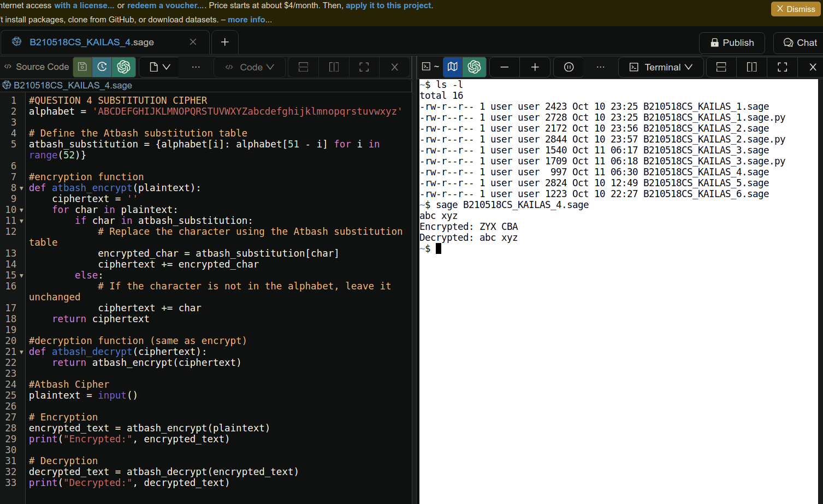
The Atbash Cipher, a type of substitution cipher that replaces each letter in the alphabet with its reverse counterpart. Here we have the code for that .

Encryption Function - atbash_encrypt(plaintext)

This function takes plaintext as input and transforms it into ciphertext using. Each character in the plaintext is replaced with its reverse counterpart from the alphabet. Non-alphabet characters remain unchanged. Here what happens is small letters become the capital counter parts and vice versa.

Decryption Function - atbash_decrypt(ciphertext)

The decryption function is essentially the same as the encryption function, as the Atbash Cipher is symmetric. It takes ciphertext as input and returns the original plaintext by applying the same reverse substitution.

#5.TRANSPOSITION CIPHER
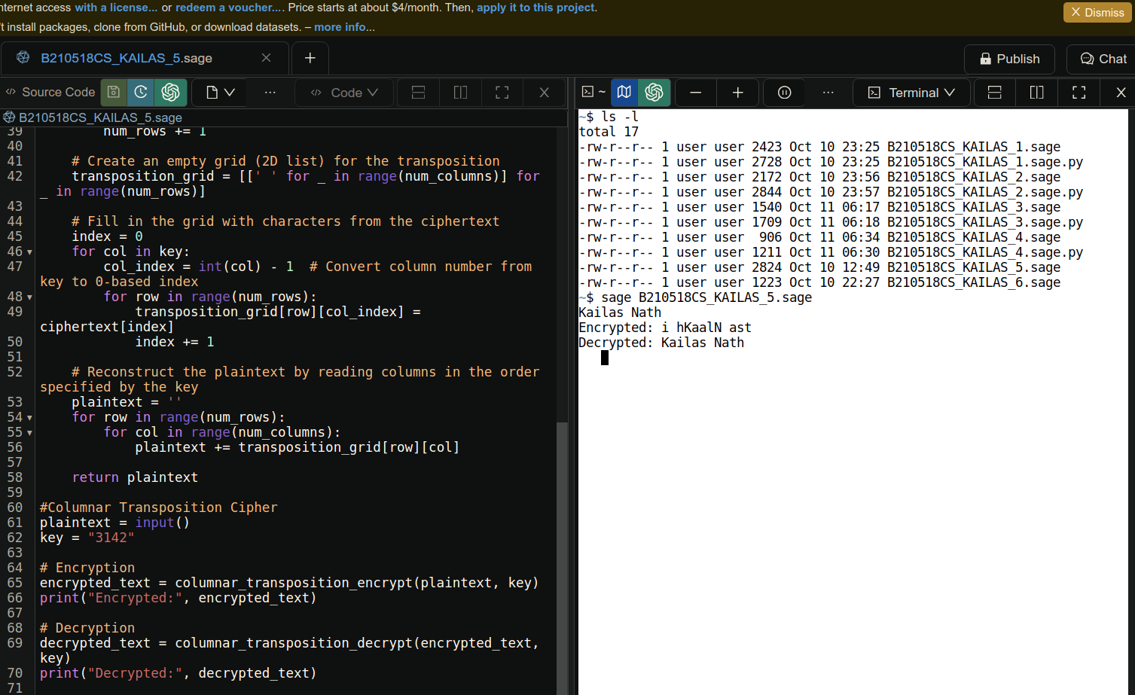
The Columnar Transposition Cipher, which is a transposition cipher where the order of the characters is rearranged according to a specific key. The code consists of two functions, one for encryption and the other for decryption.

columnar_transposition_encrypt(plaintext,key)

In the encryption process, the plaintext is first arranged in a grid. The grid has a number of columns determined by the length of the encryption key. The characters from the plaintext are filled into the grid row by row. Once the grid is filled, the ciphertext is generated by reading the columns in the order specified by the key.

columnar_transposition_decrypt(encrypted_text, key)

Decryption, on the other hand, is the reverse process. The ciphertext is first arranged in a grid, and the key is used to determine the column order. The characters are then read row by row from the grid to reconstruct the original plaintext.

#6.VIGENERE CIPHER
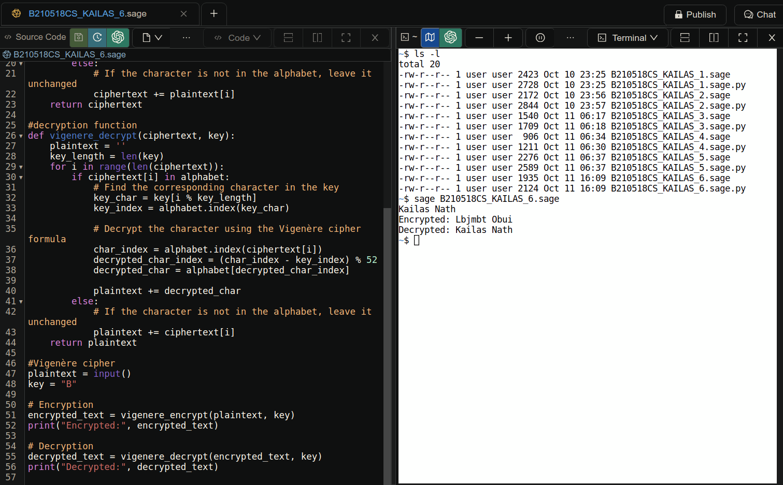
The Vigenère Cipher is a polyalphabetic substitution cipher that improves upon the Caesar Shift Cipher by using a keyword to vary the shift at each position in the plaintext. It's a more secure method of encryption.

Encryption Function - vigenere_encrypt(plaintext, key)

The encryption function takes the plaintext to be encrypted and a keyword as input. It applies the Vigenère cipher by shifting each character in the plaintext based on the corresponding character in the keyword. If the character is in the alphabet, it is shifted, and the result is appended to the ciphertext. If the character is not in the alphabet, it remains unchanged.

Decryption Function - vigenere_decrypt(ciphertext, key)

The decryption function takes the ciphertext and the same keyword used for encryption as input. It reverses the encryption process, shifting each character in the ciphertext back to the original plaintext character. The result is appended to the plaintext. Non-alphabet characters remain unchanged. The Vigenère Cipher is a more robust method of encryption than the Caesar Shift Cipher, as it uses a keyword to introduce variability in the shift, making it less susceptible to simple frequency analysis.

Cryptanalysis

#QUESTION 3 SHIFT/CAESAR CIPHER

#cryptanalysis, if i have an encrypted text ,then all possibilities are checked
for i in range(0,26):
s=i
de=shift_decrypt(encrypted_text,s)
print("shift=",i," ","text=",de)

#QUESTION 1 Affine cipher

#cryptanalysis
print("Cryptanalysis")
e_text=encrypted_text
possible_k1=[1,3,5,7,9,11,15,17,19,21,23,25]
possible_k2=[0,1,2,3,4,5,6,7,8,9,10,11,12,13,14,15,16,17,18,19,20,21,22,23,24,25]
for i in possible_k1:
for j in possible_k2:
t= decrypt(e_text,i,j)
print("multiplicative key=",i," additive=",j," possible text=",t)

#QUESTION 2 HILL CIPHER

Brute-Force Attack: Without knowledge of the key matrix size and values, a brute-force approach would involve trying all possible key matrices of a specific size, encrypting the plaintext with each, and checking if the decrypted text makes sense. It's important to note that the Hill Cipher can be quite secure if a large key matrix is used. To successfully cryptanalyze it, the attacker would need a substantial amount of ciphertext and potentially knowledge of the plaintext. The security of the Hill Cipher increases with the size of the key matrix, but it can still be vulnerable if the key matrix is small or not chosen carefully.

#QUESTION 4 SUBSTITUTION CIPHER

def atbash_decrypt(ciphertext):
plaintext = ''
for char in ciphertext:
if char in atbash_substitution
decrypted_char = atbash_substitution[char]
plaintext += decrypted_char
else:
plaintext += char
return plaintext

#QUESTION 5 TRANSPOSITION CIPHER

def ecrypt_bruteforce(ciphertext):
num_columns = len(ciphertext)
column_permutations = permutations(range(1, num_columns + 1))

for key in column_permutations:
decrypted_text = columnar_transposition_decrypt(ciphertext, ''.join(map(str, key)))
print("Key:", ''.join(map(str, key)), "Decrypted:", decrypted_text)

#QUESTION 6 VIENERE CIPHER

decrypt the Vigenere cipher using a variety of key lengths, guessing key characters based on the most frequent letters in each key position. The correct decryption key should produce a meaningful plaintext. Note that this is a simplified approach and may not be effective for long or complex texts. You might need more advanced techniques for more secure Vigenere ciphers.

