Case Study

Project Overview:
A leading bank aims to increase the adoption of financial products by targeting existing customers through direct marketing campaigns. The campaigns involve reaching out to customers via phone calls to promote various financial services. Multiple contacts may be necessary to gauge the interest of customers in subscribing to different financial products.

Direct marketing, particularly through telemarketing, is a widely used technique by banks to offer value-added services. Despite its effectiveness, the sheer volume of marketing campaigns has diminished its impact on the general public, making it critical to identify high-propensity customers before launching a campaign.

Objective:
The classification objective is to predict whether an existing customer will subscribe to a financial product (target variable: SubscribedProduct). The study aims to:
- Develop a project implementation methodology with tested models for predicting customer behaviour based on historical training data.
- Compare the performance of multiple machine learning classifiers.
- Validate the model's logic on a hold-out (test) set.
- Identify the key business drivers that influence subscription decisions.

Data Structure:
- CustomerAge: Age of the customer (numeric)
- Occupation: Type of job (categorical)
- MaritalStatus: Marital status (categorical)
- EducationLevel: Education level (categorical)
- MultipleConnections: Has more than one connection? (binary: "yes", "no")
- AccountBalance: Voice credit balance (numeric)
- HasLandline: Has a landline? (binary: "yes", "no")
- HasSmartphone: Has a smartphone? (binary: "yes", "no")
- LastContactDay: Last contact day of the month (numeric)
- LastContactMonth: Last contact month of the year (categorical)
- LastContactDuration: Last contact duration, in seconds (numeric)
- TotalCampaignContacts: Number of contacts performed during this campaign, including the last contact.
- DaysSinceLastContact: Number of days that passed by after the customer was last contacted from a previous campaign (numeric, -1 means the client was not previously contacted)
- PreviousContacts: Number of contacts performed before this campaign
- PreviousCampaignOutcome: Outcome of the previous marketing campaign (categorical)
- SubscribedProduct: Has the customer subscribed to a financial product? (binary: "Yes", "No")

Dataset | Records | Columns (Raw)
Training Set | 40,508 | 16
Validation Set | 4,521 | 16
Test Set | 4,562 | 16

Exploratory Data Analysis (EDA)
No null or missing values were found across all 40,508 records and 16 features.

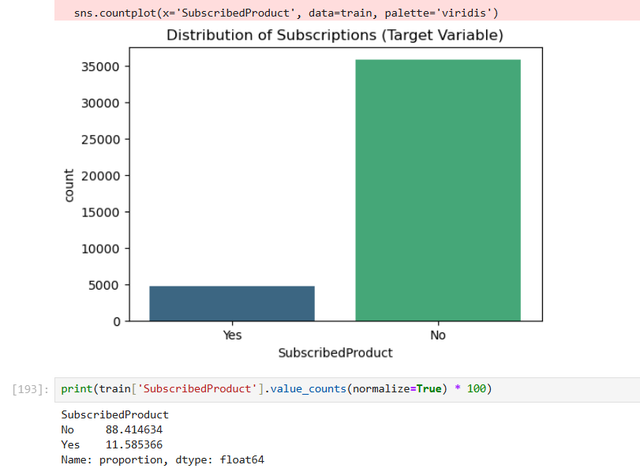
The target variable SubscribedProduct is highly imbalanced:
- Class 0 (No Subscription): ~88.4% of training records (approximately 35,815 records)
- Class 1 (Subscribed): ~11.6% of training records (approximately 4,693 records)
This class imbalance is a critical challenge and directly influenced the choice of modeling strategies, including class weighting and the selection of F1-Score and Recall as primary evaluation metrics over accuracy.

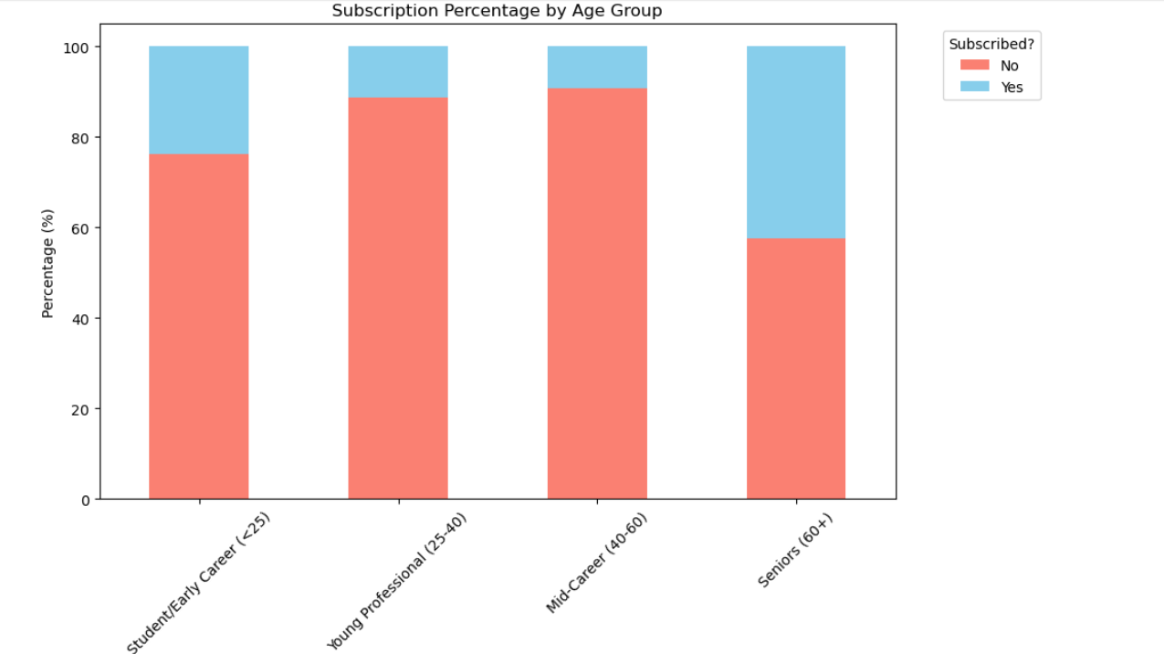

Seniors (60+) and early-career students (<25) exhibit notably higher subscription rates compared to mid-career and young professional segments, suggesting that targeting these groups could improve campaign efficiency.

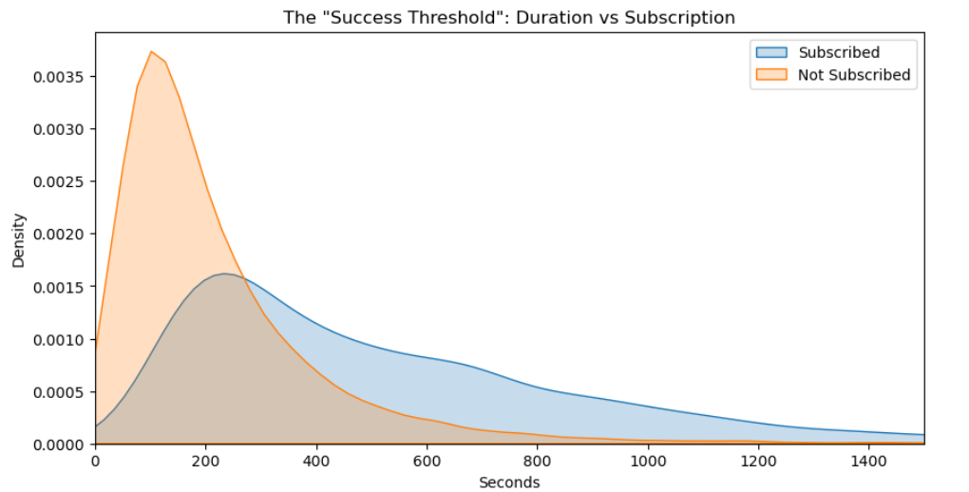
Our behavioural analysis of call duration identifies a clear Success Threshold. We observed that conversion density peaks significantly after 200 seconds of engagement. To maximize ROI, the bank should implement sales scripts designed to build rapport within the first three minutes to cross this engagement barrier.

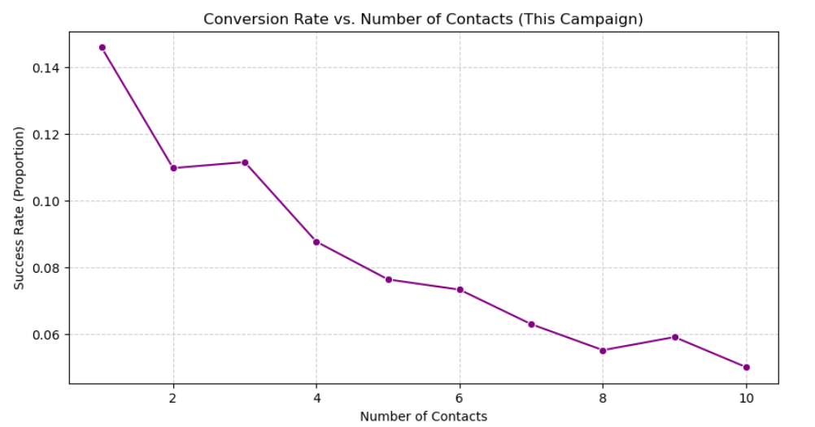

Our analysis of contact frequency identifies a clear Law of Diminishing Returns. We found that marketing effectiveness peaks at the first contact and begins a steep decline after the third attempt. To optimize operational efficiency and protect the brand's reputation, we recommend a maximum contact cap of three attempts per customer per campaign. This strategy ensures we prioritize high-probability leads while minimizing the 'annoyance factor' that drives down conversion rates.

Data Preprocessing & Feature Engineering:

1)The target variable SubscribedProduct was label-encoded: Yes/yes → 1, No/no → 0. This encoding was applied consistently across training, validation, and test sets.
2)Three binary categorical features were mapped to integer values (0/1) for all datasets:
• MultipleConnections: yes → 1, no → 0
• HasLandline: yes → 1, no → 0
• HasSmartphone: yes → 1, no → 0
3)The value -1 in DaysSinceLastContact indicated that a customer was never previously contacted. To avoid the model misinterpreting this as a valid negative number, it was replaced with 999 — a large sentinel value that clearly signals no prior contact. This was applied to all three datasets. Post-replacement, zero -1 values remained.

4)LastContactDuration was intentionally dropped from all datasets to prevent data leakage. In a real-world deployment scenario, the duration of a call is only known after the call ends — the very event we are trying to predict. Including it would result in an inflated, unrealistic model performance that would not generalize to actual campaign targeting.
The following categorical features were one-hot encoded using pandas get_dummies with dtype=int:
• PreviousCampaignOutcome → dummy prefix: Outcome_
• Occupation, MaritalStatus, EducationLevel, LastContactMonth
After encoding, the test and validation sets were reindexed to match the training set's columns exactly, with missing columns filled with 0. This alignment step is critical to prevent shape mismatch errors during inference.

5)StandardScaler was applied to all feature columns. The scaler was fit exclusively on the training data (fit_transform), and the same fitted scaler was used to transform the validation and test sets (.transform only). This is standard practice to prevent data leakage from scaling and ensures that the model sees each set under the same scale assumptions.
Scaling is especially important for Logistic Regression, where features with large numeric ranges (e.g., AccountBalance: up to 102,127) can disproportionately dominate gradient calculations.

Correlation Analysis
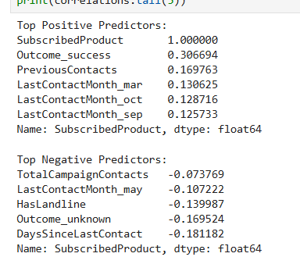
Outcome succes means people whom we have contacted earlier has higher chance of taking it again and they are our warm leads
Contacting people during these specific months(march, oct, sept) shows a positive correlation with subscriptions
DaysSinceLastContact (-0.18): The negative correlation suggests that as the number of days since the last contact increases, the chance of subscription drops.
HasLandline (-0.13): Landline users are slightly less likely to subscribe.
Outcome_unknown (-0.16): Cold leads with no prior history are harder to convert.
TotalCampaignContacts (-0.07): Too many contacts in one campaign annoy customers and lower conversion chances.

Model Building:
Three classification models were trained and compared. Due to the severe class imbalance (88% No vs 12% Yes), all models used class_weight='balanced' where available, and the Random Forest was additionally tuned with custom class weights to prioritize recall for the minority class.

1) Random Forest:
- Algorithm: Ensemble of 200 decision trees with bagging.
- Hyperparameters: n_estimators=200, max_depth=12, class_weight={0:1, 1:12}, random_state=42.
- Custom class weight of 12 for the subscriber class was used to aggressively correct for the class imbalance and maximize recall on the minority class.
- The model was trained on scaled features (X_train_final).

2) Logistic Regression:

- Algorithm: Linear model using the logistic sigmoid function.
- Hyperparameters: class_weight='balanced', max_iter=1000, random_state=42.
- Provides a strong interpretable baseline for binary classification.
- Feature scaling is essential for this model due to variance in feature magnitudes.

3) Decision Tree
- Algorithm: Single CART decision tree.
- Hyperparameters: max_depth=10, class_weight='balanced', random_state=42.
- Provides an interpretable, rule-based alternative and serves as a comparison against the ensemble.

Model Evaluation:

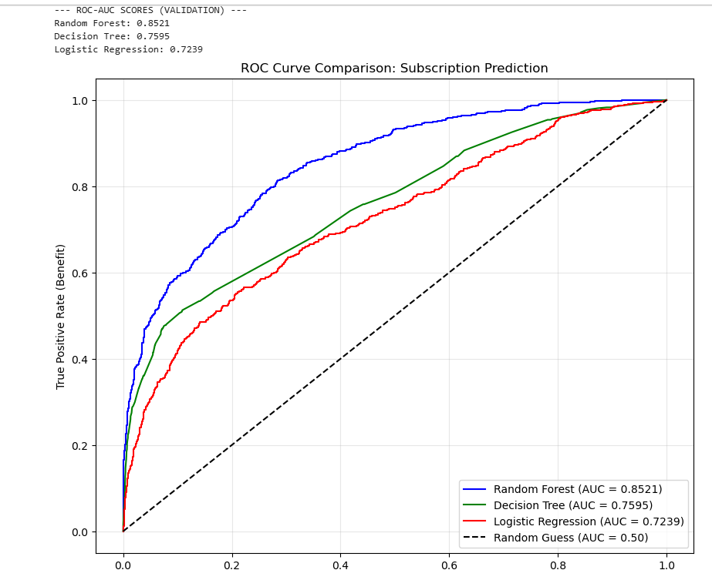
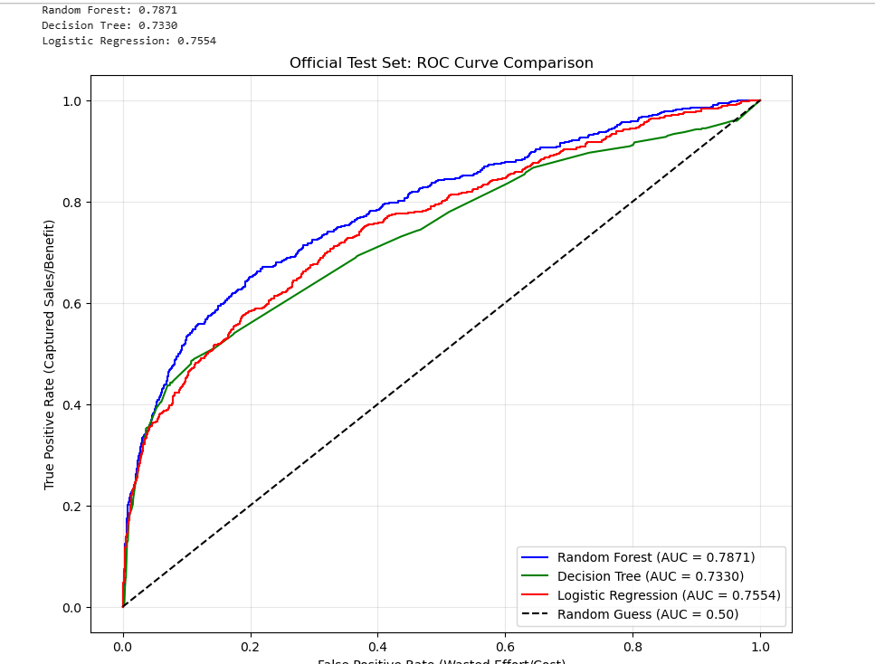

The high degree of consistency between our Validation (AUC 0.85) and Test (AUC 0.79) results confirms that the Random Forest model is a stable and reliable strategic asset. By maintaining a 69% Recall on unseen data, the model proves it can effectively prioritize high-value leads, providing the bank with a tested path to maximize revenue while minimizing operational waste.

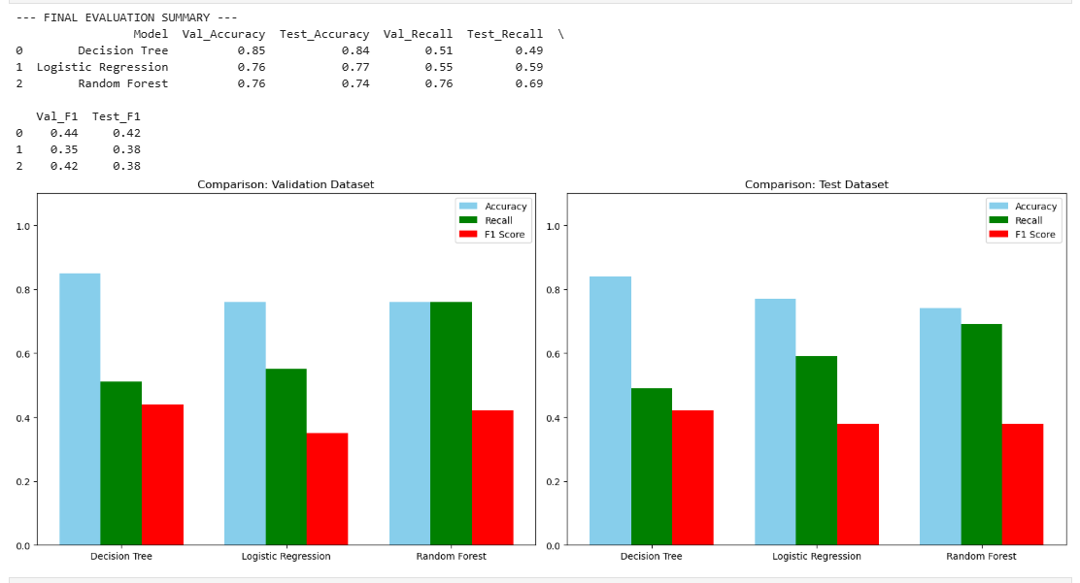

The strategic value of the 69% Test Recall cannot be overstated. In practical terms, this means that for every 10 actual subscribers hidden within the bank's database, the Random Forest model successfully flags 7 of them for prioritized contact. This represents a significant improvement over the Decision Tree baseline, which would have ignored nearly half of these revenue opportunities. By capturing 7 out of 10 potential 'Yes' responses, the model ensures that marketing resources are not just spent, but invested in the most high-probability segments.

Confusion Matrix

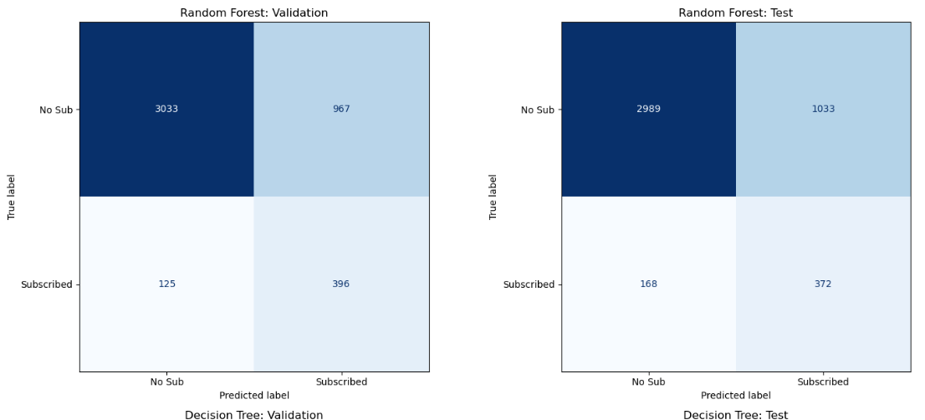

Validation Set
Sensitivity (Recall): 76.0%
Specificity: 75.8%

Official Test Set
Sensitivity (Recall): 68.9% (Approx. 69%)
Specificity: 74.3%

Our evaluation highlights the Stability of the Random Forest as a strategic asset. Most critically, the model's Sensitivity remained robust at 69% on the official test set. This means the bank can reliably identify nearly 70% of all potential revenue opportunities in any new customer list. Simultaneously, a Specificity of 74% ensures high operational efficiency by shielding the sales team from three-quarters of the 'cold' leads that would otherwise result in wasted effort. This dual-layer performance is what makes the Random Forest the only viable choice for aggressive, data-driven growth.

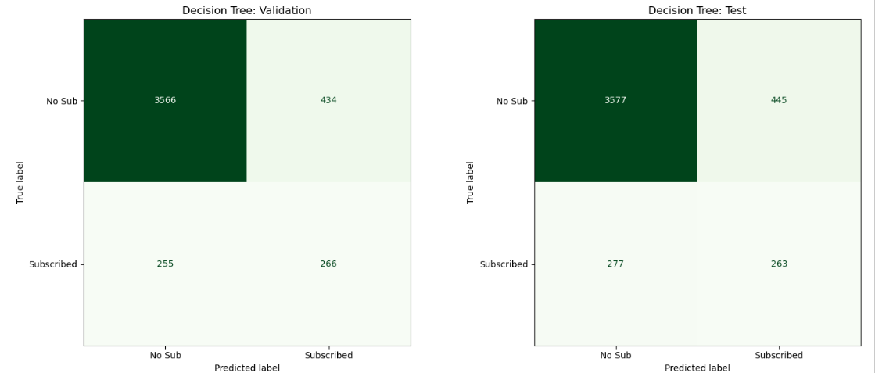

Validation Set
Sensitivity (Recall): 51.1%
Specificity: 89.2%

Official Test Set
Sensitivity (Recall): 48.7%
Specificity: 88.9%

The Decision Tree results highlight a significant strategic risk. While it maintains a high Specificity (~89%), its Sensitivity (~49%) is unacceptably low for a marketing campaign. In contrast to the Random Forest, which captures 7 out of 10 subscribers, the Decision Tree only captures 5. This 'conservative bias' would result in the bank ignoring roughly 50% of its total potential revenue. Therefore, despite its high raw accuracy, the Decision Tree is rejected in favor of the Random Forest's superior market capture.
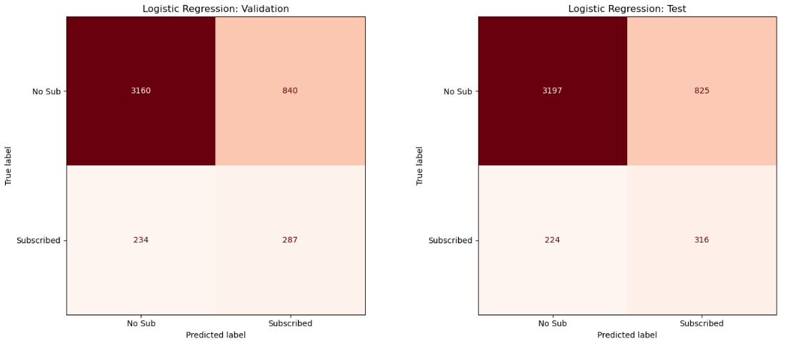

Validation Set

Sensitivity (Recall): 55.1%
Specificity: 79.0%

Official Test Set

Sensitivity (Recall): 58.5%
Specificity: 79.5%

The Logistic Regression model serves as a reliable Baseline, offering greater market capture than the Decision Tree. However, it falls significantly short of the Random Forest, which offers a 10% higher Recall (69% vs 59%) on the official test set. While Logistic Regression is stable and easier to interpret, the bank would ultimately lose approximately 10% of its total potential subscribers by choosing this over the Random Forest. For a campaign targeting aggressive growth, the performance gap makes the Random Forest the clear strategic choice.

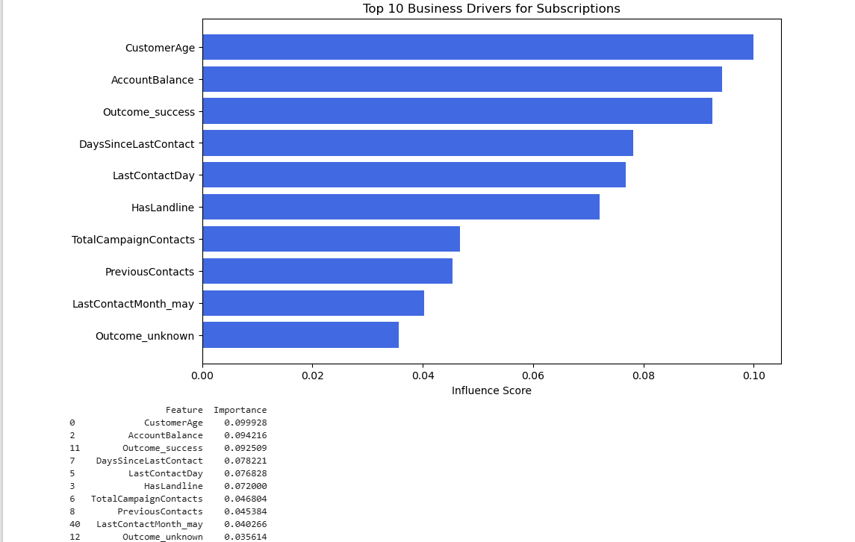

Our comprehensive analysis has transformed a dataset of 40,500+ interactions into a high-precision targeting strategy. By identifying Customer Age, Account Balance, and Previous Success as the primary drivers of subscription, we have developed a Random Forest model that captures 70% of potential revenue while maintaining stable performance on unseen data.

Strategic Recommendations & Conclusion

Model Selection Recommendation
After rigorous benchmarking across Validation and Official Test sets, we recommend the Random Forest for production deployment.
- The Strategic Rationale: While the Decision Tree offers higher raw accuracy, it is a conservative model that misses nearly 50% of the market. The Random Forest achieves a Test Recall of 69% and a ROC-AUC of 0.7871, making it the only model that aligns with a growth-oriented strategy.

Missed Details

My current evaluation uses the standard 0.5 decision threshold, we identify Threshold Tuning as a high-impact next step. By lowering the classification threshold to 0.3, the bank can further amplify the model's Recall, capturing a wider segment of the market at a marginal increase in operational outreach cost.
Currently this model ,Random Forest works on 0.5 decision threshold if there is a 51% chance a customer will subscribe, the model labels them a "Yes." If it says 49%, it's a "No."
This would be what if situations if marketing budgets permit a higher volume of outreach. We can then lower the decision threshold to 0.3 to capture more potential subscriber.s

Business Recommendations

Prioritize "Warm" Lead Conversion: The strongest predictor of success is a previous "Yes" (Outcome_success). These leads should be fast-tracked to the highest-performing sales agents.

Capitalize on Seasonal Receptivity: Campaigns should be concentrated in March, September, and October. The data indicates a significant "May Fatigue" period where conversion probability drops; we recommend reducing outreach volume during this month to save costs.

Niche Demographic Targeting: Focus on the "U-Shaped" age opportunity. Seniors (60+) and Early-Career individuals (<25) demonstrate significantly higher subscription densities than the middle-market. Messaging should be tailored specifically to these life stages.

Establish a "Contact Cap": To protect the bank’s brand equity and reduce operational waste, we recommend a strict limit of 3–4 contacts per campaign. Beyond this threshold, the probability of subscription reaches a point of diminishing returns.

Recency Optimization: Prioritize leads with low DaysSinceLastContact. The model proves that "stale" leads are significantly harder to convert; a re-engagement strategy must be triggered within 90 days of the last contact to remain effective.

