Beamline Characterization: L/D Ratio & Intrinsic Blur
Contents
1. Overview and Experimental Challenges 1
2. Edge Spread Function Measurements 1
Measurement 1: Near-Contact (Distance = 50.0 mm) 1
Measurement 2: Flight Tube (Distance = 2800.0 mm) 2
3. The Two-Point Solution 2
4. Final Results 3

1. Overview and Experimental Challenges
I summarized the methodology used to calculate a first estimation of L/D ratio and intrinsic blur of the ORCHD neutron imaging beamline during the 2nd CROCUS campaign. Initial calculations using a standard single-point Edge Spread Function (ESF) calculation were skewed by the use of a 5 cm thick borated plastic block. The thickness of this object introduced several physical artifacts:
- Parallax Effect: Misalignment of the thick block creates a slanted shadow, artificially widening the projected edge.
- Built-in Geometric Blur: The front face of the 5 cm block is set back from the detector, meaning the 'near-contact' measurement still contained significant geometric divergence.
- Scatter Halo: Borated plastic scatters neutrons, creating a localized glow that softens the sharp edge required for accurate baseline calculations.

2. Edge Spread Function Measurements
Despite these challenges, edge profiles were successfully extracted at two different distances using a robust center-out search algorithm to filter distant plateau noise. The red line depict the line used to fit the ESF function in both cases.

Measurement 1: Near-Contact (Distance = 50.0 mm)
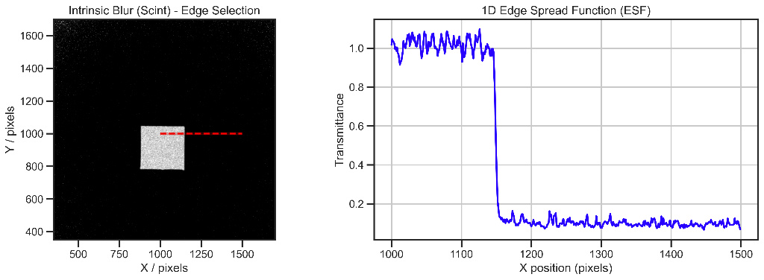
Calculated Total Blur (B_tot1): 0.953 mm. Note that this value is higher than the theoretical limit of the Li6F:ZnS scintillator (few hundreds of μm) because it includes the geometric blur caused by the 50 mm gap and neutron scatter.

Measurement 2: Flight Tube (Distance = 2800.0 mm)
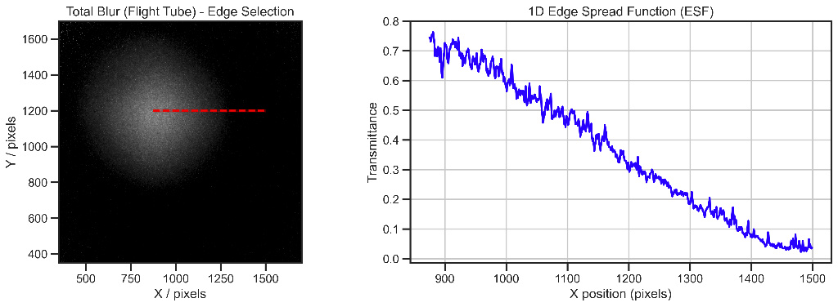
Calculated Total Blur (B_tot2): 43.211 mm. The massive, sweeping slope seen in the ESF is dominated by the geometric divergence of the neutron beam over the 2.8-meter flight path, just at the exit of the aluminum flight tube and outer shell concrete as seen in the pictures below.
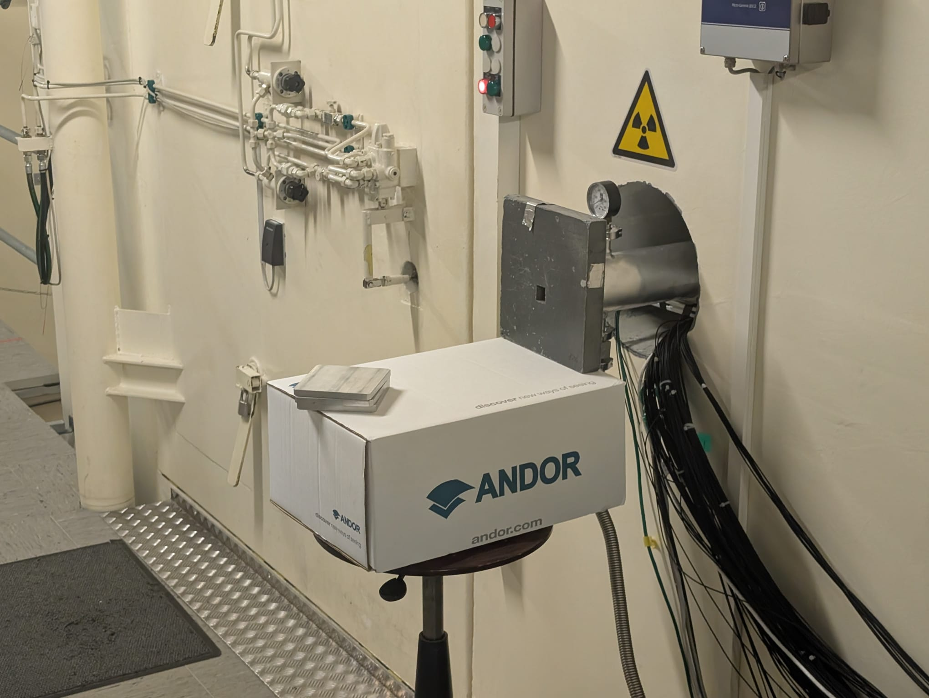
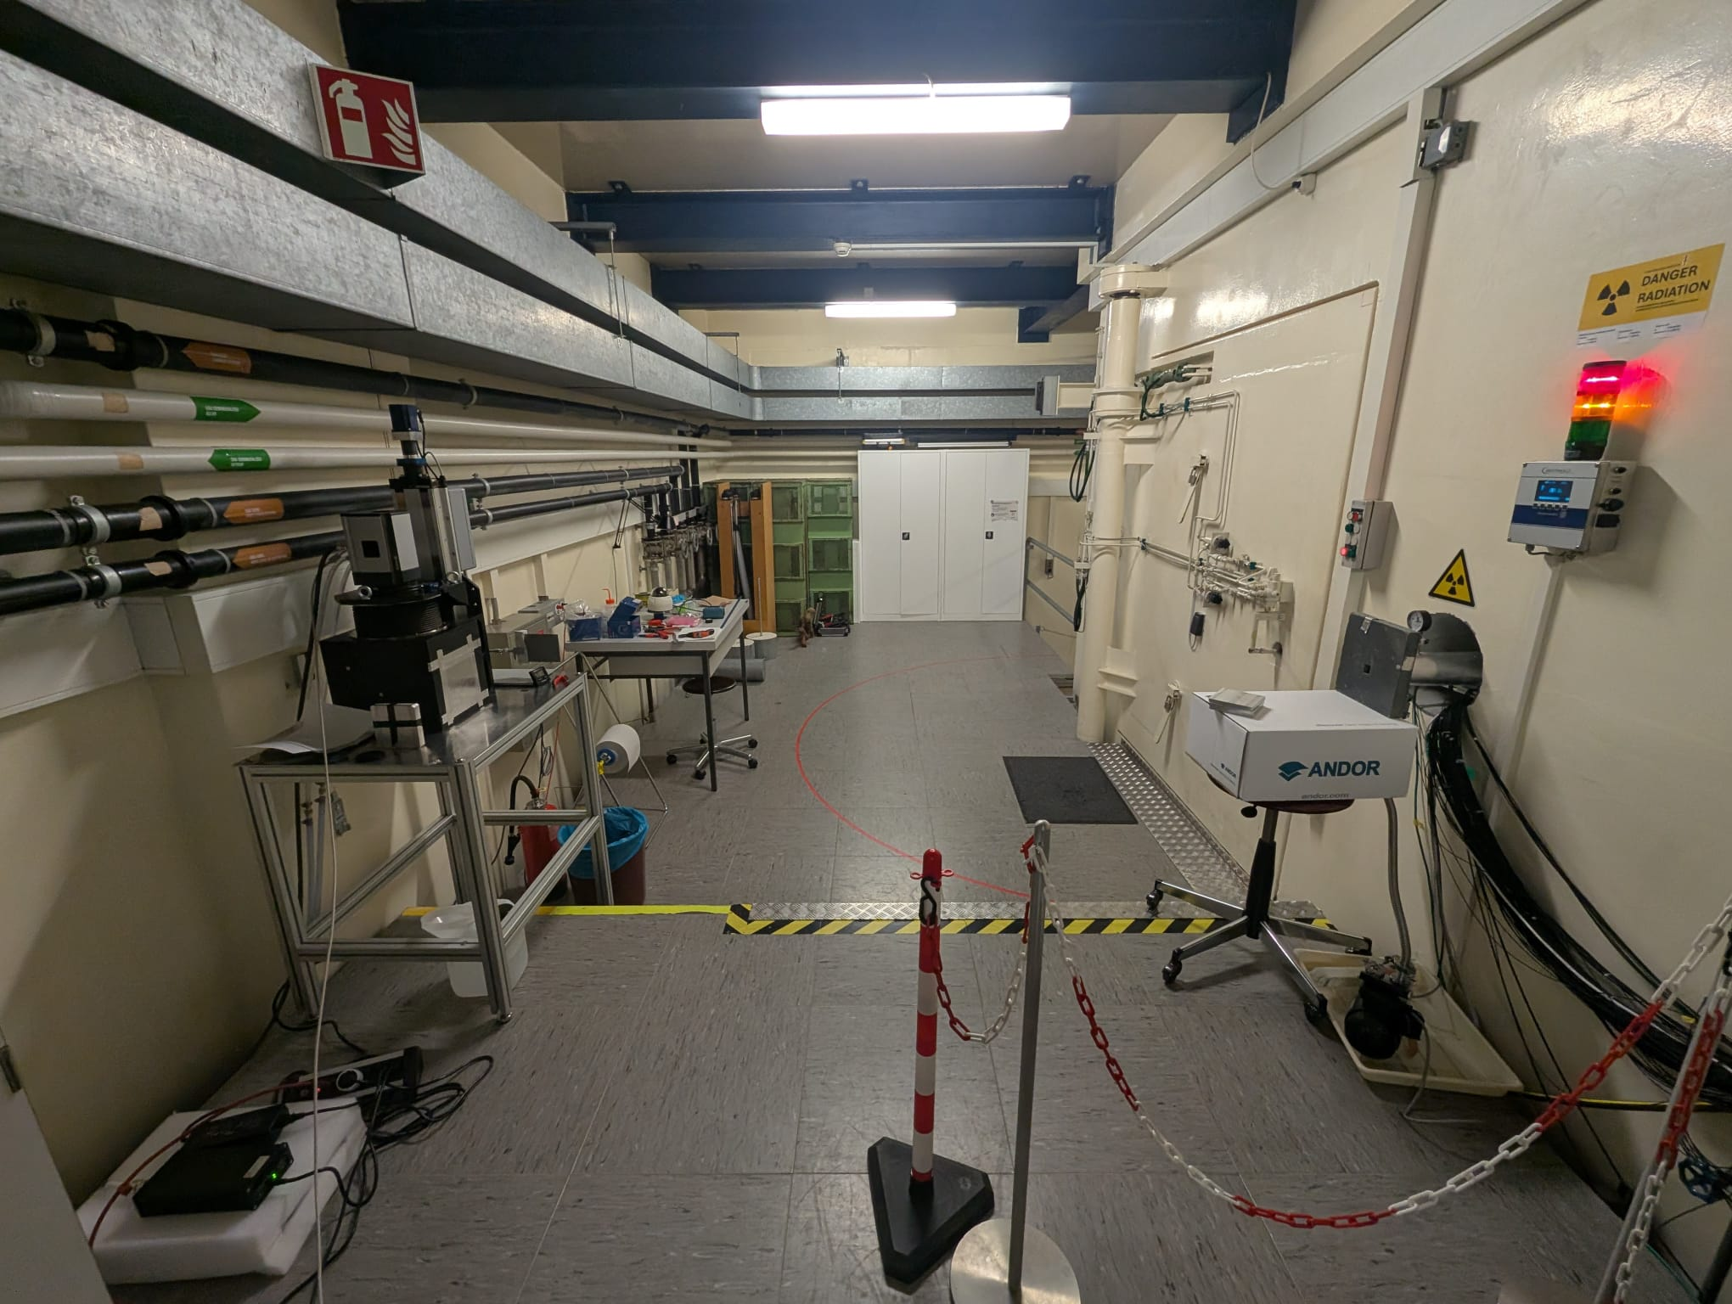

3. The Two-Point Solution
Because the thick block introduces a known geometric offset, we cannot assume B_geo = 0 at the detector. Instead, we set up a system of equations taking advantage of the two measurements at known distances to mathematically isolate the true intrinsic blur (B_int) and the beam divergence ratio (R = D/L).
The governing equation for total blur is:
B_tot² = B_int² + (l × R)²
Substituting our two experimental data points yields the following system:
- 1) 0.953² = B_int² + (50 × R)²
- 2) 43.211² = B_int² + (2800 × R)²

4. Final Results
Solving the system of equations successfully strips away the geometric divergence penalty caused by the 50 mm gap. The corrected characterization values are:
• Calculated Intrinsic Blur (B_int): 0.560 mm
• Estimated L/D Ratio: 64.8
Conclusion: An L/D of ~65 is a realistic and expected figure for a high-flux setup. Furthermore, by using the two-point method, the estimated intrinsic blur was reduced from ~1 mm to 0.560 mm. This brings it much closer to the physical limits of the Li6F:ZnS screen, proving that the two-point mathematical correction successfully mitigates the parallax and gap errors introduced by using a 5 cm thick scattering object.

