Preliminary Tests of the PSI MIDI Box for Neutron Imaging
Date: April 7 2026
Author: Michel Saliba, PhD Candidate, LRS-EPFL
Contents
Introduction 1
Experimental Tests and Results 1
2.1 Dark Current Evaluation 1
2.2 Beam Alignment and Light Tightness 2
Conclusion 2

Introduction
The MIDI box is a specialized dark box designed by the Paul Scherrer Institute (PSI) specifically for conducting neutron imaging experiments. The enclosure provides a secure holder for the scintillation sheet while allowing the camera to be positioned off-axis from the main radiation beam. This off-axis geometry is achieved using an internal mirror positioned at a 45-degree angle.
On April 7th, initial testing was conducted by Michel Saliba, a PhD candidate at LRS-EPFL, to verify the operational integrity and optical tightness of the newly acquired MIDI box from PSI.

Experimental Tests and Results
Initial diagnostics were performed to evaluate the baseline noise of the camera and to check for any potential light leaks within the experimental setup.

2.1 Dark Current Evaluation
The first test involved capturing an image without an active beam to establish the baseline sensor noise. As shown in Figure 1, the recorded counts indicate a standard dark current count rate. This result is expected and is similar to the data acquired during a closed-shutter configuration.

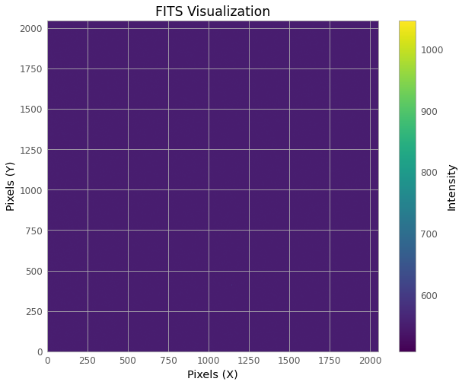
Figure 1 - Picture acquired by the camera inside the MIDI box, demonstrating baseline dark current.

2.2 Beam Alignment and Light Tightness
A subsequent exposure was taken with the active neutron beam. The resulting image ( Figure 2)demonstrates excellent optical isolation. The data clearly shows that the only light detected by the camera is originating directly from the scintillation process. Crucially, there is no evidence of external light leaking around the edges of the scintillator screen.

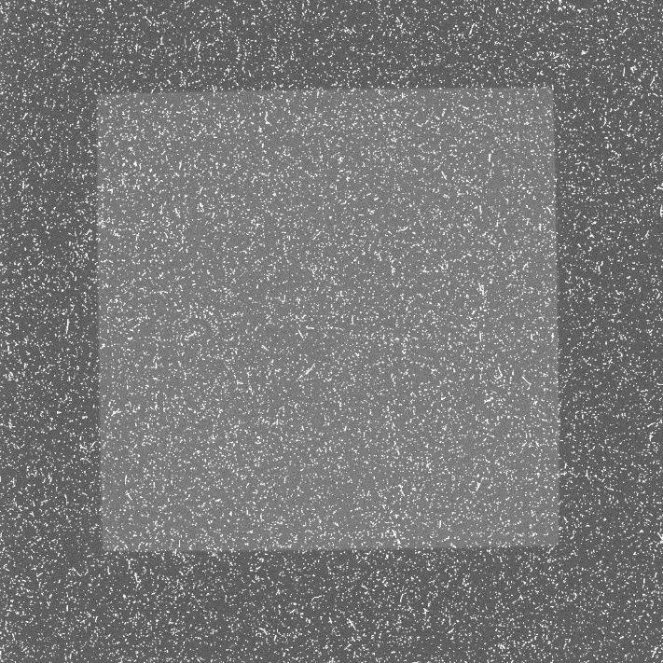
Figure 2 - Image acquired with an active neutron beam, confirming that detected light is strictly limited to scintillation with no surrounding light leakage.

Conclusion
The preliminary tests indicate that the PSI MIDI box is functioning as intended. The internal mirror and off-axis camera position successfully capture the scintillation, the baseline dark current is within expected closed-shutter parameters, and the enclosure is properly sealed against external light leaks.

