Furkan Salık – 150200056

**Part 2)**

$y\left(t\right)=t^{2}x(t+10)$

It is not memoryless, since the system depends on inputs other than the present.

It is non-invertible since we cannot uniquely identify $x(t)$ for $t=0$.

It is not causal since it depends on future inputs.

It is not stable since a bounded input yields unbounded output, because of $t^{2}$ part.

$y\left(t\right)=7x^{2}\left(t\right)+5x\left(t\right)+3$

It is memoryless, since it depends on only the present input.

It is not invertible since some 2 inputs may lead to the same outputs.

It is causal since it does not depend on future inputs.

It is stable since for $x\left(t\right)<B,$ $y\left(t\right)<2B^{2}+5B+3$, so the outputs are bounded.

$y\left[n\right]=\sum_{m=-∞}^{n}{x[m]}$

It is not memoryless since it depends on past inputs.

It is invertible, since distinct inputs lead to distinct outputs, and its inverse is $y\left[n\right]=x\left[n\right]-x[n-1]$

It is causal since it does not depend on future inputs.

It is not stable since output is unbounded for a bounded input.

$y\left[n\right]=0.5x\left[6n-2\right]+0.5x[6n+2]$

It is not memoryless since it depends on inputs other than the present.

It is not invertible since $x[6n-2]$ and $x[6n+2]$ pairs are interchangeable, so it is not possible to uniquely form $x[n]$ using $y[n]$.

It is not causal since for $n≥0$, it depends on future inputs.

It is stable since for $x\left[6n-2\right]<B and x\left[6n+2\right]<B,$ $y\left(t\right)<0.5B+0.5B$, so the outputs are bounded.

**Part 3)**

$$y\left[n\right]=a_{0}x\left[n\right]+a_{1}x\left[n-1\right]+a_{2}x\left[n-2\right]+a_{3}x[n-3]$$

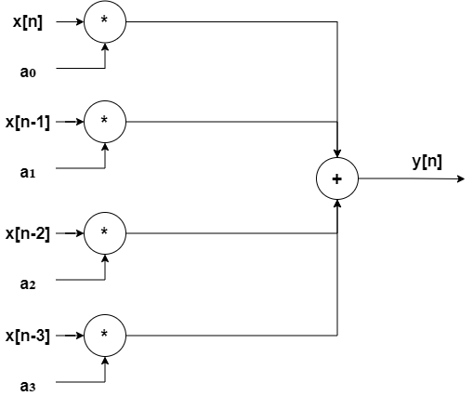

**B)** Let largest one among the products be $a_{0}x[n]$ and be bounded by $B$. ($a_{0}x\left[n\right]<B$). Then, at maximum, $y\left[n\right]=B+B+B+B$, so the outputs would also be bounded. Therefore, the system is BIBO stable for all real numbers $a_{0},a_{1},a_{2},a_{3}$.

**C)**

**A)**

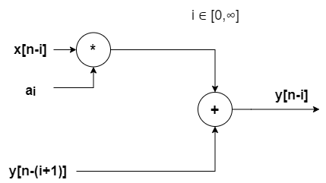

In the diagram above, $i$ must be initially $0$ to maintain the desired order of coefficients (from 0 to ∞).

**B)** The system is not BIBO stable since for a bounded input, the output is unbounded and goes to infinity.