**Glossary**

Anaconda

is a free and open-source[6] distribution of the Python and R programming languages for scientific computing (data science, machine learning applications, large-scale data processing, predictive analytics, etc.), that aims to simplify package management and deployment.

Dynamically typed languages

A language is dynamically-typed if the type of a variable is checked during run-time. Common examples of dynamically-typed languages includes JavaScript, Objective-C, PHP, Python, Ruby, Lisp, and Tcl.

In Dynamically typed languages, variables are bound to objects at run-time by means of assignment statements, and it is possible to bind the same variables to objects of different types during the execution of the program.

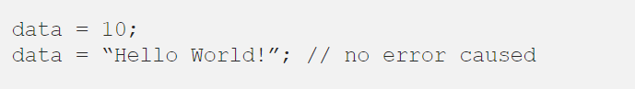

Functions

Function is block of code that is also called by its name. (independent)

The function can have different parameters or may not have any at all. If any data (parameters) are passed, they are passed explicitly.

It may or may not return any data.

Function does not deal with Class and its instance concept.

High Level Language

A high-level language is a programming language designed to simplify computer programming. It is "high-level" since it is several steps removed from the actual code run on a computer's processor. High-level source code contains easy-to-read syntax that is later converted into a low-level language, which can be recognized and run by a specific CPU.

Jupyter Notebook

The Jupyter Notebook is an open source web application that you can use to create and share documents that contain live code, equations, visualizations, and text.

Kernal

A notebook kernel is a “computational engine” that executes the code contained in a Notebook document. The ipython kernel, referenced in this guide, executes python code. Kernels for many other languages exist

Python Method

Method is called by its name, but it is associated to an object (dependent).

A method is implicitly passed the object on which it is invoked.

It may or may not return any data.

A method can operate on the data (instance variables) that is contained by the corresponding class

Pandas DataFrames

Data structures that contain:

* **Data** organized in **two dimensions**, rows and columns
* **Labels** that correspond to the **rows** and **columns**

Static typed languages

A language is statically-typed if the type of a variable is known at compile-time instead of at run-time. Common examples of statically-typed languages include Java, C, C++, FORTRAN, Pascal and Scala.

In Statically typed languages, once a variable has been declared with a type, it cannot ever be assigned to some other variable of different type and doing so will raise a type error at compile-time(some IDE’s generally shows a Red Cross mark denoting the error).

Java Example

Statically-typed languages require you to declare the data types of your variables before you use them

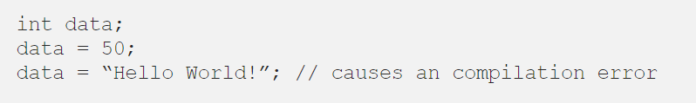

**Resources and Issues**

Saving Jupyter Notebook to alternative location:

<https://stackoverflow.com/questions/41110338/how-to-save-a-file-into-a-directory-in-jupyter-notebook>

Rmarkdown Cheat Sheet

<https://www.code2bits.com/cheat-sheet-markdown/>

Difference between randrange and randint

<https://www.codecademy.com/forum_questions/521bcf2b548c359b28000367>

String Formatting

String objects have one unique built-in operation: the % operator (modulo). This is also known as the string formatting or interpolation operator. Given format % values (where format is a string), % conversion specifications in format are replaced with zero or more elements of values.

<https://docs.python.org/3/library/stdtypes.html#old-string-formatting>