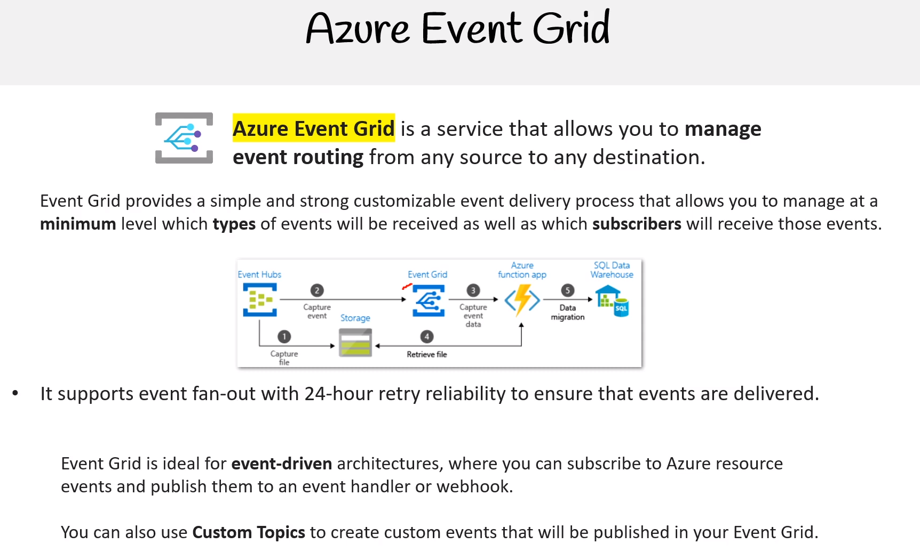

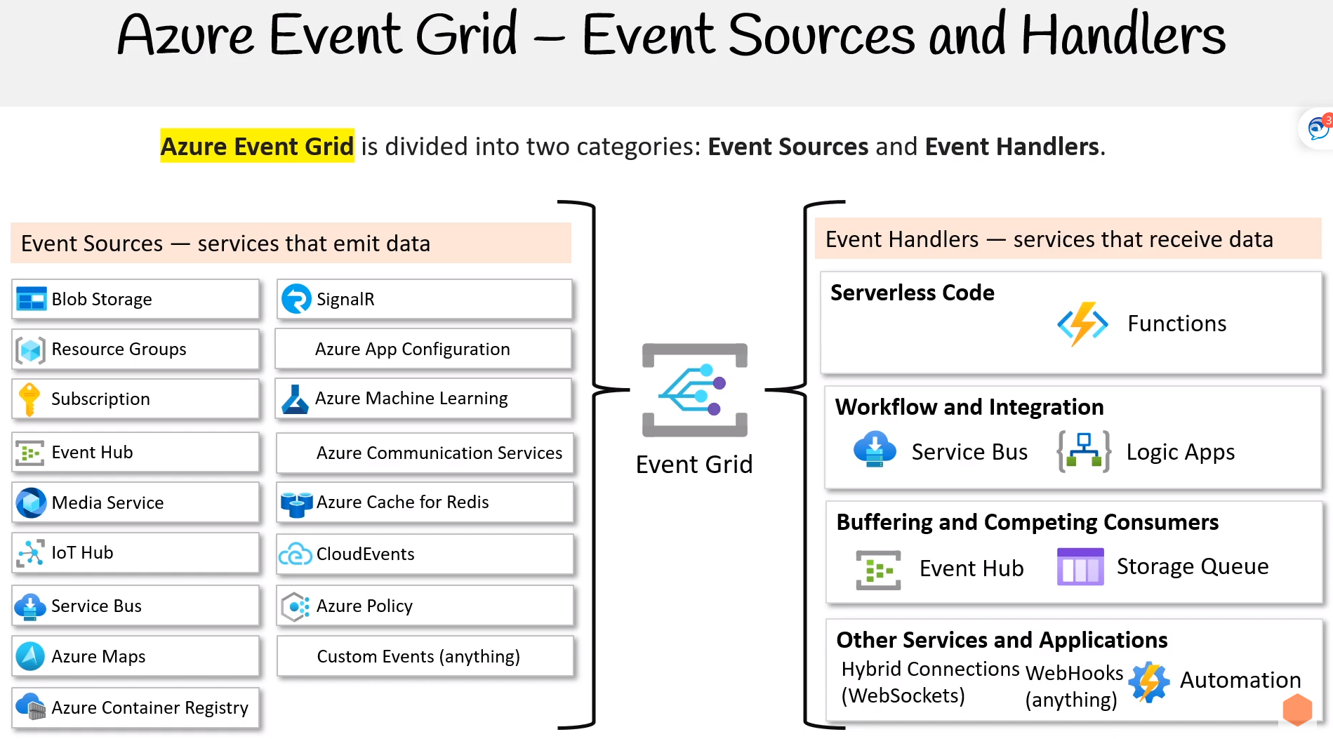

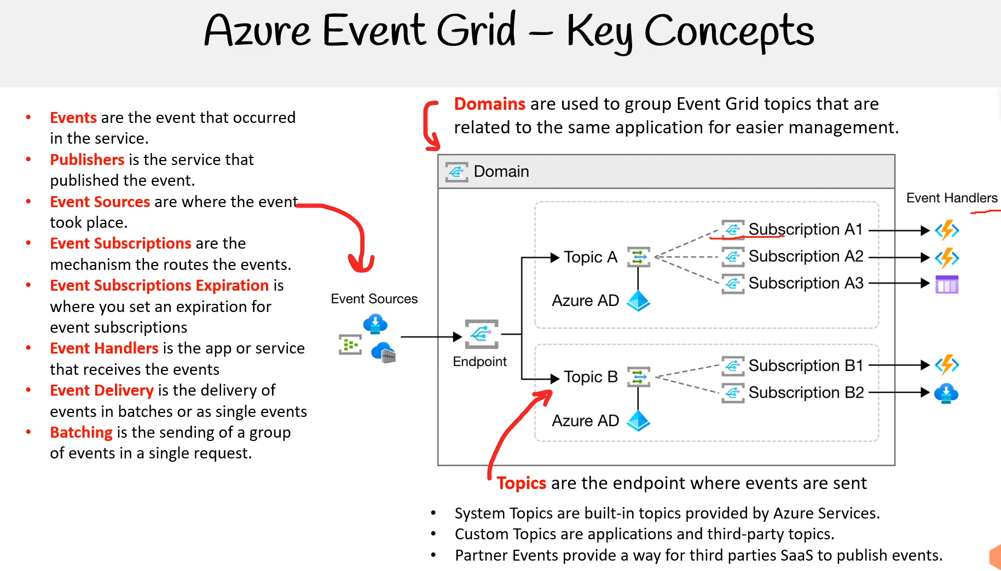

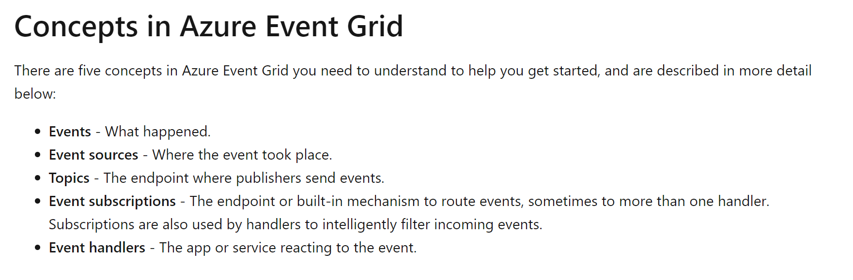

Events consist of a set of four required string properties. The properties are common to all events from any publisher. The data object has properties that are specific to each publisher. For system topics, these properties are specific to the resource provider, such as Azure Storage or Azure Event Hubs.

Event sources send events to Azure Event Grid in an array, which can have several event objects. When posting events to an Event Grid topic, the array can have a total size of up to 1 MB. Each event in the array is limited to 1 MB. If an event or the array is greater than the size limits, you receive the response 413 Payload Too Large. Operations are charged in 64 KB increments though. So, events over 64 KB will incur operations charges as though they were multiple events. For example, an event that is 130 KB would incur charges as though it were 3 separate events.

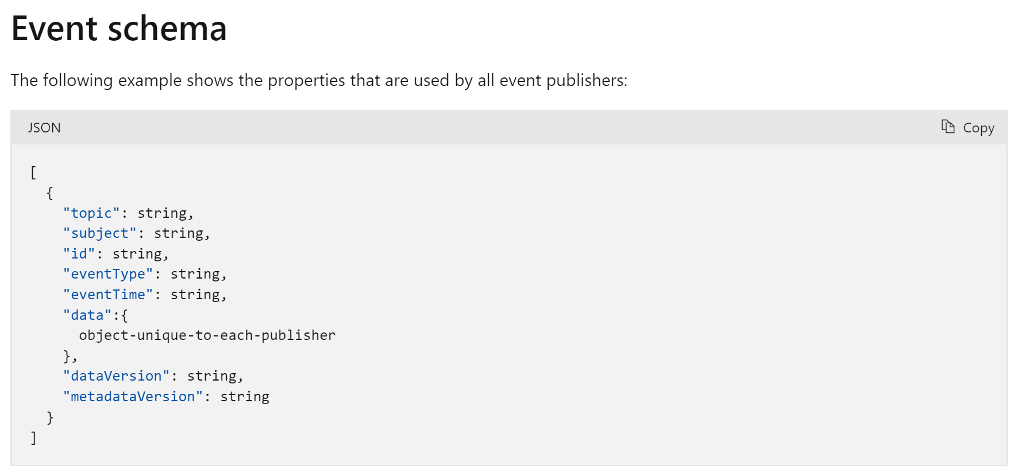

When publishing events to custom topics, create subjects for your events that make it easy for subscribers to know whether they're interested in the event. Subscribers use the subject to filter and route events. Consider providing the path for where the event happened, so subscribers can filter by segments of that path. The path enables subscribers to narrowly or broadly filter events. For example, if you provide a three segment path like /A/B/C in the subject, subscribers can filter by the first segment /A to get a broad set of events. Those subscribers get events with subjects like /A/B/C or /A/D/E. Other subscribers can filter by /A/B to get a narrower set of events.

Sometimes your subject needs more detail about what happened. For example, the **Storage Accounts** publisher provides the subject /blobServices/default/containers/<container-name>/blobs/<file> when a file is added to a container. A subscriber could filter by the path /blobServices/default/containers/testcontainer to get all events for that container but not other containers in the storage account. A subscriber could also filter or route by the suffix .txt to only work with text files.

**CloudEvents v1.0 schema**

In addition to its default event schema, Azure Event Grid natively supports events in the JSON implementation of CloudEvents v1.0 and HTTP protocol binding. CloudEvents is an open specification for describing event data.

CloudEvents simplifies interoperability by providing a common event schema for publishing, and consuming cloud based events. This schema allows for uniform tooling, standard ways of routing & handling events, and universal ways of deserializing the outer event schema. With a common schema, you can more easily integrate work across platforms.

Here is an example of an Azure Blob Storage event in CloudEvents format:

JSONCopy

{

"specversion": "1.0",

"type": "Microsoft.Storage.BlobCreated",

"source": "/subscriptions/{subscription-id}/resourceGroups/{resource-group}/providers/Microsoft.Storage/storageAccounts/{storage-account}",

"id": "9aeb0fdf-c01e-0131-0922-9eb54906e209",

"time": "2019-11-18T15:13:39.4589254Z",

"subject": "blobServices/default/containers/{storage-container}/blobs/{new-file}",

"dataschema": "#",

"data": {

"api": "PutBlockList",

"clientRequestId": "4c5dd7fb-2c48-4a27-bb30-5361b5de920a",

"requestId": "9aeb0fdf-c01e-0131-0922-9eb549000000",

"eTag": "0x8D76C39E4407333",

"contentType": "image/png",

"contentLength": 30699,

"blobType": "BlockBlob",

"url": "https://gridtesting.blob.core.windows.net/testcontainer/{new-file}",

"sequencer": "000000000000000000000000000099240000000000c41c18",

"storageDiagnostics": {

"batchId": "681fe319-3006-00a8-0022-9e7cde000000"

}

}

}

A detailed description of the available fields, their types, and definitions in CloudEvents v1.0 is [available here](https://github.com/cloudevents/spec/blob/v1.0/spec.md#required-attributes).

The headers values for events delivered in the CloudEvents schema and the Event Grid schema are the same except for content-type. For CloudEvents schema, that header value is "content-type":"application/cloudevents+json; charset=utf-8". For Event Grid schema, that header value is "content-type":"application/json; charset=utf-8".

You can use Event Grid for both input and output of events in CloudEvents schema. You can use CloudEvents for system events, like Blob Storage events and IoT Hub events, and custom events. It can also transform those events on the wire back and forth.

...devamı var.