**ASSIGNMENT -2**

**NAME :SRUTHI.B**

**HT NO : 2403a52417**

**BATCH : 15**

**Task 1:** **API Configuration:**

* **Register for a free OpenWeatherMap API key.**
* **Read the documentation and test API calls using tools like Postman or Python requests.**

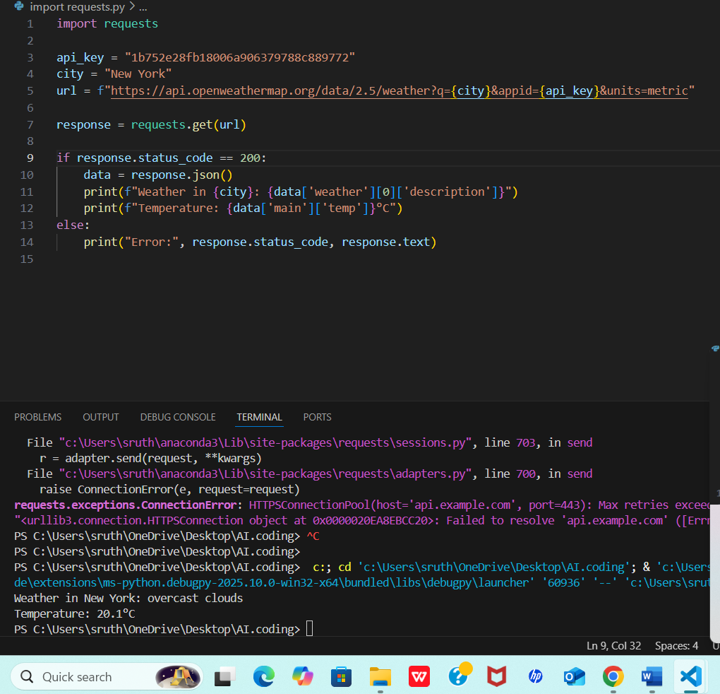

**2. NLP Integration:**

* **Use spaCy or NLTK to extract city names from user input.**
* **Convert natural language queries to appropriate API parameters.**
* 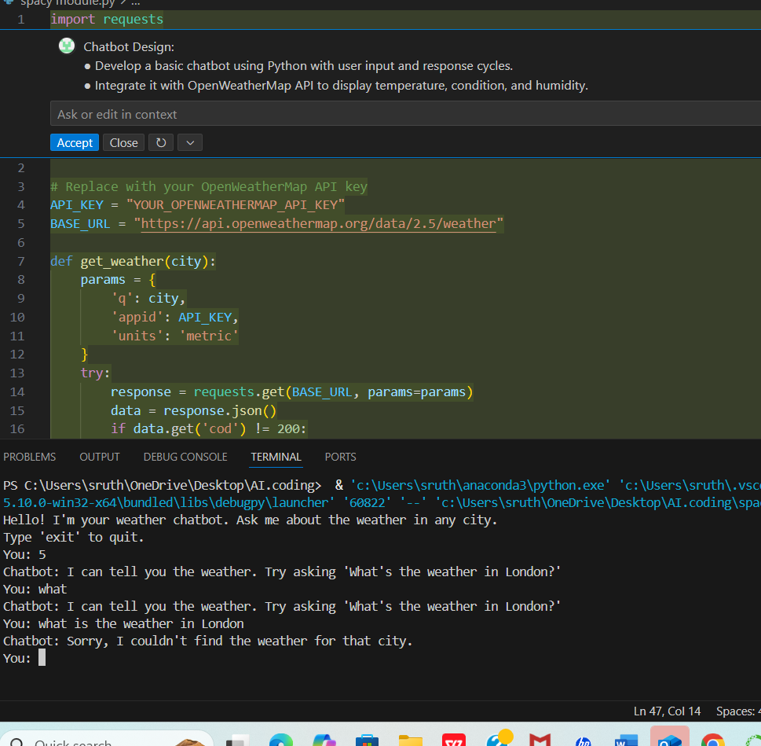

**3. Chatbot Design:**

* **Develop a basic chatbot using Python with user input and response cycles.**
* **Integrate it with OpenWeatherMap API to display temperature, condition, and humidity.**

