**Name: Saliha Siddique KS**

**Batch: Jan(Batch)2023**

**Project: Weather Forecast App**

**Problem Statement:**

Weather Forecast App

Make a web app for users to see the current weather and the weather forecast for the next 7

days.

Requirements

An input for users to type city name

Display current weather including weather condition, temperature, humidity, wind speed, and

date and time

Visualization to display the temperature change, humidity change, and weather conditions of

each day.

Suggested Implementation

Fetch user's device position. If you're unable to get the user's position, set India as the

default location.

Fetch weather data (forecast data and current weather data) of the location from weather

API

Format the data into charts

Display the chart and current weather

**Github link:-** https://github.com/salihasiddique/Web-Development-Weather-Forecast-Application

**Input:**

**Index.html(home):**

Step 1:In this scenario I have added JavaScript ,bootstrap, font awesome libraries. In body <body> tag loaded date and time.

I have created a form page for entering the location to know the current weather and added one search button.

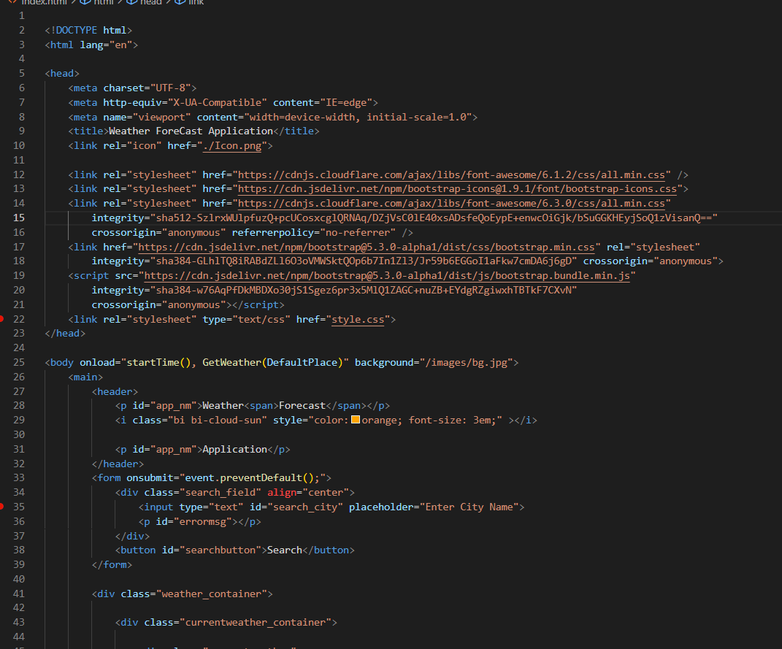

In this scenario, I have displayed weather details like humidity, temperature, wind speed, date and time,

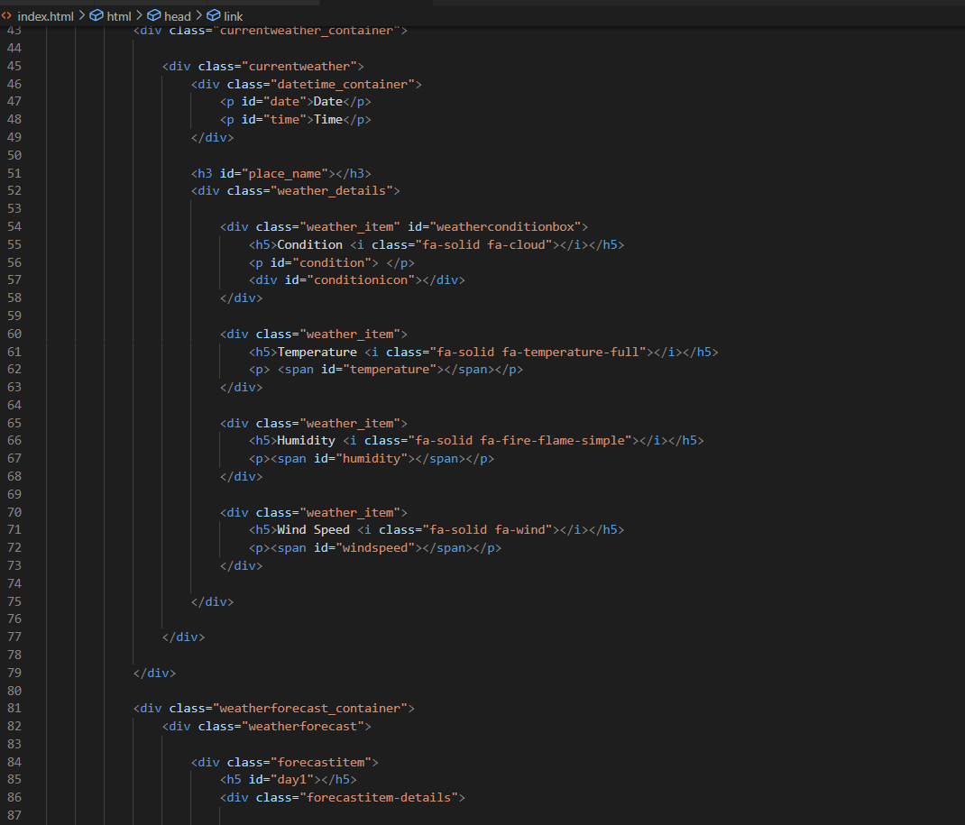

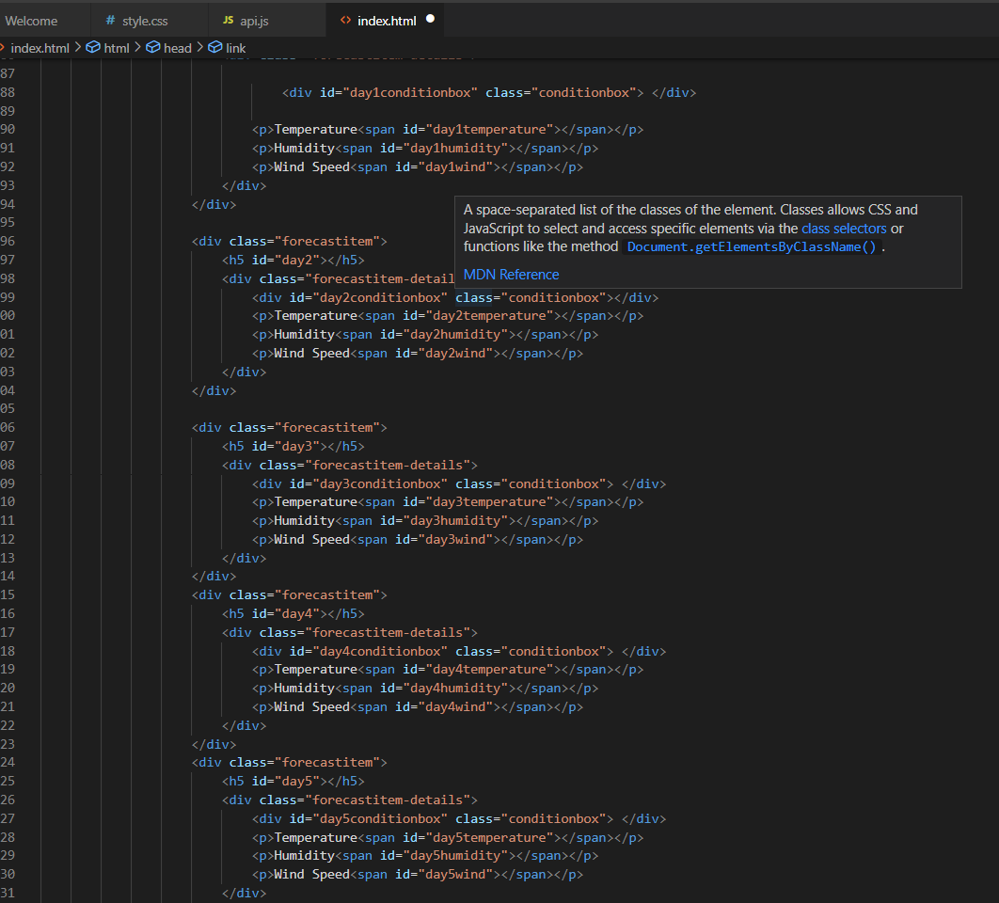

Finally In footer tag I included the title and mention designer name as well as social media link

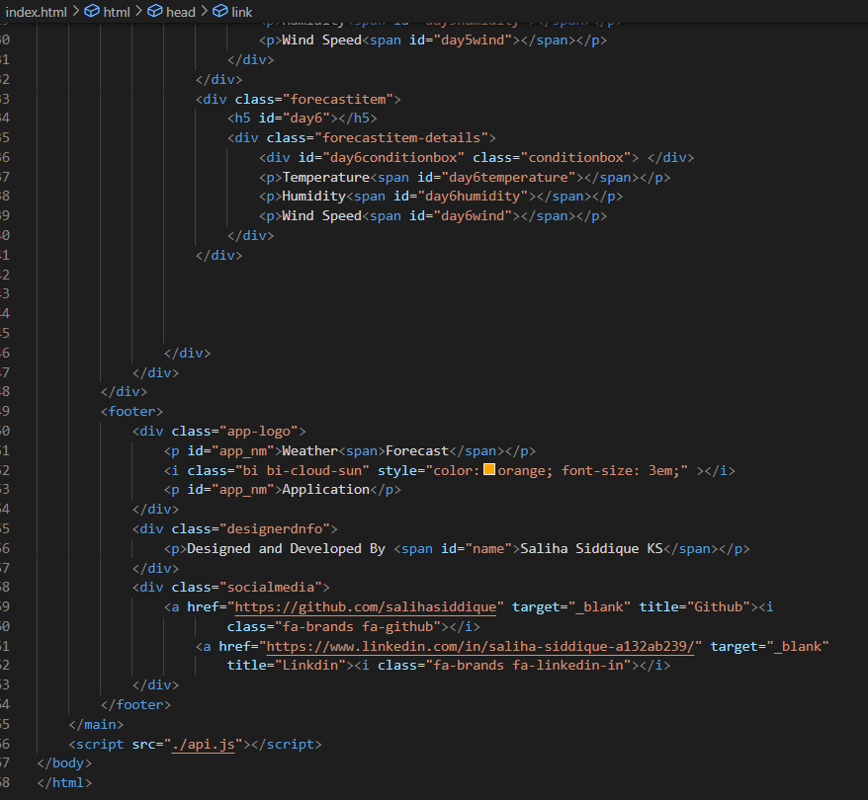

Step2 : Js code

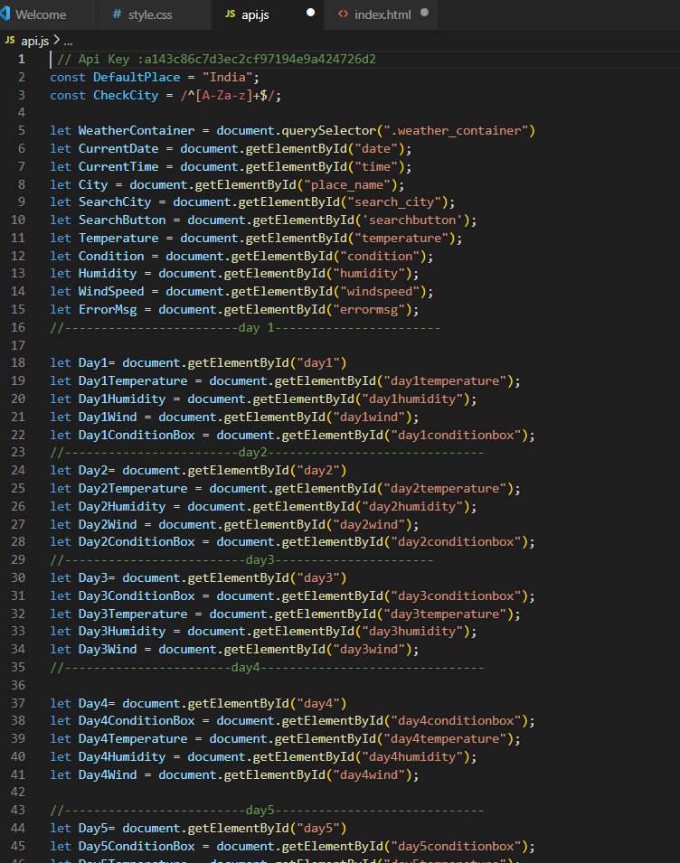

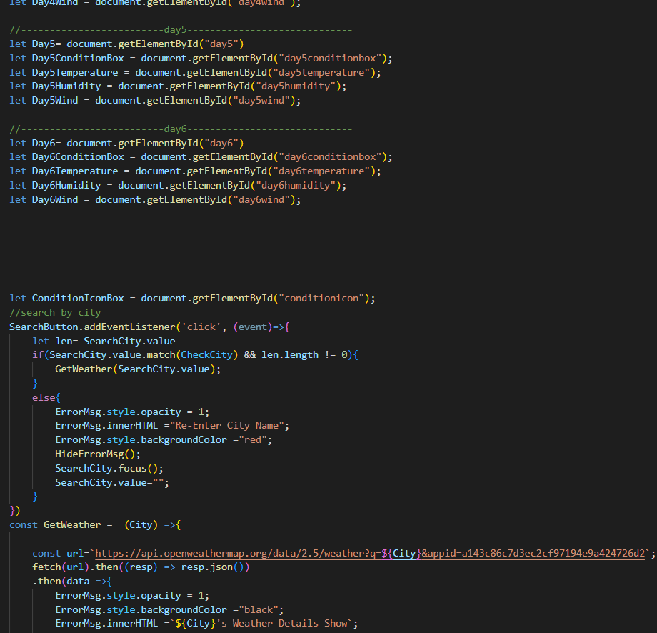

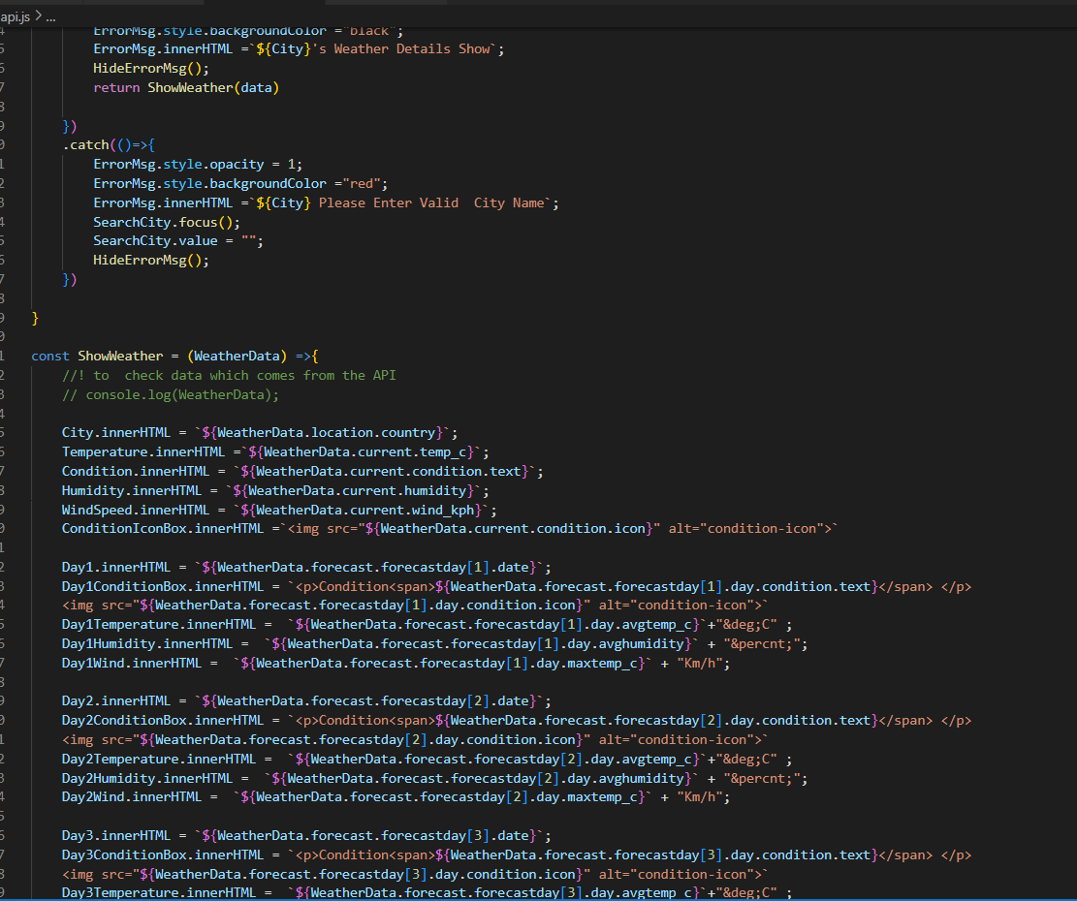

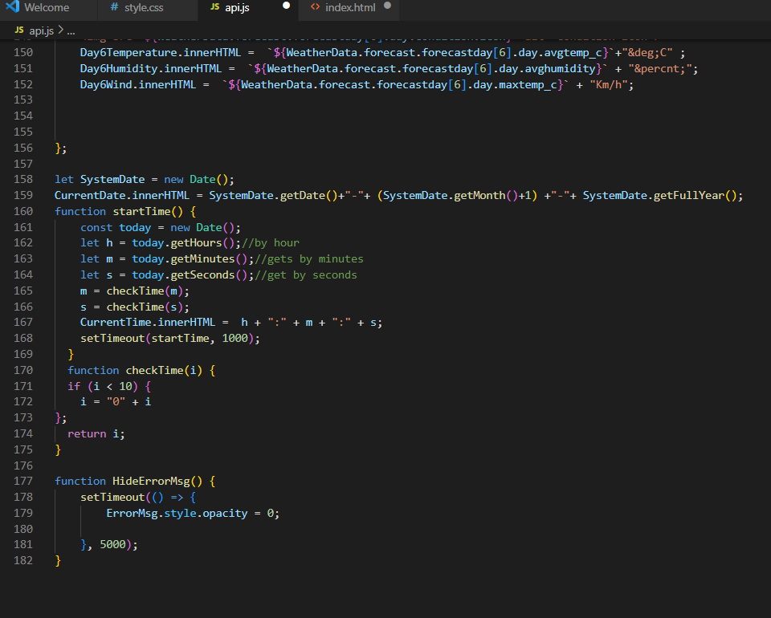

Step3: CSS code

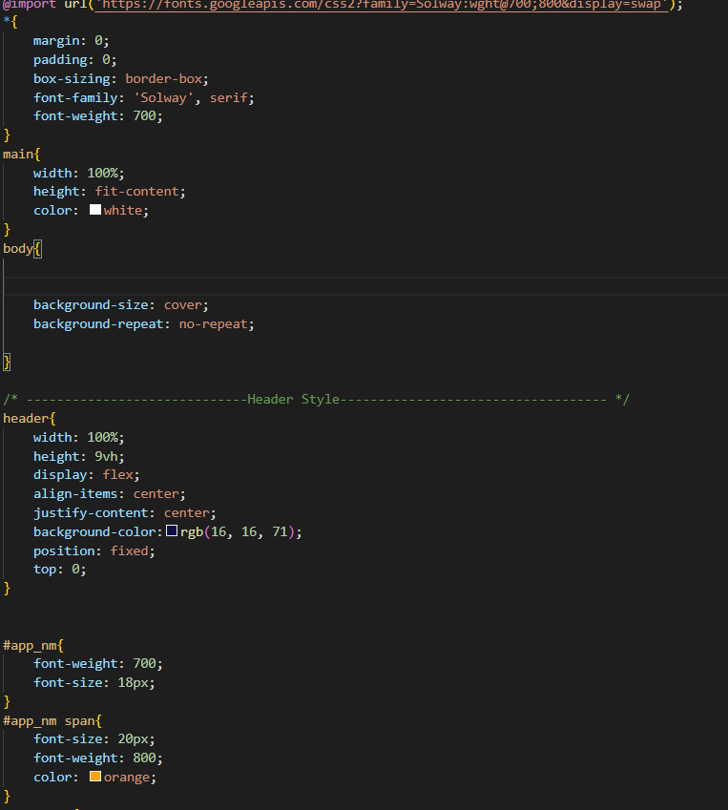

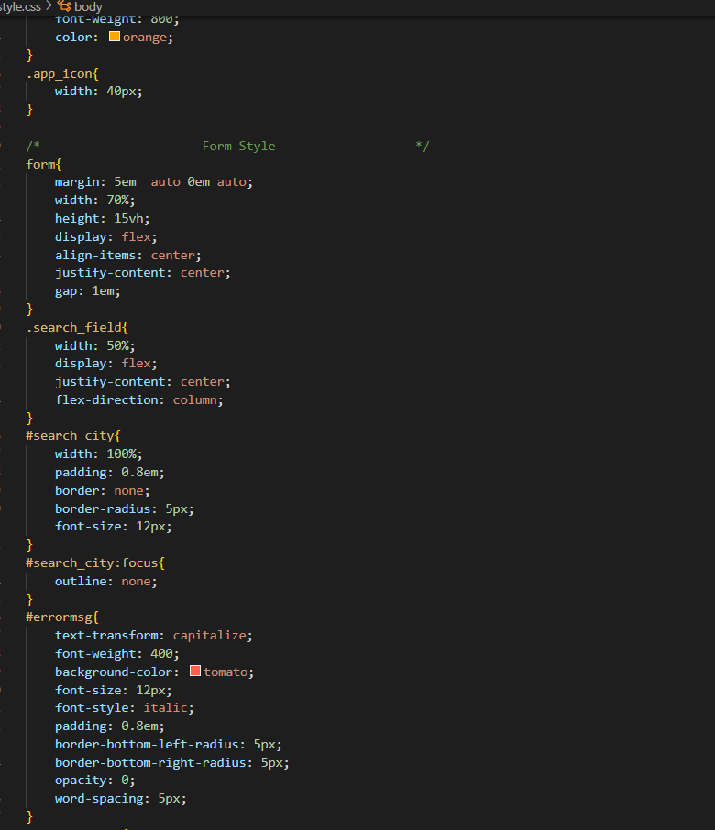

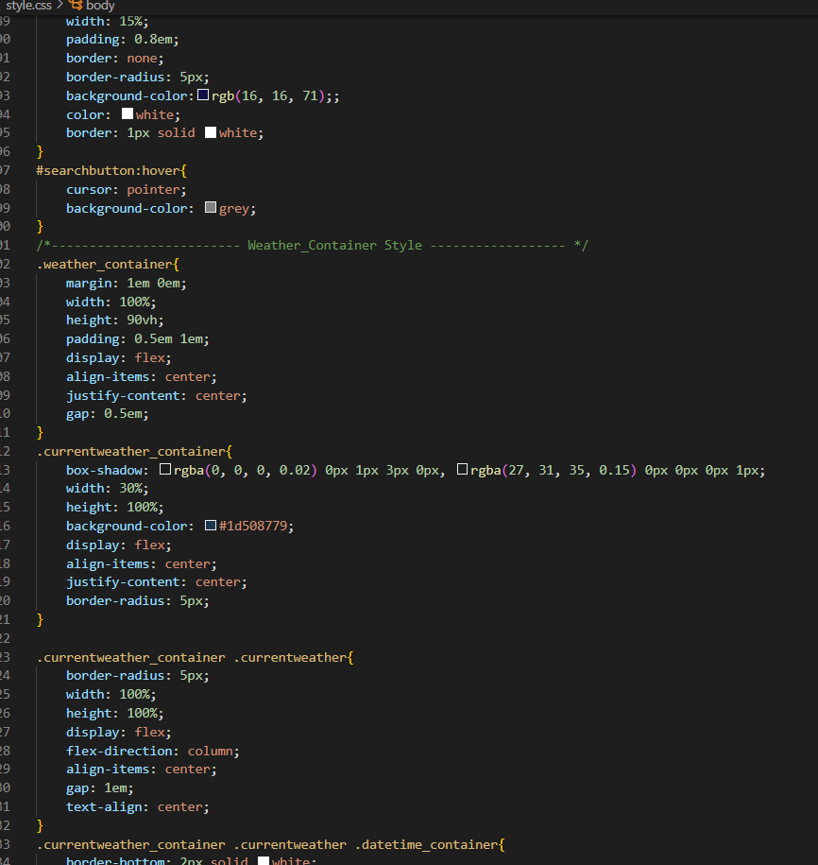

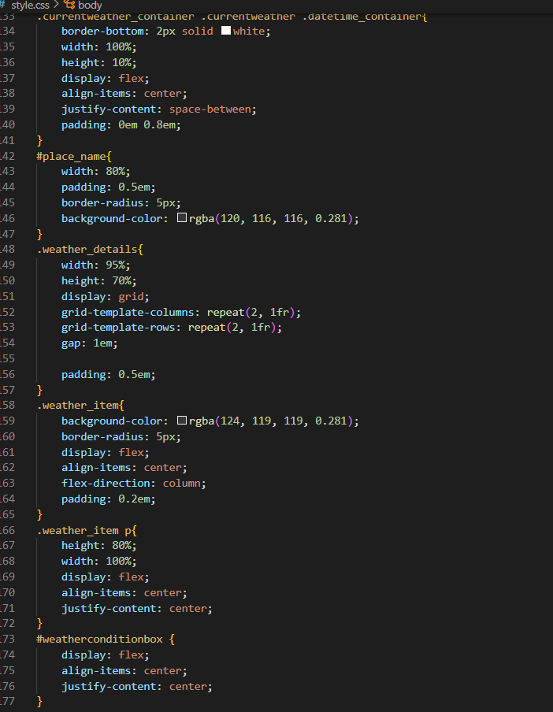

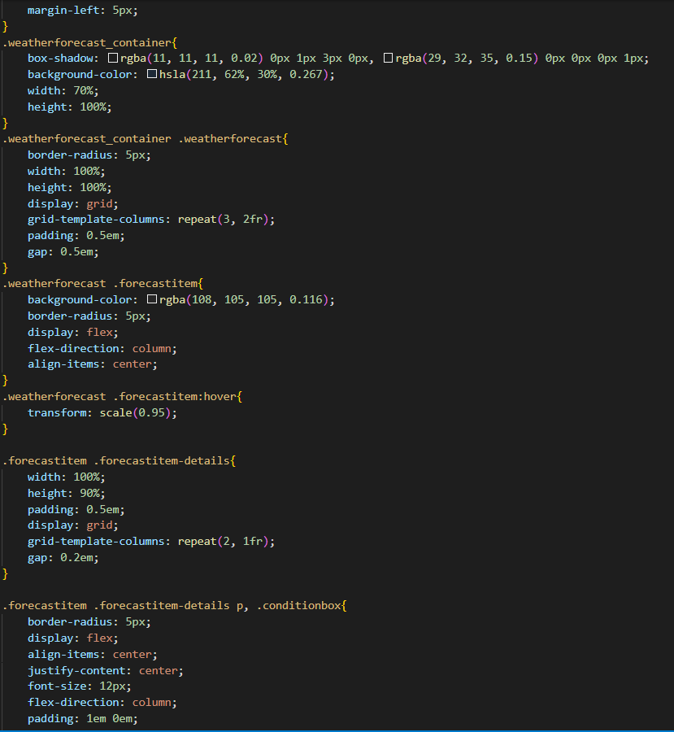

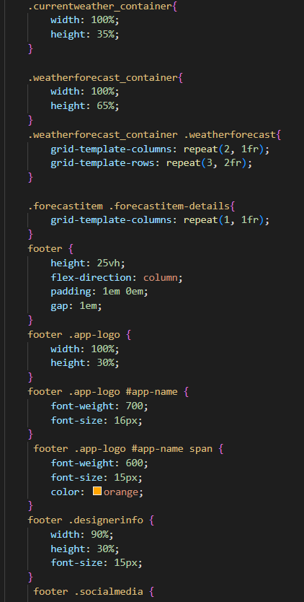

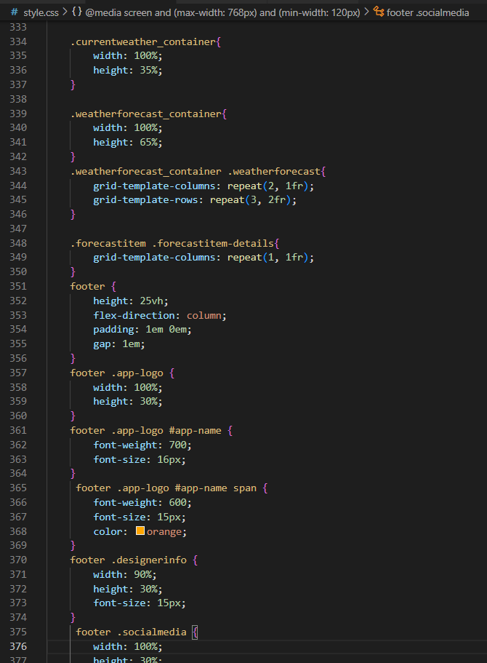

**Output:**

