## **Test Charter**

**Charter** - Analyse Search component of Wiki

**Areas** - Search wit minimum parameters

Set advanced search filters

Search with complex filters

Logged in / Guest user searches

**Test environment** - Chrome latest (*99.0.4844.83*)

Safari 15.0

**Url** - <https://en.wikipedia.org/w/index.php?search>

**Test Harness** - Manual test

**Start** - 27/03/2022 start time

**Tester** - Salih Cem Akyol

**Duration** - 60 mins

**Task breakdown** - Feature familiarisation and bug logging

**Testing notes** - Open search page

- Verify search bar and search CTA

- Verify advanced search filters and search tags

- Verify all inputs and select box

- Verify search results (search list, empty state, etc.)

**Issues and Data-files** -

1. The same word can be applied for “include” and “exclude” parameters

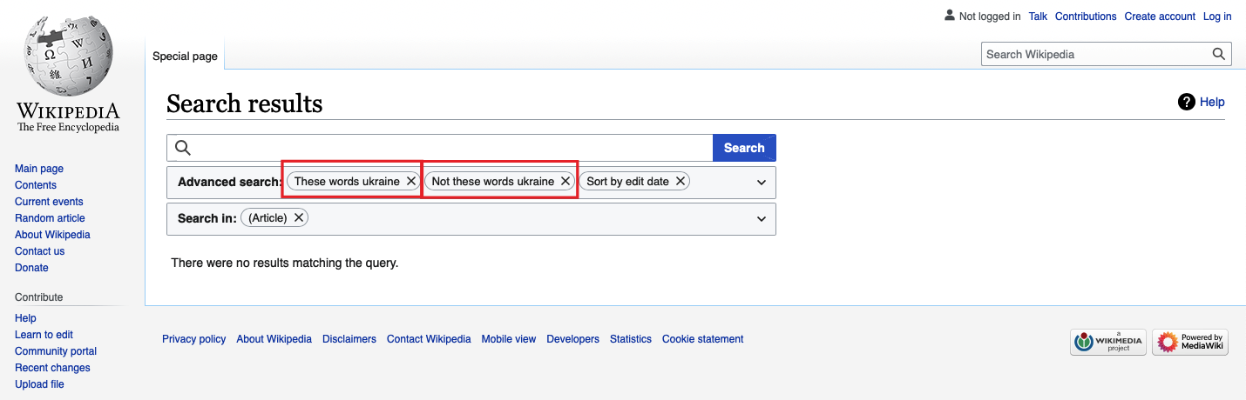

2. Sorting order cannot be removed

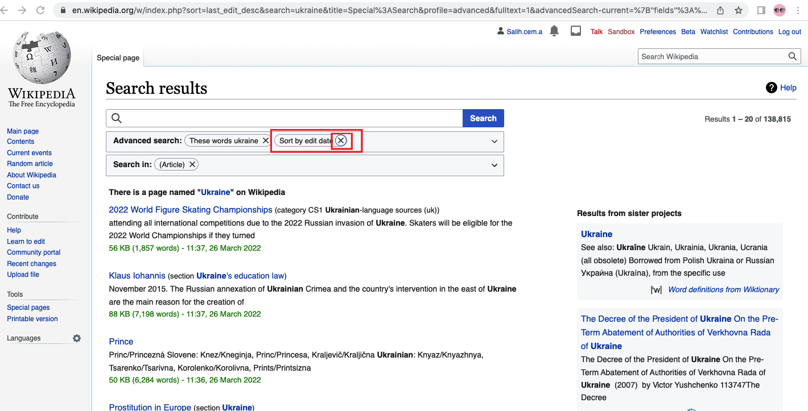

3.

**Session setup time** - 30% of time required to setup

**Test design and Execution** - 70% of time spend on this phase