Piri Reis University
Faculty of Economics and Administrative Sciences
Management Information Systems Department

YBS405
Big Data Management

Online Retail II: Sales Trends and RFM-Based Customer Segmentation of a UK E-Commerce Retailer

Team Members
Ahmet Salih Ağaç (20230305058)

Instructions
In this assignment, you will conduct a data analytics project where you select a dataset of your choice from any reliable source and perform meaningful analysis to extract insights. You are expected to apply analytical concepts such as data cleaning, transformation, visualization, and interpretation using tools like Power BI, Excel, Python, or R. The goal is to demonstrate your ability to handle data, analyze relationships, and present results clearly through dashboards, charts, or reports. You may work individually or in groups of 2–3, and your submission should include your dataset source, analysis output, and a short explanation describing your findings and conclusions.

Important:
Final Report / Presentations Deadline: 07.12.2026

Project Proposal
Prepare a project proposal that clearly describes the project you plan to carry out. You will explain the tool you plan to use and the dataset you plan to analyze. The proposal should be clear, realistic, and feasible within the given project period.

Project Report
Present your data analytics process, key findings, and visual results. Explain your approach, tools used, and insights gained from the analysis. Upload your project to GitHub and include the repository link in this report. If you prepare a dashboard (e.g., Power BI) or a Canvas presentation, also provide its public view link within the same report.

In-class Project Meetings
There will be three in-class project meetings during the semester. Each meeting is worth 10 points and will contribute to the project grade. Attendance, progress, and active participation will be evaluated.
Project: 20% of Grade
- Presentation (20 points)
- Project Proposal (20 points)
- Project Report (30 points)
- In-class Project Meetings (2 × 15 points = 30 points)

Project Proposal: %25 of Midterm
PROJECT PROPOSAL
Project Title:
Online Retail II: Sales Trends and RFM-Based Customer Segmentation of a UK E-Commerce Retailer
Team Members:
Ahmet Salih Ağaç (20230305058)
Project Description:
Online retailers record every order line, which quickly produces large transaction logs. Turning this raw data into decisions (when to stock up, which products to promote, which customers to retain) is a core task of management information systems. This project analyses a real e-commerce transaction log to uncover sales patterns and to segment customers by value.
UCI Machine Learning Repository – "Online Retail II" (Chen, 2019), https://archive.ics.uci.edu/dataset/502/online+retail+ii. It contains about 1.07 million transaction lines of a UK-based online gift-ware retailer (many customers are wholesalers) from 01.12.2009 to 09.12.2011, with 8 attributes: Invoice, StockCode, Description, Quantity, InvoiceDate, Price, Customer ID and Country. The source is a public, citable academic repository.
Python 3 with pandas (data cleaning and transformation), matplotlib and seaborn (visualisation) and Jupyter Notebook (documented, reproducible analysis). The code, notebook and figures will be published in a public GitHub repository.

In-class Project Meetings
1st:
2nd:
Project Summary: %25 of Final
PROJECT SUMMARY
Your project summary should clearly describe the key features of the project, specify the technologies used, and outline any challenges encountered during the process.
Project Title:
Online Retail II: Sales Trends and RFM-Based Customer Segmentation of a UK E-Commerce Retailer
Team Members:
Ahmet Salih Ağaç (20230305058)
Project Summary:
Key features
The project analyses 1,003,417 cleaned transaction lines (39,516 orders, 5,852 identified customers, 43 countries) of a UK online retailer. It includes a reproducible cleaning pipeline, ten visualisations (revenue trend, year-over-year comparison, top products, countries, weekday-hour heatmap, cancellations, RFM segments, cohort retention, order value distribution, price-quantity relationship) and an RFM customer segmentation exported as a CSV table.
Main findings
Revenue is highly seasonal (September–November = 37% of revenue; peak in 2011-11), the UK generates 86% of revenue, the top 20% of customers generate 77% of revenue, and 17% of invoices are cancellations.
Technologies used
Python 3, pandas, NumPy, matplotlib, seaborn, Jupyter Notebook, Apache Parquet (fast intermediate storage), python-docx / python-pptx (document generation), Git and GitHub (version control and publication).
Challenges
(1) Reading the 45 MB Excel file takes about two minutes, so the raw data was cached once as Parquet. (2) Mixed data types (numeric product descriptions) broke the Parquet export and had to be forced to text. (3) 22.8% of rows have no Customer ID; they were kept for sales analysis but excluded from customer analysis. (4) Cancellations, returns, postage and bank-charge lines had to be identified and separated so that revenue is not distorted. (5) December 2011 is incomplete and the December 2009 cohort includes pre-existing customers, which required careful interpretation of trends and retention.

PROJECT REPORT
Online Retail II: Sales Trends and RFM-Based Customer Segmentation of a UK E-Commerce Retailer
GitHub repository: https://github.com/salihgac/ybs405-online-retail-analysis
Contents of the repository: notebooks/analysis.ipynb (full analysis with outputs), src/ (cleaning and analysis code), figures/ (all charts), deliverables/ (proposal, report, presentation).

1. Introduction
Online retailers record every order line, producing large transaction logs that are rarely used beyond basic accounting. The aim of this project is to show how such data can be cleaned, transformed and analysed to support management decisions in sales planning, product management and customer relationship management. Five research questions guided the work:
• RQ1 – How does revenue develop over time and is there seasonality?
• RQ2 – Which products and countries generate most of the revenue?
• RQ3 – On which days and hours are orders placed?
• RQ4 – How large is the share of cancelled orders?
• RQ5 – Which customer segments exist (RFM analysis) and how well are new customers retained (cohort analysis)?

2. Dataset and Source
The dataset is "Online Retail II" from the UCI Machine Learning Repository (Chen, 2019; https://archive.ics.uci.edu/dataset/502/online+retail+ii). It contains all transactions of a UK-based, non-store online retailer that mainly sells unique all-occasion gift-ware; many of its customers are wholesalers. The data covers 2009-12-01 to 2011-12-09 and is delivered as one Excel file with two sheets.
Attribute | Description
Invoice | 6-digit invoice number; a leading 'C' marks a cancellation
StockCode | Product code (5 digits); special codes for postage, fees, adjustments
Description | Product name
Quantity | Units per line (negative for cancellations/returns)
InvoiceDate | Date and time of the transaction
Price | Unit price in GBP (£)
Customer ID | 5-digit customer number (missing for some rows)
Country | Country where the customer resides

3. Tools and Technologies
Tool | Purpose
Python 3 + pandas / NumPy | Loading, cleaning, transforming and aggregating ~1M rows
matplotlib + seaborn | All charts and heatmaps
Jupyter Notebook | Documented, step-by-step and reproducible analysis
Apache Parquet (pyarrow) | Fast columnar cache of the raw data (Excel read ≈ 2 min → Parquet < 1 s)
Git + GitHub | Version control and publication of the project

4. Methodology

4.1 Data cleaning
The cleaning pipeline (src/clean.py) was applied in the following order. The table shows how many rows remained after each step:
Step | Rows remaining | Rows removed
Raw data (2 sheets merged) | 1,067,371
Exact duplicate rows removed | 1,033,036 | 34,335
Cancellation invoices separated | 1,013,932 | 19,104
Non-positive quantity removed | 1,010,539 | 3,393
Non-positive price removed | 1,007,913 | 2,626
Non-product stock codes removed | 1,003,417 | 4,496
of which with Customer ID (used for customer analysis) | 776,579

• Exact duplicate lines (same invoice, product, quantity, time, …) were removed.
• Cancellation invoices (prefix 'C') were not deleted but stored separately (8,292 invoices) and analysed in Section 5.5.
• Lines with zero/negative quantity or price (stock adjustments, damaged goods, free samples) were removed.
• Non-product stock codes such as POST (postage), M (manual), BANK CHARGES, AMAZONFEE and ADJUST were removed so that product statistics only contain real products.
• 22.8% of raw rows have no Customer ID (guest orders). They were kept for sales and product analysis (13% of revenue) but excluded from customer-level analysis (RFM, cohorts).

4.2 Transformation
New variables were derived: Revenue = Quantity × Price, and date features Year, Month, Weekday and Hour. Because the data ends on 09.12.2011, December 2011 is incomplete and was excluded from monthly trend charts.

4.3 Analytical techniques
• Descriptive statistics and time-series aggregation (monthly revenue, year-over-year comparison).
• Ranking and Pareto analysis of products, countries and customers.
• RFM analysis: each customer receives a 1–5 quintile score for Recency (days since last purchase), Frequency (number of orders) and Monetary value (total spend). Six segments are derived from the R score and the average of the F and M scores.
• Cohort analysis: customers are grouped by their first purchase month and the share still buying in each following month is measured.
• Correlation analysis between product price and units sold (log–log scale).

5. Findings
Key indicator | Value
Total revenue (clean) | £19.65M
Orders (invoices) | 39,516
Identified customers | 5,852
Products | 4,731
Countries | 43
Average / median order value | £497 / £301

5.1 Revenue trend and seasonality (RQ1)
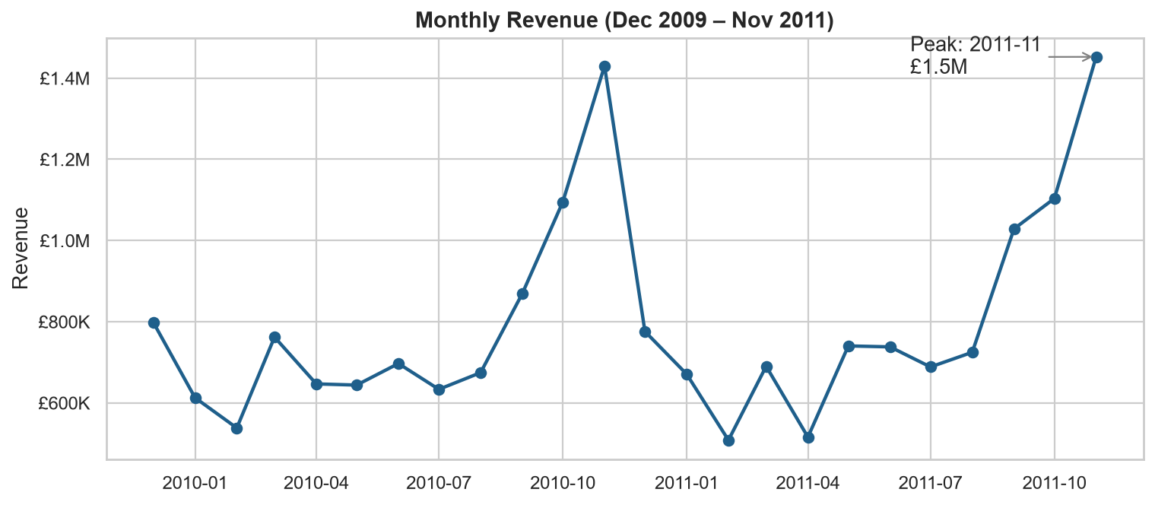
Figure 1. Monthly revenue, December 2009 – November 2011
Revenue shows a strong and repeating seasonal pattern. Sales are relatively flat in the first half of each year (lowest month: 2011-02, £507,867) and rise sharply from September, peaking in 2011-11 with £1.45M. September to November alone account for 37% of all revenue in the period. This fits the business model: wholesale customers buy gift-ware for the Christmas season.
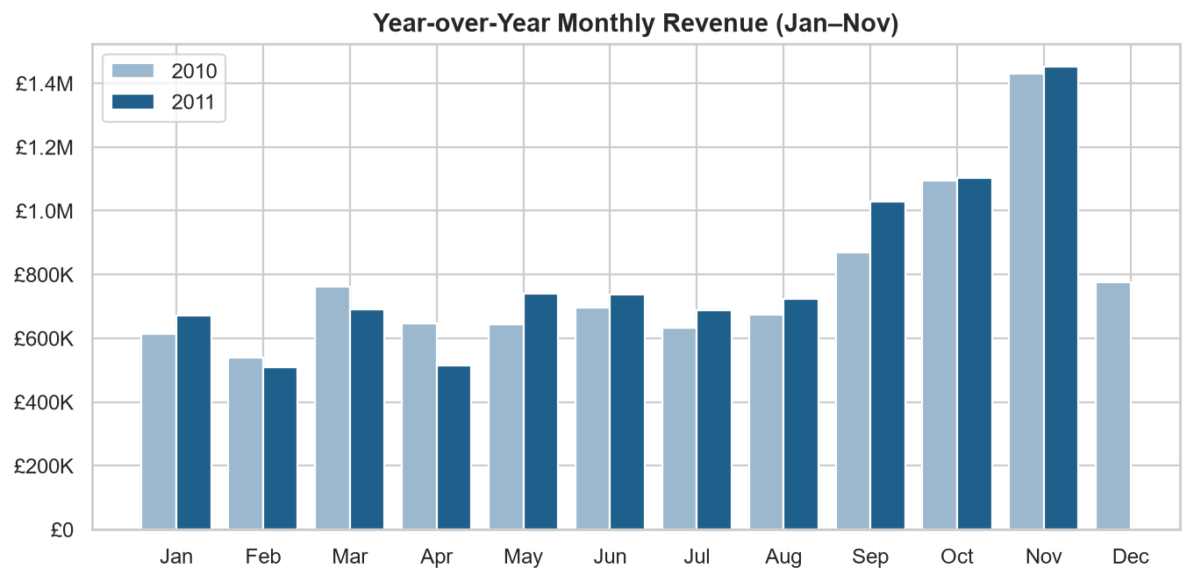
Figure 2. Year-over-year comparison of monthly revenue (January–November)
Comparing January–November, revenue grew from £8.60M in 2010 to £8.86M in 2011 (+3.0%). Growth is therefore modest; the business is stable but heavily dependent on the fourth quarter.

5.2 Products (RQ2)
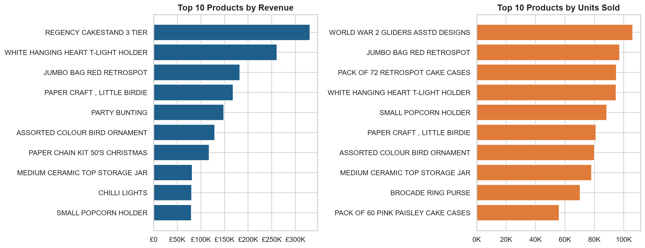
Figure 3. Top 10 products by revenue and by units sold
The best-selling product by revenue is the 'Regency Cakestand 3 Tier' (£330,590), while the 'World War 2 Gliders Asstd Designs' sells the most units. Cheap, small items lead the unit ranking, whereas higher-priced decorative items lead the revenue ranking. Out of 4,731 products, the top 100 generate 29% of revenue – a long-tail assortment.

5.3 Countries (RQ2)
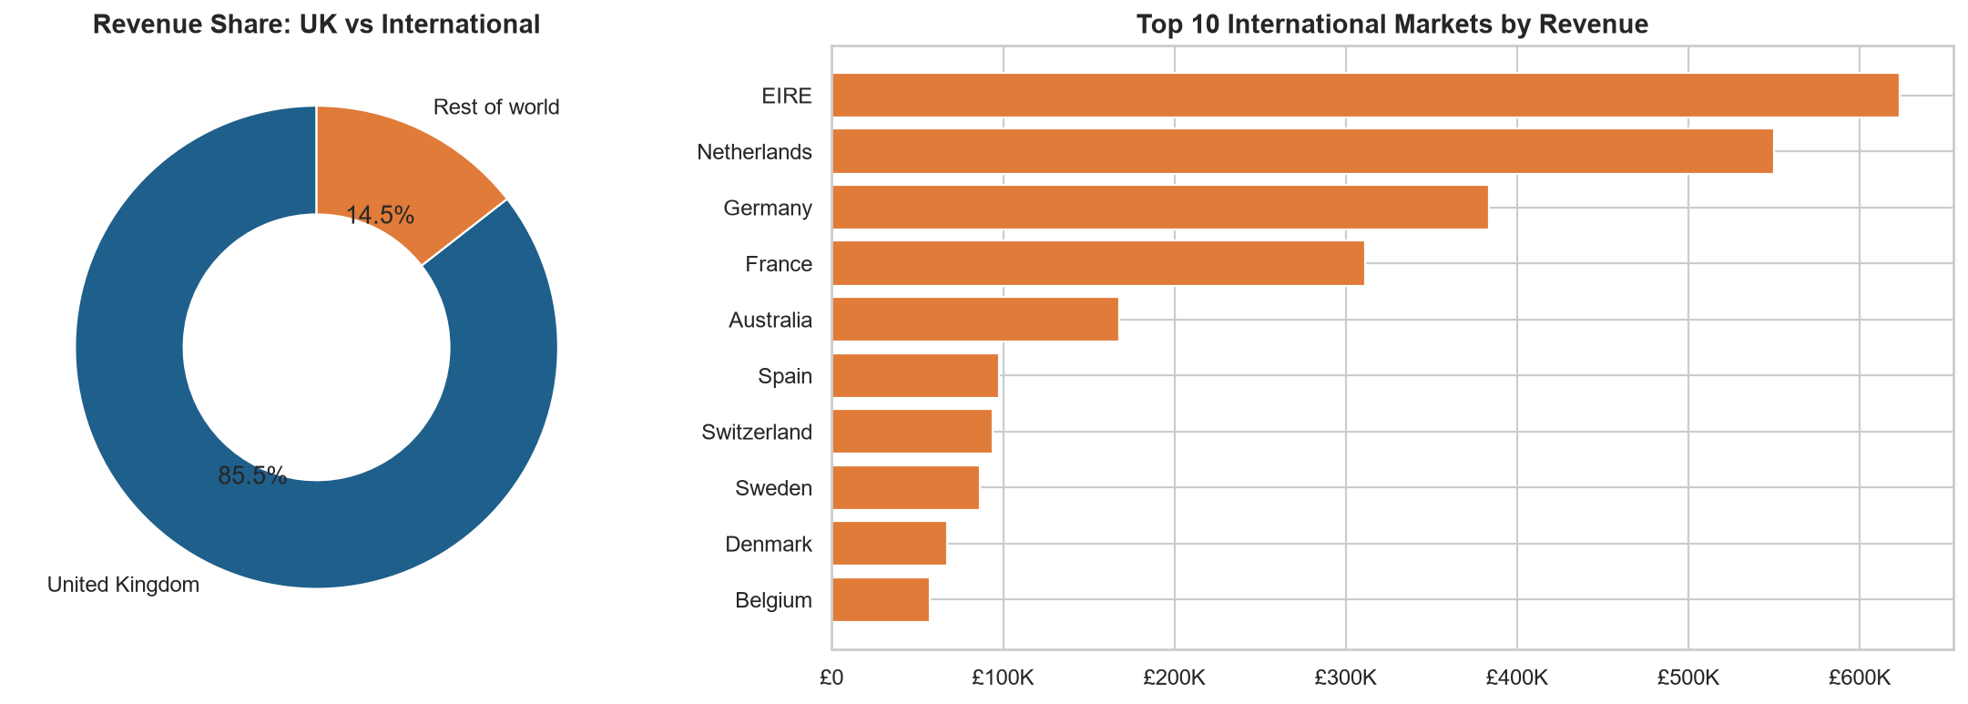
Figure 4. UK vs international revenue and top international markets
The United Kingdom generates 86% of revenue. The most important foreign markets are EIRE, Netherlands and Germany (EIRE = Ireland); almost all international revenue comes from Europe. The company is therefore domestically concentrated, and its European customers represent a growth opportunity.

5.4 Order timing (RQ3)
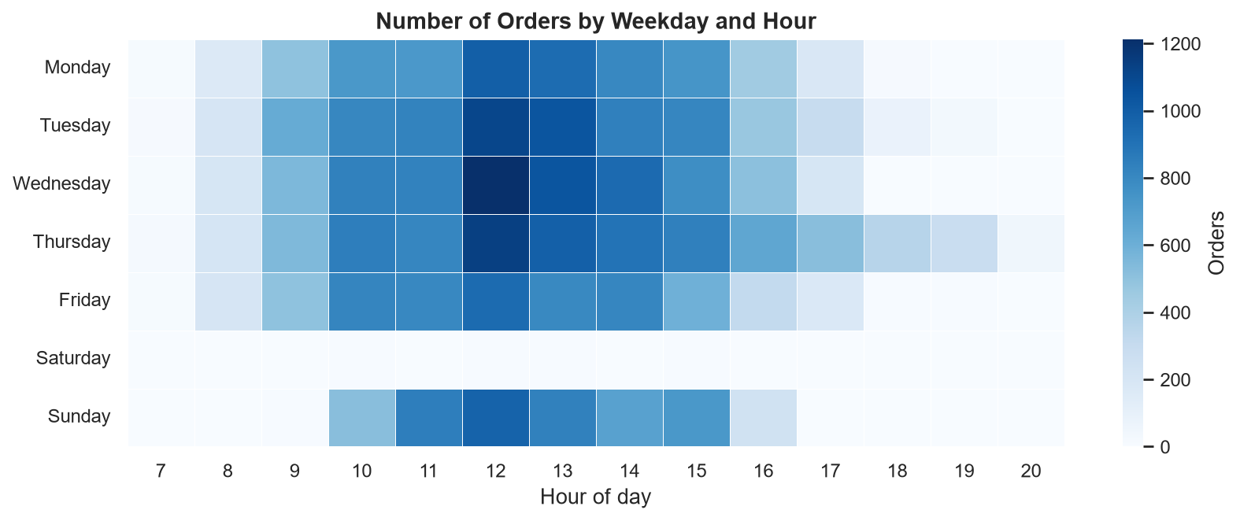
Figure 5. Number of orders by weekday and hour
Orders are placed almost exclusively on weekdays during office hours, peaking around 12:00, and Thursday is the busiest day. Saturday has practically no orders (30 in two years), which suggests that the shop does not process orders on Saturdays and that most customers are businesses rather than private consumers. Marketing emails and customer-service capacity should therefore be planned for weekday mornings and middays.

5.5 Cancellations (RQ4)
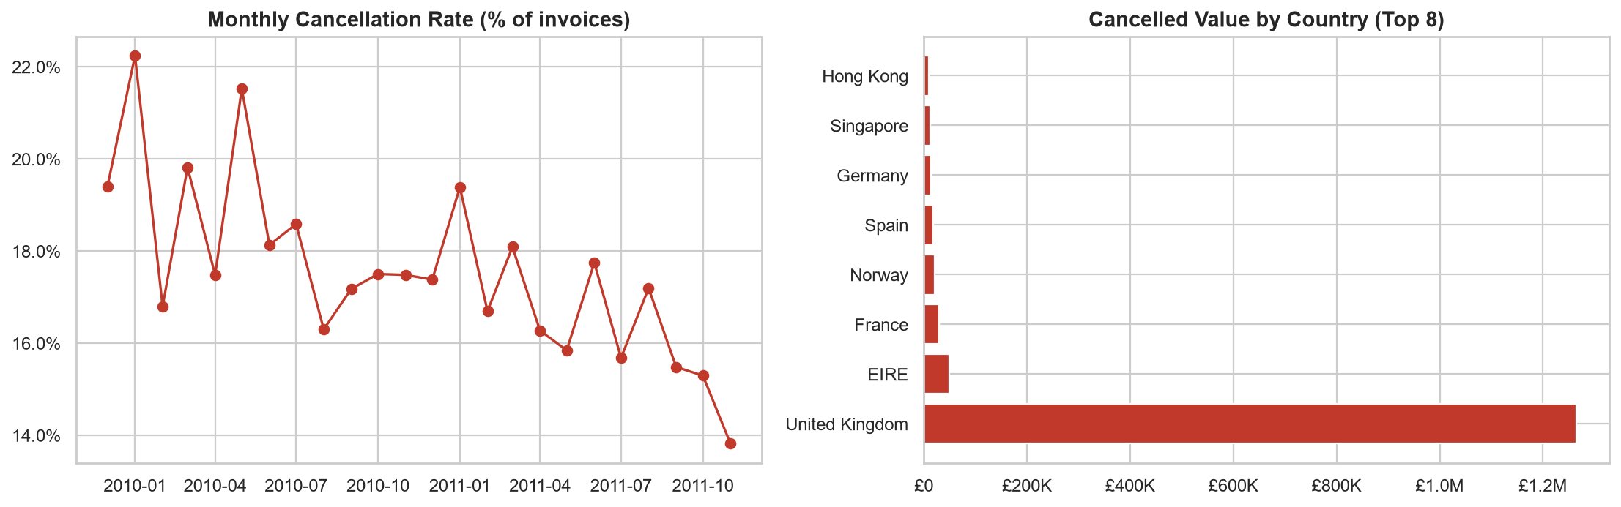
Figure 6. Monthly cancellation rate and cancelled value by country
8,292 invoices – 17.3% of all invoices – are cancellations, with a total value of £1.46M (≈7.4% of clean revenue). The cancellation rate fluctuates between roughly 14% and 22% per month but shows a downward trend during 2011. Cancelled value is concentrated in the UK simply because most customers are there.

5.6 Customer segmentation with RFM (RQ5)
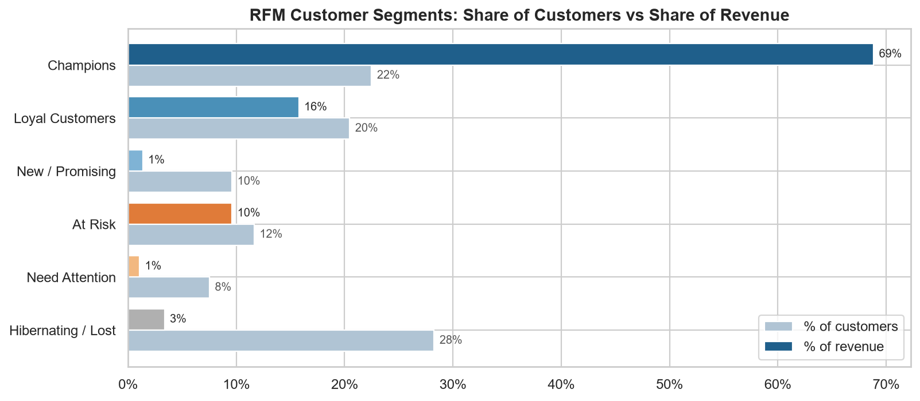
Figure 7. RFM segments: share of customers vs share of revenue
Segment | Customers | % customers | % revenue
Champions | 1,316 | 22.5% | 68.8%
Loyal Customers | 1,198 | 20.5% | 15.8%
New / Promising | 562 | 9.6% | 1.4%
At Risk | 682 | 11.7% | 9.6%
Need Attention | 440 | 7.5% | 1.1%
Hibernating / Lost | 1,654 | 28.3% | 3.4%

Customer value is very unequal: the top 20% of customers generate 77% of revenue (Pareto principle). The 'Champions' segment (22% of customers) alone produces 69% of revenue. The 'At Risk' segment is important for action: these 682 customers used to buy often and spend a lot (10% of revenue) but have not purchased recently. 28% of customers bought only once, and 28% are classed as hibernating or lost.

5.7 Customer retention – cohort analysis (RQ5)
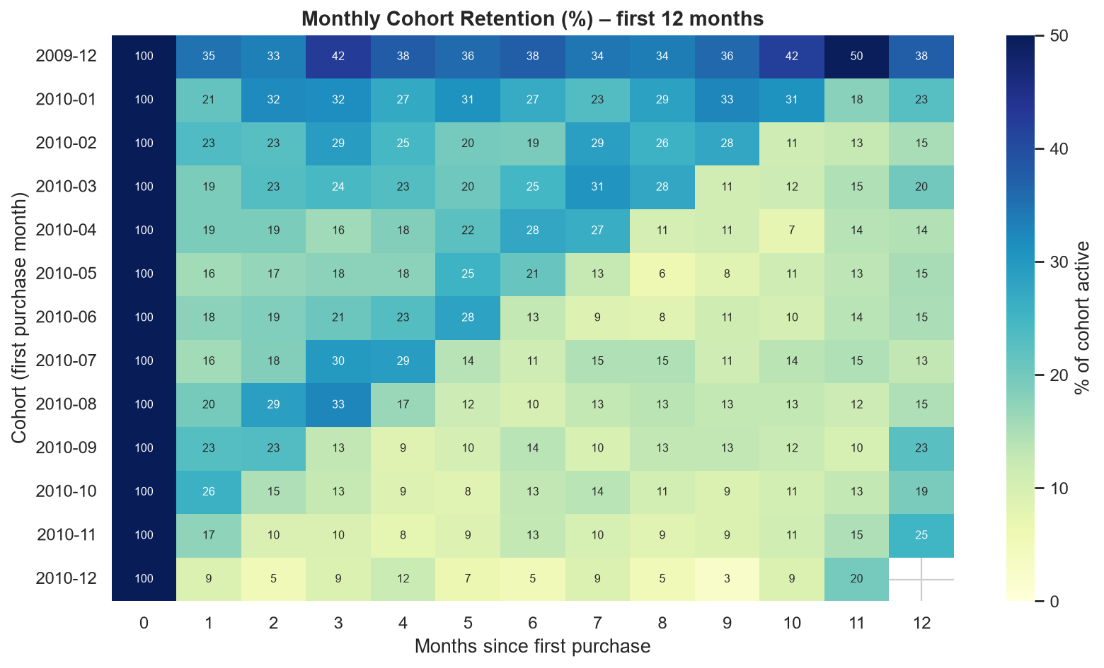
Figure 8. Monthly cohort retention during the first 12 months
On average only 19% of new customers (cohorts from January 2010 on) buy again in the month after their first purchase, and retention typically stabilises at 10–20%. The December 2009 cohort looks much more loyal (35% in month 1, 38% after 12 months) because it also contains long-standing customers whose first purchase happened before the dataset starts. Retention increases again around months 10–12 for many cohorts, showing that customers return for the next Christmas season.

5.8 Order value and basket size
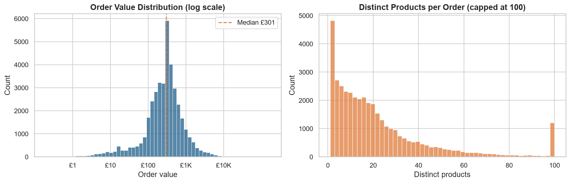
Figure 9. Distribution of order value and products per order
The median order is worth £301 and contains 15 different products, while the mean is £497. The difference between mean and median shows a right-skewed distribution: 8.6% of orders exceed £1,000. These large baskets confirm that many customers are wholesalers.

5.9 Price vs quantity
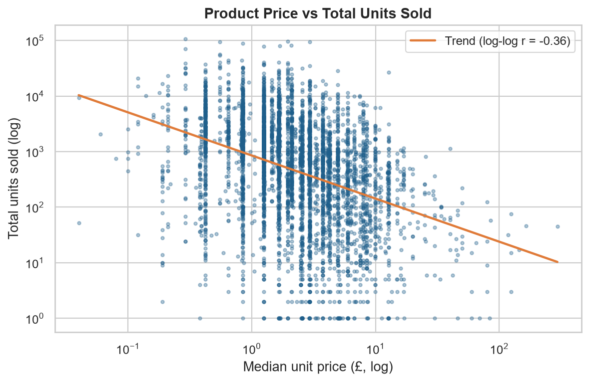
Figure 10. Relationship between product price and units sold (log–log)
There is a moderate negative relationship between a product's price and the number of units sold (correlation on log scale r = -0.36; slope ≈ -0.78). Cheaper products sell in larger quantities, as expected, but price explains only part of the variation – design and seasonality also matter.

6. Conclusions and Recommendations
The analysis answers the five research questions as follows:
• RQ1: Revenue is stable year-on-year (+3.0%) but strongly seasonal, with a September–November peak (37% of revenue).
• RQ2: A small set of decorative products and the UK market (86%) dominate revenue.
• RQ3: Orders arrive on weekdays around midday, and there are almost none on Saturdays (a B2B pattern).
• RQ4: Cancellations are a significant issue (17.3% of invoices) but are slowly decreasing.
• RQ5: The top 20% of customers bring 77% of revenue; new-customer retention is low.
Recommendations for the retailer:
• Plan inventory, staff and marketing budgets around the Q4 peak; start campaigns in August.
• Launch a key-account / loyalty programme for 'Champions' and 'Loyal Customers'.
• Run win-back campaigns (personal offers, reminders) for the 'At Risk' segment, which still represents a large share of historical revenue.
• Improve onboarding of new customers (follow-up offers within the first month) to raise month-1 retention.
• Investigate the main reasons for cancellations (stock-outs, pricing errors, delivery) to reduce lost revenue.
• Expand marketing in the strongest European markets (Ireland, Netherlands, Germany, France).

7. Limitations
• Data is from 2009–2011 and from a single retailer, so results cannot be generalised directly.
• 22.8% of rows have no customer ID, so customer-level analysis covers only identified customers.
• No cost or profit data is available; all value figures are revenue, not profit.
• Product categories are not provided, so products could only be analysed individually.

References
Chen, D. (2019). Online Retail II [Dataset]. UCI Machine Learning Repository. https://doi.org/10.24432/C5CG6D
McKinney, W. (2010). Data structures for statistical computing in Python. Proceedings of the 9th Python in Science Conference, 56–61.
Fader, P. S., Hardie, B. G. S., & Lee, K. L. (2005). RFM and CLV: Using iso-value curves for customer base analysis. Journal of Marketing Research, 42(4), 415–430.

