PRO-Simat: Protein network simulation and design tool

USER MANUAL

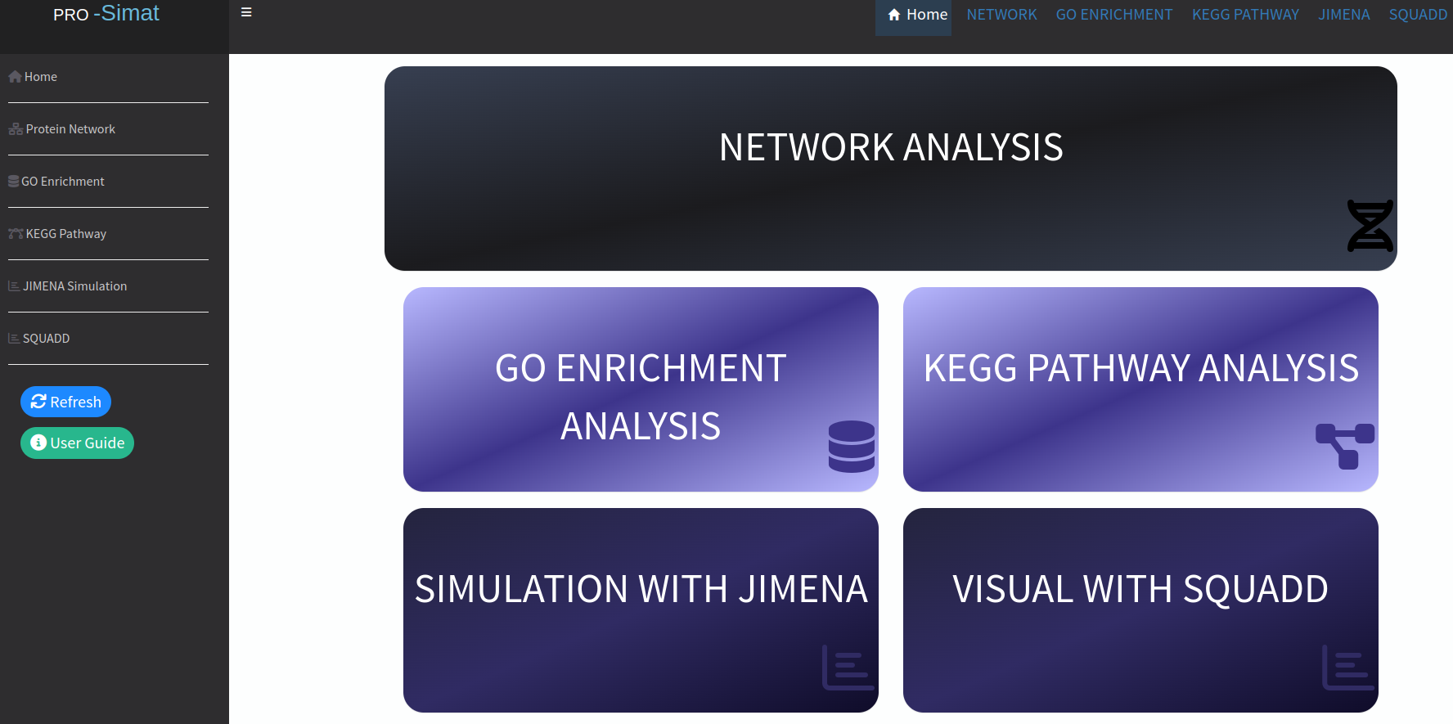

Introduction

Gene lists are mostly obtained by studies on genomics, transcriptomics, proteomics, or metabolomics. Enrichment analysis helps to correlate these gene lists with underlying molecular pathways and functional categories using databases such as gene ontology (GO) and KEGG (Kyoto Encyclopedia of Genes and Genomes) pathway.

In this study, we present our new integrative web tool “PRO-Simat” designed by using the R Shiny package. This tool provides GO enrichment and KEGG pathway analyses and network visualization from an integrated database of more than 8 million protein-protein interactions of organisms such as Arabidopsis thaliana, Bacillus subtilis, Bacillus anthracis, Bos taurus, Caenorhabditis elegans, Cavia porcellus, Danio rerio, Drosophila melanogaster, Escherichia coli, Gallus gallus, Homo sapiens, Helicobacter pylori, Listeria monocytogenes, Mus musculus, Oryzias latipes, Ovis aries, Plasmodium falciparum, Rattus norvegicus, Saccharomyces cerevisiae, Schizosaccharomyces pombe (strain 972 / ATCC 24843), Staphylococcus aureus, Treponema pallidum, Vaccinia virus, Vaccinia virus Copenhagen, Vaccinia virus WR, Vaccinia virus L-IPV, Vaccinia virus Ankara, Vaccinia virus GLV-1h68, Xenopus laevis. In this tool, we also integrated the dynamical network simulation from the Jimena framework, which efficiently and fast simulates Boolean genetic regulatory networks. It enables the user to get simulation outputs with attached explanatory notes directly on the website. This integration also results in the creation of PRO-Simat signaling networks for any process of interest such as design of an oncolytic virus evaluating host cell and virus interactions. The users evaluate the consistency of their network models using the simulation graphs, activity heatmaps, as well as principal component analysis. The PRO-Simat as a graphical web tool will help researchers to establish and analyze dynamical cellular networks from gene clusters.
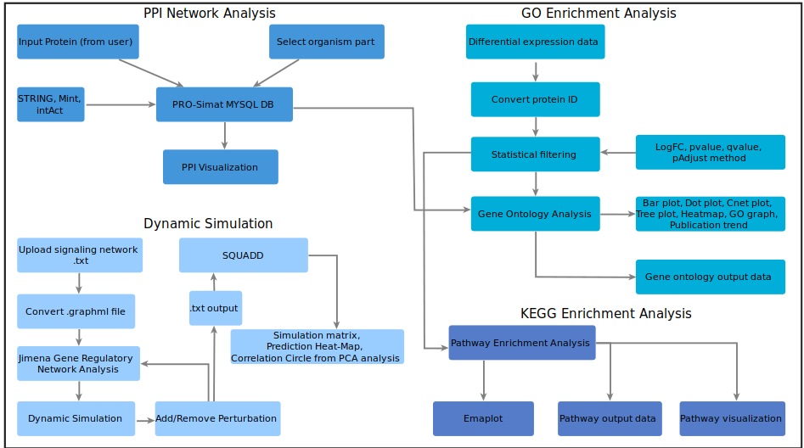

Fig 1. The workflow of PRO-Simat web tool



Steps for Protein-Protein interaction visualization;

➊ When the users want to refresh the page, they can use the refresh button.
➋ It guides you how to use PRO-Simat.
➌&➍ Select Organism 1 and Organism 2 for which the users would like to display protein-protein interactions.
➎ Select the node shape where your proteins will be displayed.
➏ Select one of the layouts from the select input box to see the network.

➌&➍ ➎ ➏
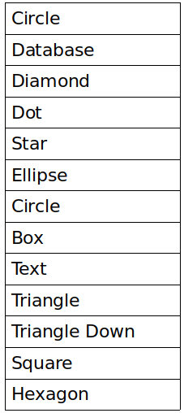
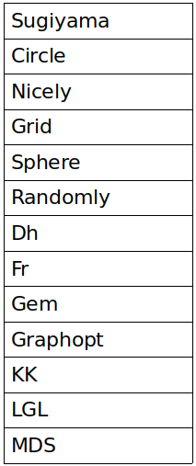
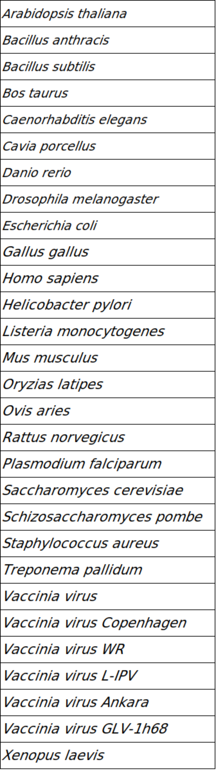
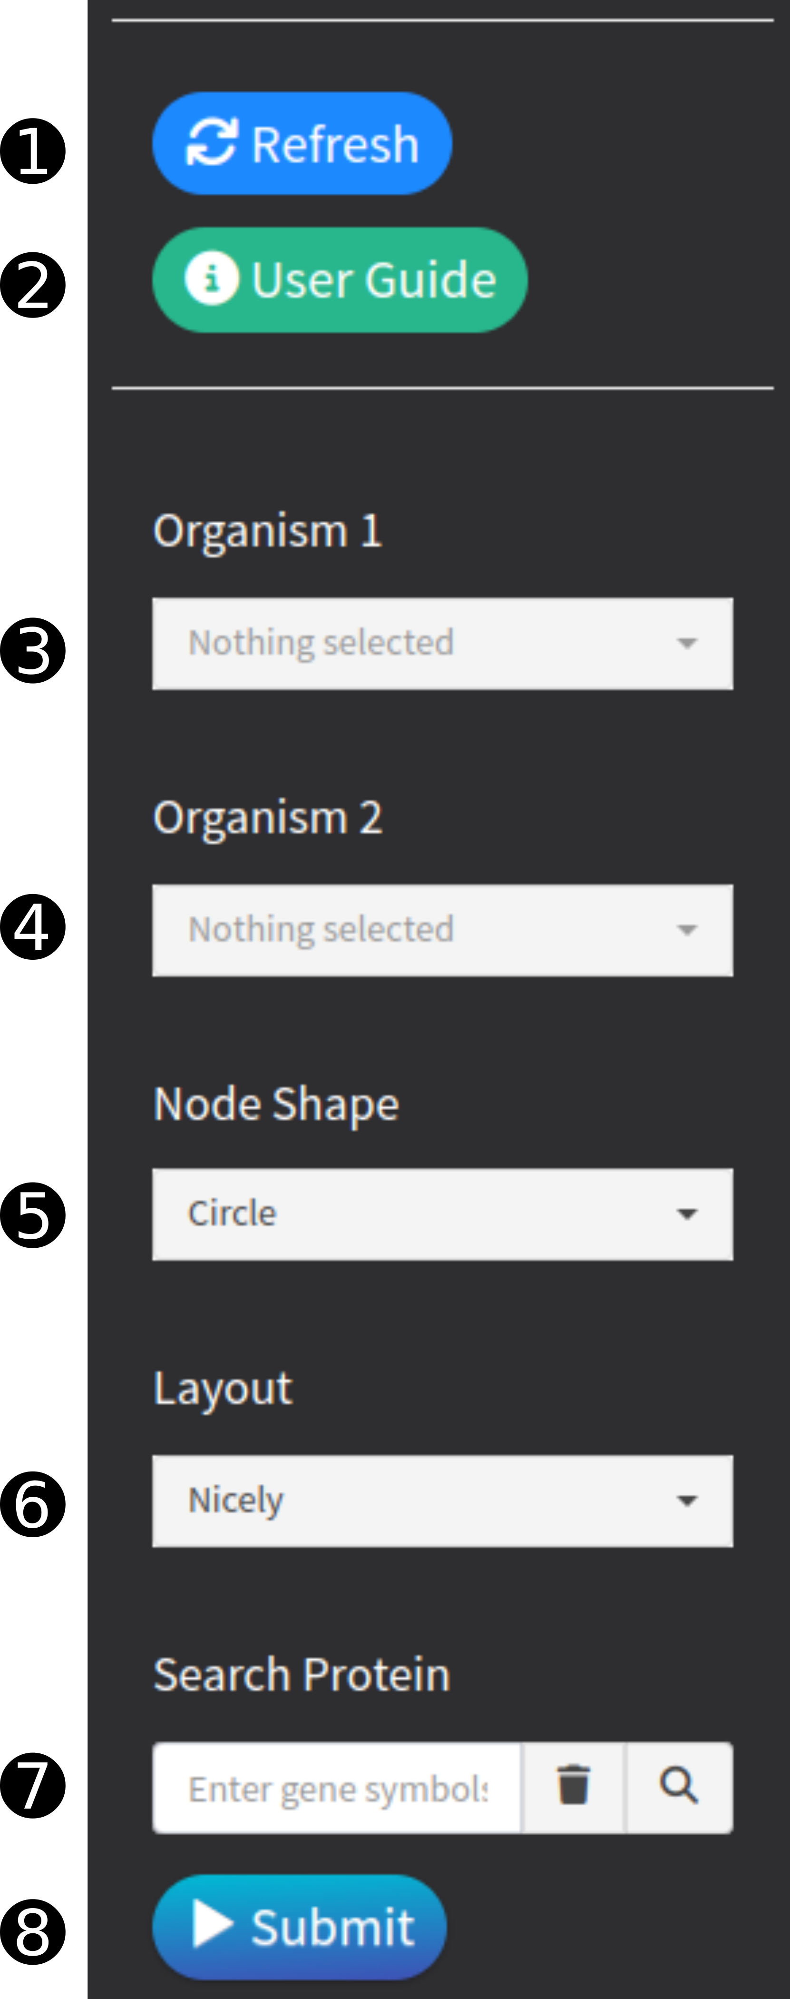

➐ The users can search in the database by typing the “Gene Symbol” of the protein they want to search in the box and see the related interactions.
➑ The submit button is clicked to use the selected parameters and visualize the protein-protein interaction.

An example Homo sapiens- Vaccinia virus GLV-1h68 protein interaction
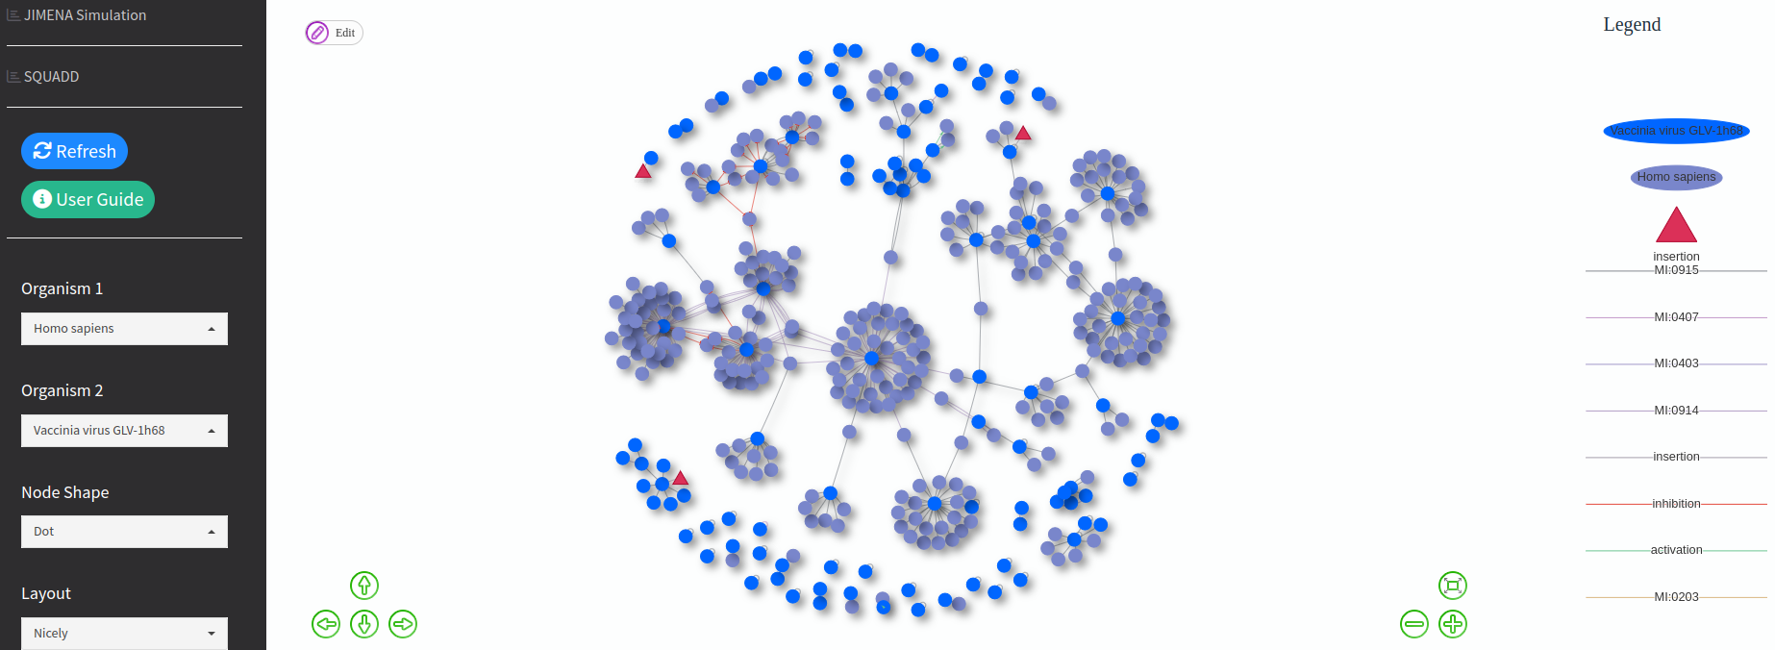

Fig 2. PPI network between Homo sapiens- Vaccinia virus GLV-1h68 modified version. Insertion refers to the parts of the genes that have been changed.

It can be done on PRO-Simat when it is desired to add or remove a new node/edge on the network. When the edit button in Network is clicked, add node and add edge options are offered (Fig 2). You can name the added node/edge. (Node/edge added or deleted by the user does not change the PRO-Simat database. Only each users can make changes on their own network).

If you hover over any protein, users can see information about the protein such as Gene, UniprotKB, Species, Taxonomy (Fig 3). Users can either select the protein they would like to search in the network or search by typing owing to the auto-complete feature.

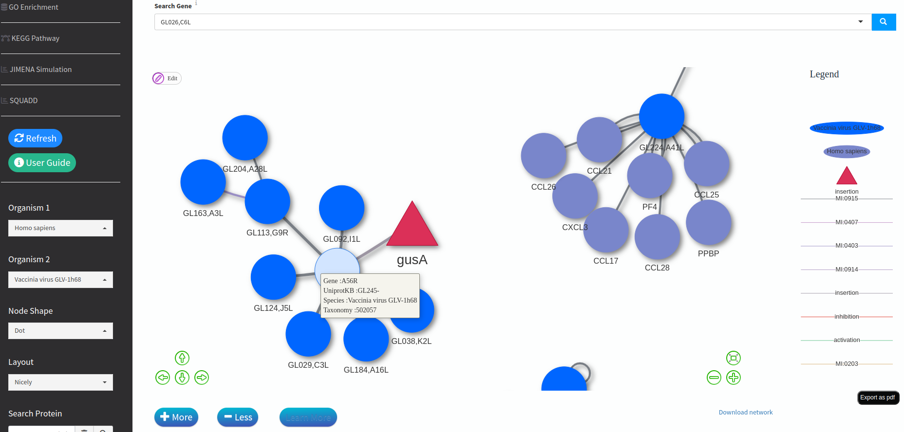
Fig 3. A zoomed-in image of the PPI network between Homo sapiens- Vaccinia virus GLV-1h68. Protein information is presented as a pop-up.

The interaction information of the protein-protein interaction created (Fig 2) in the PRO-Simat network analysis is presented in a table. The table is in searchable form and it is also allowed to download the table (Fig 4). Thus, the file downloaded in csv format can be used in software programs such as Cytoscape for visualizing complex networks.
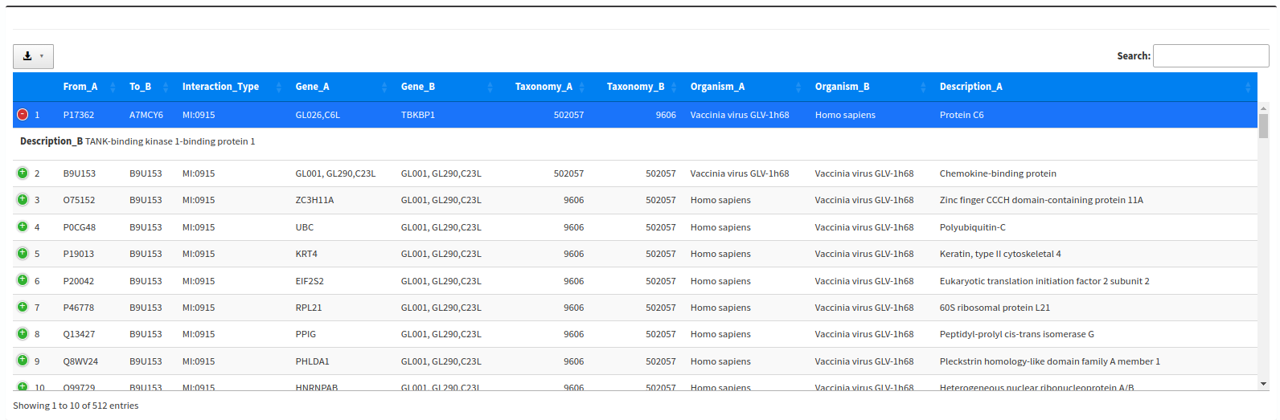
Fig 4. PPI network table between Homo sapiens- Vaccinia virus GLV-1h68

When users click on any protein, the gene ontology information of the protein is shown in a tabular form (Fig 5). It is allowed to search for the desired term in the table using the Search Box.
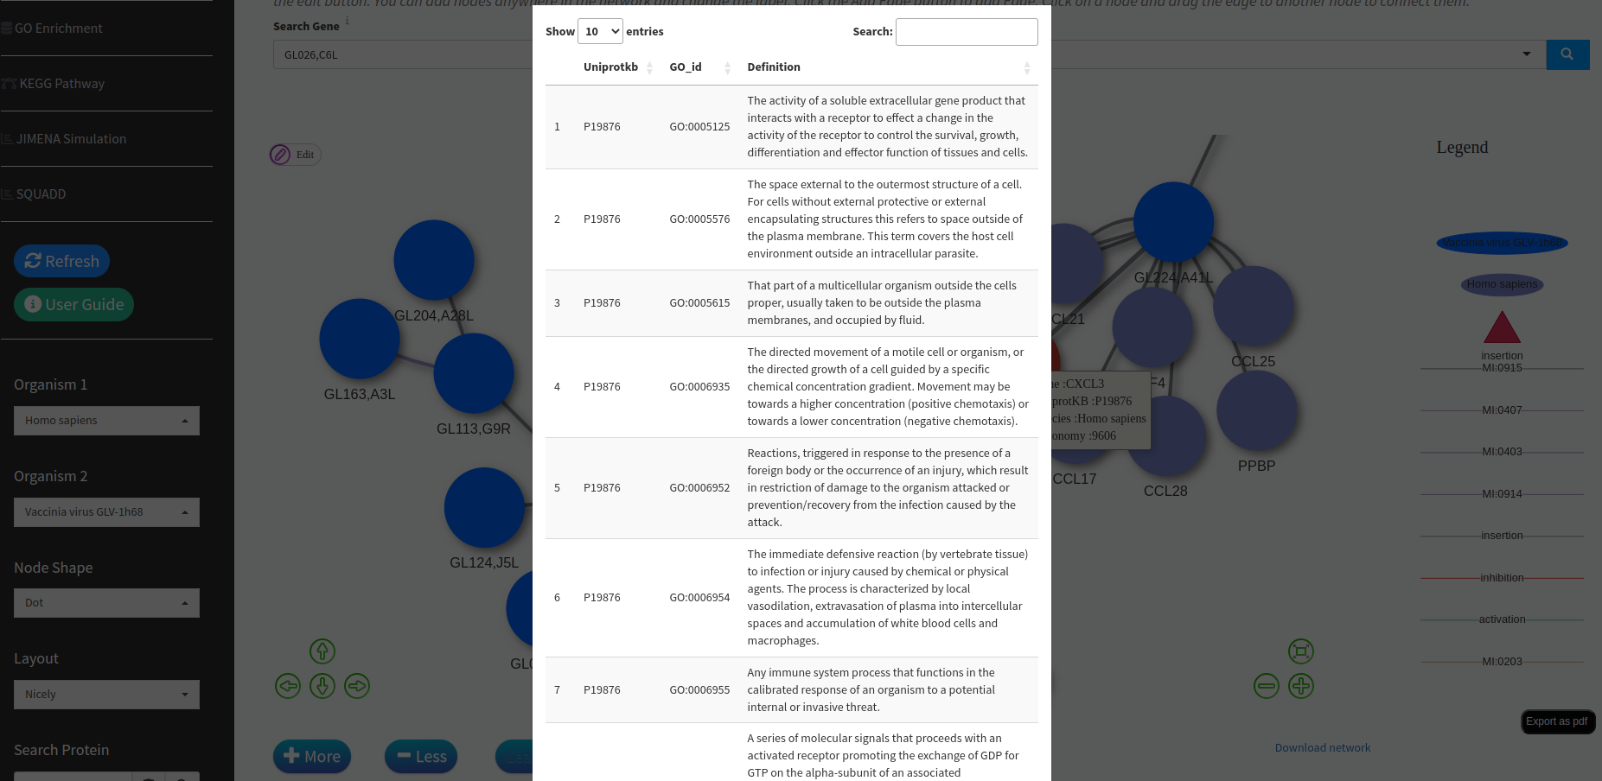

Fig 5. The created PPI network between Homo sapiens- Vaccinia virus GLV-1h68 is clicked on the protein to see the gene ontology information of each protein.



Before starting the GO Enrichment and KEGG pathway analysis, users should decide whether they would like to use their own differential expression genes (DEGs) data or continue with the protein list that they created in the PRO-Simat Network Analysis tab.
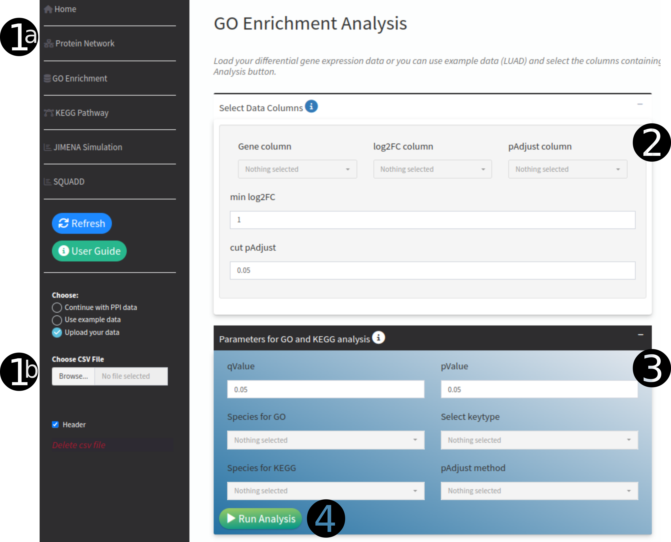
Fig 6. Box with parameters required for GO and KEGG analyzes

❶
a) If users want to continue the analysis using the protein list in the Network Analysis tab, they should select the "continue with PPI data" option from the "choose" section. In line with this selection, the second part (number 2) is skipped, and the third part (number 3) where can specify the analysis parameters.
b) If users would like to continue with their DEGs data, they should upload the data in a “.csv” format.

❷
Please select the columns with Gene, Log2FC and pAdjust values in the data that you have loaded. Pre-processing is applied to the uploaded data. A Volcano plot will be created together with the thresholds of the parameters users will be able to specify here. In addition, GO and KEGG analysis are continued using only filtered genes.

❸
Pvalue, qvalue, keytype, GO/KEGG species (which organism's genes are used) and which padjust method the analysis is desired should be selected.

❹
Click the Run Analysis button and start the analysis.

Detailed instructions for each tab can be obtained from the “User Guide” button, where users will be prompted to make the analysis easily (Fig 7).
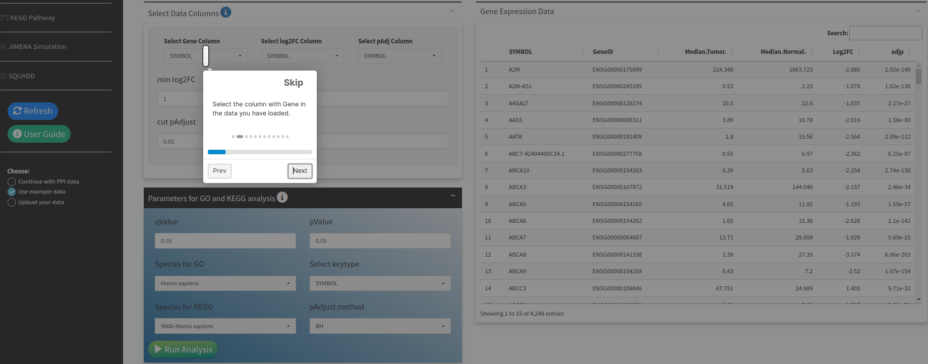

Fig 7. “User Guide” button guides the user interactively


When the information icon next to the box headings is clicked, the user is informed about how to use the web page (Fig 8).
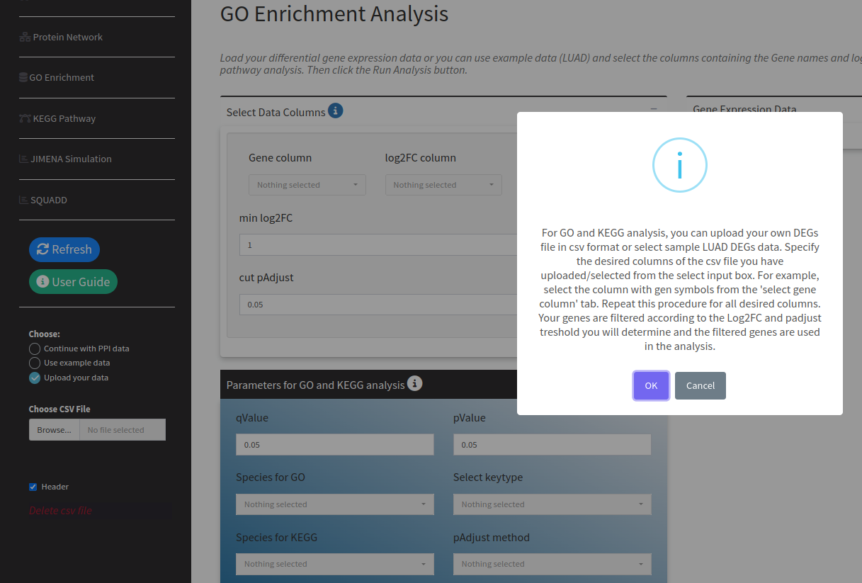

Fig 8. Information button guides the user interactively

Users can display the Biological Process (BP), Molecular Function (MF) and Cellular Component (CC) gene ontology categories and associated genes (Fig 9). In addition, PRO-Simat subcategorizes apoptotic process, proliferation, and positive and negative regulation (Fig 9).
(GO and KEGG analyzes were performed using proteins belonging to Homo sapiens-Vaccinia virus GLV-1h68 organisms obtained in ‘Network Analysis’ tab.)
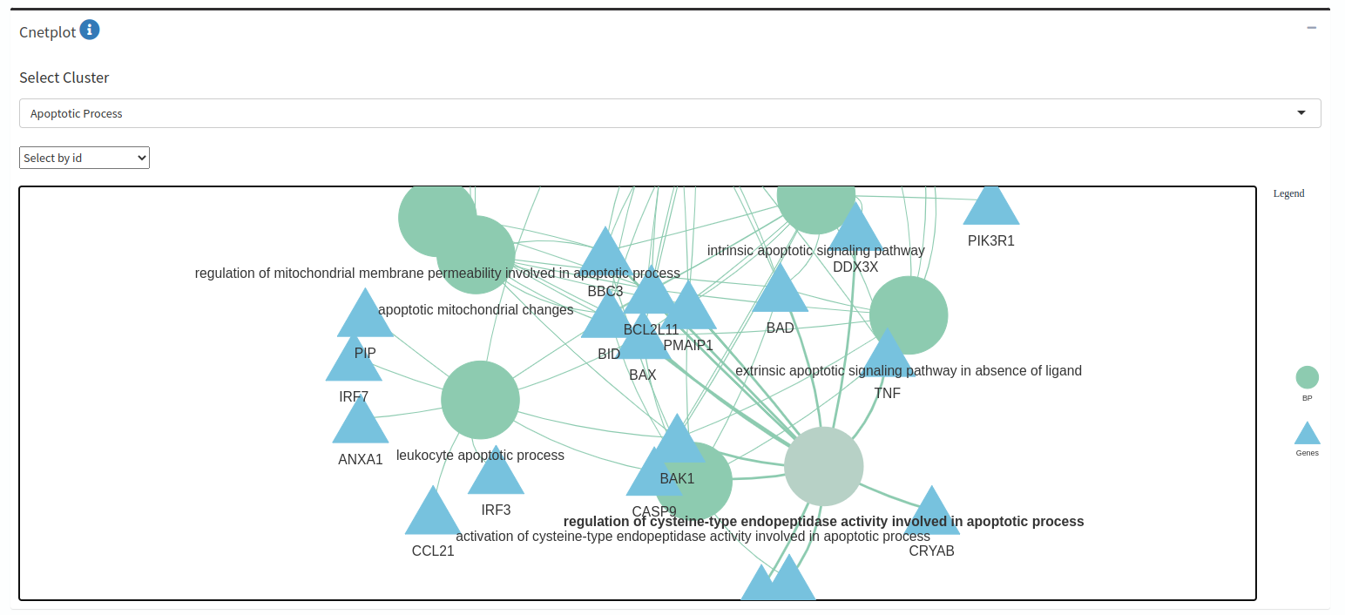

Fig 9. Cnetplot visualization of GO enrichment analysis result obtained in “Network Analysis” tab using proteins belonging to Homo sapiens- Vaccinia virus GLV-1h68 organisms

Gene ontology has 17 different zoomable graphics options that can be downloaded as “.svg” format using the related button. Thanks to the numeric input of Show Category options, users can specify the desired number of categories.
Gene ontology terms are displayed in treeplot according to the number of categories selected by the user (Fig 10).

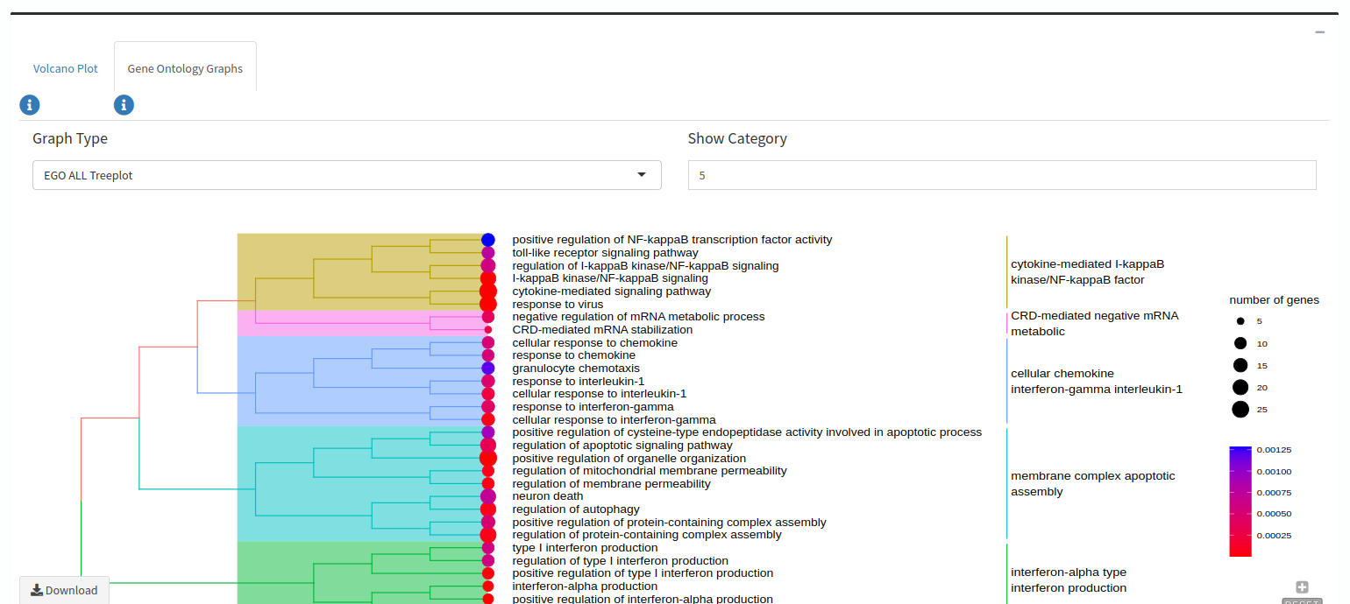

Fig 10. Hierarchical clustering of enriched terms of biological process, cellular component and molecular function

By displaying the result of gene ontology enrichment analysis as a heat map, it provides the user to understand the expressions more easily. As an example, significant 5 categories were selected (Fig 11). User can increase/decrease the number of categories. Increasing the number of categories too much can cause clutter on the heatmap network.
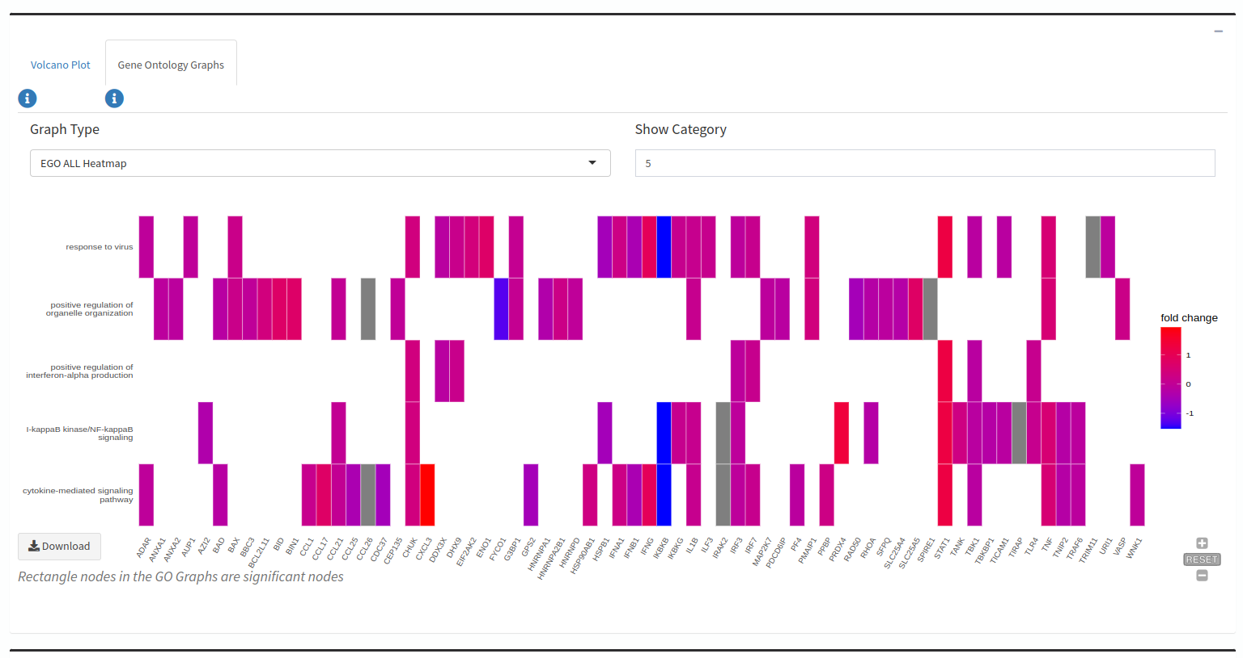
Fig 11. Display of gene and significant terms as heat plots

Gene ontology enrichment results are presented to the user in 4 different tables as BP, CC, MF and all category (Fig 12). Users can download the outputs as PDF, or save them as in a “.csv/excel” format.

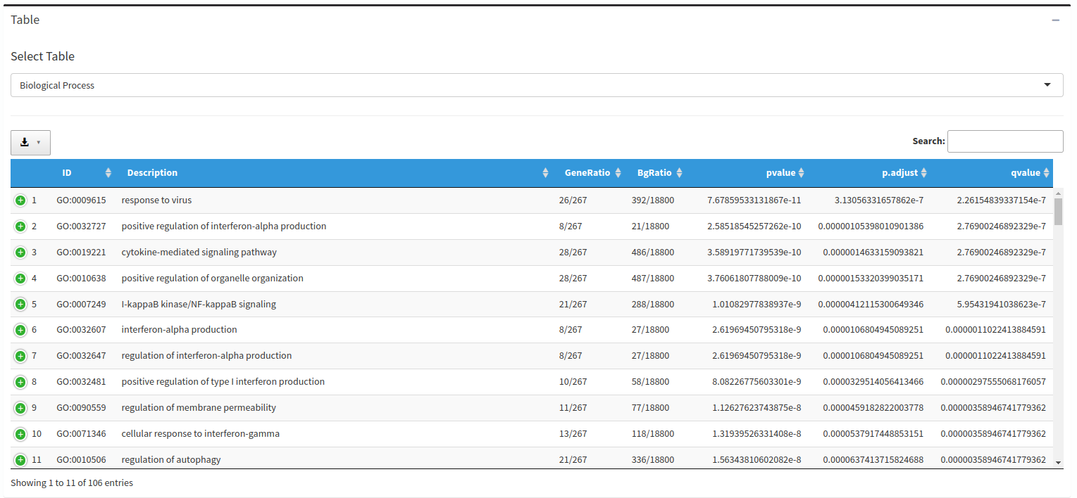
Fig 12. Biological process result of GO Enrichment Analysis

If users selected the GO and KEGG analysis using their own DEGs data, the volcano plot is created based on the Log2FC and pAdjust threshold values (Fig 14). Fig 13 displays an example of this step, where the Pancreatic cancer DEGs data from the GEPI database was used.
(Figure 6 shows how the GO and KEGG analysis was performed using user data.)
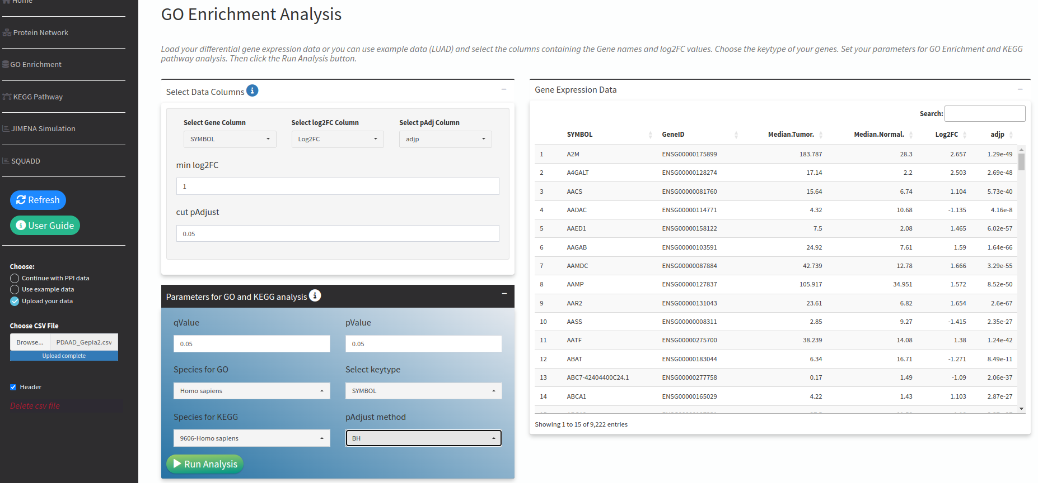

Fig 13. Uploading DEGs data of pancreatic cancer

An interactive volcano plot is created based on the Log2FC and pAdjust values that users set.

Here you can save your volcano plot
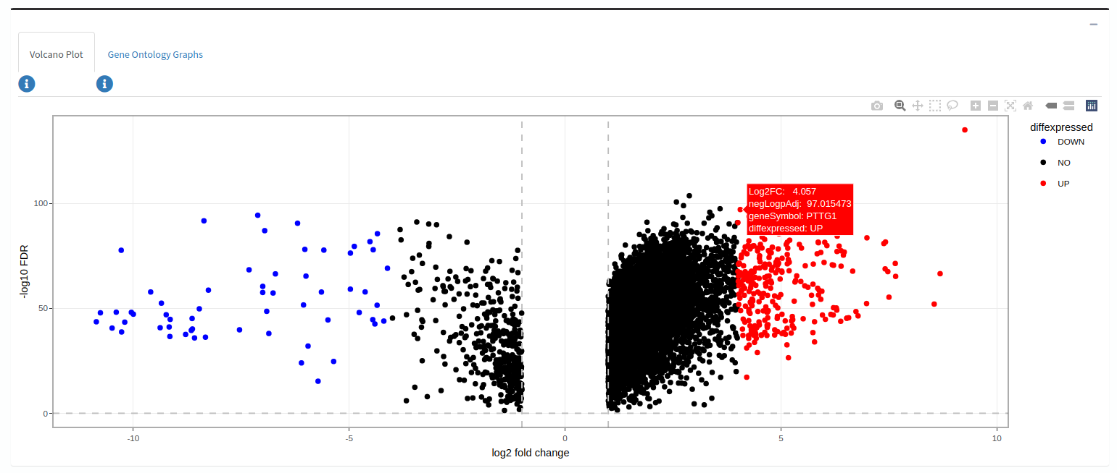

Fig 14. Volcano plot of pancreatic cancer DEGs data



According to the filtering and parameter selections found in the GO enrichment UI tab, the results of the KEGG enrichment analysis are displayed in the KEGG Enrichment Analysis tab. Analysis result is presented in tabular form and can be saved in pdf, csv, excel format (Fig 15 and Fig 16).

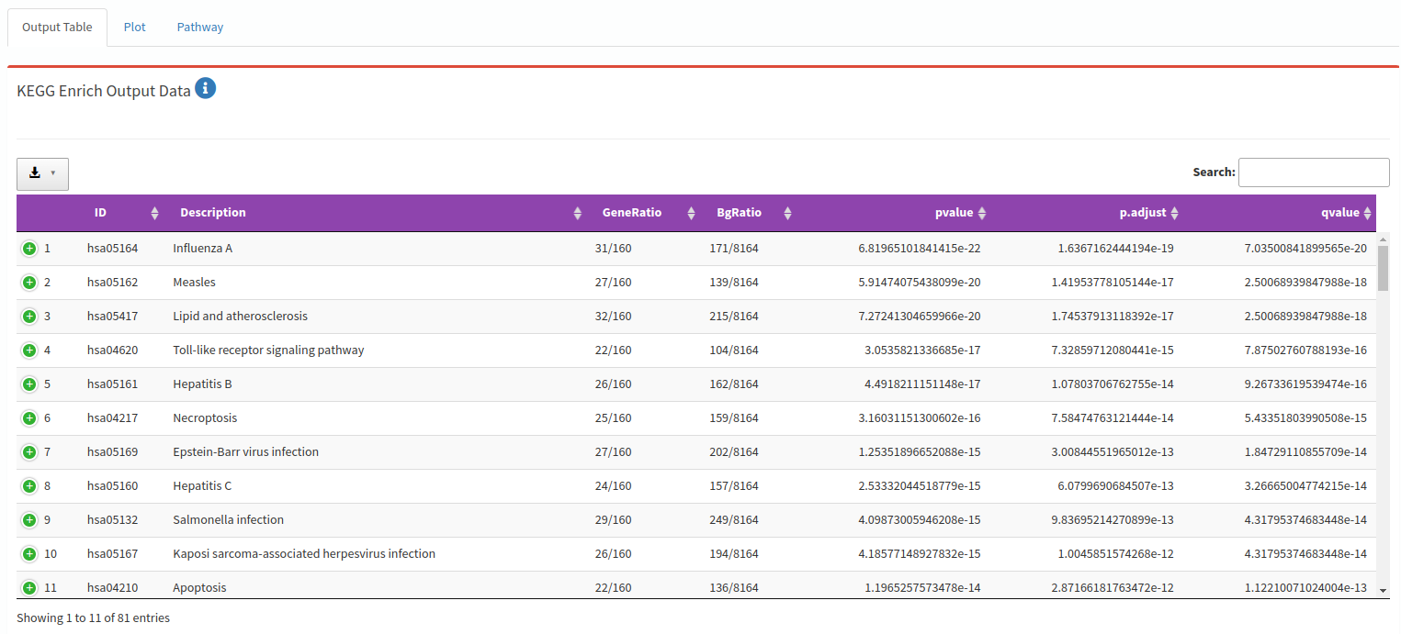
Fig 15. KEGG pathway enrichment analysis result

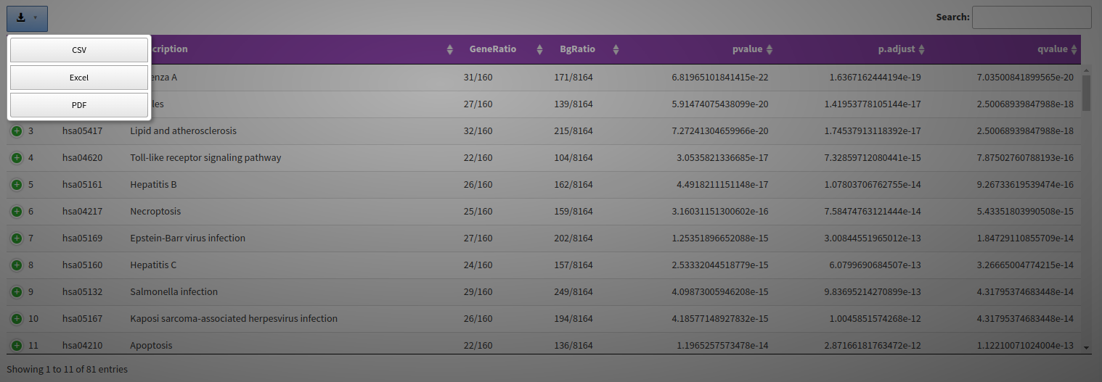
Fig 16. KEGG pathway enrichment analysis results table download options

Users can access the Enrichment Map for the result of over-representation analysis (ORA) in the KEGG enrichment emapplot in Plot tab (Fig 17).

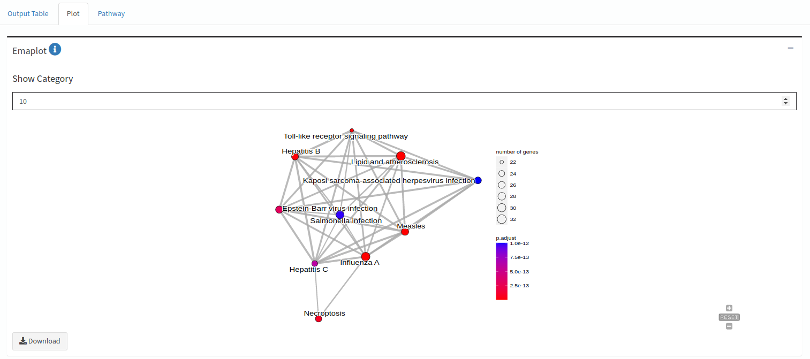
Fig 17. Emap plot with 10 categories

According to the data obtained as a result of ORA, when users write the pathway ID to the text box of input pathway, an enriched KEGG pathway will be created (Fig 18). If users upload their own DEGs data, the coloring will be done using the log2FC scores. If users proceed by using the genes in the PRO-Simat Network Analysis tab, the log2FC values of the DOSE package for Homo sapiens will be used.

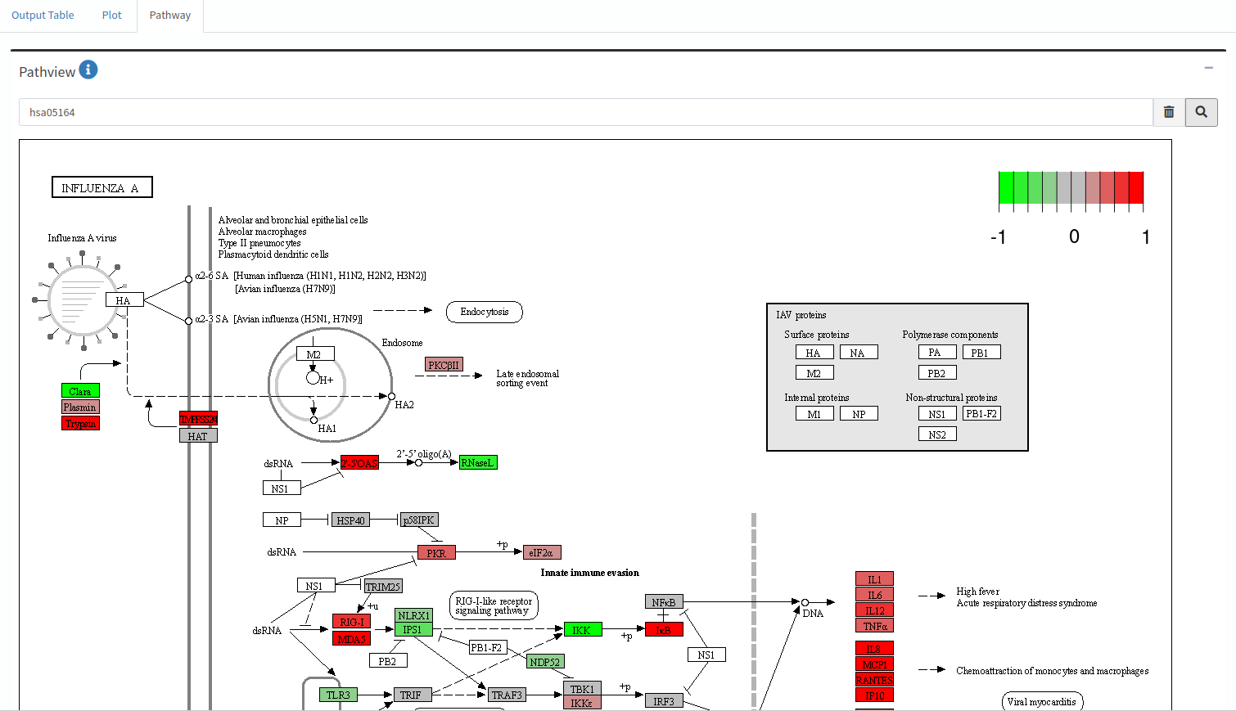
Fig 18. Colored pathway with the help of Pathview package

Users can download the pathway images from the “Download.png” and “Download.pdf” buttons (Fig 19).

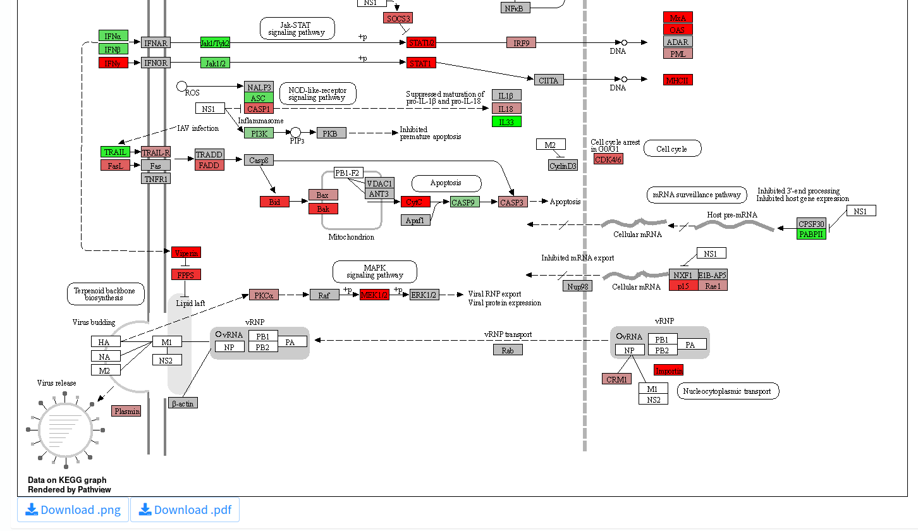
Fig 19. Options to download the colorized path image created with the Pathview package



Users can choose the “Step 1” and “Step 2” information boxes or the User Guide button to learn how to use Jimena genetic regulatory simulation with Squad method (Fig 20).
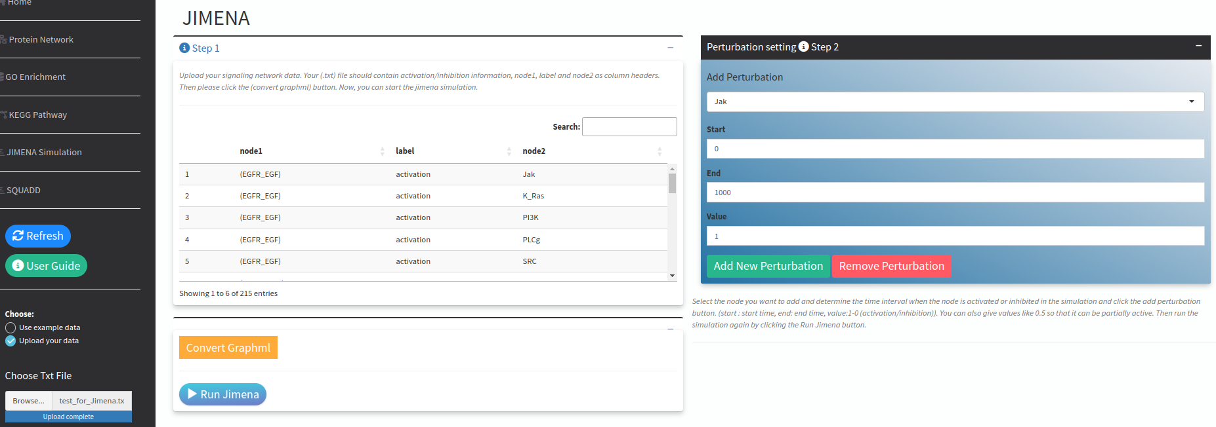
Fig 20. Jimena genetic regulatory network simulation tab

- Upload the .txt file containing the genes containing Node1, label, Node2 titles and the activation/inhibition information of the signals between them and click the "Convert Graphml" button (Fig 20).
- PRO-Simat will convert the txt file you have uploaded to graphml format and make it suitable for use by the Jimena program (Fig 20).
- You can start the first analysis by clicking the Run Jimena button (Fig 20).
- Step 2 includes adding and subtracting Perturbation. From the “Add perturbation” selection input box, select the node you want to change the activation level (overexpression or knockout), the time interval you want this node to change in the simulation, and the activation level (between 0 and 1). You can also give values like 0.5 so that it can be partially active, and click the Add New Perturbation button. At the same time, after selecting any node you have added, you can remove the node you have selected by clicking the Remove Perturbation button. Thus, you will see the node you want to change and the values added to the table in the analysis (Fig 20).
- By pressing the Run Jimena button again, perform the analysis based on the node you have changed. The interactive chart will be updated in a few seconds (Fig 20). Your Jimena dynamic simulation will look like the one below (Fig 21).
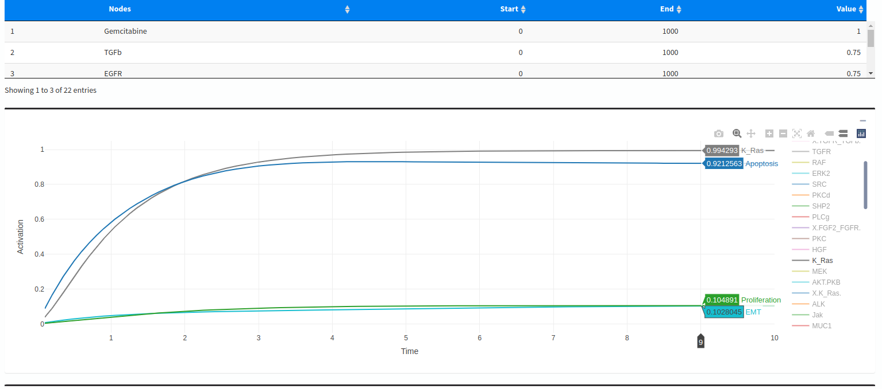
Fig 21. Jimena dynamic simulation output with added perturbations

When you double-click on the node you see on the right and want to select, only the trend of that node will be displayed. Alternatively, after the first double click, you can single click the node you want to compare (Fig 21). In addition, the output obtained as a result of the Jimena simulation is presented in the form of a downloadable table in pdf, csv, and excel formats (Fig 22).

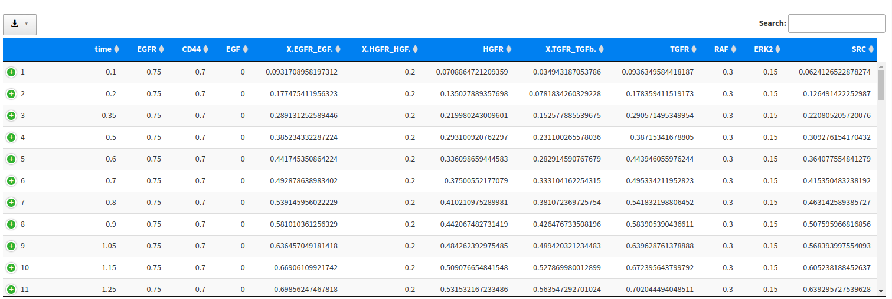
Fig 22. Jimena dynamic simulation output as a table



Users have to Run Jimena before using the SQUADD visualization package. The reason is when you Run Jimena for each node users added by changing the activation level, the results are indexed and kept in PRO-Simat until users close the web application. Different simulation results are re-visualized for the genes users choose with the help of the SQUADD R package. Thus, matrix graphs are created for each gene users have selected for each condition they change.

Please select the nodes from the Select nodes box and click the Run button.
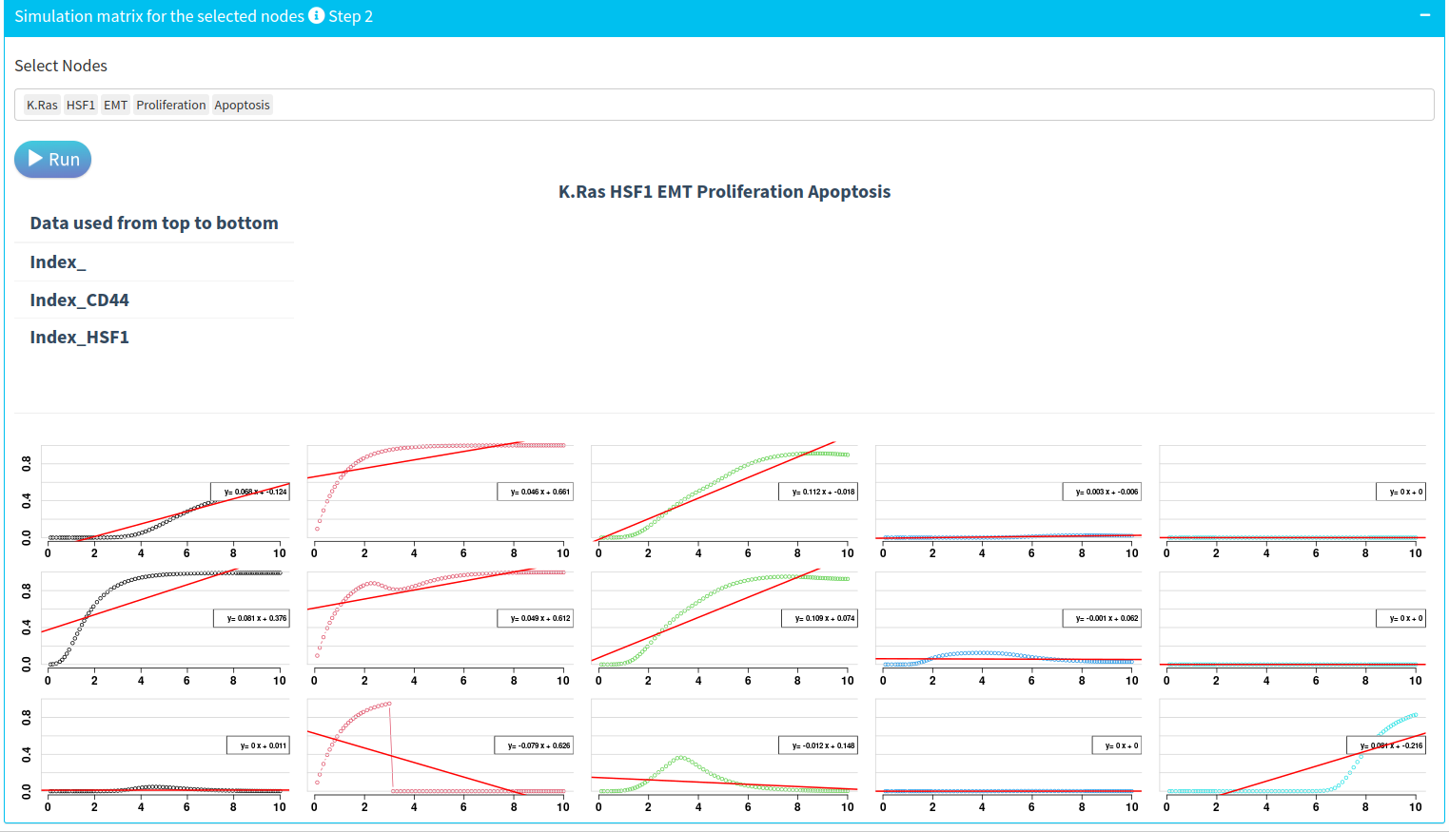

Index_

Index_CD44

Index_HSF1

Fig 23. Index_, result of the first Jimena run simulation without applying add/remove perturbation.
Index_CD44, second simulation result run by changing activation level. In this example, it was tried by blocking CD44. In the Index_HSF1 sample, active HSF1 was blocked.

The correlation circle was used to assess the consistency of a model. If the angle between each vector is greater than 90 degrees, we can say that there is no correlation (Fig 24). The darker the color, the higher the increase of the node activation in prediction heatmap (Fig 24).

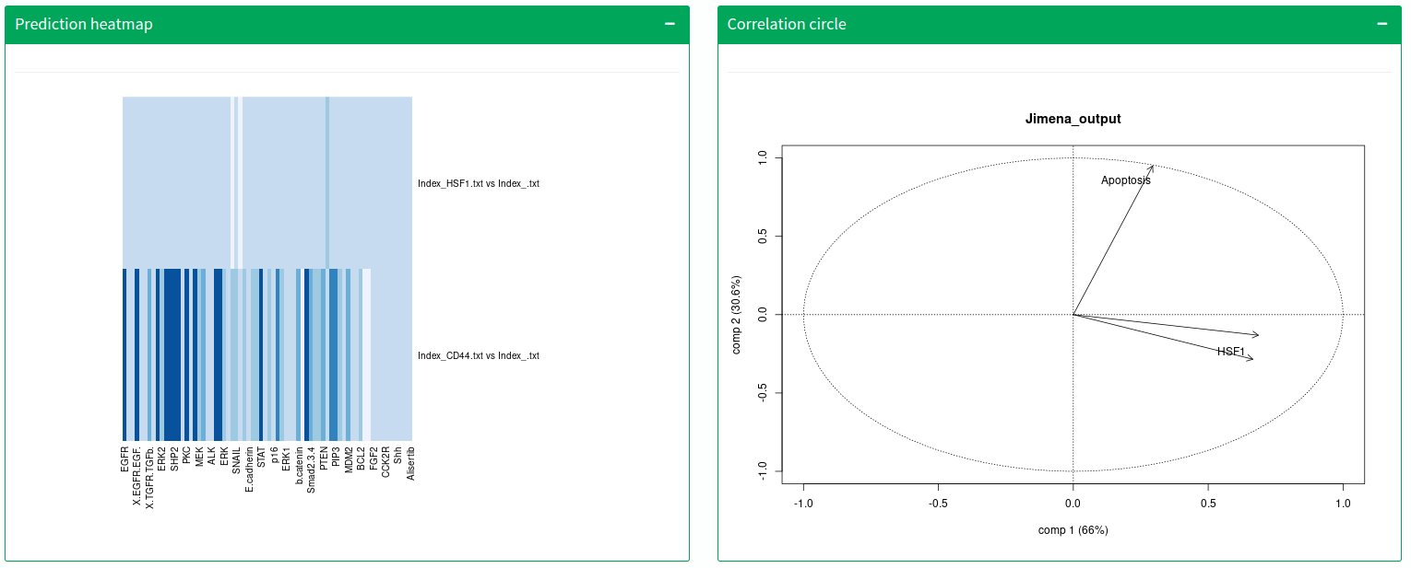
Fig 24. Prediction heatmap and Correlation circle with selected nodes and applied different activation level of genes in Jimena

