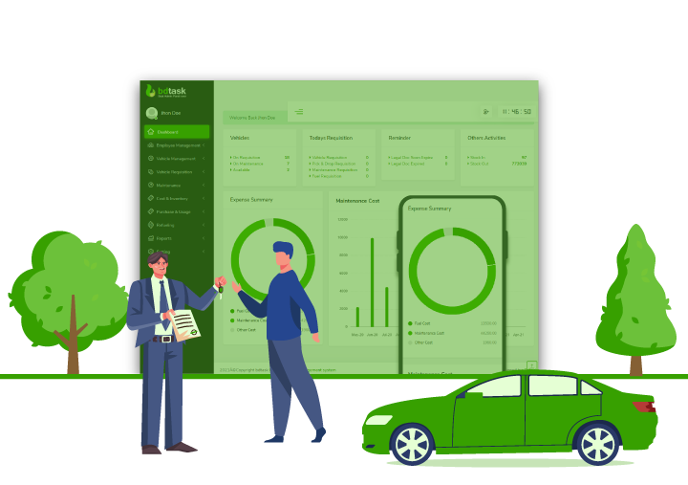

Car Management

You can manage your car maintenance requests.

**Car Management**

User Manual / Contents

**Getting Started**

Overview **3**

Install the Application **4**

Change Default Settings **4**

How to Use **5**

Build Process

Using Visual Studio 2022 **6**

Database Design **7**

Pages **8,9,1****0**

Uninstalling

Uninstalling the Game **11**

Contact Us

Developers **12**

# Overview

Welcome to our Car Management Desktop Application. This manual will help you find your way around the excellent mobile game offered by Muhammet Ali Özkaya, Salih Özkara, Beyza Erdem, Zeynep Arslan. You can download application from our website, or you can visit our Github repository. First, let’s begin with a few notes on Car Management.

* The car saves with plate. **(Araba plakasıyla birlikte kaydedilir.)**
* Car saves with oil, brake services, gearbox, car type, years. **(Arabayla birlikte motor, fren, vites, arac tipi ve yılları kaydedilir.)**
* When maintained the car, we save odometer, date. **(Araca bakım yapıldığında o anki kilometre ve tarihiyle birlikte kaydediyoruz.)**
* User can be note with maintain. **(Kullanıcı araca bakım yaptığında not ekleyebilir.)**
* User can be authenticated on desktop app. **(Masaüstü uygulamasında kimlik doğrulaması yapılabilir.)**
* Admin and password should be kept in settings file. **(Admin ve şifre ayar dosyasında saklanmalı.)**
* User can print the maintain card. Without odometre and date. **(Kullanıcı bakım kartını yazdırabilir. Kilometresi ve tarihi olmadan.)**
* User can filter maintain history by customer's car. **(Kullanıcı müşterinin aracına göre bakım geçmişini görüntüleyebilir.)**

## Minimum System Requirements

* Windows 10 or later
* Dotnet 6 Runtime or later
* 42 MB space on the phone memory

**Note:** You can download the application from Github

# Getting Started

## Install Application

Download the installer from Github. You can complete the installation steps easily by clicking next buttons.

## Update Default Settings

Start the application and enter your password. (Default username = admin and password = 1234qwe) We recommend that you change your default password. Change your password in settings screen.

# How to use

Enter the car plate. If car already saved on your data the car details will be filled in the boxes, otherwise it will be saved with your first maintain adding.

Maintain types will be listed on maintain checkbox and you can filter with entering characters. If you want to add new maintain type, just enter the name to checkbox and it will be saved automatic when maintain adding.

## Application Pages:

* + Login page
  + Home page (All management process is here)
  + Settings page
  + Information page

# Using Visual Studio 22

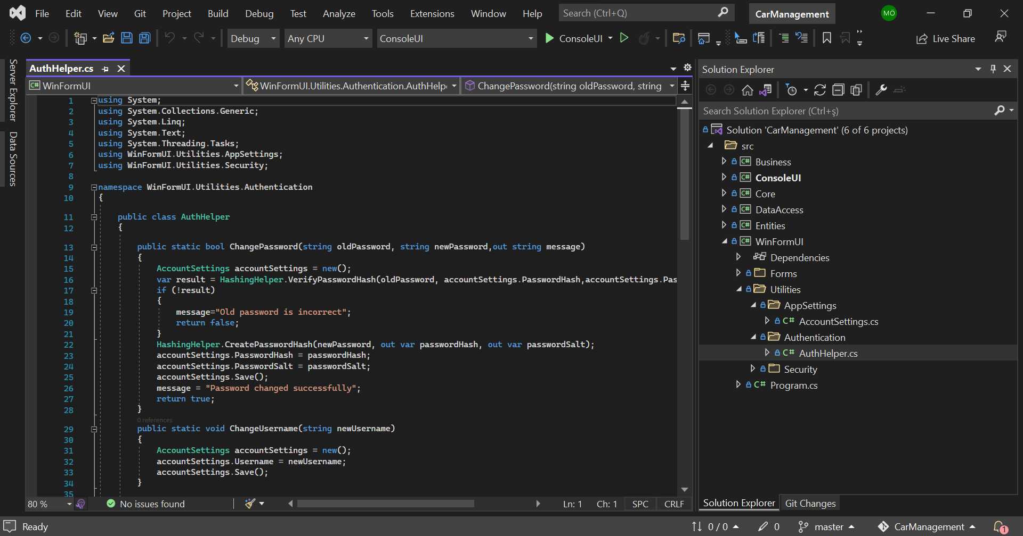

We are using Visual Studio 22. It is supporting many tools you can use free. Example: SqlServer, and Windows Form Designer. We designed a tiered project. We used ConsoleUI for testing Business codes. We built a GUI with Windows Form for using easily.

# Database Design

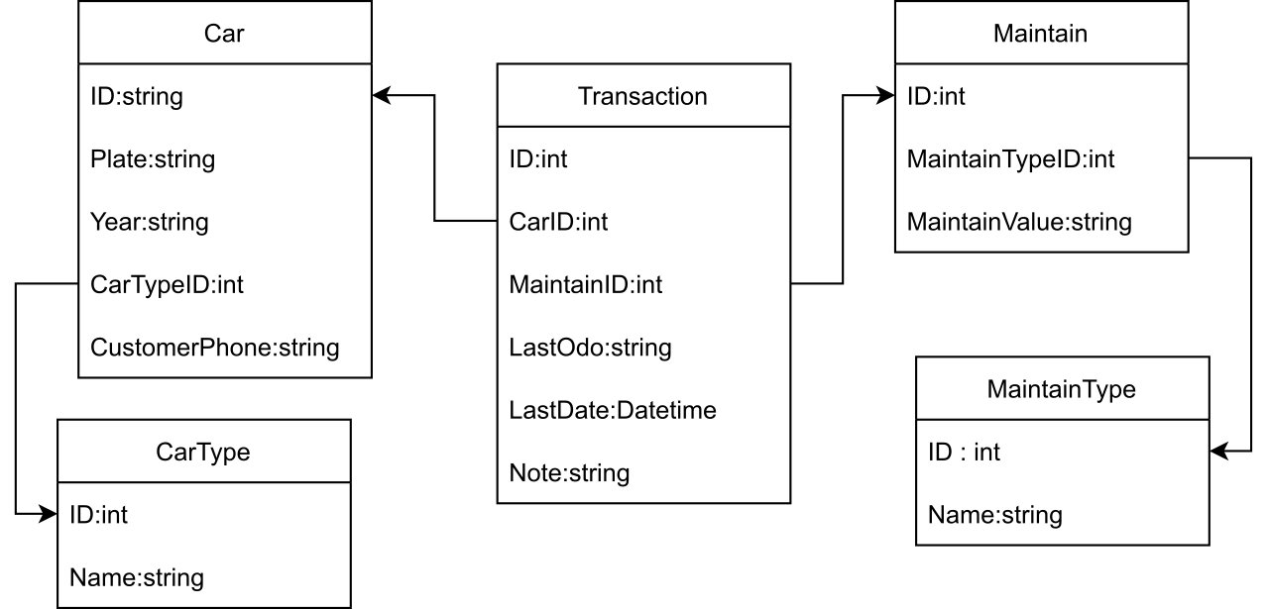

Normalization rules were followed in the database design.

# Home Page

**metin içeren bir resim

Açıklama otomatik olarak oluşturuldu**

# Login Page

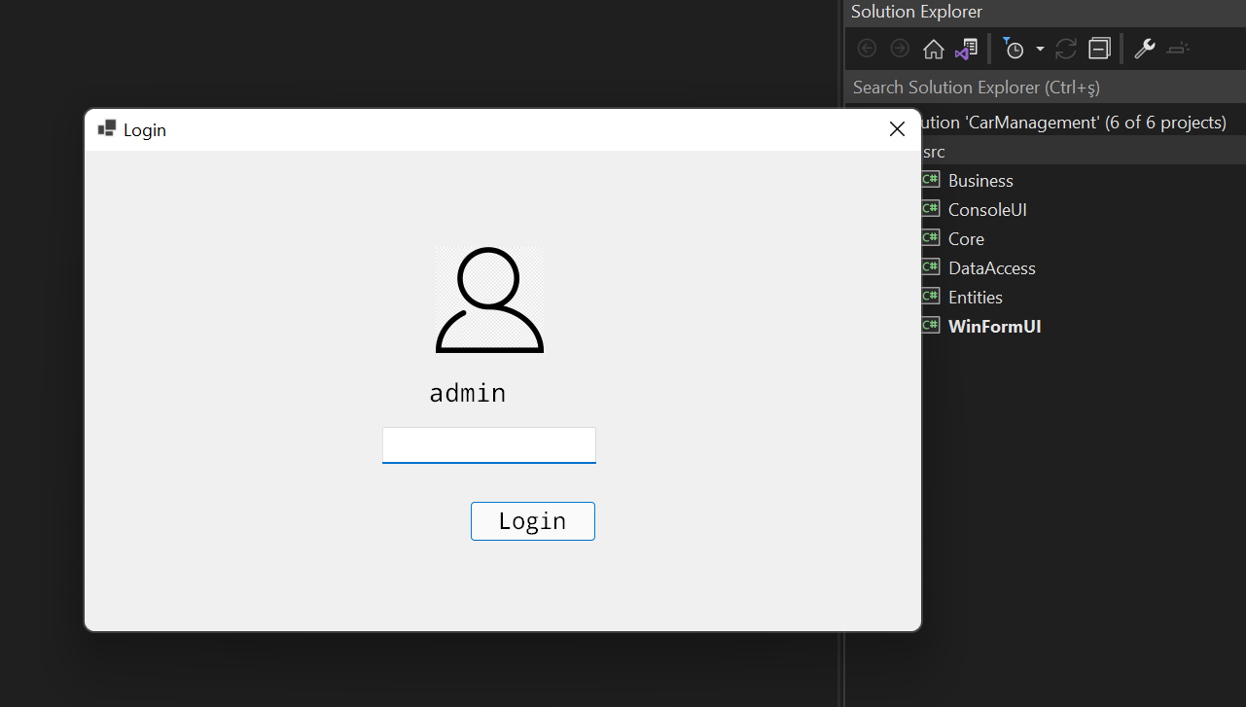

# Information Page

**metin içeren bir resim

Açıklama otomatik olarak oluşturuldu**

# Settings Page

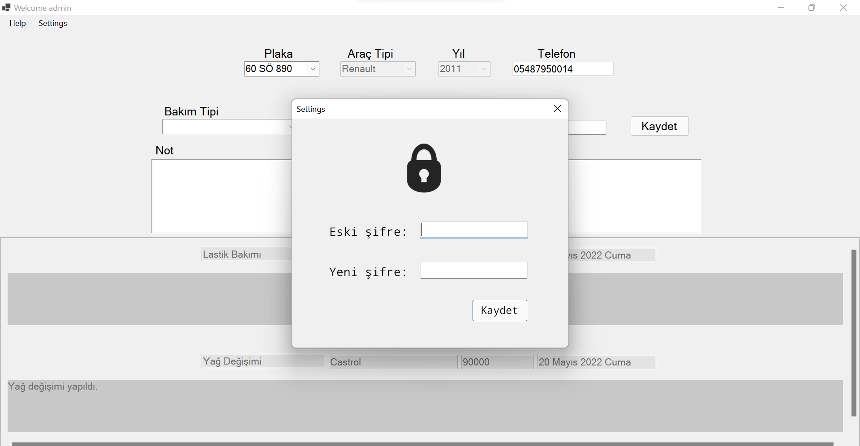

Car Management

User Manual / Uninstalling

# Uninstalling the Application

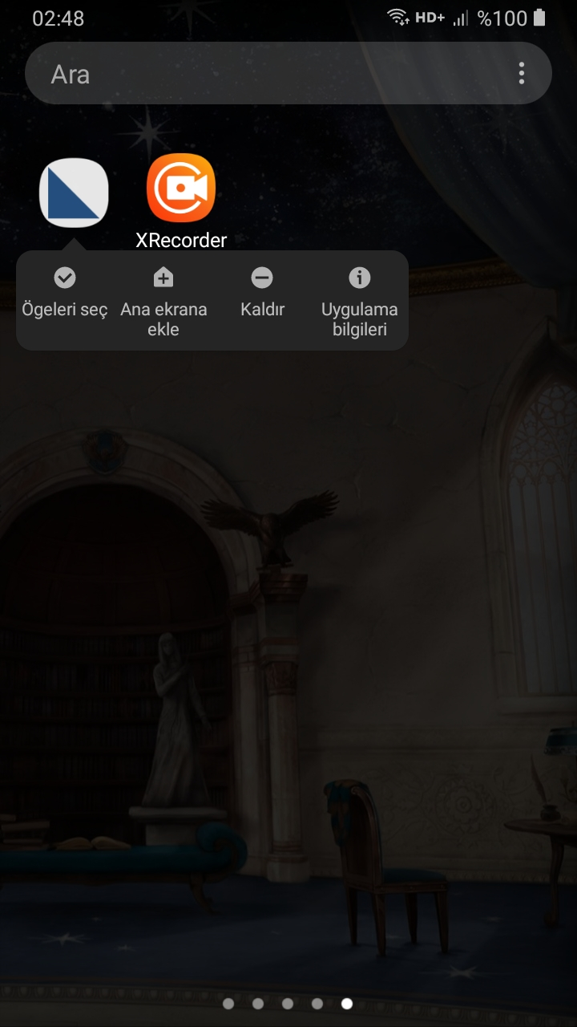

1. Go to Apps.
2. Search the Car Management.
3. Choose “Kaldır”(Turkish).
4. Tap “yes”.
5. It is removed.

For more information about the game, see the help scene at Tangram Game

# 

# Contact Us

For more information about us and services we can provide, visit us at Manisa Celal Bayar University-Hasan Ferdi Turgutlu Technology Faculty. Turgutlu/Manisa.

**Useful Links**

Project Link: https://github.com/salihozkara/CarManagement

Youtube:

**The Developing Team**

Muhammet Ali ÖZKAYA | **No:** 192802055 **| Github:** https://github.com/m-aliozkaya

Salih ÖZKARA | **No:** 192802010 **| Github:** https://github.com/salihozkara

Beyza ERDEM | **No:** 192803045 **| Github:** https://github.com/beyzaerrdem

ZeynepARSLAN | **No:** 192803035 **| Github:** https://github.com/zeycoder