Salih ÖZYURT 150117855

Muhammed Bera KOÇ 150116062

Operation Systems Project #1 Report

# Overall Reveiw

The main goal in this project is to explore and learn about shell scripting. There are five different shells. Each of them has a peculiar purpose. Now we will go over each of them while showing you the fundamental design pattern of each of them.

1) Palindrome

In this script our main idea is to detect if a word or a sentence is a palindrome(Same as its reverse form). To detect it we removed the spaces, formed it to the lowercase version then compared it with its reversed version whether it is equal or not.

We first control if given input is a string using is_string function then using is_palindrome we return an integer value (0 for false, 1 for true). Also we handled other errors using if else.



2) CProgs

First of all, We found all C files according to argument. We found all cprogs under directory if an argument is given us as a directory. If directory argument is empty, We started to find from current directory. We used few bash command for this script such as find, mkdir, mv. We used mkdir command for creating a new file named cprogs according to argument. We used find command to find all C files’s directories before we move all C files to the new file named cprogs.



3) Hallowed Squares

In this one our foremost objective is to print a number of stars to form a square. There is two integer arguments. First one must be greater than the second one. And the difference must be even. Using two dimensional loop we print them with constraints given.

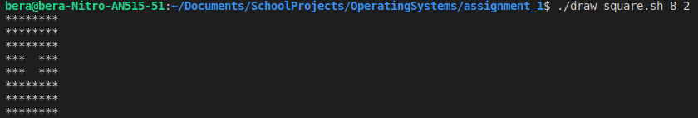

4) Uppercase Conversion

Firstly, we take two arguments. But, first argument is mandatory and second argument is optional. Word is given us by first argument. It can have star(*) like “j*y” form. It means that we must find all words start with “j” and end with “y”. Directory is given us by the second argument. If the directory is empty, we use current directory and search word inside text files are under current directory. We used the directory if second argument given us directory is not null.

We used several bash command such as find, grep. We found all text files’ directory with find command. We change star with “+[a-z]+”. For example, if word is “j*h”, we change it with “j+[a-z]+h”. We find word changed with text files’ directory using grep bash command. We formated output and write on screen.

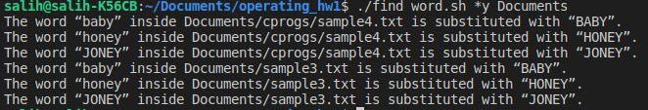

5) Delete Files

This script is implemented recursively. We have a remove_files method which removes all empty files in current directory. We have two arguments. First argument is alias –R optional. Second one is the path which is optional. -R alias means recursive remove which removes all empty files in current directory and subdirectories. The path argument sets current directory. Using if else for different situation of arguments with one remove function we can accomplish the very task of removing files. Remove_recursively method removes files in a given directory recursively.

