CONFIDENTIAL
VULNERABILITY ASSESSMENT &
PENETRATION TESTING REPORT
Target Organization:
Mediroza General Hospital
https://medirozahospital.com

Prepared By | Muhammed Salih Cv
Role | Cybersecurity Intern — Network Walks Academy (Batch B083A)
Engagement | Week 4 Internship Practical Task — Web Application VAPT
Assessment Type | Black-Box Web Application Penetration Test
Report Date | 30 September 2026
Classification | Confidential — For Internal / Academic Use Only

Document Control

Confidentiality Statement
This report contains sensitive information regarding security vulnerabilities identified on the web application hosted at https://medirozahospital.com, including evidence of exposed personal, financial and shareholder data. This document is classified CONFIDENTIAL and is intended solely for academic review under the Network Walks Academy internship program and for the awareness of the concerned website owner. It must not be distributed, copied, or disclosed to any unauthorised party.

Revision History
Version | Date | Author | Description
1.0 | 30-Sep-2026 | Muhammed Salih | Initial report — Week 4 internship deliverable

Distribution List
Name | Organization | Purpose
Muhammed Salih | Network Walks Academy — Intern | Author / Assessor
Internship Mentor / Reviewer | Network Walks Academy | Evaluation of internship task

1. Executive Summary
As part of the Week 4 practical task of the Network Walks Academy cybersecurity internship (Batch B083A), a black-box security assessment was performed against the publicly reachable web application of Mediroza General Hospital, hosted at https://medirozahospital.com. The objective of the engagement was to identify security weaknesses in the externally facing application and infrastructure that could be exploited by a malicious actor, and to provide practical, prioritised remediation guidance.
The assessment began with reconnaissance using Nikto, which revealed that directory indexing was enabled on three sensitive paths: /staff/, /patient/ and /old/. Manual review of the /old/ directory uncovered a publicly downloadable legacy database backup file, mediroza_db_backup_2019.sql, which disclosed the full names, job titles, departments, email addresses, phone numbers, national identification numbers and monthly salaries of 30 hospital staff members, together with a full shareholder register listing shareholder names, shareholding percentages, number of shares held and share class.
Separately, the Patient Portal login form (patient/login.php) was found to be vulnerable to classic SQL injection, allowing authentication bypass using payloads such as admin'-- and ' OR '1'='1'--. Once authenticated, the portal exposed downloadable, password-"protected" pathology PDF reports belonging to real patients. These PDF passwords were found to be weak and were recovered within seconds using a dictionary/wordlist attack (passwords recovered included 123456, password and !@#$%^&), fully defeating the confidentiality control and exposing patient names, dates of birth, referring doctors and laboratory results.
Collectively, these issues represent a severe and immediately exploitable data breach risk. An unauthenticated attacker requires no specialised skill or paid tooling to obtain payroll data, national ID numbers, shareholder financial interests and patient medical records. The findings below are rated Critical to High and are recommended for urgent remediation.

Overall Risk Rating: CRITICAL
# | Finding | Risk Rating | Status
1 | Directory Listing / Indexing Enabled on Sensitive Paths | Medium | Open
2 | Sensitive Data Exposure — Public 2019 Database Backup (PII, Salary & Shareholder Data) | Critical | Open
3 | SQL Injection — Authentication Bypass on Patient Portal Login | Critical | Open
4 | Weak Password Protection on Patient Pathology PDF Reports | High | Open

2. Scope of Engagement

In-Scope Target
Target URL | https://medirozahospital.com
Application | Mediroza General Hospital — Patient Portal & Public Website (Mediroza CMS)
Testing Type | Black-box, unauthenticated external web application assessment
Environment | Kali Linux (VirtualBox), Mozilla Firefox ESR
Testing Window | 30 September 2026, approx. 01:16 – 01:41 (local capture time)

Objectives
- Identify externally exploitable vulnerabilities in the Mediroza web application.
- Assess exposure of sensitive personal, financial and medical data.
- Validate the strength of authentication and document-level access controls.
- Provide clear, actionable remediation guidance prioritised by risk.

Limitations
This assessment was limited to the publicly accessible web application and did not include internal network testing, social engineering, physical security testing, or denial-of-service testing. Findings reflect the state of the application at the time of testing only.

3. Methodology
The assessment followed a standard black-box web application testing methodology, broadly aligned with the phases of the OWASP Testing Guide and PTES (Penetration Testing Execution Standard):

Phase 1 — Reconnaissance & Scanning
Automated scanning was performed against the target host using Nikto to enumerate server information, HTTP headers, TLS certificate details and common misconfigurations such as directory indexing.

Phase 2 — Discovery & Enumeration
Directories flagged by the scanner were manually browsed to confirm indexing and to enumerate any files exposed within them. Files of interest were downloaded for offline analysis.

Phase 3 — Exploitation
- Manual SQL injection payloads were submitted to the Patient Portal login form to test for authentication-bypass vulnerabilities.
- Downloaded patient PDF reports were found to be encrypted; their password hashes were extracted and subjected to a dictionary/wordlist password-cracking attack.

Phase 4 — Analysis & Reporting
Findings were validated, screenshots and evidence captured, and each issue was rated for risk based on its exploitability and business impact before being documented in this report with remediation recommendations.

4. Tools Used
Tool | Purpose
Nikto v2.6.0 | Web server scanning — identified directory indexing on /staff/, /patient/ and /old/, and enumerated TLS/HTTP server information.
Mozilla Firefox ESR (Kali Linux) | Manual browsing, manual SQL injection testing, and file download / review.
Network Walks — Hash Calculator (networkwalks.com/hash-calculator) | Extraction of a crackable ($pdf$) password hash from encrypted patient PDF reports.
Network Walks — Password Cracker (networkwalks.com/password-cracker) | Dictionary/wordlist attack against the extracted PDF password hashes to recover plaintext passwords.

5. Detailed Findings

Finding 1: Directory Listing / Indexing Enabled on Sensitive Paths
Risk Rating | Medium | CVSS 3.1 (Est.) | 5.3 (Medium)
Category | CWE-548: Exposure of Information Through Directory Listing | Affected URL | https://medirozahospital.com/staff/, /patient/, /old/

Description
A Nikto scan against the web root revealed that directory indexing (auto-listing of folder contents) is enabled on the web server for at least three top-level paths: /staff/, /patient/ and /old/. Because these directories have no index page and directory browsing is not disabled at the web-server level, any visitor who requests the folder URL directly is shown a full listing of its files rather than being redirected or shown a 403/404 response. This misconfiguration was the initial foothold that led directly to Finding 2.

Steps to Reproduce
- Step 1: Ran nikto -h https://medirozahospital.com/ -o nikto.txt from Kali Linux.
- Step 2: Reviewed the scan output, which flagged: "GET /staff/: Directory indexing found", "GET /patient/: Directory indexing found" and "GET /old/: Directory indexing found".
- Step 3: Manually browsed to https://medirozahospital.com/old/ in Firefox and confirmed a directory listing page titled "Index of /old/" was returned, exposing a file named mediroza_db_backup_2019.sql.

Evidence
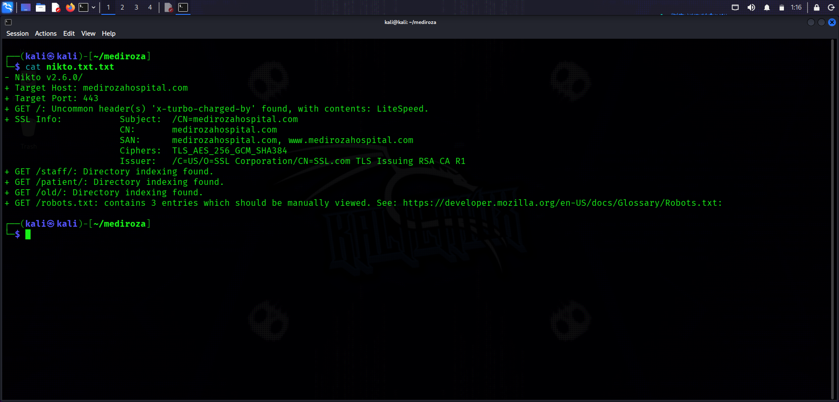
Figure 1.1 — Nikto scan output showing directory indexing on /staff/, /patient/ and /old/.
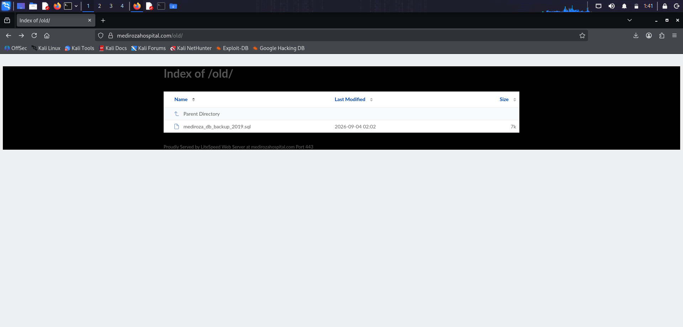
Figure 1.2 — Directory listing of /old/ exposing mediroza_db_backup_2019.sql to unauthenticated visitors.

Business Impact
Directory listings act as a free reconnaissance map for attackers, revealing file names, backup archives, and application structure that are never meant to be browsed directly. In this case it directly exposed a highly sensitive database backup (see Finding 2), turning a low-effort misconfiguration into a critical data breach.

Remediation
- Disable directory indexing/auto-index on the web server (e.g. Options -Indexes in Apache, autoindex off; in Nginx, or the equivalent LiteSpeed directive).
- Remove or relocate any non-production files (backups, old CMS versions, test scripts) out of the public web root entirely.
- Add a default index.html/index.php (even a blank one) to every directory as defence-in-depth.
- Periodically re-scan the site with Nikto/Nmap NSE http-enum and a directory-brute-forcing tool (e.g. gobuster, ffuf) to catch regressions.

References
- OWASP: Testing for Directory Listing / OTG-CONFIG-006
- CWE-548 — Exposure of Information Through Directory Listing

Finding 2: Sensitive Data Exposure — Public 2019 Database Backup (Staff PII, Salaries & Shareholder Register)
Risk Rating | Critical | CVSS 3.1 (Est.) | 9.1 (Critical)
Category | CWE-200 / CWE-538: Information Exposure via Files & Directories | Affected URL | https://medirozahospital.com/old/mediroza_db_backup_2019.sql

Description
The /old/ directory (Finding 1) contains a fully public, unauthenticated, downloadable SQL database backup file named mediroza_db_backup_2019.sql (~7 KB), dated 2019‑08‑27 in its own header comments, from the "mediroza_hr" database of the Mediroza CMS. The file's own header explicitly warns: "WARNING: contains confidential staff and shareholder records." Opening the file in a text editor revealed two full SQL tables: staff (30 records) and shareholders (10 records). The staff table discloses, for every employee, their full name, job title, department, work email address, personal phone number, national identification (ID) number and exact monthly salary in ZAR. The shareholders table discloses the identity of every hospital shareholder, their shareholding percentage, number of shares held and share class (Ordinary/Preferential) — effectively the hospital's private capitalisation table.

Steps to Reproduce
- Step 1: Browsed to the /old/ directory listing (Finding 1) and clicked mediroza_db_backup_2019.sql.
- Step 2: The file rendered directly in the browser (no authentication, no download restriction) and was saved locally.
- Step 3: Opened the file in a text editor and confirmed the presence of complete CREATE TABLE and INSERT INTO statements for the staff and shareholders tables, including national ID numbers and salaries for 30 named staff members and shareholding percentages for 10 named shareholders.

Evidence
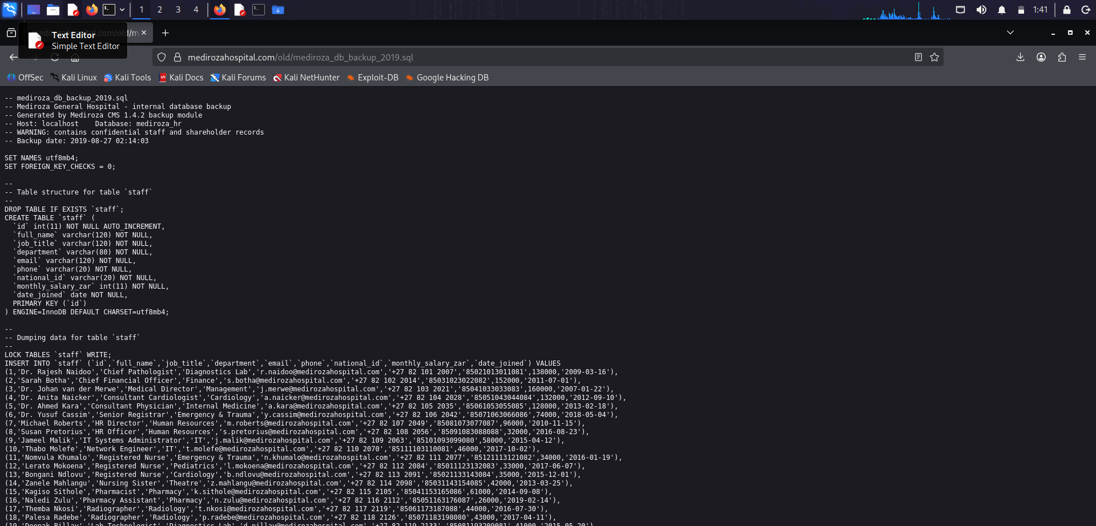
Figure 2.1 — Publicly downloadable database backup revealing staff national ID numbers, salaries, and shareholder shareholding percentages.

Business Impact
This is the most severe finding in the assessment. Exposure of national ID numbers combined with full names, phone numbers and salaries creates a direct and immediate identity-theft and targeted phishing/social-engineering risk for 30 real employees, including senior clinicians and executives. Disclosure of the shareholder register exposes private ownership and financial interests of the hospital's shareholders, which could cause reputational, competitive and legal harm (data protection legislation such as South Africa's POPIA is likely engaged, given the presence of ID numbers and other personal information of identifiable natural persons). Because the file is unauthenticated and was indexed by the web server itself, it may already have been accessed by search engine crawlers or archival services.

Remediation
- Immediately remove mediroza_db_backup_2019.sql (and the entire /old/ directory) from the public web server.
- Treat this as a confirmed data breach: assess POPIA/relevant data-protection notification obligations, and consider notifying affected staff and shareholders.
- Rotate/monitor for misuse of exposed national ID numbers, and review email/phone-based social-engineering risk for the named staff.
- Store database backups outside the web root, encrypted at rest, with access restricted to authorised administrators only (e.g. a dedicated backup server or object storage with IAM controls).
- Establish a secure backup retention and secrets-handling policy that includes verification that no backup or archive files are ever placed inside a web-served directory.
- Search engine and cache services (e.g. Google) should be checked for cached copies of the file and a removal request submitted if found.

References
- CWE-200 — Exposure of Sensitive Information to an Unauthorized Actor
- OWASP Top 10 A01:2021 — Broken Access Control / A05:2021 — Security Misconfiguration

Finding 3: SQL Injection — Authentication Bypass on Patient Portal Login
Risk Rating | Critical | CVSS 3.1 (Est.) | 9.8 (Critical)
Category | CWE-89: Improper Neutralization of Special Elements used in an SQL Command | Affected URL | https://medirozahospital.com/patient/login.php

Description
The Patient Portal login form does not sanitise or parameterise user-supplied input before using it in a backend SQL query. Submitting the classic authentication-bypass payload admin'-- (or alternatively ' OR '1'='1'--) in the Username field, with any value in the Password field, was sufficient to bypass authentication and reach the authenticated "My Reports" area of the portal without knowledge of a valid password. This confirms the login query is built by directly concatenating user input into a SQL statement (e.g. SELECT * FROM users WHERE username='<input>' AND password='<input>'), which the injected comment sequence (-- ) truncates, neutralising the password check entirely.

Steps to Reproduce
- Step 1: Navigated to https://medirozahospital.com/patient/login.php.
- Step 2: Entered admin'-- in the Username field and an arbitrary value in the Password field.
- Step 3: Clicked "Sign in" and was successfully authenticated, landing on the "My Reports | Mediroza Patient Portal" page (patient/portal.php) without a valid password.
- Step 4: Confirmed the equivalent payload ' OR '1'='1'-- produces the same authentication-bypass behaviour.

Evidence
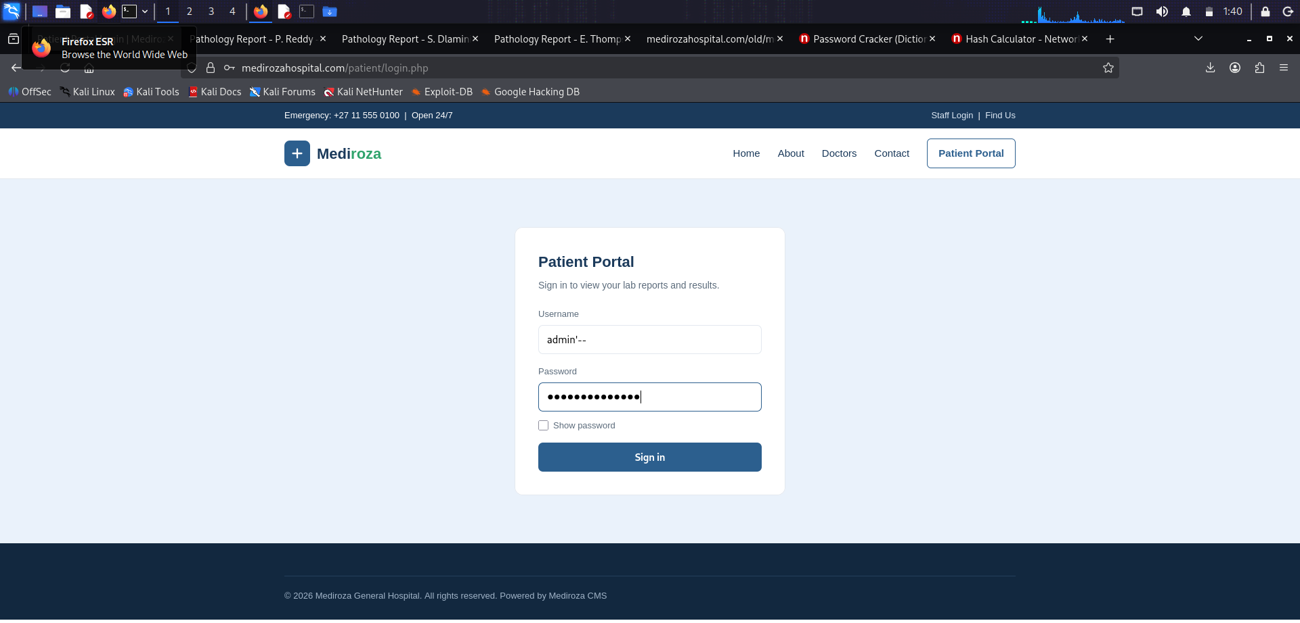
Figure 3.1 — SQL injection payload admin'-- entered in the Patient Portal login form.
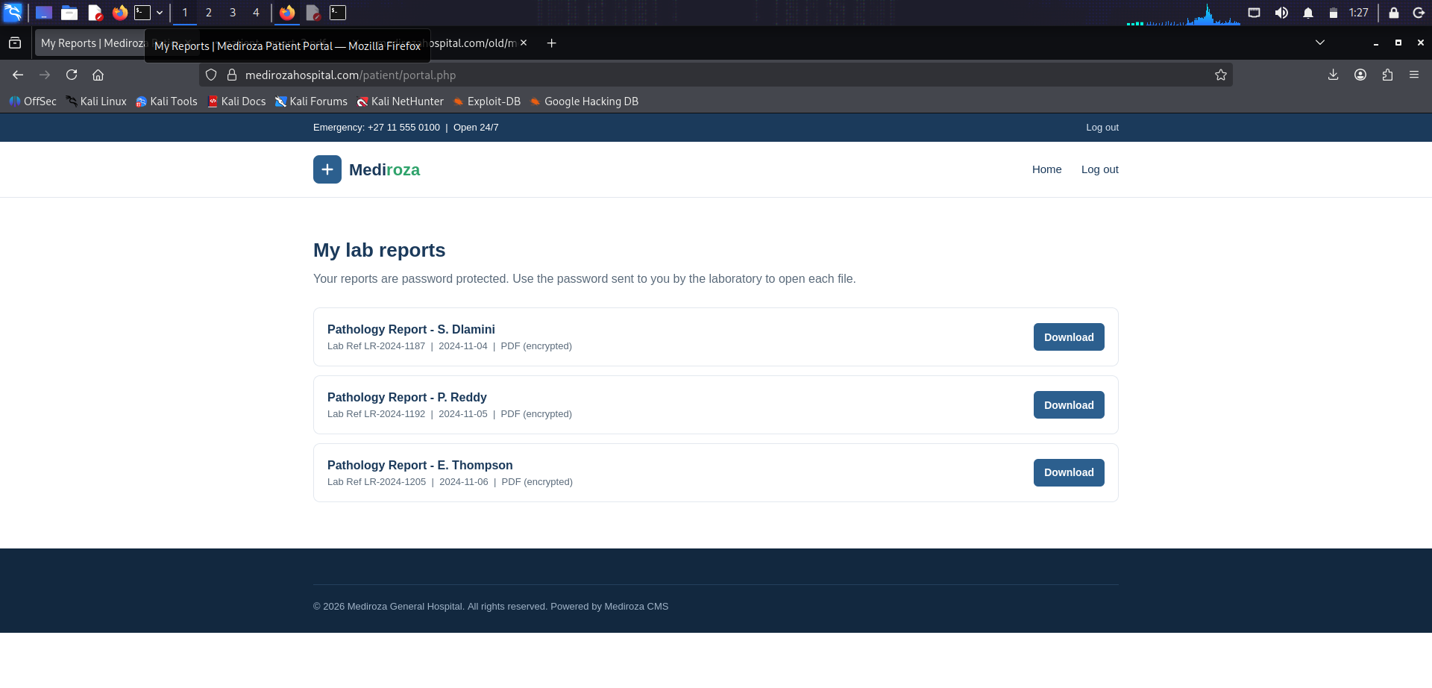
Figure 3.2 — Authenticated "My Reports" page reached after the SQL injection bypass, listing downloadable patient pathology reports.

Business Impact
SQL injection in a login form is one of the most severe classes of web vulnerability. In this case it allowed complete authentication bypass without any valid credentials, granting access to the patient reports area shown in Finding 4. Depending on how the underlying query is constructed, the same injection point could plausibly be extended (e.g. via UNION-based or boolean/time-based blind techniques) to read or modify arbitrary data in the underlying database, including other patients' records, or in the worst case to achieve broader compromise of the database server.

Remediation
- Rewrite all database queries to use parameterised queries / prepared statements (e.g. PDO with bound parameters in PHP) — never concatenate user input directly into SQL strings.
- Apply strict server-side input validation and output encoding as defence-in-depth (allow-list expected username formats).
- Deploy a Web Application Firewall (WAF) with SQL injection rule sets as an additional protective layer while the code fix is rolled out.
- Enforce the principle of least privilege for the database account used by the web application (no DROP/ALTER/UNION-friendly privileges beyond what the app strictly requires).
- Add multi-factor authentication (2FA/MFA) to the Patient Portal and Staff Login so that credential/login-logic flaws alone cannot fully compromise an account.
- Perform a full source-code review of all other login and search forms on the site for the same unsafe query-construction pattern, and re-test with an automated tool such as sqlmap under authorised conditions.

References
- OWASP Top 10 A03:2021 — Injection
- CWE-89 — SQL Injection
- OWASP Testing Guide — Testing for SQL Injection (OTG-INPVAL-005)

Finding 4: Weak Password Protection on Patient Pathology PDF Reports
Risk Rating | High | CVSS 3.1 (Est.) | 7.5 (High)
Category | CWE-521: Weak Password Requirements | Affected URL | https://medirozahospital.com/patient/portal.php (report downloads)

Description
After bypassing authentication (Finding 3), the Patient Portal's "My Reports" page allowed direct download of encrypted pathology PDF reports for multiple real patients (e.g. Pathology Report - S. Dlamini, P. Reddy, E. Thompson). While the PDFs are password-protected (128-bit RC4/AES per the extracted encryption dictionary), the passwords protecting them are extremely weak and match entries in common password wordlists. Using a hash-extraction tool followed by a dictionary/wordlist password-cracking tool, the passwords for all three downloaded reports were recovered in seconds: 123456, password and !@#$%^&.

Steps to Reproduce
- Step 1: Downloaded patient_report_1.pdf, patient_report_2.pdf and patient_report_3.pdf from the authenticated portal reached via Finding 3.
- Step 2: Extracted a crackable $pdf$ password hash from each file using the Network Walks Hash Calculator (pdf2john/hashcat-compatible format).
- Step 3: Submitted each extracted hash to the Network Walks Password Cracker, which ran a dictionary attack against a common password wordlist.
- Step 4: Recovered the passwords 123456, password and !@#$%^& for the three reports respectively, each within a handful of attempts.
- Step 5: Opened each unlocked PDF and confirmed exposure of full patient name, date of birth, patient ID, referring doctor, specimen type, lab reference number and detailed laboratory results (e.g. cholesterol, haemoglobin, ferritin, vitamin D levels).

Evidence
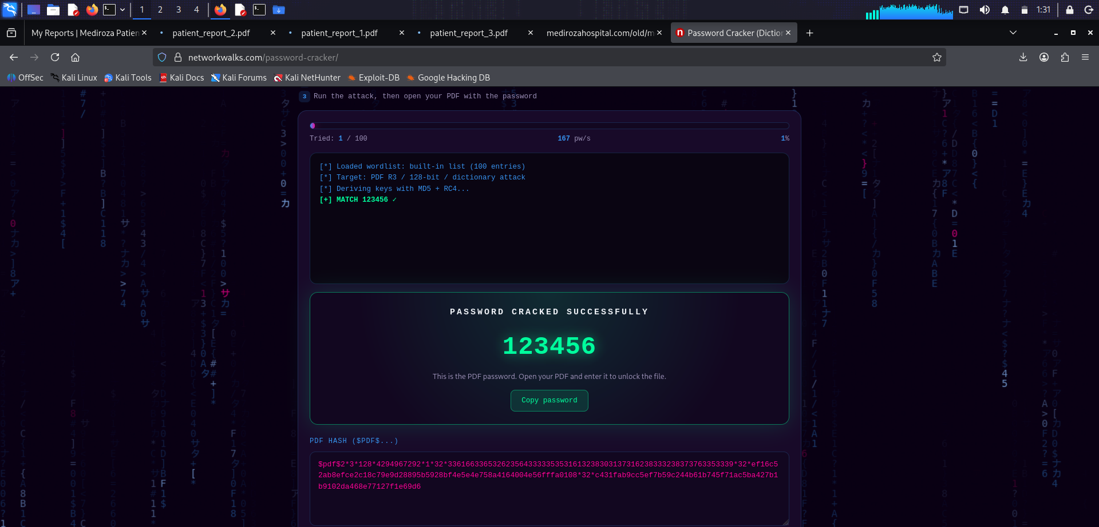
Figure 4.1 — Dictionary attack recovering the PDF password "123456" for patient_report_1.pdf within a single attempt.

Business Impact
Password protection on medical documents is only as strong as the password chosen. Using trivially guessable, shared or default passwords means the encryption provides no meaningful protection at all — any attacker who obtains the file (which, combined with Finding 3, requires no valid credentials in the first place) can unlock it in seconds using free, publicly available tooling. This exposes patient medical history and personally identifiable health information, which carries significant legal (health-data protection law), reputational and patient-trust consequences for the hospital.

Remediation
- Do not rely on static, guessable, or shared PDF passwords for medical documents. Generate a strong, unique, per-report password or per-patient passphrase (e.g. system-generated, 12+ characters, delivered securely out-of-band such as SMS OTP).
- Prefer a proper access-controlled patient portal (already authenticated download) over password-protected file encryption as the primary control, and fix Finding 3 so the portal itself cannot be bypassed.
- If PDF-level encryption is still desired for defence-in-depth, use strong AES-256 encryption with high-entropy passwords, and never reuse the same password across multiple patients' reports.
- Educate staff who generate these reports on secure password practices and disable any "default/common password" convenience feature in the reporting system.
- Enforce 2FA on the Patient Portal so that even a leaked or cracked PDF is only obtainable by an already-authenticated, verified patient.

References
- CWE-521 — Weak Password Requirements
- OWASP Top 10 A02:2021 — Cryptographic Failures

6. Risk Rating Methodology
Each finding in this report has been assigned a qualitative risk rating based on its likelihood of exploitation and potential business impact, informed by an estimated CVSS 3.1 base score. The rating scale used is:
Rating | CVSS Range | Definition
Critical | 9.0 – 10.0 | Trivially exploitable, no authentication required, leads to full compromise of data or system.
High | 7.0 – 8.9 | Exploitable with modest effort, leads to significant data exposure or loss of integrity.
Medium | 4.0 – 6.9 | Requires some precondition or provides limited information; still worth prompt remediation.
Low | 0.1 – 3.9 | Minimal direct impact; typically hardening or best-practice recommendations.

7. Remediation Roadmap
The following prioritised action plan is recommended for the hospital's IT/development team:
Priority | Action | Target Timeframe
Immediate | Remove /old/ directory and mediroza_db_backup_2019.sql from the public web server; disable directory indexing on /staff/, /patient/ and /old/. | Within 24 hours
Immediate | Patch the SQL injection vulnerability in patient/login.php using parameterised queries; re-test with admin'-- and ' OR '1'='1'-- payloads to confirm the fix. | Within 48–72 hours
High | Force-reset passwords for all downloadable patient PDF reports to strong, unique, system-generated values. | Within 1 week
High | Implement 2FA/MFA on the Patient Portal and Staff Login. | Within 2–4 weeks
Medium | Assess data-breach notification obligations for affected staff, shareholders and patients; review broader codebase for similar injection flaws. | Within 2–4 weeks
Ongoing | Establish periodic VAPT cycles, a secure backup-handling policy, and a WAF in front of the application. | Quarterly

8. Conclusion
This assessment identified four notable security weaknesses in the Mediroza General Hospital web application, two of which are rated Critical and are trivially exploitable by an unauthenticated attacker using only free, publicly available tools. A single web-server misconfiguration (public directory listing) directly led to disclosure of a highly sensitive historical database backup containing staff national ID numbers, salaries and the shareholder register, while an unrelated SQL injection flaw in the patient login form allowed complete authentication bypass into an area exposing real patients' medical pathology reports, which were themselves protected by trivially weak passwords.
None of the identified issues require advanced skill or custom exploit development to reproduce; all were found using a standard vulnerability scanner (Nikto), well-known manual SQL injection payloads, and free online hash/password-cracking utilities. This indicates the application is exposed to essentially any opportunistic attacker or automated scanner, not solely to a sophisticated adversary. It is strongly recommended that the immediate and high-priority items in the Remediation Roadmap (Section 7) be actioned without delay, followed by a full re-test to validate that each finding has been resolved.

Disclaimer
This report reflects the security posture of https://medirozahospital.com strictly at the time testing was performed and is not exhaustive; it should not be interpreted as a certification that the application is otherwise secure. Testing was conducted for academic/training purposes as part of the Network Walks Academy internship programme (Week 4 task, Batch B083A). All data captured during testing (including the downloaded database backup and patient PDF reports) should be securely deleted by the tester once this report has been reviewed and acted upon by the site owner.

