All sessions in Hyatt Ziva Peninsula I & II
(please note this is the usual room on the same floor as the hotel lobby near the entrance)

Friday Afternoon, May 1, 2026
16:00 -16:15 | Introduction and Welcome  to Cabo XXXIV |  | Ian Wilson and Andrej Šali
16:15-17:35 | Short Presentations (4 + 1 min.) by TSRI Graduate Students  (Chair: Keren Lasker, TSRI)
 | Cassandra White | TSRI | Multi-modal in vivo Perturb-seq to identify cell type-specific roles of DNA methylation machinery
 | Niel Chakraborty | TSRI | Identification of novel protein(s) responsible for cellular, reductive activation of a highly potent DNA-alkylating prodrug; mechanistic elucidation through LCMS/LCUV based assay development
 | Cindy Chen | TSRI | Biosynthesis of natural product-inspired macrocycles using ribosomal translation
 | Andrew Ecker | TSRI | A modular route to the trienomycins for probing eukaryotic translation inhibition
 | Ariana Sulpizio | TSRI | Phenotype-based discovery identifies IPO9 as a new regulator of cGAS-STING pathway activation
 | Kaylin Ro | TSRI | Towards global profiling of protein-protein interactions by crosslinking mass-spectrometry
 | Allison Barkdull | TSRI | Computational design of small molecules that interact with the lipid bilayer
 | Joseph Harmon | TSRI | Blocking innate immune sensing of mRNA therapeutics with de novo binders against TRIM25
 | Daniella Marinelli | TSRI | Antibody discovery and characterization for immunogen development in serotype-diverse astroviruses
 | Morgan Gee | TSRI | Deciphering differential influenza virion architecture of clinical isolate strains with cryo-electron tomography
 | Nathan Liendo | TSRI | Discovery and characterization of Lassa virus antibodies
 | Justice Fleischmann | TSRI | Identification of CD40L as a novel costimulatory target for trispecific T cell engagers
 | Peter Rory Hall | TSRI | Computational therapeutic design against SLC15A4
17:35-17:50 | Break
17:50-18:30 | Short Presentations (4 + 1 min.) by UCSF Graduate Students and Postdocs  (Chair: Keren Lasker, TSRI)
 | Gyasu Bajracharya | UCSF | What do protein language models learn (or forget), and how can we tell?
 | Shih-Wei Chuo | UCSF | RAPID biopanning: From antibody discovery to protein engineering
 | Haley Ogasawara | UCSF | Unraveling the mechanism of 'Don't Eat Me' signaling mediated by the bacterial ligand P66
 | Karson Chrispens | UCSF | Sampleworks: modeling conformational ensembles of macromolecules by integrating experiments and structure prediction
 | Fangzhu Zhao | UCSF | Targeted shedding of extracellular membrane proteins by induced protease recruitment
 | Kevin Alexander Estrada Alamo | UCSF | Deciphering organization determinants of B cell signaling using protein design
 | Maggie Horst | UCSF | De novo design of proteins towards allosteric control of ligand binding by ligand binding
18:30 | Break
18:45– 19:45 | Biophysics and Biology of Cellular Processes I  (Chair: James R Williamson, TSRI)
18:45 | Carolyn Larabell | UCSF | Soft x-ray tomography: whole-cell quantitative imaging
19:05 | Danielle Grotjahn | TSRI | Messages across membranes: connecting mitochondrial structure, function, and communication
19:25 | Keren Lasker | TSRI | Engineering synthetic condensates to interrogate the biophysics of selective autophagy
20:00 – 22:30 | Reception with Buffet  (open to all including guests) |  |  | Poolside (adult pool)
Saturday Morning, May 2, 2026 Biophysics and Biology of Cellular Processes II
(Chair: Carolyn Larabell, UCSF)
08:30 |  | Luke Wiseman |  | TSRI |  | Pharmacologically targeting the unfolded protein response
08:50 |  | Laurel Kinman |  | UCSF |  | Resolving dynamic proteins in the cellular stress response
09:10 |  | Caleigh Azumaya |  | Genentech |  | CryoSHIELDs: tunable amphipathic peptides for Cryo-EM
 | 09:30 |  | Break

Keynote Lecturer

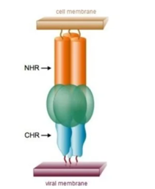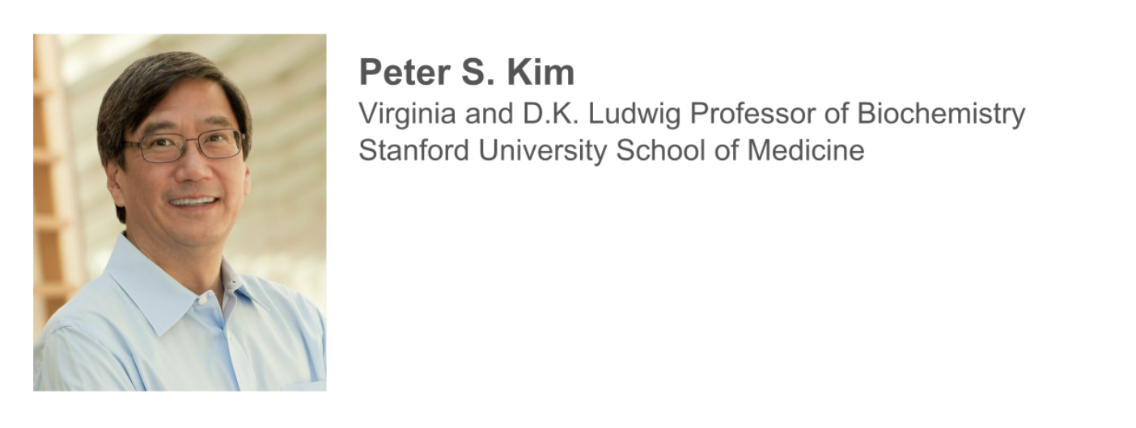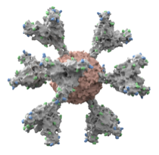
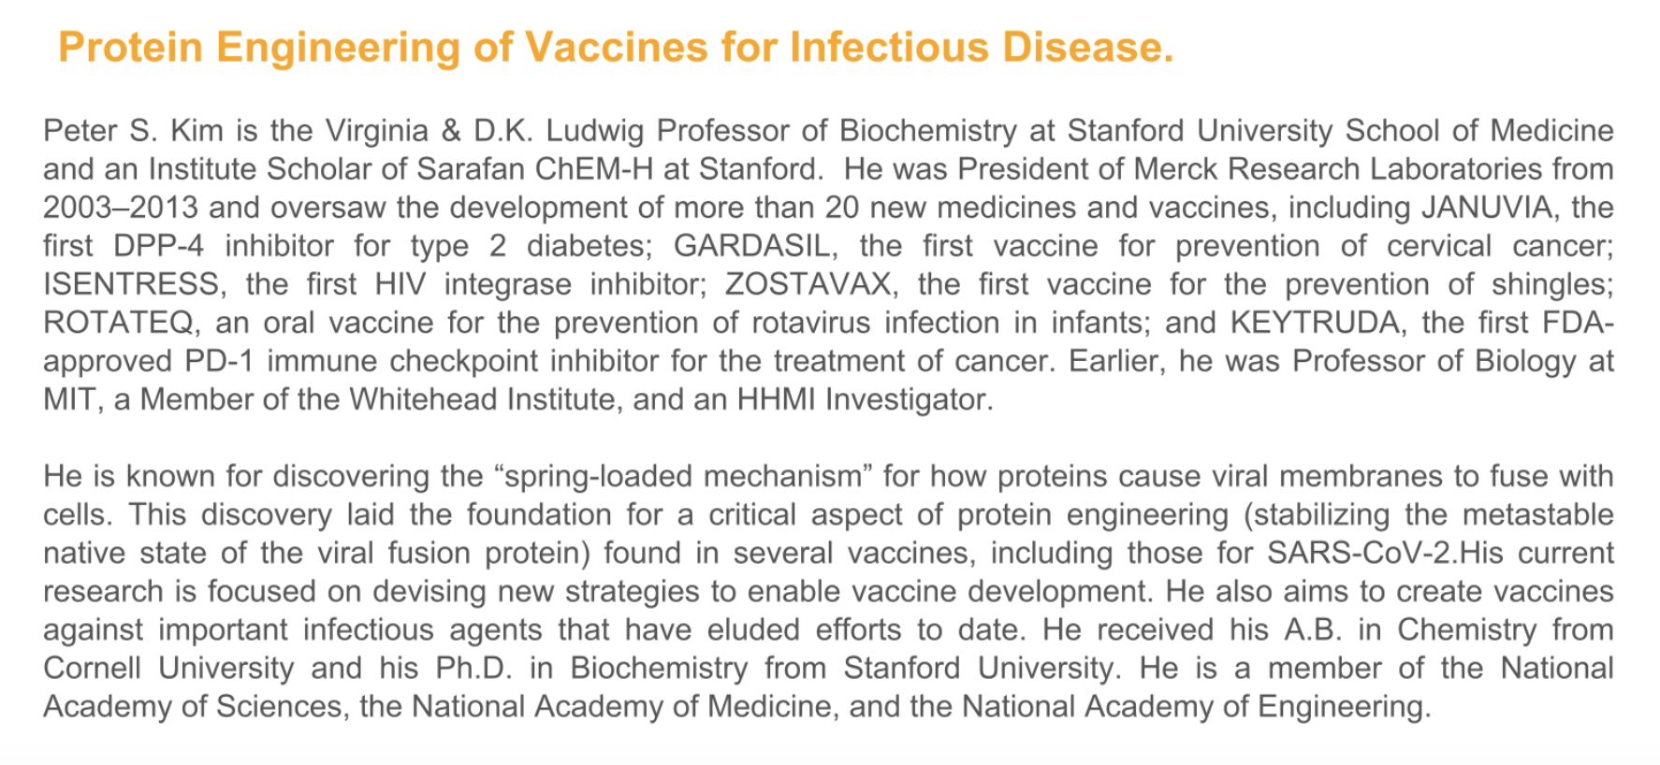
Saturday Morning, May 2, 2026 Keynote Lecture
(Introduction: James Wells, UCSF)
10:00 |  | Peter S. Kim |  | Stanford University |  | Protein engineering of vaccines and antibodies for infectious disease
11:00 |  | Questions & Discussion
11:15 |  | Break
Saturday Morning, May 2, 2026 Antibodies, Vaccines, and Microbial Pathogens
(Chair: James Wells, UCSF)
11:40 |  | Jordan Barrett |  | TSRI |  | Structure of the full-length Plasmodium falciparum blood-stage invasion complex with synergistic anti-PfRIPR antibodies
12:00 |  | Bryan Briney |  | TSRI |  | De novo discovery of antigen-specific human antibodies
12:20 |  | Ian Wilson |  | TSRI |  | Antibody-inspired peptide and small molecule therapeutic design against influenza virus
12:40-16:00 |  | Break
Saturday Afternoon, May 2, 2026 Chemistry and Biology
(Chair: Charles Craik, UCSF)
16:00 |  | Ahmed Badran |  | TSRI |  | Synthetic biology strategies to study and improve photosynthetic carbon capture
16:20 |  | Dorothee Kern |  | TSRI |  | Ancestral enzymes to the rescue for modern gluten intolerance
16:40 |  | Balyn Zaro |  | UCSF |  | Ninhydrin as a covalent warhead for discovery and engagement of reactive arginines
17:00 |  | Leah Roe |  | UCSF |  | Protein backbone editing using acyl chemistry
17:20 |  | Group photo |  |  |  | Main lobby steps to pools
17:55 |  | Dan Santi |  | UCSF |  | Optimizing drug delivery
18:15 |  | James Wells |  | UCSF |  | All in the neighborhood
18:35 |  | Ian Seiple |  | TSRI |  | Synthetic optimization of natural products informed by modern structural biology and computational approaches
 | 18:55 Evening free to network
Sunday Morning, May 3, 2026 Integrative Computational Structural Biology and AI
(Chair: Danielle Grotjahn, TSRI)
 | 08:30 |  | Andrej Šali |  | UCSF |  | Integrative mapping reveals molecular features underlying the mechanism of nucleocytoplasmic transport
 | 08:50 |  | Ignacia Echeverria Riesco |  | UCSF |  | Integrative modeling of compositionally and conformationally heterogeneous protein assemblies
 | 09:10 |  | James Fraser |  | UCSF |  | Large scale prospective evaluation of co-folding
 | 09:30 |  | Stefano Forli |  | TSRI |  | Fold it like you mean it: perils and opportunities folding proteins for drug discovery
 | 09:50 |  | Andrew Su |  | TSRI |  | Agentic AI for collaborative science
 | 10:10 |  | Break
Sunday Morning, May 3, 2026 Tageting Cancer
(Chair: Shannon Miller, TSRI)
 | 10:40 |  | James Paulson |  | TSRI |  | Targeting Siglec ligands to enhance immune responses to cancer
 | 11:00 |  | Peng Wu |  | TSRI |  | Enforced E-selectin ligand display for treating solid tumors
 | 11:20 |  | Charles Craik |  | UCSF |  | Targeting intracellular proteins through MHC I for cancer
 | 11:40 |  | Luke Lairson |  | TSRI |  | Small molecule modulators of γδ T cell activation
 | 12:00 |  | Travis Young |  | Calibr-Skaggs |  | Multi specific antibodies for inmuno oncology
 | 12:20-16:30 |  | Break
Sunday Afternoon, May 3, 2026 Membrane Proteins
(Chair: Andrej Šali, UCSF)
 | 16:30 |  | Robert Stroud |  | UCSF |  | Think well! Packing neurotransmitters for Quantal release in brain
 | 16:50 |  | Daniel Minor Jr. |  | UCSF |  | Frog protein saves mice from deadly toxin - a test of the toxin sponge hypothesis
 | 17:10 |  | Mark Yeager |  | Frost Inst |  | Structure/function analysis of heteromeric membrane protein complexes using cleavable concatemers
 | 17:30 |  | Marco Mravic |  | TSRI |  | Membrane protein design
 | 17:50 |  | Break
 | 18:15 |  | Colleen Maillie |  | TSRI |  | Structure informs, design enables: Strategies to target ABC transporters
 | 18:35 |  | Aashish Manglik |  | UCSF |  | Uncovering the action of unconventional GPCR stimuli
 | 18:55 |  | Katherine Susa |  | UCSF |  | Mechanisms of tetraspanin function on B cells and in the retina
 | 19:15 |  | Evening free to network
Monday Morning, May 4, 2026 Nucleic Acids, Cancer and Neurodegenerative Disease
(Chair: Stefano Forli, TSRI)
 | 08:50 |  | James Williamson |  | TSRI |  | Linkage between methionine metabolism and stable RNA modification in cancer
 | 09:10 |  | Giordano Lippi |  | TSRI |  | Leveraging post-transcriptional mechanisms for therapy
 | 09:30 |  | Jonathan Moore |  | ADnova |  | ADnova Therapeutics Introduction
 | 09:40 |  | Break
Monday Morning, May 4, 2026 Therapeutics, Genetic Variation, Genome-editing and HIV
(Chair: Balyn Zaro, UCSF)
 | 10:00 |  | Tony Capra |  | UCSF |  | Leveraging human genetic variation to therapeutically target dominant & dispensable disease alleles
 | 10:20 |  | Shannon Miller |  | TSRI |  | CRISPR-free gene insertion in human cells
 | 10:40 |  | David Millar |  | TSRI |  | Dynamics of HIV-1 Gag

Closing remarks
11:00 -11:15 | Ian Wilson and Andrej Šali

In order to protect individual rights and promote discussion, it is a requirement of the Scripps/UCSF CABO Annual Meeting that no information presented is to be used or disclosed without the specific approval of the disclosing party. Each attendee of the Conference agrees that any information presented, whether in a formal talk or discussion, is a private communication from the individual making the contribution and is presented with the restriction that such information is not for public use. Each member of the Conference acknowledges and agrees to these restrictions as a condition of attending the Conference.

Thanks to our sponsors
