**Name: Salil Kanetkar**

**UCLA ID: 704557096**

**Homework 3 submission-**

**R Code Output:**

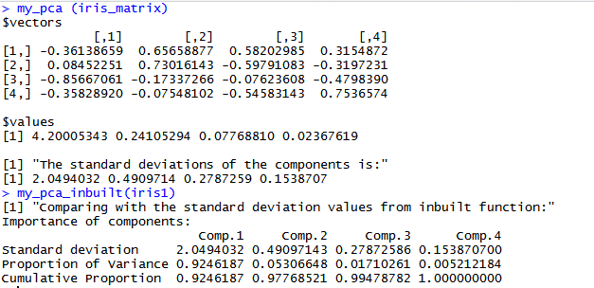

**Python Code Output:**

