**Name: Salil Kanetkar**

**UCLA ID: 704557096**

**Homework 5 submission-**

**Logistic Regression:**

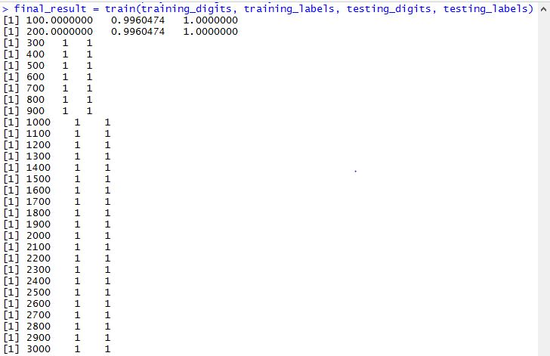

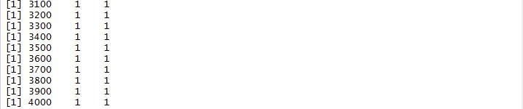

**Train Accuracy Plot:**

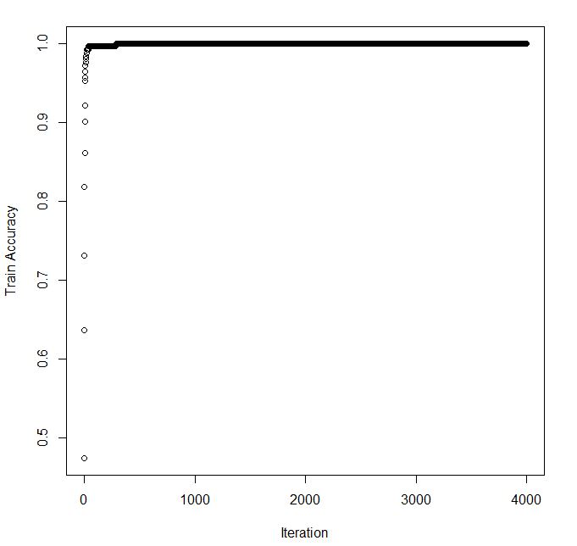

**Testing Accuracy Plot:**

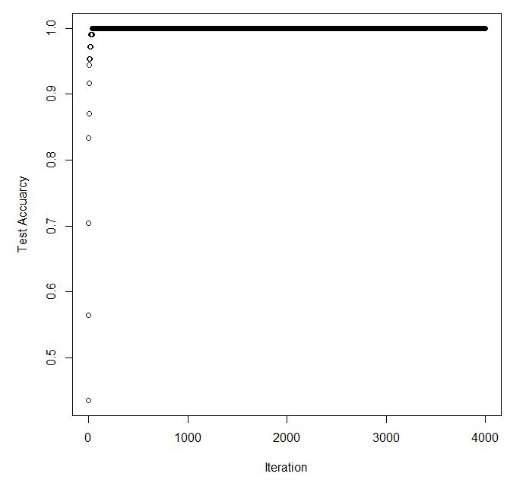

**Neural Networks:** (learning_rate=1e-1)

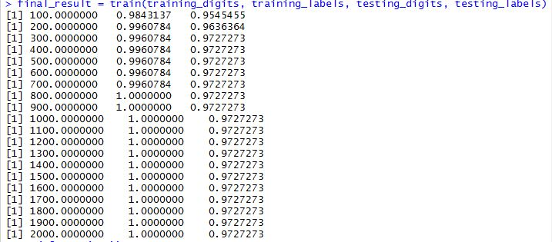

**Train Accuracy Plot:**

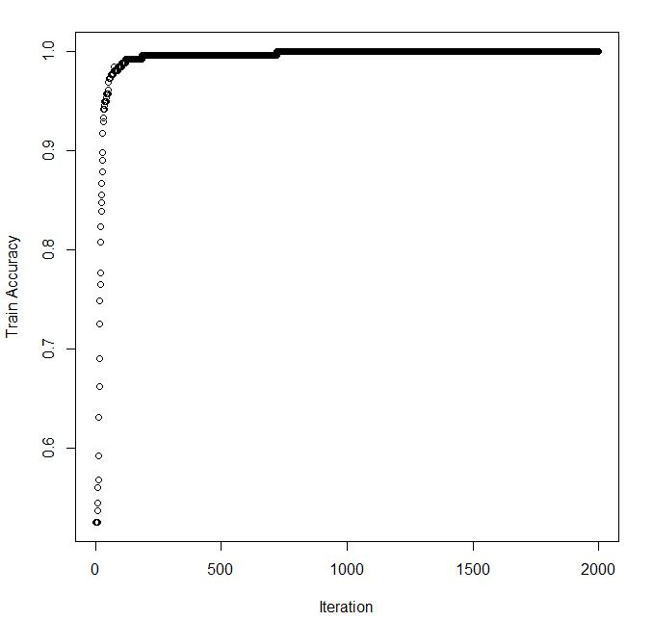

**Test Accuracy Plot:**

