**Name: Salil Kanetkar**

**UCLA ID: 704557096**

**HW 7 Submission:**

**Performance Function:**

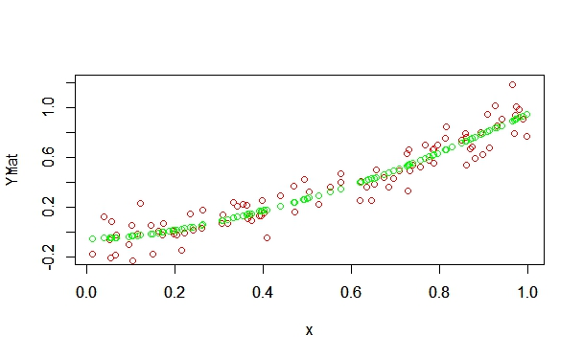

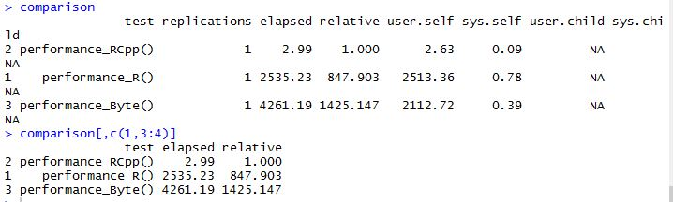

**Plots of the learned spline curves for different values of lambda:**

**Lambda= 0.0001**

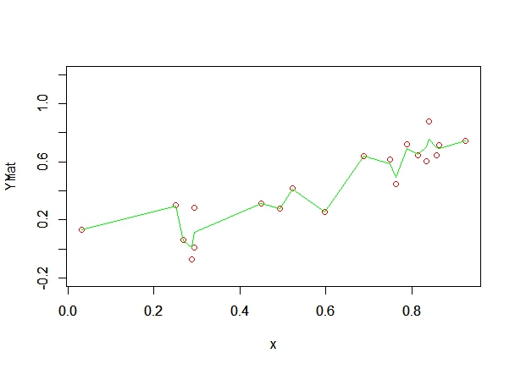

**Lambda = 0.001**

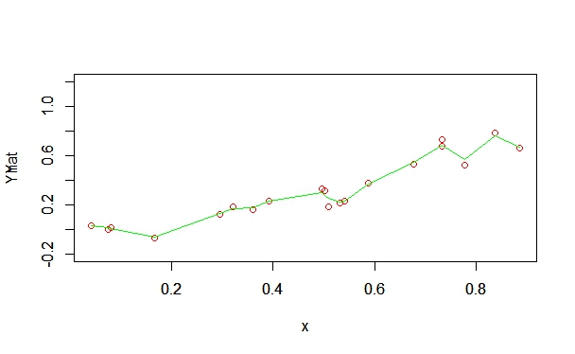

**Lambda = 0.01**

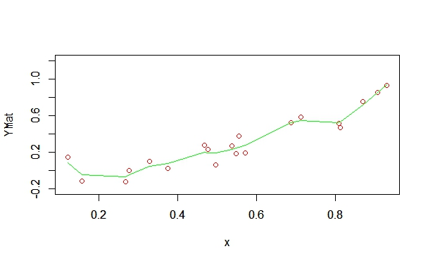

**Lambda = 0.1**

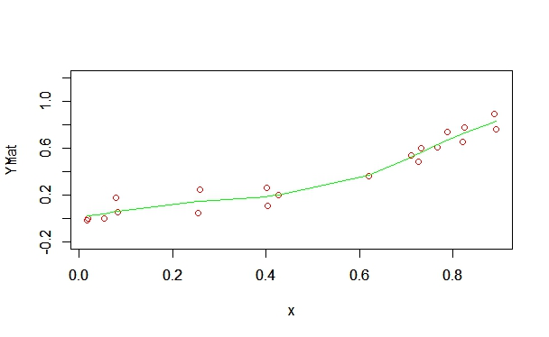

**Lambda = 0.5**

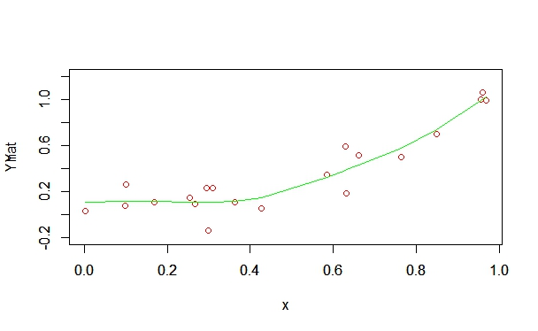

**Lambda = 1**

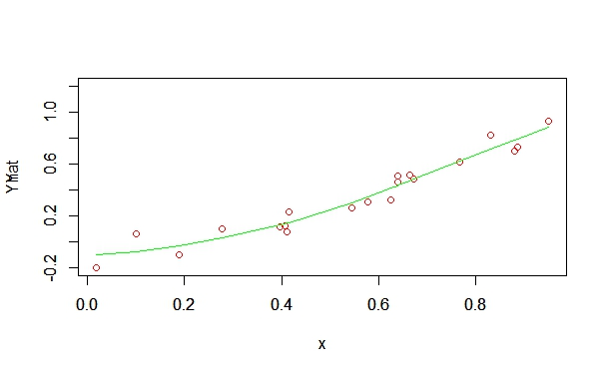

**Lambda=10**

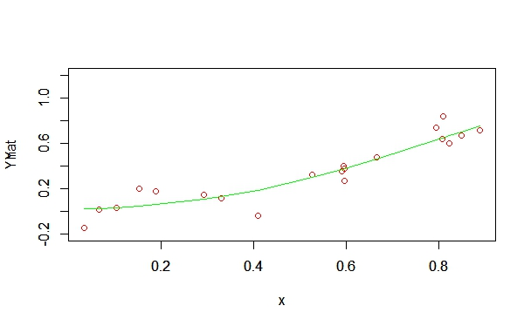

**Lambda=25**

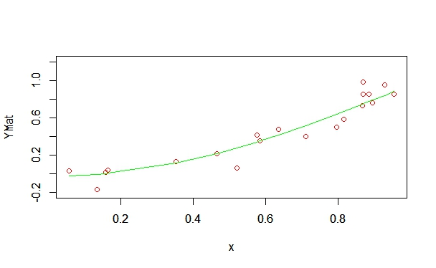

**Lambda=50**

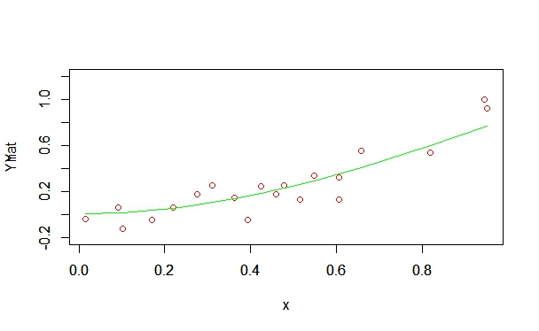

**Lambda=100**

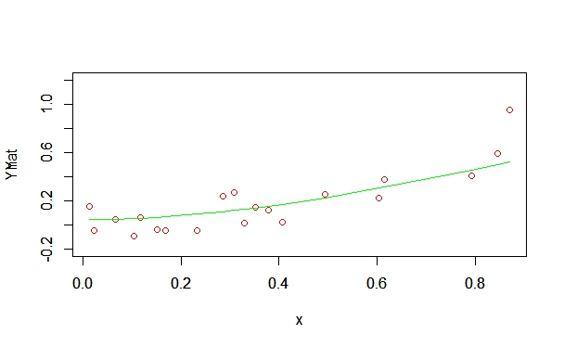

**Training and Testing Plots for Spline Curves:**

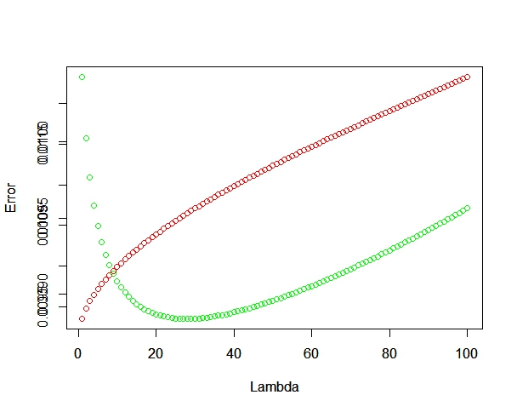

**Green is the Testing Error and Red is the Training Error.**

At a lower value of Lambda, the model is overfitting the data. Later the model improves. Towards the very end, it again starts under fitting.