checker-orthographicFront


checker-perspectiveLeft

diagonal-orthographicFront


diagonal-perspectiveLeft

coarse-orthographicFront
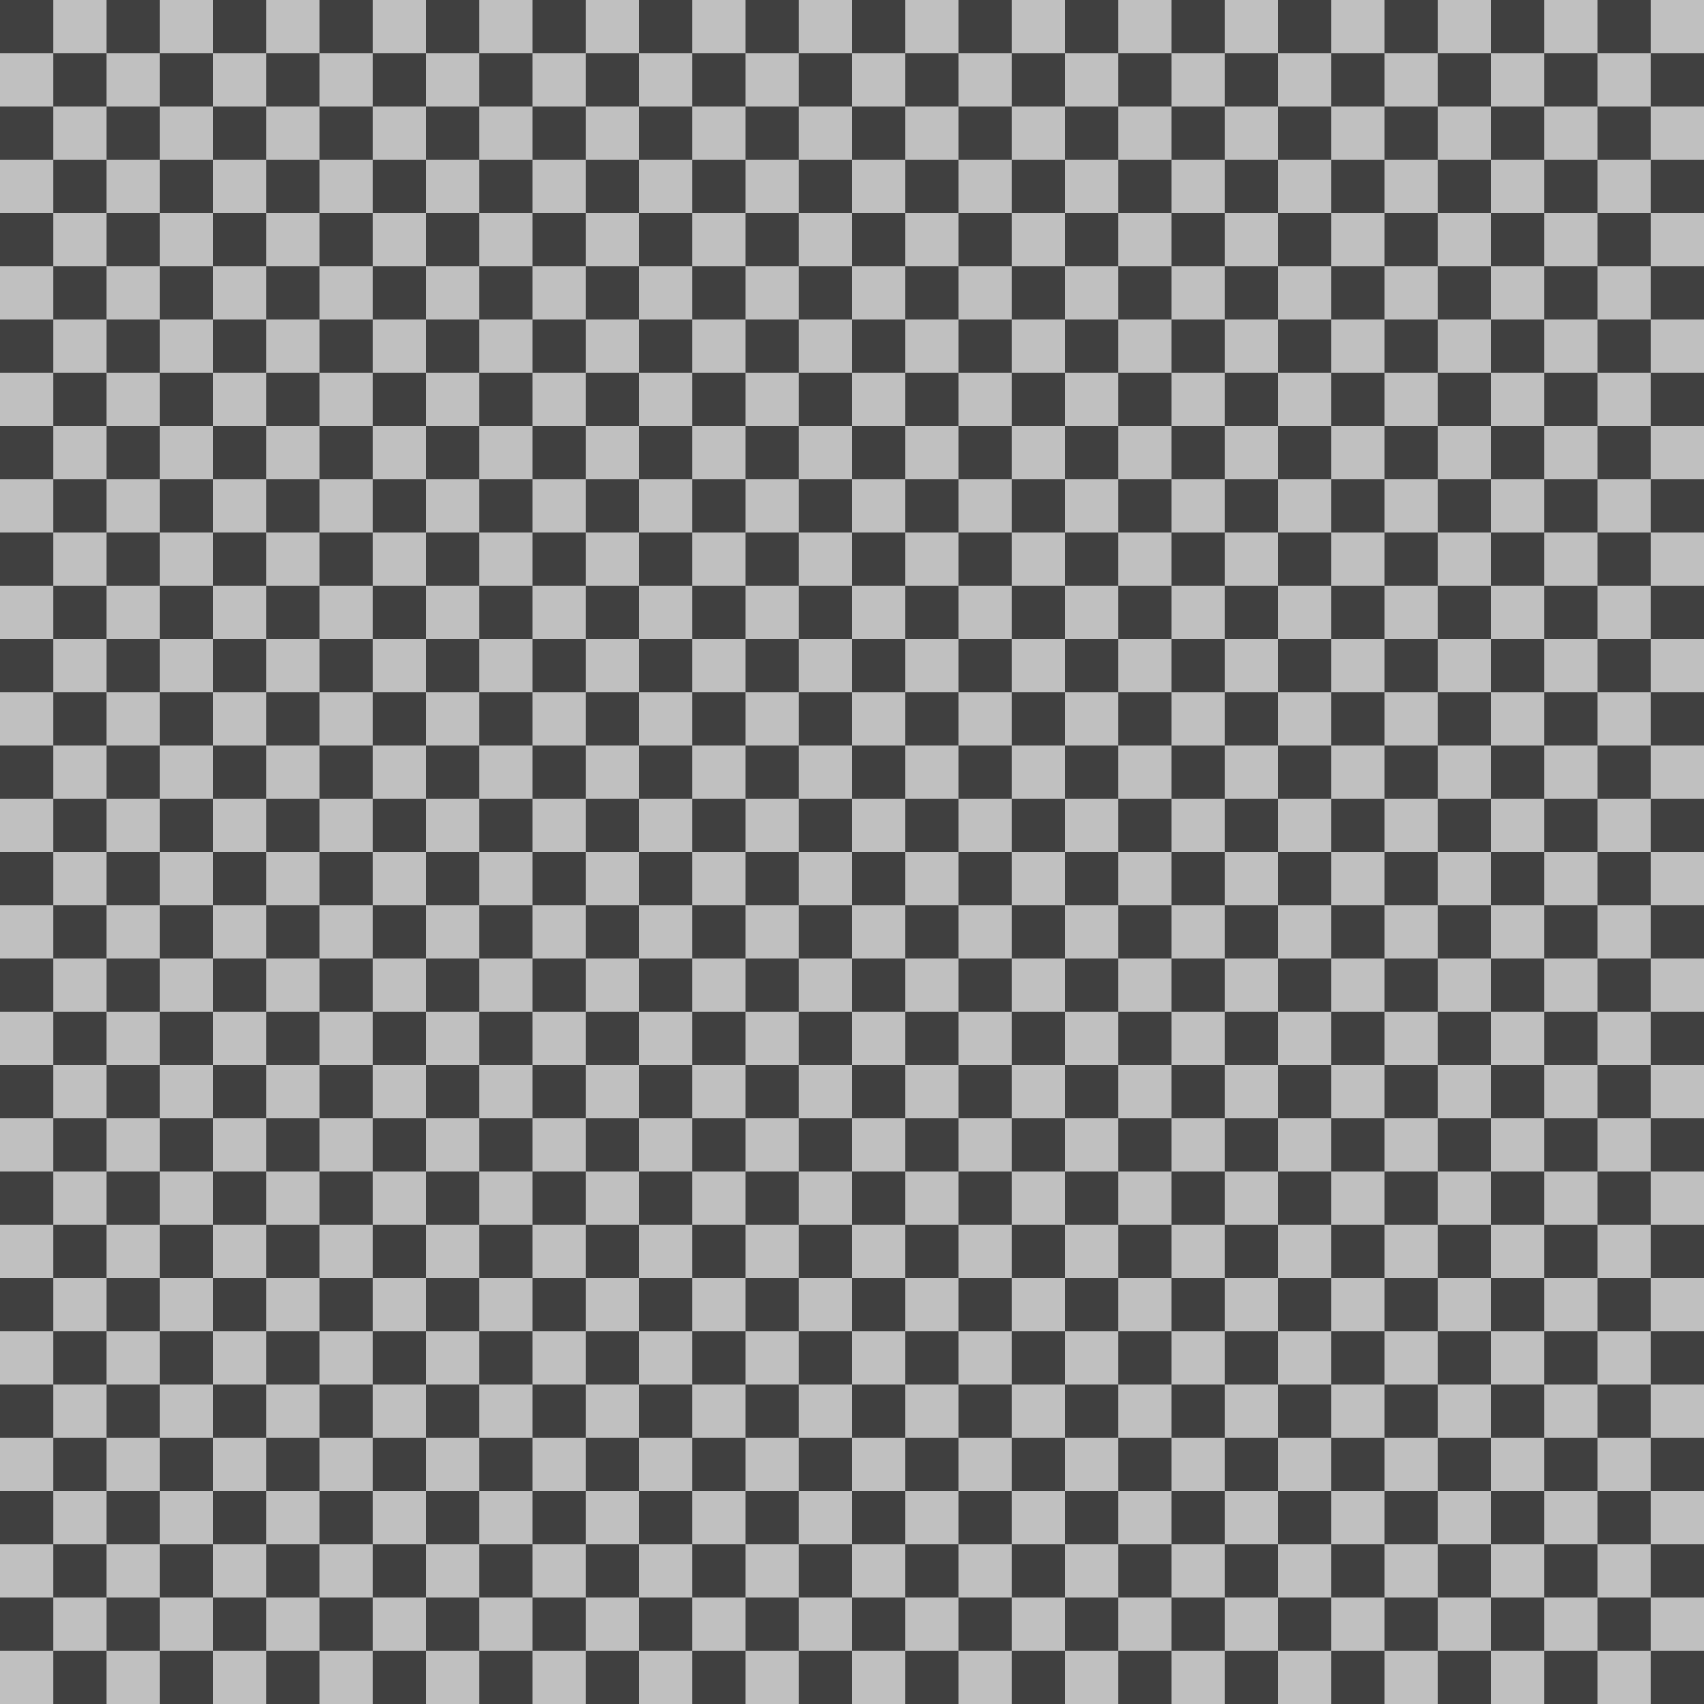

coarse-perspectiveLeft

