**OCR BASED RECEIPT READING**

**SUMMARY**

The application is an OCR-based receipt recognition program that reads the slips loaded by users and converts them to string format and then reads the desired data from the string.

**1.INTRO**

The first time the user runs the application, he / she encounters the plug loading screen. When you press the Select File button, a File Chooser window will open for receipt loading.

After the user selects the receipt, the file path of the receipt is saved.

Then, certain operations are applied to the selected chip image with OpenCV. After the image quality is improved, let's read with Tesseract. After converting into string with Tesseract, after regex fragmentation on string, Business Name, Date, VAT, Voucher NO, Total Price are recorded in the database.

**2.** **BASIC KNOWLEDGE**

JAVA language was used in project development. Maven build automation is used to use the necessary libraries. OpenCV library is used to improve image quality. Tesseract library was used for reading the image.

**3. DESIGN**

The project was developed under the following headings.

**3.1 INTERFACE**

**3.1.1 Image Upload Interface**

It is the interface where the plug images are loaded. The components are given below.

**Dosya Yükle** a new image can be loaded by.

**Ekle** the image data is uploaded to the database by.

**Sil** to delete to image data.

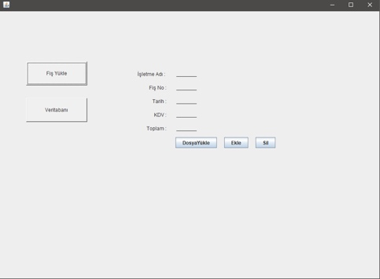

Figure 1. Image Uploaded Interface

**İşletme Adı** is the business name to which the receipt belongs.

**Fiş No** is the plug number of the loaded plug.

**Tarih** is the date that the plug was cut.

**KDV,** KDV amount of the loaded receipt.

**Toplam** is the total amount of the receipt.

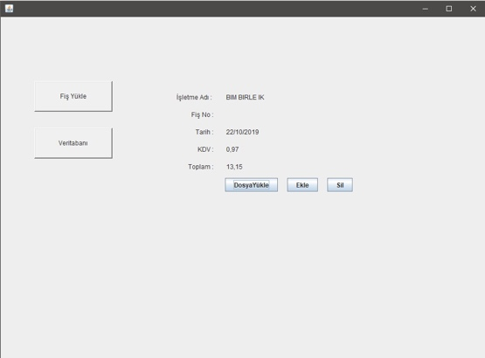 Figure 2. Interface After Insert Button

**3.1.2 Database Interface**

Indicates the database in which read receipts are stored.

With the ***Ara*** button, it searches according to the data entered in the ***İşletme Adı*** and ***Tarih*** boxes.

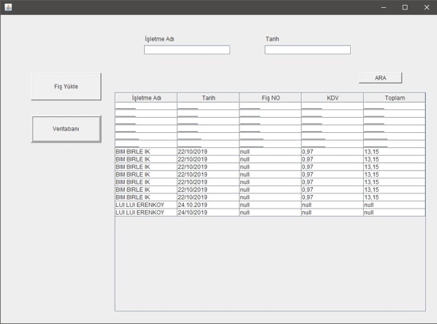

Şekil3. Database Interface

**3.2 Functions**

**3.2.1 Main.java**

**getData ()** Function that connects to the database and retrieves the requested information from the database.

**add ()** Writes the given information to the database.

**3.2.2 ReceiptScannerImpl.java**

**getTextFromReceiptImage ()** Converts the given image path to a string.

**downScaleImage ()** reduces the size of the image.

**cleanImageSmoothingForOCR ()** smoothes the image and changes color codes.

**3.2.3 UI.java**

**fileChosserActionPerformed ()** Opens the file upload window. Reads and parses the selected image. Writes the matching data in the boxes.

**list ()** Retrieves information from the database.

**addButtonActionPerformed ()** Writes the information in the boxes to the database.

**deleteButtonActionPerformed ()** Clears the boxes.

**loadReceipt_button1ActionPerformed ()** Opens the File Upload interface.

**showDB_buttonActionPerformed()** Shows information from the database in the JTable.

**searchButtonActionPerformed()** Searches the table according to the data in the boxes.