**VoIP Configuration**

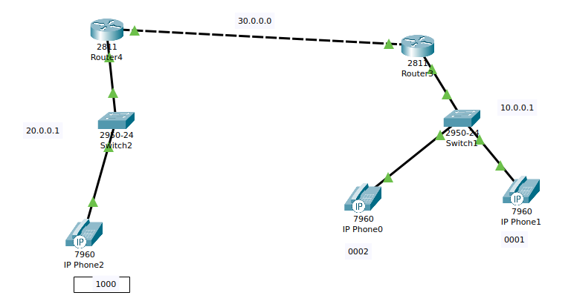**Note:** Use router 2811 for VoIP connected network.

**Single router configuration:** https://www.packettracernetwork.com/tutorials/voipconfiguration.html

**Router 3**

Router3>enable

Router3#configure terminal

Router3(config)#interface FastEthernet0/0

Router3(config-if)#ip address 10.0.0.1 255.0.0.0

Router3(config-if)#no shutdown

Router3(config-if)#exit

Router3(config)#

Router3(config)#interface FastEthernet0/1

Router3(config-if)#ip address 30.0.0.1 255.0.0.0

Router3(config-if)#no shutdown

Router3(config-if)#exit

Router3(config)#router rip

Router3(config-router)#network 10.0.0.0

Router3(config-router)#network 30.0.0.0

**Router 4**

Router4>enable

Router4#configure terminal

Router4(config)#interface FastEthernet1/0

Router4(config-if)#ip address 20.0.0.1 255.0.0.0

Router4(config-if)#no shutdown

Router4(config-if)#exit

Router4(config)#

Router4(config)#interface FastEthernet1/1

Router4(config-if)#ip address 30.0.0.2 255.0.0.0

Router4(config-if)#no shutdown

Router4(config-if)#exit

Router4(config)#router rip

Router4(config-router)#network 20.0.0.0

Router4(config-router)#network 30.0.0.0

**DHCP configuration**

Router3(config)#ip dhcp pool VOICE1

Router3(dhcp-config)#network 10.0.0.0 255.0.0.0

Router3(dhcp-config)#default-router 10.0.0.1

Router3(dhcp-config)#option 150 ip 10.0.0.1

Router4(config)#ip dhcp pool VOICE2

Router4(dhcp-config)#network 20.0.0.0 255.0.0.0

Router4(dhcp-config)#default-router 20.0.0.1

Router4(dhcp-config)#option 150 ip 20.0.0.1

## Configure the Call Manager Express telephony service on Router3 and Router4

Router3(config)#telephony-service

Router3(config-telephony)#max-dn 5

Router3(config-telephony)#max-ephones 5

Router3(config-telephony)#ip source-address 10.0.0.1 port 2000

Router3(config-telephony)#auto assign 4 to 6

Router3(config-telephony)#auto assign 1 to 5

Router3(config-telephony)#exit

Router3(config)#ephone-dn 1

Router3(config-ephone-dn)#number 0001

Router3(config-ephone-dn)#exit

Router3(config)#ephone-dn 2

Router3(config-ephone-dn)#number 0002

Router4(config)#telephony-service

Router4(config-telephony)#max-dn 5

Router4(config-telephony)#max-ephones 5

Router4(config-telephony)#ip source-address 20.0.0.1 port 2000

Router4(config-telephony)#auto assign 4 to 6

Router4(config-telephony)#auto assign 1 to 5

Router4(config-telephony)#exit

Router4(config)#ephone-dn 1

Router4(config-ephone-dn)#number 1000

Router4(config-ephone-dn)#exit

## Configure a voice Vlan on Switch 1 and 2

Switch1(config)#interface range fa0/1 – 5

Switch1(config-if-range)#switchport mode access

Switch1(config-if-range)#switchport voice vlan 1

Switch2(config)#interface range fa0/1 – 5

Switch2(config-if-range)#switchport mode access

Switch2(config-if-range)#switchport voice vlan 1

## Verify the configuration

Ensure that the IP Phone receives an IP Address and a the phone number 0001 from Router3  (this can take a short while). Check for rest two IP Phones

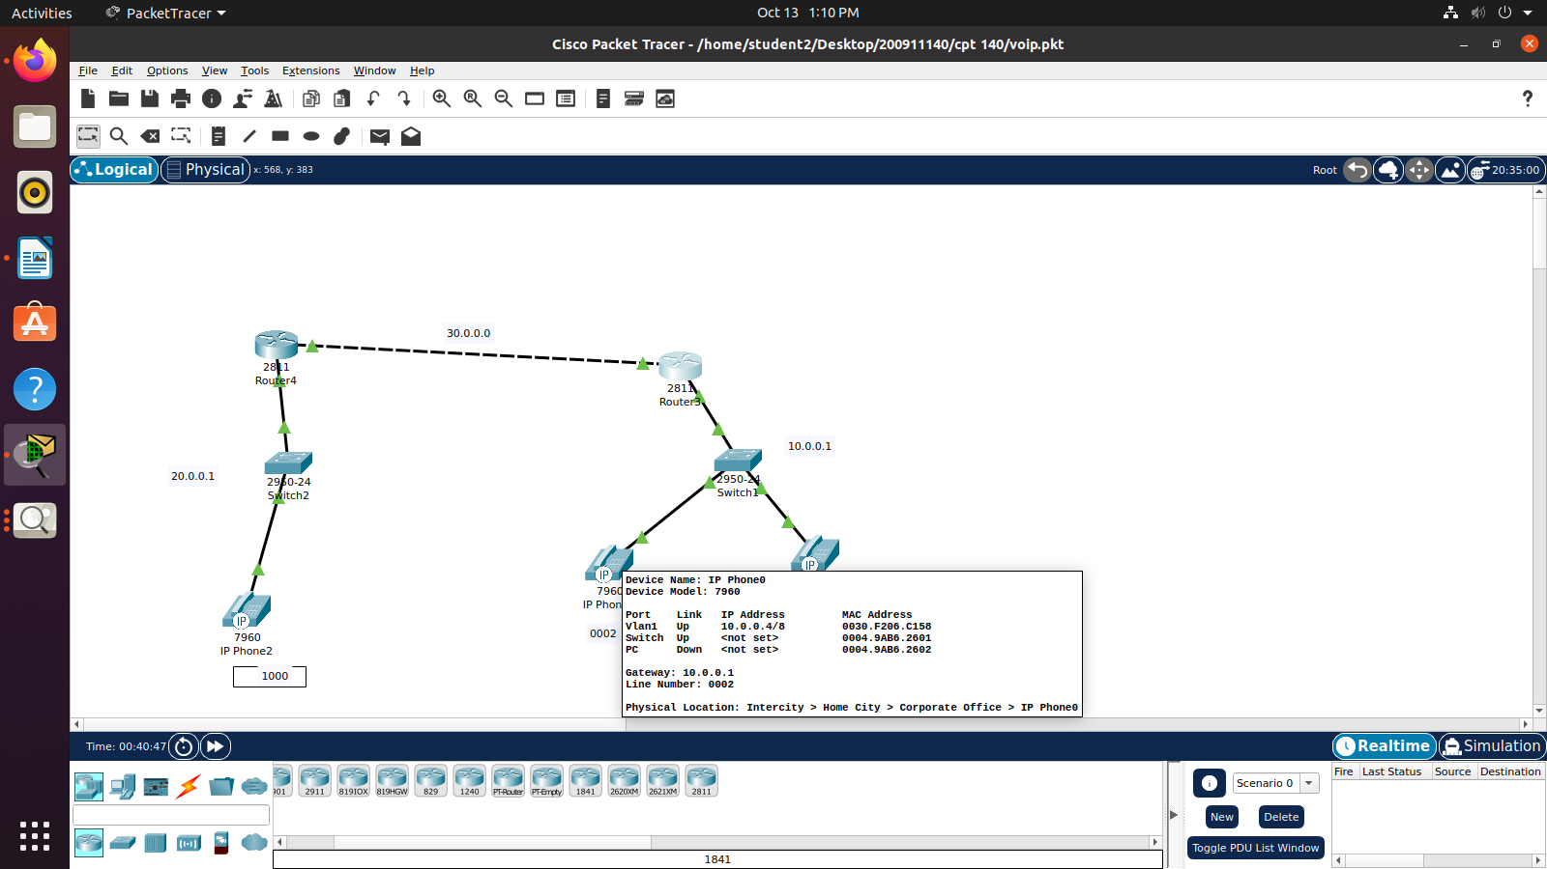

Double Click on IP phone 1 and go to GUI in its menu bar. Click on reciever and dial the phone number 0002 of IP Phone 0.

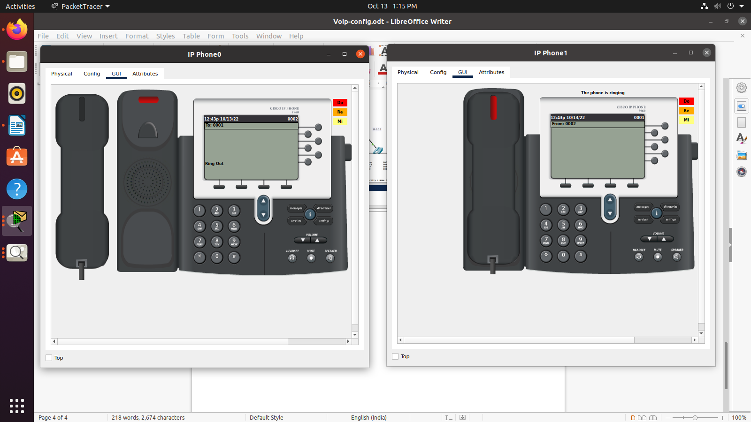

We have checked the VoIP phones which is connected in the same network id. In Next step, We have check the VoIP phones connected in different network id. Click on receiver of IP Phone 1 and dial the phone number 1000 of IP Phone 2.

## Configure the telephony service on Router3 and Router4

Router3(config)#dial-peer voice 1 voip

Router3(config-dial-peer)# destination-pattern [0-9][0-9][0-9][0-9] *# To represent IP Phone number 0001 or 0002*

Router3(config-dial-peer)# session target ipv4:30.0.0.2

Router4(config)#dial-peer voice 1 voip

Router4(config-dial-peer) # destination-pattern [0-9][0-9][0-9][0-9] *# To represent IP Phone number 0001 or 0002*

Router4(config-dial-peer) # session target ipv4:30.0.0.1

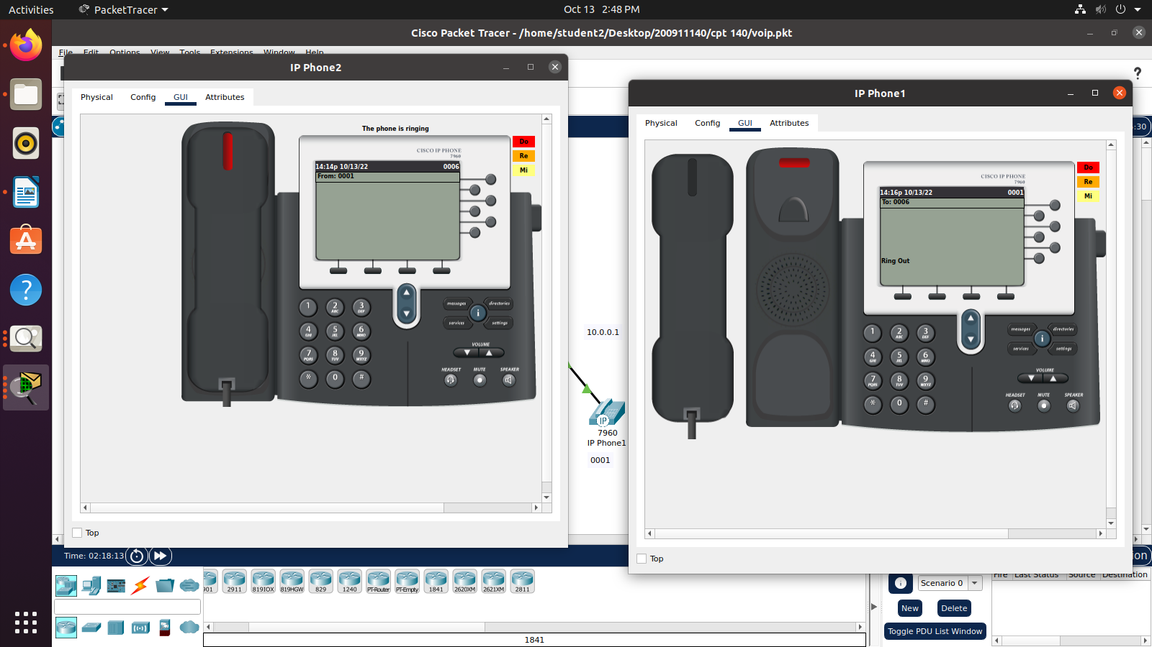

Double Click on IP phone 1 and go to GUI in its menu bar. Click on receiver and dial the phone number 1000 of IP Phone 2.