1. Please explain the git Flow and write set of commands that produces following flow. Give tag to each subquestion and push it to git repository. Put the link to your repo.

a. One of the two branches doesn't have any new commits since the branching happened - its latest commit is still the common ancestor.

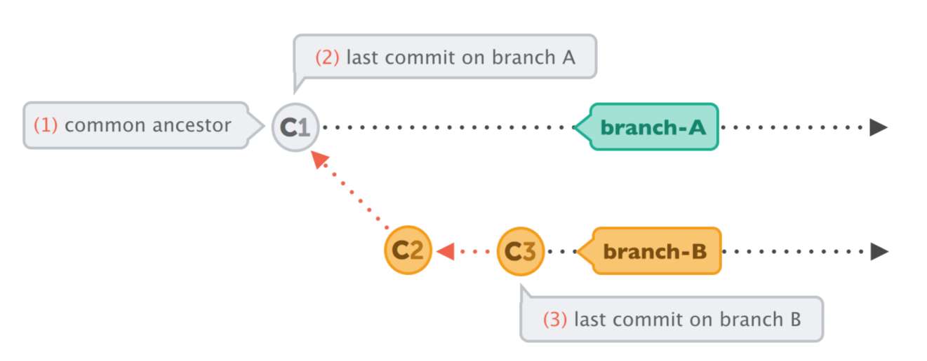

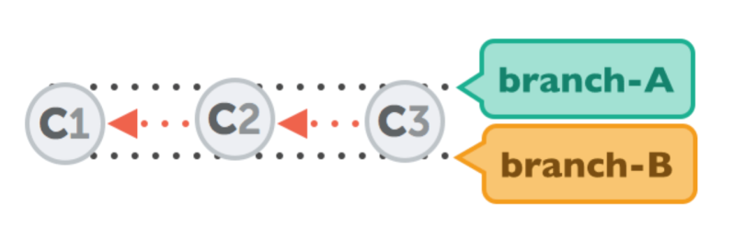b. This is a "fast-forward" merge. Both branches then share the exact same history.

C. Git will have to create a new commit that contains the differences between them - the merge commit

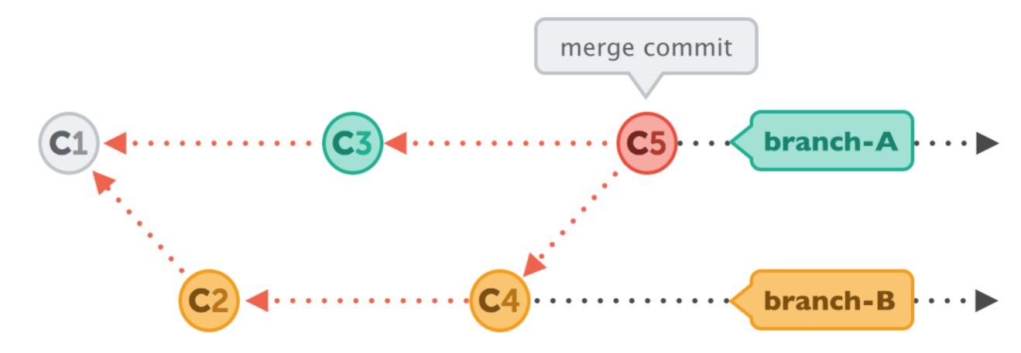

d. Both branches moved forward individually.

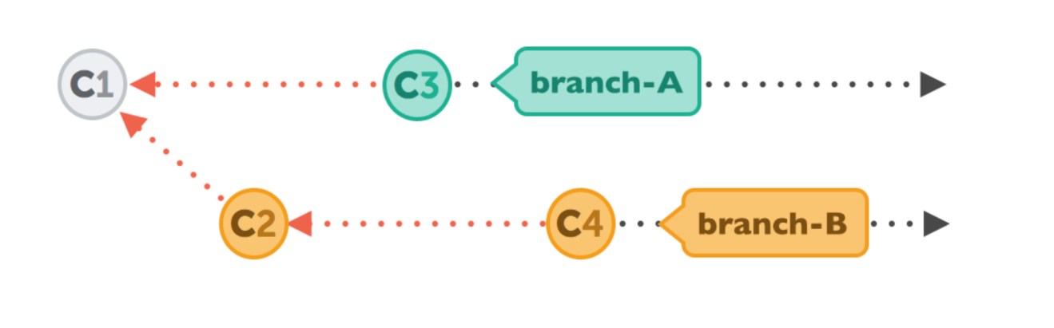

e. This diagram is integrating using Rebase.

First, GIT will undo all of the commits on branch –A after the branch out and save them temporarily.

Then, GIT will apply the commits from branch –B and both branches will look the same.

In the end, the new commits on branch-A are now reapplied - but on a new position, on top of the integrated commits from branch-B

