Cherry picking in Git is designed to apply some commit from one branch into another branch. It can be done if you eg. made a mistake and committed a change into wrong branch, but do not want to merge the whole branch.

Cherry picking in git means to choose a commit from one branch and apply it onto another.

This is in contrast with other ways such as merge and rebase which normally applies many commits onto a another branch.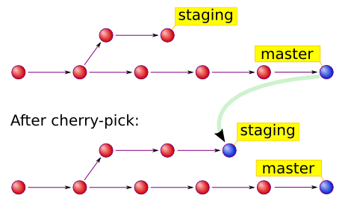

Git Stashing takes the dirty state of your working directory – that is, your modified tracked files and staged changes – and saves it on a stack of unfinished changes that you can reapply at any time.

