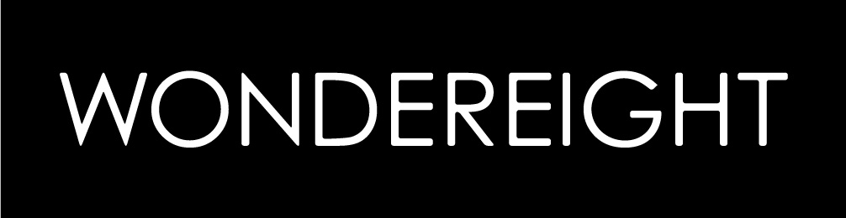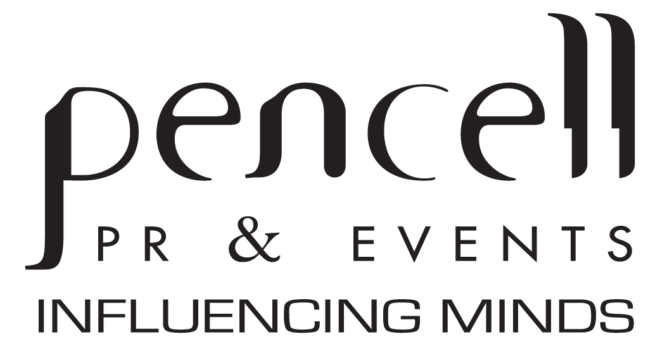

FOR IMMEDIATE RELEASE

WonderEight hosts select media at their new offices in Beirut

Beirut, Lebanon, May 14th - Select media of the region were recently invited to a special brunch hosted by global branding and interactive agency, WonderEight (W8). The Beirut-based agency, operating since 1999, positions itself as a cross-cultural and cross-disciplined world agency for world brands. The media was invited to the new WonderEight offices to meet the team as well as get updated on the agency’s imminent plans.

Operating in a boutique style structure, WonderEight is a creative space boasting of a multi-faceted environment. WonderEight, simply put, is a gestalt of a constant art gallery for contemporary art, a creative workshop where prototypes of graphics, prints and objects are created, a learning box for lectures, training and workshops and an open library that contains all the books that inspired 14 years of W8. Some of WonderEight’s activities include: Brand creation, logo and corporate identity, brochures, posters, product packaging, stands, copywriting, creating websites and interactive solutions, apps and game design, ATL and BTL campaigns and strategic media booking among numerous others.

A force to reckon with, WonderEight is truly an agency at which creativity knows no bounds.

For more information visit www.wondereight.com, or call +961 (0)1 494 331

#######################

