**Final Specification**

**Uses cases:**

When you run the code:

1. Enter the number of days you wish the simulation to go about

2. Enter the probability of an ignorant person becoming a zombie (Hint: This should be a high probability since ignorant people are more likely to turn into zombies when they’re approached by zombies)

3. Enter the probability of an ignorant person becoming alarmed (Hint: This should be a high probability since ignorant people are more likely to become alarmed when they’re approached by other alarmed people)

4. Enter the probability of an alarmed person becoming a zombie (Hint: This should be a low probability since alarmed people are less likely to turn into zombies when they’re approached by zombies)

5. Enter the probability of a citizen moving from one district to another

6. The simulation will show the data day by day with the total number of zombies, alarmed, and ignorants.

**UML**

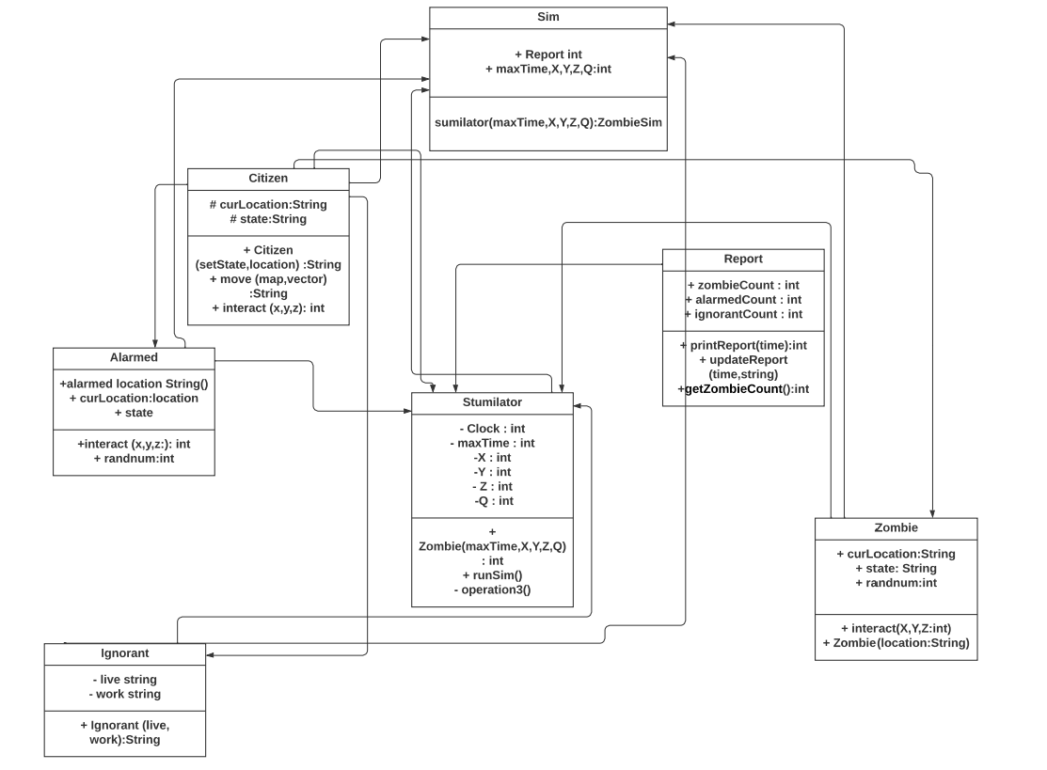

**Pseudo-code**

