Todo List - React Js

**Description:**

Todo List is a web-based desktop app using the Firebase database from Google. It's built on Javascript framework React.js. Application is for writing tasks anywhere and anytime. The app also includes registration where you can create your own profile.

**Open:**

1. unzip file
2. open folder in some editor
3. open terminal and write :
4. npm i (install node module packages)
5. npm start (run on local host)
6. finished the project run on localhost

**How to change add your own Firebase database:**

1. go to firebase
2. create your new project
3. clicked on web

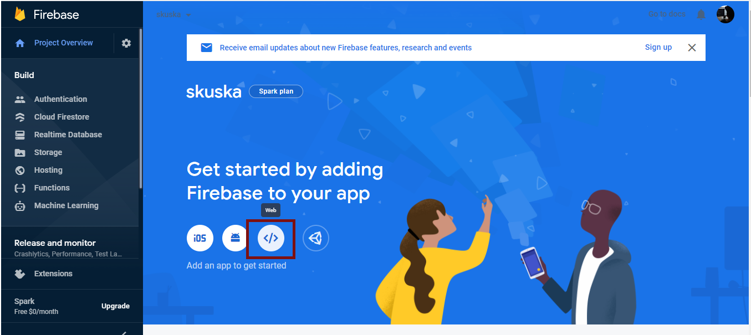

1. register app and add your own firebase config to **const firebase config** in **firebase_config.js**

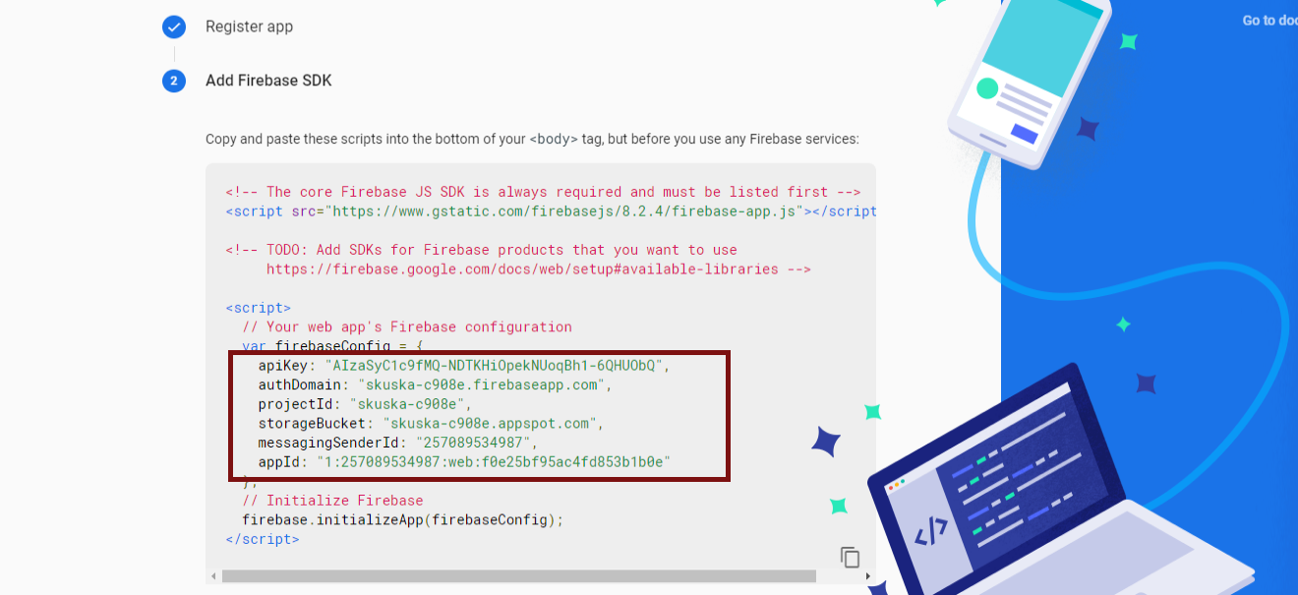

1. go to authentication and click **get start** and **enable** auth with email+password and click **save**

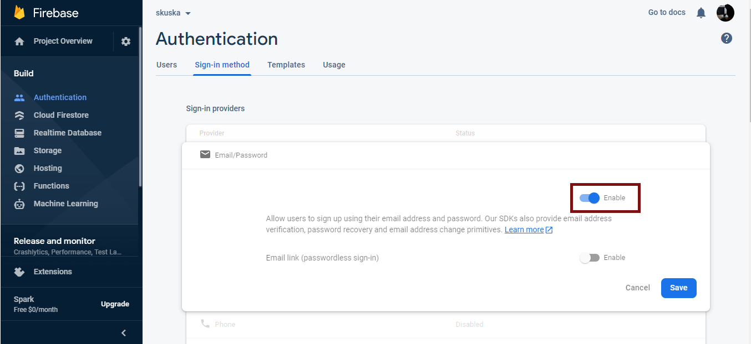

1. go to cloud firestore and click create database and don't change anything and then go to rules change like in image

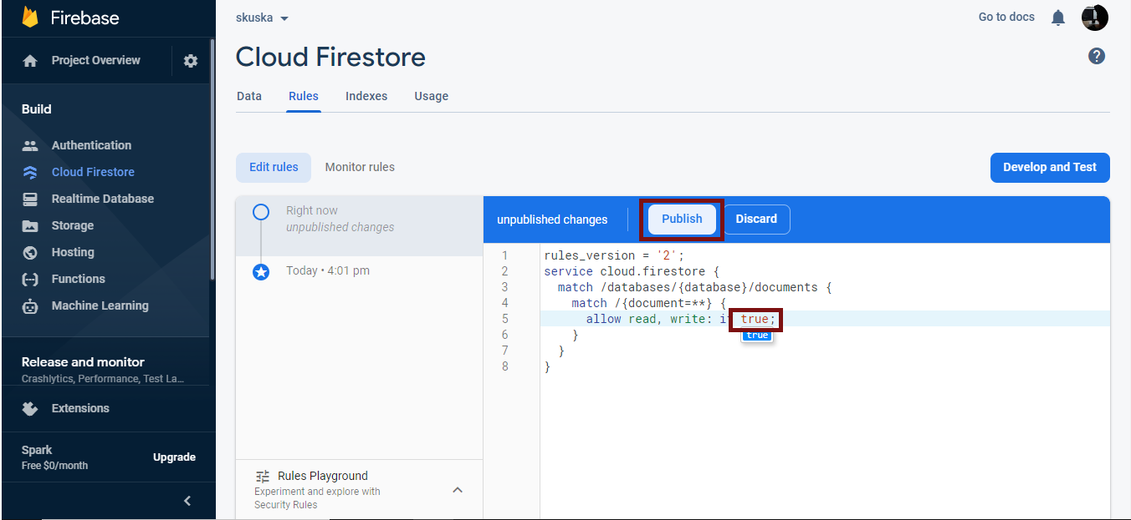

1. go to storage and follow rules like in image

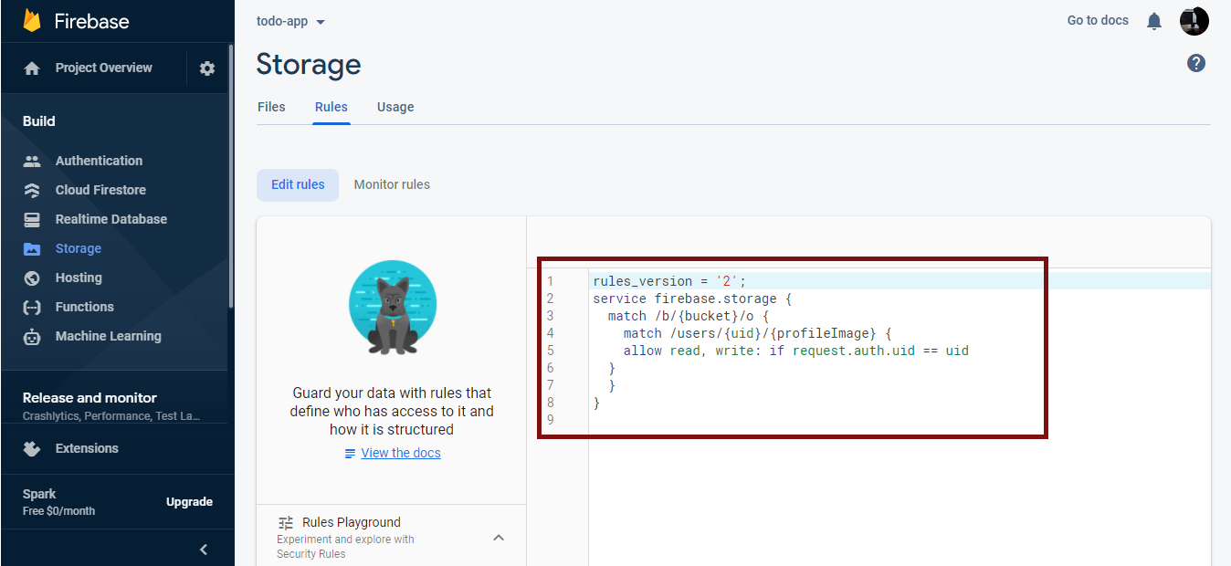

1. And everything would be done.

**FeedBack**

[***fistrba@gmail.com***](mailto:fistrba@gmail.com)

* *If you want something new or create a project or something to add to the app and more - contact me at email.*