Technical Assessment

Senior Software Support Engineer

Salim Sema

Installed and configured Jira Software using Docker on my local Windows machine by following the instructions provided in the documentation.

Added the ScriptRunner JAR file to Jira Software and applied a trial license to enable its functionality.

To implement the desired behavior during the transition to the "In Review" state, I determined that a post function within the workflow transition is the most appropriate choice.

To perform **Task 1** from the assessment, I wrote a ScriptRunner script with the following key steps:

1. **Identify the User Group:**
   * Used ComponentAccessor to retrieve the currently logged-in user.
   * Checked the user’s group membership to verify permissions (e.g., jira-administrators).
2. **Determine the Transition ID:**
   * Referred to sample scripts and Jira’s workflow configuration to locate the correct transition ID for moving issues to **Done**.
3. **Access the Current Issue Key:**
   * Used issue.key to identify the current issue within the workflow context.
4. **Handle Subtasks:**
   * Checked if the current issue has subtasks.
   * If subtasks exist, transitioned each of them to the **Done** state.
5. **Transition the Parent Issue:**
   * After confirming all subtasks are completed, transitioned the parent issue to **Done** as well.

**Resources used to prepare below script.**

Identify the Groups of a User

[Identify the Groups of a User](https://www.scriptrunnerhq.com/help/example-scripts/identify-user-groups-onPrem)

Auto close all subtasks

[Auto close all subtasks when the parent issue is transitioned to the Done status](https://www.scriptrunnerhq.com/help/example-scripts/close-all-subtasks-when-parent-issue-moved-to-done-cloud)

Scriptrunner Groovy script

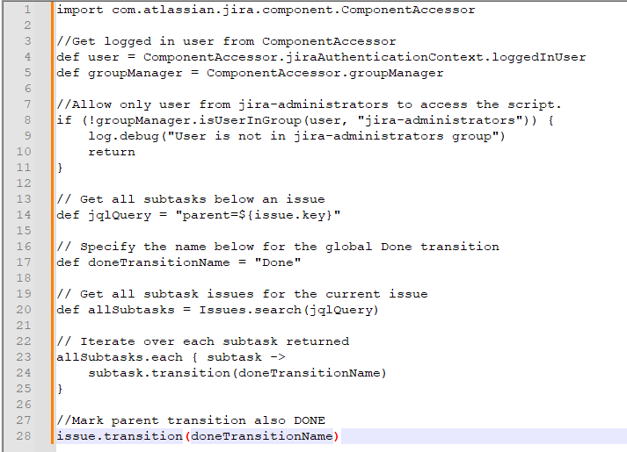

The ScriptRunner script is restricted to run only for users who belong to the jira-administrators group.

As expected, the parent issue successfully transitions to the "Done" state, and all associated subtasks are also moved from "In Progress" to "Done". This confirms that the ScriptRunner script executed correctly.

The ScriptRunner script will not execute for users who are not part of the jira-administrators group, as shown in the behavior below.

As observed, the parent issue transitions to the "In Review" state, but it does not move to the "Done" state. Additionally, the associated subtasks remain in the "In Progress" state and are not updated as expected.

**Assessment Task 2**

**Analysis**

* I reviewed the **ScriptRunner custom REST endpoint script** and the associated **HAR log file** to debug the issue.
* The script calls Issues.getByKey(issueKey) using the issueKey obtained from the query parameter.
* From the HAR logs, it is clear that this call results in a **500 Internal Server Error**, with the message:

"The issue no longer exists."

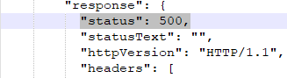

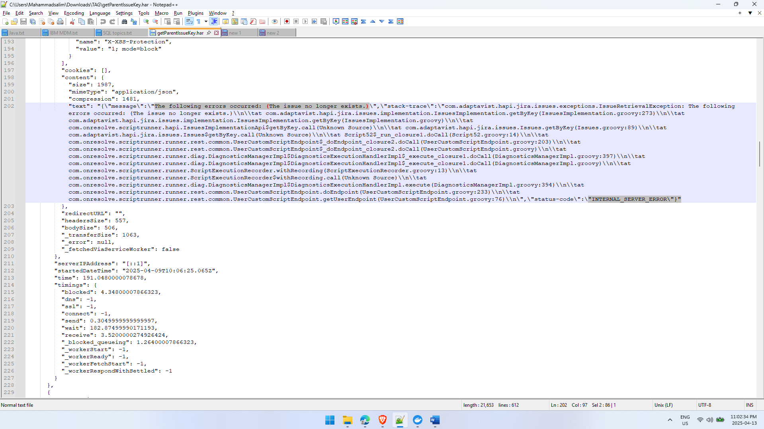

**Problem**

* The error occurs because the script is trying to retrieve an issue using a key that **does not exist** in the system.
* When getByKey fails to find a matching issue, it throws an unhandled exception, causing the server error.

**Solution**

To handle this scenario gracefully, we can add **input validation and error handling** in the script:

1. **Check for Missing or Null Issue Key:**

* If the issueKey is not provided in the query parameters, return an HTTP 400 Bad Request response.

1. **Check for Non-Existent Issue:**

* If Issues.getByKey(issueKey) returns null, respond with HTTP 404 (issue is not found) Not Found.

**Updated Behavior**

* This validation ensures the script will no longer throw a server error.
* Instead, it will return **clear and meaningful error codes** that help with debugging and frontend handling.