MIDDLE EAST TECHNICAL UNIVERSITY
Department of Electrical and Electronics
Engineering

EE 583 ARTIFICIAL INTELLIGENCE
Spring 2006

PROJECT INTERMEDIATE REPORT

Project Topic

Simultaneous Localization and Mapping Implementation on Khepera Robot Simulator

Project Group

Bengi Koç , Barış Tanrıverdi , Salim Sırtkaya

TABLE OF CONTENTS

1. Problem Definition 3
2. Summary of Previous Efforts 4
3. SELECTED ALGORITHM 6
4. References 6

LIST OF FIGURES

Figure 1 A vehicle taking relative measurements to environmental landmark for SLAM 3
Figure 2 Performance of different SLAM algorithms 6

LIST OF TABLES

Table 1 Task environment specifications 4

Problem Definition
A critical ability of autonomous robots is navigation. The functions of navigation can be expressed in four questions: where am I going, which is the best way to get there, where have I been, and where am I? In order to solve these questions, the robot needs to know its environment. As the robot explores new environments, it may be part of its mission to map them. The acquisition of unknown environments is known as robotic mapping. [1]

In particular, Simultaneous Localization and Mapping (SLAM) can be described as the ability of a robot to build a map of its environment while localizing itself in that map to reach true autonomy. [2] SLAM problem tries to answer the following question: “Is it possible for an autonomous vehicle starting at an unknown location in an unknown environment to incrementally build a map of the environment while simultaneously using this map to compute the vehicle’s location?”[3]. This scenario is shown in Figure 1. [4]

Figure 1 A vehicle taking relative measurements to environmental landmark for SLAM
In this project, we’ll implement SLAM on Khepera simulator. Khepera is a circular shaped robot that has two wheels and 6 range sensors. The simulator is a Matlab application that simulates a Khepera robot connected to the computer in a very realistic way. The simulated Khepera is controlled from Matlab in the same way as real, physical Kheperas. We can control the wheels and take measurements from each range sensor. The simulator robot will be placed on an unknown grid map. Each grid will be represented by white or black color indicating the state of the grid, empty or full. The simulator robot will start from an initial pose and will gradually build the map of its environment while localizing itself on that map.

The problem defined in the previous paragraph can be analyzed and categorized using the tools mentioned in the class. Respective categorizations and task environment specifications are as follows:

- Problem is deterministic, sequential/episodic, partially observable, static, discrete and single agent

Table 1 Task environment specifications
Agent Type | Performance Measure | Environment | Actuators | Sensors
Khepera Robot Simulator | Speed, Consistency of the map | Grid Map of Khepera Simulator | 2 Motors Controlling 2 Wheels | 6 Proximity Sensors

Summary of Previous Efforts
The general SLAM problem has been the subject of substantial research since the inception of a robotics research community and indeed before this in areas such as manned vehicle navigation systems and geophysical surveying. A number of approaches have been proposed to address both the SLAM problem and also more simplified navigation problems where additional map or vehicle location information is made available.
The most popular of these is a feature based approach, estimation-theoretic or Kalman filter approach. The popularity of this approach is due to two main factors. First, it directly provides both a recursive solution to the navigation problem and a means of computing consistent estimates for the uncertainty in vehicle and map landmark locations on the basis of statistical models for vehicle motion and relative landmark observations. However, common to all feature based approaches, the increase in computational complexity with the size of the environment and number of landmarks is a serious drawback of this method. A number of techniques have been proposed to alleviate this problem, such as the Extended Kalman Filter (EKF), information filter and fastSLAM.
The EKF uses linearized kinematics and observation equations to generate state predictions. EKF immediately reduces the error in both the robot and the landmarks upon seeing and correctly matching a previous landmark. The covariance actually reduce the error in all landmarks simultaneously. However, EKF-based SLAM is slow to update and is not scalable in its simple form.
In information filter method the inverse of the covariance matrix is utilized instead of the covariance matrix itself. The algorithm exploits the fact that the information matrix is approximately sparse, requiring storage space. The information matrix representation allows integration of a new measurement in computation time, but to produce a map estimate, a system of linear equations must be solved. The equation solving is performed iteratively by relaxation. The drawback of this algorithm is its linear assumption. [6]

Fast-SLAM makes use of the observation that the landmark estimates are conditionally independent given the robot pose. Basically, the algorithm is a particle filter , in which every particle represents a sampled robot trajectory plus a set of Kalman filters estimating the position for each landmark as a Gaussian distribution. These distributions are independent, so small covariance matrices are needed, instead of one large matrix. The computation time for integrating a measurement is for particles with storage space. This algorithm can cope with uncertain landmark identification, which is a unique advantage over the other algorithms. [6] There exist other methods such as thin junction tree filter, treemap algorithm, hierarchical SLAM, relaxation based SLAM, compressed EKF etc. The performance measure of some algorithms are given in . This figure is taken from [6].

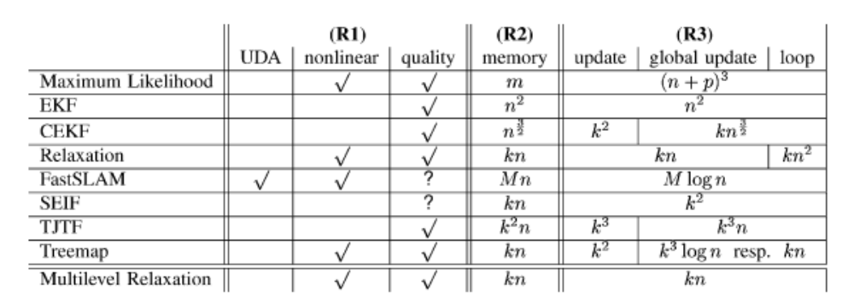
Figure 2 Performance of different SLAM algorithms

With n landmarks or frames, respectively, m measurements, p robot poses, and k landmarks/frames local to the robot.

UDA stands for “uncertain data association,” meaning that the algorithm can handle landmarks with uncertain identity.

SELECTED ALGORITHM

References
[1]
[2] Local Maps Fusion for Real Time Multirobot Indoor Simultaneous Localization and Mapping* , Diego Rodriguez-Losada, Fernando Matia and Agustin Jimenez

[3] ARIA and Matlab IntegrationWith Applications , Jonas Borgström
[4] Simultaneous Localization and Mapping, 2002 Summer School, Eduardo Nebot Australian Centre for Field Robotics The University of Sydney NSW 2006 Australia
[5] A Direct Localization Method Using only the, Bearings Extracted from Two Panoramic
Views Along a Linear Trajectory , Henry Huang, Frederic Maire, and Narongdech Keeratipranon
[6] A Multilevel Relaxation Algorithm for Simultaneous Localization and Mapping , Udo Frese, Per Larsson, and Tom Duckett

