MIDDLE EAST TECHNICAL UNIVERSITY
Department of Electrical and Electronics
Engineering

EE 583 ARTIFICIAL INTELLIGENCE
Programming Assignment #1

Project Group: Bengi Koç, Barış Tanrıverdi, Salim Sırtkaya

1.
The program is developed in Matlab.

2.
There exists a graphical user interface to easily examine the results of the implementations. Run *.fig for the GUI. From the GUI, you can:
- Select the puzzle size
- Randomly initialize the puzzle
- Load a preconfigured file as initial puzzle
- Load the goal state and go back from it step by step randomly. Also observe the step number
- Select the type of the search algorithm. Necessary input boxes for different algorithms will automatically show-up and/or disappear
- Start the selected search algorithm on the current puzzle
- Observe the solution step by step or in total
- Observe the process time
- Observe the current iteration (node, level)
- Observe the total number of iterations (final level)
- Run Monte-Carlo simulations.
In order to run the gui, type gui_deneme_1 in “Matlab Command Window” and press enter. The project source folder should be selected from the “Current Directory” section of the Matlab in order to run the gui properly.
A proper order to execute the application and run one of the methods from the gui is listed as follows:
- Run gui_deneme_1.m form Matlab Command Window
- In the gui first select the puzzle size
- Initialize the selected puzzle from randomize button or from loading the goal and going back from the goal step by step ( It is recommended to initialize the puzzle by selecting the goal and going back N<20 steps from it. Solving randomly initialized puzzles will take too much time for some methods.)
- Select the method from the corresponding combo box. (A*, Iterative Deepening etc.)
- Wait for the solution. Show solution and Step solution buttons will appear after the program finds a proper solution. Press the Step Solution button to see a single step going to the solution.
- You can observe the process time and total iteration number in the gui.

3.
Several kernel functions such as Successors(), randomize(), DFS_limited(), solve_onestep() etc. Are implemented in order to have a more structured software.

4. Breath First Search

Maximum expandable node number is set to 100000.
4.a.
“960” nodes are expended to reach the goal state during the execution of the program.
4.b.
“12” tiles are moved in order to reach the goal state.
4.c.
The program takes “6.6 sec.” to reach the goal state.

5. Depth First Search

Max. depth is set to 15. Note that this very useful for this specific example since it can be solved in 12 steps. Therefore DFS seems to work faster than Iterative DFS. However this will not be true for different max depth selections and/or different examples.
5.a.
“270K” nodes are expanded to reach the goal state during the execution of the program.
5.b.
“14” tiles are moved in order to reach the goal state.
5.c.
The program takes “28,11 sec.” to reach the goal state.

6. Iterative Deepening

Max. depth is set to 15.
6.a.
“300K” nodes are expanded to reach the goal state during the execution of the program.
6.b.
“12” tiles are moved in order to reach the goal state.
6.c.
The program takes “58,11sec.” to reach the goal state.

7. A* Search

7.1. Heuristic Misplaced Search

7.1.a.
“303” nodes are expanded to reach the goal state during the execution of the program.
7.1.b.
“12” tiles are moved in order to reach the goal state.
7.1.c.
The program takes “0,36 sec.” to reach the goal state.

7.2. Heuristic Manhattan Search

7.2.a.
“63” nodes are expended to reach the goal state during the execution of the program.
7.2.b.
“12” tiles are moved in order to reach the goal state.
7.2.c.
The program takes “0,03 sec.” to reach the goal state.

8.
Monte Carlo Simulation is done for 20 times for each algorithm with different initial states. The results of the findings are shown below:

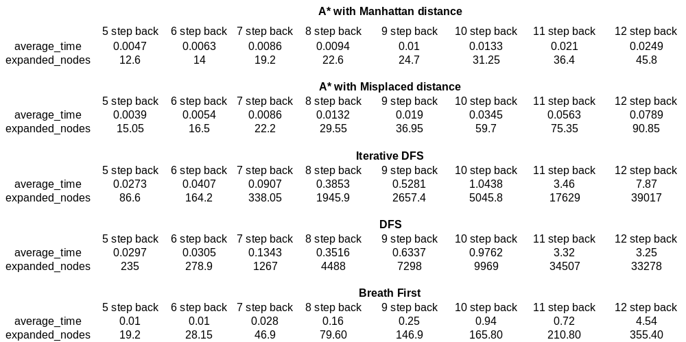
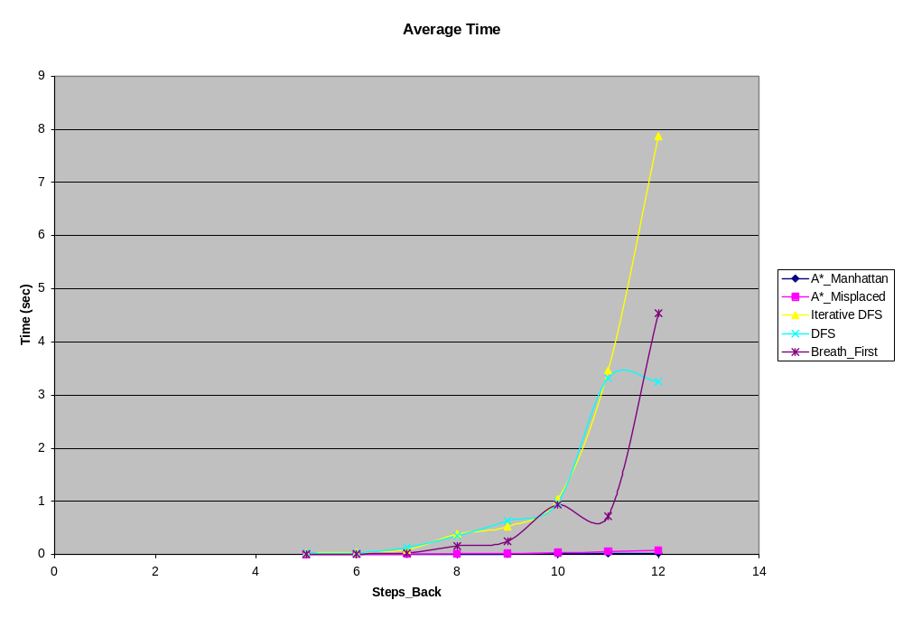

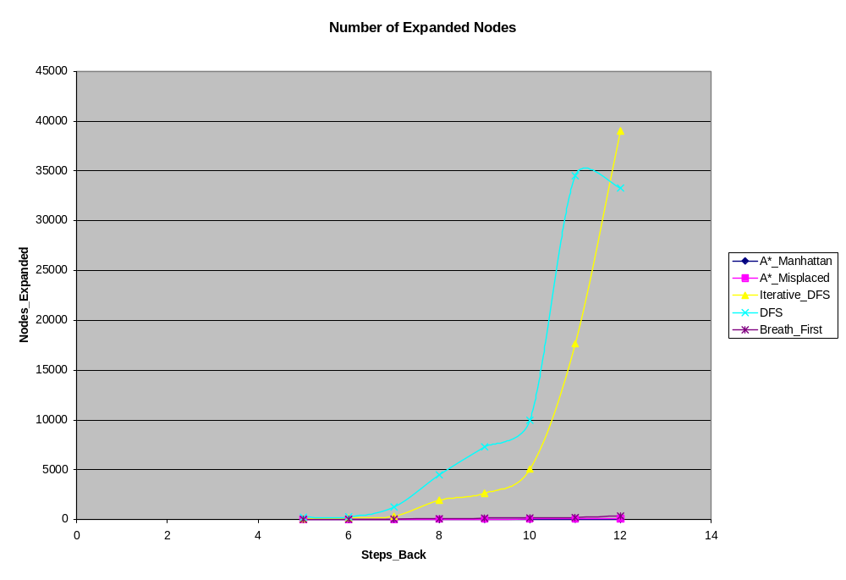

As it can be concluded from the graphs, A* search has the best performance on time and memory wise among all algorithms. A* with Manhattan distance is has a better memory performance compared to A* with misplaced distance. Time wise performances of A* with Manhattan distance and A* with misplaced distance are almost the same.

Memory and time wise performance of breath first search is better than deep first and iterative deepening searches. Iterative deepening is better than deep first in memory wise but iterative deepening is worse than deep first in time wise.

9.
Breath first search algorithm is experimented also with a puzzle of size 4x4.
Monte Carlo simulation is done for 20 times for that and the results are compared with the previous 3x3 puzzle sized breath first case.

