EE504 – HW#1 S SIRTKAYA
112434-6

-------- P.5-(a) -----------

Average Error for Linear Minimum MSE Estimator: 0.1107

Average Error for Mean Estimator: 0.1249

These numbers are averaged out from 1000 experiments. It is seen that the linear minimum MSE estimator is better than the mean estimator.

-------- P.5-(b) -----------

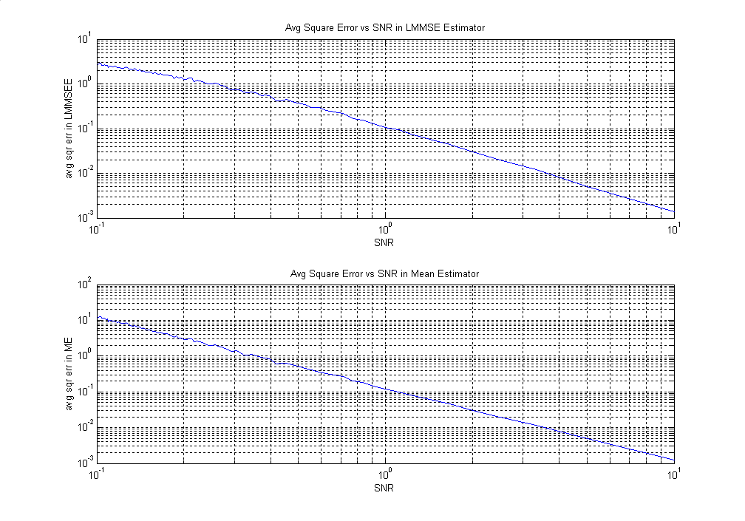

From the above figures we can conclude that the Linear Minimum MSE estimator is better than the Mean Estimator when the signal-to-noise ratio is low. Therefore it is a more robust estimator. For high SNR both estimators perform well.

-------- P.5-(c) -----------

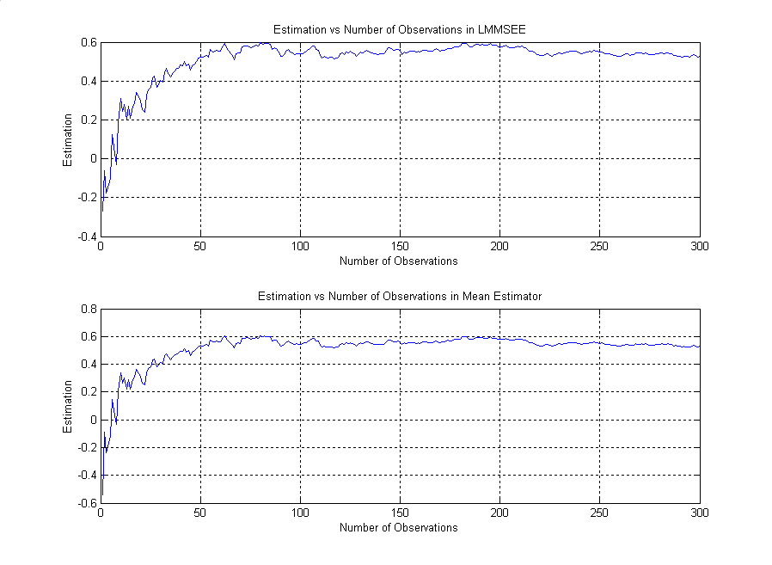

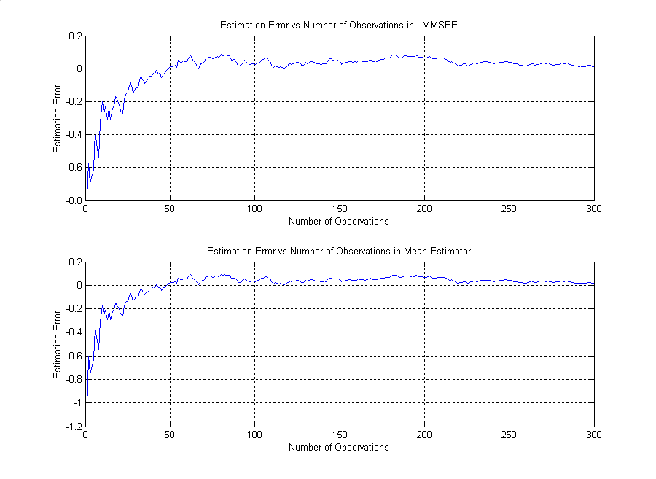

The number to be estimated is -1.2644 in this experiment. The recursion number is 300.

From the above figures we can conclude that, the overshooting is severe in Mean Estimator and its settling time is worse than the LMMSE estimator.

We see that the bias of the min. MSE estimator decreases when the number of recursion increases. Therefore, the min. MSE estimator is asymptotically unbiased.

