EE504 – HW#3 Salim SIRTKAYA
112434-6

P.2:
-------- P.2-(a) -----------

r(n) = A cos (n.π/10 + φ) A=4 & φ= π/4

Figure shows 200 samples from r(n)

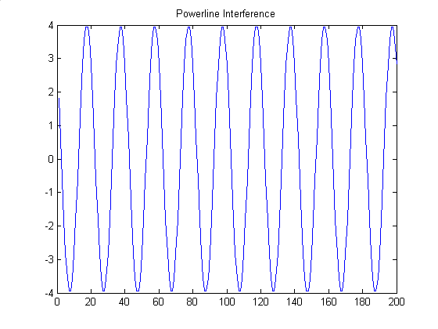

-------- P.2-(b) -----------

It is analytically shown that r(n) can be written as,
r(n) = w₁ x(n) + w₂ x(n-1) where x(n) = cos (n.π/10)
For these values of A and φ, w₁ and w₂ are found as; w₁= 11.9814 w₂= -9.1530

-------- P.2-(c) -----------

The LMS algorithm is applied for 3 different values of μ: 0.1, 0.5 and 1. It is seen from the figures that, the algorithm does not converge with small μ since the number of iterations is not enough. When we increase μ, convergence is satisfied but this time we have more excess error in the steady state. I observed that if use smaller μ with larger sample numbers, the filter converges with less excess error; but obviously convergence time increases. The red straight line indicates w₁ and the magenta straight line indicates w₂.

I tried different A and φ values and observed that the filter converges for all trials. The result of one of these trials is given at the end of the figures of this section. A is selected as 0.5 and φ is π/8.
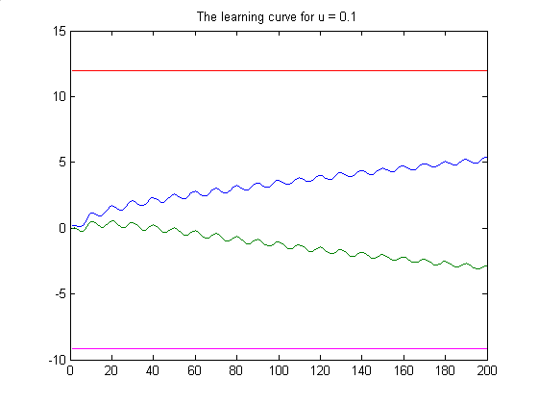

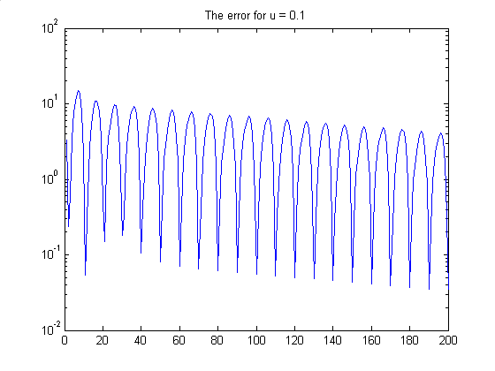

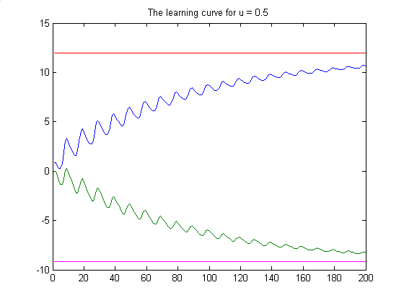

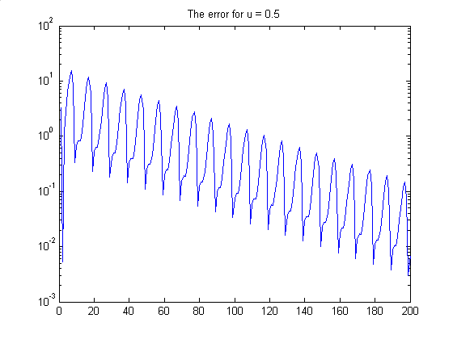

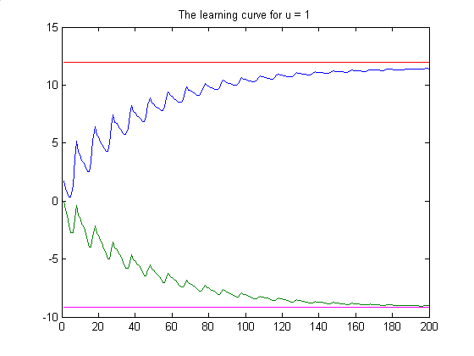

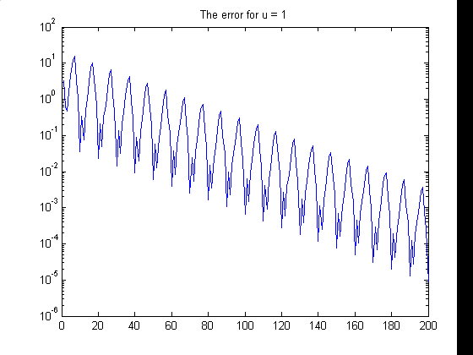

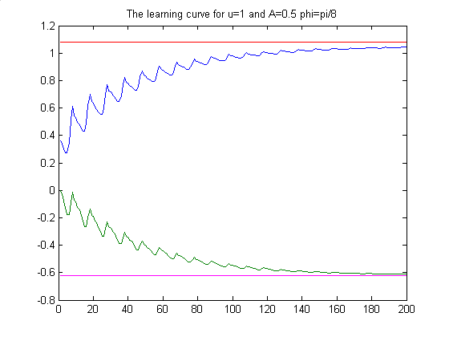

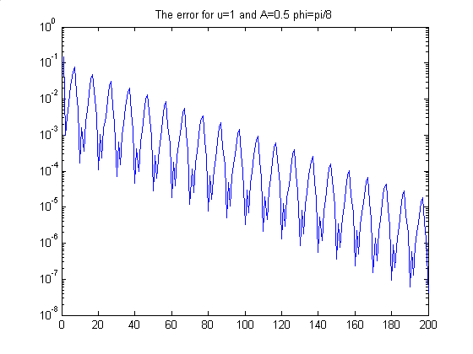

-------- P.2-(d) -----------

If we use an third order adaptive filter one of the filter coefficient converges to zero (since it is not necessary, this seems to be a logical result). However the convergence performance of the other two filter coefficients degrades in this case. Following two figure sets illustrates the convergence characteristics of this filter with two different initial value sets. μ is selected as 1 in order to guarantee fast convergence.
The first figure set is for initial values [0 0 0] and the second for [ 9 -7 0]. It is seen that although we choose the initial values close to the true values the filter does not converged. This is due to the fact that the gradient is replaced with its estimate in LMS. Near the optimum point, gradient is very close to zero therefore the algorithm slowly converges to the optimum. However the gradient estimate may not close to zero around the optimum.

Initial values [0 0 0]

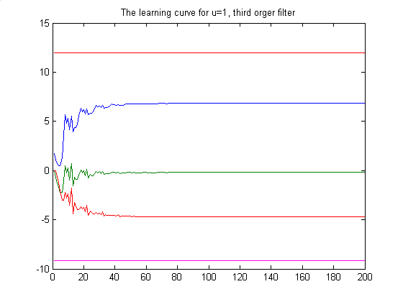

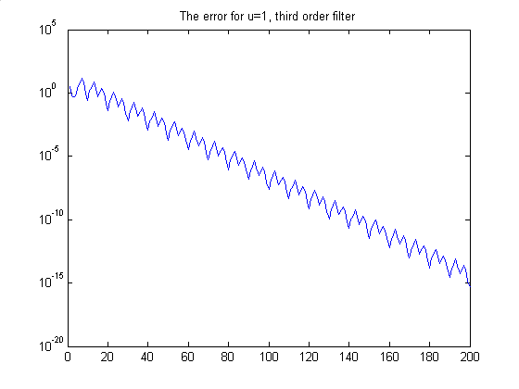

Initial condition [ 9 -7 0]

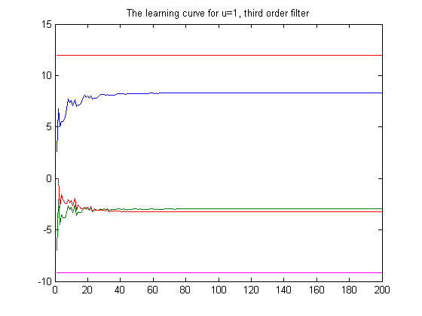

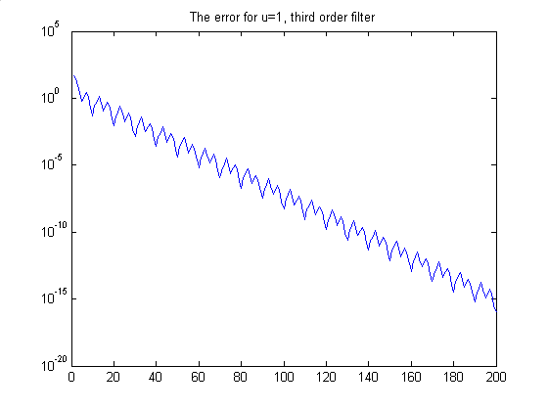

P.3:

-------- Exercise 1 -b -----------

The filter does not converge for μ=0.5 . I decremented μ until the filter converges. The convergent μ is 0.2 . The adaptive filter settles at the following filter coefficients:

w_{1_final} = 0.99999 w_{2_final} = 1.79999 w_{3_final} = 0.81000 w_{4_final} = 3.45623x10⁻⁶

It is observed that one of the coefficients converged to zero since the order of the process is 3. And the other coefficients converged to their true values.

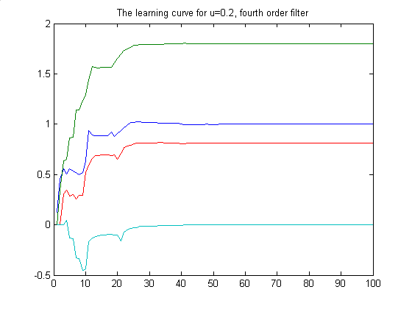

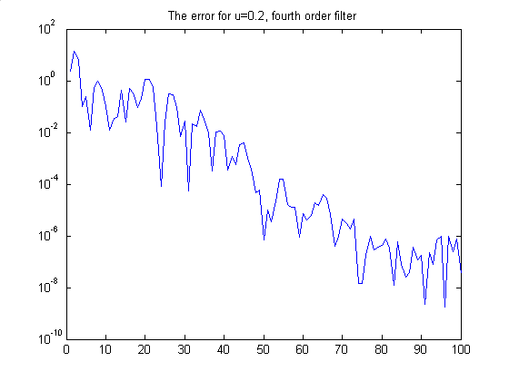

-------- Exercise 1 -c -----------
25 iterations are sufficient for the mean square error to fall to the 10% of its peak value.
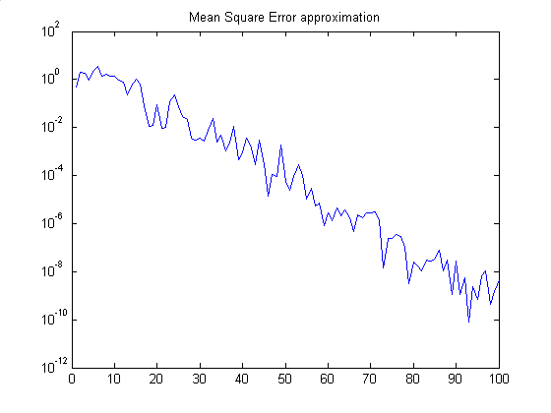
-------- Exercise 1 -d -----------

The excess error is the error at steady state. If we assume that the filter converged at the 30th step the excess mean square error is : 0.001227
The mean square error was 0.34315. It is seen that the excess error is very small compared to the mse error. This is due to the fact that we choose μ very small. If it was bigger the excess error will be larger.

-------- Exercise 1 -e -----------
μ = 0.1

w_{1_final} = 1.00009 w_{2_final} = 1.79995 w_{3_final} = 0.81003 w_{4_final} = 1.41887x10⁻⁵

It is observed that convergence time increased when μ is decreased.
The excess error = 2.85713e-004
Mean square error = 0.324078
The excess error is smaller in this case. It is an expected result since μ is decreased.

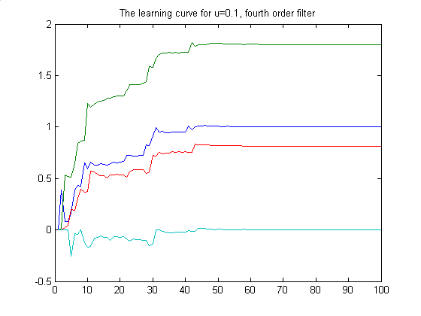

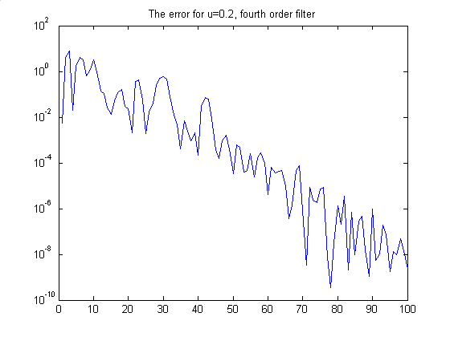

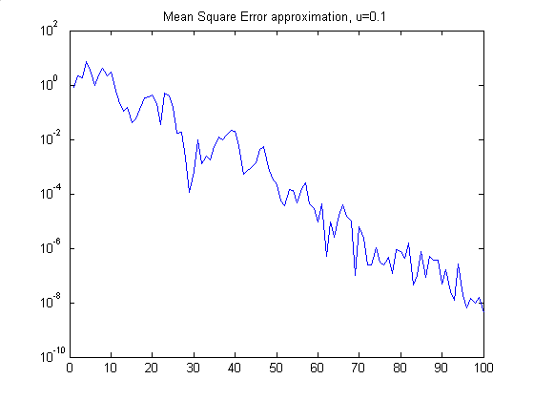

μ = 0.05

w_{1_final} = 0.99548 w_{2_final} = 1.79549 w_{3_final} = 0.80643 w_{4_final} = -0.002138

It is observed that convergence time increased when μ is decreased. For such a small μ 100 iterations is not enough for full convergence (compared to previous results).
The excess error = 0.00423
Mean square error = 0.58997
The excess error is large in this case. Because the filter did not converged in 100 iterations.

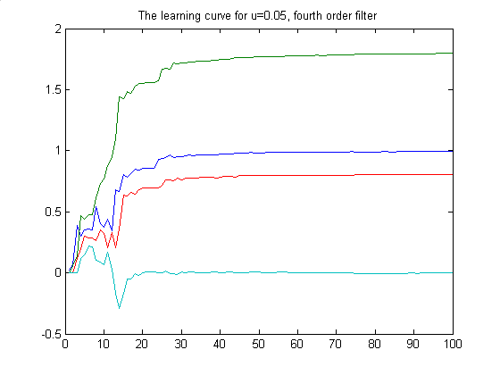

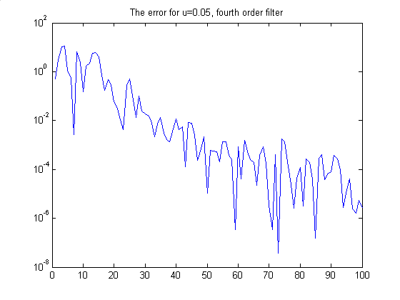

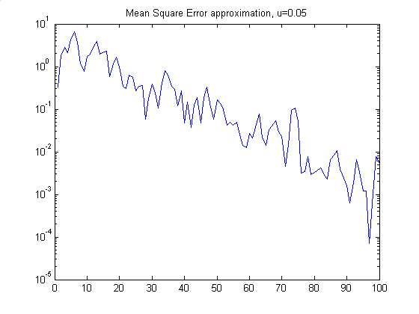

-------- Exercise 1 -f -----------
N = 3 , μ = 0.1
w_{1_final} = 1.00000 w_{2_final} = 1.80002 w_{3_final} = 0.80998

It is observed that the results are very similar to N=4 case. This is expected since it is enough to estimate a system of order with order-3 filters. This observation is supported with the observation that fourth coefficient converges to zero.
The excess error = 1.23347e-004
Mean square error = 0.34249
The excess error is very small in this case.

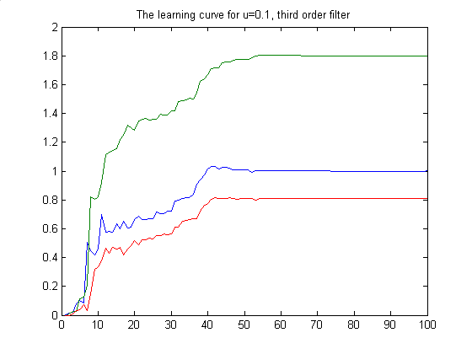

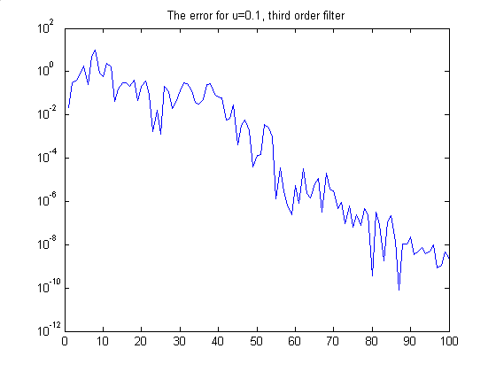

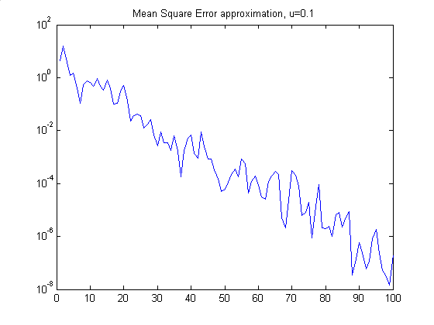

-------- Exercise 2 -a -----------

The filter cannot converge with step size 0.5, Therefore I decreased the step size to 0.1 in order to understand the effect of noise on the system. It is observed that the noise introduced degraded the convergence performance of the filter . This is true for both orders 4, 5.

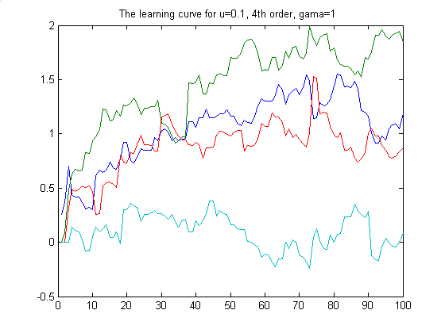

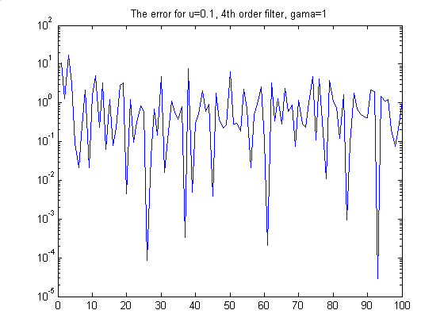

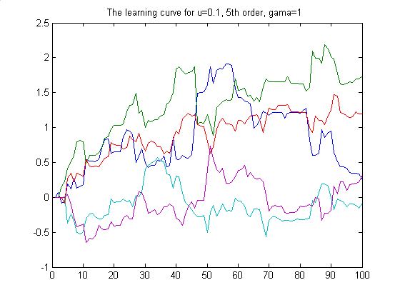

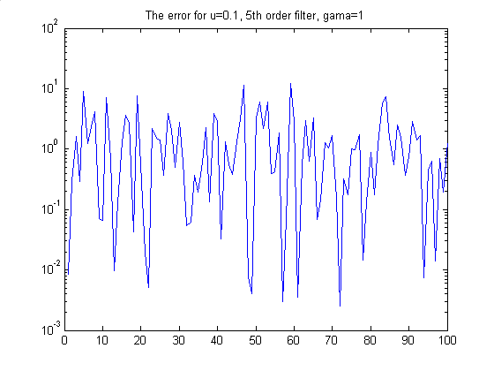

-------- Exercise 2 -b -----------

It is observed that the convergence gets better as we decrease the noise amplitude. Also the step size is an important parameter in this noisy case. Large step sizes do not contribute convergent filters. And obviously small step sizes lead large settling time (as they do in noise free case). Therefore there should be a trade-off between these variables.
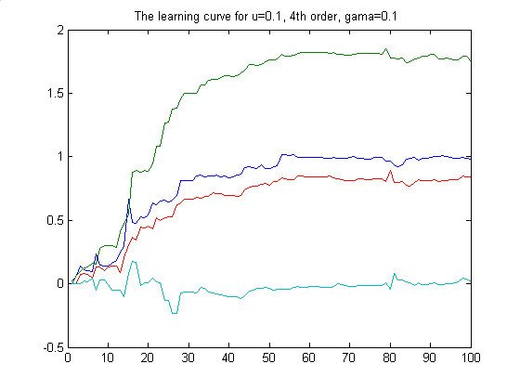

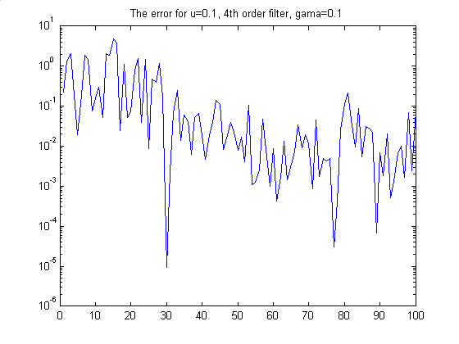

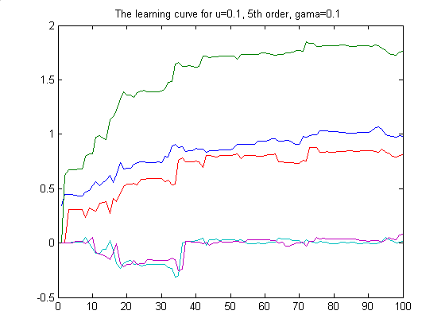

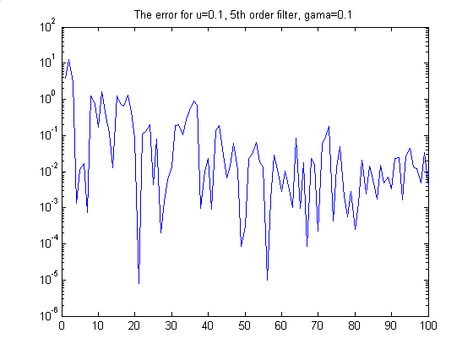

-------- Exercise 3 -a -----------

I selected the step size as 0.1 in order to observe convergence. The final filter coefficients after 300 iterations are :
w1_final = 0.81315377848199
w2_final = -0.29185645347737
w3_final = 0.33486329114671
w4_final = -0.31432472583004

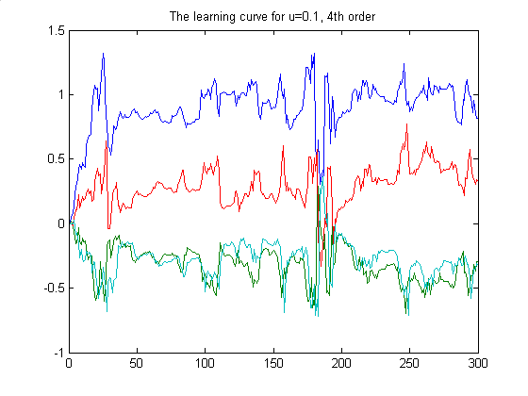

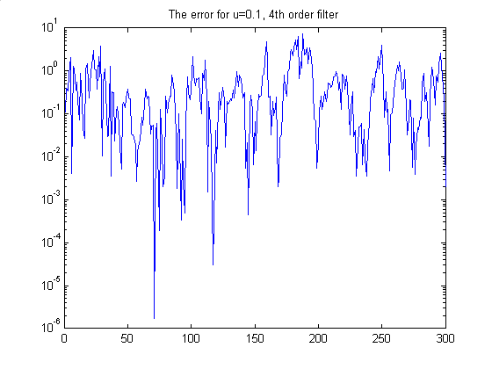

-------- Exercise 3 -b -----------

It is logical to use higher order filters to model an IIR system. By playing with the model order and recording mean square error, I can say that a model order of 6 is reasonable.

-------- Exercise 3 -c -----------

It is observed that when we increase the noise amplitude the convergence performance degrades.

