EE504 – HW#4 COMPUTER EXERCISES Salim SIRTKAYA
112434-6

P.1 - c:

x(n) = 1.2728 x(n-1) – 0.81 x(n-2) + v(n)

v(n) : unit variance white noise

linear predictor: x’(n) = w_{n}(1) x(n-1) + w_{n}(2) x(n-2)

Recursive estimator for the coefficients w(1) and w(2) is

w_{n+1}(1) = w_{n}(1) + μ * e(n) * x(n-1);
w_{n+1}(2) = w_{n}(2) + μ * e(n) * x(n-1);

If the step size μ is sufficiently small, then the coefficients w(1) and w(2) will converge in the mean to their optimum values, w(1)=1.2728 and w(2) = -0.81, respectively.

The initial values are selected as zero. The maximum eigenvalue of the autocorrelation of x is approximately 10. Therofore, μ should be selected between zero and 0.2.

In the following figures you will find the variation of the coefficients as the number of iterations increases. In the first two figures, μ is selected as 0.005. In the third and fourth figures μ is increased to 0.02. It is observed that, for the small step size although it takes longer time to converge, the estimator is much smoother. This is a good illustration for the trade-off between the rate of convergence and stability (variance) of the final solution.

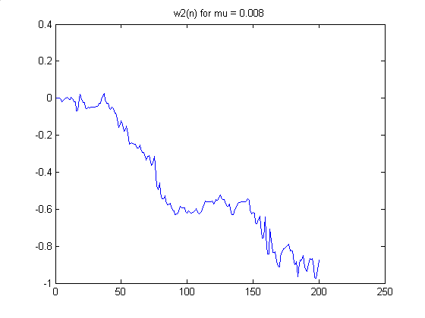

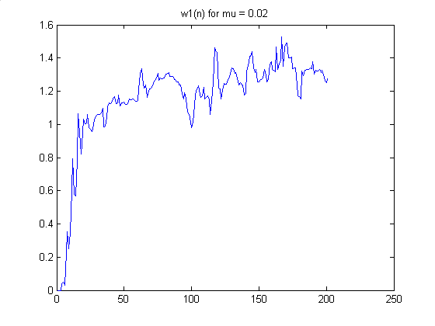

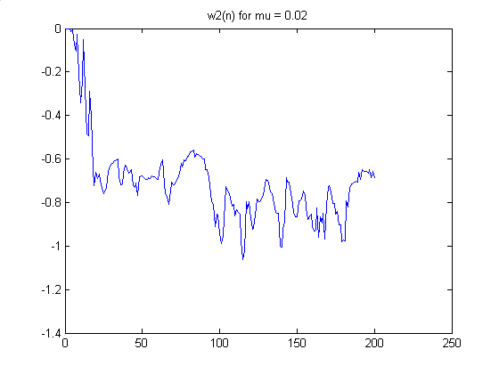

The p vector implementation:

In the p vector algorithm d(n).x(n) term at the update equation is replaced with E{d(n).x(n)}. In our case d(n) is x(n) itself. Therefore, expected value of d(n).x(n) is the autocorrelation of x (in vector form). It is seen from the results that, the performance of the p-vector estimator is strongly dependent on the p-vector estimation (autocorrelation vector estimation in our case). In the following two figures the results of p-vector algorithm are presented. It is seen that the results are biased compared to the results of first part. The p-vector is estimated using the standard autocorrelation method (biased autocorrelation estimation, see the matlab code).

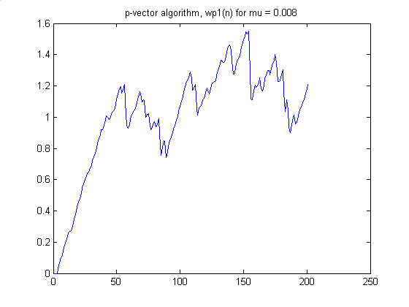

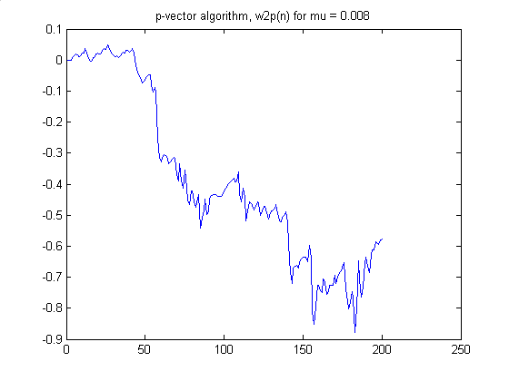

The following figures illustrate the results of the same algorithm with slightly changed p-vector. An error term of 0.001 is added to each term of the p-vector. It is observed that the results are enormously affected with this small perturbation.

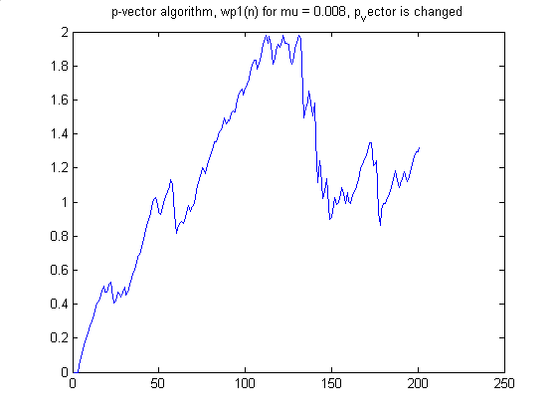

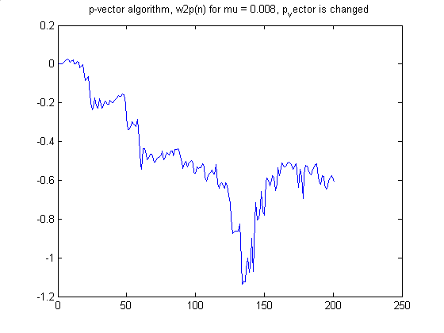

MATLAB CODE

%%%%%%%%%%%%%%%%%%%%%%%%%%%%%%%%%
% EE - 504 Homework #4, P.1 %
% Salim Sirtkaya, 112434-6 %
%%%%%%%%%%%%%%%%%%%%%%%%%%%%%%%%%

close all;
clear all;

N = 500; % number of samples
no_iter = 200 ; % number of iterations
mu= 0.02; % step size

% unit variance white gaussian noise
v = randn(N,1);

% generation of x(n)
b=1;
a=[1 -1.2728 0.81];

x = filter(b,a,v);

% Iterative w estimation
% x(n) is approximated by w(1)x(n-1)+w(2)x(n-2)

% initialize w vector
w1(1:no_iter)=0;
w2(1:no_iter)=0;

for n=3:no_iter
y(n) = [w1(n) w2(n)]*[x(n-1);x(n-2)];
e(n) = x(n) - y(n);
w1(n+1) = w1(n)+mu*e(n)*x(n-1);
w2(n+1) = w2(n)+mu*e(n)*x(n-2);
end

figure;
plot(w1);
TITLE('w1(n) for mu = 0.02');

figure;
plot(w2);
TITLE('w2(n) for mu = 0.02');

%% p-vector algorithm implementation

mup=0.01;
no_iter = 200;
wp1(1:no_iter)=0;
wp2(1:no_iter)=0;
y=0;

% p vector estimation

p(1)=0;
p(2)=0;

eps=0.001;

for i=2:500
p(1) = (p(1) + x(i)*x(i-1));
end
p(1) = p(1)/499;
%p(1) = p(1)+eps; % introduce small changes to p-vector to see the effect

for i=3:500
p(2) = (p(2) + x(i)*x(i-2));
end
p(2) = p(2)/498;
%p(2) = p(2)+eps; % introduce small changes to p-vector to see the effect

% p = xcorr(x,'coeff');
% p= p(size(x):2*size(x)-1);

for n=3:no_iter
y(n) = [wp1(n) wp2(n)]*[x(n-1);x(n-2)];
wp1(n+1) = wp1(n) + mup*p(1) - mup*y(n)*x(n-1);
wp2(n+1) = wp2(n) + mup*p(2) - mup*y(n)*x(n-2);
end

figure;
plot(wp1);
TITLE('p-vector algorithm, wp1(n) for mu = 0.008’);

figure;
plot(wp2);
TITLE('p-vector algorithm, w2p(n) for mu = 0.008’);

