EE504 – HW#5 COMPARISON OF LMS and RLS Salim SIRTKAYA
112434-6

P.1 - a:

x(n) = 1.2728 x(n-1) – 0.81 x(n-2) + v(n)

v(n) : unit variance white noise

linear predictor: x’(n) = w_{n}(1) x(n-1) + w_{n}(2) x(n-2)

Recursive estimator for the coefficients w1and w2 with RLS, λ = 1 . It is seen that the convergence rate of the RLS algorithm is much more higher than the LMS algorithm. Since we choose λ as 1, the solution of RLS filter is unbiased.

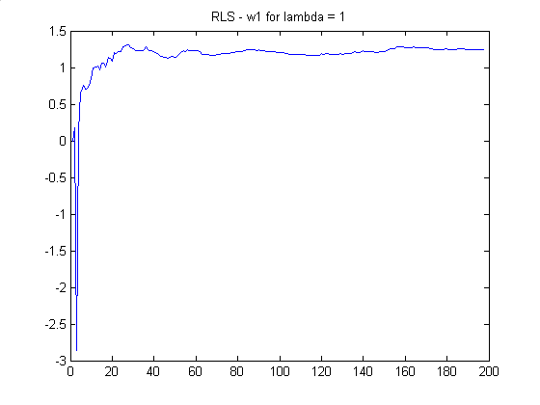

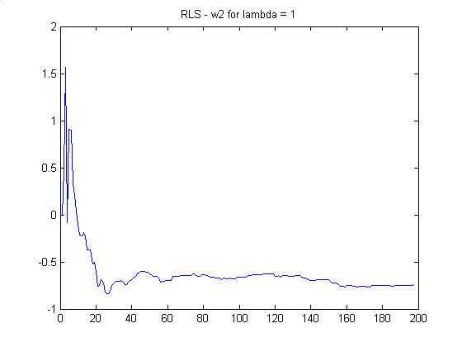

Remember the LMS algorithm results for different μ values:

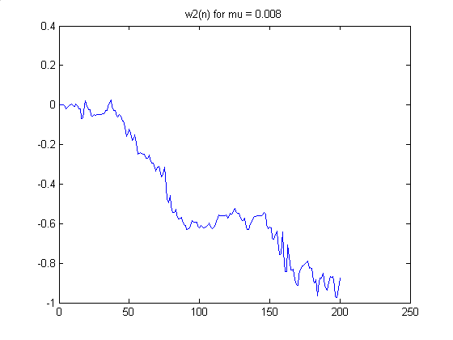

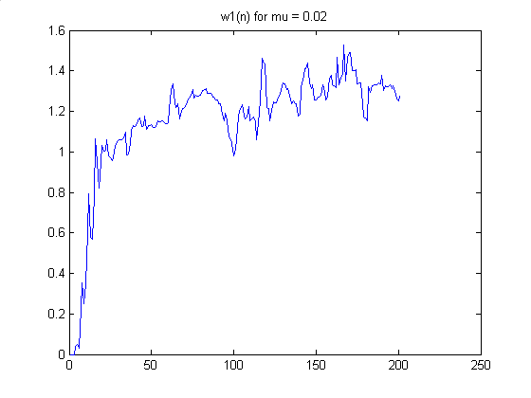

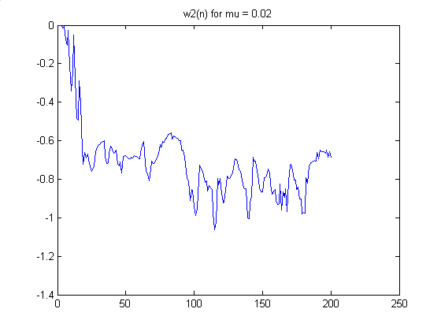

P.1 - b:

The learning curve for the RLS implementation is as follows.. The number of samples is chose as 500, and the number of trials is 100. λ is chosen as 1. This learning curve implies that RLS has a better excess error characteristic because LMS learning curves were not this good. This is due to the fact that RLS does not have any excess error as n goes to infinity, however LMS have.
Note that the first two sample errors are taken as zero therefore they do not contribute to the figure actually..

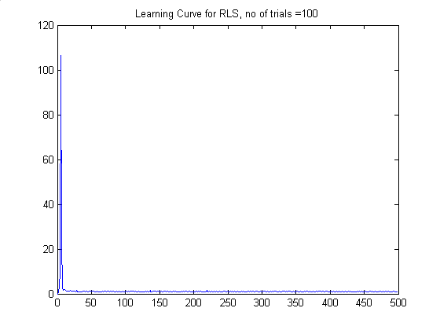

P.1 - c:

Following figures are the learning curves of RLS algorithm for λ=0.99 , λ=0.95 , λ=0.92 and λ=0.90 respectively. It is seen that the excess error increases and the learning curve degrades as we decrease the forgetting factor. Also the solution is biased in this case.

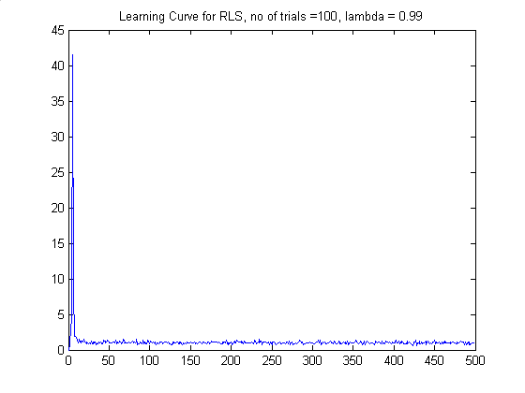

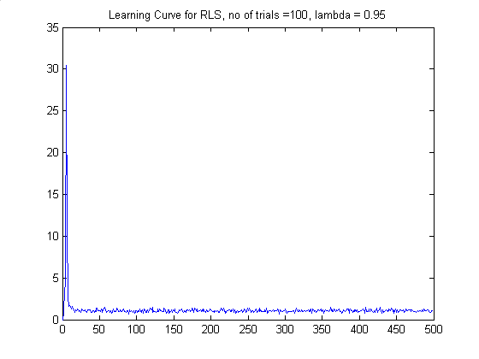

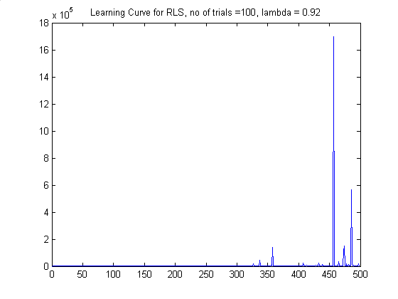

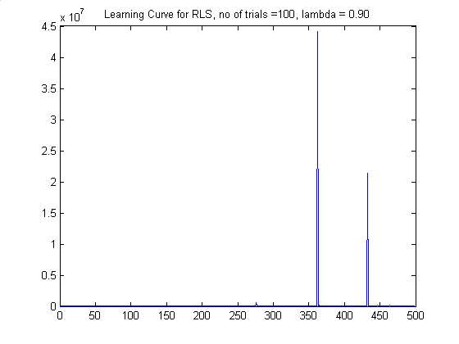

P.1 - d:
The following figures are the results of the Sliding window RLS estimator.

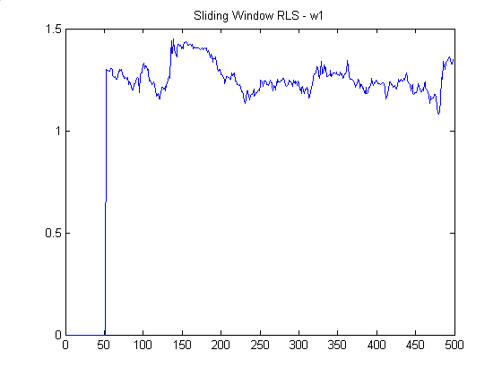

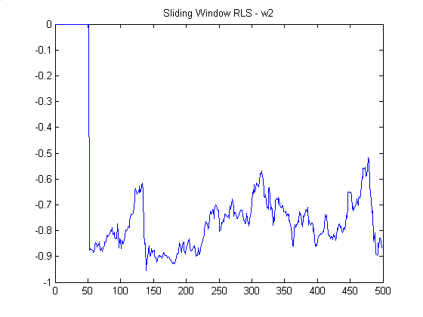

P.1 - e:

In the following figures, you will find the results of the LMS, Growing Window RLS, Exponentially Weighted RLS and Sliding Window RLS results, in respective orders. The system that is to be estimated is:

x(n) = w_{n}(1) x(n-1) + w_{n}(2) x(n-2)

where w_{n}(1) = { 1.2782 ; 0 <= n < 50 and w_{n}(2) = -0.81 for all n.
0 ; 50 <= n < 100
1.2782 ; 100 <= n < 200

It is observed that Exponentially Weighted RLS and Sliding Window RLS methods are able to track the statistical changes in the system . Although Growing Window RLS has a better characteristic than LMS we can say they were not able to track the changes.
If the process have step changes, both sliding window RLS and Exponentially weighted RLS is suitable in terms of tracking capability (Exponentially weighted RLS tracking capability dpends on selection of forgetting factor). However, they have some disadvantages:
- Exponentially weighted RLS solution is biased and it still needs infinite memory. Also choosing the forgetting factor is a challenging issue
- Sliding Window RLS is more complex, and since the number of data points is decresed the bias is increased.
Keeping these facts in mind, I will choose one of them according to the characteristics of my estimator system. But I guess Sliding Window RLS has more probability.

