Salim SIRTKAYA – 1124346

EE557- ESTIMATION THEORY
TAKE-HOME
KALMAN FILTERING

Note: I made Monte-Carlo simulations and put these results at the end of the report.
In the first part, where I made comments, I put the results of a single run. But you’ll see that these comments are also supported by the Monte-Carlo Simulations.

Part A. Plot of the true and observed trajectories for the given system

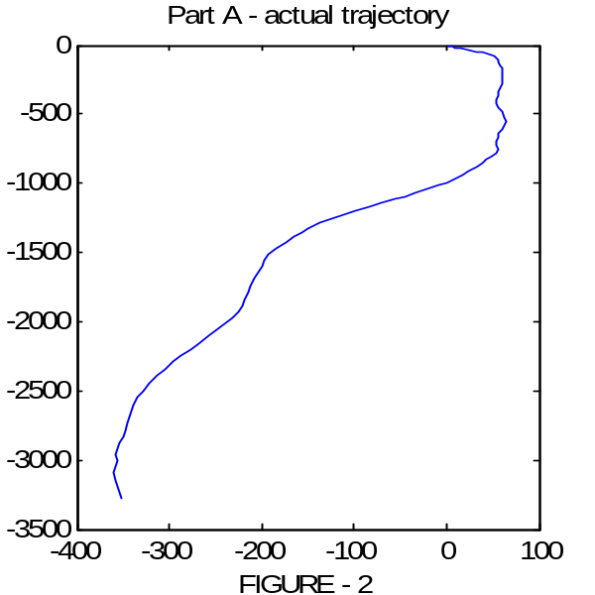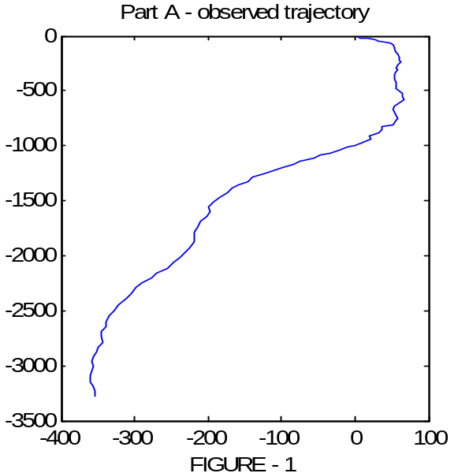

Part B. Plot of Predicted Trajectory, Filtered Trajectory, the predicted/filtered state errors and the norm of the Kalman Gain Matrix..
Figures 3 and 4 show the predicted and filtered trajectories respectively. It can visually be inspected that the filtered state is more reliable than the predicted state. This inspection is supported by Figures 5 and 6 which show the errors in the states. The root-mean-square values of the state errors are also given on those figures. We see that the rms value of the errors in filtered position estimate is half of the predicted position state estimate. The rms error in the filtered velocity state is ~%30 decreased with respect to predicted velocity state.
These results show that filtering (making use of both observations and model) increase the performance of the estimator. Actually this is the essence of Kalman Filtering : We know how the system behaves according to the state equation, and we have measurements of the position, we determine the best estimate of the state x. We want an estimator that gives an accurate estimate of the true state even though we cannot directly measure it : Kalman...
In Figure 7, the evolution of the norm of the Kalman Matrix is given. We see that the gain converges to a steady state value. This result is consistent with the theoretical discussions about the steady state behaivour of the Kalman Filter.

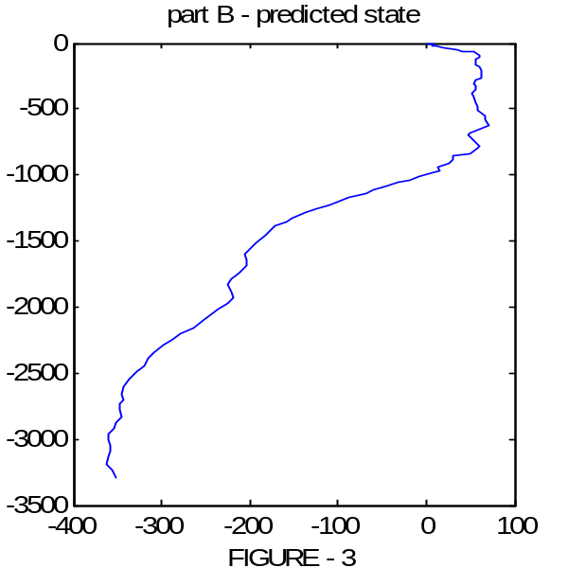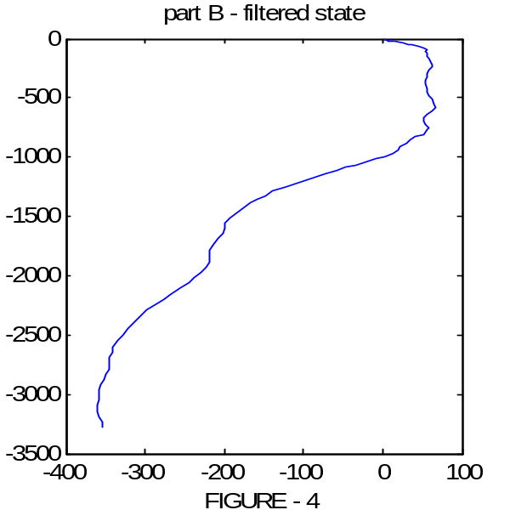

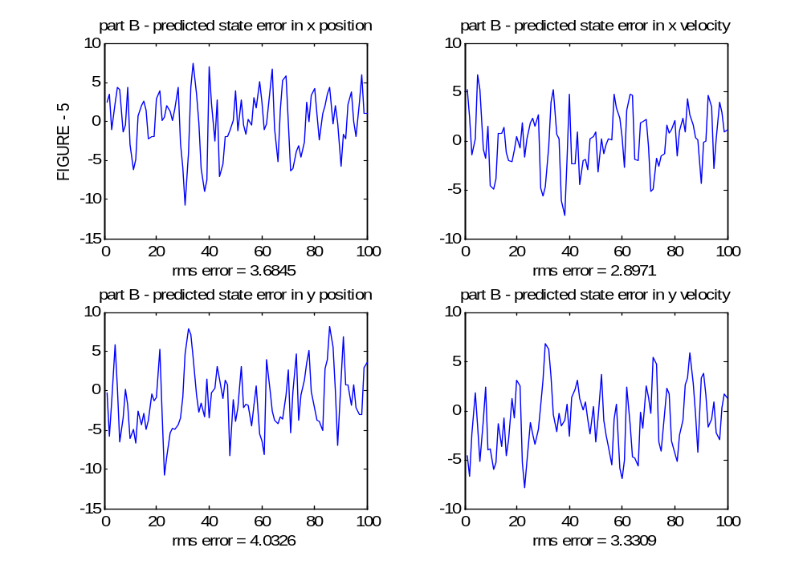

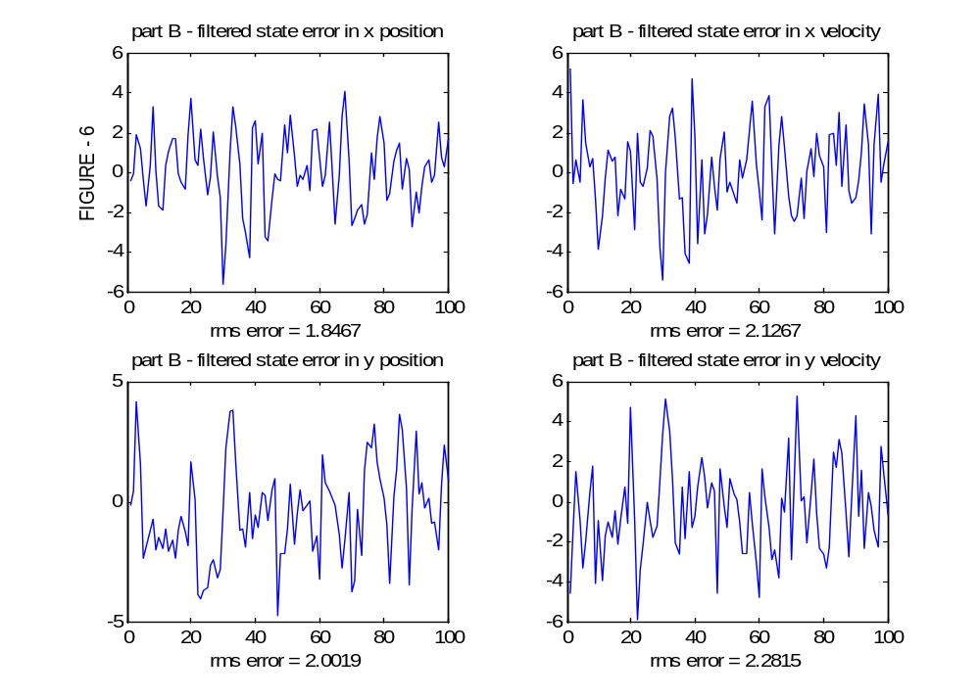

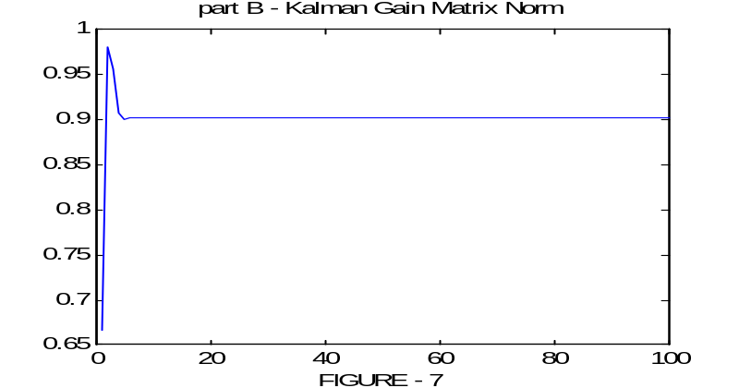

Part C. Same with part B, this time the Q matrix is increased from 5xI₂ to 10xI₂
This means the process noise is increased. Therefore we are more depending on our observations, since the randomness in our model is increased. The physical interpretation of this change can be summaized as follows: In the model we are assuming that the object moves with constant velocity, and we modeled the acceleration as white gaussian noise. Therefore increasing the covariance of the error means there is more acceleration and more degradation from the assumed model. This fact can also be seen from the steady state of the Kalman Gain. It converged to a larger value compared to the previous case. This means we give more importance to our observations.
We see that the error in this case is slightly larger than the previous case both for predicted and filtered states.
Another important observation about the Q matrix is as follows: When we increase Q, the filter uses the observations much and increases Q. Therefore, if the random error on the observation is large at a time, the state estimation is erroneous also. This contributes sudden jumps in the estimate and the smoothness is degrades.
In the analysis we observed the adaptation capability of Kalman Filter in case of an increase in mdel uncertainty. Altough we have a slight increase in error we can say that KF performed well in this case.

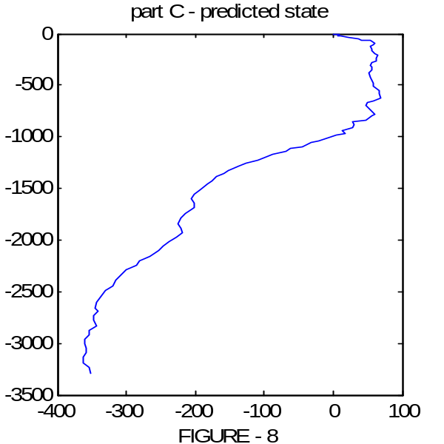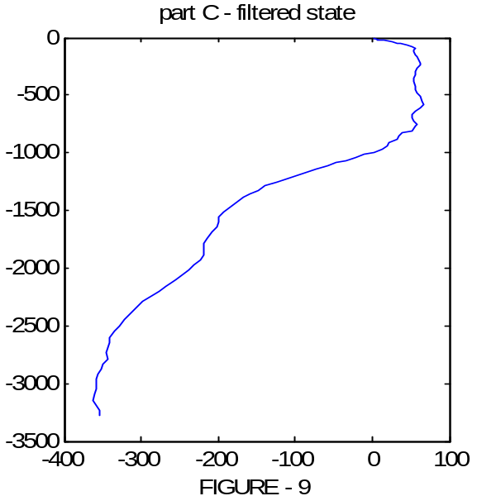

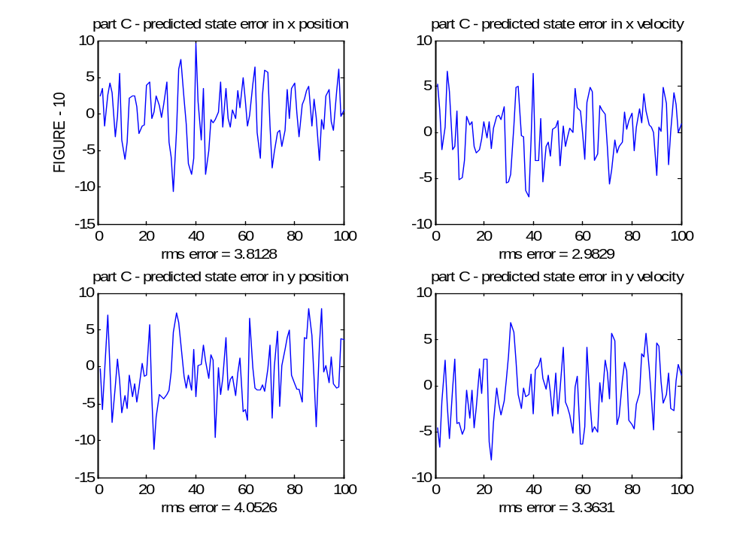

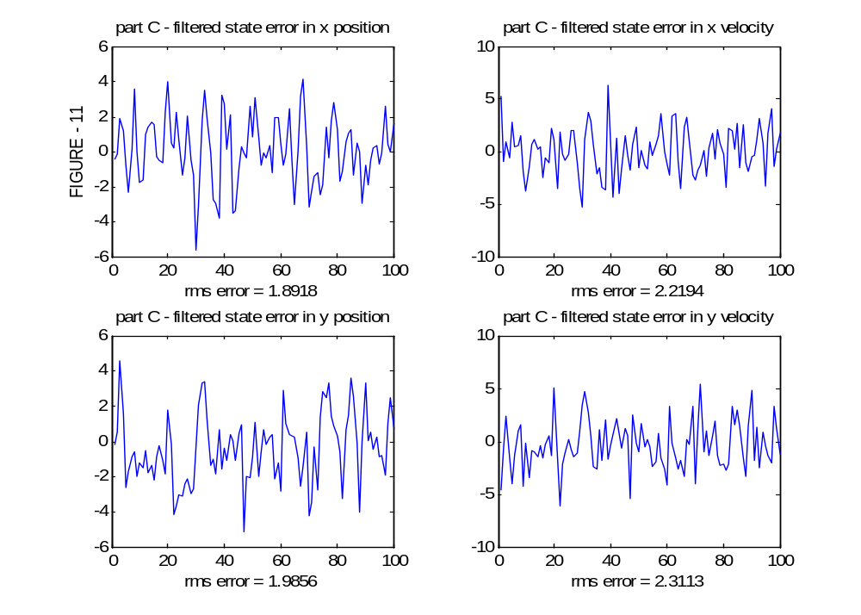

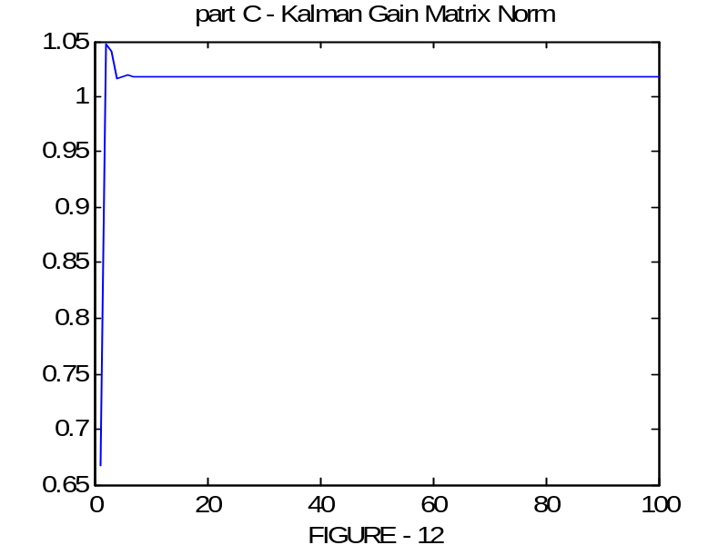

Part D-1. Same with part B with fixed Kalman Gain which is obtained from part B.
In this part we apriorily use the steady state value of the Kalman Gain that is found in part B. We observe that the error slightly decreases in this case. This is due to the fact that, the (comparibly) large errors in the pre-convergence phase of the KF are omitted, as if we have a converged filter from the beginning.

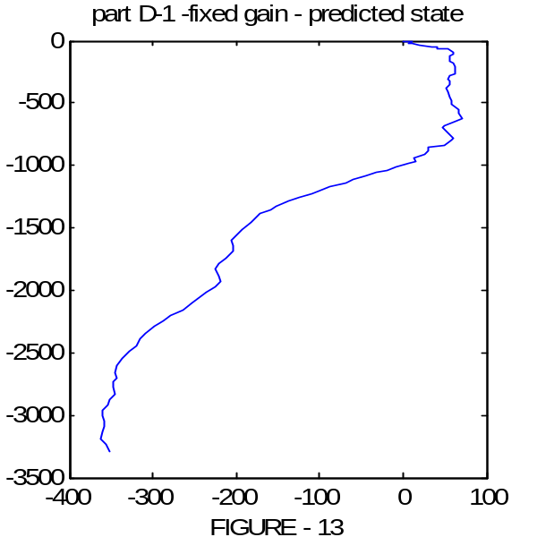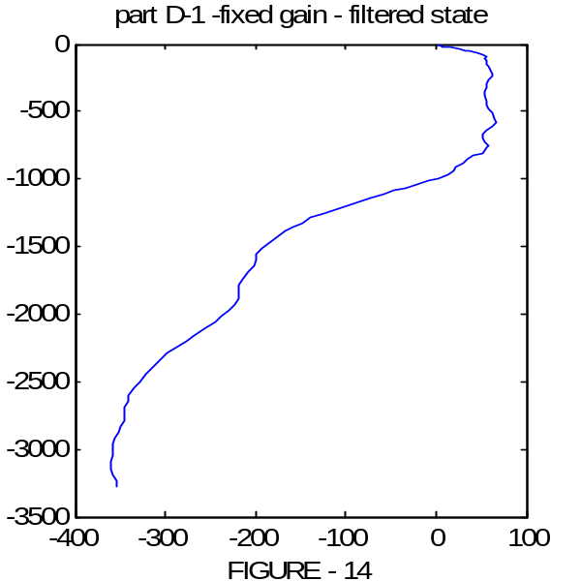

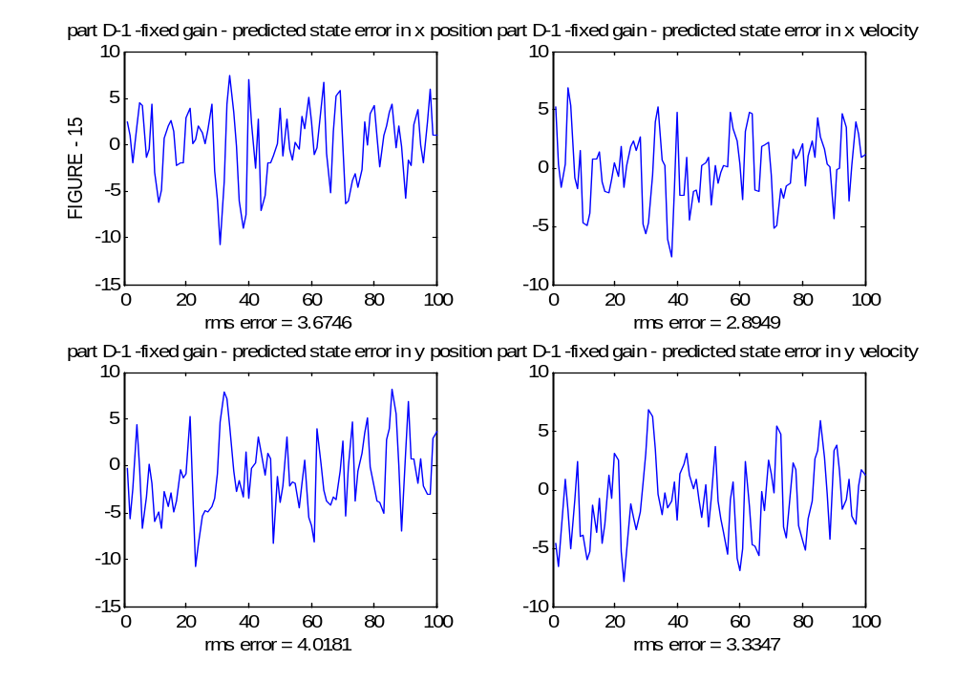

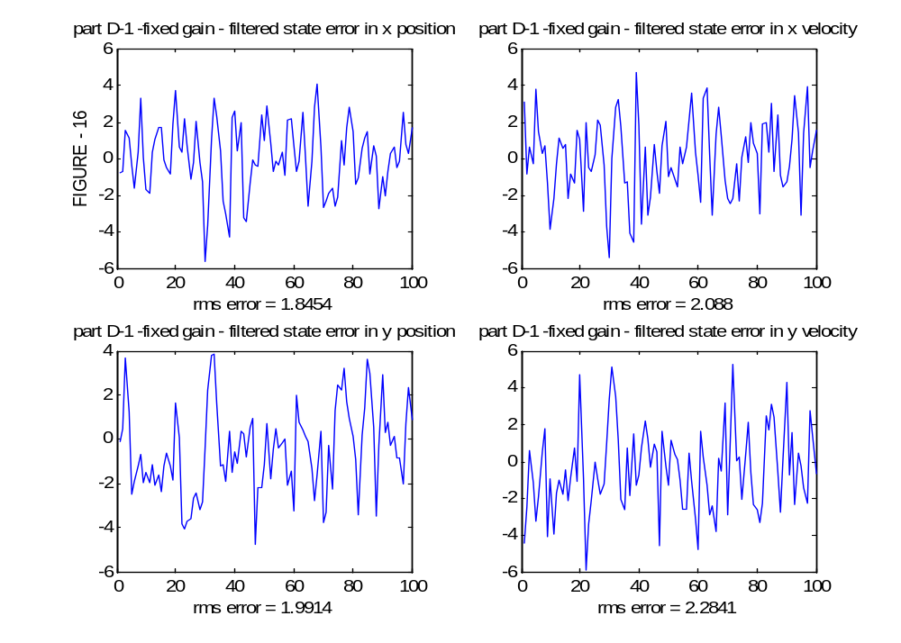

Part D-2. Same with part C with fixed Kalman Gain which is obtained from part C.
In this part we apriorily use the steady state value of the Kalman Gain that is found in part C. We observe that the error slightly decreases in this case. This is due to the fact that, the (comparibly) large errors in the pre-convergence phase of the KF are omitted, as if we have a converged filter from the beginning. Therefore, we get similar result with part D-1 in case of large process noise.
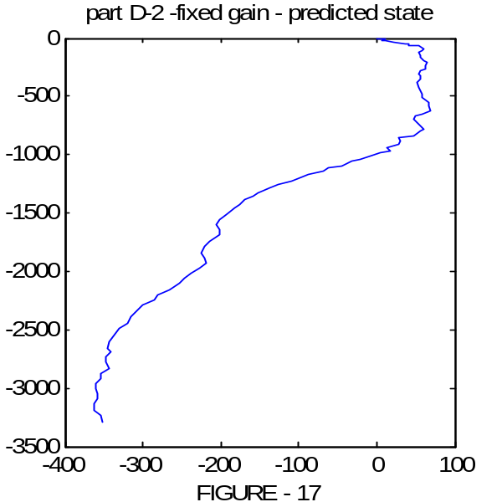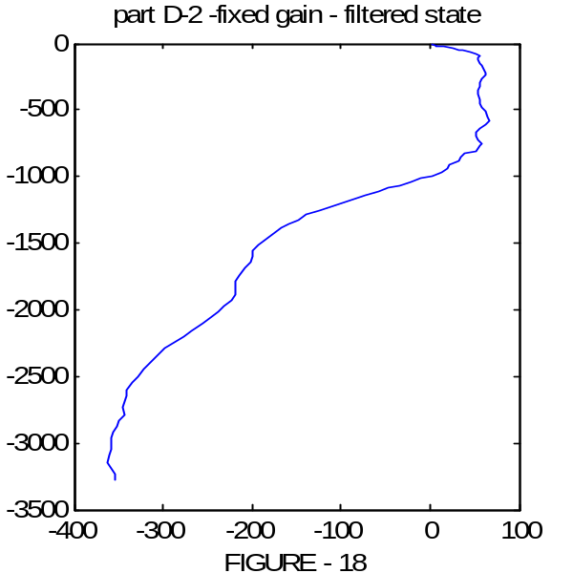

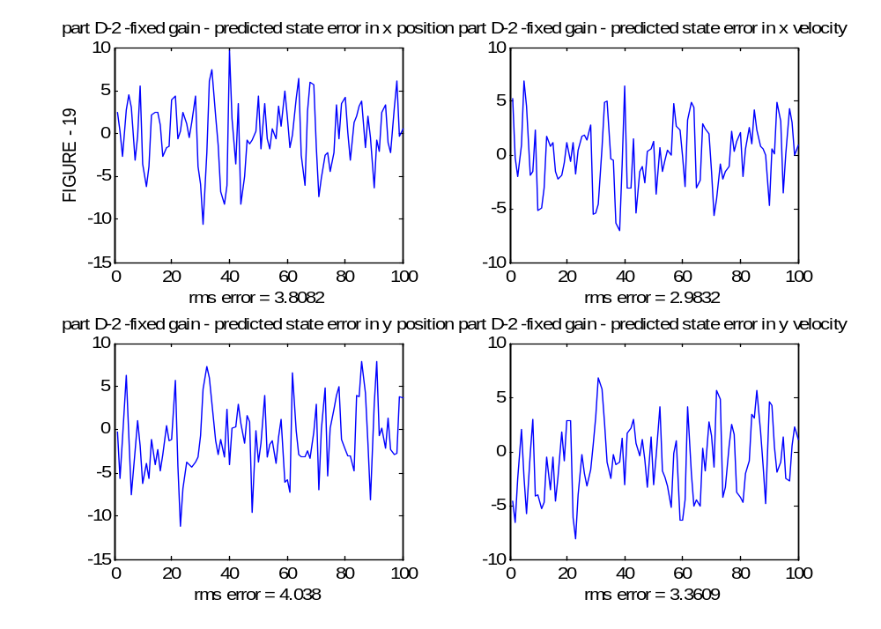

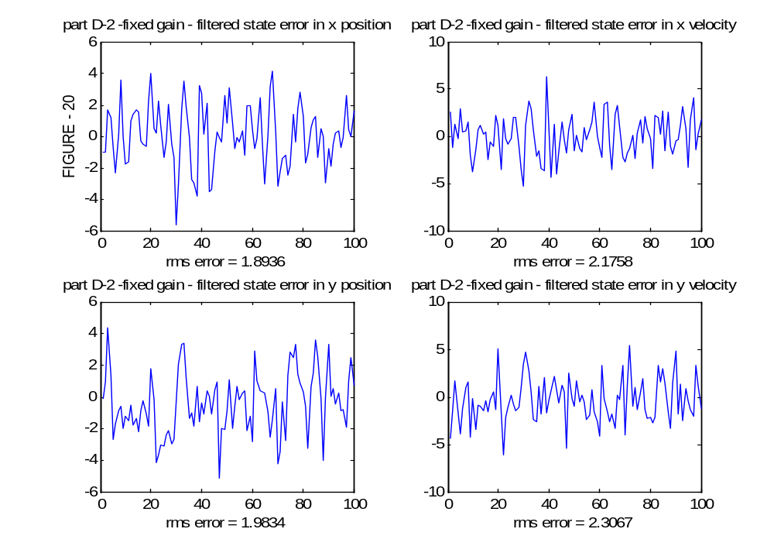

Part E. Same with part B with decreased initial state covariance.
We observed that decreasing the initial state covariance does not contribute a significant improvement to the filter. The KF Gain converged slightly faster compared to previous cases.

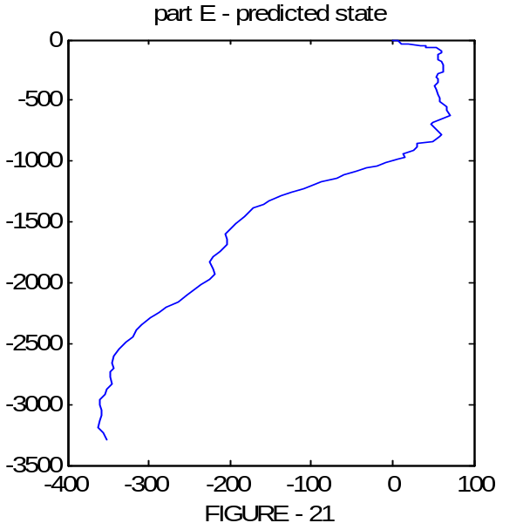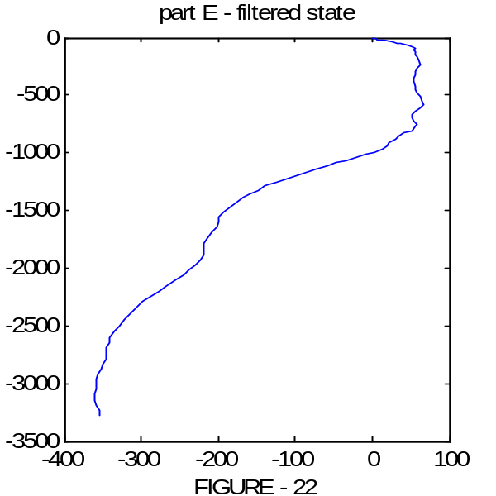

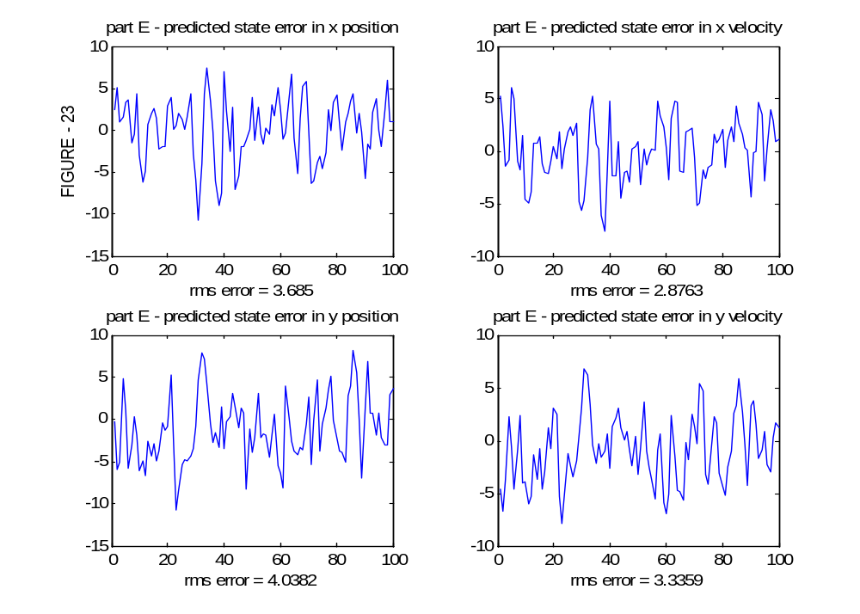

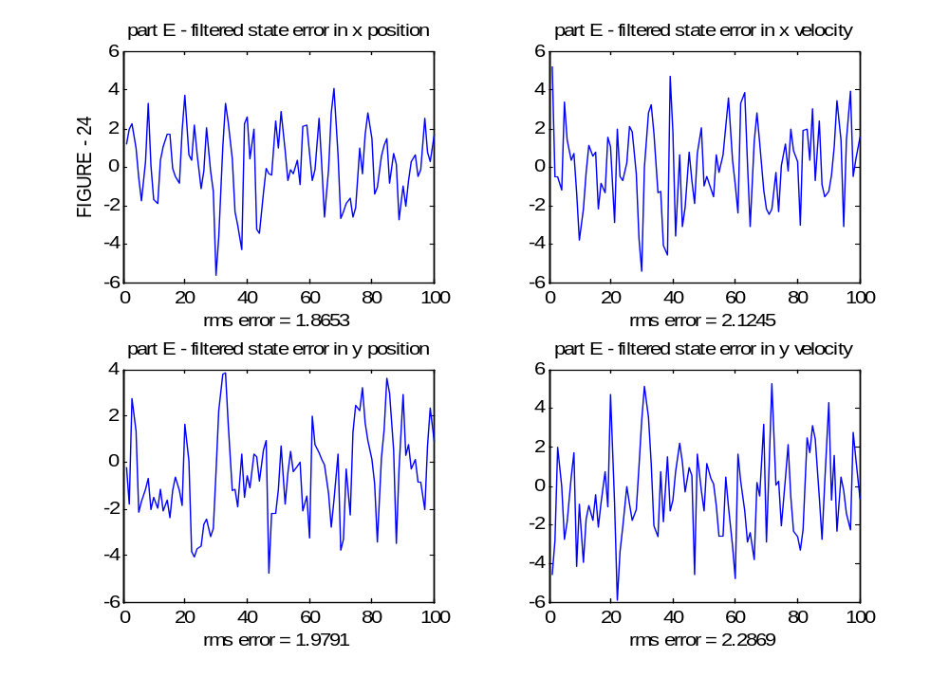

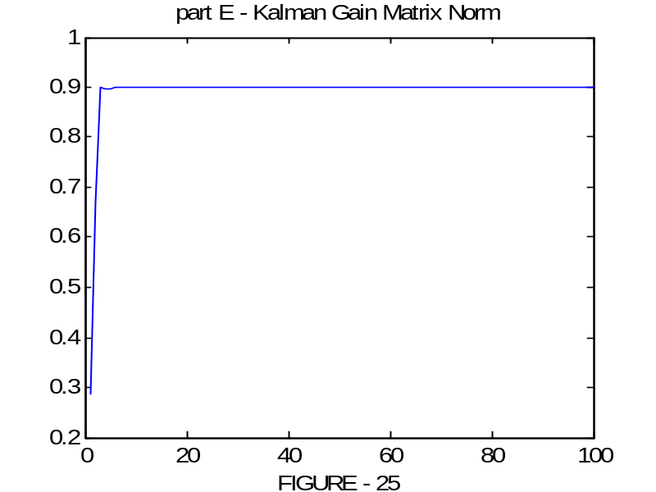

Part F. If there exists correlation between the x and y coordinate measurements
Since R is different, I generated a different trajectory for this case.
We observe that the error increases for this correlated case and the KF Gain converges to a different steady-state point compared to previous results obtaned in Part-B. Note the error increase in x-channel is more significant than y-channel. This is expected since the x-only component of the Q matrix is larger than the other components. Therefore the process uncertainty in x-channel is higher.
The general KF equations that I use in this example are derived with the assumption of uncorrelated noises. And the filter concentrates it attention to minimizing the diagonal elements of the error covariances. Therefore, theoretically it is normal to have larger errors with correlated noises.

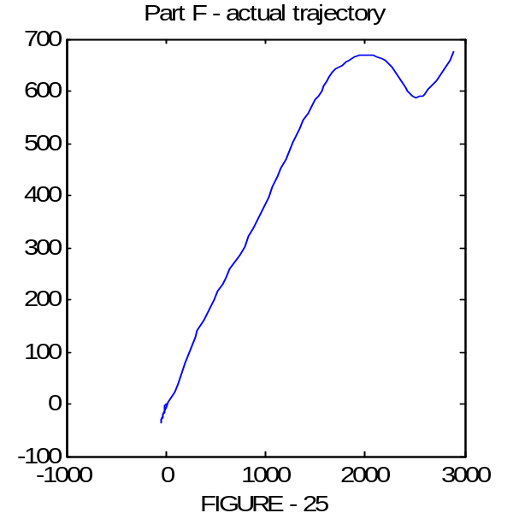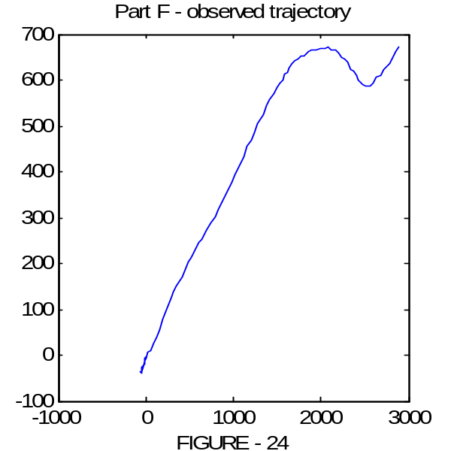

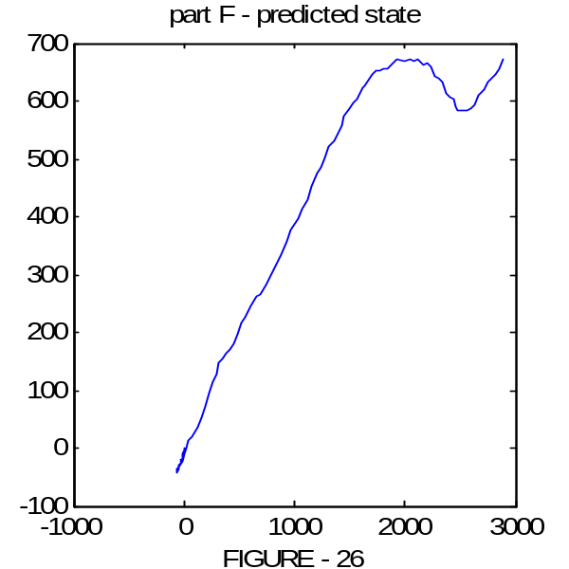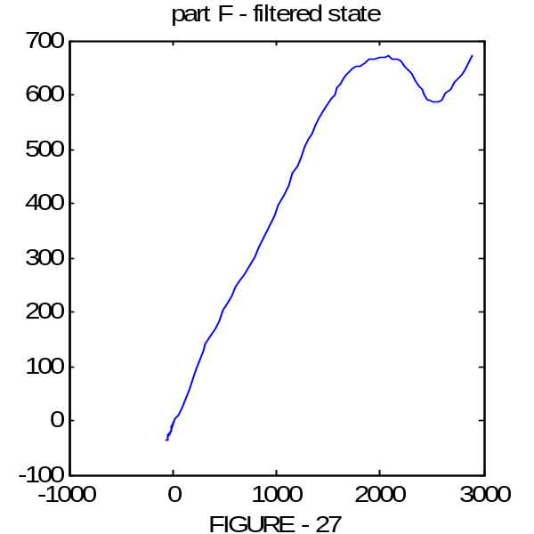

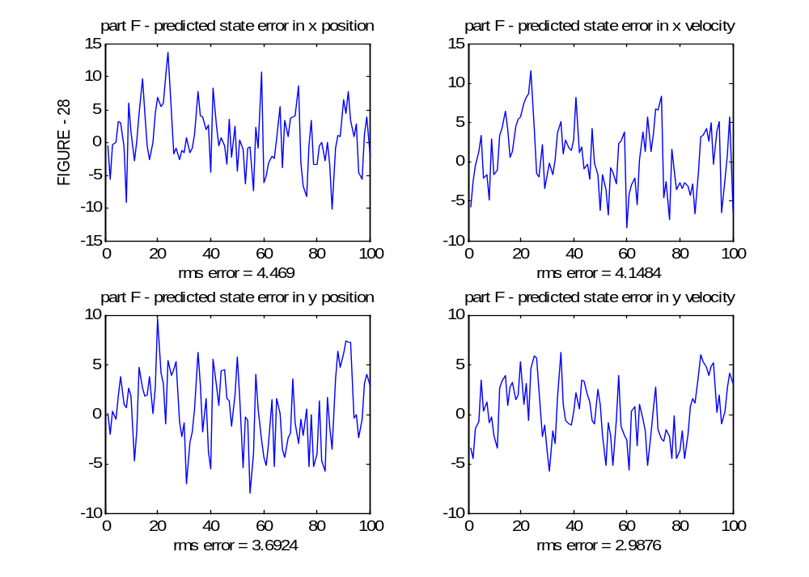

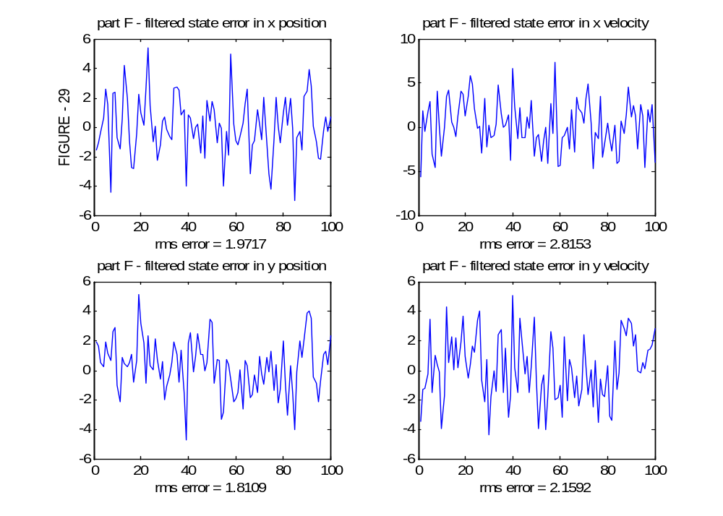

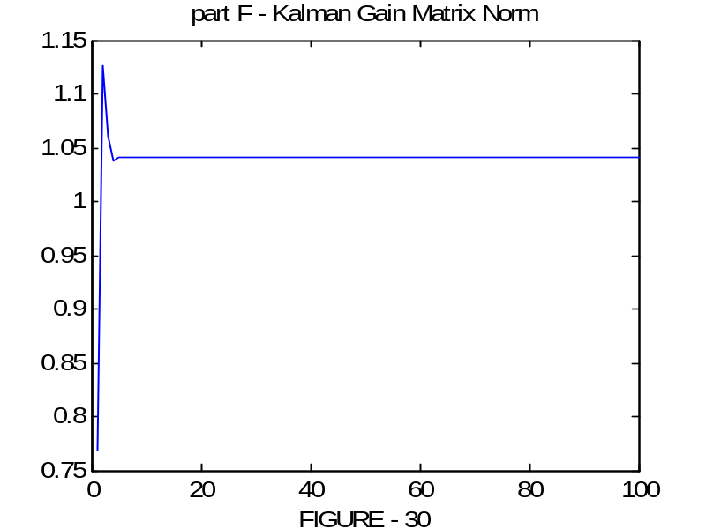

Part G. New trajectories from a variable speed object
Figure 31 shows the actual trajectory. Figure 32 and 33 show observations taken from an uncorrelated and correlated observer systems. Note the degradation in the observations for the correlated case.

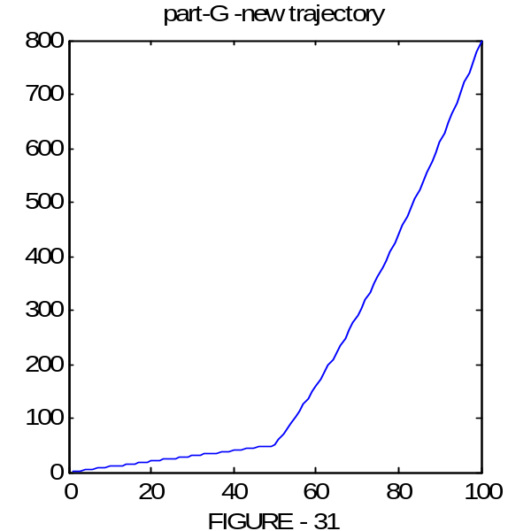

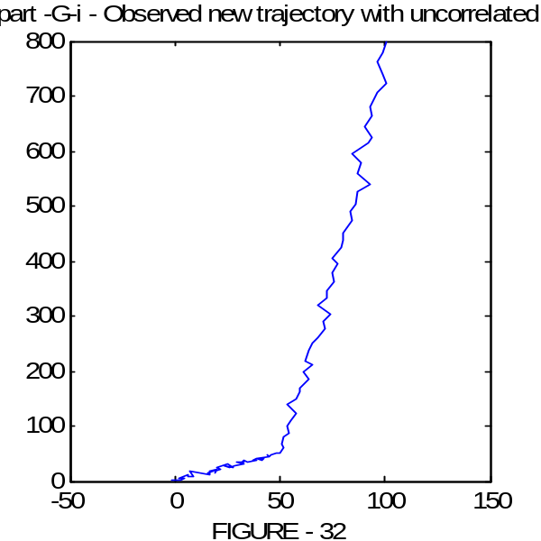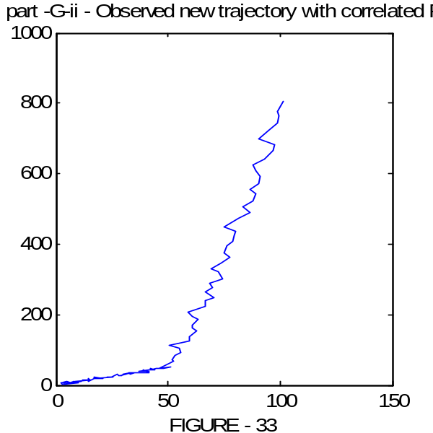

Part H – i . Results for the uncorrelated case
In this example we have a serious problem. In the model we assumed that the object is moving with constant velocity and modeled the acceleration as a white gaussian process noise. In this example the object moves with variable speed. It first moves with constant speed, and suddenly it swiches to an acceleration mode. It is obvious that the model will not be sufficient for this case. Therefore we expect our KF to increase the gain and begin to trust to observations more. However, since the model is incorrect we expect to have a slower convergence.
When we have a modeling error the KF tends to diverge and there exists two kind of divergence, apparent and true. In apparent divergence the KF filter converges to a wrong point (a kind of divergence) but the error is bounded. In true divergence the error is unbounded. Note that in our example we have apparent divergence.
Also note that there is an increase in y-axis error at time 50 due to the model change. This jump last for 5-10 sample and then KF again converges to a minimum variance error point. Also note that the Kalman gain is not effected from the samples, therefore it can be calculated offline and be used from the beginning.

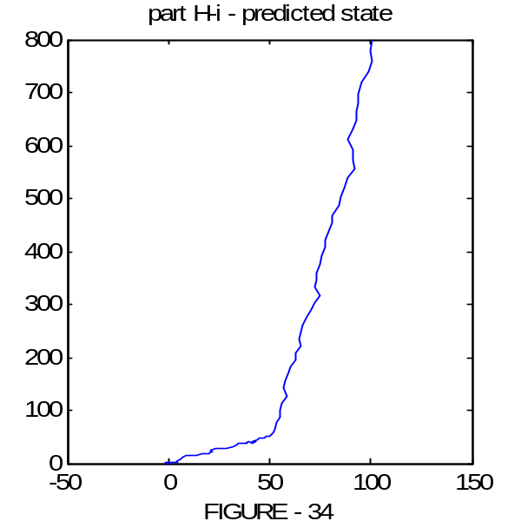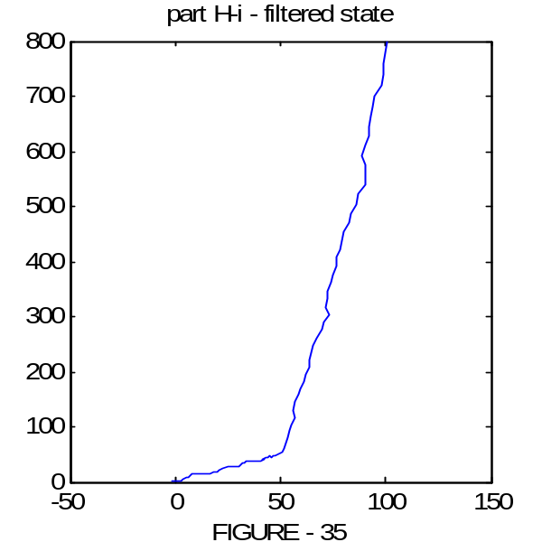

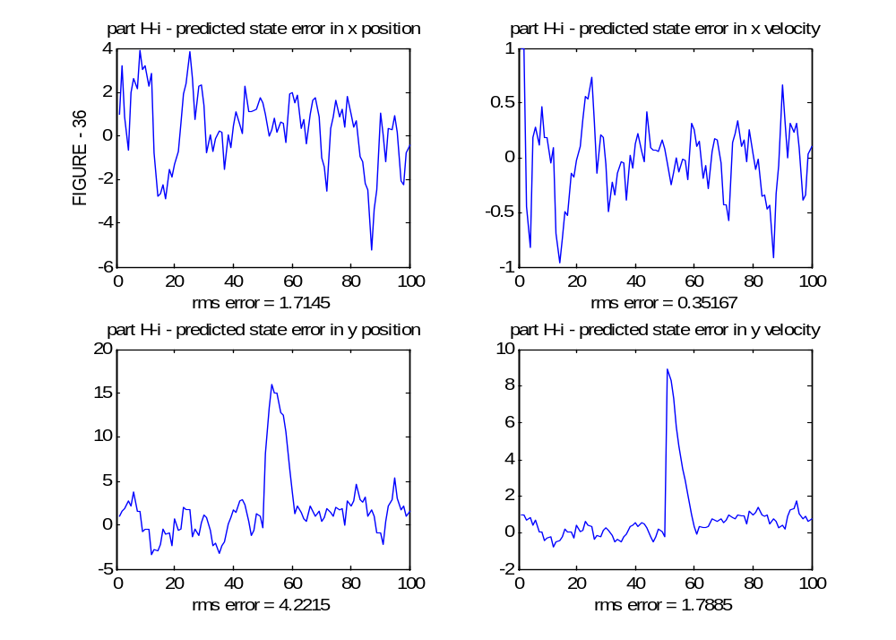

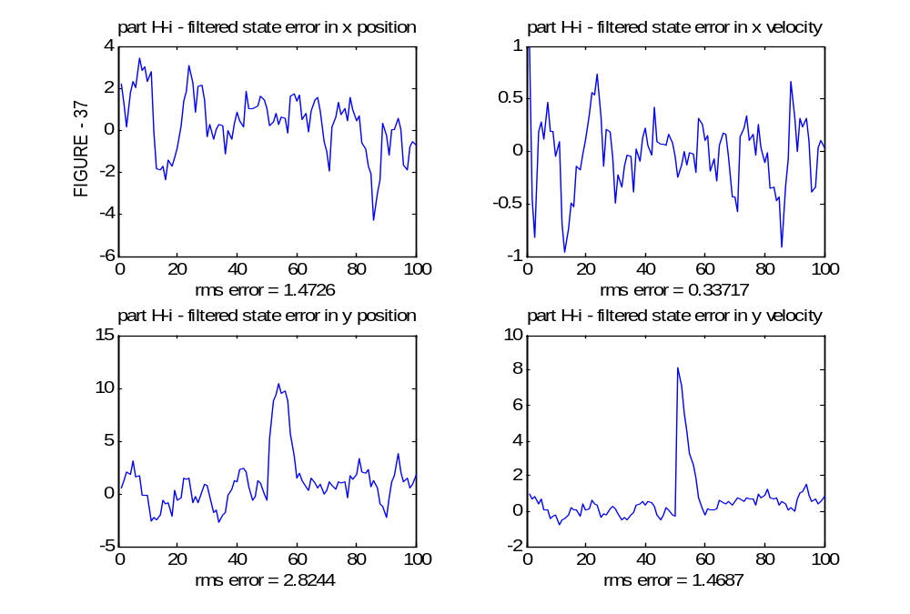

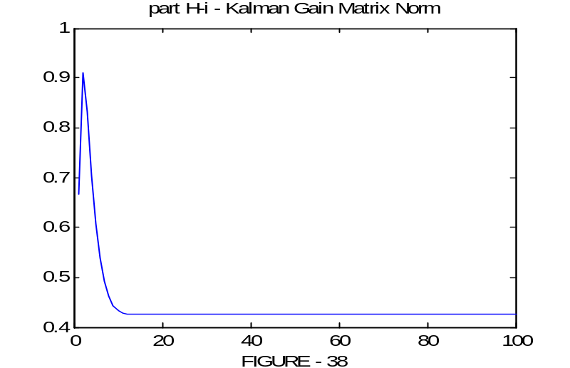

Part H – ii. Results for the uncorrelated case
Discussions of part H-i hold for this case also. In addition, we see the effect of correlated observation noise in this case. The correlation, degrades the performance of the estimator.

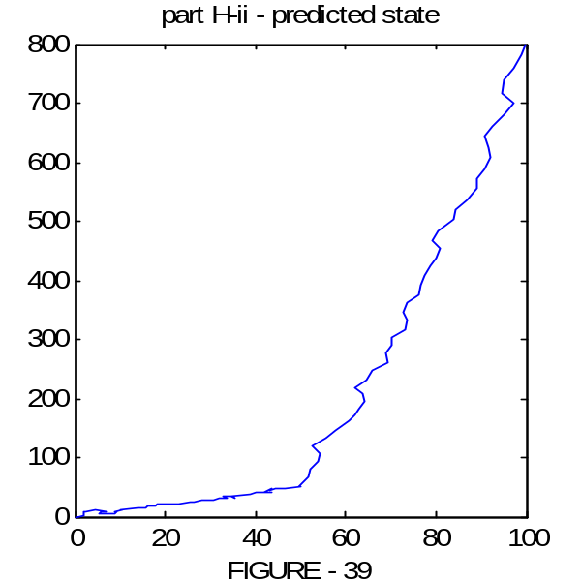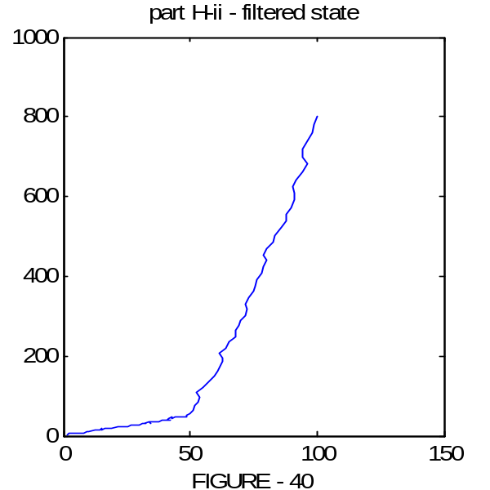

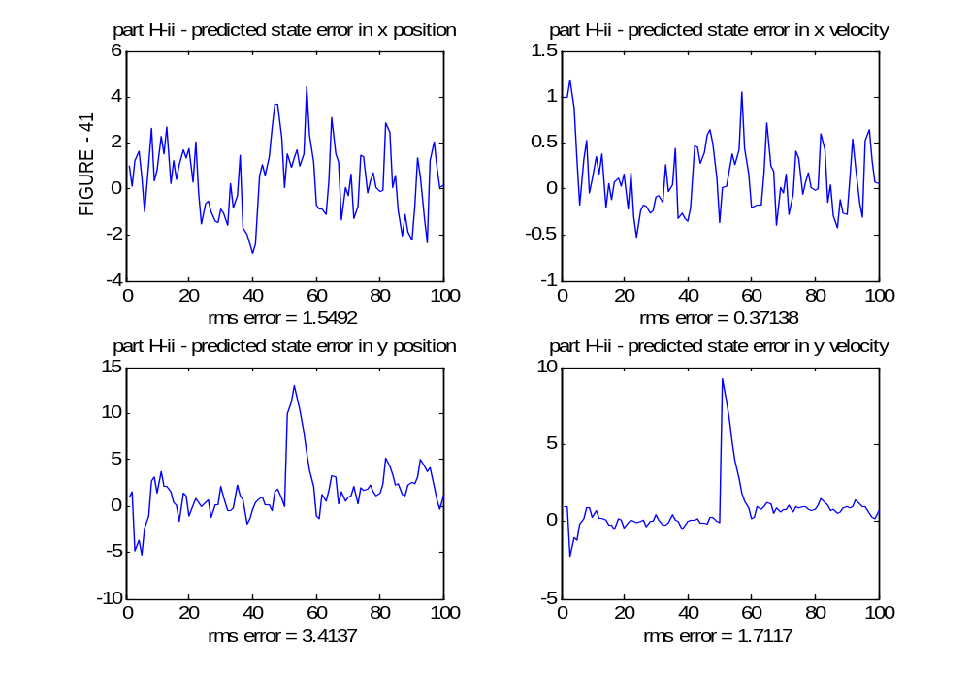

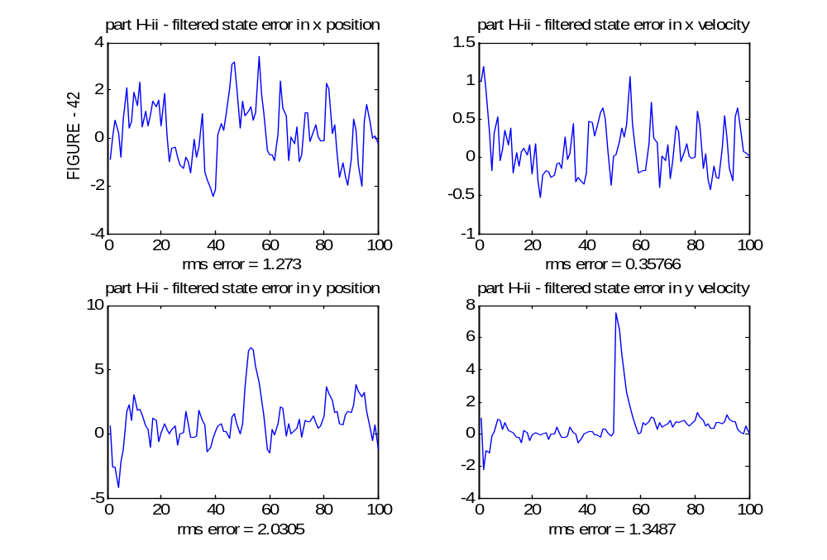

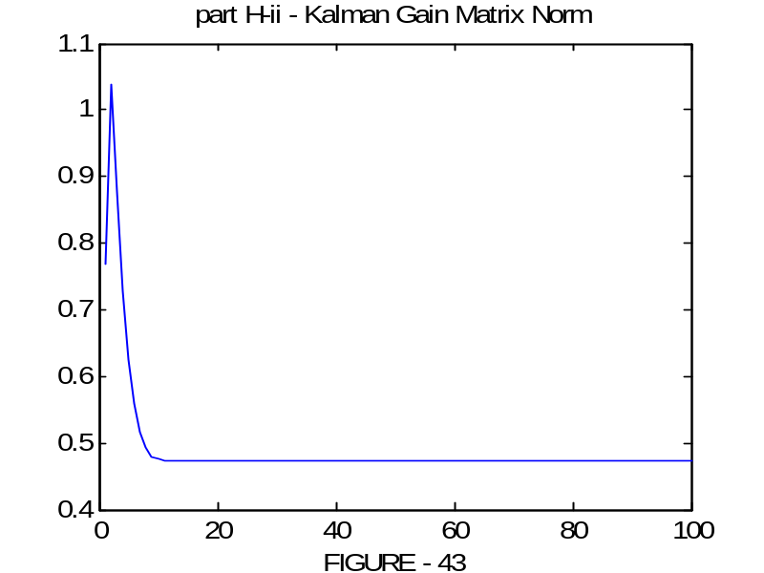

Part I – i. Increase Q and repeat Part H.i
An attractive solution of preventing divergence due to modeling error is the addition of fictitious process noise to the system model. By this way system depends more on observations and the effect of wrong model decreases. Note that the error in y-channel decreases significantly, conversely the error in x-channel increases slightly. This is expected since the modeling error exists only in y-channel. Therefore increasing Q decreases the error in this channel. The model in x-channel is true, therefore increasing Q degrades the performance in this channel.
Another important observation about the Q matrix is as follows: When we increase Q, the filter uses the observations much and increases Q. Therefore, if the random error on the observation is large at a time, the state estimation is erroneous also. This contributes sudden jumps in the estimate and the smoothness is degrades.

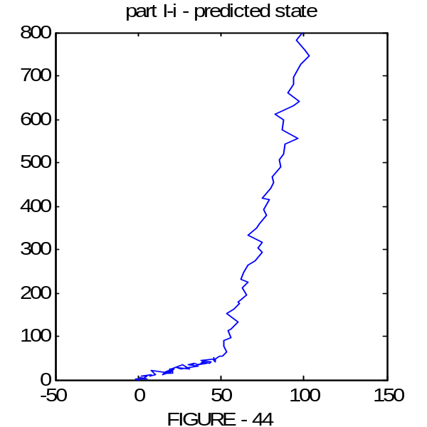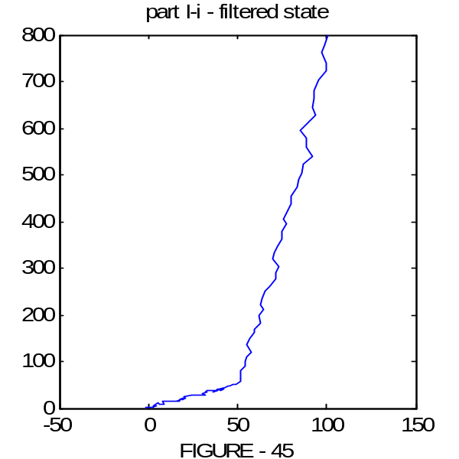

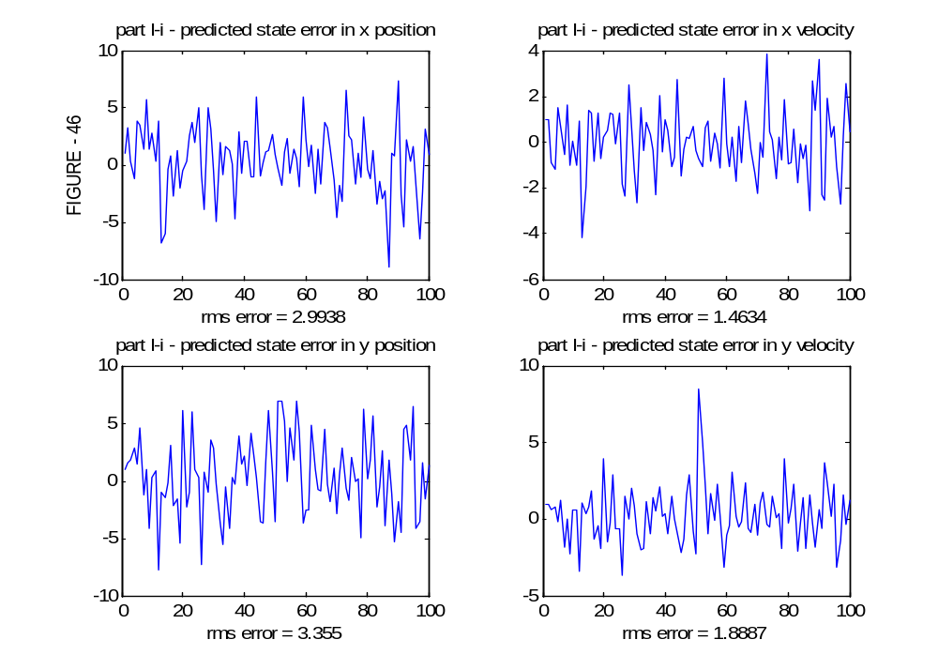

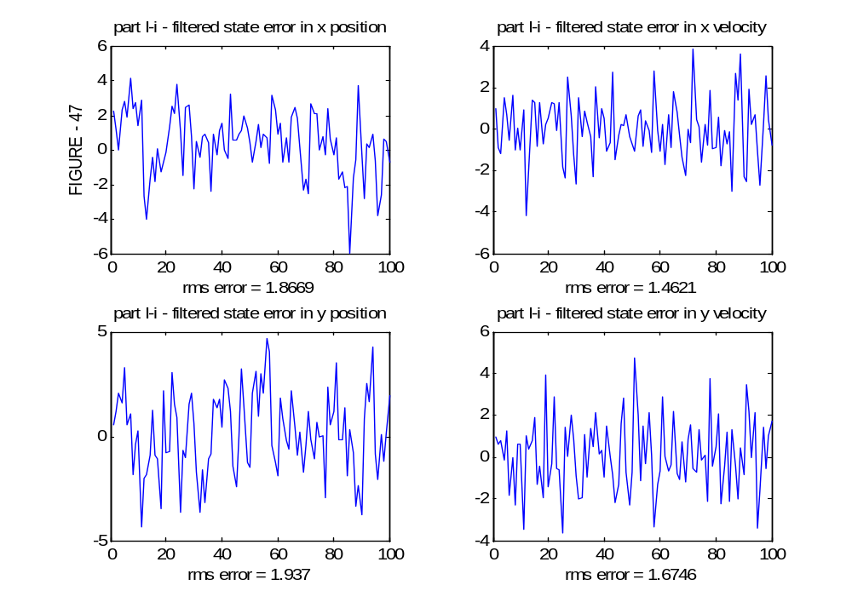

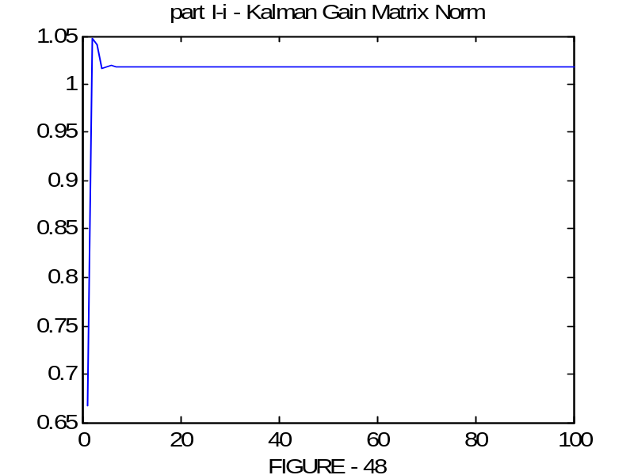

Part I – ii. Repeat Part I-i with correlated R
Discussions of part H-i hold for this case also. We see the effect of correlated observation noise in this case. The correlation, degrades the performance of the estimator.

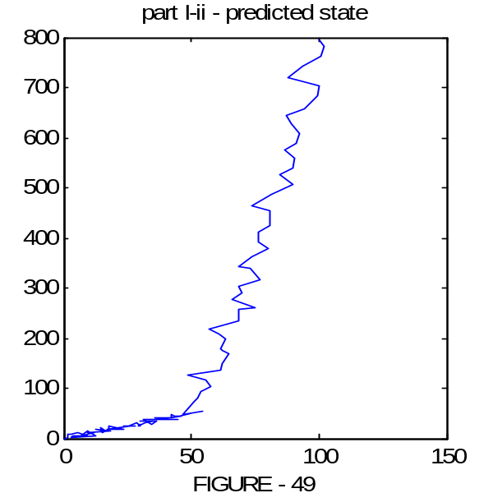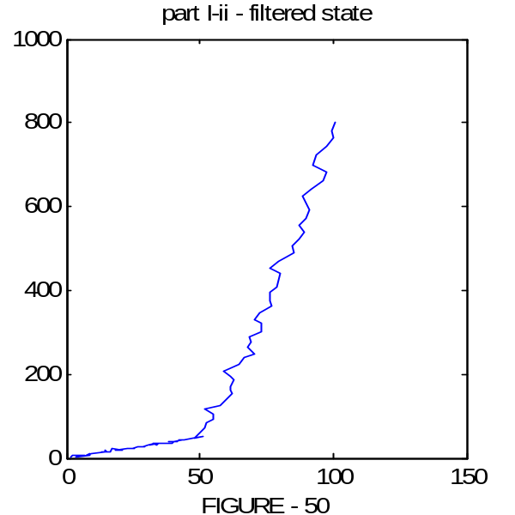

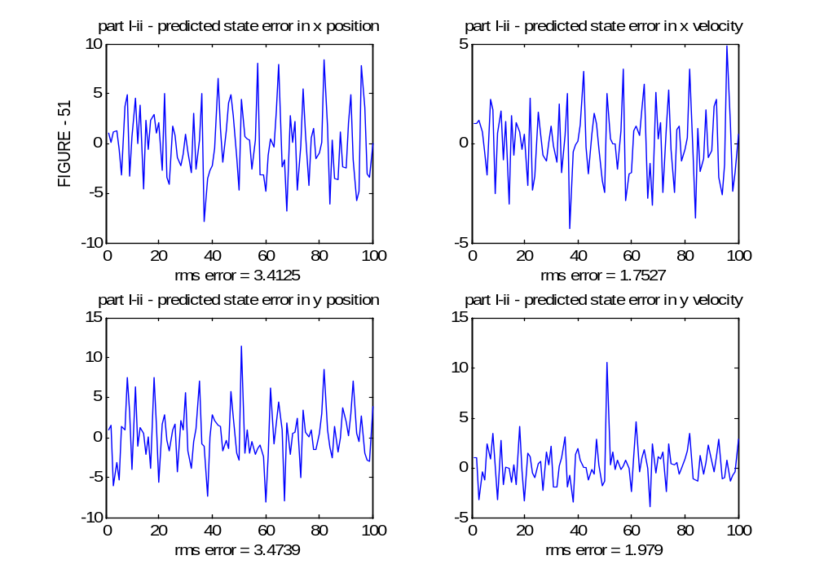

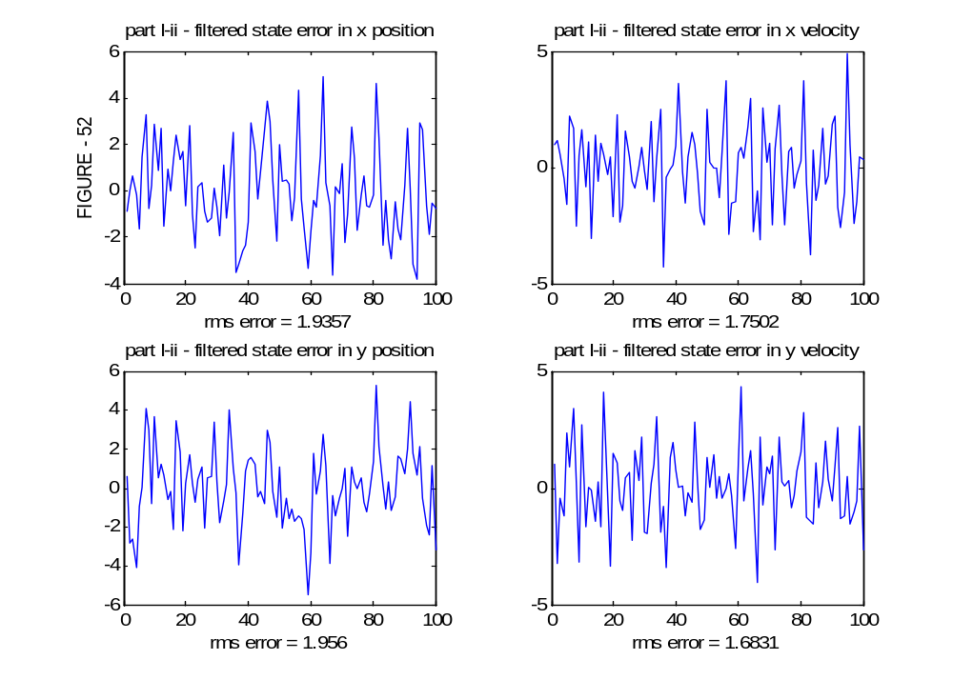

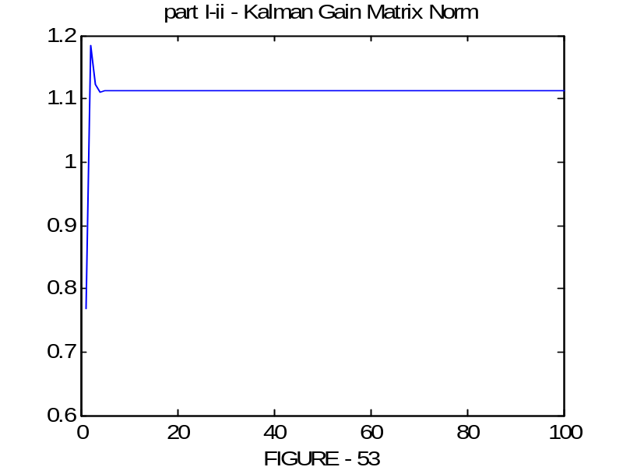

MONTE-CARLO SIMULATION RESULTS

Note: The estimated trajecories are not plotted after part B..

