EE505 - Homework Salim SIRTKAYA 1124346

Comparison of SHORT TIME FOURIER ANALYSIS and WAVELET ANALYSIS
(using Haar and Sinc Wavelets)

Theoretical Aspects:

Although it is a powerful tool for signal analysis, Fourier Transform lacks the time analysis of the frequency change. Therefore it is not suitable for non-stationary signal whose frequency contents change in time. Scientist developed methods to analyse these kind of signals both in time and frequency.
Short Time Fourier Transform is one of this methods. Basically it analyses the frequency content of the signal in small time intervals by making use of window functions (Kaiser, Rectangular, Hanning etc.). Spectograms are used to realize the STFT results (we’ll use spectgrams in the example as well). However it makes this analyses exactly the same for all frequencies (the time duration of the analysis is same for low and high frequencies). Therefore this analyses is insufficient to modify the necessary time duration for the specific frequency content.
Wavelet analysis, on the other hand, uses different time intervals for different frequency contents. It uses large time intervals to catch the low frequency characteristic (low pass) of the signal. And decreases the time interval for high frequencies. Another important difference between STFT and wavelet analysis is, STFT uses time-frequency decomposition for the analysis, on the other hand wavelet analysis uses time scales and frequency shifts for the analysis.
For the sake of completeness of the discussion about our example, we should mention the structures of haar and sinc wavelets. The basic structure about these mother wavelets is, haar wavelet is time limited and sinc wavelet is band limited (in frequency domain). We can intuitively say that, wavelet analysis with haar mother wavelet will have poor frequency localization (since it has infinite frequency content) and sinc wavelet will have poor time localization since it has infinite time content. We’ll discuss this more on the example.
In the example a signal which has rich frequency content and abrupt changes will be used to see the difference with naked eyes.

Example:

As seen from figure 1, the signal in analysis has different frequency components, flat parts, abrupt changes etc. meaning it is a non-stationary signal. The signal has 750 samples.
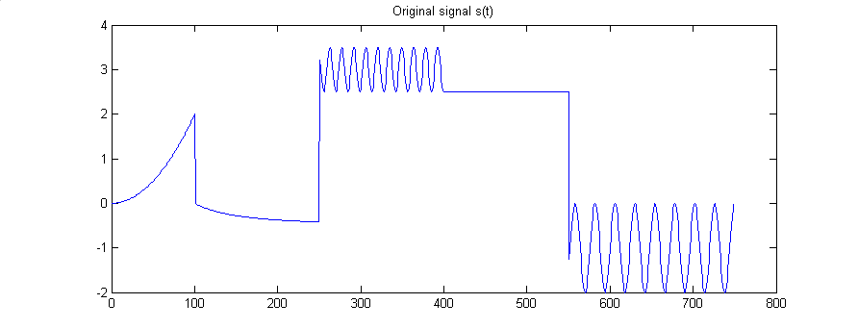
Figure 1 – Original signal

- At first STFT is conducted for time-frequency analysis of this signal.
A hanning window is used for the STFT analysis. Figure 2,3 and 4 shows the results of STFT with window lengths 128, 64 and 32 respectively as spectograms. The time localizations of the frequency contents and changes can easily be seen from these spectograms. You can see that the time localization is best at the window length of 32. However at that level the frequency localization is not so good. This trade-off was expected due to the nature of the STFT. The frequency resolution deteriorates as the time resolution gets better.

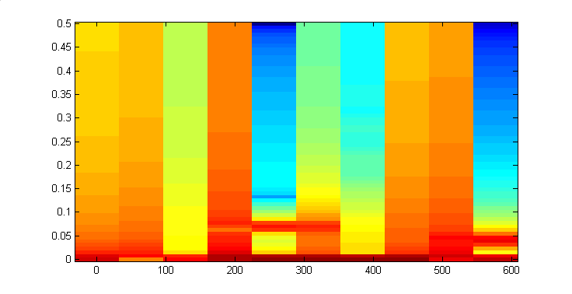
Time resolution is not good
Frequency resolution is good
Figure 2 – Spectogram of STFT with hanning window of length 128

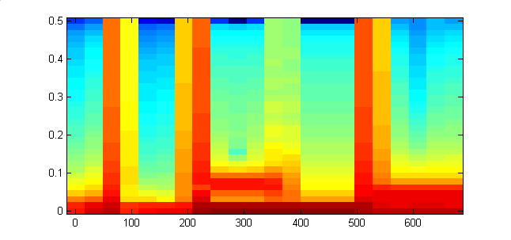
Time resolution gets better
Frequency resolution begins to deteriorate
Figure 3 – Spectogram of STFT with hanning window of length 34

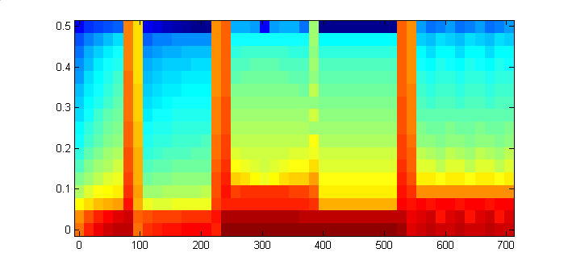
Time resolution gets better
Frequency resolution continue to deteriorate
Figure 4 –Spectogram of STFT with hanning window of length 32

- Now lets look at wavelet analysis of this signal with haar mother wavelet.

In the scalogram it is seen that the time resolution differs for different scales. This enables the wavelet analysis to concentrate on different frequencies accordingly. In figures 6,7 and 8 we see the reconstruction results of the wavelet decomposition in scales 1, 3 , 5 respectively. We observe that as the scale increases the reconstruction performance degrades, as expected, since we are sacrificing the high frequency content as we increase the scale. However, we also observe that the localization in time domain is still exceptable. This is an interestin result, and is consistent with our previous discussion.

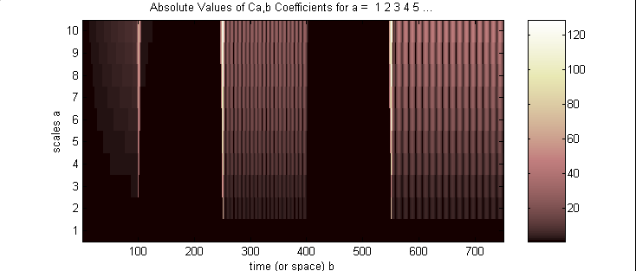
Figure 5 –Scalogram of haar cwt with 10 scales
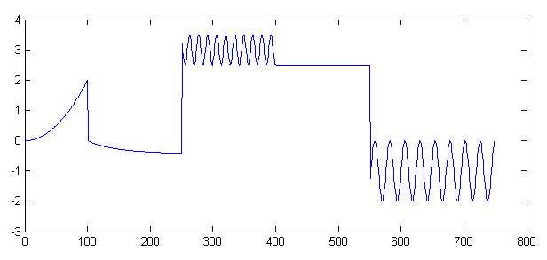
Figure 6 –Reconstructed signal after haar wavelet transform at level 1
The norm of the error is = 8.7426e-015

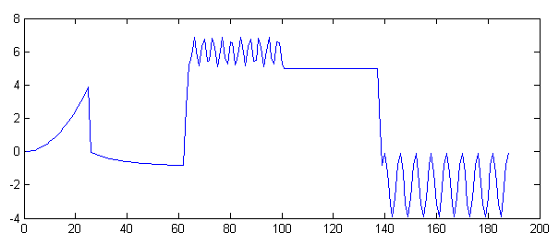
Figure 7 –Reconstructed signal after haar wavelet transform at level 3

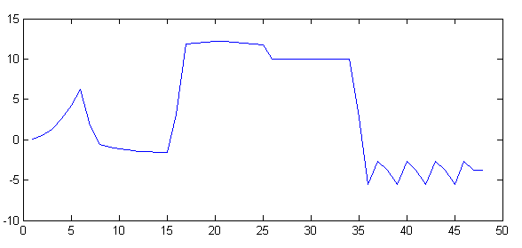
Figure 7 –Reconstructed signal after haar wavelet transform at level 5

